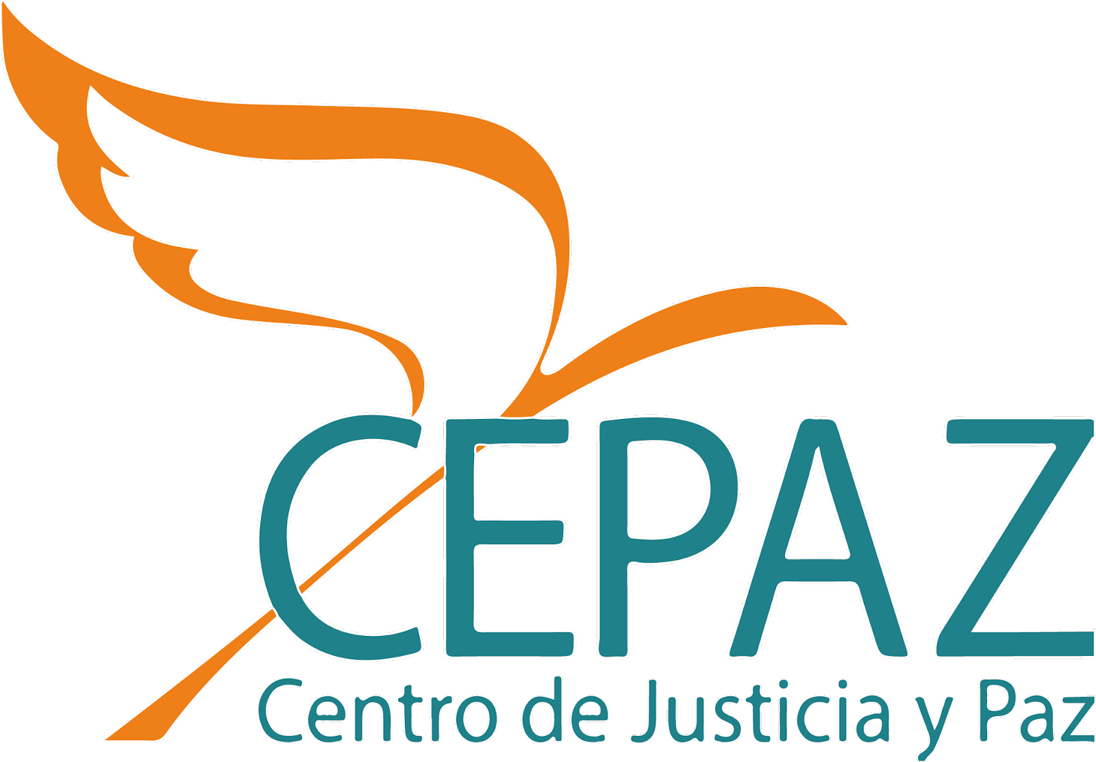
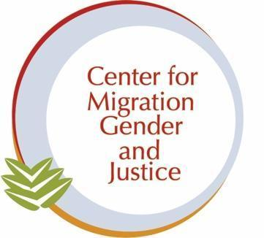
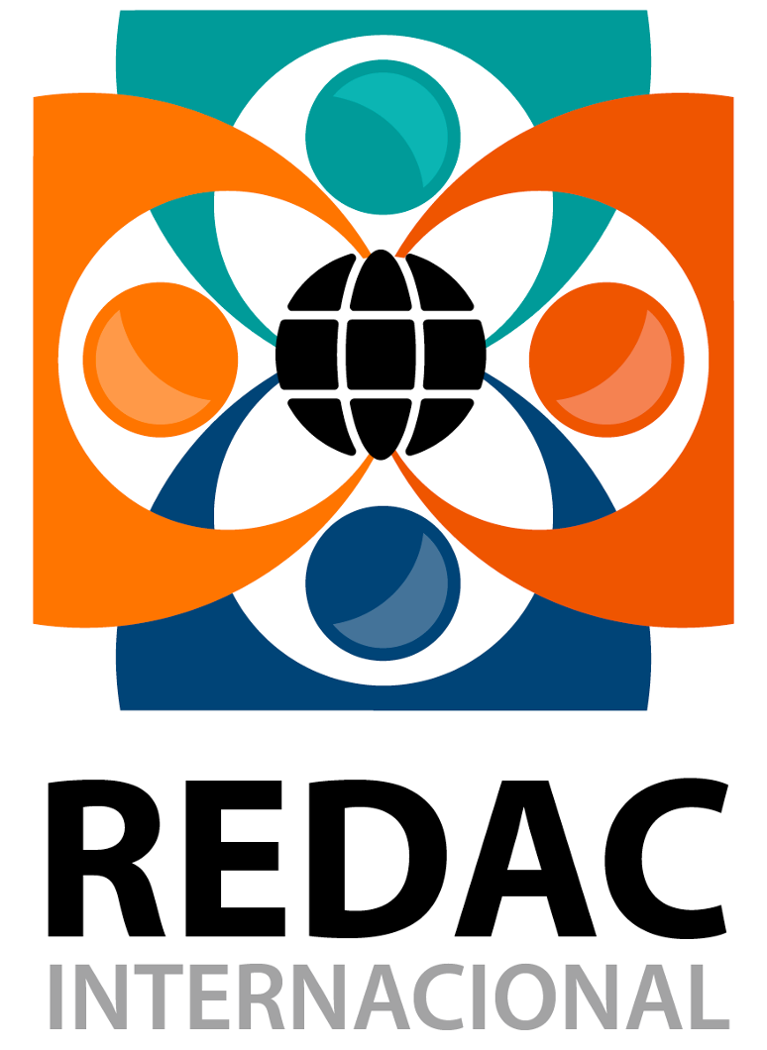

NGO Report on Venezuela, presented to the Committee of the Convention on the Elimination of All Forms of Discrimination Against Women (CEDAW)
Shadow Report to the Ninth Periodic Report presented by the Bolivarian Republic of Venezuela, on the situation of Venezuelan migrant and refugee women and girls
April 2023
The following report analyzes the situation of Venezuelan migrant and refugee women and girls, per the Ninth Periodic Report and the Responses to the list of issues and questions submitted by the State of the Bolivarian Republic of Venezuela, under Article 18 of the Convention on the Elimination of All Forms of Discrimination against Women. The purpose is to show the responsibility of the Venezuelan State concerning the violation of the rights of Venezuelan women and girls abroad, notwithstanding the responsibilities destination countries may have to that same population under CEDAW and/or other international obligations.
The report is presented by the coalition of organizations comprised of:
Centro de Justicia y Paz (Cepaz). Contact e-mail: incidencia@cepaz.org
Center for Migration, Gender, and Justice (CMGJ). Contact e-mail: info@migrationgenderjustice.com
Red de Activistas Ciudadanos por los Derechos Humanos (Redac Internacional): Contact email: activismosredac@gmail.com

- General context
1. The Venezuelan human mobility crisis is the second largest globally. The exodus of more than seven 7 million people in recent years invites us to reflect on the necessary transformations that the State must promote to ensure the protection of the rights of Venezuelans inside and outside its territory. The first obstacle to progress in this direction is that the government does not recognize these figures. In Venezuela's interactive dialogue before the United Nations Committee on Migrant Workers in September 2022, the delegation affirmed that its most recent measurement (2015-2019) did show an increase in the outflow of Venezuelans from the country, but since 2020 the flow had slowed down and by now could even have “turned positive”. According to the delegates, the figures handled by the international community are the product of a "very great creativity", which has been used to obtain funds for cooperation and to support the narrative of a "supposed humanitarian crisis, which does not exist in Venezuela". Given this position, the need to document, denounce and disseminate the reality of Venezuelan migrants and refugees becomes imperative.
2. The complex humanitarian emergency (CHE), inflation, institutional collapse, lack of access to electricity and water services, as well as the absence of the rule of law and persecution of dissidents or perceived dissidents in Venezuela, among other reasons, have forced the Venezuelan population to flee, primarily to other countries in the region. Despite the severity of the crisis, according to the United Nations Office for the Coordination of Humanitarian Assistance, Venezuela's Humanitarian Response Plan 2021 received only 39% of the required funding, despite being the fourth-largest food crisis in the world and the second-largest migration and refugee crisis. Compared to other crises, the Venezuelan crisis remains among the least funded worldwide.
3. It is precisely due to the CHE, that international standards of protection must be awarded to Venezuelan migrants and refugees. The UNHCR has recognized that these people are fleeing a situation in which their lives, safety, or freedom are being threatened and are therefore to be considered refugees according to the Cartagena Convention.

- Differentiated Effect of the Venezuelan mobility crisis on the Rights of Women and Girls
4. As of March 2022, there were at least 18 million people in the country in need of humanitarian assistance due to the risk of harm to their personal integrity, life, security, and livelihoods. Of these, 9.5 million are girls, adolescents, and women. The situation of poverty in Venezuela is widespread and all around the country, there are people severely affected by the depletion of their livelihoods, moderate and severe food insecurity, and lack of medical care and medicines, and severe deterioration of basic services. In 2019, Hum Venezuela was created as a CSO initiative to close the official data gap and provide relevant information on the scale of emergency and assistance needs.
5. Women, particularly those who are heads of household, are the first to restrict their nutritional intake, to give that food to other members of their families, which can significantly and permanently affect their general health. 92% of all women-led households in Venezuela have children, so to provide for those under their care, many abandon their studies. Maternal mortality rates are soaring in Venezuela, as well as adolescent pregnancies; malnutrition is common among pregnant women, and access to sanitary products for menstrual hygiene is scarce.
6. It is in this heightened state of vulnerability, that Venezuelan women, adolescents, and girls take part in, often involuntary, human mobility. In a study conducted by Cepaz, it was recorded that the four main difficulties during the journey of women interviewed were the following: lack of resources (67%), lack of food/water (35%), lack of means of transportation (33%) and lack of information (33%). The level of risk and vulnerability in the destination countries is high, women are in subsistence conditions upon arrival and without support networks at the destination. The restrictive regulatory frameworks in the countries of destination, where it can take months to regularize documents to enter the labor market, are an important risk factor for migrant women.
7. Moreover, the right to an identity document is severely vulnerated for Venezuelan migrants and refugees; these documents are frequently required to initiate a regularization process in destination countries. This impacts women in a differentiated way, given that due to their caretaker role, not only are they responsible for procuring said documents for those under their care, but they’re also more likely to forgo regularization altogether, as they work under any available conditions to provide. This, in turn, makes them especially vulnerable to predatory practices, scams, and trafficking, among other vulnerabilities which will be expanded upon in section IV.
8. Another risk factor is the place of reception upon arrival in the country of destination; the data reveal that 7.6% of women do not have a place to stay upon arrival, and 3.8% have a place contingent on a job offer; these two groups are the most at risk due to the absence of a shelter upon arrival. Although shelters have been created in the four main destination countries (Colombia, Peru, Ecuador, and Chile), they are overcrowded. In the case of women who have a place to stay upon arrival, Cepaz found that only 15.54% were able to rent it; the rest have made temporary arrangements with family members or acquaintances.
- Violence against women, adolescents, and girls
9. The condition of migrant women implies the risk of being survivors of different forms of violence, including acts of physical, sexual, and psychological violence, which amount to human rights violations under the Convention of Belém do Pará. Migrant and refugee women and girls are at serious risk of being victims/survivors of trafficking, sexual exploitation, sexual violence, and reproductive violence. In the context of COVID-19 and the States' response of closing borders, exacerbated the vulnerabilities of women and girls.
10. A study by Cepaz et al. shows the most prevalent types of violence suffered by migrants : physical violence (35%), verbal violence (25%), psychological violence (11%), and sexual violence (10%). Forty percent of the women interviewed responded that they had experienced discrimination and 86 percent of them reported that it had been based on their nationality. According to estimates by the United Nations Population Fund, 2% of Venezuelan women abroad between the ages of 15 and 49 may be survivors of sexual violence. In terms of migratory transit, it was observed that many of those who control informal border crossings consider sexual violence to be a standard form of fee payment.
11. According to the results of a Rapid Gender Analysis carried out by CARE International in 2020 in Ecuador, it was found that the majority of women who entered the country through irregular routes suffered sexual assault and other forms of gender-based violence. The same study shows that in Colombia, men offer shelter to women who sometimes have small children, in exchange for domestic servitude and sexual slavery. Additionally, in all four countries under analysis, Venezuelan women seeking employment reported having been subjected to harassment, or receiving offers of employment in exchange for sexual favors.
12. Proyecto Migración Venezuela, notes that 79.4% (2,538) of the cases of gender-based violence reported in Colombia in 2020 were women. The age range of the most victimized migrant women was between 12 and 17 years old, and they represented 34.7% of the total number of survivors of sexual violence in this population. Among the surveyed population, migrant women represented 88.6% (109) of all survivors of psychological violence. In Peru, the Women's Emergency Centers attended 1,332 Venezuelan women, survivors of gender-based violence between January and September 2021, as part of the National Program for the Prevention and Eradication of Violence against Women and Family Members, which represents 82.4% of the total number of foreign women assisted, according to program data.
13. A study by Plan International (2021) showed that 72% of Venezuelan women surveyed said that they had faced some form of GBV in Ecuador, with psychological violence in public and private spaces (51%) being most prevalent, followed by sexual harassment at work (41%), physical assault within the home (32%), and income control (10%).In seeking resources and services as GBV survivors, Venezuelan migrant women are thus confronted with limited protections based on irregular status and lack of information on existing complaint mechanisms.
14. In Colombia, GBV against Venezuelan migrant women increased by 71% between 2018 and 2021. This includes GBV targeted against those with gender identities and sexual orientations beyond binary and heteronormative conceptions for whom regularization processes often pose additional obstacles such as having official documents that match their gender identity. Venezuela does not recognize gender identity that differs from that which is assigned at birth.
15. Similarly in Peru, heightened risks of violence against women, girl, LGBTQIA+ and Venezuelan gender-diverse migrants have been identified, notably as GBV against Venezuelan migrant women increased by 31% between 2019 and 2021. While Peru has implemented various regularization programs, access to healthcare remains restricted. This specifically impacts sexual and reproductive health (SRH).
16. Also important to highlight are the risks of GBV for indigenous women from Venezuela. As found in a situation report (2022) by UN Special Rapporteur on Violence Against Women, Reem Alsalem, indigenous women and girls from Venezuela “face a disproportionate risk of experiencing gender-based violence during the migration route, transit and in destination countries”. Irregular entry and migratory routes are identified as factors that expose indigenous women to sexual harassment, sexual assault, and rape, and “women traveling by themselves and with children reported situations of kidnapping, sexual violence, and torture at the hands of human traffickers”. More concretely, the Special Rapporteur notes:
17. “Lack of access to regularization processes and the recognition of the refugee’s status, linked to language barriers, absence of specific regularization routes for indigenous populations, costs, and lack of information increases exposure to risks of labor exploitation, including sexual exploitation some of which also includes sexual violence. Women-headed households and widows have faced particular challenges in registering the births of their children, either in the destination country or the country of origin leaving their children deprived of basic and specialized medical services and presenting a further risk of statelessness.”
18. As part of the UN Special Rapporteur’s report, in Brazil, indigenous women from Venezuela shared that “intimate partner violence has increased with displacement and COVID-19” and that they are not “aware of services or entities to approach when in need”. Additionally, the report points out that “indigenous women don’t have access to subsidies provided to the government,” which further informs economic precarity due to irregular status that then heightens risks of labor and sexual exploitation.
19. In this context, it is again important to emphasize that women who are forced to take irregular migration routes are far more likely to suffer from sexual violence and gender-based discrimination.
20. This lack of protections for Venezuelan migrant women was found to have contributed to a rise in rates of femicide: the Digital Observatory of Femicides by CEPAZ (2022) found that on average, there was a frustrated femicide committed against a Venezuelan migrant woman every ten days in March 2022 alone. Between January and October 2021, there were 74 femicides of Venezuelan women abroad and 12 attempted femicides were reported. The monitoring also considers the phenomena associated with these violent deaths, such as orphanhood, the existing link with the aggressor, and access to justice for the case, among others. It highlights that as a result of those registered abroad, 23 children were orphaned in the period January-October 2021.
- Trafficking of women and girls
21. Entry points to trafficking networks are abundant along the South American migration route and are often disguised as employment opportunities. Trafficking is often practiced for sexual exploitation. According to information gathered by CARE, minors are recruited by armed groups at border crossings from Venezuela to Colombia. In Ecuador, data show that migrants without family or support networks along the route are particularly vulnerable, and the extreme violence used within trafficking networks means that survivors suffer long-term or sometimes lifelong consequences. The Venezuelan NGO Mulier reports that in 2020, 517 Venezuelan women were rescued from confinement and enslavement in transit and destination countries. This figure exceeds the 480 survivors rescued in 2019 and 372 in 2018. Ninety percent of those rescued have been women 27 years old or younger.
22. In this regard, it is important to highlight that the measures taken by the government as highlighted in paragraphs 70-76 of the State’s report are not only insufficient but based on grossly under-reported data. As an example: the subcommittee on women and gender equality of the National Assembly, published in June 2020, estimates about 250 Venezuelan women were trafficked to Spain; whereas the report of the Center for Human Rights of the Catholic University Andres Bello Guayana published in May 2020 on the forms of modern just in the slavery in the State of Bolivar, estimates about 3500 survivors of trafficking; and the CARICOM report prepared by Dr. C.Justine Pierre, estimates about 4000 Venezuelan women trafficked to Trinidad and Tobago in the same year.
23. Traffickers promise migration regularization and employment, but once they arrive in the destination country, migrants are forced to work without remuneration and engage in transactional sex to survive. The lack of complete data on the number of Venezuelan women and girls trafficked and sexually exploited abroad is a serious problem. Commonly, the survivors do not report to the authorities, due to their irregular migratory status and possible deportation to their country of origin, as well as for fear of reprisals against their relatives in Venezuela. A recent report by the organization FundaRedes denounces the appearance of "coyotes" in the migratory routes of Venezuelans. These are in addition to the irregular groups that operate along the Colombian-Venezuelan border (paramilitary groups and criminal gangs) and increase the dangers faced by people on the move. It has been identified that the people in the greatest danger of being captured by irregular groups are young men, while the people at greatest risk of being trafficked are women.
24. State acquiescence in the increase of human trafficking and other forms of modern slavery in Venezuela has been well documented. For example, the illegal boats that leave for Trinidad and Tobago do so with the acquiescence of members of the security forces, and in mining areas, it has been documented that agents of the Bolivarian National Guard force women to provide them with sexual services.
- Remaining legal challenges
25. Despite existing legislation for the protection of women and another for the control of organized crime, norms are not properly implemented, and the typifications vary as the crimes are contained in various norms. The Venezuelan State accepted the recommendations aimed at consolidating the draft bill on human trafficking, but they are yet to be implemented
26. The Organic Law for the Protection of Children and Adolescents (LOPNNA) was reformed in June 2015 and no legal adjustments were made to require greater public investment by the different levels of government in bodies, programs, and services for the comprehensive protection of children and adolescents and specialized care for survivors of sexual abuse, including human trafficking.
27. Despite the second reform of the Organic Law on the Right of Women to a Life Free of Violence, in December 2021, disappearances of girls, adolescents, and women are not typified as a gender-based crime, despite General Recommendation No. 2 of the MESECVI (2018). This seriously affects families by not having institutional protocols for search and rescue and demanding a 72-hour wait period. This deepens revictimization and increases exposure to more extreme forms of violence such as trafficking, human exploitation, slavery, and femicide.
28. In 2019 the Public Ministry created the 95th National Prosecutor's Office, which specializes in the crime of women trafficking. However, transsexual women, who are especially vulnerable to this crime are excluded, as they are discriminated against because of their gender identity.
29. At the same time, the official opacity regarding the approach to modern slavery, trafficking, and labor exploitation in Venezuela is worrisome. There is no data disaggregated by sex, age, and forms of violence against women, including forms of trafficking and modern slavery. The only official information available is limited to speeches by government representatives who offer figures without any kind of methodology and periodicity.
30. There is an intrinsic relationship between the right to identity, specifically in its sphere related to the right to access identification documents, and the possibility of accessing mechanisms for migratory regularization. Venezuelan refugees and migrants face significant challenges in acquiring these documents, which include, but are not limited to prohibitive costs, unjustified delays, the impossibility of processing certain documents from abroad, fear of approaching consular offices and being potentially persecuted, lack of clear information from said consular offices, among others. Impeding their access to identity documents disproportionately affects women because of the threat it carries of increased vulnerability and because of the way it disproportionately affects children, and therefore, their caretakers.
31. The mere presence of a Venezuelan consulate does not guarantee that Venezuelan nationals can effectively access consular services, as proven by a study carried out by Redac Internacional. On the other hand, the absence of a consular presence, as in the case of Colombia or the United States, exacerbates the situation of lack of protection in which Venezuelan nationals find themselves, especially those in vulnerable situations.
32. The United Nations Human Rights Committee has been emphatic in establishing that Article 25 of the ICCPR imposes on States the obligation to "adopt such legislative or other measures as may be necessary to ensure that citizens have the opportunity to enjoy the rights it protects. This also includes persons from that country abroad who wish to exercise their right to vote. The massive Venezuelan human mobility crisis is linked to the loss of democratic institutions and the capacity of the state to guarantee the rights of the population. In the years 2024 and 2025, Venezuela should hold elections for the presidency, the National Assembly, and the regional leadership, so the discussion on the right of Venezuelans abroad to vote is especially timely.
33. The current Organic Law for Electoral Processes, establishes in article 124 that only those who reside legally abroad can participate in elections, and that is even limited to presidential elections exclusively. Moreover, the only way to participate is in person, on the day of the election, in a consular office. These conditions are insufficient to guarantee the rights to electoral participation of Venezuelan migrants and refugees, given that, on the one hand, no definition of “legal residence” is provided, so different consulates are free to interpret the norm in a more or less restrictive way. However, even the laxest interpretations would likely live out hundreds of thousands of Venezuelans who don't have a regular migration status in their destination countries.
34. Additionally, the operational capacity of the consular offices is insufficient to facilitate in-person voting, especially in the countries which host the greatest numbers of Venezuelan migrants and refugees. Different provisions would necessarily have to be made to accommodate the potential number of voters abroad, which some estimates place at over 4MM - the current electoral registry accounts for barely over 120.000 thousand voters outside the country.
35. But perhaps the most serious violation of the right of political participation of Venezuelan migrants and refugees, men and women alike, is that it is currently not possible to register in any consular office, despite express government declarations that affirm otherwise. Those consulates which provide information on the requisites to register, sometimes require additional documentation to that which the law requires, which should be considered as an undue restriction. These are direct infringements on the right to political participation. Other ways in which this right is restricted for women are explained in great detail in a shadow report submitted to this committee by the Red Electoral Ciudadana.

- Recommendations
Differentiated impact of human mobility of women and girls
36. Ensure a gender-sensitive response to the CHE, to lessen the vulnerability of women and girls who could potentially become a part of migratory flows, with a special focus on vulnerable, indigenous, and other marginalized communities.
37. Prioritize improving access to identity documents, especially for children and women-led households, as lacking these documents increases their vulnerability in mobility.
38. Collect and publish disaggregated data on migratory flows and data from “Plan Vuelve a la Patria”, which must be applied with full respect to migrant and refugee rights, including the right of non-refoulment, and its services be offered proprietarily to survivors of gender-based violence, without prejudice of other pathways of attention.
Violence against migrant and refugee women and girls
39. Offer response resources and services to survivors of gender-based violence, and mitigation resources and services to those at heightened risk in consular offices, irrespective of migratory status, and communicate these services widely through all available channels.
40. Establish effective communication with organizations that provide gender-based violence prevention, mitigation, and response resources and services to refugees and migrants in transit and destination countries, so that those who wish to get in touch with the consular office can do so, and actively investigate any instances of violence against Venezuelan women, adolescents, and girls, especially cases of femicides.
Trafficking of women and girls
41. Address the issue of human trafficking from a human rights approach, gender, and LGBTI perspective, adopting measures aimed at preventing, investigating, sanctioning, and providing reparation to the survivors.
42. Strengthen regional and binational cooperation with border countries to improve response to human trafficking; provide complete, disaggregated, and accurate data of the number of survivors recovered and guarantee re-integration services to them and their families.
43. Train state agents, especially agents in migration control, on the existence of the international obligations of human rights, gender, and LGBTI issues, with emphasis on the study of individual cases during the identification of international protection needs.
Legal challenges
44. Measure and recognize the magnitude of Venezuelan human mobility and its needs. Only based on an adequate analysis of the dimension of the required response, will it be possible to guarantee the rights of Venezuelan nationals abroad, especially those in a situation of vulnerability, which is disproportionately women.
45. Ensure consular presence in as many countries as possible and reevaluate the State's capacity to respond to the growth of the Venezuelan population in mobility, as well as the re-establishment of diplomatic and consular relations with those countries with which there was a rupture with the main purpose of guaranteeing the rights of the population.
46. Adopt all legislative, administrative, or any other type of measures to guarantee that Venezuelans can effectively access official documents and identification through official, corruption-free and affordable mechanisms, without undue delays.
47. Enable the registration and updating of data in the Electoral Registry from consular offices, establishing simple, expeditious, and free mechanisms so that Venezuelans abroad may exercise their right to vote, as well as review the applicable regulations and modify them appropriately, to allow migrants and refugees in an irregular migratory situation abroad to access the Electoral Registry and to update their data therein, regardless of their migratory status.
References
Amnesty International. 2022a. “Unprotected in Ecuador: Venezuelan refugee women survivors of gender-based violence.” https://reliefweb.int/report/ecuador/unprotected-ecuador-venezuelan-refugee-women-survivors-gender-based-violence
Amnesty International. 2022b. “Americas: Desprotegidas: Violencia basada en género contra mujeres refugiadas venezolanas en Colombia y Perú.” https://www.amnesty.org/es/documents/amr01/5675/2022/es/
Amnesty International. 2022c. “Colombia and Peru: Abandoned by the state in host countries, Venezuelan women face increasing gender-based violence.” https://www.amnesty.org/en/latest/news/2022/07/colombia-peru-venezuelan-women-face-gender-based-violence/
Amnesty International. 2022d. “Between invisibility and discrimination: Venezuelan LGBTIQ+ refugees in Colombia and Peru.” https://www.amnesty.org/en/latest/news/2022/06/venezuelan-lgbtiq-refugees-colombia-peru/
CARE. 2020. “An Unequal Emergency: CARE Rapid Gender Analysis of the Refugee and Migrant Crisis in Colombia, Ecuador, Peru, and Venezuela”. https://www.care-international.org/files/files/ENG_LAC_Regional_VZ_RGA_FINAL_compressed.pdf.
Center for Migration, Gender, and Justice. “Migration, Peace, and Security.” https://www.migrationgenderjustice.com/mps
Center for Migration, Gender and Justice and Centro de Justicia y Paz. 2023. “Report on how to expand and diversify regularization mechanisms and programs to enhance the protection of the human rights of migrants” - submitted to the United Nations Special Rapporteur on the Human Rights of Migrants, in response to the call for inputs. https://www.ohchr.org/en/calls-for-input/2023/report-how-expand-and-diversify-regularization-mechanisms-and-programs-enhance
Centro de Derechos Humanos de la Universidad Católica Andrés Bello. 2021. “Esclavitud Moderna y Explotación Laboral En Venezuela Con Especial Énfasis En Las Condiciones Del Estado Bolívar.”

Centro de Justicia y Paz. 2022. “Urgent action for the rights of migrant women and girls.”
Centro de Justicia y Paz. 2022. “Monitorio de femicidios en Venezuela.” https://cepaz.org/noticias/observatorio-digital-de-femicidios-de-cepaz-documento-62-femicidios-consumados-en-los-primeros-3-meses-de-2022/#
Centro de Justicia y Paz. 2021. “Las voces de ellas: Situación de las mujeres venezolanas en el contexto de la movilidad humana.” https://cepaz.org/wp-content/uploads/2021/12/Las-voces-de-ellas-Situacion-de-las-mujeres-venezolanas-en-movilidad.pdf
Con Ellas. 2022. “Ser mujer en Venezuela: Diagnóstico comunitario y propuestas para la acción humanitaria.” https://cepaz.org/wp-content/uploads/2022/10/20220928InformeSerMujerenVenezuela.pdf
Hum Venezuela. 2022. Resultados del Diagnóstico Comunitario. https://humvenezuela.com/wp-content/uploads/2022/09/HumVenezuela-Informe-Marzo-2022.pdf

FundaRedes. 2022. “La figura del coyote se reinventa en la frontera colombo-venezolana para captar migrantes”. Boletín #39. https://www.fundaredes.org/2022/04/13/boletin39-la-figura-del-coyote-se-reinventa-enlas-fronteras-colombo-venezolanas-para-captar-migrantes/
Mulier. 2020. Informe #LibresYSeguras 2020. https://humvenezuela.com/wp-content/uploads/2022/10/MULIER-INFORME-2019-LIBRES-Y-SEGURAS-..pdf
Plan Internacional. 2021. “Estudio sobre violencia basada en género hacia las mujeres migrantes y/o refugiadas en los países receptores de Perúy Ecuador.” www.r4v.info/es/document/Plan_International_Estudio_Binacional_VBG_Feb22
Proyecto Migración Venezuela. 2021. “Violencia Basada en Género en el contexto de la migración venezolana, Boletín número 18.” https://migravenezuela.com/web/articulo/violencia-de-genero-contra-migrantesvenezolanos-en-colombia/2493
Red de Activistas Ciudadanos por los Derechos Humanos (Redac Intencional). 2023. “Huellas de la movilidad venezolana: análisis y documentación del derecho a la identidad y a la participación de las personas venezolanas migrantes y refugiadas”. https://cepaz.org/wp-content/uploads/2023/03/INFORME-REDAC-Movilidad-2023-2.pdf
R4V. 2022a. “Asylum seekers and refugees.” https://www.r4v.info/es/solicitudes-refugiados
R4V. 2022b. “Regional Platform.” https://www.r4v.info/es/regional
R4V. 2022c. “RMRP 2023-24.” https://rmrp.r4v.info/
R4V. 2022d. “Situation of Venezuelan indigenous women and girls in host countries in Latin America and the Caribbean.” https://reliefweb.int/report/colombia/situation-venezuelan-indigenous-women-and-girls-host-countries-latin-america-and
UN Media. 2022. Recording of Venezuela's statement in front of the Committee for the Rights of Migrant Workers and their Families. https://media.un.org/es/asset/k1x/k1x2do4hos
UNDP & ILO. 2021. “Migration from Venezuela: Opportunities for Latin America and the Caribbean.” http://www.ilo.org/americas/publicaciones/WCMS_775183/lang--en/index.htm
UNHCR. 2022. “Americas factsheet.” https://reporting.unhcr.org/document/3829
UNHCR. 2021. “Situation Reports.” http://reporting.unhcr.org/situation-reporting.
Unión Afirmativa. 2018. “ Crisis política en Venezuela y sus efectos en la población LGBTI”. https://unionafirmativa.org.ve/unaf/wp-content/uploads/Crisis-pol%C3%ADtica-en-Venezuela-y-sus-efectosen-las-personas-LGBTI.pdf
OCHA. 2021. “Financial Tracking Service. Humanitarian Aid Contributions, 2021”. https://fts.unocha.org/
Organization of American States. 1994. The Inter-American Convention on the Prevention, Punishment, and Eradication of Violence against Women. https://www.oas.org/en/mesecvi/convention.asp

https://cepaz.org/
https://www.migrationgenderjustice.com/
https://activistasciudadanos.org/
https://www.r4v.info/en/refugeeandmigrants
https://media.un.org/es/asset/k1x/k1x2do4hos
Financial Tracking Service. Humanitarian Aid Contributions, 2021. https://fts.unocha.org/
For more information on the disproportionate effect of the CHE on women, adolescents and girls, see (in Spanish) https://cepaz.org/wp-content/uploads/2022/10/20220928InformeSerMujerenVenezuela.pdf - or, a report submitted to this committee by the “Con Ellas” coalition.
https://www.acnur.org/noticias/briefing/2019/5/5ce33ee54/acnur-la-mayoria-de-las-personasque-huyen-de-venezuela-necesitan-proteccion.html
https://humvenezuela.com/wp-content/uploads/2022/09/HumVenezuela-Informe-Marzo-2022.pdf
https://humvenezuela.com/en/inicio/
https://www.r4v.info/sites/default/files/2021-06/Regional%20Survey%20on%20Evictions%20of%20Refugees%20and%20Migrants%20from%20Venezuela.pdf
https://cepaz.org/wp-content/uploads/2022/10/20220928InformeSerMujerenVenezuela.pdf
https://cepaz.org/wp-content/uploads/2019/03/Informe-DEF-EDI.pdf.
https://cepaz.org/wp-content/uploads/2023/03/INFORME-REDAC-Movilidad-2023-2.pdf
For more information regarding challenges to regularization of Venezuelan migrant and refugees, from a gender and diversity perspective, see Center for Migration, Gender and Justice and Cepaz (2023)
https://cepaz.org/wp-content/uploads/2019/03/Informe-DEF-EDI.pdf.
https://www.oas.org/juridico/spanish/tratados/a-61.html
https://cepaz.org/wp-content/uploads/2019/03/Informe-DEF-EDI.pdf.
https://data2.unhcr.org/en/documents/download/65109
https://www.care-international.org/files/files/ENG_LAC_Regional_VZ_RGA_FINAL_compressed.pdf.
Idem
https://migravenezuela.com/web/articulo/violencia-de-genero-contra-migrantesvenezolanos-en-colombia/2493
Idem
https://www.amnesty.org/es/latest/research/2021/11/estado-peruano-fallaatencion-mujeres-venezolanas-sobrevivientes-violencia-genero/
https://efectococuyo.com/venezuela-migrante/venezolanas-peru-y-ecuador-violencia/
https://www.amnesty.org/es/documents/amr01/5675/2022/es/ ; See also Center for Migration, Gender and Justice and Cepaz (2023)
Idem
Idem
http://reporting.unhcr.org/situation-reporting ; See also Center for Migration, Gender and Justice and Cepaz (2023)
Idem
Centro de Justicia y Paz. 2022. “Urgent action for the rights of migrant women and girls.” Unpublished.
https://cepaz.org/noticias/observatorio-digital-de-femicidios-de-cepaz-documento-62-femicidios-consumados-en-los-primeros-3-meses-de-2022/#
https://humvenezuela.com/wp-content/uploads/2022/10/MULIER-INFORME-2019-LIBRES-Y-SEGURAS-..pdf
Idem
CEDAW/C/VEN/9 p.70-76
https://humvenezuela.com/wp-content/uploads/2022/10/MULIER-INFORME-2019-LIBRES-Y-SEGURAS-..pdf
https://humvenezuela.com/wp-content/uploads/2021/08/2021-08-13.FORMAS-DE-ESCLAVITUD-MODERNAY-SU-IMPACTO-EN-PERSONAS-MIGRANTES-FORZADAS-Y-REFUGIADAS-VENEZOLANAS.pdf.
https://www.fundaredes.org/2022/04/13/boletin39-la-figura-del-coyote-se-reinventa-enlas-fronteras-colombo-venezolanas-para-captar-migrantes/
Idem
REDHNNAVE_UPR40_VEN_S_Main
https://unionafirmativa.org.ve/unaf/wp-content/uploads/Crisis-pol%C3%ADtica-en-Venezuela-y-sus-efectosen-las-personas-LGBTI.pdf
Centro de Derechos Humanos de la Universidad Católica Andrés Bello. (2021). Esclavitud Moderna y Explotación Laboral En Venezuela Con Especial Énfasis En Las Condiciones Del Estado Bolívar.
https://cepaz.org/wp-content/uploads/2023/03/INFORME-REDAC-Movilidad-2023-2.pdf
Idem
Idem
Idem

