CEDAW - Convention on the Elimination of All Forms of Discrimination against Women
89 Session (07 Oct 2024 - 25 Oct 2024)

Japan
(CEDAW/C/JPN/9)

NGO Submission

August, 2024

Family Association of the Missing Persons Probably Related to the DPRK
https://www.chosa-kai.jp/kazokukai
Investigation Commission on Missing Japanese Probably Related to North Korea (COMJAN)
http//www.chosa-kai.jp
Address: 301 No.6 Matsuya-Bldg.2-3-8 Koraku Bunkyo-ku, Tokyo 112-0004 JAPAN
TEL: +81-3-5684-5058 Fax: +81-3-5684-5059
Email: comjansite2003@chosa-kai

Abductions and Disappearance of Japanese
Probably Related to the Democratic People’s Republic of Korea
~ Issue of Exploitation and Human Rights Violation against Japanese Women

- About Us
“Investigation Commission on Missing Japanese Probably Related to North Korea (COMJAN)” is a Japanese non-government organization established in January 2003 to research numerous cases of disappearance which are “probably related” to DPRK. “Family Association of the Missing Persons Probably Related to the DPRK” established in 2017 is a group of families whose family members’ disappearance is “probably related” to DPRK.

We have obtained consent from the abductee’s families to release the names of the victims publicly. However, in this report, we replace the names with initials according to information from the CEDAW secretariat.

- Summary

The abductions of Japanese citizens by DPRK are serious human rights violations. A resolution “Situation of human rights in the Democratic People’s Republic of Korea” (A/HRC/RES/52/28) was adopted by the Human Rights Council on 4 April 2023. It stresses that “with grave concern the urgency and importance of the issue of international abductions, which involves a serious violation of human rights, and of the immediate return of all abductees, as they and their family members age”, expresses “grave concern at the long years of severe suffering experienced by abductees and their families, the lack of any concrete or positive action by the Democratic People’s Republic of Korea, notably since the investigations on all the Japanese nationals commenced on the basis of the government-level consultations held between the Democratic People’s Republic of Korea and Japan in May 2014”, and demands “the Democratic People’s Republic of Korea sincerely listen to the victims and their families to address all allegations of enforced disappearances, clarify the fate and whereabouts of disappeared persons and faithfully provide accurate, detailed and full information promptly to the families of victims, and resolve immediately all issues relating to all abductees, in particular the realization of the immediate return of all abductees of Japan and the Republic of Korea.”

According to our research in 2018, there are approximately 546 Japanese abductees and missing persons, whose names are public, identified by the Government of Japan, the National Police Agency and COMJAN, and the possibility of Abduction by DPRK cannot be ruled out

Among 546 individuals, 151 are female, with 90% being young girls and women aged from their teens to thirties. (See the graphs and tables in the annex on page10-11.)

We are convinced that the DPRK’s purpose in abducting young females is to force them to marry male abductees or DPRK high officials. This conclusion is based on the following facts;

- Ms. H.S. was abducted in 1978 when she was 19 years old. While in DPRK, she was forced to marry a United States Army deserter and prisoner.
- Mr. A.M., a former DPRK agent and a defector, testifies that the female abductees were forced to marry against their will.
- Ms. M.Y., who was abducted in 1977 at the age of 13, was forced to marry a South Korean abductee.

The families of victims have no information about the fate and whereabouts of the victims. In particular, we are deeply concerned about the young female abductees who are being detained and deprived of their women's rights.

Abductions by DPRK are a serious state crime against humanity and a violation of Japanese sovereignty. 80% of victims are now over the age of 60, and 30% are over the age of 80. As the victims and their families age, there is very little time left for them.

Therefore, we demand the Japanese government to put an end to decades of human rights violations against Japanese nationals by the DPRK. We urge the government to take strong and positive actions, to return all abductees and missing persons immediately, and to rescue Japanese female victims from exploitation and violation.

We sincerely request CEDAW to raise the issue of Japanese female abductions by DPRK during the 89-session dialogue with the delegations of the Japanese government.

- Proposed Recommendation

We kindly request CEDAW to recommend that the government of Japan take the following actions.

The government of Japan should;
- Recognize the abduction and disappearance of Japanese females as issues of exploitation and human rights violations against women;
- Research the human rights situation of Japanese women detained in DPRK and report the findings to the families;
- Return all the abductees and missing persons;
- Disclose/release all the related information about missing Japanese citizens and the total approximate number apart from the 17 abductees officially identified by the Government of Japan;
- Disclose/release all the information about foreign citizens abducted from Japan.

- Background of Abduction by DPRK

On September 17, 2002, Kim Jong Il, the then Supreme Leader of DPRK admitted that DPRK Agents had abducted 13 Japanese nationals.

Consequently, in the following month, five of them returned to Japan. DPRK announced that “Amongst those 13 Japanese, 5 of them are “alive” and 8 of them had already died.” And they “released” 5 abductees to “return” to Japan.

But regarding those 8 abductees that DPRK announced “already died”, there was absolutely no clear evidence of their death. In particular, it has been confirmed that several of them are certainly alive in DPRK after “the date of death” that DPRK referred to in their report.

The Government of Japan has officially identified 17 Japanese citizens (in 12 cases) as abductees by DPRK. But those cases are just “the tip of the huge iceberg”.

We strongly believe that there must be a larger number of Japanese citizens abducted and still being captured in the DPRK. This situation has come to light due to numerous pieces of physical evidence and testimonies.

- Issue of Missing Japanese Probably Related to DPRK

On September 17, 2002, the then Japanese Prime Minister Junichiro Koizumi visited Pyongyang to have the very first leaders’ meeting with DPRK. Supreme Leader Kim Jong Il admitted to Prime Minister Koizumi that DPRK agents had abducted 13 Japanese nationals (seven women and six men). As a result, on October 15, five Japanese abductees returned to Japan.

Since Ms. H. S., one of the five abductees who returned to Japan, had not been identified as an abductee by the government of Japan before that time, a large number of inquiries about missing family members from all over the country were made. The National Association for the Rescue of Japanese Kidnapped by North Korea (NARKN) as well as a lot of local police stations received a flood of those inquiries saying “We wonder our missing family member(s) could be kidnapped by DPRK agents.”

Under these circumstances, “The Investigation Commission on Missing Japanese Probably Related to North Korea” (hereafter “COMJAN”) was established on January 10, 2003, to research a large number of disappearances which could be related to DPRK.

Concurrently, we designated a new term “specific missing persons” who are defined as “missing Japanese citizens with whom the possibility of the abduction by North Korea cannot be ruled out”.

As of September 2022, COMJAN has a list of approximately 470 “specific missing persons”. The National Police Agency also has its list of approximately 900 missing persons who have the possibility of being abducted by DPRK.

Apart from these missing persons, we assume there could be many cases of disappearances that have not been inquired about because of the absence of family members/relatives nearby, or because those family members would never imagine the possibility of abduction at all, but actually those disappearances were caused by abductions by DPRK.

- Cases of Missing Japanese Females Probably Related to DPRK

(1) Ms. N. F. (then 18): She was born on 1 January 1955. She suddenly disappeared on 7 July 1973 after she left home in Ichihara, Chiba. She had just started working at a big company full of hope. She was witnessed in May 1990 at 915 Hospital, a hospital for agents in the suburb of Pyongyang. She is now 69 years old.
Her elder sister has been waiting for Ms. N.F’s safe return home for 51 years, and is now a secretary of the “ Family Association of the Missing Persons Probably Related to the DPRK.”

(2) Ms. K. K. (then 21): She was born on 27 August 1938. She disappeared on 27 February 1960 after she left the school dormitory. She was a nursing school student at that time. There is a witness testimony on her presence in the DPRK by a Thai woman who went to DPRK in 1982 and then went back to Thailand. In addition, Mr. K. F., a chef formerly working for Kim Jong Il witnessed her in mid-December 1982 at a restaurant in Pyongyang where he was working as a chef. There are other pieces of information on her presence in the DPRK.

(3) Ms. T. K. (then 17): She was born on 4 May 1944. She was a homemaker. She disappeared in April 1962 after she left a beauty salon. A defector from the DPRK residing in South Korea provided a photo of a woman for the Japanese media in September 2004. The specialist who analyzed the photo said, “It is appropriate to judge that the woman in the photo is anthropologically and anatomically the same person as Ms. T. K.”

(4) Ms. K. K. (then 22): She was born on 1 January 1948. She disappeared in Kitakyushu, Fukuoka, on 8 August 1970 on her way to her workplace. She was an employee. A former DPRK agent, witnessed a person considered to be Ms. K. K many times between 1988 and 1990 at Kim Jong Il Political and Military University, an agent education institution located in the suburb of Pyongyang.

(5) Mr. H. S. (then 53) and Mrs. T.S. (then 42): Mr. H.S. was born on 25 February 1918 and Mrs. T.S. was born on 7 September 1929. They married in 1948 and were working as employees for the poultry company. They disappeared on 30 December 1971 on their way by car from home to Miyazaki Airport. Their car is not found. There are pieces of information by defectors that Mrs. T.S. was seen in DPRK.

(6) Ms. T.I. (then 31): She was born on 14 June 1941. She was an employee in a city hall. She disappeared on 1 November 1972 after she left her home in Tokyo. A South Korean professor saw and spoke to a person who appeared to be Ms. T. I. in Pyongyang in 1986. The professor was lured from West Germany to DPRK with his family and then later defected. The professor also witnessed a person who appeared to be Mr. T. I., an abductee identified by the Japanese government, in Pyongyang.

(7) Ms. K.K. (then 6) and Mr. T.K. (then 2 or 3): Ms. K. K. was born on 10 April 1967 and Mr. T. K. was born on 29 June 1970. They were abducted before attaining the age for school education. Their mother got married to a Korean, without knowing that he was a DPRK agent. As their father suddenly disappeared after he was told to come back to DPRK, the mother, together with two children, looked for the father and visited his workplace, which was a shell corporation of the DPRK agency. There, other agents confined them as they were afraid of their activities to be revealed. Ms. K. K. and Mr. T.K. are considered to have been abducted to DPRK around June 1973 from the coast of Obama, Fukui. Some people believe that their mother has been killed. However, her whereabouts are unknown to this day. The National Police Agency of Japan officially announced on 12 April 2007 that they were abducted by DPRK.
(They are not included in the 17 abductees officially recognized by the Government of Japan. They have Korean nationality because their father is a Korean. Only those with Japanese nationality are officially recognized as abductees by the Government of Japan. For the communications here, they are treated as Japanese nationals as their mother is Japanese.)

(8) Ms. T. K. (then 24): She was born on 9 February 1952. She disappeared on 2 August 1976 in Ube, Yamaguchi after she left home. She was a nurse. There is a witness testimony that she was seen in the DPRK.

(9)Ms. M. Y. (then 20): She was born on 3 March 1964. She disappeared on 4 June 1984 in Kofu, Yamanashi after she left home. Later, her bag was found at the cost in Kashiwazaki, Niigata. She was preparing for entrance examinations at university. Mr.K.H. testified that Ms. M. Y. was seen in DPRK.

(10) Ms. M.A. (then 21): She was born on 25 January 1964. She disappeared on 4 December 1985 in Kobe, Hyogo after she left her university. She was a university student. Her bag and shoes were found at the coast in Hyogo Prefecture on the following day of disappearance just as in the case of Ms. M.Y. Many young women disappeared throughout Japan around 1985. Abductions for marriage to abducted men are suspected.

(11) Ms. E. S. (then 27): She was born on 6 December 1963. She disappeared on 22 April 1991 after she left home in Urawa, Saitama. Mr. K.H.ma testified her presence in DPRK.

- Cases of Female Abductees officially identified by the Government of Japan

(1) Ms. K. M. (then 29): She was born on 7 September 1948. She was a factory worker. She was abducted on 21 October 1977 on her way to a knitting class near her home in Yonago City, Tottori Prefecture.
(note) Ms. K. M. was originally on the COMJAN’s list “Specific Missing People”. The Government of Japan, later, officially identified her as a Japanese citizen abducted by DPRK on November 20, 2006.

(2) Ms. M. Y. (then 13): She was born on 5 October 1964. She was a junior high school student. She was abducted on 15 November 1977 on her way home from school in Niigata City, Niigata Prefecture.

(3) Ms. Y. T. (then 22): She was born on 10 August 1955. She was a staff of a restaurant. She was abducted around June 1978, from Toshima-ku, Tokyo.

(4) Mr. Y. C. (then 23) and Ms. F. H. (then 22): Mr. Y. C. was born on 4 June 1955 and Ms. F. H. was born on 8 June 1955. Mr. Y. C. worked for a company, and Ms. F. H. worked for a shop. Both were abducted on 7 July 1978 in Obama City, Fukui Prefecture. They returned to Japan on 15 October 2002.

(5) Mr. K. H. (then 20) and Ms. Y. O. (then 22) : Mr. K. H. was born on 29 September 1957 and Ms. Y. O. was born on 15 April 1956. Mr. K.H. was a university student and Ms. Y. O. worked for a company. Both were abducted on 31 July 1978 in Kashiwazaki City, Niigata Prefecture. They returned to Japan on 15 October 2002.

(6) Mr. S. I. (then 23) and Ms. R. M. (then 24): Mr. S. I. was born on 20 October 1954 and Ms. R. M. was born on 1 November 1953. Mr. S. I. worked for a company. Ms. R. M. also worked for a company. They were abducted on 12 August 1978 on the coast of Fukiage, Kagoshima Prefecture.

(7) Mrs. M. S. (then 46) and Ms. H. S. (then 19): Mrs. M. S. was born on 28 December 1931. Her daughter, Ms. H. S., was born on 17 May 1959. Mrs. M. S. was a homemaker and Ms. H. S. was a nursery school student. Both were abducted on 12 August 1978 in Mano Town, Niigata Prefecture. Only Ms. H. S. returned to Japan on 15 October 2002.

(8) Ms. K. A. (then 23): She was born on 12 January 1960. She was studying abroad and was abducted around July 1983 in Europe.

References
1. Headquarters for the Abduction Issue, Government of Japan
https://www.rachi.go.jp/en/index.html
- Abductions of Japanese Citizens by North Korea
https://www.rachi.go.jp/jp/shisei/keihatsu/pdf/2022english.pdf
- For the Return of All of the Abductees - Points of Contentions with the North Korean Position
https://www.rachi.go.jp/jp/shisei/keihatsu/mondaiten_en.pdf

2. The National Police Agency of Japan
https://www.npa.go.jp/english/
- Suspected Abduction Cases by North Korea
https://www.npa.go.jp/keibi/gaiji1/index_e.html

3. Investigation Commission on Missing Japanese Probably Related to North Korea (COMJAN)
https://www.chosa-kai.jp/
- List of missing persons
https://www.chosa-kai.jp/archives/missingPlease refer to the following websites for the names and photos of the victims public.

ANNEX
Family Association of the Missing Persons Probably Related to the DPRK (2018)
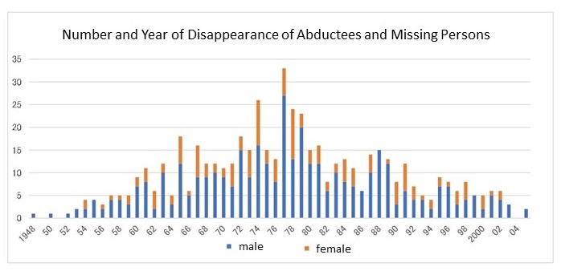
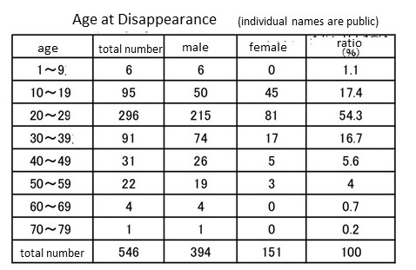
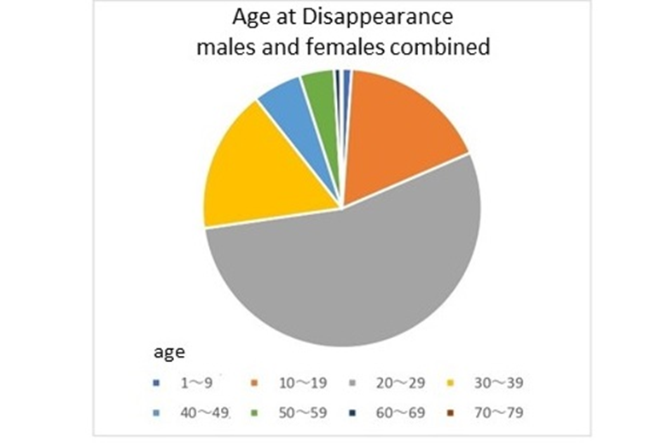
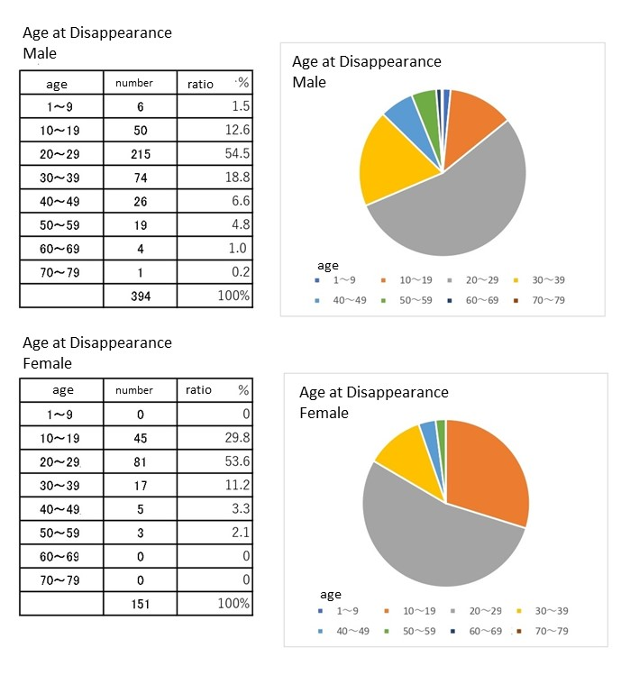

See the list of missing persons on COMJAN official website. https://www.chosa-kai.jp/archives/missing

