Additional Information for the UN Committee on the Rights of the Child
Date: December 2022
Date: day/month/year
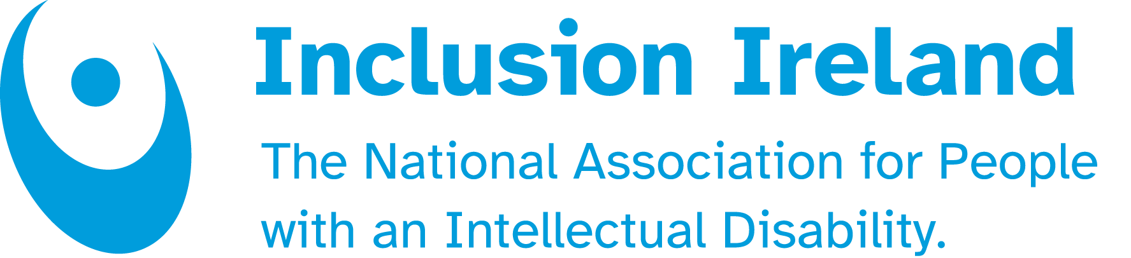
TABLE OF CONTENTS

About Inclusion Ireland
Access to advocacy and accessing rights
Access to education
Seclusion and restraint
Lack of access to services

About Inclusion Ireland

Established in 1961, Inclusion Ireland is a national, rights-based advocacy organisation that works to promote the rights of people with an intellectual disability.

We work towards the full inclusion of people with intellectual disabilities by supporting people to have their voices heard and advocating for rights under the United Nations Convention on the Rights of People with Disabilities (UNCRPD).

The vision of Inclusion Ireland is that of people with an intellectual disability living and participating in the community with equal rights as citizens, to live the life of their choice to their fullest potential. Inclusion Ireland’s work is underpinned by the values of Respect, Inclusion, Equality, Voice and Choice.
Access to advocacy and accessing rights

In Ireland a public Consultation has just begun which is looking at the next Government Policy Framework for the Participation of Children and Young People in Decision Making.
Inclusion Ireland will highlight the need to include young disabled people through the establishment of a Youth Disability Strategy in Ireland.

Inclusive Education

Inclusion Ireland organised an event in November on inclusive education and gathered government officials (including the minister for special education), the National Council for Special Education (NCSE) teachers, principals, civil society organisations, families, and academics, and those with lived experience of intellectual disability to share their knowledge and expertise. The event focused on the present barriers to inclusive education and the concrete actions which need to be implemented to achieve inclusive education in the future.

Additionally, a national consultation has started about the review of the Education for Persons with Special Educational Needs (EPSEN) Act 2004. Much of the original act has never been commenced and this has created a significant block to children being able to have their right to education realised. The review of Ireland by the UNCRC Committee and the future concluding observations regarding the way education should be provided in Ireland will hopefully influence the outcome of the consultation on the Act itself.

Seclusion and restraint

The All-Island Restraint Reduction Network (AIRRN) organised its first conference on the 11th of October 2022. The Event was opened by the Ombudsmen for Children from the Republic of Ireland and Northern Ireland. Families spoke about their children’s experience with seclusion and restraint in educational settings. Academics, professionals from schools and officials from the Department of Education were also present.

The AIRRN Conference 2022 presented a variety of keynote addresses with roundtable discussions which explored the work that is being done, and still needs to be done to tackle the use of restraint and seclusion in educational settings. The event facilitated discussions and sharing of good practice, whilst considering how to champion the rights of children and young adults in specified settings, with the view on how to work cooperatively to eliminate the use of unnecessary restrictive practice. More information can be found here.

It is worth noting that at this stage, the Irish government has still not published the guidelines on seclusion and restraints.

A primary school has been ordered by the Workplace Relations Commission (WRC) to pay €12,000 compensation to a girl with Down syndrome after she had to spend most of her school day in a foyer outside the classroom away from her classmates. More info can be found here.

Lack of access to services
An article from the Irish examiner highlighted that the number of children with a disability waiting for initial contact to access care rose to 18,000. The number increased by around 1500 in September compared to August. The article also stressed that 8,751 children out of 18,473 have been waiting over 12 months for initial contact. The article additionally underlined the high vacancy rate within the Children and Disability Network Teams (CNDTs) of 28%. This represents 524 vacancies out of a total of 1892 allocated staff members. The HSE has publicly apologised to families as the situation has worsened over time.

More information can be found here.

These issues are key areas which will impact on the experience of growing up as a child with an intellectual disability in Ireland and they are areas which Inclusion Ireland will continue to advocate strongly on throughout 2023 and beyond.

For further information, contact;
Guillaume Jacquinot Policy co-ordinator.
0860353888
guillaume@inclusionireland.ie





