The International Alliance for Peace and Development

The IAPD seeks to promote for peace and sustainable development all over the world. The IAPDA works to counter hatred, violence and extremism and to work side by side with the UN mechanism and other affective institutions all over the world. The IAPDA follows its vision by networking in order to mobilize efforts, cooperation and integration.

WOMEN RIGHTS IN CHINA
(80 PSWG of CEDAW COMIITTEE)

This report discusses women rights in the People’s republic of China, Under the Convention on the Elimination of All Forms of Discrimination against Women (CEDAW) adopted by United Nations General Assembly in 1979. It is submitted for the 80 pre-Sessional Working Group (PSWG) of the CEDAW committee.
China is a party of 8 of the 24 international conventions of Human rights, on this regard China has accepted the convention on the elimination of discrimination against women (CEDAW), ratified it in December 1980. The country has not yet signed the two major human rights covenants: The International Covenant on Civil and Political Rights and the International Covenant on Economic, Social, and Cultural Rights. China has submitted six country reports under (CEDAW), In the reports, the government refers to the body of domestic law which has been issued to address and protect the status of women.
China has a long and rich history of diverse stages of growth of culture, literature, architecture, political theory, and experience. The revolution of 1949 offered equal access to education and jobs to women, and the concept of freedom was expressed in the idea that women possess half of the society. According to the last visit report of the working group on discrimination against women in law and in practice. China has experienced remarkable and consecutive reform cycles over the past 30 years, resulting in notable growth in GDP expansion, an impressive reduction in the poverty rate between 1981 and 2009, and a notable improvement in its index of human development. China has made tremendous strides towards the accomplishment by the end of 2013 of almost half of the Millennium Development Goals.

- laws enhanced women rights in China.
China has taken a range of steps, leading to the relevant CEDAW in China, addressing the definition of sexism and the implementation of legislation and legislative initiatives to eradicate discrimination against women. Efforts are being made to further improve the legal system for the defense of women's rights, to incorporate a gender context into law enforcement and the administration of justice, to keep up with women's advancement in national policies and services, to enhance the national mechanism to guarantee women's social status, to promote gender-disaggregated statistics, and so on.
# | Year | Description of the law
1 | 1992 | “Law to Guarantee the Rights and Interests of Women of the Republic of China” were passed, which is considered the first basic law related to the rights and interests of women in China, as it clarifies the rights and interests of women in receiving education and work. to regulate using land and the distribution of profits in collective economic units in rural areas. Also, to regulate property in the inheritance of property, to provide the statutory legal guarantee of gender equality.
2 | 1995 | “Labor Law of the People's Republic of China” has entered into force, as it provides for special protection for working women.
3 | 2005 | The National People's Congress of China has revised the "Law on Guarantee of the Rights and Interests of Women of the People's Republic of China" and added equality between women and men to its provisions as it is the basic policy of the state.
4 | January 2008 | “Employment Payment Law of the People's Republic of China” has been implemented, which states that the state guarantees women equal rights to work with men, and that the work contract does not include restrictions on working women regarding marriage and childbearing, thus providing a guarantee of fair employment of women and freedom from discrimination.
5 | October 2010 | the “Organizing Law of the Rural Residents Committee” was issued after its review, specifying the percentage of female members among the representatives of the committee, thus providing the legal basis for reviewing and amending village laws in terms of gender equality.
6 | 2012 | The implementation of "Special Provisions on the Protection of Working Women of the People's Republic of China" has begun.
7 | January 2014 | The Central Committee of the Chinese Communist Party and the State Council issued (proposals on deepening reform in rural areas and accelerate agricultural modernization in a comprehensive manner), which stresses the protection of the rights and interests of women in the land contract.
8 | 2016 | The implementation of the "Law on Combating Domestic Violence against Women of the People's Republic of China" since 2016 in developing this chain and making it more comprehensive, integrated and robust, as this law specifies the mandatory reporting system, the mandatory housing system, the warning letter system and the personal safety protection system, which is a major breakthrough in the implementation and development of this law.

- The contribution of Chinese Women’s Development Program (2011-2020).
The Chinese Women’s Development Program has defined an increase in the proportion of women participating in government affairs, decision-making and corporate management.
The program stipulates that girls of the appropriate age must have equal access to compulsory education and eliminate the phenomenon of girls' dropping out of school. In this context, women can obtain higher education equally, so the ratio of the number of males and females in universities is balanced, and the percentage of Chinese admission and receiving of higher education increases greatly. Thanks to a good education, women can participate in administrative affairs. Thus, women play a major role in the economic development and development of urban areas, for instance, Shanghai society. In 2019, the proportion of highly qualified women in Shanghai was 24.9%.

- Birth Control policy and its Impact on Chinese women.
During the reform period, the Communist authority in China regulated birth control. The government has instituted policies aimed at developing demographics through a selective understanding of Western science and technology. In 1979, the Planned Childbirth Policy was implemented. The Chinese government allowed only one child for each family. while allowing more children for other families. Since this planned birth policy was implemented based on local laws rather than national population law, the level of birth restriction differs in urban and rural areas. In families that depend on agriculture for income, the family is the basic unit of production. Therefore, many rural families prefer to pay hefty fines for an extra birth.
In 2011, a reform has been issued in-laws concerning about “one-child policy" as those who grew up in single-child families were allowed to have a second child; While couples in rural areas can have a second child, if only one of them comes from a family with one child. In 2013, the further revision of the Planned Births policy allowed couples who have no siblings from both parents to have two children.
Another case of population control is the prevalence of female infanticide. Residents of the rural area practice femicide and selective neglect due to sons' preference over girls. Since the 1980s, an estimated 200,000 female infants have been killed annually due to the preference for male babies, and advances in technology such as ultrasound have helped determine the sex of the fetus. In addition to femicide, they are not registered or left by their families, which in turn prevents them from accessing education and legal benefits provided by the government. These methods of controlling the population have led to a large gender gap in China.
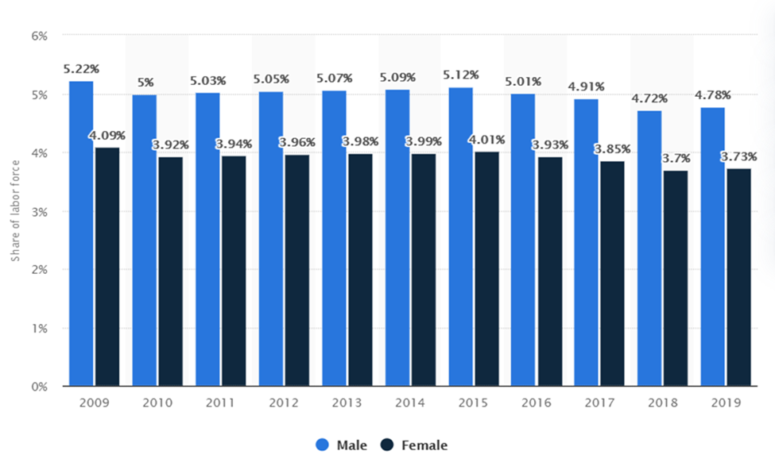
Unemployment rate in China from 2009 to 2019, by gender.

- Gender discrimination at work.
Significant attempts have been made by the Chinese government to reach a high degree of economic status for women. Since 1949 and with the founding of the People's Republic, the rate of working women has increased, with Chinese women accounting for 44% of the workforce and 34.5% of working women in the world.
China's economic policies laid the foundation for industrialization in export-oriented development, and it relied on low-wage manufacturing to produce consumer goods for the global market. Girls left rural areas to work in urban industrial areas. The business included export-oriented manufacturing, manufacturing in electronics, toy assembly, sewing in garment production, and mixed assembly and sewing in the footwear industry. Both Hong Kong and Shenzhen are cities that were established as centers of export-oriented manufacturing, and female migrant workers make up 70 percent of the three million people in Shenzhen.
Employers in the private sector hesitate to recruit women because Chinese law allows the company to pay maternity leave and birth expenses. However, some industries prefer female workers for supposed benefits. For example, the beauty economy is defined as a market in which young and attractive women are used to promote commercial products and services, within the sales industry. After the beginning of Deng Xiaoping's economic liberalization, a widening gender disparity in labor force activity and earnings has followed China's economic achievements. The loosening of state regulation on the marketplace, which has allowed private sector companies and even state-owned enterprises greater latitude in a dynamic economic climate to discriminate against women in the workforce and in wages, has been a major factor behind this pattern. Around the same time, childcare services funded by the state have deteriorated, imposing a more burden on women seeking jobs.
According to statistics, gender gap in China's labor force increased from 9.4 percentage points in 1990 to 14.1 percentage points in 2020. The gap has been narrowing in other global economies, such as the US. Many variables have led to China's widening gender gap. Women have had to spend more time at home taking care of their children with a drop in childcare funding from the state, which has restricted their ability to actively engage in the work force.

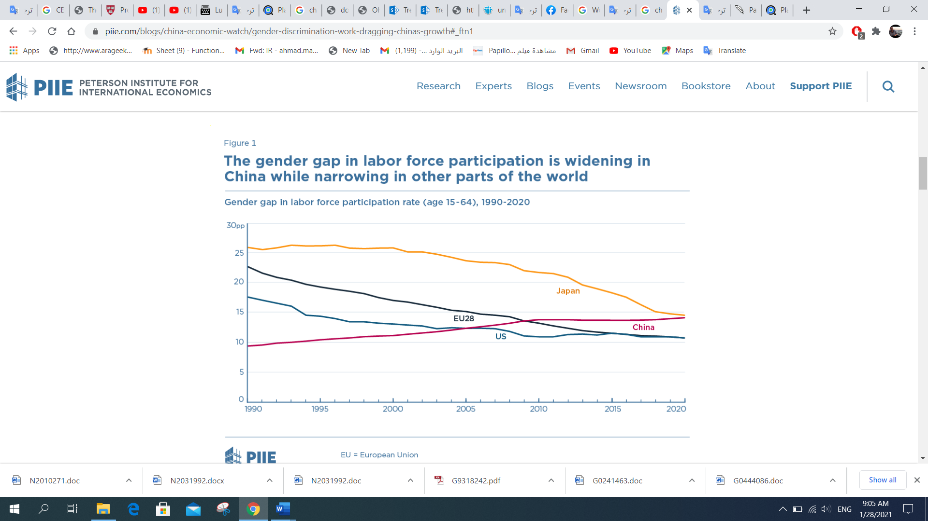
The Gender gap in labor force participation is widening in China while narrowing in other parts of the world.
- Women representation in the Chinese political system.
Women have low participation rates in politics. The disadvantage of women is even more evident in the underrepresentation of the more powerful political positions. At the highest level of decision-making, no woman was among the nine members of the Standing Committee of the Politburo of the Communist Party of the 27 ministers in the cabinet, only 3 are women and, according to the Inter-Parliamentary Union, China has sunk to 53rd out of 16th in the world since 1997 in terms of women's participation in the National People's Congress. Parties such as (Zhao Ziyang) are opposed to the inclusion of women in the democratic sphere.
The Chinese Communist Party includes only one woman out of 25 members of the political bureau of the party, while the Standing Committee of the Political Bureau of the party has not included any woman at all, and it is a more powerful committee in China, and it consists of only nine members. The party also has only 10 female members out of the 204 members of the CPC Central Committee.
- Domestic violence.
In China under Confucianism traditions, the model family is patriarchal, because men had the ability to pass on a family name and continue lineage from ancestors; It is expected that women will obey this. The adoption of Western family values in the 20th century challenged traditional Chinese values. Patriotism contributed to changing the customs and social status of women. Violence against females in the family is normalized. The endorsement of "family harmony" and "fulfilling family responsibilities" represents the deep traditional belief of Chinese culture in family solidarity over dispute and separation and implicitly supports the notion that victims (particularly women) should remain virtuous in the face of violence and be obliged to endure abuse.
The 2015 Domestic Violence Law was the first law issued to face domestic violence. The law article stated that “to prevent and stop domestic violence; protect the equal rights of family members; preserve equal, harmonious, civilized familial relationships; promote family harmony and social stability.” But, during Covid-19 lockdown, the domestic violence rate increased by high rate, for instance its increased in “Wuhan” from 47 cases in 2019 to 162 in the beginning of 2020. During these cases of violence, the police authorities could not interfere or response to the violations happened against women, the tradition and Chinese people collective mind, prefer the mediation in these cases to end domestic violence, under the state “Promote family harmony and social stability” that shows the law ineffectiveness.

- Recommendations.

- The non-application of the Convention directly in the local courts of the State party, which resulted in the failure to cite its provisions or to apply it directly in the local courts.
In this regard China must accept and ratifying the optional protocol of the convention.

- Ensure women's effective access to justice, including through the provision of legal aid that includes women involved in lawsuits related to land, and support non-governmental organizations, where appropriate, that facilitate women's access to justice.
Thus, independence of the judiciary from the states party is a must, including preventing all forms of interference by the political wing of the State party in the judiciary, so that all disputes involving women's human rights can be considered and decided in a manner consistent with the rule of law.

- As result of One-Child policy, many women who were born as the second daughter of the family, do not get recognize by the state, they do not get Identity cards, or approval from the government to enjoy their nationality, therefore they have no rights to be announced as citizen, deprived from their rights, as if they are not exist. The government should solve such problem, issuing laws to guarantee rights of those women, especially after its backward of implementing the one-child policy.

- The National Action Committee for Women and Children of the State Council has been strengthened by providing it with more human and financial resources. Nevertheless, there are such reports about that the Labor Committee is only a coordinating agency with no mandate or budget to implement policies, and that it is not empowered to assess laws and policies gender. Moreover, the limited cooperation between the Action Committee and a wide range of civil society organizations concerned with women's rights issues in China, made many questions confronting its credibility.

- The Covid-19 crisis pandemic shown that the domestic violence increased, and the (2015 Domestic Violence Law) lack in guarantee women against violence. Thus, Recourse to the Convention and General Recommendation No. 9 (1992) issued by the Committee, as well as the Committee's jurisprudence, when drafting its law against domestic violence, to ensure its prompt adoption and comprehensive treatment of violence against women, including domestic violence.

- Ensure that the Domestic Violence Act provides for the use of protection orders, And the availability of an adequate number of adequately equipped shelters for women victims of violence.

- Take measures to ensure the effective implementation of the Program for the Advancement of Chinese Women (2011-2020) at the national and local levels, with adequate financial resources.

- Political participation of women is a must, the government should enhance the representation ratio of women from rural areas in the political life.

The report of the working group on discrimination against women in law and in practice, session 59(2014). Available at: https://docstore.ohchr.org/SelfServices/FilesHandler.ashx?enc=6
Tamney, J. B., & Chiang, L.H. (2002). Modernization, Globalization, and Confucianism in Chinese Societies. Westport, CT: Praeger. p. 130.
Xin, Lin and Gang, Wu (October 30, 2015). "One-Child Policy Lifted, All Couples Allowed Two Children". Global Times (Beijing, China).
Guthrie, Doug. (2008). "China and Globalization: The Social, Economic and Political Transformation of Chinese Society". pp. 77- 86.
https://www.statista.com/statistics/916316/china-unemployment-rate-by-gender/
Hayes, Jeff (2019). "Working Women in China-Facts and Details".
ibid
Eva (Yiwen) Zhang (PIIE) and Tianlei Huang (PIIE) June 16, 2020, Gender discrimination in China, The International Labor Organization (ILO).
Tatlow, Didi Kirsten (2010-06-24). "Women Struggle for a Foothold in Chinese Politics”, The New York Times (3 January 2021).
China’s Hidden Epidemic: Domestic Violence, Sophie Mak, April 06, 2020. Available at: https://thediplomat.com/2020/04/chinas-hidden-epidemic-domestic-violence/

