

SHADOW REPORT TO THE UNITED NATIONS COMMITTEE ON THE ELIMINATION OF DISCRIMINATION AGAINST WOMEN

June 2020

Submitted by:
Land Sea Maldives

Land Sea Maldives
M. Babuna, Male’ city, 20326, Maldives
Phone/Fax: +960 7291200
Email: landseamaldives@gmail.com
Website: www.landseamaldives.org

Introduction
- LandSea Maldives is a non-governmental organization focusing on advocacy of right to food security, healthy living, economic empowerment of people and promote sustainable & equitable use of natural resources. Our vision is to see a decentralized Maldives with a diversified economy to include more productive industries to our economy and be less dependent on tourism and land to be owned as communities via community land trusts and economy to be equitable through worker cooperatives.

Article 13(b) – Financial credit facilities
- A significant population of women in Maldives are housewives and spend most of their time carrying out housework which are unpaid and unvalued. This leads to a barrier in accessibility for women to apply for financial credit facilities such as loans where even the lowest facilities require formal employment and collateral – both which cannot be presented for women who are housewives. This created further dependency on the spouse who is in formal employment and making the circumstances more difficult for women subject to domestic violence and discrimination to get out of violent relationships.

Article 14(2) – Rural Development & discrimination against women in rural areas
- Current practices of the Government of Maldives in allocation of land for tourism is very removed from local participation and abuses autonomy of indigenous people in having access to neighboring islands for economical and food security work. Women in rural areas have had neighboring islands and mangroves, which they have been using for economical and non-economical use, destroyed for development of resorts and gentrification.

Case 1 – V. Bodumohoraa
Indigenous locals, especially women, have been using the island Bodumohoraa for agriculture & recreation. Nearly 200 people from the atoll signed a petition led by the council president of V. Keyodhoo emphasizing that the issue is a concern of not just keyodhoo but the locals of the entire atoll which does not have any other island remaining aside from Bodumohoraa for economical and non-economical use as other islands have been given away for development by the Government of Maldives to different companies. The smallest inhabited island in the Maldives Vaavu Rakeedhoo also have expressed the desire to shift to Bodumohoraa with people from other islands in the atoll. Without any regard for the outcry of locals, the island was given to local businessman and member of the parliament Abdulla Jabir for a total of 42.3 million MVR (USD 2.7million) as acquisition fee which he has paid 8.4 million MVR (USD 545,000) and will have a period of 5 years upon initiation of his resort titled ‘The Jabir Happy Club” to settle the payment. | 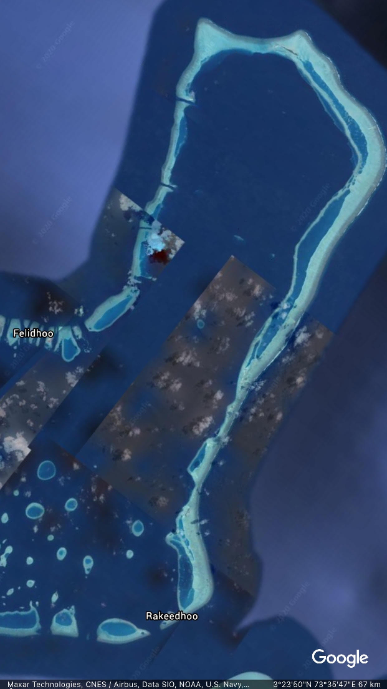

Case 2– Mangrove in Hdh. Kulhudhufushi
Locals of Kulhudhufushi were known to have used the mangrove when making coir rope they sold to resorts and for other economical uses before a huge part of the wetland was destroyed to develop an airport. The project was initially proposed to reclaim 30% of the wetland but was reclaimed to 50% of the mangrove. Upon observation after the project was over, it was found to be that the reclamation was 70% of the mangrove. (Uthema, 2018).

- The Government of Maldives allocates islands for tourism and airport development without any consultation or approval from the people of the atoll that use neighboring islands for economical and non-economical use.

- There are no island allocated for agricultural purposes given to the inhabitants of neighboring islands to use to ensure food security for their communities. Islands leased to 99 years deprives generations of locals from accessibility & women in rural areas from economic empowerment. Table 1: Note that only one island is allocated to citizens out of over 900 islands.

Table 1: Status of uninhabited islands
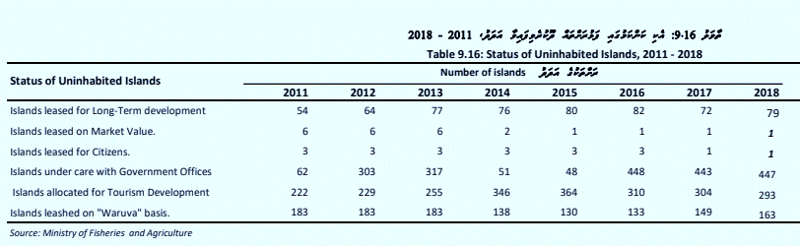

Factory island
- Resort workers spend months away from their family with only a few days off from work to visit their families. This deprives them from their right to family & community, alienating them from community engagement and robs them of their sense of belonging. Most resort workers are men, which means the women carry on housework and look after children without the help of a father while children grow up with an absent father.

Lack of job opportunities
- Workers spend time away from home because of lack of job opportunity within the island and while youth unemployment is at all-time high of nearly 19%, economically active women population is around 42% & while agriculture amounts to less than 1% of GDP, 52% of farmers in Maldives are women.

- Governments’ favoured method of creating employment seems to be opening more corporate owned resorts which do not employ much female (Table 2). The men and the women have to more or less give up family life and community participation if they want to work in autonomous resort islands for entire working life in their own country.

Allocating more uninhabited islands to tourism has decreased job opportunities for women since it mandates to leave families behind to live in resort if they want jobs.

Table 2: Local employment in Agriculture and tourism
Industry | Female (local) | Percent of female | Male  (Local) | Percent of Male | Total (local)
Agriculture (2018) | 3,992 | 53% | 3,544 | 47% | 7,536
Tourist Resorts (2020) | 1,348 | 6%* | 19,983 | 94% | 21,332

Data Source: Ministry of Fisheries and agriculture, National bureau of Statistics (the last census 2020)

*Total resort work force including expatriates is 44,958 of which only 3% are local women. The percentage is 6% when taking only locals to account.

- At present already 30% of uninhabited islands have been allocated for tourism without much regard to local needs for agriculture, service islands (health education), recreation, etc. The people Maldives in particular women who used to roam these islands in search of food and materials for work no longer enjoy benefits of natural resources which rightly belongs to those communities.

Lack of housing
- Housing needs rather through community planning of housing is left to the real estate market to deliver, causing the gap between the rich and poor to widen and leave extended families to occupy homes beyond capacity. Housing is not treated as a human right and social housing is not delivered according to community needs and it is very much removed from life wellbeing in the sense islands are developed without any regard to food security, greenery needed for healthy living and free of slumming.

Case 3: R. Ufulandhoo
The people of Raa atoll Maduvvaree (R. Maduvvaree) have made numerous requests to successive governments to allocate Raa Ufulandhoo (an uninhabited Island nearby) to the people of Maduvvaree to alleviate problem of congestion since there is no land available to fulfil local needs. Council president Hassan Abduraheem in an interview given to Sun (Maldivian newspaper) states that they need Ufulandhoo for housing adding that, they do not want artificial beaches and more reclamations which is environmentally destructive. | 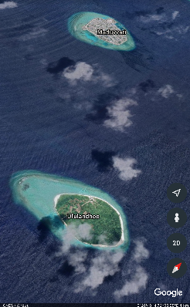
The allocation of Ufulandhoo to people of Maduvvaree will give women and families an opportunity to settle into more environment friendly and greener life that will contribute to better wellbeing and better livelihood opportunities as well. However, to this day no action has been taken in this regard and natives are uncertain of their future

Sustainable Development
- Government budgeted 1.5billion ruffiya in 2020 for reclamations of new land while islands like Maduvvaree is begging to allocate nearest uninhabited islands to them. Smaller islands like V. Rakeedhoo are requesting to move to better uninhabited islands in the atoll like Bodumohoraa, Livelihoods like community owned guesthouses or agri plots show sustainability in small communities catering to tourists and local populations.

- One of the smallest islands in Maldives, K. Maafushi now is a major contributor of tax revenue through guesthouse industry even though the community does not receive any share of it to make it a livable island for locals. A change of policy to fair fiscal decentralization are interventions government can use in this regard.

- In spite of resilient community involved development methods showing success; governments’ reluctance to allocate uninhabited islands to communities and give priority to allocate it to private companies in tourism industry which is the biggest contributor to marginalization of women and communities in Maldives for the past 40 years is not very conducive to establishing gender equality.

- Objective of Poverty alleviation, gender equality, achieving SDGs (especially life bellow water) and sustainability is not found when one analyzes budget allocations. A report on poverty released in June 2020 states that 87% of 95,000 who are multidimensionally poor in Maldives lives in the atolls. (all islands except capital Male’). Hence one would expect more budget will be allocated to atolls instead of the capital. However, the bulk of public sector invest program (PSIP) budget is allocated (often more than 50%) to greater Male reclamations, bridge and other infrastructure projects increasing pull factors to one of the worlds most congested island city!

- Atolls also find, often the little budget allocated to them is for environmentally destructive infrastructure projects like making expensive harbors (current government manifesto pledged to change the method to more environmentally friendly alternatives but seems not following it) instead of livelihood for women and communities and strengthening social sector which is severely underfunded. The smallest island in Maldives V. Rakeedhoo with no school is questioning as we write this report, “why government is carrying a harbor project for ‘one boat’ when the island have no school”?

- The current development model adopted in the Maldives by active centralization to greater male’ region and land reclamation surrounding male’ to increase land capacity is against the sustainable development pledges the government of Maldives has committed to. Dredging environmentally sensitive and protected areas in the name of development is impacting livelihood of women communities and right to sustainable development. It continues to force families in rural areas to migrate to the greater male’ area to access the most basic services such as healthcare & education. For families that cannot afford to migrate, they are forced to make frequent trips to male’ to access these services.

- The government’s reluctance to allocate uninhabited islands for locals deprive them of right to mitigate and adapt to climate change using natural methods. The biggest impact of landlessness is on women since they lose livelihood opportunities when they migrate to rented flats in capital Male’ leaving all uninhabited islands to tourism industry which have only minimal participation of women.

- A member of the Parliament submitted a motion this June 2020, to find out why gender inequality is still high in Maldives irrespective of passing several laws to improve it! Some answer to members concern may lie in the budget allocation they approve and economic laws they pass! One such example is recent uproar over increasing child sexual abuse cases. It was revealed that only 80 case workers are employed in the whole Maldives which is inadequate in a country with worlds’ highest divorce rate. Similarly, tourism related laws and regulations when implemented keep on marginalizing women at an alarming rate and is an obstacle to sustainable development since it grabs natural resources needed for locals to adapt, for generations to come. Gender equality is impossible if the country keeps on restricting involvement of half the population & communities in its biggest industry possibly for coming 99 years!

- Gender is treated as segregated issue instead of key policies and laws (economic and planning) woven into interventions to address key challenges and systemic gender discrimination.

Recommendations
- The government of Maldives to;

  - Value unpaid housework and allow women without formal employment access to credit facilities without collateral and with low interest rates to allow accessibility.

  - Allow residents of any island to vote for their local council to ensure equal representation.

  - Have a referendum within the atoll when leasing any island within the atoll and leave at least 40% of uninhabited islands for use of atoll locals for their economical and non-economical use & to allocate 30% of uninhabited islands within each atoll for agriculture to ensure food security.

  - Have a referendum when carrying out projects that would permanently alter the natural environment and to ensure proper information regarding the project is made available to locals and civil society organizations before proceeding with any of its implementation or financing.

  - Outlaw factory island living and immediately adopt concepts such as “1 week work, 1 week off” as a universal program for workers who have their work sites away from home that deprives them from returning home for the day with maximum commute of 1 hour.

  - Change the structure of existing mechanism in tourism industry to make it more women and family friendly by moving some departments like call center, HR, finance to inhabited islands in addition to providing ferry connectivity to resorts.

  - To recognize housing as a human right and ensure no one lives more than 5 years on rent and to facilitate personal ownership of permanent housing.

  - Decentralize and develop services such as healthcare, education and housing in the outer atolls and facilitate loan scheme for worker cooperatives specially targeted for economic empowerment of women.

  - Give priority to allocating natural islands to solve population congestion problems instead of reclamation that destroys marine ecosystems to ensure natives have better livelihood opportunities as well as opportunity to mitigate and adapt to climate change naturally.

  - Come up with proper natural resource allocation and management Plan in consultation with communities and with appropriate legal framework to ensure natural resources are prioritized for native needs, women and communities ensuring a life of wellbeing for them.

References

- Country Briefing Paper: Women in Republic of Maldives (2001), Asian Development Bank

Vaavu Atoll in disarray over Bodumohoraa deal, begins petition (2020), The Edition
- Employment in tourist resorts 2019, (2019) National bureau of statistics Maldives
- National Statistics year book Maldives 2019, (2020) National bureau of statistics Maldives
- Ufulandhoo to be allocated to the people of Maduvvaree: The hope of citizens (2020), Maduvaree Online https://www.maduvvarionline.com/report/1112/
- Multidimensional poverty in Maldives (2020), National bureau of statistics, Maldives

