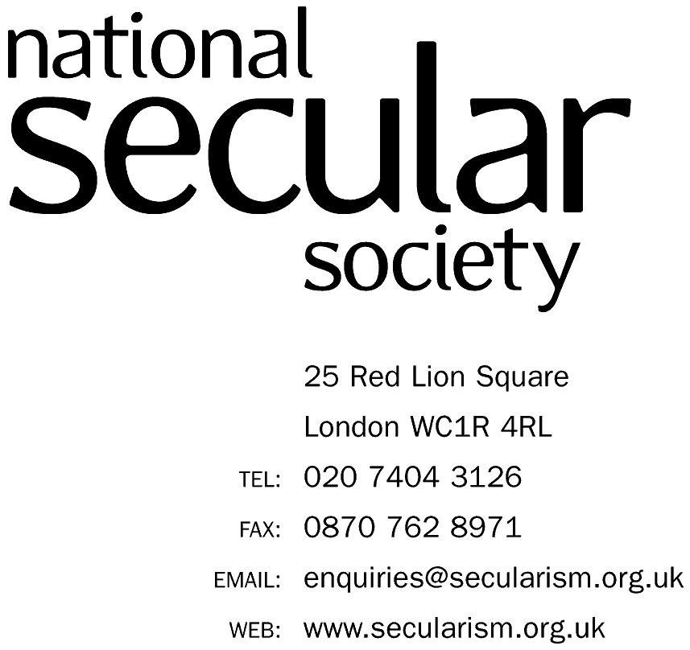


UNITED NATIONS CONVENTION ON THE RIGHTS OF THE CHILD

ALTERNATIVE REPORT ON PORTUGAL

PREPARED BY THE (UK) NATIONAL SECULAR SOCIETY

FOR THE 82nd SESSION

OCTOBER 2018

THERE IS NO TABLE OF CONTENTS AS ALL MATERIAL RELATES TO CLUSTER 4.

4 Civil Rights and Freedoms (Article 19)

Authors
- This report has been prepared by the UK National Secular Society’s (NSS) President, Keith Porteous Wood, and NSS Council member Josephine Macintosh. She has spoken for the NSS at the United Nations Human Rights Council (UNHRC). Mr Porteous Wood made several representations, both verbal and written at the UNHRC 2009-2013 to encourage the Holy See to file its long-overdue second periodic report so it could be examined by the Committee. After it had done so, we submitted evidence to the Committee to assist it in compiling its concluding observations. We have submitted numerous other alternative reports to assist the Committee’s examination of other State parties, particularly in the field of clerical abuse of minors.
Methodology and general approach
- The National Secular Society works for the separation of religion and state, and for equal respect for everyone's human rights so that no one is either advantaged or disadvantaged because of their religion or belief. We have been in special consultative status with the United Nations Economic and Social Council since 2016.
- The purpose of this submission is to create, in the interests of justice and the victims of such abuse, a more level playing field so that religious institutions do not enjoy privileges that allow much abuse to go unpunished and victims/survivors to be denied protection, treatment and rehabilitation provided for under Articles 19, 34 and 39 of the Convention.
- Our work mentioned above relative to the Holy See and other state parties has led us to conclude that clerical abuse is much more widespread in ecclesiastical organisations than is realised and such abuse is often concealed for decades. Given Portugal is an overwhelmingly Catholic country, there must be a considerable risk of clerical abuse there, as it is found in most predominantly Catholic countries. Australia’s Royal Commission into Institutional Responses to Child Sexual Abuse reported in 2018 and it provided a great deal of evidence corroborating widespread clerical abuse of minors for decades, indeed centuries.
- The Appendix shows media coverage alleging Catholic and Jehovah’s Witness clerical abuse in Portugal, which we accept are not very substantial and ostensibly much less than is evident in most Catholic majority countries in the West. This may be because insufficient investigations have been carried out, possibly as a result of obstruction by the Church or those supporting it (this problem was identified in Australia). It is normal for substantial abuse to be suddenly revealed in countries previously thought to be largely abuse-free, normally because of a high-profile scandal or the publication of a report or film. This happened in Poland with the release in 2018 of the film Kler about clerical abuse and corruption, a topic which had previously been unmentionable. The film broke box office records as the portrayal of clerical abuse resonated with people’s lived experience. It provoked hundreds of accusations of abuse.
- The real levels of abuse will be considerably higher than that reported, partly because of the decades-long delay customary between abuse of minors and them mustering sufficient confidence to report it as adults. Vows of secrecy, repeated denials and aggressive legal action taken by clerical organisations are key factors in maintaining concealment. This allows abuse to continue unchecked, perpetrators (and those shielding them) to evade justice and victims/survivors to be denied compensation and help.
- We recognise, however, that much abuse (sexual and other violence by adults) against minors is not institutional but familial and institutional abuse also occurs in non-ecclesiastical institutional environments. Clearly, credible accusations, wherever they occur, should be pursued with the full force of the law.
- We also readily acknowledge that abuse in ecclesiastical organisations is not limited to Catholic or Christian organisations. Nevertheless, we urge the Committee to consider the implications of such abuse being prevalent in varying and generally alarming degrees across all denominations and religions throughout the world. This is manifest from even a cursory examination of criminal and media reports, particularly in countries with less restricted media, and is confirmed both by the Australian Commission’s report and in Chapter 7 of Child Sexual Abuse in the Catholic Church: An Interpretive Review of the Literature and Public Inquiry Reports, compiled by Desmond Cahill and Peter Wilkinson of the Centre for Global Research School of Global, Urban and Social Studies, RMIT University, Melbourne, and published August 2017.
SOME HISTORY RELATIVE TO THE CATHOLIC CHURCH
- Given Portugal is an overwhelmingly Catholic country, we note the following historical contexts. The Australian Commission’s report confirms that “Child sexual abuse in the Catholic Church is not a recent phenomenon. It has a long history reaching back to the first centuries of Christianity.” (148)
“The founder of a RC [Roman Catholic] treatment programme in the US for priests accused of sexual misconduct “gained a private audience [in 1963] with Pope Paul VI and warned the pope about the dangers of reassigning clergy who had sexually abused children, and the need to laicise and remove them from ministry.” (165)
- A recent 400-page report by ordained Catholic academics from the Melbourne RMIT University concludes that there is a consistent worldwide picture for the Catholic Church, placing the source of the problem at the top of the hierarchy.
EXTENT AND CHARACTERISTICS
(Numbers in parenthesis are references to page numbers in the Australian Commission’s report.)
- The Portuguese channel TVI broadcast a documentary in October 2015 about Jehovah's Witnesses concerning Child abuse, shunning, blood transfusions and many other topics. It was called The Shadow of Sin.
- The Committee on the Rights of the Child itself wrote in 2014 about large scale abuse in Catholic Church institutions, of which there are many in Portugal. It stated in its concluding observations to the Holy See that “[w]ell-known child sexual abusers have been transferred from parish to parish or to other countries to cover-up such crimes, a practice documented by numerous national commissions of inquiry” and that this “still places children in many countries at high risk of sexual abuse”.
- The Commission’s findings echo (and implicitly corroborate our earlier reports on) other Western countries with significant Catholic populations by concluding that a significant majority, 58.6%, of institutional abuse is in religious institutions and a significant majority of that is in Catholic institutions, particularly residential institutions. (13)
- The extent and nature of abuse in religious institutions is based on Australian Commission report: The abuse occurred in religious schools, presbyteries and rectories, confessionals, residential religious institutions such as (often isolated and remote) orphanages, children’s homes and missions, in places of worship or during religious activities “such as a confessional, a priest’s residence or a ritual bathhouse”. The sexual abuse took many forms, including rape. It was often accompanied by physical or emotional abuse. …”(9), (17-19) “… survivors on average took 23.9 years to disclose and 33 years to claim” (15).
“Of all Catholic priests included in the survey who ministered between 1950 and 2010, taking into account the duration of ministry, 7 per cent were alleged perpetrators.” In one order this exceeded 40% and three others exceeded 20%. 90 per cent of alleged Roman Catholic perpetrators were male (31) as were most victims/survivors.
Confession/confessionals were a major problem in the Catholic Church. “We heard about priests misusing the practice of religious confession to facilitate child sexual abuse or to silence victims. Survivors told us about experiencing sexual abuse as children in the confessional at their church.” (20)
We are not aware of any reason why Catholic clerical abuse should be absent from Portugal when it is so prevalent in so many other predominantly Catholic countries.
EFFECT ON SURVIVORS (ALSO TAKEN FROM THE ABOVE AUSTRALIAN REPORT, WITH PAGE NUMBERS IN PARENTHESIS)
- “For many, the harm was irreparable”. “…The impacts can be intergenerational and can affect entire communities.” (21 and 32)
“Some survivors described ‘clusters’ of suicides in affected communities. In some cases, we heard about children who took their own lives.” (21) “Some … became pregnant after being sexually abused as children by people in religious ministry …. this led to miscarriage … forced adoption, abortion or marriage”. (21) Survivors were routinely disbelieved, by their religious communities and even by their parents, those in religious power falsely denied the abuse and survivors who disclosed their abuse were routinely threatened, punished or shunned. (20-23)
- Typically, the abuse suffered by survivors is compounded by:
(a) their perpetrator escaping justice, and
(b) difficulty in obtaining compensation, which is obstructed by religious organisations even when they know the claim is justified.
In both instances, statutes of limitation, both criminal and civil, often prevent prosecution and settlements.
The destruction of records also does so. Bishop Accountability reports “Other Catholic Dioceses Have Destroyed Incriminating Priest Personnel Files”. This gave rise to a USA-wide legal proscription in 2018 “Federal Government Tells Catholic Bishops Not to Destroy Sex Abuse Documents”.
Our recommendations seek to ameliorate both problems.
TYPICAL INSTITUTIONAL RESPONSES (ALSO TAKEN FROM THE ABOVE AUSTRALIAN REPORT, WITH PAGE NUMBERS IN PARENTHESES)
- This was denial, failure to report perpetrators to civil authorities, even to punish them internally; indeed, some were later promoted or retired without penalty. They were frequently moved to places unaware of their abuse history, putting more children at risk. (9-10, 23-28)
Our own experience over decades and from all over the world is that we have yet to find a religious organisation to which the above descriptions do not largely if not entirely apply.
- Even when secular authorities received reports, they frequently failed to act (52).
- No leadership from the Church – neither the current Pope or his predecessors, the Curia or most other Catholic leaders, have an impressive record in tackling abuse. He has failed to use his authority to direct the Church worldwide to report suspected abusers and provide evidence to secular authorities, as the CRC Concluding Observations on the Holy See’s 2nd periodic report called for. Instead, the Holy See attacked the Committee for its report. Archbishops around the world are being defrocked and/or criminally convicted for abuse or covering it up. We can provide additional evidence to justify these claims on request. Furthermore, The Australian Commission concluded that “Bishops have close relationships with clergy in their dioceses, which at times clearly affected their response to allegations.”
- Catholic religious orders seem to be completely autonomous and a law unto themselves and few if any are subject to oversight and most act solely in their own interests rather than in those of those in their care. The almost countless number of such orders a major factor. This problem is identified by Cahill, a Catholic academic from RMIT in his 400-page informative study Child Sexual Abuse in the Catholic Church: An Interpretive Review of the Literature and Public Inquiry Reports
- “We have concluded that there were catastrophic failures of leadership of Catholic Church authorities over many decades, particularly before the 1990s.” (32)

CAUSES AND AGGRAVATING FACTORS – A BRIEF SUMMARY, FOCUSSING MAINLY ON THE CATHOLIC CHURCH WHERE THE HIGHEST LEVELS OF ABUSE WERE FOUND
- The huge power imbalance between children and religious figures both creates opportunities for abuse and the ability to cover it up. Religious organisations, seeking to hold themselves out as moral leaders will be obsessive about covering up abuse. Having adherents in powerful positions in the community including the arms of justice and the media will enable pressure to be brought to reinforce the secrecy. The film Spotlight (about Boston Massachusetts) illustrated this.
- Clericalism/Priest superiority a major factor: them being considered both by children and parents as “representatives of god” leads to them being treated with extreme deference.
- Further factors increasing the risk of abuse in religious institutions and their propensity to cover it up, including institutionally include: “closed” communities; and children coming “from religious families where sex was a taboo subject”, compounded by them “receiv[ing] very little sex education” (20 and 412). We have included a recommendation on this.
- The absence of mandatory reporting of institutional abuse is a major contributory factor in many countries. We are pleased to note that such mandatory reporting is in force in Portugal although we do not know how well it is enforced and whether it includes the confessional. We cover this in a recommendation.
Even if the levels of such abuse in Portugal are less than in other Catholic countries, the measures we are proposing will harm no one, could be helpful to some and are designed to prevent abuse occurring in future.
RECOMMENDATIONS –
The State Party should:
- Conduct and publish a nationally representative prevalence study on a regular basis to establish the extent of child maltreatment in institutional and non-institutional contexts in the state party.
- Eliminate of arbitrary statutory time bars on criminal convictions and civil claims in respect of abuse of minors, which will nevertheless remain subject to the normal standards of proof and thresholds of evidence.
- Ensure that Mandatory Reporting applies to the confessional and conduct enquiries to ensure Mandatory Reporting is being effectively enforced.
- Create a criminal offence with an appropriately severe penalty for destroying files and other evidence relating to abuse of minors. If files are sent out of Portuguese jurisdiction, e.g. to the Holy See, they should be copies, which we accept may well contradict Roman Catholic canon “law”, and the originals should remain under Portuguese jurisdiction.
- Review sex education at all levels to warn of abuse in an age-appropriate way. This should include an imaginative use of social media.
- Introduce information and help-seeking services to support people who are concerned they may be at risk of sexually abusing children. The design of these services should be informed by the Stop It Now! model implemented in Ireland and the United Kingdom.
- Introduce information and help seeking services about abuse of minors for parents and other members of the community concerned that:
i. an adult they know may be at risk of perpetrating child sexual abuse
ii. a child or young person they know may be at risk of sexual abuse or harm
iii. a child they know may be displaying harmful sexual behaviours.
- Endeavour to ensure that the Jehovah’s Witness organisation abandons its application of the two-witness rule in cases involving complaints of child sexual abuse, and consideration be given to statutory measures to reinforce this.
- Endeavour to ensure that all Jewish institutions reform their complaint handling policies to explicitly state that the halachic concepts of mesirah, moser and loshon horo do not apply to proscribe the communication and reporting of allegations of child sexual abuse to police and other civil authorities.
- Require each religious institution to make provision for family and community involvement by publishing all policies relevant to child safety in notices at each location and on its website, providing opportunities for comment on its approach to child safety, and seeking periodic feedback about the effectiveness of its approach to child safety. All should include contact details for external secular agencies to whom complaints should be directed.
- Require that any person in religious ministry or lay person working in a religious environment who is the subject of a complaint of child sexual abuse which is substantiated on the balance of probabilities, or who is convicted of an offence relating to child sexual abuse, should be permanently removed from ministry or from working in any religious institution. Religious institutions should also take all necessary steps to effectively prohibit the person from in any way holding himself or herself out as being a person with religious authority.
- Take appropriate measures to promote physical and psychological recovery and social reintegration of a child victim of: any form of neglect, exploitation, or abuse; torture or any other form of cruel, inhuman or degrading treatment or punishment, as per article 39 of the Convention on the Rights of the Child. We recommend that this should include appropriate compensation.
APPENDIX

The Portuguese channel TVI broadcast a documentary in October 2015 about Jehovah's Witnesses concerning Child abuse, shunning, blood transfusions and many other topics. It was called The Shadow of Sin. We understand that the organisation declined requests to comment about it.

BishopAccountability.org

Priest Charged with Sexual Abuse in Portugal
Press TV July 4, 2014

Priest Charged with Sexual Abuse in Portugal
Press TV
July 4, 2014
A priest and his accomplice have been charged with sexually abusing patients in several hospitals across Portugal, prosecutors say.
The alleged crimes were reportedly committed between 2004 and 2010 in hospitals run by the Roman Catholic order.
"The charge relates to the sexual abuse of four patients in the care of institutions run by the Hospitaller Order of Saint John of God," prosecutors said in a statement on Thursday.
The order operates more than 250 medical centers around the world. One of the hospitals mentioned in the indictment is an institution specialized for the mentally ill.
The latest church scandal is unveiled as the Portuguese Catholic Church is already under fire for the case of another priest named Luis Miguel Mendes. He was sentenced in 2013 to ten years in prison for the sexual abuse of six minors aged between 13 and 15.
The Vatican has been rocked by major inquiries into claims of abuse in Ireland, the United States, Belgium, Holland, Switzerland and several other countries.
A United Nations committee has been questioning the Vatican over the global child sex abuse scandal involving priests.
The committee has also blasted the Vatican’s practice of transferring the abusing clergymen from parish to parish in a bid to cover up their crimes.
Meanwhile, Pope Francis has said the church must be bolder in efforts to protect children.
On May 3, the pope’s newly-formed sexual abuse advisory board said it was to develop “clear and effective” protocols to hold bishops and other church authorities accountable if they failed to report suspected abuse or protect children from pedophile priests.

CRC/C/VAT/CO/2, 31 January 2014 (Speaking for International Humanist and Ethical Union) https://www.secularism.org.uk/uploads/iheu-submission-to-the-uncrc-march-2013.pdf https://www.secularism.org.uk/uploads/holy-see-pack-unhrc.pdf
https://www.childabuseroyalcommission.gov.au/sites/default/files/final_report_-_volume_16_religious_institutions_book_1.pdf
Ibid page 52
https://www.theguardian.com/world/2018/oct/15/polish-film-the-clergy-sparks-hundreds-of-allegations-of-abuse-kler-catholic
Ibid page 56.
https://www.rmit.edu.au/content/dam/rmit/documents/news/church-abuse/child-sex-abuse-and-the-catholic-church.pdf
https://www.rmit.edu.au/content/dam/rmit/documents/news/church-abuse/child-sex-abuse-and-the-catholic-church.pdf e.g. page 312 on secrecy
https://www.youtube.com/watch?v=8UE3--fnSH8
Committee on the Rights of the Child, Concluding Observations, CRC/C/VAT/CO/2: Extract from paragraph 44(e)
https://www.childabuseroyalcommission.gov.au/sites/default/files/final_report_-_volume_16_religious_institutions_book_1.pdf numbers in parenthesis are page numbers in this book.
http://www.bishop-accountability.org/news3/2005_04_24_Arellano_ShreddinOther.htm
https://www.nytimes.com/2018/10/26/us/catholic-bishops-sex-abuse.html
https://www.thejournal.ie/religious-abuse-compensation-3278789-Mar2017/
https://www.rmit.edu.au/content/dam/rmit/documents/news/church-abuse/child-sex-abuse-and-the-catholic-church.pdf page 304
https://eige.europa.eu/gender-based-violence/resources/portugal/portuguese-code-criminal-procedure-article-242-denuncia-obrigatoria-mandatory-reporting
https://www.youtube.com/watch?v=8UE3--fnSH8
http://www.bishop-accountability.org/news2014/07_08/2014_07_04_PressTV_PriestCharged.htm (Originally http://www.presstv.ir/detail/2014/07/04/369785/priest-charged-with-sexual-abuse/ but no longer available)

