6 September 2023

In behalf of
The Asia-Pacific Association of Jehovah’s Witnesses,
The European Association of Jehovah’s Witnesses,
The African Association of Jehovah’s Witnesses
and
Asociación Simple de los Testigos de Jehová en las Américas

Joint Submission to the United Nations Human Rights Committee
Subsequent to the Adoption of the List of Issues
139th session (9 October–3 November 2023)

Republic of Korea

Contact Information

Contact address in Japan  Office of APAJW:  5-11-2-605, Mita Minato-ku, Tokyo, 108-0073 Japan  Tel: 81 50 5050 5893  Email: apajw.jp@jw.org | Office of EAJW:  Am Steinfels 1, 65618 Selters,  Germany  Tel: 49 6483 41 3802  Email: inboxopieajw@jw.org

Table of Contents
ABOUT THE SUBMITTING ORGANIZATIONS 2
SUMMARY OF THE SUBMISSION 3
I. INTRODUCTION 3
II. VIOLATIONS OF THE PROVISIONS OF THE COVENANT 4
III. CONCLUSION AND RECOMMENDATIONS 8

Annexes
Annex 1 – Asia-Pacific Association of Jehovah’s Witnesses, Report: Alternative Civilian Service in South Korea — August 2023

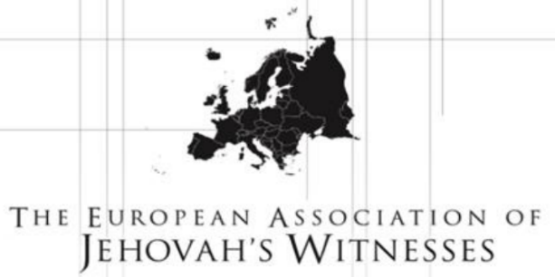 | The European Association of Jehovah’s Witnesses (EAJW) is a charity registered in the United Kingdom. It provides support to Jehovah’s Witnesses facing fundamental human rights violations in various parts of the world.  Address: 1 Kingdom Way, West Hanningfield, CHELMSFORD CM2 8FW, UNITED KINGDOM  Telephone: + 44 20 8906 2211  Offices in: Austria, Belgium, France, Georgia, Germany, Greece, Italy, Poland, Portugal, Spain and Switzerland  Registered Charity Number: 1085157
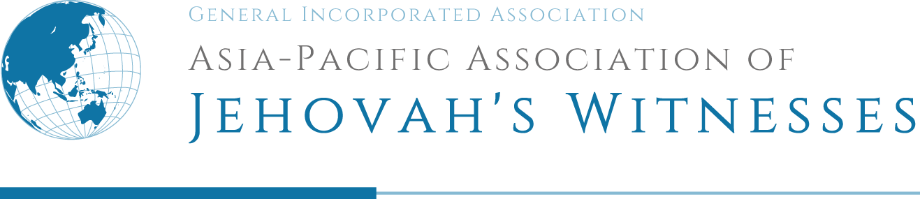 | Asia-Pacific Association of Jehovah’s Witnesses (APAJW) is a general incorporated association registered in Japan. It supports the activities of Jehovah’s Witnesses and promotes the protection of fundamental freedoms in various part of the world, mainly in the Asia-Pacific region.  Address: 5-11-2-605, Mita Minato-ku, Tokyo, 108-0073 JAPAN  Telephone: + 81 50 5050 5893  Offices in: Australia, Fiji, Guam, Hong Kong, India, Indonesia, Japan, Kazakhstan, Kyrgyzstan, Malaysia, Myanmar, New Caledonia, Papua New Guinea, Philippines, Republic of Korea, Solomon Islands, Sri Lanka, Tahiti, Taiwan and Thailand  Registered Corporate Number: 7010405019149
 | African Association of Jehovah’s Witnesses (AAJW) is a public benefit organization registered in South Africa.  Address:1 Robert Broom Drive East, Rangeview, Krugersdorp, 1739, SOUTH AFRICA  Telephone: + 27 11 761 1200  Offices in: Angola, Benin, Burundi, Central African Republic, Democratic Republic of Congo, Ethiopia, Ghana, Kenya, Liberia, Madagascar, Malawi, Mozambique, Nigeria, Rwanda, Senegal, South Africa, Uganda, Zambia and Zimbabwe  Registered PBO Number: 930067639
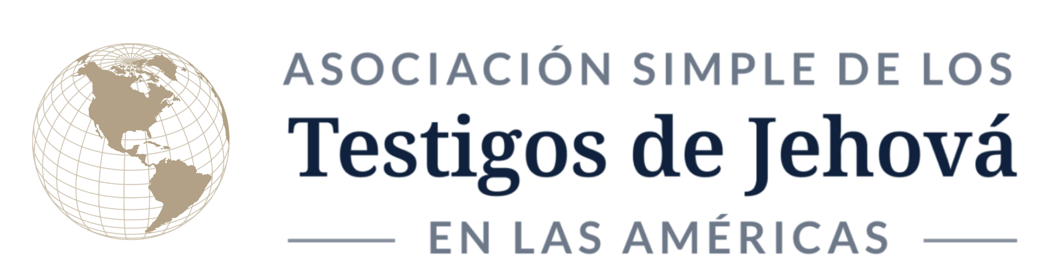 | Asociación Simple de los Testigos de Jehová en las Américas (AJWA) is a civil association constituted in Argentina. It supports the activities of Jehovah’s Witnesses and promotes the protection of fundamental freedoms in various part of the world, mainly in the Americas region.  Address: Bvrd. de la Plaza 255, Of. 85, Nordelta, C.P. 1670, Tigre, B.A., ARGENTINA  Telephone: + 54 11 3220 5996  Offices in: Argentina, Brazil, Canada, Chile, Colombia, Ecuador, Mexico, Paraguay, Peru, United States and Venezuela  Notarial Constitution: Title Deed No. 229, 11/1/2022, Nordelta, Tigre, ARGENTINA 1611.

ABOUT THE SUBMITTING ORGANIZATIONS

SUMMARY OF THE SUBMISSION
This submission to the Human Rights Committee (CCPR) on the Republic of Korea highlights violations of the provisions of the International Covenant on Civil and Political Rights (the Covenant) subsequent to the adoption of the List of issues to be taken up in connection with the consideration of the 139th report of the Republic of Korea.
Jehovah’s Witnesses in the Republic of Korea and as a worldwide organization respectfully request the Government of the Republic of Korea to:
- Ensure that conscientious objectors to military service have the option to perform a genuine alternative civilian service of a non-punitive nature in line with international standards;
- Ensure that such alternative service (AS) is made available to applicants without unreasonable delay;
- Ensure that appropriate provision is made for reservists who have become conscientious objectors since performing military service;
- Ensure that the criminal records of individuals formerly imprisoned for conscientious objection to military service are fully expunged;
- Abide by its commitment to uphold the fundamental freedoms guaranteed by the Covenant for all citizens, including Jehovah’s Witnesses.

INTRODUCTION
  - Jehovah’s Witnesses have been in the Republic of Korea for some 110 years. In 2022, there were some 105,000 active adherents in the country, with more than 138,000 attending meetings for worship.
  - The Republic of Korea acceded to the Covenant, including the procedures for individual complaints under CCPR-OP1, on 10 April 1990.
  - Article 18 of the Covenant provides that “everyone shall have the right to freedom of thought, conscience and religion.” General Comment No. 22 (CCPR/C/21/Rev.1/Add.4), adopted at the forty-eighth session of the Human Rights Committee (CCPR) on 30 July 1993, states at para. 11: “The Covenant does not explicitly refer to a right to conscientious objection [to military service], but the Committee believes that such a right can be derived from article 18.”
  - For more than 70 years, Jehovah’s Witnesses in the Republic of Korea have endured imprisonment or other forms of detainment because of their stand as conscientious objectors. During these years, more than 19,000 of Jehovah’s Witnesses have been convicted and imprisoned, even though they were willing to serve their communities in nonmilitary roles.
  - In 2018, the Constitutional Court of Korea declared Article 5, paragraph 1, of the Military Service Act unconstitutional because the government made no provision for AS. In its landmark decision, the court paved the way for an AS provision but stated that “if the duration or severity of alternative service is excessive to the extent that even conscientious objectors find it difficult to choose such service, this would defeat the purpose of alternative service or degrade it to a mere form of punishment, causing violations of other fundamental rights.”
  - In response, the Republic of Korea implemented a form of AS in October 2020 and placed the programme under the jurisdiction of the Ministry of Defence. Sadly, the AS programme’s punitive nature continues to infringe on the rights and freedoms of Jehovah’s Witnesses who object to serving in the military because of their religious beliefs.

VIOLATIONS OF THE PROVISIONS OF THE COVENANT
Freedom of thought, conscience and religion (article 18)
Punitive Alternative to Military Conscription

A. Freedom of thought, conscience and religion (article 18)
  - In essence, the conditions for South Korea’s AS programme closely resemble the situation that existed during imprisonment for conscientious objection: AS personnel must reside in correctional facilities in de facto detention, their freedoms are severely curtailed, their fundamental rights are abrogated; and they are required to perform the same work as convicted prisoners did when they were punished as conscientious objectors. Although some policies have been amended to allow AS personnel to leave the premises to attend religious meetings for worship, implementation of these changes has been inconsistent. Furthermore, AS has a duration of 36 months—twice the length of military service—making it one of the longest AS requirements in the world. In essence, South Korea’s AS programme does not conform to the international standards for genuine alternative civilian service.
  - It is noteworthy that the Constitutional Court of South Korea strongly warned the Korean authorities about the risk of establishing a punitive AS. It stated:
  - “If the duration or severity of alternative service is excessive to the extent that conscientious objectors find it difficult to choose, this would defeat the purpose of the alternative service or degrade it to a mere form of punishment, causing violations of other fundamental rights.”—2011Hunba379, etc. of 28 June 2018.

  - The punitive nature of South Korea’s AS programme has caused concern in both the Republic of Korea itself and in the international human rights community. Han In-seob, former head of the Korean Institute of Criminology and Justice, stated: “The current AS can be considered a form of ‘alternative punishment’ according to the United States Commission on International Religious Freedom.” The Chairman of the National Human Rights Commission of Korea (NHRCK), Song Doo-hwan, stated in part: “Although an AS system was introduced after the Constitutional Court’s decision in 2018, I deeply agree on the need to improve the system to meet international human rights standards.” Arnold Fang, Amnesty International’s East Asia researcher, pointed out that “confining people to work in a prison—and for almost twice as long as the typical military service—does not respect their right to freedom of thought, conscience, religion, or belief.” Furthermore, on 10 May 2023, subsequent to petitions filed by AS personnel, the NHRCK issued recommendations (NHRCK Recommendation) to improve AS by reducing the service duration and by introducing a variety of service types.
  - Duration and Severity. The current AS programme was devised by the Ministry of National Defence and is under its overall jurisdiction, with the Ministry of Justice having direct management and supervisory authority over its operation and the day-to-day activity of personnel. It is the only alternative to military service offered to those who decline on conscientious grounds and in effect functions as an alternative punishment, being punitive in both length and severity.
    - Before the programme’s implementation in 2020, conscientious objectors were imprisoned for 18 months. Participants in AS now serve for 36 months—double the time of imprisonment and double the time of military service—a disparity considered punitive by international standards. For example, in 2008, the Council of Europe recommended that “alternative service may not exceed one and a half times the length of armed military service.” Even that duration can be considered punitive, as evidenced by the comments of the CCPR to Austria, where alternative service is one and a half times as long as military service. The CCPR noted that “the length of the civilian alternative service to military service for conscientious objectors is longer than military service and may be punitively long if not based on reasonable and objective grounds,” suggesting that the disparity potentially violates Articles 18 and 26 of the Covenant.
Regarding duration, the NHRCK Recommendation proposes, in part: “To the Minister of National Defense, it is recommended that the in-camp service period of 36 months for Alternative Service personnel be adjusted within the range of 6 months in accordance with Article 19 of the Act on Assignment to and Performance of Alternative Service.”
    - AS personnel are held in de facto detention. Instead of being allowed to commute to their place of work, they are housed in gated, barracks-style facilities on prison grounds. Instead of performing public sector work that benefits the community, AS personnel are limited to working in prison facilities, performing labour-intensive tasks similar to those previously assigned to persons imprisoned for conscientious objection.
Commenting on the State’s justification for limiting service to correctional facilities to ensure work equivalence to military service, the NHRCK Recommendation explains: “Social welfare field, which includes assisting the severely disabled and caring for patients with dementia, is never low in intensity, and conscripted firefighting, abolished due to reduction of military manpower in 2023, as well as public health, medical services, and relief work cannot be regarded as low-intensity work either, and also there is a high social necessity for such work.” Therefore, it concludes: “To the Minister of Justice, it is recommended that relevant directions be arranged to assign tasks in consideration of the aptitude and qualifications of Alternative Service personnel serving in correctional facilities.”
  - Limitations on Personal Freedoms and Rights. AS personnel are deprived of their freedoms in much the same way as are convicted prisoners.
    - The authorities severely restrict the movement of AS personnel and enforce strict curfews when leave is granted. Personnel may not leave the facility in any circumstances—even after regular working hours—during the first month of service. Subsequently, if granted permission, a strictly limited percentage of the personnel is permitted to leave after working hours, but those concerned must return by 9:30 p.m.
Such restrictions prevent AS personnel from taking care of their families’ physical and emotional needs. In one case, an individual received news at 10:30 a.m. on 8 March 2022, that his mother had been admitted to hospital in a critical condition. His initial request for leave to visit her was denied. He was finally granted leave at 3:00 p.m., but this was too late because his mother had died shortly after noon.
    - Cell phones and other electronic devices are impounded during working hours and may not be accessed by personnel, even in an emergency.
    - AS personnel are not permitted to park personal vehicles at the facility. This arbitrary rule makes it very difficult for them to travel to religious meetings or to visit their families, especially in view of the very limited amount of time occasionally granted for leave.
    - When AS personnel visit medical facilities outside the detention centres, prison officials accompany them. At times, consultation with a clinician has only been allowed after a prison official with no medical training evaluated the individual’s medical needs. When an individual is permitted to consult a clinician, an official is present during the consultation and examination. This is a breach of fundamental rights that abrogates the patient’s privacy and confidentiality.
  - Personal Health Status. National military service members who receive a level-4 health classification because of a physical or psychological condition are permitted to perform their service by commuting to various facilities. In contrast, conscientious objectors with a level-4 health classification who apply for AS are required to perform their service exclusively from a communal dormitory within a correctional facility. As a result, they are subject to considerable pain and suffering because of their unacknowledged health limitation.
  - Backlog for AS Call-up. Because AS is restricted to correctional facilities, which have limited accommodation, persons who qualify face a waiting period of up to four years before they can begin their service, which means, effectively, a seven-year delay before returning to permanent employment or other economic activity. This seriously affects family life and career development. It is estimated that only half of the applicants who qualify for AS will be accommodated by the end of 2023. According to figures from Korea’s Military Manpower Administration, 1,652 out of 2,910 already approved for alternative service are still waiting to perform their service as of May 2023.
  - AS Personnel With Children. The Republic of Korea has established systematic provisions for national service members who are parents. None of these provisions is extended to AS personnel. Because AS personnel are assigned to facilities without consideration for where they live, fathers may have to travel long distances to visit their children. They cannot live with their children and commute to their place of service, nor can they financially support their family, contravening parental obligations and rights under Articles 3, 5, 9, 14, 18 and 27 of the United Nations Convention on the Rights of the Child.
  - Because of the punitive nature of AS, a number of conscientious objectors have declined enlisting in AS or have discontinued their service. Such conscientious objectors who call for service improvements in line with international standards and decline AS face court proceedings and possible imprisonment.
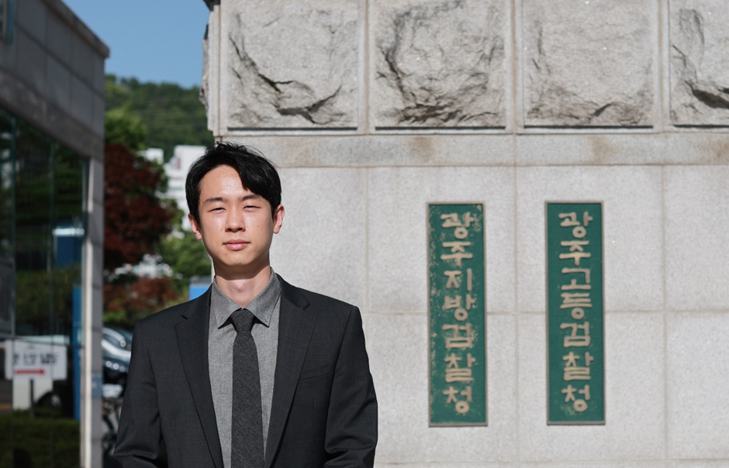
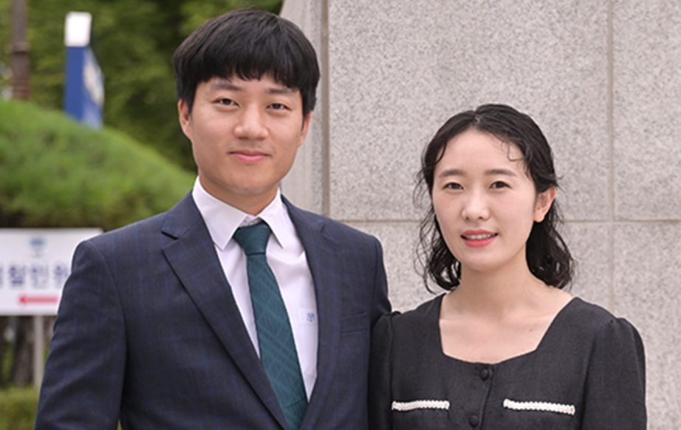
  - An outstanding example is that of the first conscientious objector who declined to perform AS. Mr Hye-min Kim was recognized as a conscientious objector by the Supreme Court in September 2020. As a result, he bypassed the evaluation process and was granted AS upon application. His call-up date was on 7 February 2022, but because of its punitive nature, he expressed his objection to AS both to the Military Manpower Administration and to the Ministry of Justice. Subsequently, he was criminally indicted for “failing to comply with the call-up without justifiable grounds in violation of the Military Service Act, Article 88, paragraph 1.” His case is pending.
Mr Hye-min Kim and his wife
  - The second legal case is that of Mr Tae-ung Seo. After he was finally found not guilty in 2020, he has been waiting to perform AS. However, he decided to decline AS after discovering that his rights would be infringed upon under the current system, which is unconstitutional and unlawful. He stated: “I have a right to accept an alternative service which is not punitive, and I am willing to perform AS if it is restructured to resolve its current punitive nature.” Mr Seo’s next court hearing is scheduled on September 19, 2023.
Mr Tae-ung Seo in front of
the court building
  - The number of cases of objection to the current AS provision is slowly increasing. As of August 2023, in addition to Mr Hye-min Kim and Mr Tae-ung Seo, another conscientious objector has rejected both the call-up to military service and the current punitive AS, and is standing trial at a local criminal court. A further three are under investigation. Meanwhile, two AS personnel have withdrawn from the provision, citing the punitive and restrictive conditions. Under the Alternative Service Act, they have been re-categorized to active duty military service and will receive a renewed enlistment notice. If they conscientiously object to the enlistment, this will trigger criminal proceedings.
  - Also, a number of persons who believe AS to be punitive but who are unable to discontinue their service have elected to file complaints to the Constitutional Court. As of August 2023, 123 such complaints have been filed. These complaints have been accepted by the Constitutional Court and are awaiting decision.

CONCLUSION AND RECOMMENDATIONS
  - Jehovah’s Witnesses in the Republic of Korea and as a worldwide organization express concern at the failure of the Republic of Korea both to follow through on the conclusions of its Constitutional and Supreme Courts by putting in place a provision for alternative civilian service in full harmony with international standards and to comply with its commitments under the Covenant. They respectfully request the Government of the Republic of Korea to take the necessary steps to:
- Ensure that conscientious objectors to military service have the option to perform a genuine alternative civilian service of a non-punitive nature in line with international standards;
- Ensure that such alternative service is made available to applicants without unreasonable delay;
- Ensure that appropriate provision is made for reservists who have become conscientious objectors since performing military service;
- Ensure that the criminal records of individuals formerly imprisoned for conscientious objection to military service are fully expunged;
- Abide by its commitment to uphold the fundamental freedoms guaranteed by the Covenant for all citizens, including Jehovah’s Witnesses.

Decision of 28 June 2018, case no. 2011Hunba379, 383, p. 38.
Amnesty International, “South Korea: Alternative to military service is new punishment for conscientious objectors,” 27 December 2019, https://www.facebook.com/amnesty, https://www.amnesty.org/en/latest/press-release/2019/12/south-korea-alternative-to-military-service-is-new-punishment-for-conscientious-objectors/.
Original document: https://www.humanrights.go.kr/download/BASIC_ATTACH?storageNo=10002346
See “European Committee of Social Rights of the Council of Europe: Conclusions 2008 (Greece).”
See United Nations Human Rights Committee, Concluding observations on the fifth periodic report of Austria, CCPR/C/AUT/CO/5, 3 December 2015, pars. 33-34.
See National Assembly Budget Office, July 2023, Final Accounts Analysis for National Defense Committee of National Assembly, p. 301.

