Cuba’s Historic Record in the Fight Against Racial Discrimination: Submission to UNHRC-CERD on Behalf of United States-based Organizations that Oppose Washington’s Economic War on Cuba

Written by Ike Nahem, representing the New York-New Jersey Cuba Si Coalition, International US-Cuba Normalization Conference Coalition

Introduction

The historic record of the 1959-61 Cuban Revolution, and subsequent revolutionary socialist governments to the present day, is astonishing in its impact in the fight against “Racial Discrimination” both inside Cuba and internationally, particularly on the African Continent. The revolutionary and internationalist policies of this small Caribbean island had a widely outsized, decisive impact on advancing the fight against racism around the world. This included on the exploding Civil Rights Movement in the United States. Black fighters for civil and human rights – most prominently Malcolm X -- in the US were conscious of and strongly attracted to the anti-racist programs and implemented actions of the Cuban Revolution, which took place legally in Cuba years before the 1964 Civil Rights Act in the United States. African Americans were prominent in the public defense of Cuba in the United States, and opposition to the US economic and political war on Cuba and remain so to this day.
It is a testimony to the continuing moral, political, and material force of the Cuban socialist revolution – “a big Revolution in a small country” as revolutionary leader Fidel Castro put it. (We salute Fidel Castro’s monumental personal part in the struggle against racism in this Centenary of his birth!) The theory and practice of the Cuban Revolution has been fundamentally defined by solidarity with nations and nationalities oppressed by the historic colonial powers and contemporary capitalist imperialism. The Cuban revolutionaries saw anti-Black racism as rooted in the system of slavery, with so-called “white supremacy” as the necessary ideological accompaniment and rationalization. Fidel Castro was also fluent in the history of the US Civil War and the struggle to abolish slavery in the United States.
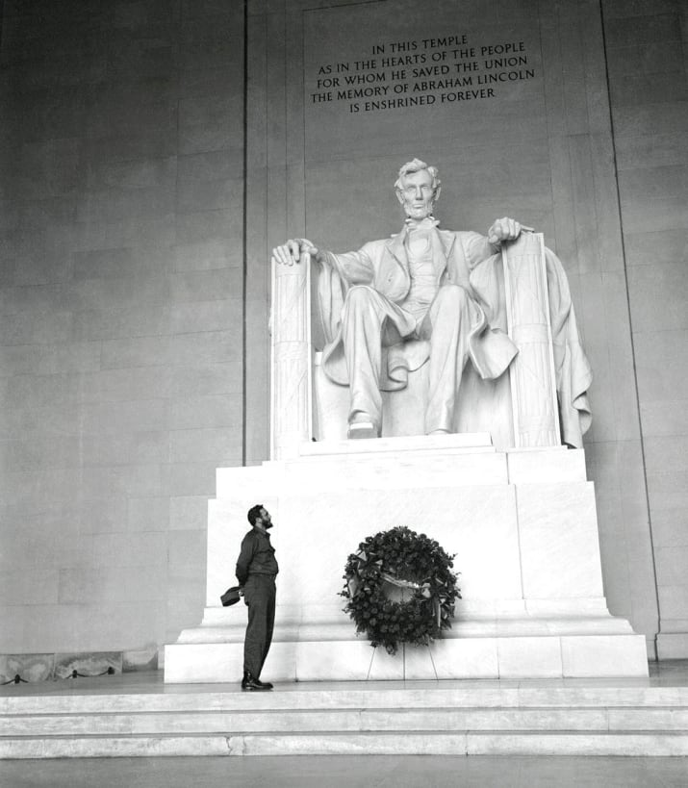
Fidel Castro at the Abraham Lincoln Memorial in Washington, DC

The Fight Against Racism Inside Cuba

Within the oppressed Cuban nation – dominated and exploited by Washington and US capital until the Revolution – Afro-Cubans were at the bottom of the neo-colonial class society. Slavery was not fully abolished legally in Cuba until 1886. Cuban-style Jim Crow segregation flourished in the US neo-colony. Smashing this odious legacy was central to the program of the July 26th Movement before the Revolution and a decisive question and priority for the revolutionary government.
The revolutionary government’s approach immediately moved to abolish all the formal laws of segregationist, neocolonial Cuba regarding racial discrimination. But more importantly this was intertwined with the overall revolutionary mobilizations for all the revolutionary reforms and policies: comprehensive land reform tied to industrialization, smashing illiteracy, wiping out mafia interests, expanding home ownership, free and high-quality medical access and education, the elevation of women’s liberation, and much more in the interests of the working people as a whole. All of this greatly benefited Afro-Cubans. The victorious July 26 Movement revolutionaries, with the participation and support of the overwhelming majority, were establishing a government defending the interests of working people as a whole and not foreign or domestic capital.
The formal abolition of legal segregation is certainly a precondition for confronting and dealing blows to racial discrimination and segregation. Nevertheless, actually advancing mass anti-racist consciousness and driving forward measures that transform the actual social, class, and “racial” relationships of forces is primarily a question of governmental leadership, mass education, and mass mobilizations. The Cuban Revolution put in power a government that was on the side of Afro-Cubans and the fight against racial discrimination. In 1960s revolutionary Cuba this transformation of mass consciousness was of course forged in the crucible of a bipartisan Washington policy of destroying the still-infant Revolution through terrorism (e.g. Operation Mongoose), sanctions, mercenary invasion, and lying propaganda on an industrial scale.
Fidel Castro often said his style was not to impose his ideas but to convince (or be convinced). In the early years of the Revolution Fidel’s speeches explaining to Cubans the historic roots of racist discrimination (and also the oppression of women) and the revolutionary government’s policies are master classes in this method. On March 29, 1959 (not even four months after the establishment of the revolutionary government), for example, Fidel took up, without pandering one milligram to residual popular prejudice or social backwardness, the question of racism at a mass rally of Cuban workers:
“I believe it is my duty to tell the people about the things on my mind and how they must collaborate with their revolutionary government and how it is helping them…But not everybody’s mentality has developed enough in the revolutionary way; a revolutionary consciousness is lagging behind the people's feelings. The people's feelings are all revolutionary, but their mentality is still not wholly so. The people's mentality is conditioned by many inherited prejudices, many vestiges of the past, and many old customs. If the people want to overcome this evil they must begin by recognizing it…Battles must be won by us…the battle against unemployment; the battle to raise the standards of the lowest paid workers; the battle to bring down the cost of living; and one of the most just battles that must be fought, a battle that must be emphasized more and more, which I might call the fourth battle--the battle to end racial discrimination at work centers. I repeat: the battle to end racial discrimination at work centers. Of all forms of racial discrimination, the worst is the one that limits the colored Cuban's access to jobs. It is true that there is in our country in some sectors the shameful procedure of barring Negroes from jobs. Everybody knows I am not a demagogue. Everybody knows I hate demagogy...[The first form] of racial discrimination we must combat is racial discrimination at work centers…
[This]…limits access to places where a living can be earned. It limits the Negro's chances of satisfying his needs, and so we commit the crime of denying the chance to work to the poorest group particularly. While the colonial society made the Negro work as a slave, made the Negro work more than anybody else, and without pay, we commit the crime in our current society, which some have wanted to call a democratic society, of doing just the opposite and trying to prevent him from working to earn a living. And so, while the colony worked him to death and beat him to death, we want to starve our colored brothers to death.
It ought not to be necessary to issue a law to establish a right that is earned by the mere fact of being a human being and a member of society. It ought not to be necessary to issue a law against an absurd prejudice. What should be proclaimed is anathema and public condemnation against those men, full of leftover prejudices, and who are unscrupulous enough to discriminate against a Cuban, to mistreat a Cuban, over a matter of lighter or darker skin, because, after all, we all have a lighter or darker skin…But nobody can consider himself of a pure race, least of all the whites. The same way that we are going to organize and wage a campaign for buying domestic products, without a law or legal penalties being needed, we are going to put an end to racial discrimination at work centers by waging a campaign to end this shame, to end this hateful, repugnant system with a new slogan: work opportunities for every Cuban, without discrimination for race or sex. Let there be an end to racial discrimination at work centers; let whites and blacks all get together to end hateful racial discrimination at work centers. In this way we will gradually build the new fatherland. We must mingle at recreation centers...At school black and white learn to live together like brothers. And if they mingle in the public schools they mingle afterwards at recreation centers and they mingle everywhere. But when they are educated separately, and the aristocrats educate their children apart from the Negroes, it is logical that later whites and blacks cannot mingle at cultural or recreation spots. [We will build] playing fields at public schools where blacks and whites can play together, and also establish clubs--or let us change the name and call them recreation centers--as we are going to do at all beaches; we are going to provide recreation centers for public school children, where they can have fun, play, and enjoy the bounties of nature, and know the joy to which every child has a right, the white child and the black together, as in the schools…”]
Of course, the legacy of centuries-old racism in Cuba, and how to confront and overcome that legacy, has engendered important debates and even contention within Cuban society, government, and institutions. Is the legal abolition of racial discrimination and segregation and the undeniable qualitative social advances for Afro-Cubans the end of the question…or only the precondition and beginning? Are Afro-Cubans a distinct nationality in Cuba? How does Cuba overcome extant vestiges of racial discrimination that are exacerbated by the conditions of economic siege and threats from Washington, currently at the sharpest levels in decades.
During the so-called “Special Period” in the early 1990s, after the massive retraction of the Cuban economy following the collapse of the Soviet Union and it’s allied Eastern European governments, Cuba began a massive expansion of tourism to counter the impact of those events. This, of course, also saw an escalation of US subversion and economic war aiming for “regime change.” As hotels and resorts were build and workers were recruited, it quickly became known that some managers and bureaucrats were discriminating against Afro-Cubans in certain jobs on the repugnant and grotesque basis that tourists would be uncomfortable and offended being served and catered to by darker-complected Cubans! Needless to say, when these surreptitious practices were exposed, Fidel Castro and his government were infuriated and heads rolled.

Cuba’s Decisive Part in the Defeat of Colonial Rule and Apartheid in Southern Africa

Cuba’s anti-racist domestic policies deeply resonated across the Americas, including, as cited above, in the United States. Early on the Cuban revolutionaries also established solidarity ties with independence and revolutionary forces on the African Continent – from Algeria to apartheid South Africa. Those who were fighting French colonialism in Algeria; the ex-British colony in “Rhodesia;” and the weak and hollowed-out Portuguese Empire in Angola, Mozambique, Guinea-Bissau, and the Cape Verde Islands. Of course, the “big enchilada” in the whole structure of super-exploitation of the African Continent -- propping up the overall rotten continental system of wealth extraction and brutal, neocolonial military-political control and rule -- was the US-UK backed apartheid regime in South Africa, by far the most industrialized capitalist economy on the African Continent.
April 1974 saw a coup by left-wing military officers in Portugal against the semi-fascist Salazarist regime there. A primary motivation for the coup, which unleashed pent-up mass struggles inside Portugal for democratic and worker’s rights, was Portugal’s unsustainable colonial wars in southern Africa. Portugal held these colonies, more or less, for centuries. The coup expedited the collapse of Portugal’s colonial holdings. Negotiations with the new Portuguese government led to the target date of November 11, 1975 for the establishment of formal Angolan independence.
The broadest-based and predominant Angolan independence organization was the Movement for the Liberation of Angola (MPLA) which was poised to take governmental power out of the political situation left with the disintegration of Portuguese rule and the withdrawal of Portuguese troops.
The South African apartheid regime sensed the danger to it in these developments. Prior to the formal, scheduled Angolan Declaration of Independence, South African forces forged alliances, which they clearly dominated, with the reactionary forces of the more narrow and insular, ethnic-tribal based, Angolan FNLA and UNITA organizations. These organizations were also aligned with the United States as well as the pro-imperialist and exceedingly venal US-backed Mobutu dictatorship in “Zaire.” (Joseph Mobutu’s regime had changed the name of the Congo to “Zaire,”) The apartheid South African regime, with covert US support, had begun incursions into Angola, which led to a full invasion on October 1975, weeks before the formal establishment of Angolan Independence.
With Mobutu’s troops directly supporting the FNLA from Zaire to the west, and apartheid South Africa’s troops accompanying UNITA from bases in the South African colony of Namibia (an illegal occupation under rulings by the United Nations), the South African apartheid army and its pro-Washington allies were on the verge of seizing the Angolan capital of Luanda when, in one of the most selfless acts of revolutionary internationalism in history, the Cuban government dispatched the first contingents of what became tens of thousands of combat troops. Within months the Cuban forces had routed the South African-Zairean invasion.
Cuban leader Jorge Risquet, the African director of the Central Committee of the Cuban Communist Party, who was centrally involved in the policymaking and execution of policy within the Cuban government in those historic days, pointed out in an interview from the excellent French documentary “Cuba: An African Odyssey,” that “Angola needed soldiers and weapons at that time. The South Africans were advancing, so they couldn’t wait until the 11th because the South Africans and Mobutu would reach Luanda. There’d be no independence. [Angolan President Augustino] Neto sent a message to the Soviet government, but they said they weren’t prepared to do anything inside Angola before November 11. We, however, were ready.”

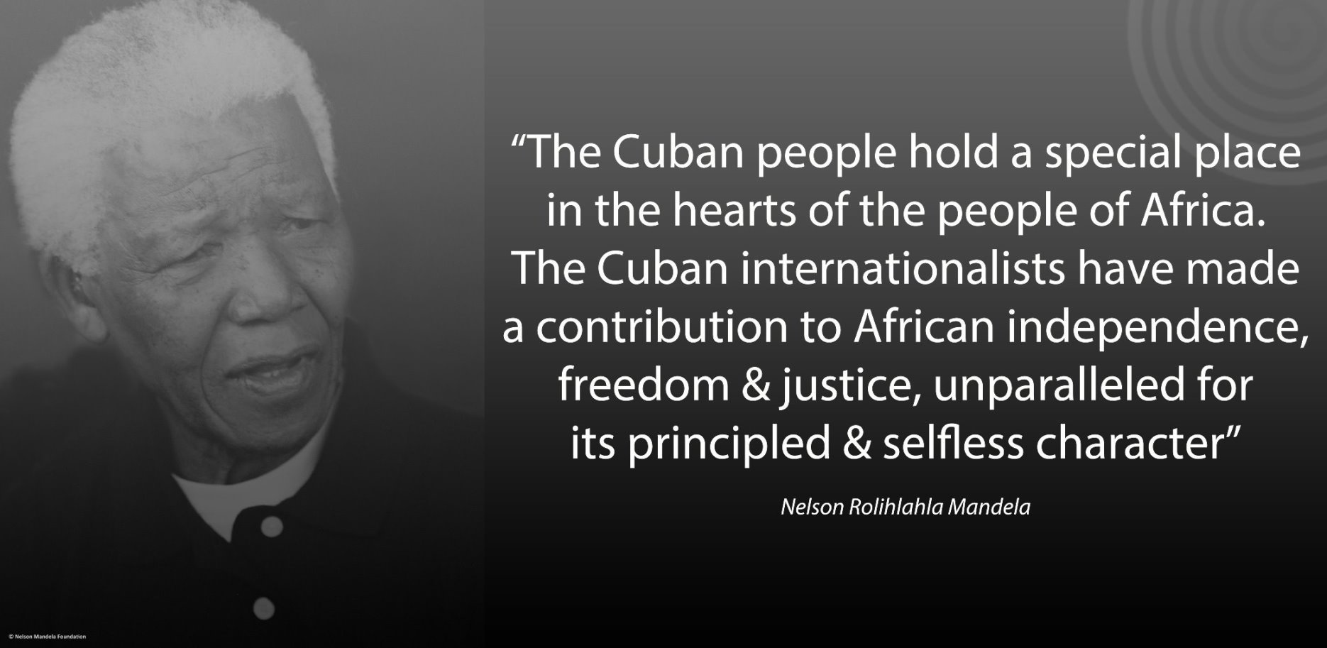

Fidel Castro said, in the same film, “When on October 23, Angola was invaded by regular South African forces, we couldn’t just sit and watch. And when the MPLA asked for our help, we offered the aid necessary to prevent apartheid from being installed in Angola.” (For a dramatic, beautifully rendered account, by the Nobel Prize in Literature-recipient Gabriel Garcia Marquez, of the Cuban mission, named “Operation Carlota,” in honor of an African slave in Cuba who, in 1843, was killed leading an uprising of women slaves in the city of Matanzas, against the Spanish slave-masters and colonizers, click below.
http://www.granma.cu/ingles/2005/noviembre/juev3/45carlota-i.html
The Cubans assembled every available, and then some, air transport carrier to transport heavy-weapons specialists and Special Forces on the first flights, making 70 transatlantic crossing roundtrips to Luanda between November 7 and December 9, 1976. The bulk of Cuban troops, which initially reached 35,000 infantries by the end of 1976, and equipment were transported by ship, boats, and other waterborne vessels commandeered from all available ships in the Cuban Merchant Marine. The volunteer troops were conscious of the political and military imperative of the mission at the gates of Luanda.
The Cuban leadership carried this out without even informing the Soviet government beforehand, which they knew would have opposed the Cuban intervention as an obstacle and irritant to their pursuit of post-Vietnam possibilities of détente with Washington. What Cuba did was done for nothing material in return, out of pure revolutionary duty, and human solidarity.
Cuban troops routed the South African-led invasion and repelled the otherwise inevitable South African seizure of the Angolan capital of Luanda. Cuban troops remained in Angola for over a decade to check South African military aggression. During this extraordinary period the clear victories of the largely Afro-Cuban military forces and their African allies defeated the mighty apartheid army. The political impact of South African military reversals inspired the entire continent, not least of all the militant, revolutionary-minded youth of South Africa’s townships and the South African Black working class.
The South African racists were bitter that the covert support and encouragement given to them by the Ford-Kissinger government could not be publicly expressed. As word of the South African aggression became public, Washington was paralyzed politically, unable to identify openly with the apartheid regime it was allied with covertly. South African Defense Minister and future South African President P.W. Botha, said in 1978, “[W]e crossed a border …in the case of Angola [and] we did so with the approval and knowledge of the Americans. But they left us in the lurch. [We] …went in there and operated in Angola with their knowledge…they encouraged us to act and, when we had nearly reached the climax, we were ruthlessly left in the lurch.”
The stunning “fact-on-the-ground” was that the mighty white-supremacist army (which included puppet African troops) had been stopped and pushed back on the road to Luanda by largely dark-skinned Cuban and Angolan forces, with Cuban combat fighters the decisive factor.
Months after the victory over the apartheid army by the Cuban armed forces – made up of internationalist volunteers – came the June 1976 mass upsurge inside apartheid South Africa. The urban townships exploded following the historic high-school student uprising in the in the impoverished Johannesburg ghetto of Soweto (South West Township). There is no question of the interconnection. Oppressed South Africans, especially industrial workers and youth in the Townships and “Bantustans,” connected to the mass African National Congress underground resistance, knew about and were emboldened by the defeat of the racist army in Angola by the revolutionary Cuban combatants. Nelson Mandela and Walter Sisulu certainly knew about it in the prisons of Robben Island, apartheid’s Alcatraz, off Cape Town.
Despite bloody repression that murdered 600-700 in the streets of Soweto, the South African regime began to weaken and politically disintegrate. The Soweto Uprising in fact signaled the beginning of the end for the apartheid regime and that hated imperialist bastion.
At each political and military turning point of the 1976-1999 war between Cuba and its allies and apartheid South Africa and its allies, covertly backed by Washington, Fidel Castro’s clear political perspective and understanding was that a military victory of apartheid South Africa in Angola would inevitably be a decisive victory that would prolong the life of the white-supremacist regime for an entire, and not inconsiderable period. It would be akin in its political impact to Hitler’s destruction of the German worker’s movement; Franco’s defeat of the Spanish Republic; and Pinochet’s coup in Chile.
The ability to clearly see the price, first of all for the African masses of every country in southern Africa, of an apartheid state victory, is what led to the bold (and exceedingly risky for the Cuban government and state) measures undertaken in 1976 and again in the decisive 1988 crisis and emergency. The latter events involved initially an on-the-ground and in-the-air debacle and disaster, under the direction of Soviet military advisors, that went forward against the strong, razor-sharp opposition of Fidel Castro and all the top Cuban leadership on-the-ground in Angola. What the Cubans did was to turn a disaster into a decisive military victory at the small town of Cuito Cuanavale on the banks of the Lomba River in Angola. (For the full, documented, and riveting account of all of this, see Visions of Freedom: Havana, Washington, Pretoria and the Struggle for Southern Africa 1976-1991 by Piero Gleijeses, University of North Carolina Press, 2013. This volume, along with the previous Conflicting Missions University of North Carolina Press 2003 are classic works where Gleijeses weaves together in meticulous detail and documentation, the amazing history of Cuban internationalism in Africa, telling the full story of the defeat and unraveling of the South African apartheid state. Gleijeses, a noted scholar at Johns Hopkins University, was able to gain unprecedented access to US, Soviet-bloc, apartheid South African, and Cuban previously secret archives and documents.)
After the Battle of Cuito Cuanavale, the apartheid army was forced into a headlong retreat back to South Africa where the African townships were now in open, permanent, mass rebellion. It was Endgame for the apartheid regime. The South African rulers, and eventually their covert allies in the Ronald Reagan Administration, were forced to negotiate massive concessions in formal talks with revolutionary Cuba, the ANC, and other southern African liberations forces. In 1990, Namibia won its independence; Nelson Mandela and all the anti-apartheid political prisoners were freed; and the ANC and all the banned anti-apartheid organizations were legalized.
Over 300,000 Cubans – doctors, teachers, and engineers alongside combatants – served in Angola in the over ten-year period. Over 2,000 died.
These giant, world-historic, world-changing accomplishments – defending the sovereignty and independence of Angola, winning the independence and sovereignty of Namibia, and the unraveling and defeat of the apartheid state – unfolded with Cuba’s political and military leadership the decisive factor. These events without question laid the historic foundation for the new, relative rise of Africa in the world.
During this period there was a vibrant, mass anti-apartheid movement in the US which was highly conscious of Cuba’s critical part in the weakening and eventual political-military defeat of the apartheid South African state.
This submission, written on behalf of opponents of US anti-Cuba policy inside the United States, highlights how a “big revolution in a small country” changed the very framework and historical context and foundation of the fight against racism. What Cuba did domestically and internationally to deal real blows to racism and segregation literally changed the objective and subjective terms of the discussion.
As this contribution is being written and submitted we must note with alacrity and alarm, that under the direction of Donald Trump and Marco Rubio, the US government, after the illegal and murderous January 3, 2026 raid and aggression against Venezuela, has sharply escalated its threats and “regime change” actions against Cuba, including attempting to sustain a total oil-energy quarantine-blockade. Of course, this flies in the face of the United Nations General Assembly votes against US anti-Cuba policies for over 30 years, and the will of the peoples and governments of the world.

Ike Nahem
March 22, 2026
New York City, NY, USA

