THEMATIC REPORT ON ARTICLE 16, FAMILY LAW AND WOMEN’S RIGHTS IN
TURKEY

82nd CEDAW Session
Geneva, Switzerland
June 2022

Submitted by:

  Havle Women’s Association  Ahmediye Mahallesi Tunusbağı Caddesi No: 25 Daire: 5 Bağımsız Bölüm 3  Üsküdar, İstanbul  Email: havle@havlekadin.com  Web: www.havlekadin.com | ​​    Musawah  15, Jalan Limau Purut, Bangsar Park, 59000 Kuala Lumpur, Malaysia  Tel: +603 2083 0202  Email: musawah@musawah.org  Web: www.musawah.org

A. INTRODUCTION

Musawah, the global movement for equality and justice in the Muslim family, and Havle Women’s Association, submit this joint Thematic Report on Article 16 and related concerns for consideration by the CEDAW Committee in its review of the Government of Turkey, reporting before the 82nd CEDAW Session in June 2022. While the family laws in Turkey are considered secular and not derived from Islamic jurisprudence, Turkey is of interest to Musawah because it is a Muslim majority country in which Islam is used as a justification for law and practice in cultural and political ways. In particular, this report examines Turkey’s laws and practices that enforce de jure and de facto discrimination against women in the following areas: child and forced marriage and the issue of surnames.

We hope that the CEDAW Committee will utilize this report as a key resource during its Constructive engagement with the State party. In particular, we hope the Committee will use the recommendations, outlined in grey boxes within the text, to identify follow-up issues in its Concluding Observations.

B. LEGAL BACKGROUND and context

- Article 10 of the Constitution declares equality between sexes. Although ‘discrimination against women’ is not defined, the Constitution mandates equality between men and women as among its main principles. In 2004, an amendment to the provision was added (‘women and men have equal rights, the State is liable for ensuring this equality in practice’). It was further amended in 2010 to facilitate temporary special measures (‘any measures to be taken to this aim shall not be contrary to the principle of equality’).

- International Conventions: The Constitution states in Article 90/V that in case of a conflict between international agreements and domestic law, the former prevails. In 2012, Turkey ratified the Council of Europe Convention on preventing and combating violence against women and domestic violence (Istanbul Convention), which adopts the principle of non-discrimination on the basis of sex. However, Turkey withdrew from the Istanbul Convention through a Presidential Decree on 20 March 2021. This withdrawal has been widely criticized as a step back in achieving gender equality in Turkey.

- Prevention of Violence against Women (Law No. 6284, 2012). Built on the Istanbul Convention but still in effect, the law broadens the definition of gender-based violence to include physical, verbal, sexual, economic, and psychological violence. It protects women, children, family members, as well as victims of stalking.

- The Turkish Civil Code. After the codification of Turkish Civil Code in 1926 (an adaptation of Swiss Civil Code), Sharia law was abolished through a constitutional amendment and Turkey was declared a secular state. The Code was extensively revised and entered into force in 2002. It revised the institution of marriage into a partnership based on ‘equality of spouses’ and equal participation of spouses in decisions on family matters.

C. KEY ISSUES AND LIVED REALITIES

1. Child and Forced Marriages Article 16

Legal Background:

The legal age of marriage in Turkey is 18 as provided in Article 124 of the Turkish Civil Code (TCC). However, the TCC provides that those aged 17 may marry with the permission of their parents. Anecdotal evidence suggests that the condition of parental consent is often overlooked in practice, making the de facto accepted age 17.

Moreover, children at the age of 16 can also marry with special permission from the courts ‘under exceptional circumstances and on vital grounds’. However, there is no elaboration in the TCC on what those exceptional circumstances entail.
Additionally, Article 103 of the Turkish Penal Code (TPC) stipulates that ‘Any person who abuses a child sexually is sentenced to an imprisonment from 8-15 years…If offender of the offence ceased at the level of importunity is a child, commencement of an investigation and prosecution depends on the complaint of the victim’ parents or guardian.’
We note with concern that the government proposed a bill on 17 November 2016 that would grant amnesty to the perpetrators of sexual abuse if they married their victims. While the government had to later withdraw it following widespread uproar from autonomous women’s organizations, it is worth noting that Article 13 of omnibus Draft Law No. 438, which proposed amendments to Article 103 of the TPC, was passed by the parliament on 24 November 2016. This was done following the Constitutional Court’s annulment, on 14 July 2016, of the provision stating that ‘any sexual behavior against any child under the age of 15 shall be considered sexual abuse’.
According to this amendment in Article 103, there is now an age categorization for 12-15-year-olds in Article 103 of the TPC, which opens the door to lowering the age of consent to 12. This could cause courts to question the consent of 12-15-year-olds and ‘force them to marry the person who abused them’.
Furthermore, although Turkey states that the ‘marry your rapist’ practice does not remove criminal responsibility, we note with concern that on 16 January 2020, Turkish Parliament debated yet another ‘marry your rapist’ bill that would provide an amnesty for men convicted of statutory rape if they marry their victims—a resurfacing of the aforementioned similar bill in 2016 that was dropped due to global outrage.
Prevalence and Implementation Concerns:
Child Marriage Statistics: Turkey has one of the highest rates of child marriage in Europe, with an estimated 15% of girls married before the age of 18 and 2% married before the age of 15. It becomes particularly challenging to track the number of child marriages occurring in Turkey because they are often conducted unofficially, with many being religious ceremonies not recognized under the law. The Turkish government does not seem to track child marriage or child trafficking. According to the 2018 Turkey Demographic and Health Surveys (TDHS), 64% of women married before age 18 had a religious ceremony first; 7% only had a religious ceremony. Child marriage is more prevalent among young women who grew up and still live in rural areas. According to a 2018 household survey by the Ministry of Family and Social Policies and Hacettepe University, among women in the 25-49 age group, 39% were married by age 20, 21% married by age 18, and 4% entered marriage before their 15th birthday.

Disproportionate Impact on Refugees: The issue of child marriage becomes particularly challenging in the case of Syrian refugees. Turkey has the largest number of refugees worldwide. As of April 2020, almost 4 million refugees resided in Turkey, of which 3.6 million were Syrian refugees. In July 2019, approximately 1.4 million of all of these refugees were under the age of 15, and over 800,00 were between the ages of 15-24. According to the 2018-TDHS Syrian Migrant Sample, among Syrian migrant women, the proportion of marriage before 18 was 44.8% and before 15 was 9.2%.

The conditions facing refugee children make them particularly vulnerable to child marriages. The issue of child, early and forced marriages, ‘has been shown to impact thousands of Syrian refugee children and Turkish children’; ‘the Turkish government’s response to the issue has been limited and criticised by a number of reports’; and ‘government data…indicates that the issue remains prevalent.’ Turkish men illegally marry Syrian child brides often as second wives who have no rights under Turkish law, which means no child support, alimony or inheritance if they divorce.

Impact of Covid-19: Amid the Covid-19 crisis, child marriages seem to have risen in Turkey even further as Syrian refugees were reported to be marrying underage daughters to Turkish men. The practice of Syrian families selling their daughters for marriage to Turkish men has become more widespread as it is an economic coping mechanism for Syrian families who have no other means of income or providing for children. Turkish men justify both polygamy and child marriage with Syrian refugees as just acts necessary in crisis times, citing Muslim religious and cultural stories and norms.

State Response and Public Opinion: Turkey’s response in the wake of such child marriages has been far from satisfactory. In 2020, the head of the state-run Turkey Human Rights and Equality Institution (TIHEK) defended underage marriages, and said that they should be differentiated from sexual assault. Süleyman Arslan stated that ‘people shouldn't be tried over shameful crimes just because they got married young’.

Interestingly, there exists divergence in Turkey between the official discourse and public opinion on issues of women and family-making. Havle Women’s Association’s (‘HWA’) research on early marriages conducted in 2019, based on detailed interviews and surveys, found that Turkish residents are opposed to marriages under the age of 18 to a significant degree. About 91.8% of the participants answered in the negative when asked if they would consider marrying their daughters off before the age of 18. Women who were married at an early age did not often refer to religion as their or their parents’ motivation for early marriages. Even if they believed that one may find room for the possibility of child marriages based on a religious framework, the participants did not want it for themselves or for their own children.

Hence, given the potential effect of religious belief and belonging in shaping people's decisions in their daily lives, we anticipate that knowledge about and support from religious tradition against child marriage alongside a state policy could support people’s already existing stance against child marriage.

Positive Developments in Family Law:

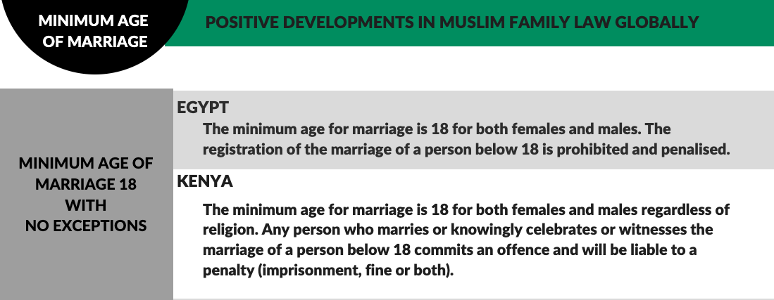

RECOMMENDATIONS

We recommend the CEDAW Committee to urge the State party to:

- Ensure that the government enacts legislation to raise the minimum age to 18 without any exceptions of parental consent or judicial permission.

- Take active steps to prevent the resurfacing of similar ‘marry your rapist’ legislation, and to proactively outlaw the practice.

- Establish a dedicated program and service to combat child and forced marriages (including specialized shelters and legal aid) with outreach to rural areas, refugee and asylum-seeking communities.

- Ensure data collection on the number of cases of child and forced marriages and number of prosecutions and penalties for those responsible for such marriages; also ensure data collection of the number of exceptions to the minimum age of marriage granted by the judiciary in the past five years, as well as the specific criteria considered by the judges when granting such exceptions.

2.The Surname Issue Article 16

Legal Background:

Article 187 of the Turkish Civil Code (TCC) provides that the ‘wife shall take on her husband’s surname after marriage’. Since this Article is a mandatory rule, spouses cannot deviate from it.

While this remains a requirement, the TCC goes on to state that ‘through a written application made to the marriage officer or civil registry office later on, the wife can also use her own surname preceding that of her husband’. In practice, the Turkish courts have changed their application of Article 187 in the last years. While Article 187 is practically considered void by the courts, there is no amendment to the relevant Article in the TCC so far. Even though the courts do not apply Article 187, administrative authorities adhere to it, so a woman who does not wish to bear a family name is forced to file a lawsuit to use her own surname.

The TCC also provides further restrictions upon the divorce of a woman. Article 173 provides that ‘in case of divorce…she shall take her maiden name as her surname… She can keep the family name of the husband if she convinces the judge that she has an interest in using this name and if this does not damage the interest of the husband. The husband can ask that this permission be revoked if the conditions change.’

Examination of the Law in Light of Domestic and International Law

Turkey is a State Party to CEDAW, Article 16(1)(g) of which includes an equal right for husbands and wives ‘to choose a family name’. Turkey is also party to the European Convention on Human Rights, Article 14 of which requires that the rights in the Convention must be secured ‘without discrimination on…sex’.

The European Court of Human Rights (ECHR), judgments of which Turkey is bound by, has ruled multiple times in favour of women regarding the issue of surnames. The Court has found that refusing to allow women to use their maiden names is a difference in treatment based on gender without any reasonable justification, constituting a violation of Article 14 in conjunction with Article 8 of the European Convention on Human Rights. In Ünal Tekeli v. Turkey, the Court concluded that the prohibition of use of the surname Ünal had a negative impact on professional activities as well as on other social fields. The purpose of reflecting family unity with a common family name was not found as an adequate ground for the discrimination based on sex.

However, despite all these rulings of the ECHR, Article 187 of the TCC remains in place, and married women must resort to court proceedings for the right to maintain their own surname.

The surname issue was also brought before the Constitutional Court of Turkey in 2011, when applicants sought permission to use their maiden names. The Court denied the request and found that the legislature did not abuse its discretion in determining that the husband’s surname should be the family name, because surnames are important to identify the family and ancestry, and that the law benefits public welfare and order. The Court also reasoned that the family is the foundation of the Turkish society and requires the State to promulgate necessary regulations to preserve the family. However, the Constitutional Court did rule in its decision in 2015 that the woman's request to change the surname of the child whose right of parental custody was given to her is rightful and valid.

Therefore, the existing surname law not only contradicts constitutional provisions of equality between spouses, but also undermines the judgments of the ECHR.

Practical Ramifications:

The requirement for women to change their surnames has many practical disadvantages for them. Firstly, they are required to amend their personal details on all of their official and non-official documents including their passports, driver’s licenses, identity cards and credit cards. This is applicable not just when women get married, but also upon divorce. Another effect of such a law is that women are compelled to announce their marital status or any change thereto immediately after such a change takes place. This also creates issues of identity for women, whose surnames continue to depend on their marital status, and hence, the will of the husband as well.

Moreover, if a man changes his surname on a justifiable cause in accordance with Article 27 of the TCC, the wife also has to change her surname accordingly. On the contrary, if she can prove a justifiable cause, she still cannot change the surname that she received from her husband. Such laws not only create inequalities between men and women, but also limit women from having an identity independent of men.

Positive Developments in Family Law:

Other Muslim majority countries do not require that the woman change her surname to that of the husband’s upon marriage, or to change it back to her maiden name upon divorce, even when the country’s laws are built on the concept of Islam as the official religion of the State. The following are some examples:

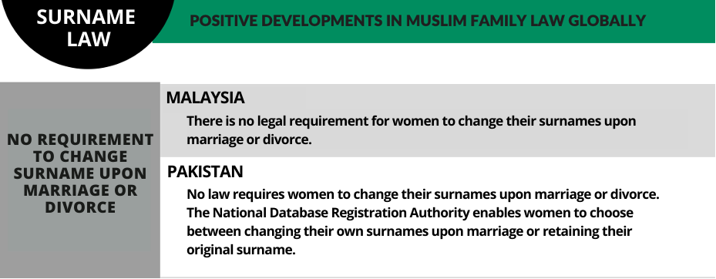

RECOMMENDATIONS

We recommend the CEDAW Committee to urge the State party to:

- Amend Article 187 of the Turkish Civil Code (TCC), in line with the rulings of the European Court of Human Rights and with Article 16 of CEDAW, to allow women to maintain their own surnames after marriage and give their surnames to their children if they choose to do so.

- Provide training and information to lawyers, judges, and relevant stakeholders about the rulings of the European Court of Human Rights and the requirements of Article 16 of CEDAW that women be allowed to retain their maiden names upon marriage instead of changing it or adding the husband’s surname.

- Amend Article 183 of TCC to, upon divorce, allow women who had previously changed their surname to their husband’s name, to retain that surname if they choose to do so, instead of requiring them to change it back to their maiden name.

We would also like to acknowledge the inputs and information provided by Women for Women's Human Rights-New Ways (WWHR-New Ways) in the preparation of this thematic report.
Turkey 7th State Party Report 2014 (hereinafter ‘Turkey SPR 2014’), para. 7.
Turkey’s Constitution (1982), https://global.tbmm.gov.tr/docs/constitution_en.pdf
Turkey SPR 2014, paras. 10, 19.
These treaties include CEDAW, CAT, CRC, and ICCPR among others.
Turkey SPR 2014, para. 8.
Statement (2021), Council of Europe, 22 March 2022, https://www.coe.int/en/web/commissioner/-/turkey-s-announced-withdrawal-from-the-istanbul-convention-endangers-women-s-rights
Turkey SPR 2014, para. 30.
Turkey 8th State Party Report 2020 (hereinafter ‘Turkey SPR 2020’), para. 25.
Turkey’s Constitution (1982), art. 174; Turkish Civil Code (1926), art. 143. (Hereinafter “TCC”) https://rm.coe.int/turkish-civil-code-family-law-book/1680a3bcd4
Turkey SPR 2020, para. 243; Esrin Orucu, “Recent Developments in Turkish Family Law”, (Recht van de Islam, 21, 2004), p. 2, http://www.verenigingrimo.nl/wp/wp-content/uploads/recht21_orucu.pdf
TCC, art. 124.
Personal Communication, ECPAT Turkey/NGOs Network Against CSEC Turkey, January 2020, as cited in FN98 of https://ecpat.org/wp-content/uploads/2021/05/ECPAT-Country-Overview-Report-Sexual-Exploitation-of-Children-inTurkey-July-2020-ENGLISH.pdf
TCC, art. 124; Turkey SPR 2020, para. 243
Statement, Association for Struggle against Sexual Violence (ASSV), 26 November 2016, https://cinselsiddetlemucadele.org/2016/11/26/article-103-of-the-turkish-penal-code-recently-amended-and-passed-through-parliament-runs-the-risk-of-seeking-consent-from-children-between-12-and-15-years-of-age/
‘Sexual behavior to every child under the age of 15 is not abuse’, BBC Turkey, 14 July 2016, https://www.bbc.com/turkce/haberler-turkiye-36798378
ASSV Statement, supra note 15.
Turkey SPR 2020, para. 81.
‘“Marry-your-rapist” bill proposed to be introduced by lawmakers in Turkey’, Independent, 22 January 2020, https://www.independent.co.uk/news/world/europe/turkey-marry-rapist-bill-child-marriage-a9296681.html
Girls Not Brides, Heinrich Böll Stiftung, https://atlas.girlsnotbrides.org/map/turkey/
‘Child Marriage Is on the Rise in Turkey as Syrian Refugees Struggle During COVID-19’, Global Citizen, 9 July 2020, https://www.globalcitizen.org/en/content/child-marriage-syrian-refugees-turkey-covid-19/
Child, Early and Forced Marriage in Turkey 1993-2018, Hacettepe University and UNFPA, Figure 33, p://fs.hacettepe.edu.tr/hips/dosyalar/yayinlar/ENG/eng_tdhs_cefm_findings_report_ENG.pdf
Ibid, p29, Figure 6.
Turkey Demographic and Health Survey 2018, Ministry of Family and Social Policies and Hacettepe University, Figure 4.2, https://fs.hacettepe.edu.tr/hips/dosyalar/Ara%C5%9Ft%C4%B1rmalar%20-%20raporlar/2018%20TNSA/TDHS2018_mainReport_compressed.pdf
Turkey Country Overview Report on Sexual Exploitation of Children 2020, ECPAT International, https://ecpat.org/wp-content/uploads/2021/05/ECPAT-Country-Overview-Report-Sexual-Exploitation-of-Children-inTurkey-July-2020-ENGLISH.pdf
Ibid.
UNFPA Report, supra note 22, p28.
Turkey ECPAT Report, supra note 25.
‘Syrian refugees married early face isolation and domestic violence’, Financial Times, 11 October 2017, https://www.ft.com/content/3754ce46-7204-11e7-93ff-99f383b09ff9
Global Citizen Report supra note 21; ‘Syrian families in Turkey marrying off ‘underage daughters for money amid coronavirus crisis’’ Independent, 8 July 2020, https://www.independent.co.uk/news/world/europe/syria-underage-daughters-marriage-coronavirus-turkish-men-a9606706.html
Turkey ECPAT Report, supra note 25.
Musawah Thematic Report on Article 16 and Muslim Family Law: Turkey, 64th CEDAW Session, July 2016, https://www.musawah.org/resources/musawah-thematic-report-on-turkey-2016/
‘Turkish government's human rights institution defends child marriages’ DuvaR, 01 October 2020, https://www.duvarenglish.com/human-rights/2020/10/01/turkish-governments-human-rights-institution-defends-child-marriages
Ibid.
Early Marriage Experiences and Perceptions Report 2021, Havle Women’s Association, https://www.havlekadin.com/wp-content/uploads/2021/09/ERKENEVLILIKLER_ING.pdf
TCC, art. 187.
Dilsah Busra Kartal, "Recent Developments In Turkish Law Regarding The Surname Of A Married Woman," Proceedings of International Academic Conferences, International Institute of Social and Economic Sciences, 2020, https://ideas.repec.org/p/sek/iacpro/10212734.html
TCC, art. 187.
Kartal, supra note 37.
Ibid.
TCC, art. 173.
See: Case of ÜnalTekeli vs. Turkey. Application No: 29865/96 dated 16/11/2004; Case of LeventoğluAbdulkadiroğlu vs. Turkey. Application No: 7971/07 dated 28/5/2013; Case of TuncerGüneş vs. Turkey. Application No: 26268/08 dated 3/09/2013; Case of TanbayTüten vs. Turkey. Application No: 38249/09 dated 10/12/2013
ECHR, art. 8 relates to the protection from interference by a public authority in the exercise of one’s right to privacy of family life, except in accordance with law.
Kartal, supra note 37.
ÜnalTekeli vs. Turkey, supra note 42.
Applications by Various Courts of First Instance to Annul a Certain Civil Law, 2011, Cornell Legal Information Institute, https://www.law.cornell.edu/women-and-justice/resource/applications_by_various_courts_of_first_instance_to_annul_a_certain_civil_law
Case of Hayriye Özdemir, Application No. 2013/3434 dated 25.6.2015, Turkish Constitutional Court, https://ayam.anayasa.gov.tr/media/2697/2013-3434.pdf
Kartal, supra note 37.
Ibid.
Id.

