

THEMATIC REPORT ON MUSLIM FAMILY LAW
AND MUSLIM WOMEN’S RIGHTS IN

INDONESIA

80th CEDAW Session
18 October - 12 November, 2021

Submitted by:
Musawah
15, Jalan Limau Purut, Bangsar Park, 59000 Kuala Lumpur, Malaysia
Tel: +603 2083 0202 Fax: +603 2202 0303
Email: musawah@musawah.org
Website: www.musawah.org

Rahima, Center for Education and Information on Islam and Women’s Rights Issues
JL. H. Shibi No. 70, RT. 007/01, Srengseng Sawah, RT.7/RW.1, Srengseng Sawah, Jagakarsa, Kota Jakarta Selatan, Daerah Khusus Ibukota Jakarta 10550
Tel/Fax. : +62-21-7873210, HP: +62-8121046676
Email : swararahima2000@gmail.com
Website : www.swararahima.com

I. INTRODUCTION

Rahima, Center for Education and Information on Islam and Women’s Rights Issues in Indonesia, and Musawah, the global movement for equality and justice in the Muslim family, submit this joint Thematic Report on concerns related to Muslim women’s legal equality, personal status, and relevant matters for consideration by the CEDAW Committee in its review of the Government of Indonesia, reporting before the 80th Session of the CEDAW Committee in October–November 2021.

This is the CEDAW Committee’s eighth engagement with Indonesia, which ratified CEDAW in September 1984 with a reservation on article 29, para. 1. Indonesia was last reviewed in 2012.

This report examines Indonesia’s legal framework and practices that enforce de jure and de facto discrimination against Muslim women in the following areas: equality before the law, child and forced marriage, polygamy and unregistered marriages, violence against women, FGM/C, and divorce rights. Each topic concludes with recommendations for the Committee to urge reforms, many providing alternative arguments of support from within Muslim legal tradition.

We hope the CEDAW Committee will utilise this report as a key resource during its Constructive Dialogue with the State party. In particular, we hope the Committee will use the recommendations to identify follow-up issues in its Concluding Observations.

II. BACKGROUND

Overview of the Muslim legal framework
Indonesia has the largest Muslim population in the world at an estimated 87.2% (229 million) of the population, with 99% of those Sunni (primarily of the Shafi’i school) and less than 1% Shia and Ahmadi; the state only recognises Sunni Islam. The legal framework in Indonesia is based on civil law, customary laws (or hukum adat), and Islamic law, which has been codified into a Compilation of Islamic Law used as the legal basis by the Religious Court. Law No.1 of 1974 or the “Marriage Law” outlines issues of marriage and divorce, which for Muslims are governed solely under laws based on the Shari‘ah. Marriage is “conducted according to laws of religion and belief of both sides” (Marriage Law, Article 2), and thus considered to be restricted between those of the same religion. Muslims cannot choose to marry under the civil regime, and Muslim marriages must be registered with the local Office of Religious Affairs, although many religious and customary marriages go unregistered. Article 63 states that cases related to marriage will be judged by the Religious Court for Muslims and the General Court for those of the five other state-recognised religions. Article 41 stipulates that the father is responsible for the expenses of care and education for his children, and the (Religious, for Muslims) Court may decide that he must pay alimony or other obligations towards the ex-wife.

COVID pandemic context:
Early marriages rose significantly to 24,000 during the pandemic, especially in provinces such as West Java and in rural areas with low levels of education, worsened by loss of livelihood, families marrying off children to ease the financial burden, and widespread school closures. Despite the age of marriage being raised in 2019 to 19 for both girls and boys, the number of judicial dispensations requested by parents to allow their children to marry increased during the pandemic, in part to counteract accidental teenage pregnancies.

As in many parts of the world, domestic violence cases rose in Indonesia during the pandemic as the population was placed under Large-Scale Social Restriction (PSBB). In the first 5 months of 2020, Komnas Perempuan, the Indonesian human rights institution, received 903 complaints, of which 542 cases were domestic violence/personal relations, and 47% (258 cases) were of sexual violence. Komnas Perempuan reported 299,911 cases of violence against women throughout 2020, consisting of cases handled by: [1] Civil and Religious Courts totalling 291,677 cases; [2] Komnas Perempuan's partner service agency totalling 8,234 cases; and [3] Service and Referral Unit (UPR) of Komnas Perempuan totalling 2,389 cases. An online survey conducted in early 2020 by Komnas Perempuan found about 80.3% of women victims of domestic violence did not report their cases. Survivors struggled to access limited available services, shelters and safe houses, due to pandemic closures, travel restrictions, prohibitive costs, and having to lodge a report with police who had inadequate capacity to receive and investigate cases online. Divorce rates went up by 5% during the pandemic, due to factors including economic strain and domestic violence.

III. KEY ISSUES, REFORMS, AND RECOMMENDATIONS

- Discriminatory legal framework Articles 1-5, 15, and 16

CEDAW Concluding Observations for Indonesia (2012), CEDAW/C/IDN/CO/6-7

Para. 48. The Committee recalls article 16 of the Convention as well as its general recommendation No. 21 (1994), on equality in marriage and family relations, and urges the State party to: ...
(b) Review, within a clear time frame, the provisions of the Marriage Act of 1974 as well as all provisions relating to family life that are discriminatory against women, to bring them in line with the Convention and ensure that the legal provisions:
(i) prohibit polygamy;
(ii) set the minimum age of marriage for women and men at 18 years;
(iii) exclude differences on the role of men and women in the household;
(iv) provide protection to women undertaking inter-religious marriage,
(v) guarantee equal inheritance rights to women as daughters and as spouses; and
(vi) include the option of availing civil marriages to all women

The Marriage Law actively perpetuates gender inequality:
- Article 34 explicitly states that the husband has the obligation to protect his wife and provide everything necessary for home life to the best of his abilities, while the wife must take care of the household to the best of her abilities.
- Article 31 states that the husband is head of household and wife is the housewife.
Furthermore, in the Civil Code, Article 105 states a husband is the head of the matrimonial union, and Article 106 requires that a wife must obey her husband. This is further underscored by the prevailing social norm that “a 'good' woman is one who stays at home.” In tandem, these have long-ranging effects in women having to shoulder the majority of the burden of unpaid care work, lower bargaining power within the household, lower participation in the formal workforce (58% compared to 80% of men), and lack of recognition and subsequent marginalisation of women who are heads of households or main providers for their families. There is continued danger of further codification of this social norm: In 2020, a draft priority bill on family resilience in the 2020 National Legislation Program (Prolegnas) sought to stipulate that husbands and wives “are responsible for performing their individual roles in accordance with religious norms, social ethics and the prevailing laws” (Article 25), further outlining that the husband is obligated to be the breadwinner, while Para. 3 outlines the wife’s obligations as managing the household, maintaining the integrity of the family, and treating well and fulfilling the rights of husbands and children; it was removed from the programme in November 2020.

The State party contends that these laws uphold Shari‘ah, but Musawah and Rahima counter that these interpretations conflate man-made Islamic jurisprudence with divine Shari‘ah. Instead marriage should be upheld as a partnership of equals built on the Qur’anic principles of mawaddah and rahmah—love and affection—(Qur’an 30:21) towards building a Sakinah (tranquil) Family—equal, fair, and non-violent.

RECOMMENDATIONS

We recommend the CEDAW Committee urges the State party to:
- Amend or repeal the provisions in the Marriage Law and Civil Code that discriminate against women by relegating her to a subordinate sex-based role in her household, as has been previously recommended by the Committee to the State party.
- SDG Indicator 5.1.1 specifically identifies family law as one of the four legal frameworks that must be reformed to accelerate progress to achieve gender equality and to meet Target 5.1. Given the close linkage between progress on SDG targets and meeting state obligations under CEDAW, the State party must amend the legal provisions that perpetuate gender inequality and address how it plans to ensure adequate legal frameworks are in place to promote, enforce, and monitor equality and non-discrimination on the basis of sex.

- Child and forced marriage Articles 5 and 16

In 2018, 1 of 9 or 11.21% of Indonesian women aged 20-24 were married before age 18. Indonesia has instituted a number of reforms to address the problem, which is also in line with SDG Target 5.3 towards gender equality: Eliminate all harmful practices, such as child, early, and forced marriage and female genital mutilation. In October 2019, Indonesia passed Law No. 16 of 2019 to amend the Marriage Law and raise the age of marriage with parental consent from 16 to 19 for girls, in line with boys (without parental consent is 21), which was a follow-up to the Constitutional Court’s December 2018 ruling that girls' lower age was discriminatory. The government is conducting a national campaign to stop child marriage and setting a target to reduce child marriage in the National Medium-Term Development Plan (RPJMN) 2020-2024 from 11.2% in 2018 to 8.74% by 2024. However, implementation is slow and the reduction in child marriages is lagging, in part due to poverty, lack of education in rural areas, and other economic drivers of the practice, and especially during the COVID-19 pandemic. There is also a culture of local celebrity figures and influencers glorifying early marriage over social media, and the ‘Indonesia Without Dating’ (Indonesia Tanpa Pacaran) movement that encourages youths to avoid dating and premarital relations in favour of an idealised vision of early marriage, often with religious overtones. Yet research from Plan Indonesia reveals that marriage in couples who are too young has an effect on parenting patterns, and the couple's unpreparedness to become parents also weakens relationships and triggers high rates of divorce.

Cultural norms based on patriarchal and increasingly conservative interpretations of Islam majorly contribute towards early marriage, manifesting in policy changes that codify social pressure on parents to curb children’s sexual activities by turning to marriage. A study found 40% of Indonesian adolescents engaged in premarital sexual activity (muhrim), which has led to parents forcing young couples to marry after being caught; in 2019, the State party drafted but, after international outcry, postponed a revision to the criminal code that would criminalise consensual sex and cohabitation outside marriage, resulting in a prison sentence and/or fine.

Despite the age of marriage being raised to 19, parents may still request dispensation from the courts under Article 7(2). In January–June 2020, about 34,000 applications were made to the Religious Courts, and 97% were granted. In a study of the Tuban, Bogor and Mamuju districts, the majority of marriage dispensation cases were approved despite lax verification methods and lack of express consent from the subjects of the marriage, seen as a “legitimate way to prevent behaviors perceived to be socially and religiously unacceptable.” Activists report that many of these cases occur without the consent of the child to be married, amounting to forced marriage, and some parents even bribe or lie to local officials to falsify ages on birth and marriage documents to circumvent the age limit. More worryingly, the dispensations are gendered: 67.7% of female subjects were aged 14–15 years, while 75% of the male subjects were aged 17–18 years, raising concerns that child marriage is disproportionately targeted towards the girl child.

Parents’ reasons | Judges’ considerations in rulings
• The dispensation subject has already been in a relationship/engaged (98%) | • The fiqiyah principle, which stipulates that approving the exemption is to prevent mudarat (damage) (92%)
• S/he has reached ‘maturity’, aqil baligh (91%) | • The existence of an intimate relationship between the subject and his/her partner (96%)
• S/he is ready to ‘settle down’ (91%) | • The parents’ “anxiety” (presumably over their child’s risky behaviour) (89%)
• S/he is already employed (89%) | Source: Koalisi 18+ and UNICEF (2019)

Judges have been issued regulations for handling cases of marriage dispensation per the Supreme Court Regulation No.5/2019 and the State party has written that the Ministry of Women Empowerment and Child Protection (MoWECP) is monitoring applications to ensure the best interest of children, but the research cited above and the high number of cases approved show that marriage is still widely considered to be in the best interest of the child(ren) especially in cases of underage pregnancy, exacerbated by lack of access to sexual and reproductive health education and contraceptives. At a recent workshop for judges, Rahima heard that many judges felt they were put in a difficult position between parents and their children, and did not have sufficient justification to prevent the marriage, thus the decisions to allow the dispensations are made quickly and affirmatively. The workshop helped to sensitise judges towards gender justice and non-discrimination principles, progressive Islamic justifications for preventing child marriage, and the negative impacts on the child’s lives, especially the girl child—Article 12 of No.5/2019 already states the judge must advise parents on the ill effects of child marriage and the religious perspective, thus more of such gender-sensitive trainings are greatly needed, especially in rural areas and those of high prevalence.

While celebrating the law reform that raised the minimum age to 19, Musawah and Rahima believe the State party must take the next step of eliminating exceptions to the minimum age, and simultaneously address cultural norms and implementation issues. Other Muslim-majority countries do not provide exceptions to the minimum age and further penalise the practice; the position is supported by religious and sociological arguments and we believe it would greatly aid in bringing down Indonesia’s high number of child marriages.

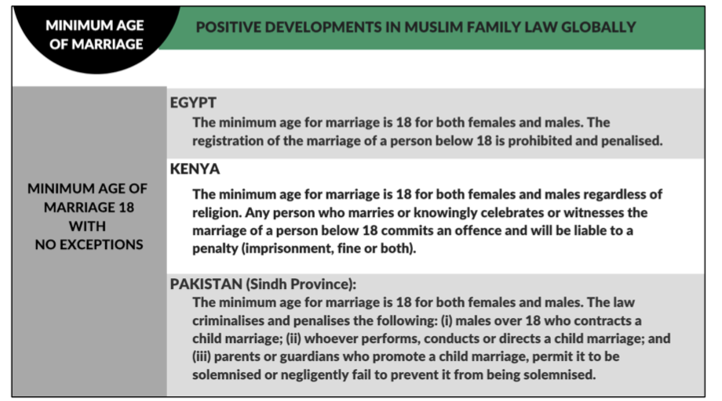

There are Islamic arguments to create an enabling environment for ending child marriage, and reforms in other Muslim countries that have raised the minimum age, as well as weighing the negative repercussions of child marriage as sufficient evidence for not fulfilling the maslahah (public interest) aspect of maqāsīd al-usrah, thus rendering it haram or forbidden. In 2017, female Islamic clerics from KUPI (Kongres Ulama Perempuan Indonesia, or Indonesian Women's Ulama Congress) issued a fatwa against child marriage (that was not legally binding but influential nonetheless) due to its harmful effects on children, although male-led ulema councils have not followed suit. The deputy grand imam of al-Azhar, an Egyptian institution considered by many to be the highest authority of Islamic Sunni jurisprudence, issued a fatwa that marriage in Islam is based on the consent of both parties and thus requires the girl to reach 18 for her full mature consent.

RECOMMENDATIONS

We recommend the CEDAW Committee urges the State party to:
- Recognise the socio-cultural and religious reasons and attitudes which contribute to child marriage, and design and implement effective measures to change mindsets and practices, including but not limited to raising awareness among the general public about the harms of child marriage.
- Repeal or amend Article 7(2) of the Marriage Law to close the loophole of parents seeking judicial dispensation to allow and/or force early marriage.
- Facilitate awareness-raising campaigns and capacity-strengthening training for judges and judiciary officers to implement No.5/2019 to ensure they exercise caution when confirming marriage dispensations and are aware of Islamic-based arguments that deprioritise child marriage as the only solution to curbing premarital sex and recognise the negative impacts on youths.
- Facilitate community-based programmes to engage with and sensitise local village and religious leaders, the Kantor Urusan Agama (Religious Affairs Office) staff, and pesantren (Islamic boarding school) teachers on gender justice, child protection laws, and reproductive health from a religious perspective.

- Polygamy and unregistered marriages Article 16

Marriage Law Article 3 permits a man to have more than one wife with permission from existing wife/ves; Article 4, para. 2 allows husbands to practice polygamy if the wife cannot carry out her wifely obligations, is disabled, and cannot produce children. This is discriminatory towards women and leaves women with disabilities especially vulnerable to being in polygamous marriages without their knowledge or consent. Although the CEDAW Committee has repeatedly urged the State to amend the provision allowing polygamy, activists report a lack of political will to change this, driven in large part by patriarchal interpretations of religion and cultural unwillingness to challenge it.

Yet polygamy is widely recognised as a pre-Islamic practice. While many proponents selectively point to an incomplete reading of Surah an-Nisa’, in fact the Qur'an sets limitations on polygamy, including the requirement to marry only one wife if husbands are unable to uphold equality in a polygamous marriage, noting the impossibility of treating all wives fairly and justly and thus establishing monogamy as the preferred norm. Furthermore, Prophetic example provides little support for polygamy, considering his first marriage was monogamous for more than 25 years, majority of his later marriages were to widowed or divorced women for political reasons, and he forbade his son-in-law from marrying multiple wives without first divorcing his daughter. This is supported by contemporary interpretations of Islamic jurisprudence; in March 2019, Grand Imam of Al-Azhar Sheikh Ahmed El Tayeb said, “Polygamy is an injustice to women and children” and the practice is the result of “a lack of understanding of the Qur’an and the tradition of the Prophet.” Given the evident harm that polygamy causes to wives, children and husbands, as well as to society in general, other Muslim countries have restricted the practice through outright prohibition (Tunisia); requirement of court authorisation and agreement from existing wife (Algeria and Kurdistan Iraq); courts imposing strict conditions such as proving sufficient resources and existing wife's permission (Morocco and Singapore); and allowing for wives to seek divorce on the grounds of a polygamous husband (Egypt, Bangladesh, Pakistan).

Unregistered marriages
There is a strong link between polygamy and unregistered marriages. Activists have highlighted the issue of unregistered marriages (kawin siri) escalating; PEKKA research has shown that 25% of the population conducts kawin siri and adat or traditional marriages. KOMNAS Perempuan found that in 2015, there were 71 cases of unrecorded marriages (religious or adat); among those, 50 cases claimed to be victims of unregistered marriages, 18 cases were married siri as second or third wives, 42 cases involved polygamous husbands—including public officials and civil servants. One of the main drivers of unregistered marriages can be administrative: some customary laws are unwritten for indigenous people, and if their religions are not recognised by the State party, they face problems with registration, especially in West Java, Kalimantan, and Sulawesi. Some of the reasons cited for Muslim unregistered marriages include: as an unintended consequence of banning (registered) child marriages; social norms that uphold marriage as cure to social ills such as unintended pregnancies and sexual activity among youth (“married by accident”); geographical issues where unregistered religious or customary marriages are seen as easier due to lack of funds, transportation, or documentation to register; and a means for men to practice polygamy. Unregistered marriages also have been used as a loophole for entering an interreligious marriage, especially given the backlash from the likes of the Indonesian Ulama Council of Clerics who have declared it forbidden.

The main problems arising from unregistered marriages stem from women not having access to their full rights as wives and legal protection when violence occurs in the family, nor can they access their rights to inherit upon death or matrimonial assets upon divorce. The precarity of their unregistered marriages lowers their status within the marriage even further, leaving them more vulnerable to threats from both husbands and first wives in the case of polygamous marriages, of physical and sexual violence, abandonment or kicking out of house, and (religious) divorce. Without a marriage certificate and thus unable to procure birth certificates for their children, women in unregistered marriages also face complications in claiming legitimacy, child support or alimony for their children, not to mention the social stigma of being in unregistered marriages.

RECOMMENDATIONS

We recommend the CEDAW Committee urges the State party to:
- Repeal or amend Article 3 of the Marriage Law to prohibit a man from having more than one wife, following the examples of other Muslim countries that have abolished the practice of polygamy in the best interest of family well-being.
- Institute preventative measures, including for the Ministry of Religion through the Office of Religious Affairs (KUA) to conduct strict monitoring of the practice of unregistered marriages, to consider enacting punitive measures including holding male parties liable, and to conduct community-based programmes aimed at training religious leaders to change the patriarchal culture of relying on conservative tafseer or interpretations of religious texts to condone polygamy.
- Amend the Marriage Law to legalise interreligious marriages to disincentivise unregistered marriages.

- Violence against women (VAW) Article 16

Indonesia has taken a number of steps to address VAW, including enacting the Elimination of Domestic Violence Law No. 23/2004, but activists report high numbers and significant problems with accessing resources and services for survivors. While sexual violence is prohibited under Article 8(a) of No.23/2004, as “anyone forcing an individual living in the same house to commit sexual intercourse,” and Article 47 lays out the punitive measures of fines and/or imprisonment, this is not necessarily understood to include marital rape. Furthermore, a general lack of awareness of these provisions among Indonesians contributes to underreporting of any sexual violence within the home. Under the PKDRT (Penghapusan Kekerasan Dalam Rumah Tangga), survivors must show evidence and produce witnesses; in cases of marital rape, the survivor’s statement is not considered enough without also displaying physical wounds, which makes for a high evidentiary burden on women and further dissuades reporting. The survivor’s complaint needs to be able to stand as evidence by itself, and law enforcement officials must allocate resources towards investigating those complaints. Cultural norms also play a part in the stigma attached to reporting cases of VAW in the family, which are considered a private matter and underreported. There are reports of law enforcement officers who refuse to open cases of domestic violence, advising the survivors to reconcile with the perpetrators instead, and of them not taking seriously cases of online gender-based violence, which have detrimental psychological and physical repercussions on women’s lives. Although the Witness Protection Act No.13/2006 includes provisions for temporary protection orders and counselling for survivors of domestic violence, it remains difficult for them to access protection orders, as they generally withdraw their complaints due to family pressure. Furthermore, it trickles down to schools, campuses, and pesantren, where shame due to stigma leads to underreporting and no access to justice for school-aged survivors of sexual violence.

The role of religion in perpetuating VAW is not new; in 2017, KUPI issued a groundbreaking fatwa against sexual violence due to the serious negative physical, psychological, social, moral and economic impacts on women and the clear Islamic arguments against it. Yet conservative interpretations of religion have led to pushback featuring fiqh-based arguments that view marriage as a “buy-sell contract,” where a wife is contracted to ease her husband’s sexual needs and is nusyuz or disobedient if she rejects him—and this is the dominant perspective shared among policy makers. Article 84 of the Compilation of Islamic Law states a wife can be considered nusyuz if she does not want to carry out her wifely obligations except for valid reasons, as long as there is evidence provided; for the duration she is considered nusyuz, the husband is freed of his obligations towards her and his children.

Rahima and others in the Indonesian women's movement have been campaigning since 2018 to push through a bill on the Elimination of Sexual Violence (RUU PKS/Penghapusan Kekerasan Seksual). Activists contend this bill is needed because there are currently only four forms of violence or kejahatan currently acknowledged by law, and this bill would criminalise additional categories of violence that Indonesian women face and allow survivors to seek justice. Such laws become a signal of the general public’s concern and prioritisation about the issue of sexual violence, which can address the ongoing issues of underreporting and re-victimisation of victims who engage with the justice system. However, the draft law continues to face delays from Parliament and backlash, in part because of the stigma against feminism and misperceptions that it legalises LGBT, disrupts families, and is anti-Islamic. Rahima, KUPI, and their allies in the women’s movement continue to challenge the patriarchal and conservative interpretations of Islamic jurisprudence and cultural traditions that are being misused to prevent law reform efforts such as RUU PKS to end discrimination against women and girls.

RECOMMENDATIONS

We recommend the CEDAW Committee urges the State party to:
- Enact and implement without further delay the bill on the Elimination of Sexual Violence (RUU PKS) to ensure protections for women against sexual violence.
- Ensure mechanisms are put into place to ease the evidentiary burden on women reporting their cases of violence in the family and/or home.
- Ensure adequate funding for and availability of female units to engage with female survivors, and facilitate sensitisation and capacity-building training for law enforcement to adequately prepare those who deal with cases of sexual violence in the field.
- Facilitate community-based programmes to engage with and raise awareness among local village, community, and religious leaders to de-stigmatise reporting to law enforcement and accessing help and support for survivors of sexual violence.
- Facilitate education, awareness building, and training for pesantren and school campus officials and teachers to create environments less conducive towards sexual violence and more supportive of younger survivors who want to report the crime.

- Female Genital Mutilation/Circumcision (FGM/C) Article 5

According to an Indonesian Basic Health Research Survey from 2013 (the latest numbers available, cited by UNICEF, which lists Indonesia as one of the top three countries with the highest rates of FGM/C), 49% of Indonesian girls up to the age of 11 have been circumcised. FGM/C is practiced as female circumcision (sunat perempuan) in Indonesia, ranging from snipping with scissors to cutting with razors to pin pricking, and commonly regarded as a traditional and religiously necessary practice to purify girls (as it is predominantly performed on infants and younger girls) and curb their sexual appetites. The Ministry of Health banned health personnel from performing female circumcision in 2006, but faced pressure from religious organisations, including the influential Indonesian Ulema Council (MUI), which issued a fatwa forbidding the banning of female circumcision, saying the type practiced in Indonesia is not as invasive or harmful (and therefore haram/forbidden) as types practiced elsewhere. Yet the prevalent practice of pin pricking or needle scratching at the hood is still included in the World Health Organization's classification of Type 4 of the banned forms of FGM/C.

In 2010 the ministry backpedaled, releasing government guidelines detailing how trained medical personnel should correctly perform female circumcision by scratching the clitoral hood, without injuring the clitoris. The regulations authorising medical professionals such as doctors, midwives, and nurses to perform it have contributed to the medicalisation of FGM/C, with female circumcision offered at clinics or by midwives among a package of services at delivery. After much outcry from the women's movement, in 2014 the Ministry of Health issued decree No. 6/2014 to repeal the 2010 decree, stating female circumcision had no medical or health basis and violated girls’ reproductive rights. This has led to continued confusion, however, since the 6/2014 decree did not clearly ban FGM/C or sunat perempuan, and without sanctions against those who perform it, it continues to be practiced by medical personnel, local religious leaders, and families around the country, with vocal support from local religious authorities and imams in the media. A survey conducted by the Center for Population and Policy Studies in 2017, found a staggering 97.8% of respondents from 4,250 households in 10 provinces said they approved of female circumcision, with 92.7% saying they believed the practice was primarily religious and 84.1% saying the practice is also traditional. The government has written that ministries will work with religious organisations including Nahdlatul Ulama (NU), Muhammadiyah, MUI, Dewan Masjid Indonesia (DMI), Indonesia Women Ulama Congress (KUPI) on targeted advocacy and awareness-raising, but there needs to be outright prohibition by a mechanism with more weight than the existing Minister of Health's Ministerial Decree ​​and stronger religious-based arguments against the practice to counteract the intergenerational culture perpetuating female circumcision, especially by religious authorities whose opinions carry weight in communities where the practice is pervasive.

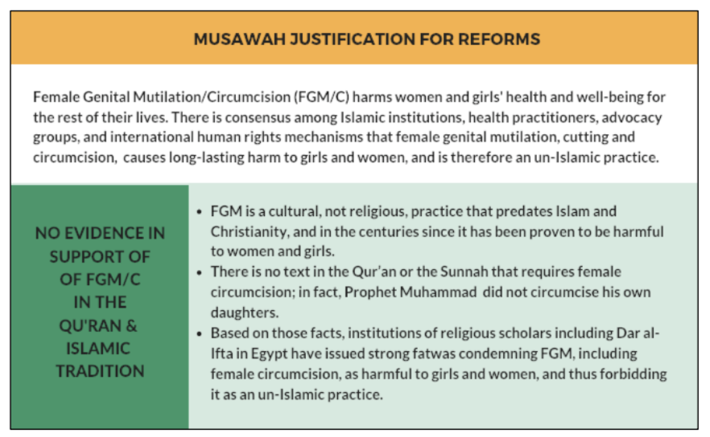

RECOMMENDATIONS

We recommend the CEDAW Committee urges the State party to:
- Enact and implement a Perpres (Presidential Regulation) or similar law to fully prohibit and criminalise all forms of female genital mutilation/circumcision, explicitly including female circumcision.
- Issue local-level directives and guidelines to fully prohibit the practice among medical, health, and religious practitioners.
- Conduct widespread awareness raising campaigns on the negative impacts of FGM/C that debunk myths and misconceptions about the practice especially from a cultural/religious perspective, citing that there is no Qur’anic or Sunnah mandate for it, and a range of Islamic jurisprudence that supports banning it. The campaigns must also engage directly with community religious leaders and target communities with low literacy rates and those with high prevalence.

- Divorce rights Article 16

Divorce proceedings in Indonesian courts can only take place if the marriage has been registered with the Civil Registry Office (for non-Muslims) or the Office of Religious Affairs (for Muslims), and must take place before the Religious Court. There are two categories of divorce: talak divorce or a divorce suit. Talak divorce is initiated by the husband against the wife, and carried out in Religious Court. As a result of this divorce, by law the husband must give mut‘ah in the form of money or objects; provide a maintenance, shelter, and clothing to the ex-wife during the iddah period; pay off the mahr or dowry if there are still dependents; and provide hadhanah costs for their children who have not yet reached 21 years old. In practice, the wife's rights within divorce are not so easily obtained, in large part because there are no strict regulations that impose sanctions on husbands who do not provide towards the rights listed above. There is a gap in monitoring and complaint mechanisms to ensure the ex-husband actually fulfills his obligations and the ex-wife can report his non-compliance to access her rights.

By contrast, the divorce lawsuit or khulu' is initiated by the wife via the Religious Court. Since the wife is suing for divorce, she must pay the resulting court costs including the lawyer's fees, which can be prohibitively expensive for women with fewer resources and takes more logistical effort on her part. In addition, the wife forfeits her post-divorce rights that she would have received from the husband-initiated talak process, which tends to leave her worse off financially. One of the main reasons for this divorce case is that the wife is a survivor of domestic violence, making it the faster and easier option for escaping the marriage and her perpetrator. The whole process can be onerous for women’s time, effort, and funds.

Although Marriage Law Article 41 states the father is responsible for maintenance and education costs of the child(ren), and may be obliged by the court to provide for maintenance for the ex-wife, many divorced women end up receiving no alimony, since there is no system to enforce such payments and there is no monitoring by the courts or authorities to ensure women receive their rightful allocation of marital property after the divorce.

RECOMMENDATIONS

We recommend the CEDAW Committee urges the State Party to:
- Put into place effective mechanisms to ensure men are held accountable to pay maintenance for the upkeep of their children and alimony for their ex-wives after divorce, including a reporting system by which women can register complaints of non-payment.
- Empower the court to impose a wide range of measures against men who default on maintenance, including: (i) imposing penalties such as fines and/or imprisonment; (ii) mandatory collection of maintenance through salary deductions; and (iii) preventing those men with open complaints of non-payment to ex-wives from applying to remarry.

V. ANNEX 1: Musawah Vision for the Family

Musawah asserts that, in the 21st century, there cannot be justice without equality. Many provisions in Muslim family laws, as defined by classical jurists and as reproduced in modern legal codes, are neither tenable in contemporary circumstances nor defensible on Islamic grounds. Not only do these family laws fail to fulfill the Shari‘ah requirements of justice, but they are being used to deny women rights and dignified choices in life. These elements lie at the root of marital disharmony and the breakdown of the family.

Musawah believes that Qur’anic principles and the richness of the Islamic juristic tradition enable us to formulate Muslim family laws today that are egalitarian and reflect the needs of contemporary societies. Islamic teachings and universal human rights standards, including the CEDAW Convention, are fully compatible and are dynamic and constantly evolving, based on changing times and circumstances. Inspired by the Qur’anic vision of justice and gender relations, Musawah contends that gender equality and non-discrimination can only be achieved with laws that transform power relations in the family and in society in the direction of more just and egalitarian outcomes. | 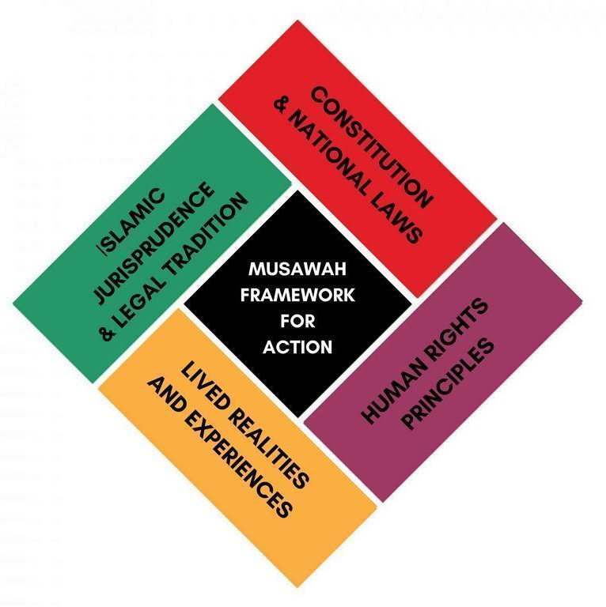

It is our hope that the CEDAW Committee will encourage Governments everywhere, and particularly those purporting to speak for and in the name of Islam and Muslim communities, to:
- Recognise the diversity of opinions, laws, and practices in the Muslim world and the growing scholarship in Islam that recognises equality and justice, as well as the possibility of and necessity for reform of Muslim family laws today.
- Promote human rights standards as intrinsic to the teachings of Islam, national guarantees of equality and non-discrimination, and the lived realities of women and men today.
- Encourage open and inclusive public debate regarding diversity of opinion and interpretations in Muslim laws and principles relating to family laws and practices.

Desilver, Drew, and David Masci. "World’s Muslim population more widespread than you might think." Pew Research Center. 31 Jan 2017. https://www.pewresearch.org/fact-tank/2017/01/31/worlds-muslim-population-more-widespread-than-you-might-think/
Marcoes, Lies. "After 36 years, who still remembers CEDAW?" Rumah KitaB. 27 July 2020. https://rumahkitab.com/after-36-years-who-still-remembers-cedaw/
Ibid.; Interview with Indonesian advocates, August 2021.
UNICEF, BPS and Bappenas. "Prevention of Child Marriage: Acceleration that cannot wait." 2020: p. 48. https://www.unicef.org/indonesia/media/5021/file/Prevention%20of%20Child%20Marriage%20Report.pdf.
UNICEF, BPS and Bappenas, p. 50.
Allard, Tom, and Agustinus Bea Da Costa. "Millions may risk jail as Indonesia to outlaw sex outside marriage." Reuters, 19 Sept 2019. https://www.reuters.com/article/us-indonesia-politics-rights-idUSKBN1W32BV
UNICEF, BPS and Bappenas, p. 45.
​​"Pernikahan Dini di Indonesia Meningkat di Masa Pandemi." Kantor Komunikasi Publik, Universitas Padjadjaran, 8 July 2020. https://www.unpad.ac.id/2020/07/pernikahan-dini-di-indonesia-meningkat-di-masa-pandemi/
Sanuri. “Marriage Dispensation in Indonesia on The Perspective of Maqāṣid Al-Usrah”. Al-Hukama’ : The Indonesian Journal of Islamic Family Law, vol. 11, no. 01, June 2021, pp. 26-56, doi:10.15642/alhukama.2021.11.01.26-56. http://jurnalfsh.uinsby.ac.id/index.php/alhukuma/article/view/1172/837
“Child marriage surges amid Covid-19 and growing conservatism." Rumah KitaB, 12 Aug 2020. https://rumahkitab.com/child-marriage-surges-amid-covid-19-and-growing-conservatism/
Sanuri, pp.50-54.
https://jdih.mahkamahagung.go.id/index.php?option=com_remository&Itemid=46&func=fileinfo&id=8395; Loasana, Nina A. "Supreme Court introduces handbook on child marriage dispensations." https://www.thejakartapost.com/news/2020/12/05/supreme-court-introduces-handbook-on-child-marriage-dispensations.html.
Koalisi 18+ and UNICEF. "Revealing the truth of marriage dispensation: An analysis of child marriage practice in Tuban, Bogor and Mamuju Districts." Jan 2019. https://www.girlsnotbrides.org/documents/887/UNICEF-Marriage-Dispensation-Research-Brief.pdf
Koalisi 18+ and UNICEF, p. 6.
Varagur, Krithika. "In Indonesia, Interfaith Marriage is Legal - But With Many Obstacles." VOA News, 3 May 2018. https://www.voanews.com/east-asia-pacific/indonesia-interfaith-marriage-legal-many-obstacles.
Ibid., p. 45; Interview with Indonesian activists, September 2021.
CEDAW/C/IDN/RQ/8, para. 128.
“Catatan Tahunan Komnas Perempuan Tahun 2020.” Komnas Perempuan, 2021: https://komnasperempuan.go.id/uploadedFiles/1463.1614929011.pdf.
Sanuri. “Marriage Dispensation in Indonesia on The Perspective of Maqāṣid Al-Usrah”. Al-Hukama’ : The Indonesian Journal of Islamic Family Law, vol. 11, no. 01, June 2021, pp. 26-56, doi:10.15642/alhukama.2021.11.01.26-56. http://jurnalfsh.uinsby.ac.id/index.php/alhukuma/article/view/1172/837
Interview with Indonesian advocates, August 2021.
Komnas Perempuan, 2020; Interview with Indonesian activists, August 2021.
https://www.state.gov/reports/2020-country-reports-on-human-rights-practices/indonesia/
Factsheet: Indonesia's Pancasila. United States Commission on International Religious Freedom, 2021. https://www.justice.gov/eoir/page/file/1376026/download
Otherwise known as the "Marriage Law." Undang-Undang Nomor 1 Tahun 1974 Tentang Perkahwinan, established 2 January 1974 (Law No.1/1974 regarding Marriage). https://www.hukumonline.com/pusatdata/detail/26834/undangundang-nomor-1-tahun-1974?r=8&p=1&q=1%2F1974&rs=1847&re=2021. English translation is available at: Soewondo Nani. The Indonesian Marriage Law and its Implementating Regulation. In: Archipel, volume 13, 1977. pp. 283-294. DOI : https://doi.org/10.3406/arch.1977.1344.
https://www.refworld.org/pdfid/3ffbd0804.pdf
Interview with Indonesian activists, September 2021; Mazrieva, Eva. "‘My parents thought this man would take care of me’: In Indonesia, former child brides push back, seek change." VOA News, 2019. https://projects.voanews.com/child-marriage/english/region/indonesia.html.
Interview with Indonesian activists, September 2021.
Sanuri, p.45; Interview with Indonesian advocates, September 2019.
"Child marriage surges amid Covid-19 and growing conservatism." Rumah KitaB, 12 Aug 2020. https://rumahkitab.com/child-marriage-surges-amid-covid-19-and-growing-conservatism.
Nisa, Eva F. "Re-establishing Juristic Expertise: A Historic Congress of Female Islamic Scholars." IIAS, October 2018. https://www.iias.asia/the-newsletter/article/re-establishing-juristic-expertise-historic-congress-female-islamic-scholars.
Maclean, Ruth. "Senior Islamic cleric issues fatwa against child marriage." The Guardian, 21 June 2019. https://www.theguardian.com/global-development/2019/jun/21/senior-islamic-cleric-issues-fatwa-against-child-marriage.
Interview with Indonesian advocates, September 2021.
Interview with Indonesian advocates, September 2021.
Interview with Indonesian activists, September 2021.
NGO Report for CEDAW, by the CEDAW Working Group Indonesia (CWGI), 2021.
Miichi, Ken. "'The New Normal' of the Feminist Movement in Indonesia." Waseda University Graduate School of Asia-Pacific Studies News, 30 October 2020. https://www.waseda.jp/top/en/news/73756.
"Tanya Jawab Seputar RUU Penghapusan Kekerasan Seksual: Dari Pandangan Kongres Ulama Perempuan Indonesia (KUPI)." KUPI, Alimat, KOMNAS Perempuan, August 2020. https://swararahima.com/2021/07/15/tanya-jawab-seputar-ruu-penghapusan-kekerasan-seksual/
Interview with Indonesian activists, September 2021.
Koalisi 18+ and UNICEF, p. 5.
Art. 1, para. 1 PMK 1636/2010; "Indonesia: Statistical Profile on Female Genital Mutilation." UNICEF Data and Analytics Section - Division of Data, Research and Policy, 2019.
No. 9A/2008.
RISKESDAS 2013; "Indonesia: Statistical Profile on Female Genital Mutilation." UNICEF Data and Analytics Section - Division of Data, Research and Policy, 2019.
Reply to Question No. 8, Para. 39, CEDAW/C/IDN/RQ/8 (2 February 2021).
CEDAW/C/IDN/CO/6-7, https://undocs.org/en/CEDAW/C/IDN/CO/6-7
Government Regulation No. 9/1975 on Marriage, Art. 1.
Nurhadi Sucahyo. "Study: Indonesians Embrace FGM as Religious, Traditional Practice." VOA News, 9 February 2020. https://www.voanews.com/east-asia-pacific/study-indonesians-embrace-fgm-religious-traditional-practice.
Cahya, Gemma Holliani. "Indonesia's family resilience bill says housekeeping wife's duty." The Jakarta Post, 19 February 2020. https://www.thejakartapost.com/news/2020/02/19/indonesias-family-resilience-bill-says-managing-household-affairs-wifes-duty.html.
Komnas Perempuan, 2020.
Komnas Perempuan, 2020.
Tristanto, Aris. "Perceraian Di Masa Pandemi Covid-19 dalam Perspektif Ilmu Sosial." Sosio Informa Vol. 6 No. 03, September–December 2020. https://ejournal.kemensos.go.id/index.php/Sosioinforma/article/view/2417/1253.
Komnas Perempuan’s Submission to the UN Special Rapporteur on Violence against Women, Calling for submission on Covid-19 and the increase of domestic violence against women. Komisi Nasional anti Kekerasan terhadap Perempuan, December 2020. https://en.komnasperempuan.go.id/reads-komnas-perempuans-submission-to-the-un-special-rapporteur-on-violence-againts-women-calling-for-submission-on-covid-19-and-the-increase-of-domestic-violence-against-women-december-2020.
"Women in the Shadow of Violence." Swara Rahima, 18 October 2020. https://swararahima.com/en/2020/10/18/women-in-the-shadow-of-violence.
"Menelaah Pentingnya Penghapusan Kekerasan Seksual." Swara Rahima: Media Islam Untuk Hak-hak Perempuan, No. 58(21), January 2021. https://swararahima.com/wp-content/uploads/2021/04/SR-58.pdf.
Gemma Holliani Cahya. "Victims of domestic violence struggle to access help during quarantine." The Jakarta Post, 12 July 2020. https://www.thejakartapost.com/news/2020/07/12/victims-of-domestic-violence-struggle-to-access-help-during-quarantine.html.
"Policy Brief 6: Muslim Marriage as a Partnership of Equals." Musawah, 2021: https://www.musawah.org/resources/?_resource_types=policy-briefs; Banban Syamsul Alim. "Garut’s Religious Figures Took Part in Tadarus on Prevention of Child Marriage." Swara Rahima, 18 October 2020: https://swararahima.com/en/2020/10/18/garuts-religious-figures-took-part-in-tadarus-on-prevention-of-child-marriage.
Laporan Penelitian: Perkahwinan Anak Dalam Perspektif Islam, Katolik, Protestan, Budha, Hindu, dan Hindu Kaharingan. University of Indonesia and Ministry of Women's Empowerment and Child Protection, November 2016. https://www.kemenpppa.go.id/lib/uploads/list/b1dac-laporan-penelitian-perkawinan-anak.pdf.
Compilation of Islamic Law, articles 114 and 149.
All information cited in "Policy Brief 3: Ending Polygamy in Muslim Marriages." Musawah, 2021: https://www.musawah.org/resources/policy-brief-3-ending-polygamy-in-muslim-marriages.
Perkawinan Tidak Tercatat. Komnas Perempuan: https://komnasperempuan.go.id/opini-pendapat-pakar-detail/perkawinan-tidak-tercatat.
https://www.dpr.go.id/dokjdih/document/uu/24.pdf
http://etheses.uin-malang.ac.id/1595/11/07210048_Lampiran.pdf.

