Submission by the European Network on Independent Living (ENIL) and Federación Vida Independiente (FEVI)

Implementation of Article 19 of the UN Convention on the Rights of Persons with Disabilities in Spain

14 February 2019

- This submission was prepared by the European Network on Independent Living (ENIL) and Federación Vida Independiente for the 21st Session of the Committee on the Rights of Persons with Disabilities (11th March - 5th April 2019). The submission focuses on the implementation of Article 19 (Living independently and being included in the community) of the UN Convention of the Rights of Persons with Disabilities (CRPD) in Spain.

I. About the submitting organisations

- The European Network on Independent Living (ENIL) is a Europe-wide network of disabled people, with members throughout Europe. ENIL is a forum for all disabled people, Independent Living organizations and their non-disabled allies on the issues of Independent Living. ENIL’s mission is to advocate and lobby for Independent Living values, principles and practices, namely for a barrier-free environment, provision of personal assistance support and adequate technical aids, together making full citizenship of disabled people possible. ENIL’s activities target European, national and local administrations, politicians, media, and the general society. ENIL works to strengthen the empowerment of disabled people, mainly through providing resources for peer support and peer-to-peer training.

- Federación Vida Independiente (FEVI) is a federal network of Spanish organizations promoting Independent Living. It was created with the objective of promoting policies and resources for all disabled people and for fighting for their rights. The organisations forming FEVI are VICOVAL (CIL of Valencia), OVI Barcelona (CIL of Barcelona), Vigalicia (CIL of Galicia), VIandalucia (CIL of Andalusia) and ZAVI (CIL of Zaragoza). FEVI promotes the following issues: the effective implementation of the UN CRPD; the creation of CILs in cities where they as of yet do not exist; the development of experiences that facilitate full participation in all resources and services available in the community; improvement of the quality of life of people with functional diversity; promotion of welfare, economics and the consideration of individual needs; and Personal Assistance as per the philosophy of the Independent Living Movement.

II. Legal context

- Spain is a State party to the United Nations (UN) Convention on the Rights of Persons with Disabilities (CRPD), which it ratified in 2007. Pursuant to Article 19 CRPD, disabled people have the right to live independently and be included in the community, with choices equal to others. States must ensure that disabled people can “choose their place of residence and where and with whom they live” and that they are “not obliged to live in a particular living arrangement”. This requires “access to a range or in-home, residential and other community support services, including personal assistance necessary to support living and inclusion in the community, and to prevent isolation or segregation from the community.” It also requires access to mainstream services and facilities, which should be available and “responsive to their needs”.

- The General Comment No. 5 (2017) on Article 19 CRPD, adopted by the Committee on the Rights of Persons with Disabilities (CRPD Committee) in 2017, sets out the defining characteristics of institutional care settings. These include: “obligatory sharing of assistants with others and no or limited influence over whom one has to accept assistance from; isolation and segregation from independent life within the community; lack of control over day-to-day decisions; lack of choice over whom to live with; rigidity of routine irrespective of personal will and preferences; identical activities in the same place for a group of persons under a certain authority; a paternalistic approach in service provision; supervision of living arrangements; and usually also a disproportion in the number of persons with disabilities living in the same environment.” The General Comment notes, in paragraph 51, that State parties must “ensure that public or private funds are not spent on maintaining, renovating, establishing building or creating any form of institution or institutionalization” and that “private institutions are not established under the guise of “community living””.

- The General Comment No. 6 (2018) on equality and non-discrimination notes the discriminatory nature of institutionalisation, and defines it as “a failure to create support and services in the community for persons with disabilities, who are forced to relinquish their participation in community life to receive treatment”.

- In the Concluding Observations on Spain, published in 2011, the Committee on the Rights of Persons with Disabilities (CRPD Committee) expressed concerns “that the choice of residence of persons with disabilities is limited by the availability of the necessary services, and that those living in residential institutions are reported to have no alternative to institutionalization”. The Committee encouraged Spain to “ensure that an adequate level of funding is made available to effectively enable persons with disabilities: to enjoy the freedom to choose their residence on an equal basis with others”.

- As part of an inquiry concerning Spain carried out by the Committee under Article 6 of the Optional Protocol to the Convention, the conclusions and recommendations of which were published on 4 June 2018, the Committee noted the wide-spread segregation, affecting around 20 per cent of disabled people “with negative repercussions on their social inclusion.” The Committee found there were limited options for students with disabilities to participation and social exclusion, once they reach the age of 21. Such opportunities “frequently involve segregation; they include attending sheltered workshops or activity centres, staying at home or attending day centres for persons with disabilities aged between 17 and 70.” Long-term institutional care was seen as “the only possible future for some persons with disabilities” by professionals.

III. Key concerns with regard to Article 19 CRPD

- As organisations led by disabled people and focusing on disabled people’s access to the right to live independently and to be included in the community, ENIL and FEVI are deeply concerned about Spain’s lack of progress in implementing Article 19 CRPD since the country’s initial review in 2011. Our key concerns in Spain, in relation to access to Independent Living are: a) Minimal progress towards independent living and failure to adopt a strategy and a concrete plan of action for deinstitutionalisation; b) Continued use of public funds to build new residential institutions for disabled people, and c) Extreme difficulty in accessing personal assistance for disabled people.

- Minimal progress towards independent living and failure to adopt a strategy and a concrete plan of action for deinstitutionalisation

- In the 8 years since the initial CRPD review, Spain has made no real progress towards facilitating access of disabled people to their right to live independently and to be included in the community, and towards the closure of long-stay residential institutions for disabled people. According to a recent report by the Academic Network of European Disability Experts “progress on de-institutionalisation and the development of support for long-term community support services” is a concern, and economic constraints affect access to services and benefits, especially for those with lower support needs. This also affects family members of disabled people, who are expected to take care of their relatives, and therefore unable to take up employment or otherwise participate in community live.

- It is of great concern that over 160.000 disabled and older people in Spain remain segregated in state-funded long-stay residential institutions (see Tables 1 and 2). Specifically, as of end of December 2018, there were 166.579 disabled and older people in long-term residential centres. A total of 406.849 (30,81%) disabled and older people were cared for by their family members and 7.026 (0,53%) disabled and older people have been using personal assistance (5.844 of these in the Basque Country). Other services offered by the state have included telecare, day care centers, night care centers, and home services. None of these services are user-led. In comparison, as of end of 31 December 2017, there were 157.174 (13,34%) people in long-term residential centers. A total of 385.476 (32,72%) disabled and older people were cared for by family members and there were 6.654 (0,56%) people using personal assistance (5.826 of them in the Basque Country).

- As is clear from Table 1, between 2014 and 2018, although the number of PA users has increased substantially, so has the number of people segregated in long-stay residential institutions. There are an additional 30.000 disabled people living in institutions compared to 4 years before. Table 2 shows that the number of people in residential institutions has been steadily increasing in all of the regions.

- Despite the increasing number of people in long-stay residential institutions, Spain does not have a deinstitutionalisation strategy in place, nor an action plan. This means that there is no political will at the moment to put in place community-based alternatives to institutional care, such as personal assistance, and close down existing institutions. It is of great concern that most, if not all institutions, are developed in partnership with organisations of and for disabled people (see paragraphs 16 and 17). This is used to legitimise the continued segregation of disabled people, despite being in violation of the UN CRPD and the European laws and policies on social inclusion.

Table 1: Data about disabled and older people (as of 31 December of each year)

 | 2018 | 2017 | 2016 | 2015 | 2014
Disabled and older people in long-stay residential institutions | 166.579 (12,61%) | 157.174 (13,34%) | 151.719 (14,19%) | 148.382 (14,87%) | 135.346 (14,55%)
Disabled and older people living with their family | 406.849 (30,81%) | 385.476 (32,72%) | 361.209 (33,79%) | 360.505 (36,12%) | 374.348 (40,25%)
Disabled and older people using personal assistance | 7.026 (0,53%) | 6.654 (0,56%) | 5.779 (0,54%) | 3.440 (0,34%) | 1.883 (0,20%)

Table 2: Data about disabled and older people in long-stay residential institutions, by region (as of 31 December)

Community | 2018 (no) | 2018 (%) | 2017 (no) | 2017 (%)
Andalusia | 24.718 | 8,85 | 24.607 | 9,69
Aragon | 4.110 | 11,90 | 3.786 | 13,25
Principality of Asturias | 3.220 | 11,33 | 3.145 | 11,58
Balearic Islands | 2.245 | 10,15 | 2.355 | 12,49
Canary Islands | 3.892 | 17,27 | 3.659 | 18,09
Cantabria | 4.538 | 25,19 | 4.450 | 25,96
Castile and Leon | 9.164 | 7,30 | 8.897 | 7,70
Castilla-La Mancha | 12.476 | 17,95 | 12.102 | 19,42
Catalonia | 33.727 | 17,48 | 28.192 | 16,04
Valencian Community | 11.606 | 15,01 | 10.585 | 16,32
Extremadura | 4.507 | 14,12 | 4.509 | 15,97
Galicia | 8.516 | 12,13 | 7.660 | 12,02
Community of Madrid | 22.938 | 12,26 | 22.859 | 14,91
Region of Murcia | 4.478 | 10,20 | 4.232 | 9,99
Chartered Community of Navarre | 1.789 | 10,10 | 1.823 | 11,69
Basque Autonomous Community | 12.800 | 15,21 | 12.743 | 16,65
La Rioja | 1.618 | 13,88 | 1.357 | 13,15
Ceuta and Mellila | 237 | 6,39 | 212 | 6,03
Total | 166.579 | 12,61 | 157.174 | 13,34

B. Continued use of public funds to build new residential institutions for disabled people

- Despite lacking capacity to continuously monitor the implementation of Article 19 CRPD in Spain, ENIL and FEVI have found substantial evidence of increasing public investment into the building of new long-stay residential institutions for disabled people. It is of an even greater concern that many of these new institutions have benefited from partnerships with organisations of or for disabled people in Spain.

- While the total annual expenditure for long-stay residential institutions is not available from publicly available documents, we have been able to establish that, for example, the Autonomous Community of Andalusia spent almost 344 mil EUR for the running of residential care institutions for disabled and older people in 2017. An additional 14 mil EUR have been earmarked in 2018. In the Community of Madrid, 341,8 mil EUR have been budgeted in 2019 for the maintenance of 24.683 places in long-stay residential institutions for people with intellectual, physical and sensory disabilities, in addition to 6.669 places for people with mental health problems.

- While many of the institutions occupy contemporary buildings, with a lot of space and modern facilities, and some claim to provide “personal assistance”, all of the long-stay residential institutions retain many of the institutional care characteristics listed in Paragraph 16c of the General Comment No 5. In particular while they offer disabled people some degree of choice and control over their lives, “these choices are limited to specific areas of life and do not change the segregating character of institutions”. Examples of the contemporary institutions include:

- “Residencia del Lesionado Medular” in Madrid for people with physical disabilities has 60 rooms, of which 14 are double and the rest are single. The institution boasts all forms of assistance – medical, psychological and social – provides various in-house activities for residents, offers training (in radio, AV and communications technology, as well as art), has areas for games and exhibitions and organises day trips for residents. The institution is publicly funded and run by Fundacion Lesionado Medular, and works in collaboration with a number of organisations of disabled people (European Spinal Cord Injury Foundation, FIMITIC, ONCE Foundation, ASPAYM, Predif and ASPAYM Madrid).

- “Envera” group runs three institutions in the Madrid mountains, with 58 residents in total (people with intellectual disabilities), divided by their degree of disability. In addition to personal care, the institution offers sports, leisure and social activities to its residents.

- There are numerous examples of newly built institutions or those that will be built in the near future. (Images of these institutions are presented in the annex to this submission.)

- In March 2014, a state-funded institution for people with spinal cord injuries was opened by ASPAYM Granada, a well-known organisation for disabled people (Residencia Aspaym Granada). The institution accommodates 63 disabled people, in 38 rooms.

- The extension of an institution for people with autism (Centro Integral de Recursos para personas con Autismo “La Virreina”) was opened in 2015. The institution is run by Fundacion Autismo Sur.

- “Aspronaga” institution was opened in 2017 in A Coruña (Autonomous Community of Galicia) and will accommodate 15 people with intellectual disabilities. The institution was built in partnership between the Amancio Ortega Foundation and ASPRONAGA (Galicia Association for People with Intellectual Disabilities), at a cost of 2,2 mil EUR, according to the project website.

- In March 2017, an institution for people with physical disabilities was opened by ASPRAMIF (Asociation para la Promocion y Atencion a Personas con Discapacidad Fisica y Organica) in Jean. The institution accommodates 24 disabled people.

- A new institution is being built in Málaga capital, in partnership with COCEMFE, a well-known organisation for disabled people, and financed by the city council, the regional government and the national government. The total cost of the institution is about 8,5 mil EUR. The institution will be the largest in Andalusia, with places for 156 persons and will bring together four types of services: residential care (34 places), residential care for people with highest support needs (20 places), a day care centre (42 places) and an occupational centre (i.e. a sheltered workshop) (60 places). It is foreseen the institution will be finished in 2019, and opened in 2020.

- Towards the end of 2018, the provincial Government of Malaga (Autonomous Community of Andalusia) announced it would invest 500.000 EUR in the construction of a new residential institution, in partnership with the Association for people with intellectual disabilities of Antequera and Comarca - ADIPA, Malaga and Plena Inclusion. This amount will be added to 300.000 EUR set aside by the Antequera City Council for the same purpose. The institution will accommodate 32 disabled people and its overall cost will be just above 3 mil EUR.

- Other examples of newly built institutions or plans for the building of new institutions include: Alcañiz (24 places), San Javier (42 places), Ávila (100 places), Logroño (20 places), Ontinyent (40 places), San Rosendo Centres (additional 117 places), San Joan d’Alacant (40 residential places/45 sheltered workshop), Pontevedra (25 places)

C. Extreme difficulty in accessing personal assistance for disabled people

- Access to personal assistance remains extremely limited (see Table 3), despite the fact that the numbers have been steadily increasing year by year (see Table 1). As of 31 December 2018, only 7.026 disabled and older people had personal assistance – equalling 0,53 per cent of the respective population. As many as 7 communities have 0 personal assistance users, and the vast majority have a small number. In contrast, 406.849 (30,81%) persons received care in the family and 235.924 (17,86%) home care during 2018.

- Although the Basque Country, with 5.844 personal assistance users, appears to be an exception, it is important to note that this refers to support to older people to continue living in their homes, and is not personal assistance as defined in the General Comment No. 5, and by the Independent Living Movement. Furthermore, it covers only the Basque province of Gipuzkoa, and leaves out the provinces of Álava and Biscay. This number, therefore, distorts the real picture of personal assistance provision in Spain – which remains extremely limited.

- Direct payments, which can be used to hire personal assistance, cover up to 120 hours per month (4 hours per day). The amount of the benefit is established each year by the Government. Currently, the maximum amount for the highest level of support needs is 715,07 EUR per month. The Governments of each autonomous community decide whether or not to increase this benefit. Some of the autonomous communities (Catalonia, Galicia and the Valencian Community) have increased the payments. In the case of Valencian Community, for example, it can reach up to 2.350 EUR per month, if the user requires personal assistance for more than 120 hours per month. (This direct payment equals the average cost of a place in a residential institution.) In addition, in a few communities, there are pilot projects to bring personal assistance in line with the CRPD (for example, in Madrid and Andalusia). While these are positive developments, to be commended, the fact remains that many autonomous communities do not provide personal assistance at all, and that, if it is provided, eligibility criteria and means testing exclude many from accessing it.

- What this shows is that Spain has failed to act on the Committee’s recommendations from 2011 and there are still no viable alternatives to institutional care. The only option most disabled people have is to be cared for by their family or home care, which is neither possible for many disabled people, nor does it facilitate the right to live independently and to be included in the community.

Table 3: Data about disabled and older people receiving personal assistance, by region (as of 31 December 2018)

Community | PA (no) | PA (%)
Andalusia | 10 | 0,00
Aragon | 0 | 0,00
Principality of Asturias | 1 | 0,00
Balearic Islands | 0 | 0,00
Canary Islands | 0 | 0,00
Cantabria | 0 | 0,00
Castile and Leon | 850 | 0,68
Castilla-La Mancha | 23 | 0,03
Catalonia | 71 | 0,04
Valencian Community | 11 | 0,01
Extremadura | 0 | 0,00
Galicia | 111 | 0,16
Community of Madrid | 89 | 0,05
Region of Murcia | 2 | 0,00
Chartered Community of Navarre | 14 | 0,08
Basque Autonomous Community | 5.844 | 6,95
La Rioja | 0 | 0,00
Ceuta and Mellila | 0 | 0,00
Total | 7.026 | 0,53

IV. Recommendations

- ENIL and FEVI call on the CRPD Committee to include the following recommendations in its observations to the Spanish Government. In order to ensure compliance with Article 19 CRPD, further explained in the General Comment No 5, Spain must:

- As a matter of priority, put in place a strategy for deinstitutionalisation, with specific timeframes and an adequate budget, in order to facilitate the closure of all long-stay residential institutions and the development of quality community-based alternatives that promote social inclusion and participation, for all groups of disabled people.

- Stop using public funds to build new long-stay residential institutions for disabled people. Instead, funds should be used to develop accessible and affordable housing solutions, including social housing and supported living that facilitate independent living and social inclusion.

- Allocate sufficient resources for the development of person centred and user-led services for all disabled people, such as personal assistance.

- Revise eligibility criteria and funding for personal assistance, in line with the human rights model of disability, to ensure that all disabled people in need of personal assistance can benefit from this service. Furthermore, the right to personal assistance, as defined in the General Comment No 5, should be enshrined in law, in order to ensure equal access and to avoid discrimination based on the place of residence (i.e. post code lottery).

- Ensure that all disabled people have access to peer support, in order to be able to make informed choices about their life, and put in place the necessary services to follow these choices.

- Together with organisations that promote Independent Living (such as Centres for Independent Living), develop and run awareness raising campaigns about the right to live independently and to be included in the community, targeting policy and decision makers, disabled people and their representative organisations, families of disabled people, service providers, media and the general public.

Annex: Images of long-stay residential institutions for disabled people that have been built recently, are in the process of construction or will be built in the near future

Centro Inegral de Recursos para personas con Autismo “La Virreina”

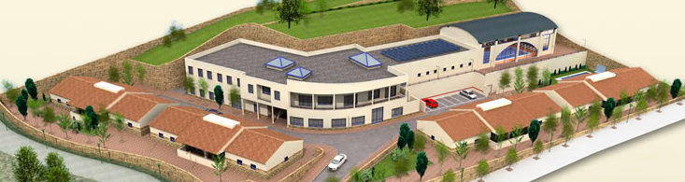

Residencia Aspaym Granada

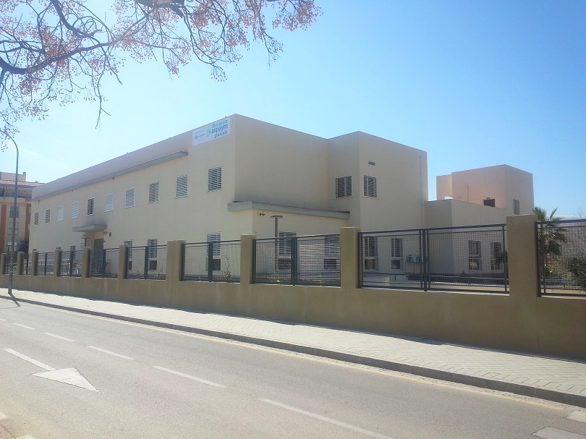

ADIPA Residence Malaga

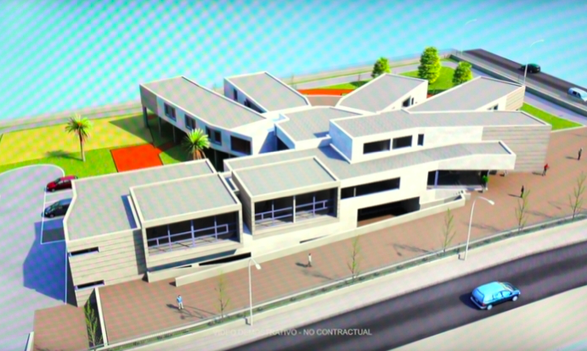

Video: https://www.youtube.com/watch?v=PN4HJwvJwxc

COCEMFE institution in Malaga

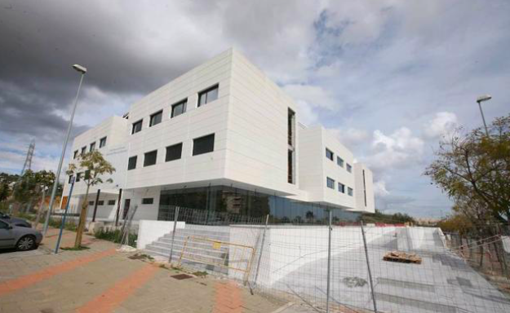

Aspronaga institution in A Coruna



We use the term ‘disabled people’ over ‘persons with disabilities’ or ‘people with disabilities’, in order to reflect the fact that people are disabled by the environmental, systemic and attitudinal barriers in society, rather than by their impairment. This is in line with the social model of disability.
Committee on the Rights of Persons with Disabilities, General Comment No. 5 (2017) on living independently and being included in the community, CRPD/C/GC/5, 27 October 2017, para 16(c), at: https://tbinternet.ohchr.org/_layouts/treatybodyexternal/Download.aspx?symbolno=CRPD/C/GC/5&Lang=en
Committee on the Rights of Persons with Disabilities, General Comment No. 6 (2018) on equality and non-discrimination, CRPD/C/GC/6, 26 April 2018, para 58, at: https://tbinternet.ohchr.org/_layouts/treatybodyexternal/Download.aspx?symbolno=CRPD/C/GC/6&Lang=en
Concluding Observations of the Committee on the Rights of Persons with Disabilities, 19 October 2011, CRPD/C/ESP/CO/1, paras 39 and 40, at: http://docstore.ohchr.org/SelfServices/FilesHandler.ashx?enc=6QkG1d%2fPPRiCAqhKb7yhslxq2MulDp%2fqMKQ6SGOn0%2fNZ5trZrfgNmKdTjE%2fScMKF96xMrtyzhDx7aguCpqdK4xQVGCY502yRGHBFyeVZXNyDyVAuXWX8uweN1J3Pv65K
Committee on the Rights of Persons with Disabilities, Inquiry concerning Spain carried out by the Committee under article 6 of the Optional Protocol to the Convention, 4 June 2018, CRPD/C/20/3, para 23.
Ibid, para 67.
Verdugo, M.A. and Jenaro, C., European Semester 2017.2018 country fiche on disability, Academic Network of European Disability Experts, page 30, at: https://www.disability-europe.net/country/spain
This number comes from official statistics, published by IMSERSO (see links below). The fact that Spain does not differentiate between disabled and older people in their official statistics makes monitoring CRPD implementation difficult; however, it is likely that older people who have been institutionalised have acquired an impairment as a result of old age.
See: www.imserso.es/InterPresent2/groups/imserso/documents/binario/im_061364.pdf
See: www.imserso.es/InterPresent1/groups/imserso/documents/binario/estsisaad20171231.pdf
See: www.imserso.es/InterPresent1/groups/imserso/documents/binario/estsisaad20161231.pdf
See: www.imserso.es/InterPresent1/groups/imserso/documents/binario/estsisaad20151231.pdf
See: www.imserso.es/InterPresent1/groups/imserso/documents/binario/estsisaad20141231.pdf
See: www.imserso.es/InterPresent2/groups/imserso/documents/binario/im_061364.pdf
Agencia de Servicios Sociales y Dependencia de Andalucia, Informe ejecutivo 2017, p. 63.
See: www.europapress.es/andalucia/malaga-00356/noticia-diputacion-malaga-destina-66-millones-politicas-sociales-2018-cada-cuatro-euros-presupuesto-20180209132138.html
See: https://www.noticiasparamunicipios.com/municipios-madrid/regional-destinan-35-millones-para-331-plazas-de-atencion-a-personas-con-discapacidad/
See: https://www.medular.org/residencia-del-lesionado-medular/
See: http://grupoenvera.org/en/servicios-discapacidad/residencias-discapacidad/#anchor
See: www.aspaymgranada.org/que-hacemos/gestion-centros
See: http://www.autismosur.es/index.php/noticias/8-apertura-unidad-estancia-diurna-la-virreina
See: www.faortega.org/en/project/aspronaga
See: www.cocemfe.es/comunicacion_portal/?p=16703
See: www.diariosur.es/malaga-capital/obras-mayor-centro-20180330215347-nt.html
See: www.andaluciacentro.com/malaga/antequera/antequera/12709/la-diputacion-reservara-500-000-euros-para-colaborar-en-la-construccion-de-la-residencia-de-adipa-en-antequera
See: http://www.aragondigital.es/noticia.asp?notid=173924&secid=9
See: https://www.murcia.com/region/noticias/2019/01/28--la-comunidad-tiene-42-plazas-concertadas-en-l-a-residencia-de-la-fundacion-pro-personas-con-discapacid-ad.asp
See: https://www.20minutos.es/noticia/3552077/0/junta-financia-centro-aspace-avila-que-atendera-centenar-personas/
See: https://www.20minutos.es/noticia/3552077/0/junta-financia-centro-aspace-avila-que-atendera-centenar-personas/
See: https://www.levante-emv.com/costera/2019/01/22/residencia-personas-discapacidad-ontinyent-entra/1824582.htm
See: https://www.xunta.gal/notas-de-prensa/-/nova/36116/xunta-oferta-mais-800-prazas-para-maiores-persoas-con-discapacidade-traves-dos
See: https://www.lavanguardia.com/vida/20190115/454158351790/dona-letizia-dara-nombre-a-la-residencia-para-discapacitados-psiquicos.html
See: https://www.lavozdegalicia.es/noticia/pontevedra/2019/01/11/lloro-me-indigno-veo-dinero-residencia/0003_201901P11C3996.htm
Data provided by IMSERSO. See: www.imserso.es/InterPresent2/groups/imserso/documents/binario/im_061364.pdf
The General Comment defines Personal Assistance in paragraph 16(d) as “person-directed/“user”-led human support available to a person with disability and is a tool for independent living.”
For ENIL’s definition of Personal Assistance, please see: https://enil.eu/independent-living/definitions/

