Alternative report on the application of the Convention on the Protection of the Rights of All Migrant Workers and Members of Their Families
Venezuela

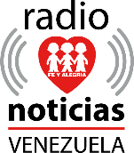
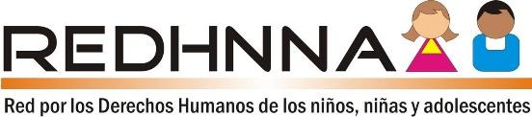
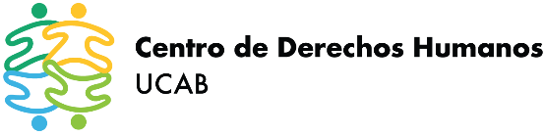

Prepared by the Human Rights Center of the Andrés Bello Catholic University, Fe y Alegría Radio News and the Network for the Human Rights of Children and Adolescents

- Quantitative information
- 1. Because of the complex humanitarian emergency affecting Venezuela, nearly 6.5 million people have been forced to leave the country; Of these, only 2,756,202 have some type of regular stay, which implies that more than more than half of Venezuelans abroad are in an irregular condition and, consequently, unable to access formal employment. In a few years, Venezuela became the largest human mobility crisis in the West and the second worldwide.

- General Information
- Measures adopted to support Venezuelans who have left the country
- In 14 countries that receive Venezuelan migrants and refugees, in which the Human Rights Center of the Andrés Bello Catholic University (CDH UCAB) monitors, it has not been reported that the Venezuelan State has taken measures to provide support to its nationals living in those countries.
- In August 2018, the regime of Nicolás Maduro launched the Plan Vuelta a la Patria (Return to the Homeland Plan), with the alleged purpose of facilitating the voluntary return to Venezuela of those who lacked the means to do so on their own. By February 2020, that is, just before Covid-19 hit the region, the Plan recorded the return of 17,522 people. After 16 months of execution, prior to the start of the pandemic, these figures are equivalent to 0.35% of the population that has left the country.
- According to a national study carried out by the NGO Community Learning Centers (CECODAP) with the support of the Datanalisis survey company, at least 930,020 children and adolescents (C&A) have been affected by the migration of their parents, and may including rising to 943,117, which is equivalent to 8.5% of the total C&A in the country. Grandparents are the main caregivers of children affected by the migration of their parents in 51% of cases.
- Many of the people who take in C&A after the migration of their parents are unaware that they must carry out legal procedures that allow them to exercise their representation. Within the framework of the migratory wave that began in 2015, a serious precedent was represented by the number of powers of attorney issued by parents who migrated, granting de facto the responsibility of raising children, as well as future notarized travel permits, without limits on their dates, putting C&A at risk. In response to this situation, the Autonomous Service of Registries and Notaries (SAREN) issued administrative measures in February and August 2019 prohibiting such procedures, when what was appropriate in these cases was to issue family placement measures, which is the responsibility of the C&A protection judges

- Role of the NHRI

- In May 2016, the Global Alliance of National Human Rights Institutions (GANHRI) decided to downgrade the Venezuelan Ombudsman to category B, alleging that “it is not prepared to speak forcefully and promote respect for human rights in response to credible allegations of serious human rights abuses by government authorities”. The lack of impartiality of the institution was evidenced again in 2017, when the Ombudsman denied the existence of a phenomenon of Venezuelan migrants.
- In November 2020, the Ombudsman finally announced the creation of a special ombudsman to address the rights of the Venezuelan migrant population. However, the institution has remained silent in the face of statements by officials who stigmatized and criminalized people who returned to Venezuela during the pandemic.

- Participation of civil society

- Contrary to what the State asserts in paragraph 36 of its initial report to the Committee, the Venezuelan authorities have a recurring practice of excluding independent civil society organizations from spaces for consultation, coordination, and decision-making for the formulation of public policies and for the preparation of coordinated responses to reports before the treaty bodies of the UN human rights system, as well as the process of the Universal Periodic Review. The process of preparing the response to the list of issues and the report for the CMW has been no exception.

- Between 2019 and 2020 officials have designated those denouncing abuses as “bandits, wretches”, and have also made unfounded accusations to deny the migration crisis. Likewise, the CDH-UCAB and Fe y Alegría have been accused by the State of publishing “biased information” and that their complaints are associated with political-partisan interests. The Living Water Community organization was accused by Venezuelan spokespersons of contributing to human trafficking, because this organization questioned mass deportations from Trinidad and Tobago.

- Articles 8 to 15
Situation of returnees
- As a result of the mandatory confinement measures, thousands of Venezuelans were forced to return to their country. When the arrival of these people began, high authorities publicly branded them as fascists and camouflaged coup plotters, bioterrorists, trocheros and karma. On July 11, 2020, the Strategic Operational Command of the Bolivarian National Armed Forces (CEOFANB), through the official Twitter account, urged the population to denounce all those who entered through unauthorized routes, as well as to who will receive a payment for facilitating entry. The national Executive broadcasted this message via television, WhatsApp messages, official web portals and official accounts of military authorities and even a priest favorable to the regime. Even though Venezuelan legislation does not criminalize the entry of nationals through irregular routes, on July 10, 2020, the general prosecutor publicly reported that 13 trocheros (people who pass through irregular paths) would be transferred to the El Dorado prison. and that a substitute precautionary measure was imposed on 23 people for having entered the country through irregular paths.
- The Venezuelan regime established Comprehensive Social Care Posts (PASI) so that Venezuelan returnees could be quarantined. The PASI did not have biosafety elements or drinking water; they had overcrowding problems that made social distancing impossible. In addition, they lacked medical assistance, information, a balanced meal, separation according to sex, age, health condition, and family ties. Additionally, people could not complain about the conditions because they were threatened. There were cases of deaths due to lack of timely assistance of diseases caused by poor conditions.
- Humanitarian actors were not allowed to carry out work in these spaces. There was also no control of the entry and follow-up registry. In Guasdualito, Apure state, 120 people remained confined for more than two months in a shelter, without being allowed to leave, despite having tested negative in all the COVD-19 tests. Journalists who made these allegations public were also targets of reprisals. It was also common for the officials in charge of the shelters to verbally mistreat them with phrases such as: why did you leave? And now what do you want, to be treated like princes? The returnees were accused by the government of being biological weapons sent from Colombia.

- Articles 16 to 22
- Mass Deportations
- As of 2013, the State developed a stigmatizing discourse against the migrant and refugee population of Colombian origin. In this way, and as a background to the mass deportations of 2015, the Association of Colombians in Venezuela had already counted some 9,000 deportations since October 2014. According to the same source, between April 2013 and August 11, 2015, spokesmen for the Maduro's government had issued derogatory expressions against Colombians in Venezuela on at least 24 occasions.

- In mid-2015, for several weeks, the Maduro government carried out a strong campaign to criminalize the Colombian population, which was held responsible for the food shortage and described as "bachaqueros" (smugglers), paramilitaries and hired assassins, also affirming the existence of a process of "Colombianization of crime". In this context, on August 19, 2015, Maduro closed the border with Colombia and ordered the expulsion of some 1,500 Colombians living in border areas, alleging that they had links to organized crime. Colombian homes were raided without warrants, searched, and marked on the walls with an R (for "reviewed") or a D (for "demolish"), in a practice reminiscent of Nazi Germany. The first raids and deportations were carried out without a State of Exception having been decreed.

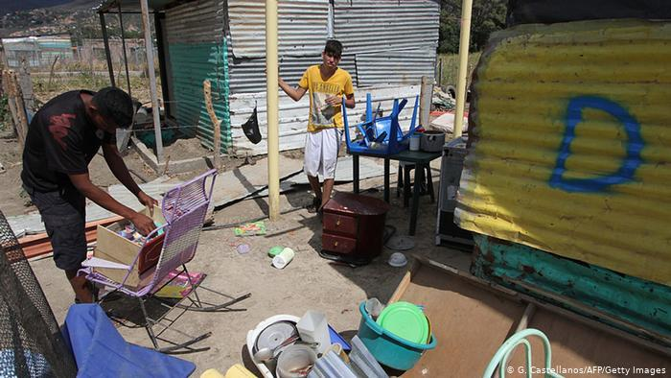 | 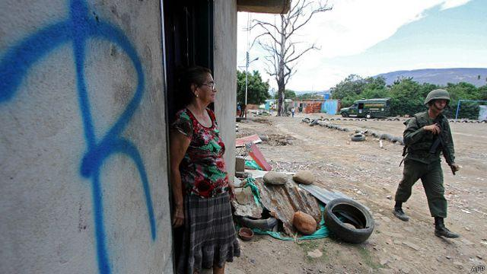 | 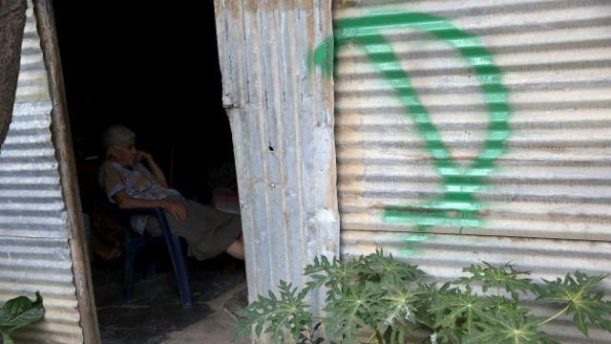
Images of Colombian homes marked with the letters D and R

- This situation was aggravated after the declaration of a State of Exception on August 21, 2015, initially in 6 municipalities of the state of Táchira (border with Colombia), then extended to 24 border municipalities and finally to the entire national territory, maintaining its validity until on April 23, 2021. The exceptional measures were never communicated to the UN Secretary General, in violation of article 4.3 of the International Covenant on Civil and Political Rights. Within the framework of these declarations, massive deportations occurred that affected legal residents, irregular migrants and people in need of international protection indistinctly. In addition to the violation of the Non-Return Principle, there were serious damages to personal safety and integrity.
- The Inter-American Commission on Human Rights made a visit to Colombia in September 2015, where it was able to verify the seriousness of the complaints. Mass deportation led more Colombians to return to their country of origin. It is estimated that between 23,000 and 33,000 people returned to Colombia during the crisis. Five years after the events occurred, the violations remain unpunished.

- Article 23

Consular assistance
- High costs associated with the processing, shortage of material for its issuance and delay in delivery, are the barriers that thousands of Venezuelans encounter when accessing a passport. The International Organization for Migration determined that the main challenges faced by Venezuelan migrants and refugees to regularize are associated with the loss, theft, expiration and inability to renew the passport; barriers to obtaining a Hague Apostille from their country, and the charge in US dollars of a criminal record. Many children of Venezuelan parents born abroad have not been able to access the civil registry and obtain their Venezuelan nationality, due to the lack of documentation from their parents and the malfunctioning of consular services.
- In some host countries, the situation of the Venezuelan population is complex due to the absence of consular services. People who left with passports may face obstacles to remain in regular status in receiving countries later, by not being able to stamp a visa on a passport that has lost its validity. Some countries have recognized the validity of Venezuelan passports that have expired for periods ranging between 2 and 10 years, but this is still a limited measure that allows certain legal actions to be taken before the authorities of the receiving country; however, it does not solve long-term needs.
- In 2019, diplomatic relations were broken between Venezuela and various countries, in some cases affecting consular relations, as is the case with Canada, Colombia and the United States, further limiting access to identity documents. In a statement from the body responsible for the identity procedures of Venezuelans, it indicated "Venezuelans residing in Colombia must manage their procedures at the Caracas headquarters."
- The absence of a passport or its expiration is also affecting the Venezuelan population outside the country in terms of opening bank accounts, driver's licenses, access to education and health. There are also limitations for the recognition of academic degrees and professional titles. In some countries, the representation of the transitional government has reached agreements with the authorities of the receiving countries so that the certification of certain procedures carried out by said representation is recognized. In general, the authorities of the Maduro government have made no effort to resolve this situation.
- In addition, the CDH UCAB has received information according to which, at least since 2018, foreigners residing in Venezuela have faced unjustified delays in renewing their visas, for periods of more than a year. Such delays are attributed by the authorities to "difficulties in the technological platform" and lead to limitations for migrants, since the lack of a visa prevents them from renewing their identity cards, an essential document for carrying out various procedures, including opening bank accounts. and notarial procedures, among others.

- Articles 64 to 71
Human trafficking and smuggling situation
- The Venezuelan state has not criminalized the trafficking of men and boys when the perpetrators are not part of an organized criminal group; therefore, there are no care services for male victims of human trafficking. In November 2019, the creation of national prosecutors specialized in crimes of trafficking of women, C&A, was announced. However, it has a single prosecutor for the entire country; furthermore, human trafficking against transgender people, boys or men was not included.
- In 2019 the expired and to date there is no design of new clear public policies for the prevention and eradication of this type of crime. Most of the officials of the National Office against Organized Crime and the Financing of Terrorism (ONCDOFT), in charge of executing the National Plan Against Human Trafficking, did not investigate crimes of human trafficking or crimes related to human trafficking. This same office created a line available 24 hours a day to receive general reports of abuse against women, including reports of human trafficking, but several of the numbers were inactive.
- International sources reported the growing number of Venezuelan trafficking victims identified abroad, many of them repatriated or deported to Venezuela. The national government did not report what type of care, if any, was provided to victims upon their return, or whether authorities coordinated efforts with foreign governments to ensure the protection of these victims. Trafficking for the purpose of labor and sexual exploitation is the most frequent form of Venezuelan victims within Venezuela and abroad. It was also not possible to obtain information about assistance to any victim, investigation, prosecution or conviction of human traffickers or efforts to stop the forced recruitment of Venezuelan women, men or children by irregular armed groups in the context of the Orinoco mining arc, sea routes to Trinidad and Tobago, border with Brazil or Colombia.
- Civil society organizations, some foreign governments, the UN, and the media managed to document cases in which Venezuelan government officials, including members of the security forces and local authorities who were mostly in border areas, conspired, tolerated, and allowed irregular armed groups linked to gold activity to operate in Venezuelan territory with impunity. These groups exploit people, including children, for forced labor in mining areas and women and girls for sexual exploitation, forcibly recruit young people to join armed criminal groups, and force children to work in mines. in dangerous conditions. The UN managed to document cases of foreign citizens residing in Venezuela who subject nationals of Ecuador, the Philippines, and other countries to forced labor in domestic service.

- Recommendations
- In view of the foregoing, the Committee is asked to consider recommending to the State to:
Adopt measures to timely provide travel and identity documents to the Venezuelan population, as well as to migrants residing in Venezuela.
Develop a care protocol for C&A whose parents have migrated, which meets international standards to protect the best interests of this sector of the population.
Develop actions against attacks and disqualifications against human rights defenders and journalists who work in favor of the rights of migrants and refugees.
Refrain from stigmatizing and criminalizing Venezuelans who return to their country, even if their entry occurs through uncontrolled paths, and take measures for the immediate and unconditional release of those who have been prosecuted for entering the country through uncontrolled paths.
Investigate and punish those responsible for the mass deportation of Colombian citizens in 2015 and for the destruction of their homes and belongings.
Take steps to restore consular services in countries where they have been closed.
Expand standards, policies, and practices to protect against trafficking to include male and transgender people.
Guarantee the participation of civil society organizations with experience in the matter, in consultations on the design of support plans and programs for the prevention and eradication of the crime of human trafficking.
Guarantee the investigation, prosecution, and conviction of human traffickers, especially taking into consideration the situation in the Orinoco mining arc, maritime routes to Trinidad and Tobago, border with Brazil and Colombia.

The CMW could ask the government of Venezuela about:
Measures taken to streamline procedures for obtaining travel and identity documents and to combat corruption and influence peddling in procedures related to obtaining identity and travel documents.
Measures adopted to protect the rights of children and adolescents who remain in Venezuela and whose parents have migrated.
Measures adopted to protect the right to identification of children and adolescents who left Venezuela before reaching the legal age to process their identity card.
Measures taken to prevent, investigate and punish attacks and disqualifications against human rights defenders and journalists who work for the rights of migrants and refugees.
Number of people prosecuted for returning to the country through uncontrolled paths and charges against them.
Measures taken to investigate and punish those responsible for the mass deportation of Colombian citizens in 2015 and for the destruction of their homes and belongings.
Measures adopted to ensure access to consular services for the Venezuelan population living in countries in which Venezuela suspended that service and for nationals of those countries in Venezuela.
Support plans and programs for the prevention and eradication of the crime of human trafficking.
Number of victims of trafficking who have returned to the country in the last five years, broken down by age, sex and country of origin.
Type of care received by victims of trafficking who have returned to the country.
Data on the investigation, prosecution or conviction of human traffickers and efforts to stop the forced recruitment of Venezuelan women, men, or children by irregular armed groups in the context of the Orinoco mining arc, maritime routes to Trinidad and Tobago, the border with Brazil or Colombia.

The CDH UCAB was founded in November 1999, as a university center that combines the work of research, teaching, and defense of emblematic cases. Its lines of action are right to political participation, freedom of expression, rights of refugees, asylum seekers and migrants, international systems for the protection of human rights. The REDHNNA is a coalition of social, academic, community organizations, research centers and institutes, and human rights defenders, from different regions of the country, in which community, academic, and professional initiatives converge, with a shared vision of children's rights in Venezuela, based on the fundamental principles of the comprehensive protection doctrine and international treaties on the protection and defense of children and adolescents. Founded in 1955, the Radio Fe y Alegría Noticias Venezuela Information Agency is part of the work of the Society of Jesus in Venezuela and is part of the alliance of the Jesuit Network with Migrants, producing analysis and information coverage about migrants and refugees in Venezuela and in the host countries of the Venezuelan population.
https://www.r4v.info/es/permisos-residencia
Bolivarian Republic of Venezuela. Ministry of Popular Power for Foreign Relations. Return to the homeland plan Figures updated as of 02/10/2020. Available at: http://mppre.gob.ve/wp-content/uploads/2020/02/2020-02-10_Bolet%C3%ADn_Vuelta_a_la_Patria.pdf
CDH UCAB and others: Fact Sheet. Second cycle UPR Venezuela. Available at: http://w2.ucab.edu.ve/tl_files/CDH/imagenes/Epu%20Vzla%202016/Defensoria%20del%20Pueblo%20EPU%20VEN%20Resumen.pdf
https://www.elmundo.com/noticia/-Venezuela-no-es-un-pais-de-migrantesDefensor-del-pueblo-venezolano/360441
https://www.elnacional.com/venezuela/politica/nicolas-maduro-arremetio-contra-acnur-bandidos-miserables/ Tweet de Pablo Fernández (secretario ejecutivo del Consejo General de Policía del Ministerio de Interior). 21. 08.20. Disponible en: https://twitter.com/pabloefb/status/1296874971453689858
https://panampost.com/sabrina-martin/2019/06/10/regimen-de-maduro-niega-cifra-de-refugiados/ and https://rpp.pe/mundo/venezuela/venezuela-canciller-venezolano-arremete-contra-acnur-mienten-e-inflan-cifras-sobre-migracion-del-pais-nicolas-maduro-noticia-1201811
Tweet by Pablo Fernandez. 08.21.20. Available at: https://twitter.com/pabloefb/status/1296862362725683207
La Iguana TV: NGOs and opposition lawyers manipulate migrants in Trinidad to declare themselves persecuted, at: http://www.laiguana.tv/articulos/88915-manipulacion-oposicion-migrantes-trinidad-tobago replicated in Aporrea: https://www.aporrea.org/venezuelaexterior/n324250.html; Truth Mission: Human trafficking and the case of the 82 illegal Venezuelans in Trinidad and Tobago, at: http://misionverdad.com/la-guerra-en-venezuela/venezolanosrepatriados-ilegales-en-trinidad-y-tobago-no-were-refugees; Con el mazo dando: Learn the truth about the "deportation" of 82 Venezuelans from Trinidad and Tobago, at: https://www.conelmazodando.com.ve/sepa-la-verdad-de-la-deportacionde-82-venezolanos-of-trinidad-and-tobago
El espejismo del retorno: violaciones a los derechos humanos de los retornados a Venezuela durante la pandemia de COVID-19 (Caracas: CDH-UCAB, 2020), p. 29. Available at: http://w2.ucab.edu.ve/tl_files/CDH/Lineastematicas/El%20espejismo%20del%20retorno%20FIN.pdf
Ibid p. 32-33
Ibid
Ibid p.31
Ibid p. 17
Ibid
Ibid p. 21
Ibid p. 22 and 25
Ibid p. 23
Ibid
Ibid p. 29
Ibid p. 30-31.
The price of being Colombian and living in Venezuela https://runrun.es/investigacion/218274/el-precio-de-ser-colombiano-y-vivir-en-venezuela-infografia/
Maduro says that between 30% and 40% of national products "are diverted to Colombia" https://www.notimerica.com/politica/noticia-venezuela-colombia-maduro-dice-30-40-productos-nacionales -are-deviated-colombia-20140814064619.html
Semana. Maduro denounces the process of "Colombianization of the underworld" in Venezuela. https://www.semana.com/nacion/articulo/maduro-denuncia-proceso-de-colombianizacion-del-hampa-en-venezuela/438255-3/
Human Rights Center of the Andrés Bello Catholic University States of Exception and Border Closure List of decrees and resolutions updated as of October 29, 2015. Available at: http://w2.ucab.edu.ve/tl_files/CDH/imagenes/States%20of%20Exception%20(table)%20REV%20(1).pdf Human Rights Center of the Andrés Bello Catholic University. Chronological list of the decrees that declare the State of Exception and Economic Emergency since 2016: Available at: http://w2.ucab.edu.ve/tl_files/CDH/Lineastematicas/recursos/Estados%20de%20excepcio%CC%81n.pdf
“During the visit, the Inter-American Commission received worrying information about the way in which the deportations from Venezuela were carried out, which indicates that multiple human rights were violated against these people and that they were subjected to collective expulsions. Within this context, the IACHR received serious complaints of violations of the rights to liberty, security, and integrity of the person; Equality before the law; to the protection of honor, personal reputation and private and family life; to maternity protection; to the protection of boys and girls; of residence and transit; to the preservation of health and well-being; to education; to work; to the inviolability of the home; to property; to protection against arbitrary detention; to judicial protection and due process; to apply for and receive asylum; and to the principle of non-refoulement”. In: IACHR concludes its visit to the Colombian-Venezuelan border. September 28, 2015. Available at: https://www.oas.org/es/cidh/prensa/comunicados/2015/109a.asp
“Transparencia Venezuela handed over to Saime more than 100 complaints for passport irregularities”, S.F, Transparencia Venezuela, accessed November 21, 2020, https://transparencia.org.ve/transparencia-venezuela-entrego-al-saime-mas-de-100-denuncias-por-irregularidades-con-el-pasaporte/
IOM, UNHCR, UNICEF and OAS, Situation of the Refugee and Migrant Population of Venezuela in Panama (Panama: IOM, 2019), PDF edition, p. 15, https://migration.iom.int/reports/panama-situaci%C3%B3n-de-la-poblaci%C3%B3n-refugiada-y-migrante-de-venezuela-en-panam%C3%A1-septiembre-2019
SAIME informs that Venezuelans residing in Colombia must manage procedures in Caracas. Available at: https://www.entornointeligente.com/saime-informa-que-venezolanos-residenciados-en-colombia-deben-gestionar-trmites-en-caracas/

