Submission from Human Rights Commission of the Maldives for information on sixth periodic report of the Republic of Maldives to United Nations Convention on Elimination of All Forms of Discrimination Against Women (CEDAW) Committee

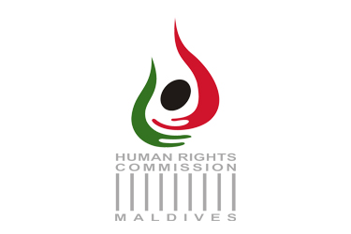

2021

Abbreviations

AHTAP Anti Human Trafficking Action Plan
CwD Children with Disabilities
DA Decentralization Act
DJA Department of Judicial Administration
DV Domestic Violence
DVPA Domestic Violence Prevention Act
FMW Female Migrant Workers
FPA Family Protection Authority
GBV Gender Based Violence
GEA Gender Equality Act
HEI Higher Education Institution
HRCM Human Rights Commission of the Maldives
IOs Investigation Officers
ISAP Income Support Allowance program
LFP Labour Force Participation
MDHS Maldives Demographic Health Survey
MoD Ministry of Defence
MoED Ministry of Economic Development
MoF Ministry of Finance
MoFA Ministry of Foreign Affairs
MoGFSS Ministry of Gender Family and Social Service
MP Maldives Polytechnic
MPS Maldives Police Service
NAHTSC National Anti-Human Trafficking Steering Committee
NBS National Bureau of Statistics
NER Net Enrolment Ratio
NSFPS National Standards for Family Planning Services
OOSC Out-of-School Child
PHTA Prevention of Human Trafficking Act (12/2013)
PM People’s Majlis
PVoT Potential Victims of Human Trafficking
PwD Persons with Disabilities
SDFC SME Development Finance Corporation
SDG Sustainable Development Goals
SME Small and Medium Enterprises
SRH Sexual and Reproductive Health
SRHR Sexual and Reproductive Health Rights
SPT Subcommittee on Prevention of Torture and other Cruel, Inhuman or Degrading Treatment or Punishment
TSM Temporary Special Measures
TVET Technical and Vocational Education Training
VAW Violence Against Women
VoHT Victims of Human Trafficking
WDC Women’s Development Committee
WwD Women with Disabilities

Introduction
This report highlights priority concerns and information on implementation of State party’s previous Concluding Observation of the United Nations Convention on Elimination of All Forms of Discrimination Against Women Committee.
To compile this report HRCM requested information from relevant government authorities, and institutions. The report was compiled based on information received from the relevant stakeholders including government authorities, institutions, civil society in addition to existing in‐house monitoring and data. The process undertaken to compile the report is attached in Annex 1.

- The only comprehensive research on VAW was conducted in 2007 and a follow-up research is yet to be conducted. According to public perception, substance abuse, financial difficulties, inability to hold perpetrators accountable are some of the root causes of DV. Religious extremist narrative is used to weaken support for gender equality and women’s rights. Additionally, religion is used as a pretext to commit VAW.
- Non-consensual pornography, recorded sexual assault and sextortion were on the rise, and claims of prior consent subject victims to further victimization, making them hesitant to report.

- Complaints lodging and referral mechanism in place for GBV are complicated. Only, two fifth of victims of VAW had sought help. Victims remained hesitant to come forward due to lack of trust in the system, failure to maintain confidentiality, and lack of protection for those reporting.

- Majority of DV cases reported to FPA were cases of VAW. While almost all protection orders were requested by women, half of the protection orders issued were emergency orders. Protection orders were violated only by men.

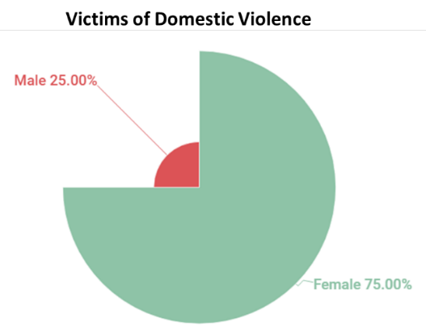
Figure 1. Victims of DV reported - FPA

- There was an increase in services acquired for GBV/DV cases with the ease of lockdown restrictions due to Covid-19 pandemic, which could be an indication that cases increased during the lockdown period.
- Challenges for investigation of VAW included lack of capacity and sensitivity among IOs, limited atoll-based female IOs, lack of sufficient evidence, limited atoll-based magistrates, lengthy trials and perpetrators holding positions of power.
- There are inconsistencies in interpretation and codifying DVPA among institutions.

- As DV itself is not regarded as a criminal offence under DVPA, prosecutors fall back on other legislations to prosecute DV. Cases of VAW prosecuted remained low; only 14% of VAW cases lodged at MPS were sent for prosecution. A total of 60 cases were prosecuted between 2016 and 2019, of which only 10 cases resulted in a conviction. Challenges included victims and witnesses retracting statements following pressure from family, relatives or perpetrators. Witness Protection Bill and new Evidence Bill are yet to be enacted.

- The four established shelters for survivors of DV were neither functional nor equipped with staff and amenities to accommodate survivors. Survivors in atolls have limited or no access to psycho-social support.

- While the complaints mechanism under GEA has reportedly been established in 38 institutions, stakeholders in the atolls were unaware of the requirement to establish this mechanism.

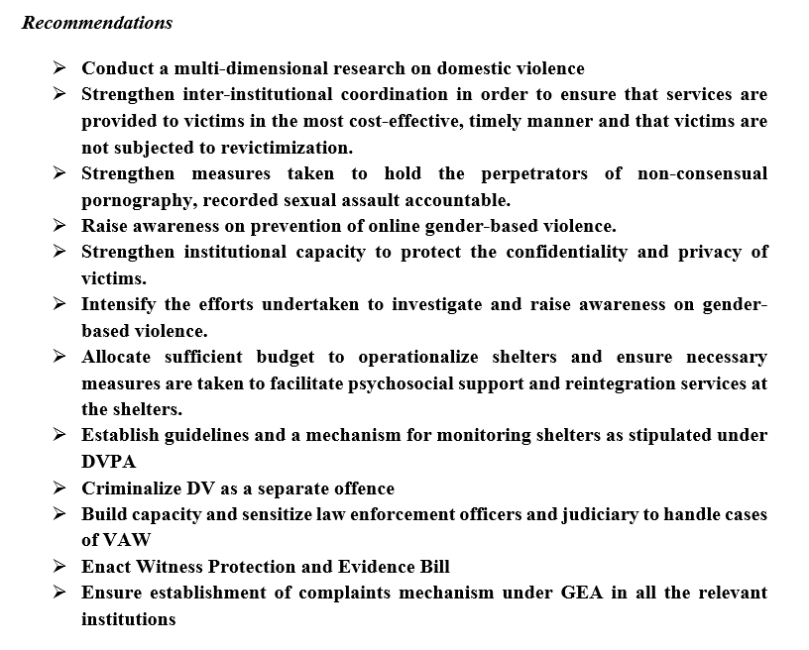
- Women remain under-represented at policy and decision-making levels in all branches of the state.
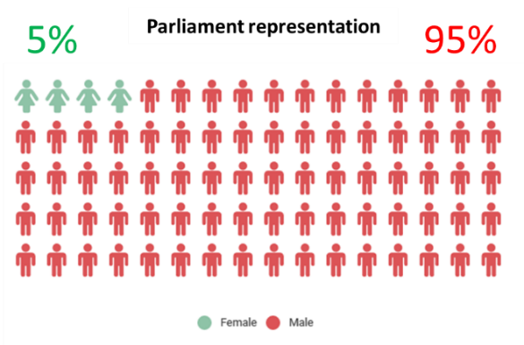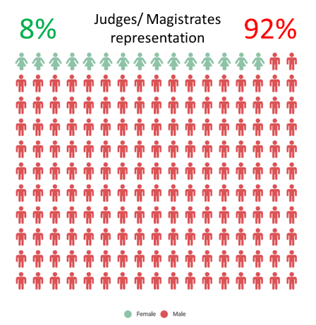
Figure 2. Representation of Women in Parliament and Judiciary. NBS, 2021
- While assignment of non-traditional cabinet portfolios to women was observed, representation of women in political posts in the executive remained at one-fourth.
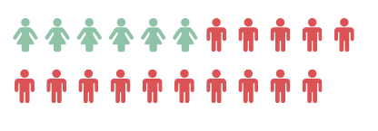
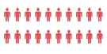
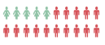
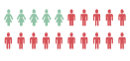
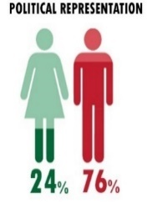
CABINET
STATE MINISTERS
MINISTERIAL RANK
DEPUTY MINISTERS
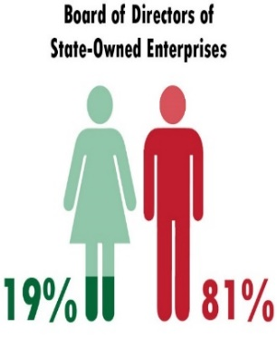
Figure 3. Political Representation. NBS,2020 Figure 4. Women’s Representation in Board of Directors of State-Owned Enterprises. MoF,2020
- Amended Decentralization Act mandates allocation of 33% of local council seats to women.
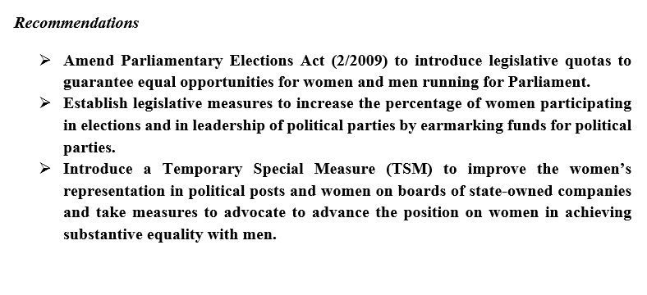

- Attitudes on women correlate with misplaced religious beliefs; a significant number of people still believe women should obey their husbands and are obligated to have sex with their spouses, irrespective of their needs. Also, a significant number of people believe gender equality is incompatible with Islam.
- Religious extremism remains an issue of concern. According to official records, there are 35 Maldivian women in foreign conflict zones. It is alarming that key stakeholders believe that women travelled to conflict zones of their own volition and will evade criminal prosecution by stating that they were forced or groomed.
- Although gender perspective was considered during the national curriculum revision process, there were challenges in the implementation and delivery process due to a lack of awareness among teachers on gender equality and stereotypes.
- Efforts to raise awareness among media personnel, to combat negative portrayal of women, gender-based reporting remained insufficient and unsuccessful.
- Advocators of human rights and gender equality were stigmatized and have faced threats.

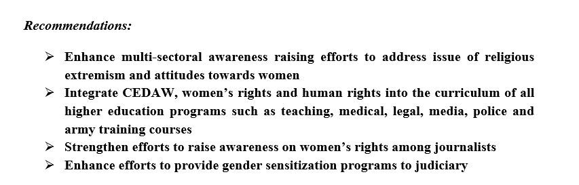

- Reported cases of exploitation have doubled. Meanwhile, failure to undertake comprehensive assessments of abuse cases within the specified period due to overwhelming workload assigned to social workers and non-inclusion of risk categories in case files, and disregard to pursue cases filed with MPS contributed to inadequacies in addressing abuse cases by MoGFSS. Moreover, vulnerability of victims remained exacerbated by prolonged time-taken to record referral forms, assign investigation officers, and complete investigations by MPS.
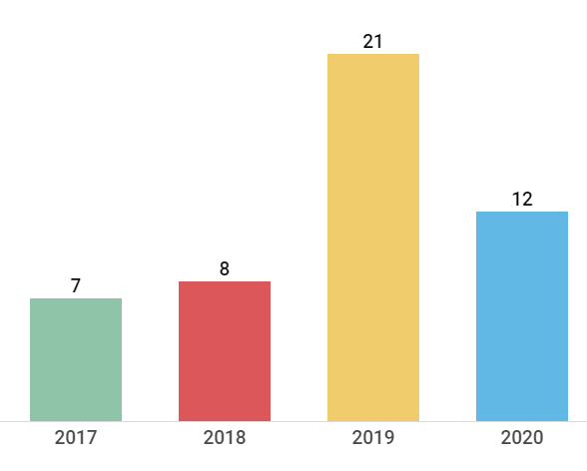
Exploitation cases
Figure 5. Commercial and sexual exploitation cases. MoGFSS, 2017 to 2020
- 6% of migrant population are FMW.
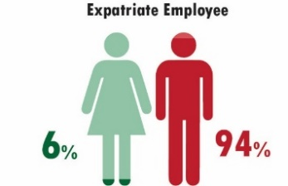
Figure 6. Expatriate Employees,2019

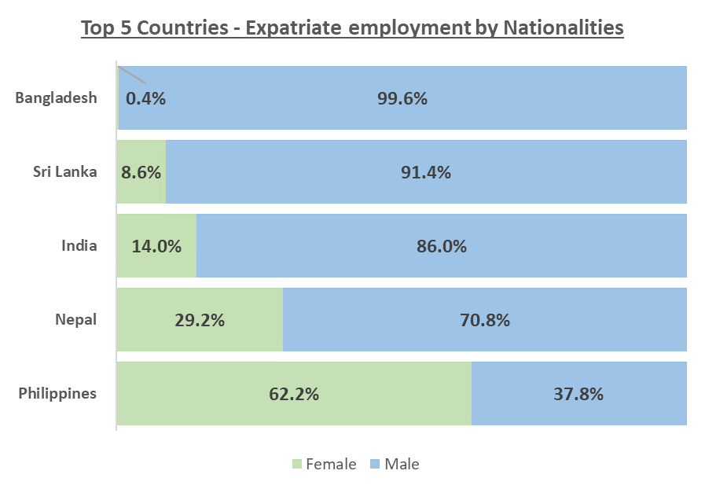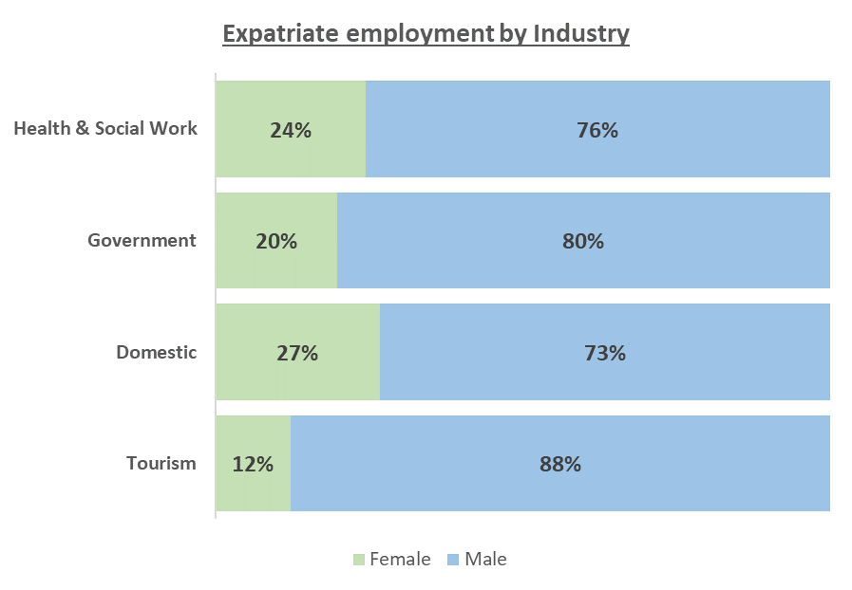
Figure 7. Top 5 Countries - Expatriate employment by Nationalities and Industry.NBS, 2019
- Similarly, application of national victim identification guideline remained nominal. An average of 13 cases of female sex workers were reported annually. MPS investigated 3 cases of forced female prostitution from 2018 to 2019 and 2 of such cases were sent for prosecution.

Figure 8. Reported Prostitution related incidents to Maldives Police Services. MPS,2020

Figure 9. Victims and potential victims of human trafficking 2015 to 2019. MPS,2020
- Regrettably, negligence by employers to pay visa payments render workers into irregular status. While less than one-fifth of FMW employment approval was expired over one year, half of FMW deported were due to visa violations. A considerably low number of FMW participated in the regularization program initiated by MoED in 2019 to address issues of undocumented migrant workers. Moreover; only 15% of FMWs enrolled were regularized.
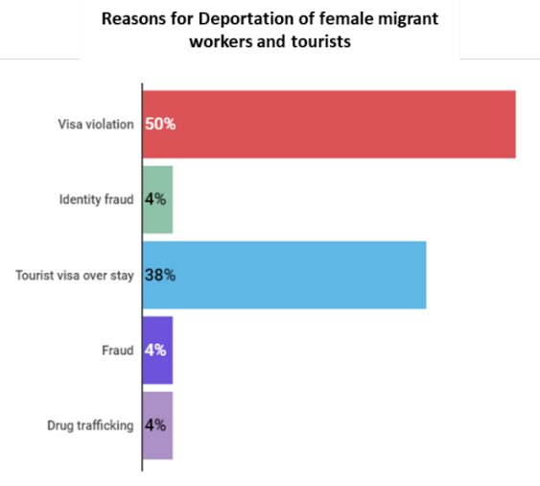
Figure 9. Reasons for deportation of female migrant workers and tourists. MI,2020
- Implementation of AHTAP remained minimal from 2015 to 2019, meanwhile NAHTSC failed to comply with legal requirement to submit its annual report to PM. Trafficking mandate was shifted from MoED to MoD in July 2019 and a new NAHTSC was convened in December 2019.
- Recent developments include establishment of an Anti-TIP Office and allocation of funds to carryout anti-human trafficking activities.Moreover, a shelter has been established for victims of human trafficking.

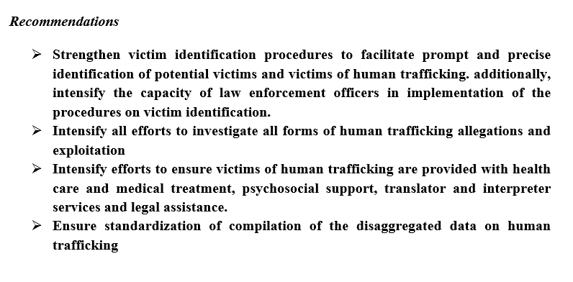

- There are no legal barriers for women in political and public life. However, no effort has been made for de facto implementation.
- Appointment of the first female justices to the Supreme Court is commendable.
- Under representation of women in decision making remains an issue; women comprise of only 4.5% of the parliament and 5.9% of the local council prior to allocation of 33% quota.
- Decentralization Act was amended to include a 33% quota for women; however, general perception of the quota is negative. There is a lack of awareness on the purpose and need for TSM.
- There are multiple challenges for women in politics and public life including lack of financing, harassment on the campaign trail, lack of support and trust in women’s capabilities, women held to higher standards than men, negative portrayal and harassment of women in public life in media and other public platforms, and lack of affordable child and elderly care options while it is the traditional gender role for women to carry this burden.
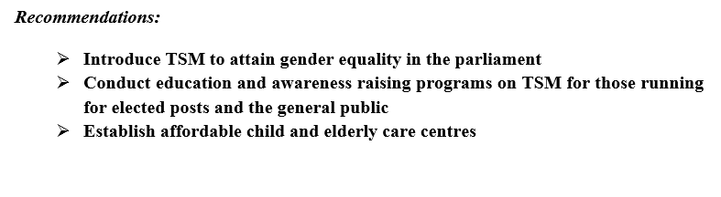

- Gender parity among Heads of Missions of the Foreign Service was achieved.
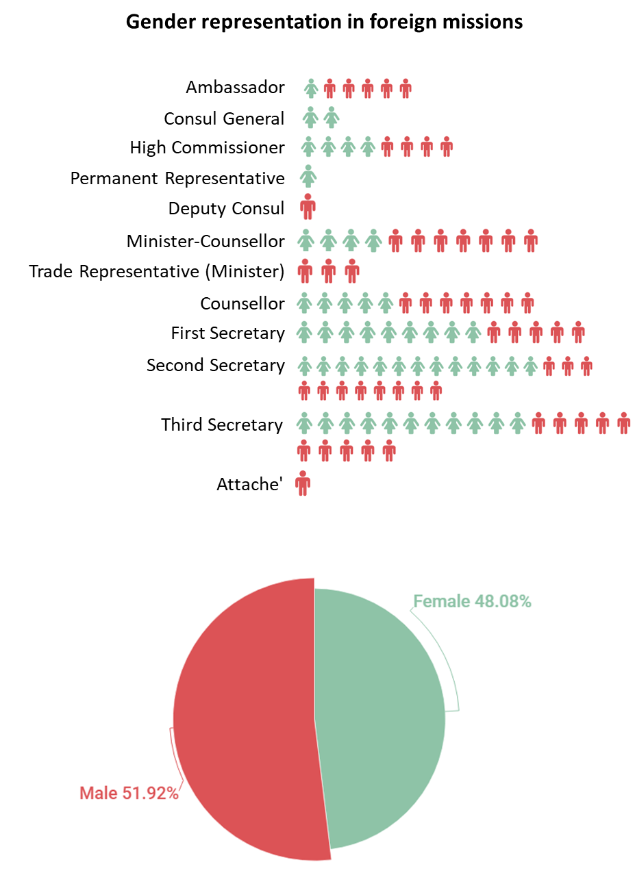

Figure 11. Gender representation in foreign mission. MoFA,2020

- For children with severe and multiple disabilities, right to education is yet to be fully realized within school system. Despite an increase in the number of schools providing some form of education for CwD, schools lacked adequate resources to provide effective specialized education for children with most types of disabilities.
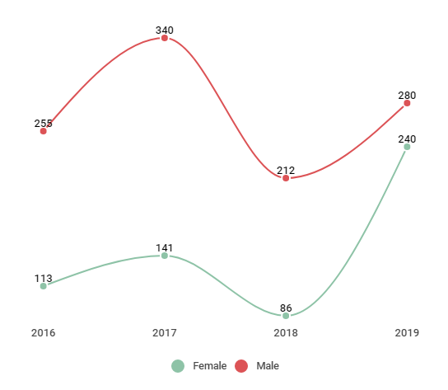
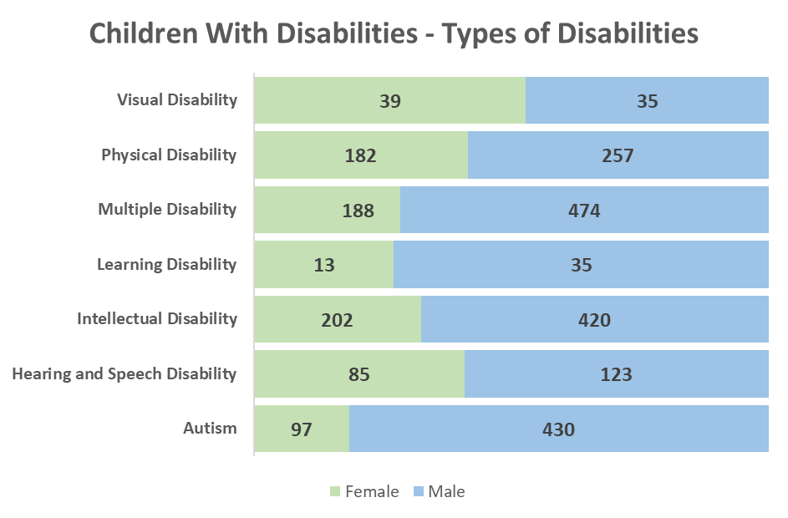
Special Classes ENROLMENT TRENDS
Figure 12. Children with Disabilities. NSPA,2020 Figure 13. Special Classes Enrolment Trends. MoE,2019
- OOSC is close to negligible for primary and lower secondary education. However; access to education for children was compromised due to missing identification documents, difficulties faced in registration of parents’ marriages solemnized overseas and religious reasons. Moreover; family violence and abuse, and teenage pregnancy (2% of females aged 15-19 had started childbearing) impact girls’ engagement in education.
- While NER in primary and lower secondary education was 100% for both sexes, it was at 37.2% in higher secondary education with the enrolment of 56% for females. Girls achieve better learning outcomes, and perform better from primary to A-Levels. Nevertheless, secondary students and youth remained unfamiliar with prospects available for further studies.
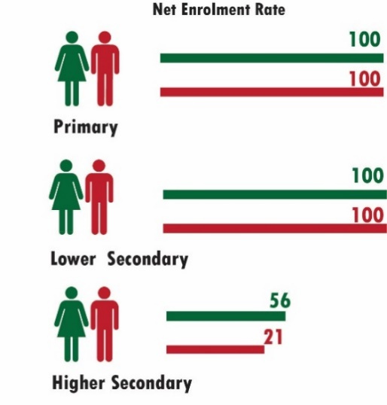
Figure 14. Net Enrolment Rate. MoE,2019
- Quality and image of technical-vocational are perceived as lower to standard HEIs. Moreover, female participation in such programmes were comparatively low.
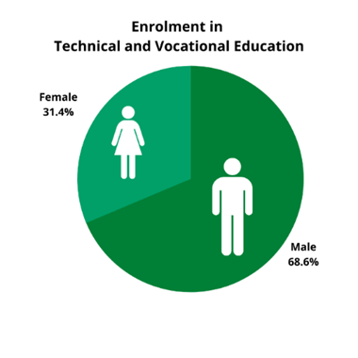
Figure 15. Enrolment in Technical and Vocational Education. MP and TVET,2020
- Disaggregated data on courses undertaken at tertiary studies remain inaccessible. Evidently, women’s enrolment in tertiary studies had increased, while a significant gender gap in graduate numbers affecting women indicated challenges to complete studies. While paid work and unpaid care work remained some of the challenges faced by students, free education scheme for degree students initiated by the government in 2019 would provide relief to constraints encountered.
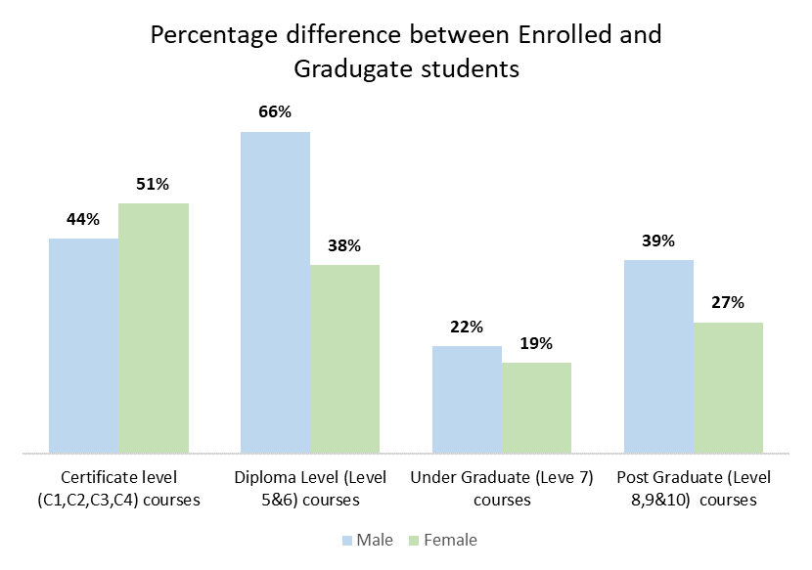
Figure 16. Percentage Difference between enrolled and graduate students.MoHE,2019
- The Education Act ratified in November 2020, would come into effect in August 2021. Moreover, Maldives Higher Education Act was ratified on 16th May 2021.
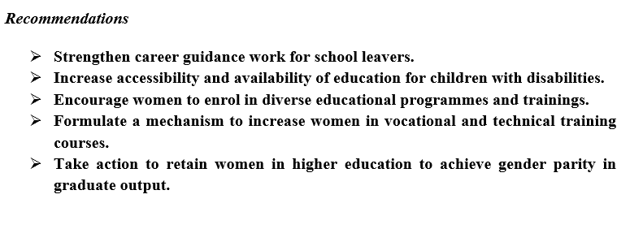

- Economically active women dominate in stereotypical and socially acceptable sectors such as education, health, small scale manufacturing.
- Slightly over half of working population were women, nonetheless LFP of women remained low. While progressive developments in maternity and paternity policy shifts to encourage LFP of women are in effect, it is yet to be integrated into law. Additionally, it addresses only one segment of the unpaid care burden by women.
Figure 16. Labour Force Participation. NBS,2019
- Uneven distribution of unpaid care work of women irrespective of their employment and marital status and lack of affordable state funded child-care options persisted as challenges to women’s LFP. It is distressing that 12% of children under 5 were left alone or in care of another child younger than age 10 for more than one hour.
Figure 17. Proportion of time spent on unpaid domestic and care work. NBS, 2016
- Participation of Maldivian women in the tourism industry was at 3%. Factors that discourage women working in resorts include unavailability of commuting options, culturally and religiously enforced restrictions on women’s roles and mobility.
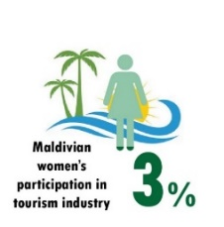
Figure 18. Representation of local women in tourism industry. NBS,2019
- Structure of economy and locality of women also influences availability and accessibility to employment opportunities. Unavailability of vocational certification, low employment opportunities coupled with occupational gender segregation in small rural islands limits women’s employment opportunities to informal production of small-scale home-based work, casual agriculture and fish processing.
- Employment in the informal sector remained higher among women, which signified that most were without stable income, paid leave and pension. Women and youth were more affected by labour underutilization resulting in significant gender gap.
Figure 19. Women’s representation in informal sector. NBS,2016.
- There is a paradoxical combination of labour shortages with high unemployment rates, especially among women and youth due to cultural stigma associated with certain occupations, limited skills in local labour force and inclination towards non-acceptance of physically demanding and low-paying jobs. Similarly reproductive roles indicated that women remained at an unfair disadvantage despite legislative standards in effect to facilitate access to employment.
- Women remain hesitant to report sexual harassment cases at workplace. The reasons for non-action by people who were subjected to harassment were because some considered it as normal behaviour while few remained apprehensive over disbelief. Additionally, lack of supporting evidence remains a challenge to prove cases lodged to sexual harassment committees established by the respective government offices.
- LFP of WwD is 23.9% and they were more likely to work in informal sector. Moreover, accessibility difficulties, limitations in inclusive workplaces remain as impediments faced by PwD to earn a livelihood.
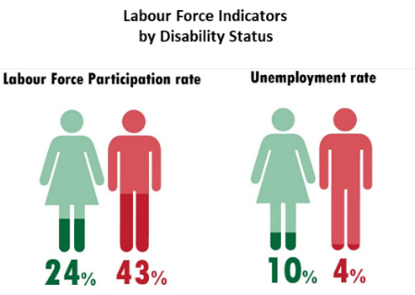
Figure 20. Labour Force indicators by disability status. NBS,2019.

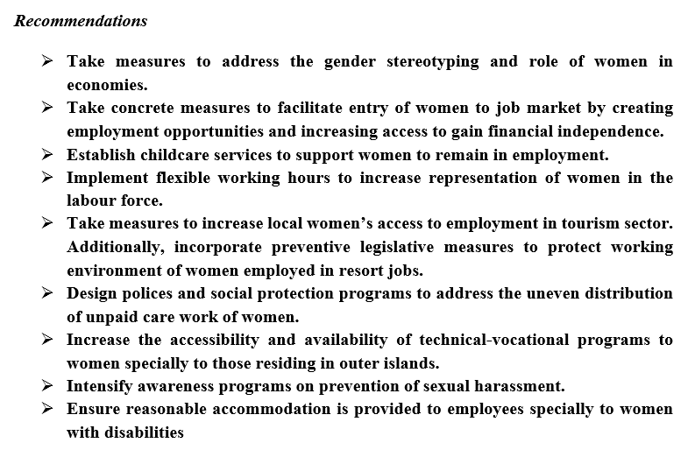

- Even with great progress in achieving SDGs, access to basic health services including SRH services was not easy, especially for people living in the atolls. Even though access to basic medicine has eased in most islands there was a lack of health care equipment and specialists such as gynaecologists in outer islands.
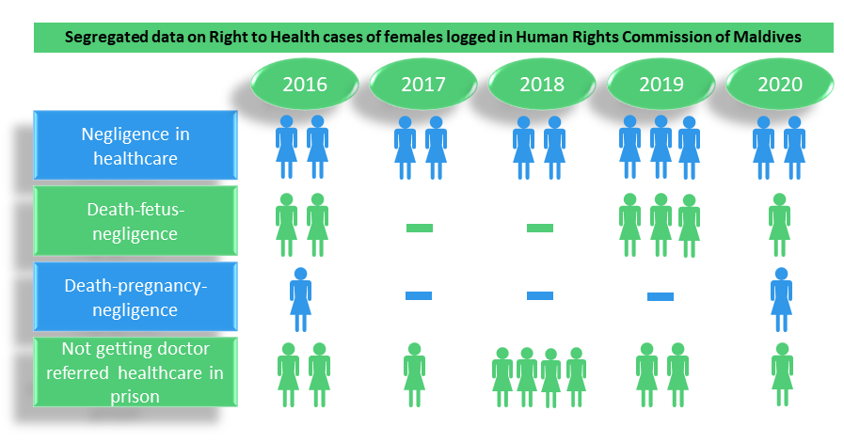

- People, especially from outer islands and mostly women, were dissatisfied with overall health services. Women in general do not trust service providers and health facilities due to lack of patient confidentiality especially in smaller communities.
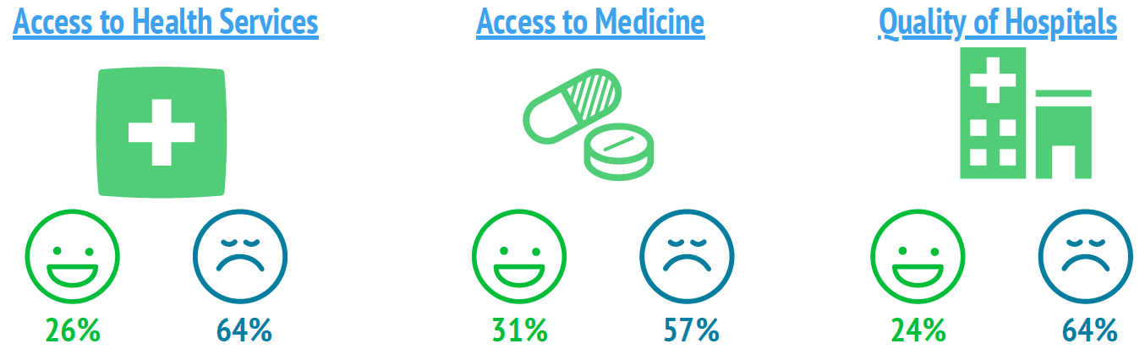
- Health care services in the islands remained poor and access to specialized healthcare was limited; OBGYN and paediatricians consult in tertiary and secondary hospitals in cities and administrative islands, pregnant women from remaining islands were required to travel prior to delivery, incurring extra cost for food and accommodation.
- While youth did not have access to reliable information on SRH or family planning, contraceptives are only accessible to married couples. Although parents were aware of the importance and support SRH education, age appropriate SRH education was not provided in schools.

- MDHS 2018 revealed that 13% of women aged 15-49 are circumcised; prevalence of female circumcision substantially increased with age, from 1% among women aged 15-19 to 38% of women aged 45-49. Among women who have heard of female circumcision, 10% believe that the practice is required by their religion, and 8% believe that the practice should be continued. Data on the frequency of FGM is not available. Some religious leaders with extreme views have called for revival of the practice, public discussion of the issue is restricted due to societal stigma.

- NSFPS requires written spousal consent for surgical sterilization which indicates an indirect barrier to family planning and bodily autonomy.

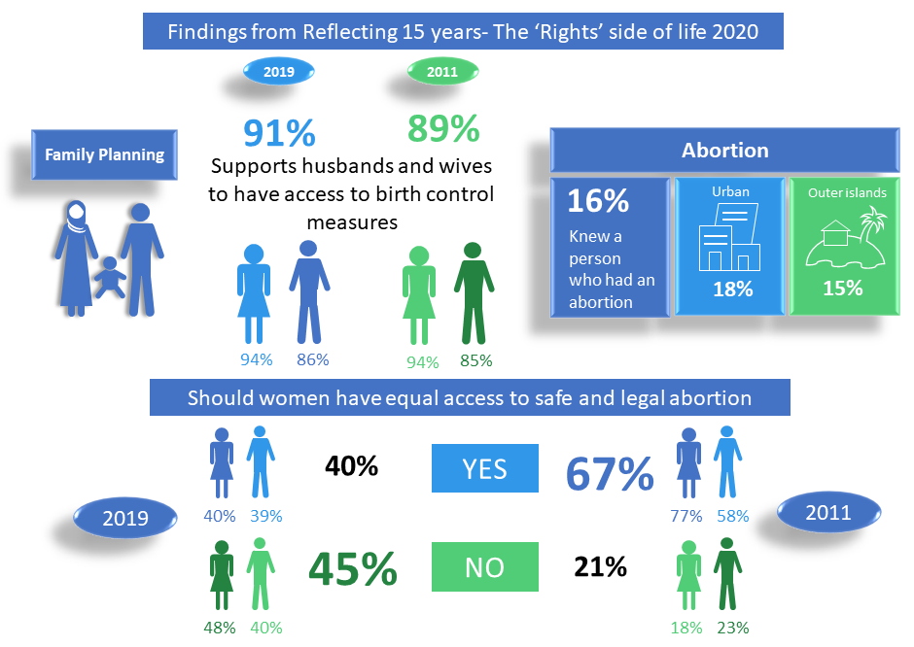

- Access to mental health services was very limited and centralized in the Male’ region due to lack of qualified mental health professionals.
- There was lack of budget and resources to setup community awareness programs within public health units of islands.

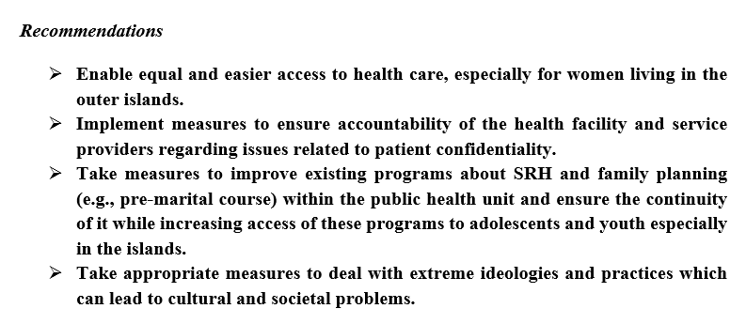

- 25% of the state loan scheme portfolio was allocated to women and youth. Finite number of women applied for the loan schemes. Women living in outer-islands remained unaware of regular loan schemes provided by SDFC.
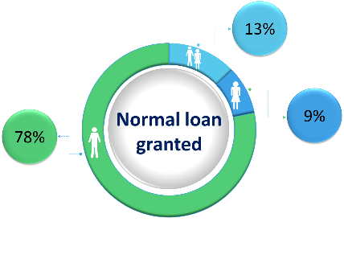
Figure 21. Loans Granted as of 27/10/2020, SDFC
- Most women living in outer islands had limited access to loans due to a lack of formal job and collateral under their possession, such as ownership and control of land, farms and vehicles.
- Two programs were initiated by the state. “Covid-viyafaari-ehee-loan” for recovery of SMEs, self-employed/freelance individuals, and “Income-Support-Allowance-Program” (ISAP) for individuals who have had their livelihoods affected after employment changes due to Covid-19 pandemic. Evidently, men benefitted from the two State initiated pandemic relief programmes. 15% female and 74% males were granted Covid-viyafaari-ehee-loan similarly, 27% of females and 73% males were granted ISAP.

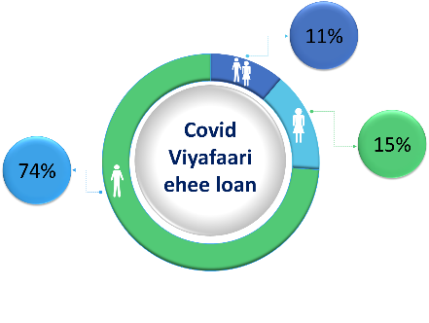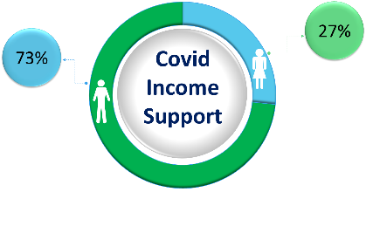
Figure 22. Ehee Loan Granted as of 27/10/2020, SDFC Figure 23. ISAP Granted as of 27/10/2020, MoF
- Some women living in outer islands were unaware of the ISAP and those who were aware of it had difficulty in applying for ISAP due to lack of proper information received, tedious process of document submission, technological issues related to internet, difficulty in getting a bank statement.
- Geographical dispersion of islands, limited social services at island level hinders efforts to reach the target populations and makes continuous monitoring a challenge in providing social security.

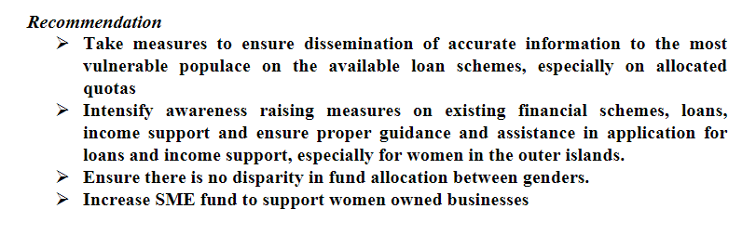

- Most WDCs have been inactive over the past five years. Challenges faced by WDCs include lack of independence over their activities and lack of workspace. Members of WDC remained without independent access to a budget. However, amendments to the DA included allocation of 5% of council’s budget to WDCs. Generally, members of WDC and communities remained unaware of WDCs mandate.
- Rural women are disproportionately affected by environmental and climate change as women are more dependent on the natural resources threatened by these changes. There are limited avenues for compensation for loss and damage due to natural disasters and women are either unaware or have not benefited from the available options. Unsustainable development practices over the years have threatened economic livelihood of women.
- There was a lack of support and business avenues for women engaging in traditional methods of earning such as weaving mats and coir rope. Although tourism is the main source of income, women in the sector are limited and involvement of rural women in local tourism was negligent.
- There was disparity in access to services for atoll-based communities.

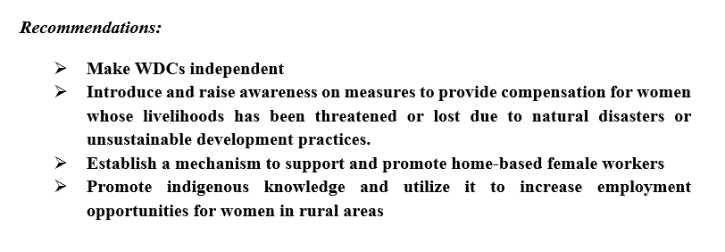

- Under the Constitution both men and women have the right to acquire, own, inherit, transfer or otherwise transact of such property.
- Majority of the land is owned by the state and it is divided equally between men and women. Moreover, Sharia governs inheritance of private land, which bequests male heirs twice the share of females.However, in practice private land is also divided equally among men and women unless there is contention over equal distribution of ancestral land.
- Equal distribution of matrimonial property was guaranteed under the Second Amendment to Family Act in 2016. As per the new amendment, if there is an existing pre-nuptial agreement between the spouses, prior to granting leave for divorce or prior to the dissolution of marriage, the court has power to equitably distribute matrimonial property acquired during the marriage. In addition, equitable distribution of matrimonial property is granted where a couple having a pre-nuptial agreement is unable to agree upon the distribution of the property acquired during the subsistence of the marriage. However, the concept of pre-nuptial agreement is relatively new thus it is not widely known or considered by most.
- During divorce proceedings, the Court is allowed to take in to consideration the amount of property or money acquired individually by either the wife or husband and the amount that has been used during marriage and whether there has been an increment to that property or money during marriage. At the same time the Court shall have regard to the extent and effort put by each in acquiring the property.
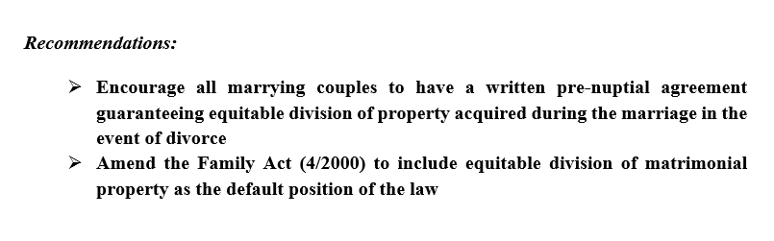

- It is disconcerting that more women believe that human rights are incompatible with Islam and strongly support the statement “A good wife always obeys her husband even if she disagrees”. Out of court and underage marriages remained as an area of concern that lacks comprehensive data.
- While divorce rate remains high, close to three-fifths of divorce petitions were filed by the wife. Additionally, 13% of divorce cases were concluded in reconciliation. A mother’s remarriage is grounds upon which she loses custody of her children according to Family law (2000) despite the guarantee afforded by the Child Rights Act (19/2019) to consider the best interest of the child in all court proceedings and decisions involving a child.
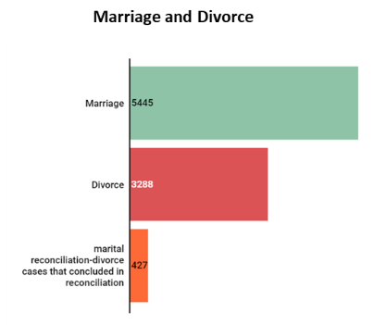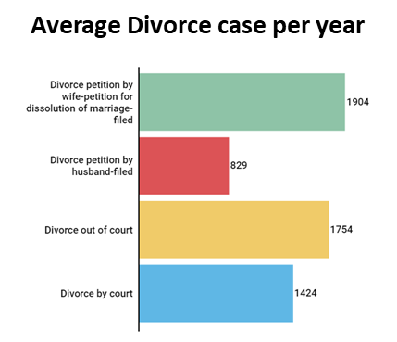
Figure 24. Marriage and divorce cases, and average annual divorce cases. DJA 2015-2018.
- On average 169 polygamous marriages were registered annually. Polygamous marriages are permitted when men declare their financial competency in providing for wives and children. Anecdotal reports suggest men enter into polygamous marriages covertly by getting their marriage solemnized overseas to circumvent restrictive provisions of law. Correspondingly in 2019 the Apex court issued a circular to enforce a prerequisite to obtain a statement from current wives to confirm financial support from husband before registering polygamous marriages, as some courts assumed financial support in cases where it lacked expense records.
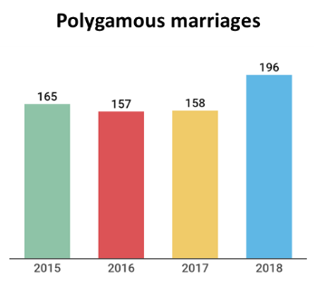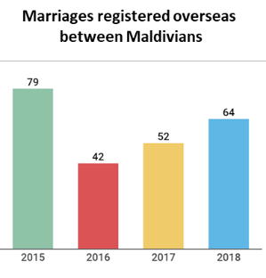
Figure 25. Polygamous marriages and marriages registered overseas between Maldivians. DJA.2015-2018.
- An average of 23 declarations of paternity cases were filed annually. While DNA is admissible as persuasive evidence in criminal cases, it is not admissible in courts to determine paternity of a child due to absence of legal provisions on application of scientific methods to determine paternity.
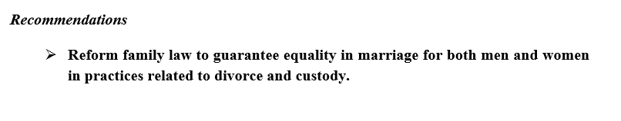

Annex 1

About HRCM
Human Rights Commission of the Maldives (HRCM) was first established under a Presidential Decree on December 10, 2003. On August 18, 2005, the Human Rights Commission Act (6/2006) was ratified, thereby making HRCM the first independent and autonomous statutory body in the Maldives. The amendments brought to the Human Rights Commission Act in August 2006 broadened the mandate and powers of the HRCM, making it compliant with the Paris Principles. With the ratification of the Constitution of the Republic of the Maldives in August 2008, the HRCM was made an independent and autonomous constitutional body.
The HRCM currently holds ‘B’ status with the Global Alliance of National Human Rights Institutions (GANHRI) and is an Associate Member of the Asia-Pacific Forum of National Human Rights Institutions (APF).
The second amendment to the HRCM Act was passed by Parliament on 6 September 2020, which adds safeguards to prevent corruption within HRCM and granting HRCM with powers to provide effective remedies in cases where human rights violations occur.

Process undertaken to compile CEDAW report 2015 onwards

Dissemination of Recommendations from CEDAW -2015
Following the publication of Concluding Observations on the fourth and fifth periodic reports of the Maldives, by CEDAW Committee, a CEDAW stakeholder forum was conducted by HRCM in September, September 1st, 2015 with the objective to disseminate information on recommendations made to the State. A separate forum was held to disseminate the information to media on October 13th, 2015. Additionally, HRCM carried out a recommendation mapping process to determine corresponding authorities for each of 55 recommendations accepted by Maldives.

Follow-up on the implementation status of the recommendation 2016 to 2018
Work done by the stakeholders, challenges faced and planned activities to implement 55 recommendations were closely monitored by HRCM from year 2015 to 2019 on an annual basis.
The status of implementation of each recommendation was evaluated using the criteria in Table 1. Table 2 illustrates implementation status based on the information shared by stakeholders.
Among the 15 stakeholders involved, some fell short to provide information on implementation status of the recommendations.
General challenges faced by HRCM in its annual follow-up work undertaken to monitor the implementation of the recommendation have not changed. These challenges include delay in stakeholder response to the questionnaires formulated by HRCM to acquire information for this report, along with different levels of cooperation from state authorities and information gaps within state institutions.

Table 1: Criteria used to evaluate status of implementation and implementation status
Score | indicator | Status | CEDAW implementation status
100 | Implemented | Recommendation fully implemented | 3%
75 | Positive progress | 50% of the recommendation implemented/completed | 3%
50 | Adequate Progress | Initiated the implementation of the recommendations in the Action Plan/ Annual Work Plan | 14%
50 | Adequate Progress | Standard Operating Procedures/Administrative codes endorsed | 14%
25 | Nominal Development | Recommendation included in the endorsed action plan | 38%
25 | Nominal Development | Recommendation included in the Annual Work Plan | 38%
25 | Nominal Development | Budget allocated to implement the recommendations | 38%
0 | No Progress | No progress | 14%
0 | No Progress | Recommendation rejected/ Not willing to implement the recommendations | 14%
 | No information received/further information required | No information received/further information required | 28%

Table 2: Implementation status based on the information shared by stakeholders 2016 - 2019
Recommendations related to | Implemented | Positive Progress | Adequate Progress | Nominal Development | No Progress | No information received/further information required
Article 2 - Policy Measures |  | 1 | 2 | 2 |  | 2
Article 3 - Guarantee of Basic Human Rights and Fundamental Freedoms |  | 2
Article 4 - Special Measures |  |  |  | 1
Article 5 - Sex Role Stereotyping and Prejudice |  |  |  | 1 | 1
Article 6 – Human Trafficking |  |  |  | 1 |  | 1
Article 7 - Political and Public Life |  |  |  | 1
Article 9 - Nationality |  |  |  |  |  | 1
Article 10 - Education |  |  |  | 1
Article 11 - Employment |  |  |  | 3 | 1
Article 12 - Health |  |  |  | 1
Article 13 – Economics and Social Benefits |  |  |  | 1 | 1
Article 14 – Rural Women |  |  |  | 3 | 2
Article 15 - Law |  |  | 1 |  |  | 1
Article 16 – Marriage and Family Life |  |  |  |  | 1 | 1
Paris Principles |  |  |  |  |  | 1
SDGs |  |  |  |  |  | 1
Dissemination |  |  |  | 1
Technical Assistance |  |  |  |  |  | 1
Ratification of other treaties |  |  |  |  |  | 1
Follow-up to the concluding observation |  |  |  | 1
Preparation of the next report | 1 |  |  |  |  | 1
Total | 1 | 3 | 3 | 17 | 6 | 11

Process of compiling this report
Some of the work undertaken by HRCM to follow-up on recommendations from the fifth cycle of CEDAW (2015) include the following
- Dissemination of information
A forum was held in September 1st, 2015 to disseminate information on CEDAW recommendations to stakeholders. A separate forum was also held to disseminate the information to media on October 13th, 2015.
- Evaluation of implementation status
Furthermore, Follow-up on the implementation status of the recommendation were conducted on an annual basis from 2015 to 2019 which includes work done by the stakeholders, challenges faced and planned activities to implement the recommendations. The status of implementation of each recommendation was evaluated using a set criterion.
- Field visits (atoll monitoring visit)
Due to the Covid-19 pandemic, scheduled field visits to monitor the implementation of concluding observations from CEDAW committee was cancelled. Hence online focus group discussions were conducted with island-based stakeholders such as Local Council Authorities, Women’s Development Committees, Family and Children’s Service Centres, Health Centres and Regional Hospitals, Civil Society Organisations, women, youth
- Information obtained from state authorities
A stakeholder questionnaire was developed to compile information. It is significant to note that the issues identified from the online consultations with island-based stakeholders, annual CEDAW recommendation follow-up and existing in-house monitoring data were considered in the formulation of the stakeholder questionnaire. The in-house monitoring data encompasses various internal reports (annual reports, assessment of compliance of national legislations with international human rights law, report to UPR Process), and findings from field monitoring visits conducted from 2015 to 2019. Evaluation of the responses shared by the relevant state authorities were reviewed to outline a set of questions.
- Consultations with Civil Society Organizations and Political Parties
Political parties as well as Civil Society Organizations working on women’s rights, civil and political rights, child rights, people with disabilities, environment and climate change were consulted to obtain a better understanding of the women’s rights situation of the country from 2016 onwards and verify the information provided by the state authorities on an annual basis.

- Validation of the information
This report was shared with government stakeholders and civil society organizations for validation and significant comments from them were considered.

Annex 2

Reference

Information obtained from stakeholders and stakeholder meetings (NGOs)
HRCM (2020). Reflecting 15 years: The “Rights” Side of Life, page 40. Retrieved December 21, 2020 from http://www.hrcm.org.mv/publications/otherdocuments/2020RSL3Report.pdf
HRCM (2020). Reflecting 15 years: The “Rights” Side of Life, page 65. Retrieved December 21, 2020 from http://www.hrcm.org.mv/publications/otherdocuments/2020RSL3Report.pdf
Information obtained from stakeholders and stakeholder meetings Aiham, A. (2020). Police reveal identity of 'exorcist' sexual predator. Retrieved December 28, 2020 from https://edition.mv/rugya/17063 Malsa, M. (2020). Gender committee launches probe into Ruqya sexual abuse case. Retrieved December 28, 2020 from https://edition.mv/rugya/20572 Mohamed, S. (2020). Police seeks charges against 2 arrested in 'Ruqya' multiple-abuse case. Retrieved December 28, 2020 from https://edition.mv/rugya/21149
Information from stakeholders and stakeholder meeting (Atoll based stakeholders, MPS)
HRCM (2019). HRCM Submission to the Universal Periodic Review of the Maldives, page 7, Retrieved March 30, 2021 from, http://www.hrcm.org.mv/Publications/otherdocuments/UPR_submission_Oct2019.pdf
Ministry of Health (2018). Maldives Demographic and Health Survey 2016-17, Page 14, Retrieved March 30, 2021 from https://dhsprogram.com/pubs/pdf/FR349/FR349.pdf
Information obtained from stakeholders and stakeholder meetings (Atoll based stakeholders, NGOs)
Family Protection Authority (2015). Reports: Annual Report 2015, page. 40. Retrieved December 21, 2020 from http://www.fpa.gov.mv/uploads/publications/reports/Published_Annual_Report_23_3_16-ilovepdf-compressed.pdf Family Protection Authority (2016). Reports: Annual Report 2016, page. 82. Retrieved December 21, 2020 from http://www.fpa.gov.mv/uploads/publications/reports/Published_Annual_Report_29_3_17.pdf Family Protection Authority (2017). Reports: Annual Report 2017, page. 45. Retrieved December 21, 2020 from http://www.fpa.gov.mv/uploads/publications/reports/Family_Protection_Authority_Annual_Report_2017_FINAL_29_3_18.pdf Family Protection Authority (2018). Reports: Annual Report 2018, page. 36. Retrieved December 21, 2020 from http://www.fpa.gov.mv/uploads/publications/reports/Family_Protection_Authority_Annual_Report_2018.pdf Family Protection Authority (2019). Reports: Annual Report 2019, page. 47. Retrieved December 21, 2020 from http://www.fpa.gov.mv/uploads/publications/reports/Family_Protection_Authority_Annual_Report_2019-FINAL-signed.pdf
Family Protection Authority (2016). Reports: Annual Report 2016, page. 92-93. Retrieved December 21, 2020 from http://www.fpa.gov.mv/uploads/publications/reports/Published_Annual_Report_29_3_17.pdf Family Protection Authority (2017). Reports: Annual Report 2017, page. 52-55. Retrieved December 21, 2020 from http://www.fpa.gov.mv/uploads/publications/reports/Family_Protection_Authority_Annual_Report_2017_FINAL_29_3_18.pdf Family Protection Authority (2018). Reports: Annual Report 2018, page. 41-42. Retrieved December 21, 2020 from http://www.fpa.gov.mv/uploads/publications/reports/Family_Protection_Authority_Annual_Report_2018.pdf Family Protection Authority (2019). Reports: Annual Report 2019, page. 52-53. Retrieved December 21, 2020 from http://www.fpa.gov.mv/uploads/publications/reports/Family_Protection_Authority_Annual_Report_2019-FINAL-signed.pdf
Ibid
UNFPA (2021). Gender Based Violence During Covid-19 Pandemic in the Maldives; an analysis of reported cases, page 31, Retrieved May 19, 2021 from, https://maldives.unfpa.org/sites/default/files/pub-pdf/gbv_analysis_final.pdf
Information obtained from stakeholders and stakeholder meetings (Maldives Police Service, Family and Children’s Services Centres, NGOs)
HRCM (2019). HRCM Submission to the Universal Periodic Review of the Maldives, page 7, Retrieved March 30, 2021 from, http://www.hrcm.org.mv/Publications/otherdocuments/UPR_submission_Oct2019.pdf
Information obtained from stakeholders and stakeholder meetings (Maldives Police Service)
Information obtained from stakeholders and stakeholder meetings (Prosecutor General's Office)
ibid
Ministry of Gender, Family and Social Services (2019). Sixth periodic report submitted by Maldives under article 18 of the Convention, page14. para. 47. Retrieved December 28, 2020 from https://tbinternet.ohchr.org/_layouts/15/treatybodyexternal/Download.aspx?symbolno=CEDAW%2fC%2fMDV%2f6&Lang=en
Information obtained from stakeholders and stakeholder meetings (Ministry of Gender Family and Social Services, Family Protection Authority)
Information obtained from stakeholders and stakeholder meetings (Atoll based stakeholders)
Ministry of Gender, Family and Social Services (2019). Sixth periodic report submitted by Maldives under article 18 of the Convention, page 9. para. 20. Retrieved December 28, 2020 from https://tbinternet.ohchr.org/_layouts/15/treatybodyexternal/Download.aspx?symbolno=CEDAW%2fC%2fMDV%2f6&Lang=en
Information obtained from stakeholders and stakeholder meetings (Atoll based stakeholders)
National Bureau of Statistics (2021). Women in Leadership: achieving an equal future in a Covid -19 World , p 7. Retrieved March 15th, 2021 from http://statisticsmaldives.gov.mv/nbs/wp-content/uploads/2021/03/IWD2021.pdf
Ministry of Gender Family and Social Service (2019). Review of the progress and remaining challenges in implementing the Beijing Declaration and Platform for Action (BPfA) in the Maldives, Page 5. Retrieved October 27, 2019 from https://asiapacificgender.org/sites/default/files/documents/Maldives%20(English).pdf
President’s Office (2020-a). The Cabinet. Retrieved November 18th, 2020 from https://presidency.gov.mv/Government/Cabinet/16 President’s Office (2020-b). Ministerial Rank. Retrieved November 18th, 2020 from https://presidency.gov.mv/Government/Officials/145 President’s Office (2020-c). State Ministers. Retrieved November 18th, 2020 from https://presidency.gov.mv/Government/Officials/17 President’s Office (2020-d). Deputy Ministers. Retrieved November 18th, 2020 from https://presidency.gov.mv/Government/Officials/141
Ministry of Finance (2020). Board of Directors of State-Owned Enterprises. Retrieved November 18th, 2020 from https://www.finance.gov.mv/public-finance/public-enterprises/board-of-directors-of-state-owned-enterprises
HRCM (2020). Reflecting 15 years: The “Rights” Side of Life, page 30-31. Retrieved December 21, 2020 from http://www.hrcm.org.mv/publications/otherdocuments/2020RSL3Report.pdf
HRCM (2020). Reflecting 15 years: The “Rights” Side of Life, page 8. Retrieved December 21, 2020 from http://www.hrcm.org.mv/publications/otherdocuments/2020RSL3Report.pdf
Information obtained from stakeholders and stakeholder meetings (Ministry of Home Affairs)
Information obtained from stakeholders and stakeholder meetings (Maldives Police Service, Ministry of Home Affairs)
Information obtained from stakeholders and stakeholder meetings (Ministry of Gender, Family & Social Services)
Information obtained from stakeholders and stakeholder meetings(NGOs) Uthema (2021). Uthema Jamiyyain Rajje TV aai gulhey gothun BordCom ah hushahelhi masala aai gulhey. Retrieved May 19, 2021 from https://uthema.org/broadcom/
Ministry of Gender Family and Social Services (2017). Cases Reported to and Attended by the Ministry in 2017.Retrieved October 27, 2019 from http://gender.gov.mv/en/?page_id=3593 Ministry of Gender Family and Social Services (2018). Cases Reported to and Attended by the Ministry from January to October 2018. Retrieved October 27, 2019 from https://gender.gov.mv/en/?page_id=3587 Ministry of Gender Family and Social Services (2018). Cases Reported to and Attended by the Ministry in November 2018. Retrieved October 27, 2019 from https://gender.gov.mv/en/?p=3710 Ministry of Gender Family and Social Services (2018). Cases Reported to and Attended by the Ministryin December 2018. Retrieved October 27, 2019 from https://gender.gov.mv/en/?p=3729 Ministry of Gender Family and Social Services (2019). Cases Reported to and Attended by the Ministry in January 2019. Retrieved October 27, 2019 from https://gender.gov.mv/en/?p=3735 Ministry of Gender Family and Social Services (2019). Cases Reported to and Attended by the Ministry in February 2019. Retrieved October 27, 2019 from https://gender.gov.mv/en/?p=3757 Ministry of Gender Family and Social Services (2019). Cases Reported to and Attended by the Ministry in March 2019. Retrieved October 27, 2019 from https://gender.gov.mv/en/?p=3777 Ministry of Gender Family and Social Services (2019). Cases Reported to and Attended by the Ministry in April 2019. Retrieved October 27, 2019 from https://gender.gov.mv/en/?p=3782 Ministry of Gender Family and Social Services (2019). Cases Reported to and Attended by the Ministry in May 2019. Retrieved October 27, 2019 from https://gender.gov.mv/en/?p=3794 Ministry of Gender Family and Social Services (2019). Cases Reported to and Attended by the Ministry in June 2019. Retrieved October 27, 2019 from https://gender.gov.mv/en/?p=3802 Ministry of Gender Family and Social Services (2019). Cases Reported to and Attended by the Ministry in July 2019. Retrieved October 27, 2019 from https://gender.gov.mv/en/?p=3811 Ministry of Gender Family and Social Services (2019). Cases Reported to and Attended by the Ministry in August 2019. Retrieved October 27, 2019 from https://gender.gov.mv/en/?p=3860 Ministry of Gender Family and Social Services (2019). Cases Reported to and Attended by the Ministry in September 2019. Retrieved October 27, 2019 from https://gender.gov.mv/en/?p=3867 Ministry of Gender Family and Social Services (2019). Cases Reported to and Attended by the Ministry in October 2019. Retrieved October 27, 2019 from https://gender.gov.mv/en/?p=3870 Ministry of Gender Family and Social Services (2019). Cases Reported to and Attended by the Ministry in November 2019. Retrieved October 27, 2019 from https://gender.gov.mv/en/?p=3879 Ministry of Gender Family and Social Services (2019). Cases Reported to and Attended by the Ministry in December 2019. Retrieved October 27, 2019 from https://gender.gov.mv/en/?p=3897 Ministry of Gender Family and Social Services (2020). Cases Reported to and Attended by the Ministry from January to June 2020. Retrieved October 27, 2019 from https://gender.gov.mv/%DE%86%DE%AD%DE%90%DE%B0-%DE%90%DE%B0%DE%93%DE%AC%DE%93%DE%A8%DE%90%DE%B0%DE%93%DE%A8%DE%86%DE%B0%DE%90%DE%B0-%DE%83%DE%A8%DE%95%DE%AF%DE%93%DE%B0-%DE%96%DE%A6%DE%82%DE%A6%DE%88%DE%A6%DE%83%DE%A9-2020 Ministry of Gender Family and Social Services (2020). Cases Reported to and Attended by the Ministry in July 2020. Retrieved October 27, 2019 from https://gender.gov.mv/en/?p=3933 Ministry of Gender Family and Social Services (2020). Cases Reported to and Attended by the Ministry in August 2020. Retrieved October 27, 2019 from https://gender.gov.mv/en/?p=3953 Ministry of Gender Family and Social Services (2020). Cases Reported to and Attended by the Ministry in September 2020. Retrieved October 27, 2019 from https://gender.gov.mv/en/?p=3971 Ministry of Gender Family and Social Services (2020). Cases Reported to and Attended by the Ministry in October 2020. Retrieved October 27, 2019 from https://gender.gov.mv/en/?p=3990 Ministry of Gender Family and Social Services (2020). Cases Reported to and Attended by the Ministry in November 2020. Retrieved October 27, 2019 from https://gender.gov.mv/en/?p=4013 Ministry of Gender Family and Social Services (2020). Cases Reported to and Attended by the Ministry in December 2020. Retrieved October 27, 2019 from https://gender.gov.mv/en/?p=4015
Auditor General’s Office (2020). Family Support and Social Services Department (Ministry of Gender, Family & Social Services) Performance Audit Report.Retrieved October 27, 2019 from https://audit.gov.mv/Uploads/AuditReports/2020/03March/Family%20Support%20and%20Social%20Services%20Department%20(Ministry%20of%20Gender%20Family%20&%20Social%20Services)%20Performance%20Audit%20Report.pdf Auditor General’s Office (2019).Kudhakudhina luraa goanaathakaa gulhigen hushaheylhey masalathakaa meydhu muasasaathakun Amalu Kuramundhaa goi dheynegathuma kureyvunu performance audit report. Retrieved October 27, 2019 from https://audit.gov.mv/Uploads/AuditReports/2019/12December/IRCA%20Performance%20Audit%20Report.pdf Auditor General’s Office (2020). Social Protection Scheme (Khaassa Ehee ah beynunn vaa meehunge marukazu) ge magusadhu haasilvefaivaa minvaru belumuge Performance Audit Report. https://audit.gov.mv/Uploads/AuditReports/2019/05May/Social%20Protection%20Scheme%20(Khaassa%20Ehee%20ah%20beynunn%20vaa%20meehunge%20marukazu)%20ge%20magusadhu%20haasilvefaivaa%20minvaru%20belumuge%20Performance%20Audit%20Report.pdf
Ibid
Ministry of Gender Social Service (2020). Cases received and attended on a monthly basis from Jan 2017 to December 2020. Retrieved November 18th, 2020 from https://gender.gov.mv/en/?p=4015
National Bureau of Statistics (2019). Table 5.11: Expatriate Employment by Nationality and Sex, 2019. Retrieved October 27, 2019 from http://statisticsmaldives.gov.mv/yearbook/2020/#collapsePop
National Bureau of Statistics (2020). Statistical Yearbook 2020, table 5.11 and 5.12. Retrieved November 18, 2019 from http://statisticsmaldives.gov.mv/yearbook/2020/
US Department of State. 2020 Trafficking in Persons Report: Maldives. Retrieved October 27, 2019 from https://www.state.gov/reports/2020-trafficking-in-persons-report/maldives/
Information obtained from stakeholders and stakeholder meetings 2020 (MPS)
Ibid
Information received from Maldives Police Service
ibid
IOM UN Migration (2018). Migration in Maldives: A Country Profile 2018, page 149. Retrieved October 27, 2019 from https://publications.iom.int/system/files/pdf/mp_maldives_2018.pdf
Information obtained from stakeholders and stakeholder meetings 2020 (MoED and MI)
Ibid
Ibid
Information obtained from Maldives Immigration
ibid
Ministry of Defence (2020). Maldives National Anti-Human Trafficking Action Plan 2020-2022. Retrieved October 27, 2019 from https://www.gov.mv/dv/files/maldives-national-anti-human-trafficking-action-plan-2020-2022.pdf
information received from Ministry of Defence
Ibid
Information obtained from stakeholders and stakeholder meetings (NGOs, political parties)
People's Majlis (2020). 19th Parliament Members. Retrieved December 21, 2020 from https://majlis.gov.mv/en/19-parliament/members
Election Commission (2017). Local Council Election 2017 report. Retrieved December 21, 2020 from https://www.elections.gov.mv/megadownloads/Local_Council_Elections_2017/LocalCouncilthakugeInthikhab2017geReport/LocalCouncilthakugeInthikhab2017geReport.pdf
Information received from stakeholders and stakeholder meetings (Atoll based stakeholders, NGOs)
ibid
ibid
Ministry of Foreign Affairs. “Statement by His Excellency Abdulla Shahid, Minister of Foreign Affairs at the Bahrain Visions Forum 2020, “Sustainable Development Goals Beyond COVID 19 Pandemic”. Retrieved October 27, 2019 from https://www.foreign.gov.mv/index.php/en/mediacentre/speeches
Information received from Ministry of Foreign Affairs
HRCM (2019). HRCM Submission to the Universal Periodic Review of the Maldives, May 2020 (36th session). Retrieved October 27, 2019 from http://www.hrcm.org.mv/Publications/otherdocuments/UPR_submission_Oct2019.pdf
Ibid
Information obtained from National Social Protection Agency
Ministry of Education (2019). School Statistics 2019. Retrieved November 18, 2020 from https://www.moe.gov.mv/assets/upload/School_Statistics_20191.pdf
Ministry of Education (2019). Maldives Education Sector Analysis, page 112. Retrieved October 27, 2019 from https://www.globalpartnership.org/sites/default/files/2019-05-maldives-education-sector-analysis.pdf Ministry of Gender Family and Social Service (2019). Review of the progress and remaining challenges in implementing the Beijing Declaration and Platform for Action (BPfA) in the Maldives, page 20,30. Retrieved October 27, 2019 from https://asiapacificgender.org/sites/default/files/documents/Maldives%20(English).pdf
US Department of State. 2019 Country Reports on Human Rights Practices: Maldives. Retrieved October 27, 2019 from https://www.state.gov/reports/2019-country-reports-on-human-rights-practices/maldives/
Ministry of Gender Family and Social Service (2019). Review of the progress and remaining challenges in implementing the Beijing Declaration and Platform for Action (BPfA) in the Maldives, page 20,30. Retrieved October 27, 2019 from https://asiapacificgender.org/sites/default/files/documents/Maldives%20(English).pdf
Ministry of Education (2019). Maldives Education Sector Analysis, page 114. Retrieved October 27, 2019 from https://www.globalpartnership.org/sites/default/files/2019-05-maldives-education-sector-analysis.pdf Ministry of Health (2018). Maldives Demographic and Health Survey 2016-17, page 67. Retrieved October 27, 2019 from http://health.gov.mv/Uploads/Downloads/Publications//Publication(56).pdf
Ministry of Education. School Statistics 2019. Retrieved October 27, 2019 from https://www.moe.gov.mv/assets/upload/School_Statistics_20191.pdf
Ministry of Gender Family and Social Service (2019). Review of the progress and remaining challenges in implementing the Beijing Declaration and Platform for Action (BPfA) in the Maldives, Page 29. Retrieved October 27, 2019 from https://asiapacificgender.org/sites/default/files/documents/Maldives%20(English).pdf
Ministry of Education (2019). Maldives Education Sector Analysis, page 15. Retrieved October 27, 2019 from https://www.globalpartnership.org/sites/default/files/2019-05-maldives-education-sector-analysis.pdf
Ministry of Education (2019). School Statistics 2019. Retrieved November 18, 2020 from https://www.moe.gov.mv/assets/upload/School_Statistics_20191.pdf
Ibid
Information obtained from stakeholders and stakeholder meetings
Information obtained from stakeholders Maldives Polytechnic and Technical Vocational Education Training
Findings from HRCM
Information obtained from stakeholders and stakeholder meetings (MoHE)
The President’s Office (2019). President inaugurates “Free Education Scheme for Degree Students” Retrieved October 27, 2019 from https://presidency.gov.mv/Press/Article/20663 Ministry of Gender Family and Social Service (2019). Review of the progress and remaining challenges in implementing the Beijing Declaration and Platform for Action (BPfA) in the Maldives. Retrieved October 27, 2019 from https://asiapacificgender.org/sites/default/files/documents/Maldives%20(English).pdf
Information obtained from Ministry of Higher Education
The President’s Office (2019). President Ratifies Education Act. Retrieved October 27, 2019 from https://presidency.gov.mv/Press/Article/23911
The President’s Office (2021). President ratifies Maldives Higher Education Bill. Retrieved May 19, 2021 from https://presidency.gov.mv/Press/Article/24666
UN Women/UNFPA. The Situation of Women in Maldives 2018, Page 65 https://maldives.unfpa.org/sites/default/files/pub-pdf/situationofwomenrp_webversion.pdf
National Bureau of Statistics. HIES 2019 – Employment. Retrieved October 27, 2019 from http://statisticsmaldives.gov.mv/hies-2019-employment/ Ministry of Gender Family and Social Service (2019). Review of the progress and remaining challenges in implementing the Beijing Declaration and Platform for Action (BPfA) in the Maldives, page 21,28,38. Retrieved October 27, 2019 from https://asiapacificgender.org/sites/default/files/documents/Maldives%20(English).pdf
The President’s Office (2019). President Solih announces the implementation of 6 months paid maternity leave. Retrieved October 27, 2019 from https://presidency.gov.mv/Press/Article/20794
Ministry of Gender Family and Social Service (2019). Review of the progress and remaining challenges in implementing the Beijing Declaration and Platform for Action (BPfA) in the Maldives, page 22. Retrieved October 27, 2019 from https://asiapacificgender.org/sites/default/files/documents/Maldives%20(English).pdf
National Bureau of Statistics. HIES 2019 – Employment. Retrieved October 27, 2019 from http://statisticsmaldives.gov.mv/hies-2019-employment/
National Bureau of Statistics. Household Income and Expenditure Survey (HIES) Analytical Report III: Employment 2016, Page 38, 39, 114 Retrieved October 27, 2019 from http://statisticsmaldives.gov.mv/nbs/wp-content/uploads/2018/10/HIES-Report-2016-Employment-Update-6112018-1.pdf
Ministry of Gender Family and Social Service (2019). Review of the progress and remaining challenges in implementing the Beijing Declaration and Platform for Action (BPfA) in the Maldives, Page 11,22. Retrieved October 27, 2019 from https://asiapacificgender.org/sites/default/files/documents/Maldives%20(English).pdf
Ministry of Health (2018). Maldives Demographic and Health Survey 2016-17, page 255. Retrieved October 27, 2019 from http://health.gov.mv/Uploads/Downloads/Publications//Publication(56).pdf
National Bureau of Statistics. Household Income and Expenditure Survey (HIES) Analytical Report III: Employment 2016, Page 38, 39, 114 Retrieved October 27, 2019 from http://statisticsmaldives.gov.mv/nbs/wp-content/uploads/2018/10/HIES-Report-2016-Employment-Update-6112018-1.pdf
National Bureau of Statistics. Employment in Tourist Resorts, Page 7. Retrieved October 27, 2019 from http://statisticsmaldives.gov.mv/nbs/wp-content/uploads/2020/06/Resort-Employee-Survey-2019-1.pdf
ibid, Page 23
Ibid, Page 36
National Bureau of Statistics. Employment in Tourist Resorts, Page 7. Retrieved October 27, 2019 from http://statisticsmaldives.gov.mv/nbs/wp-content/uploads/2020/06/Resort-Employee-Survey-2019-1.pdf
UN Women/UNFPA. The Situation of Women in Maldives 2018, Page 73,81. Retrieved October 27 https://maldives.unfpa.org/sites/default/files/pub-pdf/situationofwomenrp_webversion.pdf
Food and Agriculture Organisation of the United Nations. The Maldives Country Gender Assessment of Agriculture and the Rural Sector, Page 36. Retrieved October 27 http://www.fao.org/3/ca6071en/ca6071en.pdf
National Bureau of Statistics. Household Income and Expenditure Survey (HIES) Analytical Report III: Employment 2016, Page 48, 6. Retrieved October 27, 2019 from http://statisticsmaldives.gov.mv/nbs/wp-content/uploads/2018/10/HIES-Report-2016-Employment-Update-6112018-1.pdf
National Bureau of Statistics. Household Income and Expenditure Survey (HIES) Analytical Report III: Employment 2016, Page 103. Retrieved October 27, 2019 from http://statisticsmaldives.gov.mv/nbs/wp-content/uploads/2018/10/HIES-Report-2016-Employment-Update-6112018-1.pdf National Bureau of Statistics. Household Income and Expenditure Survey (HIES) Employment 2019, Page 2. Retrieved October 27, 2019 from http://statisticsmaldives.gov.mv/nbs/wp-content/uploads/2020/08/HIES2019_Employment-Dhivehi.pdf
National Bureau of Statistics. Household Income and Expenditure Survey (HIES) Analytical Report III: Employment 2016, Page 48, 6. Retrieved October 27, 2019 from http://statisticsmaldives.gov.mv/nbs/wp-content/uploads/2018/10/HIES-Report-2016-Employment-Update-6112018-1.pdf
IOM UN Migration (2018). Migration in Maldives: A Country Profile 2018, page 166. Retrieved October 27, 2019 from https://publications.iom.int/system/files/pdf/mp_maldives_2018.pdf
HRCM. Reflecting 15 years, the “Rights” Side of Life, page 57, Retrieved October 27, 2019 from http://www.hrcm.org.mv/publications/otherdocuments/2020RSL3Report.pdf
National Bureau of Statistics. Disability in Maldives Household Income & Expenditure Survey 2019. Retrieved October 27, 2019 from http://statisticsmaldives.gov.mv/nbs/wp-content/uploads/2020/12/Disability-2019-HIES.pdf
National Bureau of Statistics. Disability in Maldives Household Income & Expenditure Survey 2019. Retrieved October 27, 2019 from http://statisticsmaldives.gov.mv/nbs/wp-content/uploads/2020/12/Disability-2019-HIES.pdf
Human Rights Commission of the Maldives (2020). Reflecting 15 year- The “Rights” Side of Life. Retrieved December 20, 2020 from http://www.hrcm.org.mv/publications/otherdocuments/2020RSL3Report.pdf
Information obtained from stakeholders and stakeholder meetings
Human Rights Commission of the Maldives (2020). Reflecting 15 year- The “Rights” Side of Life. Retrieved December 20, 2020 from http://www.hrcm.org.mv/publications/otherdocuments/2020RSL3Report.pdf
Information obtained from stakeholders and stakeholder meetings
ibid
ibid
ibid
Ministry of Health. (2018). Maldives Demographic and Health survey 2016-17, page 266, Retrieved April 7, 2021 from https://dhsprogram.com/pubs/pdf/FR349/FR349.pdf
United States Department of State (2017). Country Reports on Human Rights Practices - Maldives, Page 20, Retrieved April 7, 2021 from https://www.refworld.org/docid/58ec8a0313.html
Society for Health Education (2020). Joint Submission for UPR of Maldives 36th Session by Society of Health Education & International Planned Parenthood Federation, page 3 para 12. Retrieved May 19th, 2021 from https://www.ohchr.org/EN/HRBodies/UPR/Pages/UPRMVStakeholdersInfoS36.aspx HRCM (2017). ICCPR Atoll monitoring report, 2017, page 7. Retrieved March 15, 2021
Information received from Atoll based Stakeholders, 2020
ibid
Information received from stakeholders and stakeholder meetings (SDFC), 2020
Information received from stakeholders and stakeholder meetings (SDFC), 2020
Information received from Atoll based Stakeholders, 2020
Information received from Atoll based Stakeholders, 2020
Covid viyafaari ehee is targeted towards self-employed workers (with annual turnover less than MVR 10 million in 2019) who are facing difficulties in meeting their current operational requirements due to covid 19 pandemic. Eligible individuals may apply for loans up to MVR 30,000 at 6% interest per annum for a 3-year period. A grace period of up to 6 months is offered during which no interest is charged, and no payment of principal or interest is required Funding is conditional on the individual having worked in 6 of the last 12 months and earned a verifiable income during this period.
Information received from stakeholders and stakeholder meetings (SDFC), 2020
Information received from stakeholders and stakeholder meetings (MoF), 2020
Information received from stakeholders and stakeholder meetings (NSPA), 2020
Information obtained from stakeholders and stakeholder meetings (Atoll-based stakeholders. NGOs)
ibid
ibid
Information obtained from stakeholders and stakeholder meetings (Atoll based stakeholders, NGOs)
ibid
ibid
ibid
ibid
Social Institutions and Gender Index (2019). Maldives, Page 3. Retrieved April 6, 2021 from https://www.genderindex.org/wp-content/uploads/files/datasheets/2019/MV.pdf Government of Maldives (2010).Common Core Document, page 36. Retrieved April 6, 2021 from https://www2.ohchr.org/english/bodies/docs/HRI.CORE.MDV.2010.pdf
Social Institutions and Gender Index (2019). Maldives, Page 3. Retrieved April 6, 2021 from https://www.genderindex.org/wp-content/uploads/files/datasheets/2019/MV.pdf
Act number 9/2016 (Second amendment to the Family Act (Act number 4/2000))
Section 32 (a) of the Family Act (Act number 4/2000)
Section 32 (d) of the Family Act (Act number 4/2000)
HRCM. Reflecting 15 years, the “Rights” Side of Life, page 57, Retrieved October 27, 2019 from http://www.hrcm.org.mv/publications/otherdocuments/2020RSL3Report.pdf
The Edition. Police investigate case of 13-year-old impregnated "bride". Retrieved October 27, 2019 https://edition.mv/news/13582
Department of Judicial Administration. Judicial Statistics 2018, Retrieved November 18th, 2020 from http://www.judiciary.gov.mv/component/fabrik/list/12.html?limit12=16&Itemid=726 Department of Judicial Administration. Judicial Statistics 2017, Retrieved November 18th, 2020 from http://www.judiciary.gov.mv/component/fabrik/list/12.html?limit12=16&Itemid=726 Department of Judicial Administration. Judicial Statistics 2016, Retrieved November 18th, 2020 from http://www.judiciary.gov.mv/component/fabrik/list/12.html?limit12=16&Itemid=726 Department of Judicial Administration.Judicial Statistics 2015, Retrieved November 18th, 2020 from http://www.judiciary.gov.mv/component/fabrik/list/12.html?limit12=16&Itemid=726
HRCM. Submission from the Human Rights Commission of the Maldives for the combined fourth and fifth periodic report of Republic of Maldives under United Nations Convention on the Rights of the Child (CRC) Committee Pre-sessional Working Group meeting Page 8 -9, Retrieved October 27, 2019 from http://hrcm.org.mv/publications/otherreports/HRCMSubmissiontoCRC27April15.pdf
Department of Judicial Administration. Judicial Statistics 2018, Retrieved November 18th, 2020 from http://www.judiciary.gov.mv/component/fabrik/list/12.html?limit12=16&Itemid=726 Department of Judicial Administration. Judicial Statistics 2017, Retrieved November 18th, 2020 from http://www.judiciary.gov.mv/component/fabrik/list/12.html?limit12=16&Itemid=726 Department of Judicial Administration. Judicial Statistics 2016, Retrieved November 18th, 2020 from http://www.judiciary.gov.mv/component/fabrik/list/12.html?limit12=16&Itemid=726 Department of Judicial Administration.Judicial Statistics 2015, Retrieved November 18th, 2020 from http://www.judiciary.gov.mv/component/fabrik/list/12.html?limit12=16&Itemid=726
Department of Judicial Administration. Judicial Statistics 2018, Retrieved November 18th, 2020 from http://www.judiciary.gov.mv/component/fabrik/list/12.html?limit12=16&Itemid=726 Department of Judicial Administration. Judicial Statistics 2017, Retrieved November 18th, 2020 from http://www.judiciary.gov.mv/component/fabrik/list/12.html?limit12=16&Itemid=726 Department of Judicial Administration. Judicial Statistics 2016, Retrieved November 18th, 2020 from http://www.judiciary.gov.mv/component/fabrik/list/12.html?limit12=16&Itemid=726 Department of Judicial Administration.Judicial Statistics 2015, Retrieved November 18th, 2020 from http://www.judiciary.gov.mv/component/fabrik/list/12.html?limit12=16&Itemid=726
findings from atoll monitoring visits
Supreme Court of the Maldives. Obtaining statement from wife before registration for polygamous marriages. 2019. Retrieved October 27, 2019 from https://supremecourt.mv/storage/mv/sc-ninmunthah/circular/2019-03-sc.pdf Maldives Independent (2019). Rules tightened for polygamous marriages. Retrieved October 27, 2019 from https://maldivesindependent.com/society/rules-tightened-for-polygamous-marriages-147053
Department of Judicial Administration. Judicial Statistics 2018, Retrieved November 18th, 2020 from http://www.judiciary.gov.mv/component/fabrik/list/12.html?limit12=16&Itemid=726
Department of Judicial Administration. Judicial Statistics 2017, Retrieved November 18th, 2020 from http://www.judiciary.gov.mv/component/fabrik/list/12.html?limit12=16&Itemid=726 Department of Judicial Administration. Judicial Statistics 2016, Retrieved November 18th, 2020 from http://www.judiciary.gov.mv/component/fabrik/list/12.html?limit12=16&Itemid=726 Department of Judicial Administration.Judicial Statistics 2015, Retrieved November 18th, 2020 from http://www.judiciary.gov.mv/component/fabrik/list/12.html?limit12=16&Itemid=726 ibid
HRCM (2019). HRCM Submission to the Universal Periodic Review of the Maldives, 2014, page 6. Retrieved October 27, Page6 http://www.hrcm.org.mv/publications/otherdocuments/upr_submission_sept_2014.pdf

