Assessment of Economic and Social Rights Fulfilment in Chile
Submission from the Human Rights Measurement Initiative to the United Nations Committee on Economic, Social and Cultural Rights for the 78th Pre-Sessional Working Group, Geneva, September 2025.
I. Reporting Organisation
1. The Human Rights Measurement Initiative (HRMI) measures the human rights performance of countries, including Chile. HRMI is an independent, not-for-profit NGO with its primary base of operations in New Zealand, and a second base in the United States of America at the University of Georgia’s Center for the Study of Global Issues (GLOBIS).
II. Assessment Methodology
2. HRMI uses the award-winning and peer-reviewed SERF Index methodology to measure the fulfilment of economic and social rights (ESRs).
3. This methodology uses bellwether indicator data from international organisations—such as the World Health Organization and UNICEF—and compares each country’s achievement to what other countries at the same level of income have achieved. In this way, HRMI measures progressive realisation of economic and social rights as defined in the International Covenant on Economic, Social, and Cultural Rights (ICESCR). A country’s ‘income adjusted’ HRMI score is a measure of how well its government is converting its resources into good human rights outcomes for its people.
4. HRMI supplements these scores with qualitative information sourced by a confidential survey of on-the-ground human rights experts, such as NGO researchers, journalists, and human rights lawyers and advocates. For more details on HRMI’s methodology, please refer to the resources on our website.
5. All HRMI’s data are published annually on the Rights Tracker and are freely available for non-commercial use under a Creative Commons License. HRMI’s Rights Tracker is a certified Digital Public Good with the Digital Public Good Alliance.
III. Overview of Economic and Social Rights Fulfilment in Chile
6. HRMI’s most recent ESR scores for Chile measure its achievement as of 2022 and indicate considerable room for improvement. They are shown in the graph below.
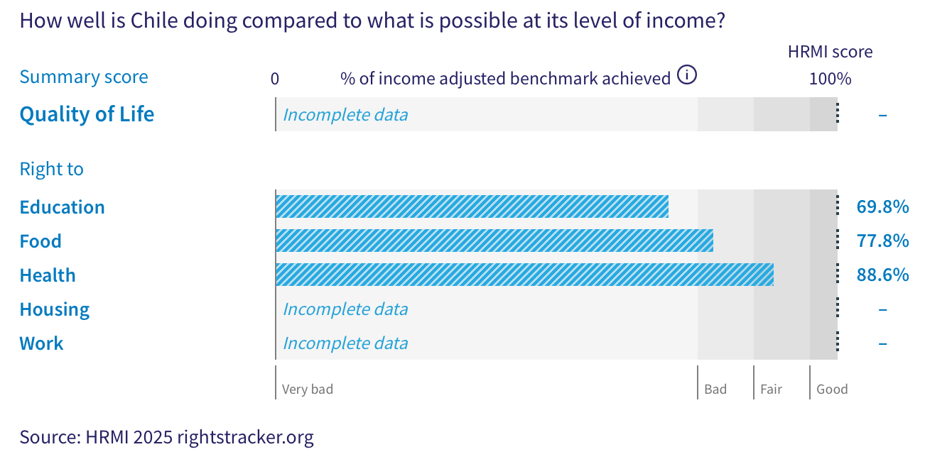
7. Chile’s scores for 2022 are as follows:
- Right to education = 69.8% (in the ‘very bad’ range)
- Right to food = 77.8% (‘bad’)
- Right to health = 88.6% (‘fair’)
- Right to housing = Incomplete data
- Right to work = Incomplete data
8. The scores available for Chile fall across the ‘very bad’, ‘bad’, and ‘fair’ ranges, with no score reaching the ‘good’ performance range.
9. We do not have an overall ‘Quality of Life’ score for Chile as there are some gaps in the international data necessary to produce all the scores. The available scores are measured against an ‘income adjusted’ benchmark, which means that they take into account Chile's resources and how well it is using them to make sure that the ‘Quality of Life’ rights of its people are fulfilled.
10. These available scores indicate that Chile is not achieving what ought to be possible with its current level of resources. Some of the scores may seem positive; however, on an ‘income adjusted’ benchmark, any score less than 100% indicates that a country is not meeting its current obligations under international human rights law. Therefore, our assessment is that Chile still has some way to go to meet its immediate economic and social rights obligations.
IV. Right to Education
11. HRMI defines the right to education in accordance with ICESCR Article 13 and CESCR General Comments 11 and 13. For high-income countries such as Chile, HRMI further breaks down the right to education into four areas of measurement: secondary school enrolment, quality of education for maths, quality of education for reading, and quality of education for science. This is measured using PISA score data from UNESCO and OECD databases. Our scores show significant challenges across the three quality of education areas with their scores falling well within the ‘very bad’ range.
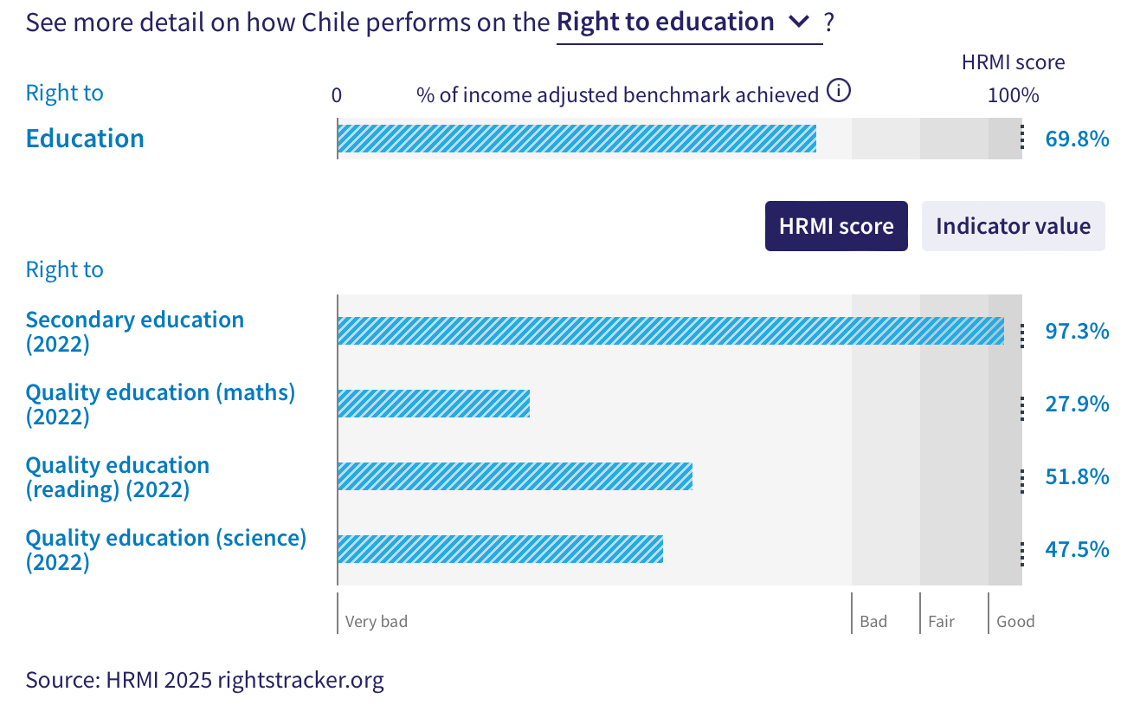
12. Chile’s score for secondary school education enrolment (adjusted for income) showed minor fluctuations between 2007 and 2012, followed by a steady increase from 87.8% in 2012 to a peak of 97.3% in 2022. According to the UNESCO database, 97.7% of children in Chile who were of upper secondary school age were enrolled in school in 2022.
13. However, in contrast to Chile’s score on the right to secondary education, the scores for the other three components—namely, quality maths education, quality reading education, and quality science education—are significantly low. Chile scores 27.9% for quality maths education, 51.8% on quality reading education, and 47.5% on quality science education, and all these scores lie well within the ‘very bad’ range.
14. The score for quality maths education is based on the OECD indicator data, which shows that only 18.8% of students in Chile were able to achieve Level 3 or higher on the PISA math test in 2022. This score largely stagnated between 2005 and 2014; however, a notable decline is observed from 38.2% in 2015 to 27.9% in 2022. It is worth noting that Chile ranks 4th lowest among 49 high-income countries on the right to quality maths education.
15. Chile’s score for quality reading education also lies in the ‘very bad’ range. This score has shown significant variations over two decades; it reached a peak of 58.6% in 2015, and steadily declined thereafter to 51.8% in 2022.
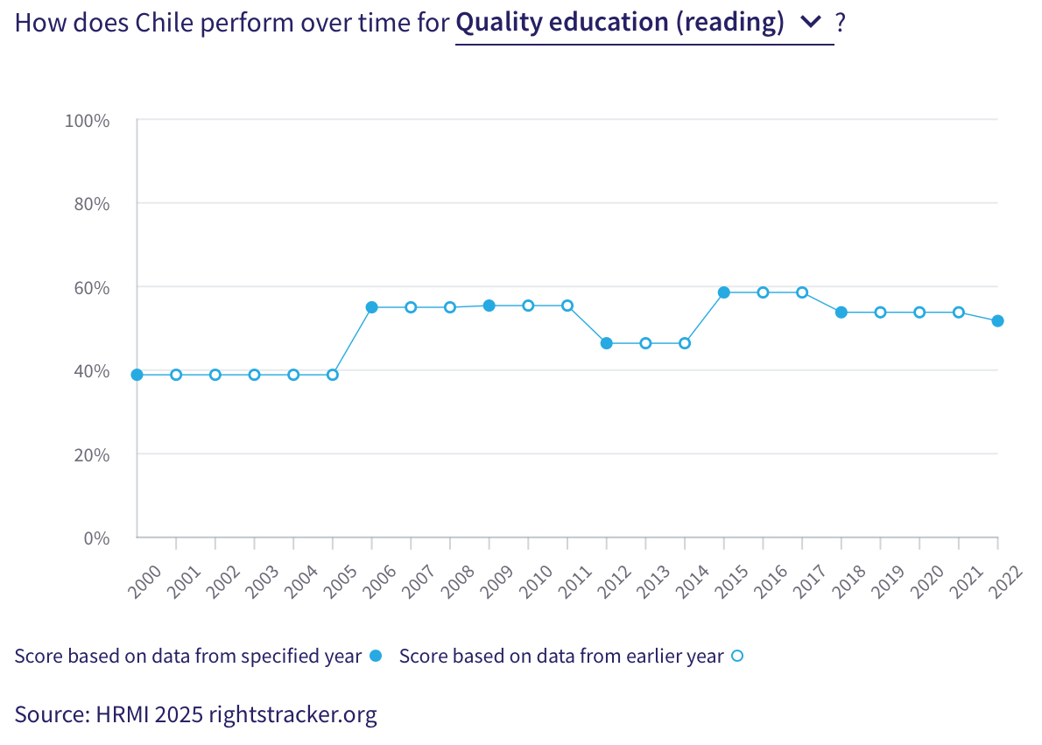
16. Chile’s score for quality science education is 47.5%, and falls in the ‘very bad’ range. This score has exhibited limited variation since 2006, with a modest increase from 46.0% in 2018 to 47.5% in 2022. Trends over the past decade reveal no marked improvement on this score.
V. Right to Food
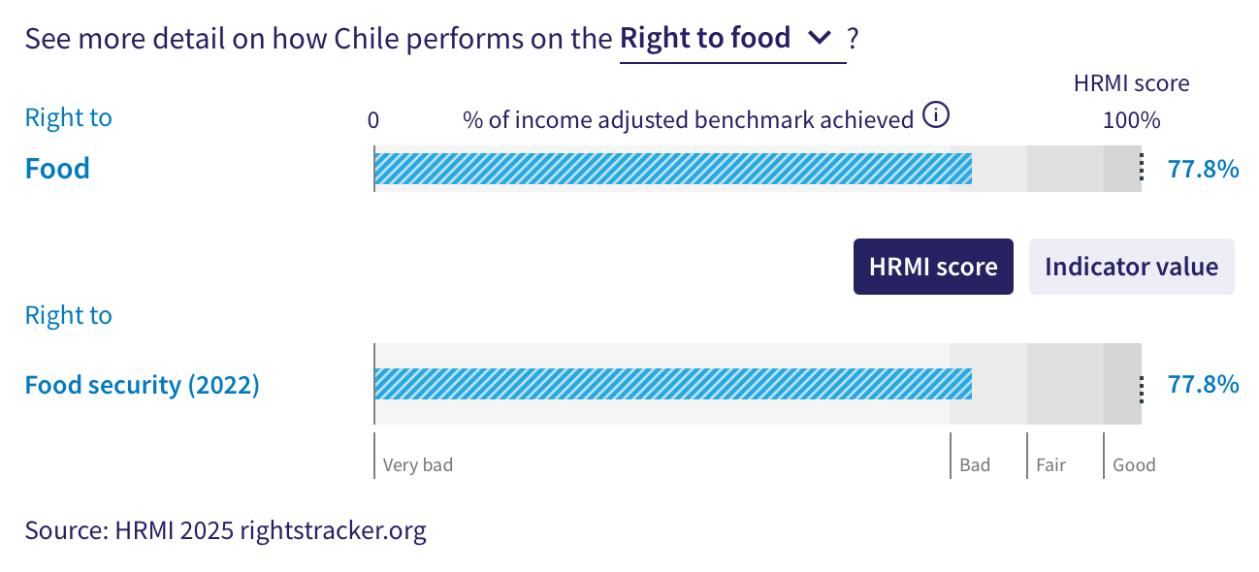
17. HRMI defines the right to food in accordance with ICESCR Article 11 and CESCR General Comment 12. For high-income countries such as Chile, HRMI measures the percentage of individuals in the population who have not experienced moderate or severe food insecurity during the reference period. This indicator value is measured on the Food Insecurity Experience Scale from FAOSTAT. Chile’s score for the right to food security is 77.8%, and falls in the ‘bad’ range. This means that Chile is doing only 77.8% of what should be possible with its existing resources to ensure the right to food security for its people.
18. Trends over time indicate a gradual decline in Chile’s score for the right to food security, dropping from 88.0% in 2015 to 77.8% in 2022, with only minor fluctuations during this period.
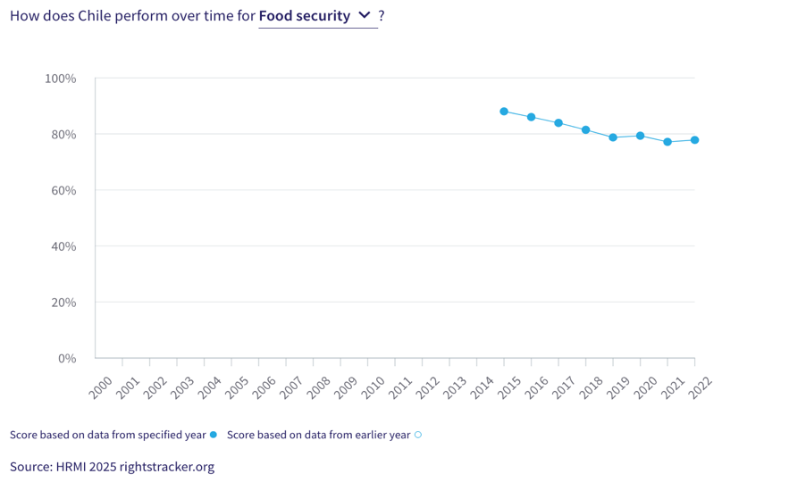
VI. Right to Health
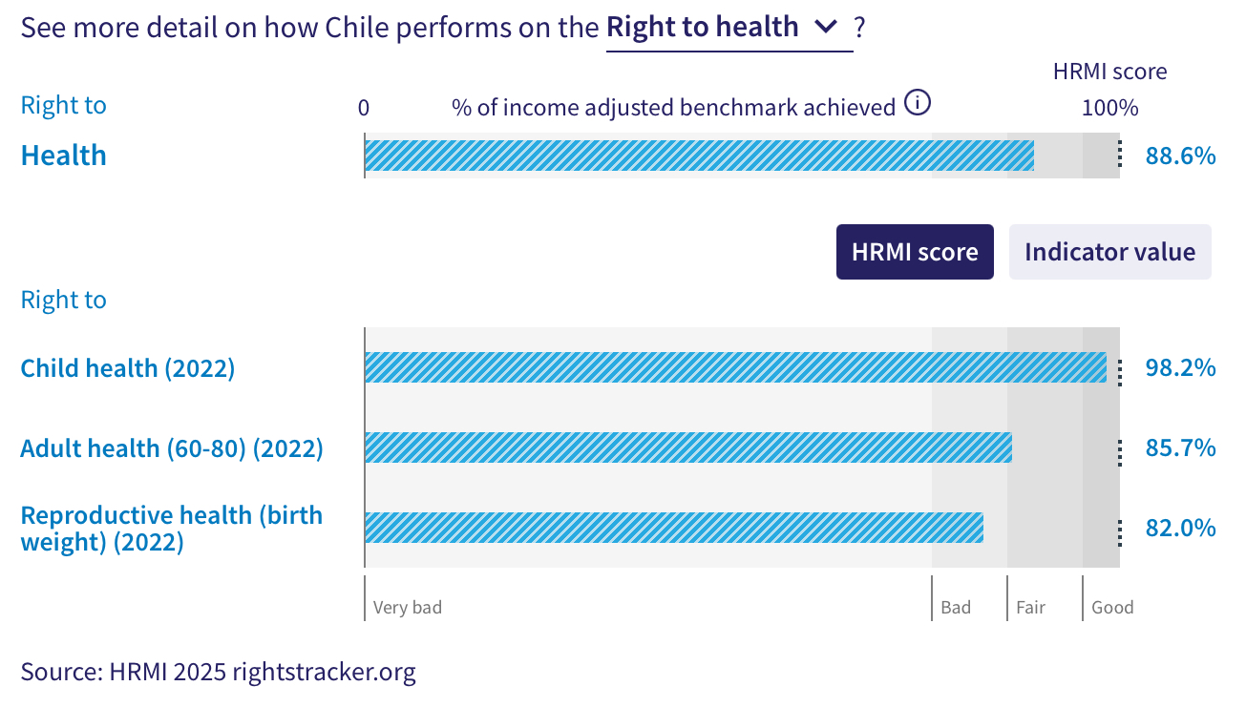
19. HRMI defines the right to health in accordance with ICESCR Article 12.1 and CESCR General Comment 14. For high-income countries such as Chile, HRMI uses three indicators to measure the country’s achievements on the right to health: percentage of children surviving to age 5, senior (60-80 years old) survival rate, and percentage of babies who do not have a low birth weight. HRMI uses data from UN IGME, UNPD, the Max Planck Institute Mortality Database, OECD, and World Bank World Development Indicators.
20. Chile has an ‘income adjusted’ HRMI score of 88.6% on the overall right to health, which means that Chile is achieving 88.6% of what should be possible at its current level of income. While this score falls in the ‘fair’ range, it has largely stagnated in recent years, with a nominal decline from 90.8% in 2019 to 88.6% in 2022.
21. Chile’s score for the right to child health falls within the ‘good’ range. It has remained relatively steady over the past two decades, rising from 96.9% in 2000 to 98.2% in 2022. Chile ranks 4th among 19 high-income countries in the Americas on the right to child health.
22. Chile has a HRMI score of 85.7% for adult health (ages 60-80), placing it within the ‘fair’ range. This score has remained relatively steady from 2000 to 2017, with only minor variations. It then declined sharply from a peak of 92.1% in 2017 to 83% in 2021, before recording a slight increase in 2022.

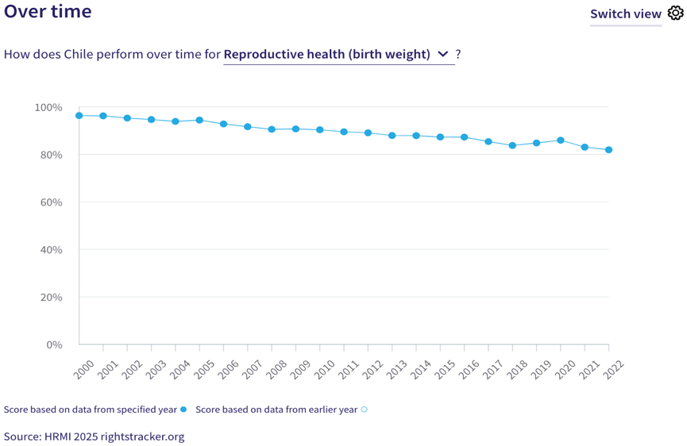
23. Chile’s HRMI score for reproductive health —measured by percentage of babies not born with low birth weight—is 82.0%, placing it in the ‘bad’ range. In contrast to other components of the right to health that have remained relatively stable, this score has undergone a slow but steady decline over the past two decades, falling from a peak of 96.3% in 2000 to 82% in 2022.
VII. Right to Housing
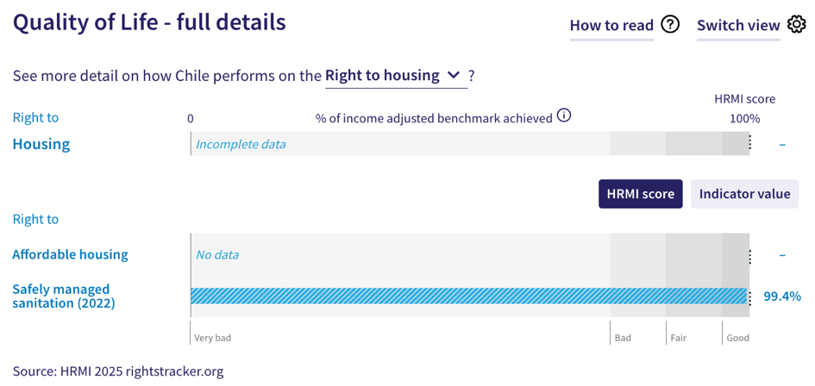
24. HRMI defines the right to housing in accordance with ICESCR Article 11.1 and CESCR General Comment 4. For high-income countries such as Chile, HRMI measures this right using two indicators: affordable housing data from Eurostats, and data on access to safely managed sanitation from the WHO UNICEF Joint Monitoring Project (JMP). We do not have a HRMI score for affordable housing for Chile, as the indicator data necessary to produce this score is not available. Therefore, we cannot produce an overall score for the right to housing for Chile.
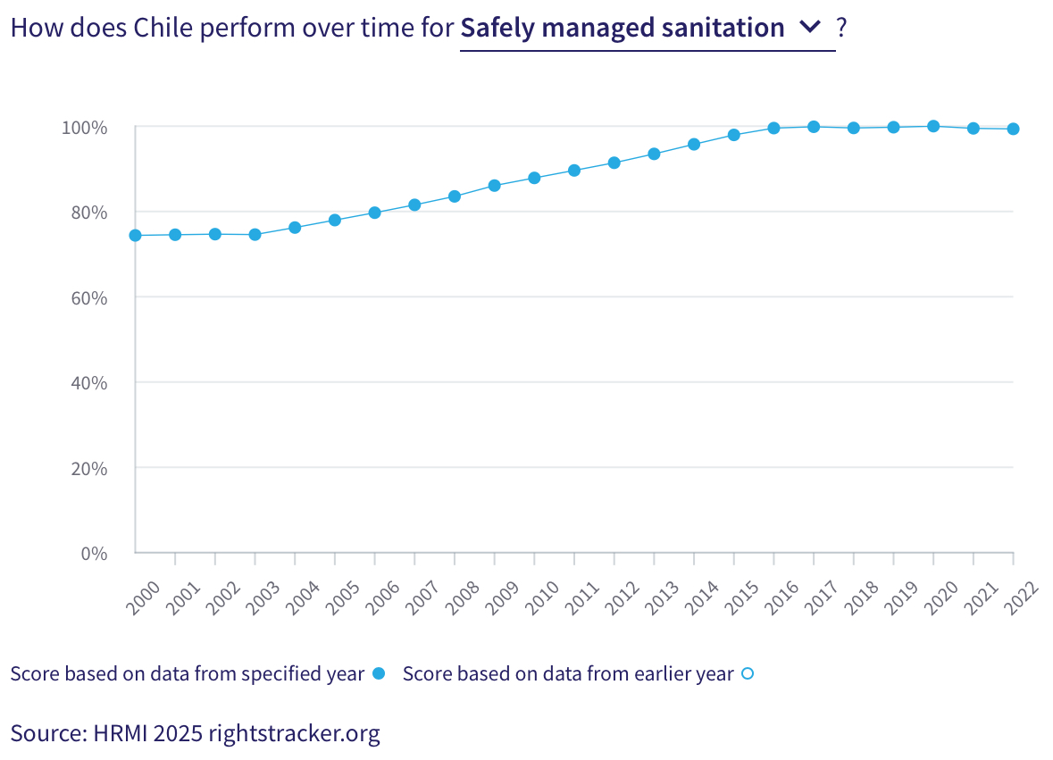
25. Chile’s ‘income adjusted’ HRMI score for the right to safely managed sanitation is 99.4%, placing it well within the ‘good’ performance range. According to the WHO UNICEF Joint Monitoring Project (JMP), 95.5% of Chile’s population had access to safely managed sanitation in 2022. Over the past two decades, this score has shown an upward trend, rising from 74.4% in 2000 to an ‘income adjusted’ 100% in 2020. Since 2016, this score has remained relatively stable, with only nominal variations. Notably, Chile ranks 10th among 52 high-income countries globally, and 1st among the six high-income countries in the Americas on this right.
VIII. Right to Work
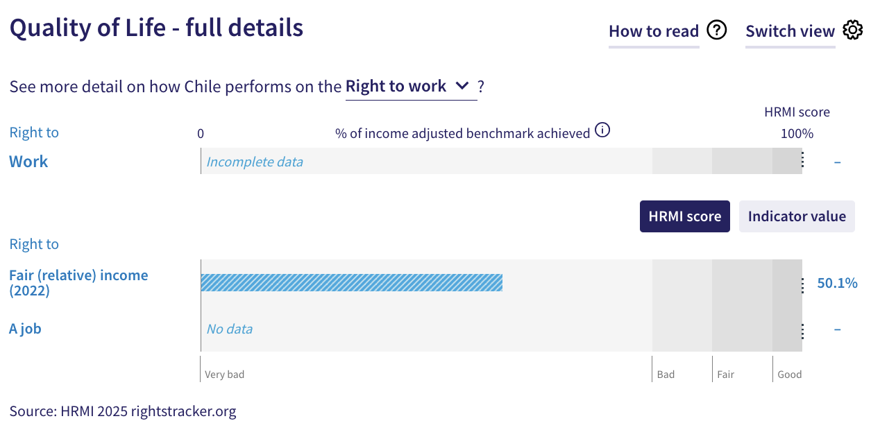
26. HRMI measures the right to work in accordance with ICESCR Articles 6 and 7. For high-income countries such as Chile, HRMI measures the right to work by drawing on data from the Luxembourg Income Study, the OECD, and World Bank PovcalNet. The indicators used to construct the HRMI score for the right to work for high-income countries are ‘how many people are not relatively poor’ and ‘the percentage of people who have not been unemployed long-term’. In the absence of a HRMI score for the right to a job, we do not have an overall score for the right to work for Chile.
27. Chile’s HRMI score for the right to fair (relative) income is 50.1%, placing it in the ‘very bad’ range. In 2022, 83.7% of people in Chile were classified as ‘not relatively poor’. Over the past two decades, this score has shown only modest variation from 42.5% in 2000 to 50.1% in 2022, without any significant improvement.
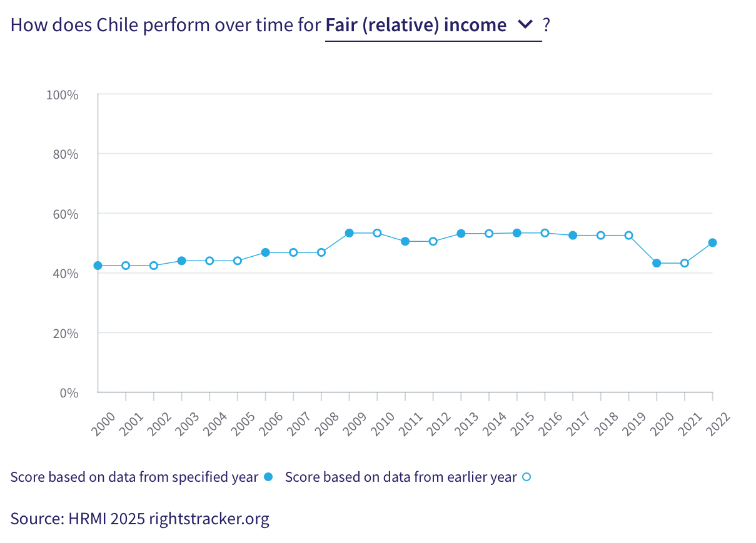
IX. Concluding Remarks
28. Chile’s strongest ‘income adjusted’ HRMI scores are for the right to secondary education, the right to child health, and the right to safely managed sanitation. All three rights fall within the ‘good’ performance range, and have remained consistently ‘good’ in the recent years, reflecting a positive trend.
29. Chile’s lowest ‘income adjusted’ HRMI scores are for the three quality components of the right to education—quality maths, reading, and science education—and for the right to fair (relative) income. All four rights have either declined or plateaued, showing no meaningful improvement in recent years.
30. Our analysis is that Chile is not constrained by resources from making improvements in areas with low scores. Rather, it has the income available, and can prioritise to put it to use to improve its people’s economic and social rights. We recommend that the Committee assure the State Party that it has the available resources to make progress, especially in the areas of quality maths, reading, and science education, as well as fair (relative) income.
31. We also recommend the following questions:
- What steps will the State Party take to enhance quality of education at all levels?
- What measures will the State Party adopt to increase the proportion of people earning a fair income and to reduce levels of relative poverty?
- What actions will the State Party undertake to ensure the continued improvement, and prevent any decline, in access to food security?
32. HRMI respectfully submits its data and findings on the fulfilment of economic and social rights in Chile. We hope that this submission will serve as a useful resource to the Committee on Economic, Social and Cultural Rights for drafting specific and meaningful questions to Chile during the CESCR’s 78th Pre-Sessional Working Group.

Visit HRMI’s website to learn more about our mission and work, https://humanrightsmeasurement.org/.
This content represents the opinions of the Human Rights Measurement Initiative. It carries no endorsement of the University of Georgia.
See HRMI’s methodology for measuring economic and social rights: https://humanrightsmeasurement.org/methodology and https://rightstracker.org/page/methodology.
Ibid.
Ibid.
HRMI 2025 Rights Tracker, https://rightstracker.org/
See Human Rights Measurement Initiative (HRMI) Digital Public Good Certificate, https://app.digitalpublicgoods.net/a/10388?
HRMI 2025 Rights Tracker, https://rightstracker.org/country/NLD?as=hi&tab=report-esr&qolFdScore=hrmi
The labels on the country charts of good, fair, bad, and very bad are used to give a general indication of how to understand the scores. HRMI’s income adjusted Quality of Life scores can be broadly interpreted as showing the percentage of the country’s obligation it has met, compared to what the best performing countries have achieved at each income level. A country scoring below 75% with a label of “Very bad” is failing to put in place the kinds of structures and policies that help people claim the right concerned, but the structures and policies in place most likely prevent many people from claiming their rights. See HRMI’s methodology for measuring human rights, https://rightstracker.org/page/methodology.
HRMI 2025 Rights Tracker, https://rightstracker.org/country/CHL
Ibid.
Ibid.
HRMI 2025 Rights Tracker, https://rightstracker.org/metric/education?tab=report-esr&qolFdScore=hrmi&as=hi&income=hi
HRMI 2025 Rights Tracker, https://rightstracker.org/country/CHL
Ibid.
Ibid.
HRMI 2025 Rights Tracker, https://rightstracker.org/country/CHL?as=hi&tab=report-esr&qolFdScore=indicator
HRMI 2025 Rights Tracker, https://rightstracker.org/country/CHL
HRMI 2025 Rights Tracker, https://rightstracker.org/metric/pisa-math?tab=report-esr&qolFdScore=indicator
HRMI 2025 Rights Tracker, https://rightstracker.org/metric/pisa-reading?income=hi
HRMI 2025 Rights Tracker, https://rightstracker.org/country/CHL?as=hi&tab=report-esr&qolFdScore=indicator
Ibid.
Ibid.
Ibid.
Ibid.
Ibid.
HRMI 2025 Rights Tracker, https://rightstracker.org/metric/under-5-survival?region=americas&income=hi
HRMI 2025 Rights Tracker, https://rightstracker.org/country/CHL?as=hi&tab=report-esr&qolFdScore=indicator
Ibid.
Ibid.
HRMI 2025 Rights Tracker, https://rightstracker.org/country/CHL?as=hi&tab=report-esr&qolFdScore=indicator
HRMI 2025 Rights Tracker, https://rightstracker.org/metric/safe-sanitation?tab=report-esr&qolFdScore=indicator&income=hi
HRMI 2025 Rights Tracker, https://rightstracker.org/metric/safe-sanitation?tab=report-esr&qolFdScore=indicator&income=hi&region=americas
HRMI 2025 Rights Tracker, https://rightstracker.org/country/CHL?as=hi&tab=report-esr&qolFdScore=indicator
Ibid.

