3 May 2021

From the European Association of Jehovah’s Witnesses

Submission to the UN Human Rights Committee
Prior to the Adoption of the List of Issues
132nd Session (28 June to 23 July 2021)

FRANCE

Contact address: Am Steinfels 1, 65618 Selters, Germany
Tel.: +49 6483 41 3802 - E-mail: jwitnesses.be@jw.org

Table of Contents

SUMMARY OF THE SUBMISSION 2
I. INTRODUCTION 3
II. Violations of the provisions of the International Covenant on Civil and Political Rights – Articles 18, 19, 21, 22, 26 and 27 4
A. Direct Attempt to Restrict the Religious Activities of Jehovah’s Witnesses by the National Authorities 5
B. Opposition to the Construction of Local and Regional Places of Worship 6
C. Vandalism of Places of Worship 7
D. Tax Exemption for Places of Worship, Legal Capacity to Receive Donations 7
E. Refusal to Rent Municipal Halls and Facilities 7
F. Refusal to Allow Ministers of Jehovah's Witnesses to Register with the Social Security Scheme for Religious Orders (CAVIMAC) 7
G. Denial of Inmates’ Right to Receive Visits of Ministers of Jehovah’s Witnesses 7
H. Discrimination at the Workplace and in the Education System 8
I. Child Custody and Child Adoption Refusals 9
J. Physical Assaults 10
III. CONCLUSION AND RECOMMENDATIONS 11

SUMMARY OF THE SUBMISSION
This submission to the Human Rights Committee (CCPR) on France highlights violations of the provisions of the International Covenant on Civil and Political Rights (the Covenant) prior to the adoption of the List of Issues to be taken up in connection with the consideration of the 6th report of France.
Jehovah’s Witnesses in France, and as a worldwide organization, respectfully request the government of France to:
- End the stigmatising of Jehovah’s Witnesses labelling them as a “sect” (French, secte) and remove any mention of them from any parliamentary lists/reports on sects and sectarian aberrations, including the:
- 22 December 1995 report entitled “Sects in France”
- 17 June 1999 report entitled “Sects and Money”
- 12 December 2006 report entitled “Stolen Childhood–Minor Victims of Sects”
- 3 April 2013 report entitled “Influence of Sectarian Movements in the Area of Health”
- 24 February 2021 report entitled “Fight Against Sectarian Aberrations”;
- Ensure that police officials prevent and promptly investigate hate speech and crimes against Jehovah’s Witnesses (physical assaults, vandalism of places of worship);
- Continue to prosecute perpetrators of criminal acts against Jehovah’s Witnesses and/or their places of worship;
- Recognise and treat Jehovah’s Witnesses as a “known religion” in accordance with their legal status established by French administrative courts, including the Conseil d’État (Supreme Court for Administrative Justice), and the recognition of their religious activities by the preeminent international human rights tribunals and bodies (for example, the European Court of Human Rights, the CCPR, the UN Human Rights Council, the European Union, and the Council of Europe’s Committee of Ministers);
- Stop the State financing of anti-sect associations, which are recognised by the authorities for their fight against so-called sects and make no distinction between dangerous sects and Jehovah’s Witnesses;
- Abide by their commitment to uphold the fundamental freedoms guaranteed by the Constitution of France and the ICCPR for all citizens, including Jehovah’s Witnesses.

INTRODUCTION
  - The European Association of Jehovah’s Witnesses (EAJW) is a charity registered in the United Kingdom. It provides support to Jehovah’s Witnesses facing fundamental human rights violations in various parts of the world.
  - The activities of Jehovah’s Witnesses in France go back to the end of the 19th century. The first local religious association was legally registered in 1906. In 1929, a national office was opened in Paris. Close to 300,000 people currently attend their meetings for worship.
  - Nonetheless, over the past three decades, various governmental agencies have consistently and egregiously labelled Jehovah’s Witnesses as a “sect” (French, secte – a seriously pejorative term in French). These agencies, principally the MIVILUDES at present, are leading a campaign of harassment and misrepresentation against Jehovah’s Witnesses. The Parliament established four parliamentary commissions on sectarian aberrations (1995, 1999, 2006 and 2012), all of which referred to Jehovah’s Witnesses. At the time, State authorities alleged that so-called sects engaged in “mental destabilisation, exorbitant financial demands, inducing people to sever ties with their home environment, bodily harm, indoctrination of children, more or less antisocial views prejudicing public order, numerous lawsuits, possible misuse of traditional financial channels and attempts to infiltrate public authorities.”
  - On 22 December 1995, the State’s anti-sect commission released its first report, entitled “Sects in France”, which listed 173 so-called sects. Jehovah’s Witnesses were the largest group named in the report. On 17 June 1999, the State’s anti-sect commission released its second report, entitled “Sects and Money,” which once again included numerous discriminatory, defamatory and false accusations about Jehovah’s Witnesses. Jehovah’s Witnesses in France contacted State officials, objecting to the inclusion of Jehovah’s Witnesses in both anti-sect reports. They also filed an application to the European Court of Human Rights (ECHR), challenging the legality of both reports. In a decision dated 6 November 2001, the ECHR held that the reports were protected from challenge by parliamentary immunity but went on to observe that such reports have “no legal effect and cannot serve as the basis for any criminal or administrative proceedings.” Subsequently, in a related 2011 judgment, the ECHR ruled in favour of Jehovah’s Witnesses (in the context of discriminatory taxation imposed on Jehovah’s Witnesses as a result of the anti-sect reports), concluding that “Jehovah’s Witnesses’ free exercise of freedom of religion is protected by Article 9 of the Convention”.
  - Despite both rulings of the ECHR, and the fact that the anti-sect reports “have no legal effect”, such reports continue to be cited by some State officials as justification for religious discrimination and human rights violations against Jehovah’s Witnesses. The primary source of that religious discrimination is the State agency MIVILUDES, which has consistently maligned Jehovah’s Witnesses for more than 25 years, tarnishing their reputation and presenting them as a dangerous sect. This has created a climate of severe religious intolerance and hostility against Jehovah’s Witnesses. Official discrimination by national and local authorities has occurred, along with countless instances of hate speech and hate crime. The present submission will provide examples of the insidious and damaging effects that such stigmatisation has had on law-abiding citizens (Part II).
  - On 25 February 2021, the French authorities released a report prepared and endorsed by the MIVILUDES, the National Police and the Gendarmerie. The report comments on “sectarian aberrations” and once again pejoratively refers to Jehovah’s Witnesses as a “sect”.
  - Furthermore, on 5 April 2021, Le Monde, one of the most respected and widely read national newspapers in France, published an article quoting Ms. Marlène Schiappa, Minister Delegate in Charge of Citizenship, attached to the Minister of the Interior, who has recently reinforced the MIVILUDES. She makes direct reference to Jehovah’s Witnesses as one of the major sects still active, along with The Order of the Solar Temple. The latter was notorious for a series of violent actions, murders and mass suicides in multiple countries in the 1980’s. This slanderous misrepresentation not only affronts the religious feelings of almost 9 million Jehovah’s Witnesses worldwide but also casts shame on our confession, which has been present and perfectly integrated into the religious landscape in France for over a century, and stigmatises tens of thousands of respectable citizens.
  - The EAJW objects in the strongest of terms to the recent and continued misrepresentation of Jehovah’s Witnesses by the MIVILUDES. Such actions by the authorities will undeniably continue to generate further discrimination and religious intolerance.
  - These recent developments are all the more shocking because during the past 30 years, the senior French administrative courts, including the Conseil d’État (Supreme Court for Administrative Justice), have systematically reaffirmed and reinforced the religious status of Jehovah’s Witnesses in France. Moreover, the ECHR has repeatedly confirmed that Jehovah’s Witnesses are a “known religion” with “an active presence in many countries world-wide, including all European States”. The ECHR, in its decision Association les Témoins de Jéhovah v. France, condemned the French authorities for violating Article 9 of the European Convention, which guarantees freedom of religion or belief. That decision ended a 16-year-long legal battle against targeted discrimination against Jehovah’s Witnesses.

Violations of the provisions of the International Covenant on Civil and Political Rights – Articles 18, 19, 21, 22, 26 and 27
  - The climate of religious intolerance and hostility against Jehovah’s Witnesses has generated countless acts of discrimination by national and local authorities. Furthermore, serious hate speech and hate crimes have been perpetrated by civil society against peaceful citizens. The Organization for Security and Co-operation in Europe (OSCE) has paid particular attention to hate crimes as among the most serious manifestations of intolerance. The EAJW has been reporting such incidents to the OSCE via the Office for Democratic Institutions and Human Rights (ODIHR) for many years.
  - It is not possible to present an exhaustive list of the types of discrimination or hate crimes that Jehovah’s Witnesses have encountered over the past 30 years or to report all incidents. The following information is intended to provide a broad overview with selected examples of the damaging effect of this religious intolerance. Manifestly, after the release of a new official report on so-called sects, the number of incidents against Jehovah’s Witnesses rises exponentially. While the examples are presented anonymously, they are all documented and based on sworn declarations.
  - The EAJW also wishes to indicate that, thanks to the assistance of domestic or international tribunals, some discrimination has ended and some violations have been addressed. In addition, it is also important to emphasize that the vast majority of the hate crimes against Jehovah’s Witnesses have been promptly and thoroughly investigated by the police and/or the gendarmerie. Jehovah’s Witnesses express their sincere gratitude for the invaluable and impartial assistance of the law enforcement authorities.
  - The following paragraphs briefly summarize the main areas of discrimination suffered by Jehovah’s Witnesses as a result of their being included in the State’s 22 December 1995, 10 June 1999 and 12 December 2006 anti-sect reports. In most cases, Jehovah’s Witnesses in France have been able to reverse some of the discrimination by bringing dozens of claims to court to vindicate their rights, which have been resolved in the Witnesses’ favour either on appeal or by an international tribunal. Doing so, however, has taken years of effort and has consumed donated financial resources and countless hours of time. Even then, despite dozens of court decisions in favour of Jehovah’s Witnesses throughout France on a host of issues related to their freedom of religion, the State agency MIVILUDES deliberately ignores those court decisions and continues to spread false, defamatory and discriminatory information about Jehovah’s Witnesses. The MIVILUDES works closely with anti-sect associations approved and largely financed by the government even though the agency spreads lies and misleading information about Jehovah’s Witnesses.

Direct Attempt to Restrict the Religious Activities of Jehovah’s Witnesses by the National Authorities
  - As noted, the first anti-sect report, which included Jehovah’s Witnesses, was published on 22 December 1995. In February 1996, during the National Assembly’s debate regarding the report, the Minister of the Budget declared: “I would like to thank the rapporteur for praising, in his excellent report, the tax authorities whose actions on several occasions resulted in a certain repression of the activity of sects ... The tax audit can therefore be the first step in a process that profoundly disrupts the sect or leads to its dissolution”.
  - The Association les Témoins de Jéhovah (ATJ) (English, Association of Jehovah’s Witnesses) was the subject of a tax audit from November 1995 to January 1999. As a result, the association was ordered to declare hand-to-hand donation for the period from 1993 to 1996. For more than 50 years, ATJ had received gifts without having them subjected to transfer tax. Traditionally, no declarations were required for modest hand-to-hand donations. However, the legislator amended the taxation system by introducing a new article establishing a tax on hand-to-hand donation that were disclosed to the tax authorities. It was accepted that this article applied only to gifts to natural persons and not to legal entities such as associations. The ATJ claimed that this law did not apply in their case and requested the exemption customarily granted to religious associations, unions of religious associations and authorized congregations. However, the Tax Services refused, maintaining that the gratuitous-transfer tax was fixed at the rate of 60 percent and that the surcharge for failure to file a declaration was fixed at 80 percent.
  - Legal action was undertaken by ATJ against the Tax Services. The domestic tribunals systematically dismissed the petitions and adopted a novel interpretation of the tax law involved in this case. For the first time, the tax audit performed by the Tax Services was assimilated as a “disclosure”. This construction created a considerable debate – and a real concern for all associations in France. The amount claimed from ATJ was more than EUR 57.5 million. Payment of this tax would have paralysed the activities of ATJ and effectively driven it to extinction.
  - An application alleging a violation of Article 9 (freedom of religion) of the European Convention on Human Rights was submitted to the ECHR, which held on 30 June 2011 that Article 9 protected Jehovah’s Witnesses’ exercise of freedom of religion. It stated: “Refusing to recognize a religious association, bringing about its dissolution, the use of derogatory language toward a religious denomination, are all examples of interference with the right guaranteed by Article 9 of the Convention.” The taxation of hand-to-hand donations in this instance had the effect of cutting off the association’s vital resources and therefore preventing its adherents from enjoying the free exercise of their worship in all practical aspects. The ECHR condemned the French government for the violation of the freedom of religion guaranteed by the Convention and awarded reimbursement and costs.
  - This was a very significant judgment of the ECHR. Nonetheless, it bears repeating that it took more than 16 years for Jehovah’s Witnesses in France to obtain a final ruling that reversed the discriminatory actions of the tax authorities, which, as the ECHR held in Association les Témoins de Jéhovah v. France, were due in large part to the inclusion of Jehovah’s Witnesses in the State’s 22 December 1995 anti-sect report.

Opposition to the Construction of Local and Regional Places of Worship
  - Local authorities have occasionally refused to issue construction permits for Jehovah’s Witnesses to build places of worship. Local officials specifically refer to the parliamentary lists of “sects”, and/or to subsequent reports mentioning Jehovah’s Witnesses, to justify their refusal.
  - Multiple official decisions have been issued by municipalities and mayors, for example:
“Taking into account the opinion of the Parliamentary Commission, which categorized the appealing association [local association of Jehovah’s Witnesses] as a sect, and that the mayor is thus obliged to use his powers to defend his view of moral standards … The Approval for the construction of a place of worship is refused.”
  - However, since numerous administrative tribunals have condemned religious discrimination of this sort, it has been observed that some municipalities have resorted to delaying the issuing of construction permits by relying on contrived technical or administrative issues.

Vandalism of Places of Worship
  - For more than a century, Jehovah’s Witnesses have operated modest places of worship in France. Acts of vandalism against these places of worship began only after Jehovah’s Witnesses were included on the Parliamentary Commission’s list of so-called sects issued in 1995. Some have been desecrated with graffiti, including swastikas and the word secte. In the worse cases, some buildings have been damaged or completely destroyed.
  - Hundreds of acts of vandalism have been reported over the past 25 years. It is noteworthy that after the release of each report by a parliamentary commission, the number of acts of vandalism drastically increases. For example, 20 acts of vandalism were reported for the year 2005. However, over the two following years (2006 and 2007), more than 200 acts of vandalism took place. This coincides with the appointment of the third parliamentarian report on so-called sects and the release of its report in 2006.
Examples of desecration of Jehovah’s Witnesses’ places of worship:
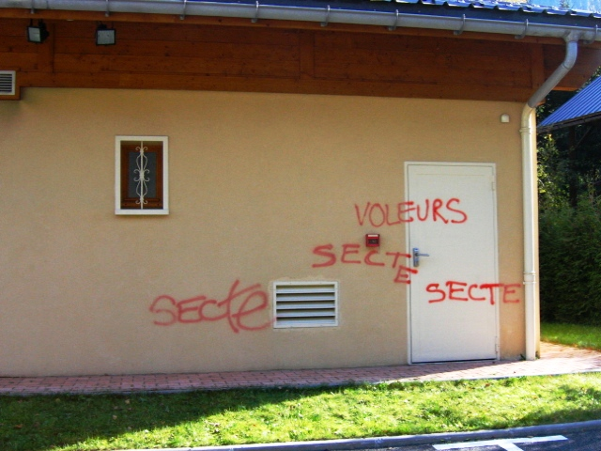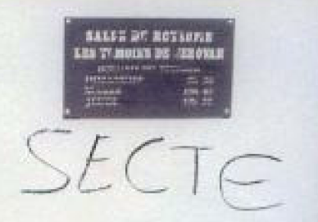

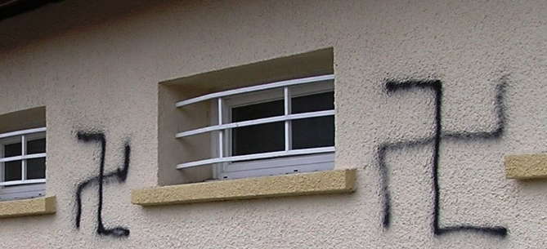

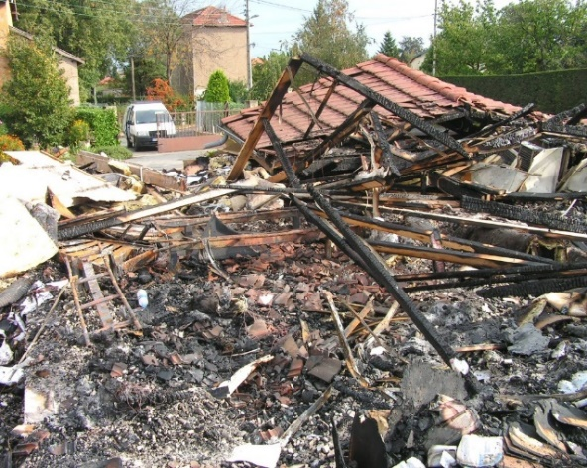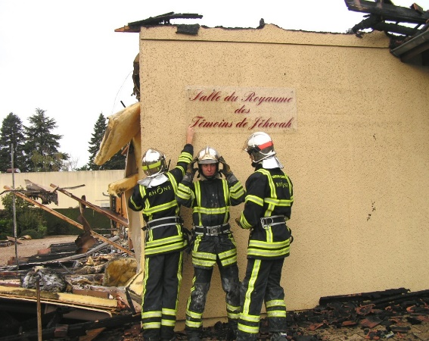

Tax Exemption for Places of Worship, Legal Capacity to Receive Donations
  - In 1993, Jehovah’s Witnesses in France received an official exemption, since their places of worship were open to the public and, like those of all other religions, should be exempt from local residence tax (Article 1407 of France General Tax Code). Since 1994, the local associations of Jehovah’s Witnesses in France asked to be exempted from the property tax on places of worship (Article 1382 of France General Tax Code) because they were registered as religious associations (Law 9, December 1905). Nonetheless, following publication of the 22 December 1995 anti-sect report, the government refused to grant Jehovah’s Witnesses this religious status (Law 9, December 1905). As a result, Jehovah’s Witnesses had to repeatedly bring court applications to confirm that they were recognised “religious associations” according to this law and that as such, they were entitled to the tax exemption for places of worship set out in Article 382 of the General Tax code.
  - In most cases, the courts sided with Jehovah’s Witnesses and ruled that their places of worship should benefit from the tax exemption provided to all other religions. It was not until two rulings of the Council of State on 23 June 2000 that the issue was definitively resolved. The Council of State rejected the anti-sect allegations made by the government against Jehovah’s Witnesses and ruled: “[T]he investigation showed that the said association had not … incited its members to commit offences, in particular that of non-assistance to a person in danger.” Therefore, it was confirmed that Jehovah’s Witnesses do not threaten public order and are not a cult (sectarian organization). From that date on, the national religious legal entities of Jehovah’s Witnesses, along with some 1,000 local religious associations, were granted the rights of “religious associations”, which confirmed their right to property tax exemption, to receive donations and bequests and also to issue receipts entitling donors to tax deductions.
  - However, once again, it took approximately 10 years to confirm this status, which was automatically granted to other religions. This 10-year period of litigation to obtain that essential status was also a direct consequence of the State’s pejorative labelling of Jehovah’s Witnesses as a “sect” in its 22 December 1995 anti-sect report.

Refusal to Rent Municipal Halls and Facilities
  - It still happens on a regular basis that local municipal authorities refuse to allow Jehovah’s Witnesses to rent a municipal hall to hold a public meeting. These refusals are often justified by a more or less direct reference to the list of sects.
  - After lengthy legal proceedings, the Council of State finally condemned these discriminatory practices. In a decision dated 30 March 2007, the Council of State ruled that a mayor’s refusal to rent a municipal hall solely on the basis of “general considerations relating to the sectarian nature of the association” constituted “a serious and blatantly illegal attack on the freedom of assembly, which is a fundamental freedom”.

Refusal to Allow Ministers of Jehovah’s Witnesses to Register With the Social Security Scheme for Religious Orders (CAVIMAC)
  - After the creation of CAVIMAC in 1978, Jehovah's Witnesses were prevented from registering their religious ministers under this specific scheme, on the grounds that they were a sect and could not benefit from it in the same way as other religions.
  - It was not until the favorable opinion of the Advisory Commission on Religious Orders, which is part of the Ministry of Health, that the CAVIMAC Board of Directors agreed in January 2003 to allow ministers of the Jehovah’s Witnesses’ religious association of France and the Christian Community of Bethelites to access this health insurance scheme, including old-age pension and disability insurance for members of religious orders.

Denial of Inmates’ Right to Receive Visits of Ministers of Jehovah’s Witnesses
  - Prior to the State’s two anti-sect reports, prison authorities had for many years allowed ministers of Jehovah’s Witnesses to visit prisons to offer spiritual guidance and counselling as prison visitors, although not having a chaplain certificate that officially recognised them as ministers of religion. This began to change in 1995 with the release of the 22 December 1995 anti-sect report, which listed Jehovah’s Witnesses as one of the so-called dangerous sects.
  - Although parliamentary reports are not legally binding, some prison administrations used the 1995 report as a basis to restrict Witness ministers’ access to inmates who requested spiritual assistance. A Witness minister could visit inmates as a prison visitor or a private citizen but not in his official capacity as a minister. He was no longer allowed to bring a Bible or any religious literature with him. All visits had to be conducted in a public visiting room in an atmosphere that was not conducive to a spiritual discussion. Some prison facilities required that inmates be strip-searched after a visit because it was not with a government-certified chaplain.
  - In an effort to obtain the same rights as certified ministers of other religions, ministers of Jehovah’s Witnesses began applying for chaplain certificates through the French penitentiary administration. All applications were categorically denied, since Jehovah’s Witnesses were among the listed sects. As a result, Jehovah’s Witnesses initiated numerous lawsuits to annul the refusals and to order the Ministry of Justice to grant chaplain certificates to Witness ministers. Every administrative court and court of appeals in the country that ruled on the matter declared that the government’s refusals were illegal. The French government not only ignored this warning and the court decisions but also lodged appeals with the Council of State, France’s highest administrative court.
  - In 2013, the Witnesses’ cases eventually came before the Council of State, which joined nine similar cases for consideration. In its 16 October 2013 decision, the Council of State rejected the appeals submitted by the French government. It ruled that in order to respect a prisoner’s rights, the Penitentiary Administration must, “as soon as the request is made, certify a sufficient number of religious ministers as chaplains, subject only to the safety and good order requirements of the facility.” Further, referring to the Constitution of France and to the European Convention on Human Rights, the Council of State declared that the “freedom of opinion, conscience and religion of incarcerated individuals is guaranteed and that they may practice the religion of their choice.”
  - Since 2014, Jehovah’s Witnesses have been included as one of seven accredited chaplaincies, and official figures from the Ministry of Justice report 170 chaplains of this faith as of 15 August 2017. However, as made clear from the above summary, it took more than six years, from 2007 to 2013, to resolve this issue through the domestic courts, all because of the discriminatory labelling of Jehovah’s Witnesses as a so-called dangerous sect in the State’s 22 December 1995 anti-sect report.

Discrimination at the Workplace and in the Education System
  - Some businesses have decided to fire excellent employees for no reason other than that they are Jehovah’s Witnesses. In some instances, co-workers sent anonymous letters to the heads of companies requesting that they fire Jehovah’s Witnesses.
  - The fact that governmental agencies issue and endorse lists or reports on so-called “sects” has emboldened some employers, contrary to French law, to ask for religious affiliation and to refuse to renew contracts of employment if the employee admits that he/she is one of Jehovah’s Witnesses.
  - To illustrate, the following clause, referring to the 1995 governmental list, was inserted in an employment contract dated April 2021:
“3.2.4. – Various duties; The Instructor certifies that he is not a member of an organization belonging to the list of sects published in the 1995 French parliamentary report (n°2468) and in its updates, whether directly or indirectly.”
  - We note and deplore the destructive effects of this list more than 25 years after it was issued, despite multiple governmental agencies and tribunals affirming that it did not have any legal effect.
  - Numerous Jehovah’s Witnesses with a position in the education system have faced severe hostility from school authorities and parents’ associations. In some instances, school authorities refused to renew their contracts of employment. For example, the regional education board issued the following official letter to one of Jehovah’s Witnesses:
“The report by the Parliamentary Inquiry Commission on sects, of June 10, 1999, confirms that Jehovah’s Witnesses are on the list of movements recognized as sects…For this reason, we cannot at present accept your request [to be approved as a maternal assistant].”
  - The following statement appeared in a tract distributed by a parents’ association:
“…we believe that it is our duty to inform you of an important fact which interferes with school life. Your child is to be supervised, this school year, by a member of the “Jehovah’s Witnesses,” that is to say, a sect. … That is why we propose that you attend a debate with us on…”
  - Some children of Jehovah’s Witnesses have been mocked and ridiculed in the school environment. Some have even undergone verbal and physical aggression from their schoolmates.
  - For example, one young Jehovah’s Witness was attacked by five pupils from his school. After referring to television programmes discussing sects and targeting Jehovah’s Witnesses, one of them violently kicked him in the face, causing a double fracture of his lower jaw. The young Witness stated:
“I had to undergo surgery and they had to immobilize my jaw with iron wire”

Child Custody and Child Adoption Refusals
  - Contrary to decisions of the ECHR, one of which involved France, some tribunals have refused to grant custody to a parent simply because he/she was one of Jehovah’s Witnesses, despite the Witness parent’s exemplary life.
  - Witness couples have been prevented from adopting children because their religious beliefs were deemed not suitable for raising a child.

Physical Assaults
  - Jehovah’s Witnesses are well-known for their public outreach in evangelising, which has been recognised by the ECHR as a legitimate exercise of the freedoms of religion and expression. However, with the stigmatisation of Jehovah’s Witnesses as a “sect”, some persons who were peacefully engaged in this activity have been threatened, insulted or physically assaulted. Some Witnesses have even suffered severe injuries.
  - In most situations, police officers have promptly and diligently investigated physical assaults, and the authorities have prosecuted such hate crimes. In very rare instances, police officers have shown prejudice or hostility toward Jehovah’s Witnesses. One chief police officer made the following outrageous comment to a female Jehovah’s Witness who went to a police station to report an assault on her person:
“It is normal that you’ve been attacked, you are one of Jehovah’s Witnesses. As for me, I don’t like Jehovah’s Witnesses. You are a sect. Perhaps I wouldn’t have put paint on your face but my foot for sure.”

CONCLUSION AND RECOMMENDATIONS
  - The EAJW expresses its grave concerns regarding the recent governmental report on “sects”, which refers once again to Jehovah’s Witnesses and has been endorsed by Ms. Marlène Schiappa, Minister Delegate in Charge of Citizenship, attached to the Minister of the Interior.
  - Representatives of Jehovah’s Witnesses in France have requested a meeting with Ms. Schiappa to open a dialogue and resolve this serious matter, which affects tens of thousands of model citizens. As of the writing of this submission, the meeting request has not been accepted.
  - The above examples illustrate the serious nature of the misrepresentation of Jehovah’s Witnesses in France and the harmful impact this has on thousands of law-abiding citizens who continue to suffer discrimination and hate crimes.
  - Jehovah’s Witnesses in France, and as a worldwide organization, respectfully request the government of France to:
- End the stigmatising of Jehovah’s Witnesses labelling them as a “sect” (French, secte) and remove their name from any parliamentary lists/reports on sects and sectarian aberrations, including the:
- 22 December 1995 report entitled “Sects in France”
- 17 June 1999 report entitled “Sects and Money”
- 12 December 2006 report entitled “Stolen Childhood–Minor Victims of Sects”
- 3 April 2013 report entitled “Influence of Sectarian Movements in the Area of Health”
- 24 February 2021 report entitled “Fight Against Sectarian Aberrations”;
- Ensure that police officials prevent and promptly investigate hate speech and crimes against Jehovah’s Witnesses (physical assaults, vandalism of places of worship);
- Continue to prosecute perpetrators of criminal acts against Jehovah’s Witnesses and/or their places of worship;
- Recognise and treat Jehovah’s Witnesses as a “known religion” in accordance with their legal status established by French administrative courts, including the Conseil d’État (Supreme Court for Administrative Justice), and the recognition of their religious activities by the preeminent international human rights tribunals and bodies (for example, the European Court of Human Rights, the CCPR, the UN Human Rights Council, the European Union, and the Council of Europe’s Committee of Ministers);
- Stop the State financing of anti-sect associations, which are recognised by the authorities for their fight against so-called sects and make no distinction between dangerous sects and Jehovah’s Witnesses;
- Abide by their commitment to uphold the fundamental freedoms guaranteed by the Constitution of France and the ICCPR for all citizens, including Jehovah’s Witnesses.
  - The EAJW will consider submitting an additional complimentary submission with the CCPR after the List of Issues has been adopted.

Kokkinakis v. Greece, 25 May 1993, § 23, Series A, no. 260-A.
The Observatoire interministériel sur les sectes (Interministerial Observatory of Sects) was created on 9 May 1996 and was renamed Mission interministérielle de lutte contre les sects, or MILS (Interministerial Mission on the Fight Against Sects), in October 1998. In November 2002, the French authorities established by presidential decree the Mission interministérielle de vigilance et de lutte contre les dérives sectaires, or MIVILUDES (Interministerial Mission of Vigilance and Combat Against Sectarian Aberrations).
Fédération Chrétienne des Témoins de Jéhovah de France v. France, no. 53430/09, 6 November 2001 (Dec).
Fédération Chrétienne des Témoins de Jéhovah de France v. France, no. 53430/09, 6 November 2001 (Dec).
Association Les Témoins de Jéhovah v. France, no. 8916/05, 30 June 2011, paras. 9-10, 50-51.
Manoussakis and Others v. Greece, no. 18748/91, 26 September 1996, para 40.
Jehovah’s Witnesses of Moscow and Others v. Russia, no. 302/02, 10 June 2010, para 155.
Association Les Témoins de Jéhovah v. France, no. 8916/05, 30 June 2011 and 5 July 2012.
Association Les Témoins de Jéhovah v. France, no. 8916/05, 30 June 2011.
CE, 23 June 2000, no. 215109, Minister of Economy, Finance and Industry c/ ALCTJ of Clamecy; CE, 23 June 2000, no. 215152, Minister of Economy, Finance and Industry c/ ALCTJ of Riom. AJDA, 20 July/20 August 2000, pp. 597-602, 671, 672; Dr. fisc. 2000, no. 30-35, p. 1100-1104; RDP, 2000, no. 6, p. 1825-1849; RTDH, October 2001, no. 48, pp. 1208-1219.
CE, 30 March 2007, City of Lyon, no. 304053.
The acronym stands for Caisse d’Assurance Vieillesse, Invalidité et Maladie des Cultes (English, Retirement, Disability and Sickness Insurance Fund of Religion; social protection)
Council of State, 16 October 2013, No. 351115, Garde des Sceaux, Minister of Justice and Freedoms v. M. F. and others; Actualité juridique Droit administratif, 21 October 2013, p. 2007; La Gazette du Palais, no. 303-304, 30, 31 October 2013, p. 28; Recueil Dalloz, no. 37, 31 October 2013, p. 2469; The Letter from the Human Rights Defender, no. 3, December 2013, p. 15.
“Worship practices and organization in detention,” Ministry of Justice, 14 February 2018, http://www.justice.gouv.fr/prison-et-reinsertion-10036/la-vie-en-detention-10039/culte-12002.html
Palau-Martinez v. France, Application no. 64927/01.
Kokkinakis v. Greece, 25 May 1993, § 48, Series A no. 260-A.
Kokkinakis v. Greece, 25 May 1993, § 23, Series A no. 260-A

