Follow-Up NGO report regarding
recommendations made to Australia
by the CEDAW Committee in July 2018

This NGO follow-up report has been coordinated by the Equality Rights Alliance (ERA), the Harmony Alliance (Harmony) and the National Aboriginal and Torres Strait Islander Women’s Alliance (NATSIWA). It is endorsed in whole or in part by the 28 organisations listed in annexure A.

ERA, Harmony and NATSIWA appreciate the opportunity to provide this update on Australia’s progress in implementing the recommendations made by the CEDAW Committee in its 2018 report on Australia’s progress on implementing the Convention on the Elimination of Discrimination Against Women.

ERA, Harmony Alliance and NATSIWA would like to thank Jesuit Refugee Service Australia, Children by Choice, Women’s Legal Services Australia, Australian Women Against Violence Alliance, National Rural Women’s Coalition, Marie Stopes Australia, National Foundation for Australian Women, International Women’s Development Agency, Zonta District 22 and Jessie Street Library for contributing text and editorial suggestions.

Recommendation 12(b)

This recommendation has not been implemented.

The Australian Constitution fails to recognise and protect Aboriginal and Torres Strait Islander rights as the first people of the country. As the Australian Human Rights Commission has noted, the Racial Discrimination Act 1975 (Cth) (RDA) has been compromised on three occasions: each time it has involved Aboriginal and Torres Strait issues. For example, the Constitution did not prevent the suspension of the RDA during the Northern Territory Emergency Response. Therefore, it was ineffective in protecting Aboriginal and Torres Strait Islander women and men from the most fundamental of all freedoms, the freedom from discrimination.

The Australian Constitution does not make adequate provision for Aboriginal and Torres Strait Islander women and men. The 2017 Uluru Statement called for constitutional recognition and a Makarrata Commission or a Treaty, Truth and Justice Commission. Australia is the only former British colony without a treaty with its Indigenous people. The inclusion of Aboriginal and Torres Strait Islander peoples in the Australian Constitution would in turn highlight the Australian Government’s obligation to achieve national reconciliation and to ensure the well-being of Aboriginal and Torres Strait Islander peoples and especially for the women. A constitutional recognition would bring Australia into line with the UN Declaration on the Rights of Indigenous Peoples and see it move closer to the position in other former British colonies, including Canada and New Zealand, where States enter into treaties with Indigenous peoples with the purpose of conferring a wider margin of autonomy on them.

Recommendation 46(b)

This recommendation has not yet been implemented.

Between the 2018 CEDAW committee recommendations and the current period, the operating environment for and the demands on the Federal Government have shifted significantly. The 2017-2020 drought, the 2019-20 bushfires and the COVID-19 pandemic have focussed critical attention on the health and resilience of Australia’s social and economic systems.

However, despite clear evidence about the different impacts of natural disasters and COVID-19 on men and women in Australia and the Government’s clear acceptance that the long-term economic and social effects of COVID-19 will fall hardest on women, the federal infrastructure for directing and allocating grant funding still lacks a commitment to encouraging the funding of specialist women’s services or feminist organisations, with no indication from the 2020 budget that additional spending on programs aimed at alleviating gender inequality will be allocated with a focus on increasing the proportion of funding allocated to specialist women’s organisations or organisations focussed on the rights of Aboriginal and Torres Strait Islander women.

One notable example of this trend occurred in May 2020, when the federal government announced an additional $63.3 million in funding for front line legal assistance services, including $49.8 million to provide services during and in response to COVID-19. This funding was warmly welcomed, particularly as 40% of the funding ($19.9 million) was quarantined to be allocated to services addressing domestic violence. Identifying and allocating funding to key areas of gender inequality in this manner is strongly supported. However, $3.4 million of the $48.8 million (7%) was allocated to women’s legal services and $7.9 million (16%) was granted to National Aboriginal and Torres Strait Islander Legal Services, while $18.2 million (37%) of the funding was granted to Legal Aid Commissions, which have no specific focus on the rights of women. In Tasmania only one third of the funding allocated to community legal services was allocated to women’s legal services, while two thirds was allocated to other community legal services without the same gender expertise. Only small amounts were allocated to community-controlled services working with particularly marginalised groups. In NSW some community-controlled organisations received as little as $3000 in additional funding. Further, national costings indicate an additional $25 million per year is needed simply to address the pre-COVID volume of requests for assistance received by specialist women’s legal services.

The 2020 Women’s Economic Security Statement (WESS20) (which accompanied the 2020 federal budget in October) announced a welcome $240.4 million in funding for a range of initiatives, primarily targeted at women’s employment. This is an increase in spending from the 2018 Women’s Economic Security Statement (WESS18), which contained spending of $109 million over four years. However, it is yet to be seen whether the initiatives included in the 2020 Statement will provide any funding to specialist women’s services or feminist organisations.
The federal budget for 2020 saw the first increase to Australia’s Official Development Assistance (ODA) budget in 7 years, with the allocation of $304.7 million in new grant-based funding to projects supporting COVID-19 response and recovery in the Pacific and Timor Leste. DFAT’s standing gender equality fund also received a welcome increase of $10 million. However, just 5% of Australia’s ODA is dedicated to programs where gender equality is the principle objective, and less than 1% of Australia’s ODA reaches women’s equality organisations and institutions (as defined by the OECD’s Development Assistance Committee). It will be critical for DFAT to consult with local women’s rights groups to ensure that the new funding will be accessible to local women’s rights organisations.

Other problematic issues relating to funding for women’s specialist services have continued. In some cases, existing funding to specialist women’s organisations has decreased in real terms, as funding has not been adjusted for inflation or indexed to the Consumer Price Index (CPI). For example, the six National Women’s Alliances did not receive any CPI increase to their funding between 2016 and 2020. In 2020, an additional $4,500 was provided to each of the six Alliances, but the renewed contract was only for a term of 10 months and will expire on 31 March 2021.

Another recurring issue arises from the practice of allocating funding to women’s specialist services on short term contracts, which creates uncertainty and limits the ability of services to engage in long term change work or build deep relationships in communities. For example, the National Women’s Alliances model has been in operation since 2008 and has a mandate to build robust community networks and engage in consultation and long-term change advocacy but are consistently funded on three-year contracts. The inadequacy of these contract terms is demonstrated by the fact that the last three contracts (2010-2012, 2013-16 and 2017-2020) have all been extended by variation in the last year of the contract at the Federal Government’s request.
We draw the Committee’s attention to the lack of progress against Recommendation 16 in the 2018 Concluding Observations. There is no comprehensive national gender equality policy in Australia. The Australian Government does not adequately apply a gender analysis to policy and spending proposals and does not engage in gender responsive budgeting.

In our view, improvement will be seen in achieving Recommendation 46(b) once Recommendation 16 has been implemented. We note the positive example set by the Victorian Gender Equality Act 2020 and propose that all Australian Governments introduce legislation which includes specific expenditure targets for gender equality and national women’s machineries, and commitments to gender responsive budgeting and policy development.
Recommendation 50(a)

This recommendation has been partially implemented.
Since the Committee’s recommendations were published in 2018, abortion has been decriminalised in New South Wales and Queensland. This means both medication and surgical abortion have been decriminalised in all jurisdictions in Australia with the exception of South Australia, where abortion is not lawful after 28 weeks gestation. A Bill to decriminalise abortion is currently before the South Australian Parliament and is expected to be debated in November 2020.

Despite progress on the decriminalisation of abortion, access to abortion services varies significantly across the country, with rural and remote communities generally having no locally available services. Most publicly funded services are located in capital cities and although Australia’s public health service (Medicare) covers some of the costs, all surgical procedures result in at least some out of pocket expenses for women. Even in capital cities, many public hospitals do not provide abortion services. In South Australia, 95% of abortion services are provided at no cost through the public hospital system but other jurisdictions have severely restricted public access. In jurisdictions where public access is generally available, access is not equitable for people ineligible for Medicare, for example due to visa status.

Legislation to create safe access zones around health facilities providing abortion services has been implemented in every Australian jurisdiction with the exception of Western Australia. There is significant variation in each safe zone framework. A Bill to implement safe zones in Western Australia is currently before the Western Australian Parliament.

During the COVID-19 outbreak in Australia, access to Medicare-subsidised telehealth was increased significantly. This was highly beneficial to women in remote and rural Australia, facilitating access to medical support which would otherwise have been unavailable. The success of the scheme led to the Federal Government extending elements of the subsidies for telehealth sessions to March 2021. However, the extended scheme hinders sexual and reproductive healthcare access in Australia by requiring most patients to have had a consultation with the relevant General Practitioner (GP) or medical practice at least once in the past year. Many GPs work in clinics that do not offer specialist sexual and reproductive health services, have not completed the additional training required to provide specific sexual and reproductive health services or conscientiously object to providing sexual and reproductive health services, requiring the patient to seek treatment from a specialist practice which they have not previously visited.

Access to information about sexual and reproductive health rights in Australia is patchy. The Australian Curriculum provides broad guidance on the areas to be covered in schools regarding relationships and sexuality but does not use a human rights-based framework or language. The Australian Curriculum does not specify any sexual and reproductive education beyond year 10 (16-17 years). States are free to interpret the broad headings in the Australian Curriculum, with the result that the information provided can vary significantly by geographic location. For example, in the Australian Capital Territory, all public (ACT government funded) schools follow a single curriculum based on the Australian Curriculum, in the Northern Territory, individual schools make decisions about what will be taught within the scope of the Australian Curriculum. In Queensland public schools sex education is not compulsory for students while in Victoria respectful relationships education is compulsory. Similar programs are available in many other States and Territories but are not compulsory.
Recommendation 54(b)
This recommendation has been partially implemented.

Since the CEDAW committee’s recommendation in 2018, Australia has removed most women and girls from offshore detention centres, however, two women still remain in precarious situations offshore, including a Tamil woman held on Christmas Island along with her family. Despite the CEDAW committee’s recommendation to stop processing asylum claims at sea, Australia currently conducts screening at sea resulting in asylum seeking women and girls not being permitted access to onshore procedures.

Many women and girls also remain in mandatory onshore detention and women and girls are subjected to inadequate refugee status determination procedures. On 31 August 2020, there were 55 women and 1,488 men in detention facilities in Australia. There were also over 200 women in community detention in Australia. However, this number has greatly reduced between Sept-Nov 2020 due to single women, single mothers with children, and women within family groups being forced on to final departure bridging visas and exited from community detention without housing or income support, putting women at greater risk. Refugee and asylum-seeking women—both in and out of detention—experience sexual and gender-based violence and challenges to accessing critical health and well-being services.

Despite the CEDAW committee’s recommendation to “repeal provisions on the mandatory detention of asylum seekers and ensure, in the interim, that detention is used only as a last resort”, mandatory detention is used routinely in Australia, not only as a last resort. Women, girls, and LGBTIQ persons are routinely placed in detention despite clearly established risks to their safety and well-being.

The CEDAW committee recommended to ensure that “all women and girls seeking asylum have access to gender-sensitive and fair refugee status determination processes within the territory and to legal representation and legal remedies”. However, this is still not the case, as offshore processing, airport screening and interception at sea still prevent women and girls from accessing asylum procedures onshore. Detention for an indefinite period of time is legal in Australia. Long timeframes for refugee status determination are extremely cumbersome and deprive asylum seeking girls and women of their fundamental right to freedom and safety for extended periods. Moreover, asylum seeking girls and women lack access to culturally responsive and age-appropriate legal representation and remedies.

Sexual and gender-based violence against asylum-seeking women and girls is a significant problem in Australia. This violence does not happen only in detention centres, but within community areas as well and it is often invisible and underreported. The CEDAW committee recommended to “ensure that all immigration facilities under the responsibility of the State party adhere to standards for the prevention of sexual and gender-based violence, instigate all complaints of sexual and physical violence against women and girls, including rape, bring perpetrators to justice and guarantee that they are punished, and provide redress and adequate compensation to victims”. Despite this, Australia’s prevention and response mechanisms for sexual and gender-based violence against refugees and asylum seekers remain insufficiently resourced and burdensome for the victims/survivors. There is currently no Government-led response or procedures for women and girls who have experienced SGBV in offshore detention, including access to justice.

Reporting of sexual and gender-based violence by asylum-seeking women and girls is very low due to lack of appropriate information about their rights, fear of detention and removal and migration status dependent on perpetrators. Sexual and gender-based violence also includes emotional abuse and coercive control which is often neglected by the authorities. Women dependent on their male family members for their refugee status determination procedures are more vulnerable due to lack of independent visa pathways and are less likely to report violence. Women who have experienced domestic and family violence struggle to separate their protection visa applications from their partners and decision makers often do not recognise that women may be at greater risk of further violence if forced to return home after a negative refugee status decision. LGBTIQ asylum seekers are disproportionately affected by sexual and gender-based violence in detention centres as well as within the communities. Sexual and gender-based violence responders are often not trained in culturally appropriate responses and trauma informed approaches to provide safe services to asylum seeking women and girls. Due to lack of appropriate and accessible legal information and services, victims and survivors also find it hard to seek legal redress for sexual and gender-based violence against them and ultimately, to access justice.

The CEDAW committee recommended to guarantee that “all refugee and asylum-seeking women and girls who are under the responsibility of the State party have access to comprehensive, adequate and accessible sexual and reproductive health services and information, including to emergency contraception and abortion services, on its territory”. The CEDAW committee also recommended that “refugee and asylum-seeking women and girls have unconditional access to gender, age, culture and language-appropriate social, education, mental and physical health services on the territory of the State party”. Australia is failing to provide adequate sexual and reproductive health, physical and mental health services to all asylum-seeking women and girls. Australia’s detention policies have been demonstrated to cause serious harm to the physical and mental health of women. Furthermore, women transferred from Nauru to Australia, some of them survivors of SGBV, remain without access to adequate gender responsive services or long-term solutions.

In particular, those who are placed on temporary or bridging visas while waiting for their refugee status determination cannot access appropriate healthcare services. Even when asylum seeking women and girls have access to public healthcare via Medicare, they are not provided age, culture and language appropriate information about their rights and availability of essential services. Transgender women are often left out in provision of essential sexual and reproductive health services. Asylum-seeking women’s and girls’ health and well-being is also undermined due to lack of childcare options available to them and associated economic costs of seeking appropriate healthcare.

Annexure A
This report is endorsed by the following organisations in whole or in part:

Women’s Safety Services SA (WSSSA)
Embolden SA Inc.
Refugee Council of Australia
Multicultural Youth Affairs Network NSW
Australian Muslim Women’s Centre for Human Rights
Asylum Seekers Centre
Association for Services to Torture and Trauma Survivors (ASeTTS)
National Ethnic Disability Alliance (NEDA)
Food For Thought Network
Welcoming Australia
Sydney Multicultural Community Services Inc.
National Refugee-led Advisory and Advocacy Group (NRAAG)
Centre for Asylum Seekers, Refugees and Detainees (CARAD)
Jesuit Refugee Service Australia
Circle Green Community Legal

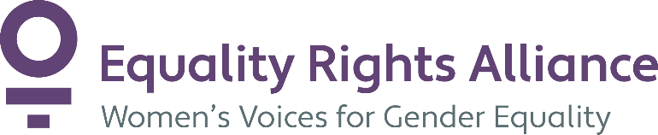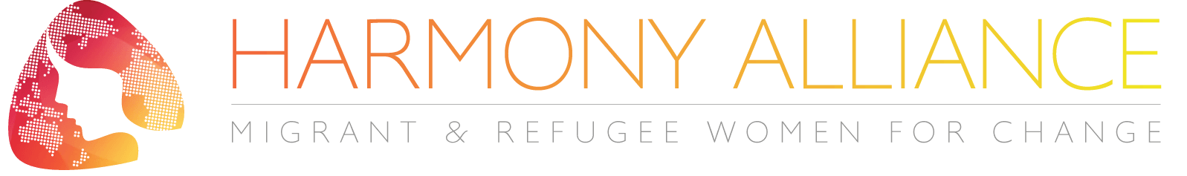
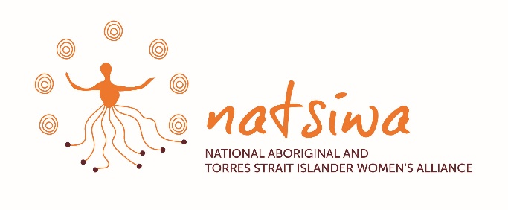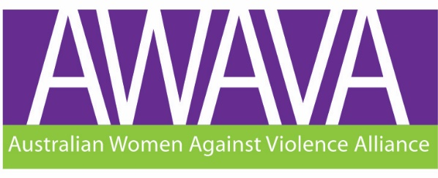

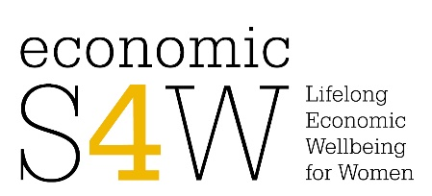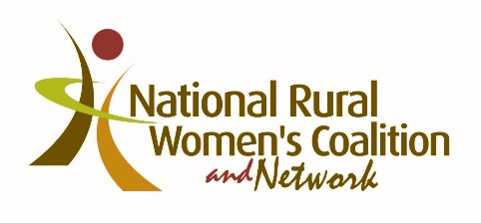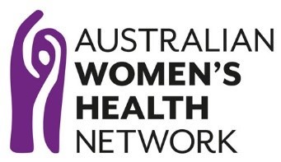
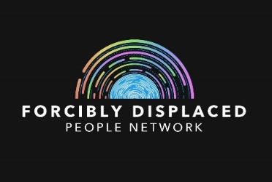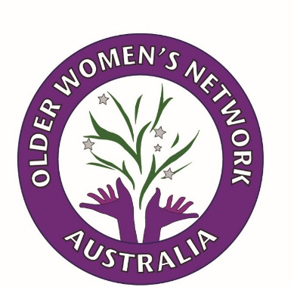
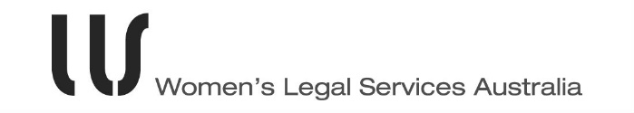



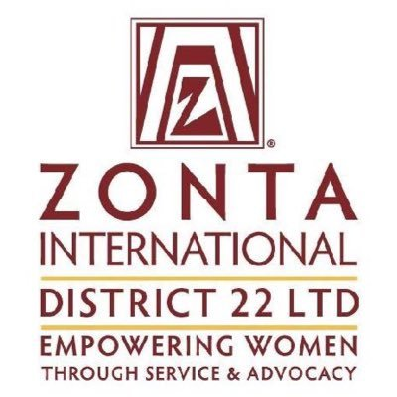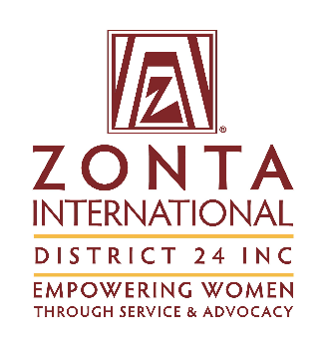

Australian Human Rights Commission Constitutional reform: Fact Sheet – Recognising Aboriginal & Torres Strait Islander people in the Constitution available at https://humanrights.gov.au/our-work/constitutional-reform-fact-sheet-recognising-aboriginal-torres-strait-islander-people
Ibid
The Uluru Statement was agreed through a process designed and led by Aboriginal and Torres Strait Islander people which included Australia’s largest ever national consultation and negotiation with Aboriginal and Torres Strait Islander people. It calls on the Australian Government to reform the Australian Constitution to give Aboriginal and Torres Strait Islander people Voice, Treaty and Truth by enshrining a Voice to Parliament and establishing a Makarrata Commission.
Siegfried Wiessner, ‘Rights and Status of Indigenous Peoples: A Global Comparative and International Legal Analysis’ (1999) 12 Harvard Human Rights Journal 57, 66–71.
See: http://www.wlsa.org.au/media_releases/dv_advocates_welcome_much_needed_funding_for_legal_assistance_services
Legal and Constitutional Affairs Legislation Committee, Attorney General’s Portfolio, Senate Estimates, Hansard, 21 October 2020 accessed at: https://parlinfo.aph.gov.au/parlInfo/search/display/display.w3p;db=COMMITTEES;id=committees%2Festimate%2Fa1ae9e40-73dd-4b84-8309-ee11c9cfbe09%2F0002;query=Id%3A%22committees%2Festimate%2Fa1ae9e40-73dd-4b84-8309-ee11c9cfbe09%2F0001%22
AWAVA Brief on the funding needs for prevention and responses to all forms of violence against women and their children
Women’s Legal Services Australia, Evidence at Senate Select Committee on COVID-19 hearing, 22 September 2020 accessed at https://parlinfo.aph.gov.au/parlInfo/search/display/display.w3p;db=COMMITTEES;id=committees%2Fcommsen%2F2b3e9814-f02c-4753-87b5-d2351761bd4e%2F0001;query=Id%3A%22committees%2Fcommsen%2F2b3e9814-f02c-4753-87b5-d2351761bd4e%2F0000%22
$3.3 million in new funding was allocated for the Australian Taxation Office to develop an electronic information-sharing system, as part of the WESS18. The implementation deadline was July 2020 but the scheme has not been designed or implemented to date. The scheme will ensure that the family law courts will be able to access superannuation information directly from the ATO, overcoming delays and problems with non-disclosure of superannuation information by perpetrators of family violence. If implemented women will be able to gain access to their fair share of superannuation entitlements after relationship breakdown leading to improved financial outcomes for women in Australia.
DFAT, 2020, Performance of Australian Aid 2018-19, https://www.dfat.gov.au/sites/default/files/performance-of-australian-aid-2018-19.pdf; OECD DAC, 2020, Aid in Support of Gender Equality and Women’s Empowerment, http://www.oecd.org/development/financing-sustainable-development/development-finance-topics/Aid-to-gender-equality-donor-charts-2020.pdf
National Foundation of Australian Women Gender Lens on the Budget 18 October 2020 available at https://nfaw.org/gender-lens-on-the-budget/gender-lens-on-the-budget-2020-2021/
In Recommendation the Committee recommended that the Australian Government ‘…adopt a comprehensive national gender equality policy with performance indicators to address the structural factors resulting in inequalities between men and women and ensure that the Office for Women has a strong mandate and sufficient human and financial resources to coordinate and monitor the implementation of this policy throughout the territory of the State party’.
Available at https://www.legislation.vic.gov.au/as-made/acts/gender-equality-act-2020
For more information about barriers to access to abortion in Australia, see https://findanexpert.unimelb.edu.au/news/9075-early-medical-abortion-is-legal-across-australia-but-rural-women-often-don't-have-access-to-it and https://findanexpert.unimelb.edu.au/news/9075-early-medical-abortion-is-legal-across-australia-but-rural-women-often-don't-have-access-to-it and https://www.abc.net.au/news/2019-05-03/abortion-access-depends-on-postcode-and-income/11073648
Pregnancy Outcome Unit, Wellbeing SA Pregnancy Outcome in South Australia 2017 October 2019 pg. 2 Available at: https://www.sahealth.sa.gov.au/wps/wcm/connect/5a2705b2-1034-4c1b-8420-095d076a28bf/Pregnancy+Outcome+in+South+Australia+2017+V1+Feb.pdf?MOD=AJPERES&amp;CACHEID=ROOTWORKSPACE-5a2705b2-1034-4c1b-8420-095d076a28bf-niRlNXa
See Caitlin Holmes and Elanor Taylor Safe Access Zones in Australia – Legislative Considerations 2020 Marie Stopes Australia available at https://awava.org.au/wp-content/uploads/2020/10/Safe-Access-Zones-in-Australia.pdf
The Australian Curriculum ‘…addresses physical, social and emotional changes that occur over time and the significant role relationships and sexuality play in these changes. The content supports students to develop knowledge, understanding and skills that will help them to establish and manage respectful relationships. It also supports them to develop positive practices in relation to their reproductive and sexual health and the development of their identities. In doing so, students will gain an understanding of the factors that influence gender and sexual identities.’ See Relationships and Sexuality, The Australian Curriculum, available at https://www.australiancurriculum.edu.au/f-10-curriculum/health-and-physical-education/structure/
For a breakdown of the curricula in each State, see Roberts, Lauren Push to Introduce Mandatory Unified Sexual Consent Lessons in Australian Schools ABC News Online 29 February 2020 available at: https://www.abc.net.au/news/2020-02-29/australian-schools-on-how-they-teach-kids-consent/11969964
https://www.refugeecouncil.org.au/detention-australia-statistics/2/
https://www.refugeecouncil.org.au/detention-australia-statistics/7/
https://www.asyluminsight.com/statistics#.X64UBy8RoQ8
https://www.refugeecouncil.org.au/nauru-report/6/

