13 September 2024

In behalf of
The European Association of Jehovah’s Witnesses,
Asia-Pacific Association of Jehovah’s Witnesses,
African Association of Jehovah’s Witnesses
and
Asociación Simple de los Testigos de Jehová en las Américas

Joint Submission to the United Nations Human Rights Committee
Subsequent to the Adoption of the List of Issues
142nd session (14 October–8 November 2024)

France

Contact Information
Office of EAJW:
Am Steinfels 1, 65618 Selters, Germany
Tel: +49 6483 41 3802
Email: inboxopieajw@jw.org

Table of Contents
ABOUT THE SUBMITTING ORGANIZATIONS 2
SUMMARY OF THE SUBMISSION 3
I. INTRODUCTION 3
II. VIOLATIONS OF THE PROVISIONS OF THE COVENANT 4
III. CONCLUSION AND RECOMMENDATIONS 8

Annexes
Annex 1 – Massimo Introvigne, “France, Administrative Court Finds MIVILUDES’s Statements About Jehovah’s Witnesses Defamatory”, Bitter Winter, 06/19/2024.
Annex 2 – The Journal of CESNUR, Volume 6, Issue 3, May–June 2022, pages 3–24.
Annex 3 – CAP Liberté de Conscience, Report on France 2023, “Public funding of anti-religious associations in France. Stigmatization and hate speech towards religious minorities caused by French policy”.

ABOUT THE SUBMITTING ORGANIZATIONS

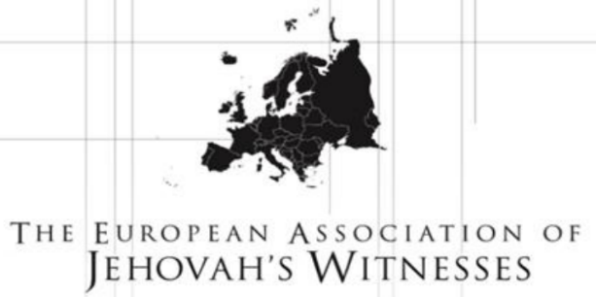 | The European Association of Jehovah’s Witnesses (EAJW) is a charity registered in the United Kingdom. It provides support to Jehovah’s Witnesses facing fundamental human rights violations in various parts of the world.  Address: 1 Kingdom Way, West Hanningfield, CHELMSFORD CM2 8FW, UNITED KINGDOM  Telephone: +44 20 8906 2211  Offices in: Austria, Belgium, France, Georgia, Germany, Greece, Italy, Poland, Portugal, Spain and Switzerland  Registered Charity Number: 1085157
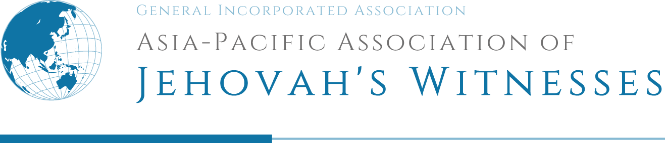 | Asia-Pacific Association of Jehovah’s Witnesses (APAJW) is a general incorporated association registered in Japan. It supports the activities of Jehovah’s Witnesses and promotes the protection of fundamental freedoms in various part of the world, mainly in the Asia-Pacific region.  Address: 5-11-2-605, Mita Minato-ku, Tokyo, 108-0073 JAPAN  Telephone: +81 50 5050 5893  Offices in: Australia, Fiji, Guam, Hong Kong, India, Indonesia, Japan, Kazakhstan, Kyrgyzstan, Malaysia, Myanmar, New Caledonia, Papua New Guinea, Philippines, Republic of Korea, Solomon Islands, Sri Lanka, Tahiti, Taiwan and Thailand  Registered Corporate Number: 7010405019149
 | African Association of Jehovah’s Witnesses (AAJW) is a public benefit organization registered in South Africa.  Address:1 Robert Broom Drive East, Rangeview, Krugersdorp, 1739, SOUTH AFRICA  Telephone: + 27 11 761 1200  Offices in: Angola, Benin, Burundi, Central African Republic, Democratic Republic of Congo, Ethiopia, Ghana, Kenya, Liberia, Madagascar, Malawi, Mozambique, Nigeria, Rwanda, Senegal, South Africa, Uganda, Zambia and Zimbabwe  Registered PBO Number: 930067639
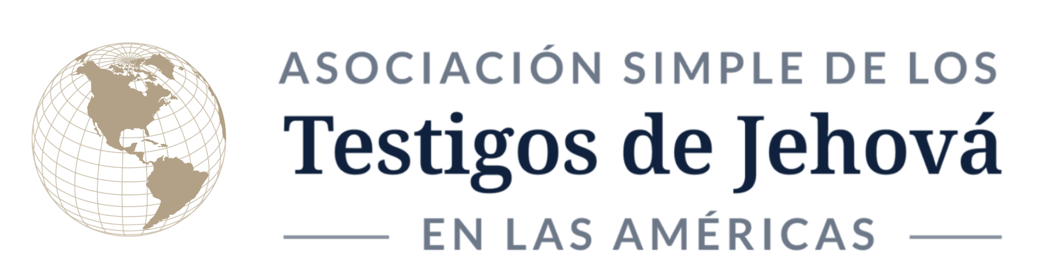 | Asociación Simple de los Testigos de Jehová en las Américas (AJWA) is a civil association constituted in Argentina. It supports the activities of Jehovah’s Witnesses and promotes the protection of fundamental freedoms in various part of the world, mainly in the Americas region.  Address: Bvrd. de la Plaza 255, Of. 85, Nordelta, C.P. 1670, Tigre, B.A., ARGENTINA  Telephone: + 54 11 3220 5996  Offices in: Argentina, Brazil, Canada, Chile, Colombia, Ecuador, Mexico, Paraguay, Peru, United States and Venezuela  Notarial Constitution: Title Deed No. 229, 11/1/2022, Nordelta, Tigre, ARGENTINA 1611.

SUMMARY OF THE SUBMISSION
This submission to the Human Rights Committee (CCPR) on France highlights violations of the provisions of the International Covenant on Civil and Political Rights subsequent to the adoption of the list of issues to be taken up in connection with the consideration of the sixth report of France.
Jehovah’s Witnesses in France and worldwide respectfully request the Government of France to:
- Put an end to religious discrimination against Jehovah’s Witnesses by withdrawing unfounded official reports stigmatizing them with the pejorative term “secte”;
- Formally consider Jehovah’s Witnesses to be a “known religion” in accordance with their legal status, established both by French administrative courts including the Council of State (Conseil d’État), and by preeminent international human rights bodies, such as the CCPR, the Human Rights Council, the European Union, the Council of Europe’s Committee of Ministers and the European Court of Human Rights (ECHR);
- Ensure that government agencies and State-funded nongovernmental entities cease spreading misleading and defamatory allegations against Jehovah’s Witnesses;
- Enforce the established right to correction of untrue or misleading statements in the media;
- Abide by its commitment to uphold the fundamental freedoms guaranteed by the Covenant and the Constitution of France (Constitution) for all citizens, including Jehovah’s Witnesses.

INTRODUCTION
  - Jehovah’s Witnesses have been in France for more than 120 years. They obtained post-war legal recognition in 1947, which was reaffirmed in 2001 by two Council of State decisions that recognized the religious status of their associations. Jehovah’s Witnesses are generally free to meet for worship, to build and maintain places of worship and to share their beliefs with others.
  - However, over the past three decades, various government agencies have labelled Jehovah’s Witnesses a “secte,” a French term used exclusively in a pejorative sense and censured by the ECHR. Currently, the government agency Interministerial Mission of Vigilance and Combat against Sectarian Aberrations (MIVILUDES) continues to sponsor a campaign of harassment and misrepresentation of Jehovah’s Witnesses.
  - Since 1995, four parliamentary commissions on so-called “cultic deviations” (dérives sectaires), an undefined, pejorative term, have issued reports that use detrimental and misleading terminology and are abusive to Jehovah’s Witnesses. The reports of these parliamentary commissions have no legal force and are not amenable to objective challenge. Nevertheless, they are frequently cited as a pretext for discrimination against Jehovah’s Witnesses.
  - Such examples of religious intolerance have spawned numerous acts of discrimination against Jehovah’s Witnesses by local and national authorities in France. Furthermore, serious hate speech and hate crimes have been perpetrated by civil society against peaceful citizens. Such incidents have been reported annually to the Organization for Security and Co-operation in Europe via the Office for Democratic Institutions and Human Rights for many years.
  - This discrimination continues despite several rulings, both in France’s domestic courts and in the ECHR, reaffirming the bona fide religious status of Jehovah’s Witnesses and upholding their right to security of the person, along with freedom of thought, conscience and religion, expression, peaceful assembly, and association, as protected by, inter alia, articles 9, 17, 18, 19, 21 and 22 of the Covenant, and articles 9 and 10 of the European Convention on Human Rights.

VIOLATIONS OF THE PROVISIONS OF THE COVENANT
A. Protection of honour and reputation (article 17); freedom of thought, conscience and religion (article 18)
  - In addition to guarantees under the Covenant, article 1 of the Constitution guarantees “the equality of all citizens before the law, without distinction of origin, race or religion”. Article 10 provides: “No one may be disturbed on account of his opinions, even religious ones, as long as the manifestation of such opinions does not interfere with the established Law and Order.”
  - Notwithstanding these provisions, France has established the MIVILUDES, a government agency under the supervision of the Ministry of the Interior. This agency publishes an annual report based on anonymous and unverified submissions (saisines) describing so-called “cultic deviations”. The term is tendentious, pejorative and legally undefined.
  - The MIVILUDES receives significant government funding, more than 1 million euros annually, to finance its work of combating religious minorities (which it pejoratively refers to as “cults”). The activity of the MIVILUDES includes publishing yearly or semi-yearly reports on its activity. Defamatory MIVILUDES reports are frequently referred to by the mainstream media and, at times, are relied on by French courts in cases involving adherents of minority religions.
  - In July 2021, the MIVILUDES released its 2018–2020 report, which contained several false statements against Jehovah’s Witnesses. In 2022, Jehovah’s Witnesses filed a claim against the 2018–2020 report with the Paris Administrative Court. On 14 June 2024, the 6th Section of the Paris Administrative Court found two statements published in the MIVILUDES’s 2018–2020 report and in its 24 February 2021 report “Lutte contre les dérives sectaires” (Fight Against Cultic Deviations) to be “errors of fact”, awarded damages, ordered deletion of the false statements within 15 days and reminded the MIVILUDES “to refrain from publishing false, misleading or defamatory information in its annual report”. Respected scholar of the sociology of religion Prof. Massimo Introvigne commented: “While this is satisfactory, the problem remains of the presence within the French government of an agency that spreads false information and defamation of religious minorities at the expenses of French taxpayers.”
  - In November 2022, the MIVILUDES released its 2021 report, which contained 19 false statements against Jehovah’s Witnesses. Although the MIVILUDES admits that only 2 per cent of the anonymous submissions it received about religions in France concerned Jehovah’s Witnesses, it still devoted nearly 20 per cent of the “subjects of concern” section of the 2021 report to slandering them, and their religious beliefs and practices. Jehovah’s Witnesses have filed a claim with the Paris Administrative Court against the MIVILUDES 2021 report. A decision on that claim is pending.
  - In addition to the MIVILUDES, the National Union of Associations in Defence of Families and Individual Victims of Sects (UNADFI), a self-appointed nongovernmental organization, supervises the work of some 29 other so-called anti-cult associations throughout France, all of which pursue their own agendas against minority religions. UNADFI and its associated bodies, notably the European Federation of Centres of Research and Information on Cults and Sects (FECRIS), have been denounced by scholars and organizations that work on behalf of religious liberty, including the bipartisan commission of the U.S. federal government United States Commission on International Religious Freedom, as a major threat to freedom of religion or belief.
  - UNADFI receives significant government funding – typically 70 to 80 per cent of its operating budget. It frequently targets Jehovah’s Witnesses with false and misleading reports. FECRIS is registered in France and also directly funded by the French government.
  - On 10 May 2024, a new law on “cultic deviations” (no. 2024–420) was passed by the National Assembly, against the opposition of the Senate. It was published in the Official Journal of the French Republic of 11 May 2024, and grants additional status and powers to the MIVILUDES and anti-cult associations. Jehovah’s Witnesses are concerned that this law will be used to unfairly target them by giving credence to unfounded complaints and prejudicial information.
  - In particular the new law creates a specific duty for the MIVILUDES to integrate awareness of therapeutic and cultic deviations (undefined) into secondary education programmes, and it creates a power for the MIVILUDES to be called upon for expert evidence in legal proceedings relating to such matters.
  - In addition, anti-cult associations are given the power to file civil suits in cases of so-called “conversion therapy” carried out in the context of cultic influence, which again is undefined and open to abuse.
  - In the year prior to the preparation of this submission, the French mainstream media published some 29 unfounded negative and defamatory reports about Jehovah’s Witnesses. Many of these reports referred to the MIVILUDES annual report.
  - On 19 November 2023, nine media outlets published similar articles quoting a disaffected former Witness who made alleged and unproven accusations. All nine newspapers refused to publish a response from Jehovah’s Witnesses.
  - On 22 January 2024, the newspaper Le Progrès published an interview with a former Witness and described Witnesses as a “secte”. It also quoted the MIVILUDES report referring to Jehovah’s Witnesses as a “cultic movement” and a source of child abuse referrals. The newspaper did not respond to right of reply requests.
  - On 18 March 2024, a radio programme broadcast by Europe 1 falsely accused Jehovah’s Witnesses of refusing to vaccinate their children. In response to a request to correct the demonstrably false statement, the broadcaster removed a recording of the programme from its website but did not publish an acknowledgement of its egregious error.
  - On 25 August 2024, the newspaper Actu Lyon published an interview with a former Witness, who falsely accused Jehovah’s Witnesses of not reporting child abuse to the police. The 2021 MIVILUDES report is quoted.
B. Right to security of person (article 9); right to freedom of expression, peaceful assembly and association (articles 19, 21 and 22)
  - Between the start of 2022 and the compiling of this submission, Jehovah’s Witnesses in France recorded at least 23 physical assaults, 56 verbal assaults, 31 acts of harassment and 93 acts of vandalism against their places of worship (Kingdom Halls), all religiously motivated. Selected examples of these hate crimes are set out below.
  - On 1 April 2023, in Distre, one of Jehovah’s Witnesses was attacked at his own home, in front of his son, by a man who had received a letter sharing peaceful religious beliefs. The Witness was hit in the face several times, and the gate of the house was damaged. A complaint was filed with the police. The outcome is unknown.
  - On 12 September 2023, in Le Havre, two elderly Jehovah’s Witnesses, a married couple, were attacked while peacefully sharing their beliefs in an apartment building. A man threatened them, followed them downstairs and grabbed the male Witness by the collar. The attacker kicked the woman several times in the legs before threatening to kill them if they returned to the neighbourhood. Some employees working in the building helped the Witnesses to leave. A complaint was filed with the police. The outcome is unknown.
  - On 17 February 2024, in Saint Magne de Castillon, two of Jehovah’s Witnesses, a married couple, were assaulted by the neighbour of a person they were visiting to share their beliefs. The man pushed them, knocking the woman to the ground. She went to hospital, which certified four days’ ITT (Incapacité Temporaire Totale: unable to resume normal activities following an injury or illness). A complaint was filed with the police. The outcome is unknown.
  - On March 4 2024, in Bordeaux, three of Jehovah’s Witnesses were peacefully sharing their beliefs in a public place, using a portable literature cart. A woman approached, called them a “cult” and accused them of annoying people in the streets. The woman threatened them with a knife and pushed one of the Witnesses. She told the Witnesses that her friends were planning to come to the Kingdom Hall the next day with baseball bats. A complaint was filed with the police. The outcome is unknown.
  - On 26 April 2024, a man telephoned the headquarters of Jehovah’s Witnesses in France, claimed that he had an appointment with the Witnesses in Paris to learn more about the “cult” and that he had hired Jihadists to kill the Witnesses one by one. A complaint was filed with the police. The outcome is unknown.
  - On 21 May 2024, in Marseille, a woman entered the Kingdom Hall property. She spray-painted the walls of the Kingdom Hall itself, as well as the outside walls, with charges against the Witnesses in general and against one local Witness in particular (See picture below). A complaint was filed with the police. The outcome is unknown.
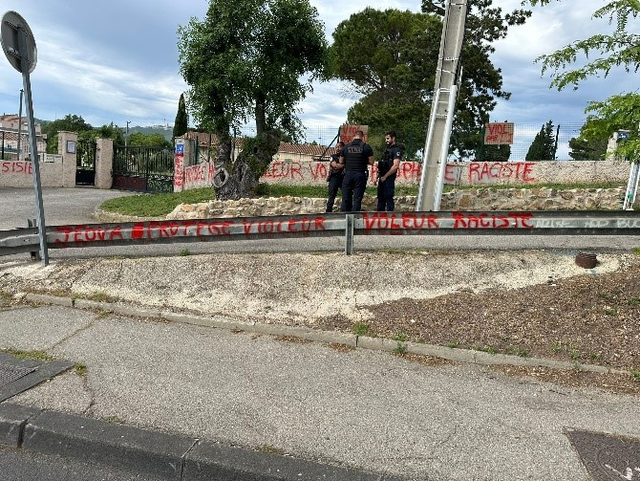
  - On numerous occasions schoolchildren have been stigmatized and penalized for respectfully declining to take part in ceremonies that offend their religious conscience. Parents who are Jehovah’s Witnesses have been called to meet with school principals, chief education officers and on one occasion, the local office of the Department Services of National Education. Parents were threatened with being reported to boards of education.
  - In Morvillars, during the 2024 school year, two 13-year-old children of Jehovah’s Witnesses who were enrolled in Collège Lucie Aubrac declined to sing the national anthem (La Marseillaise) in music class because of their religious conscience. One of the children also declined to take part in boxing during the sports class and requested an alternative because of their religious conscience. The school principal threatened these children with permanent exclusion. On 4 July 2024, the parents and children were summoned to appear before a 15-member disciplinary board, which the board justified because of an alleged “lack of respect for the values of the republic and contestation of school curricula”. Each board hearing lasted around two hours, and its members, especially the teachers, virulently accused the students of undermining secularism and the values of the Republic. While several members of the disciplinary board were in favour of expelling the students from the school, the final decision was a warning that was recorded in both students’ school files until the end of the school year.
  - In addition, since 1 September 2023, at the municipal level, there have been numerous interferences with or restrictions on Covenant-protected peaceful religious activity, by 35 mayors (or mayor’s assistants) and 33 policemen. These include:
    - 119 direct interferences with or restrictions on door-to-door sharing of beliefs;
    - 12 direct interferences with or restrictions on manifesting belief in public;
    - 25 municipal decrees restricting religious activity;
    - 28 unlawful demands for authorizations;
    - 7 fines or threatened fines.
C. Earlier observations, issues and submissions
  - In the concluding observations on the fifth periodic report of France (CCPR/C/FRA/CO/5), the CCPR expressed concern at the potential marginalization of certain religious minorities “in the light of [France’s] obligations under the Covenant, in particular article 18 on freedom of conscience and religion and the principle of equality set out in article 26” (para. 22).
  - Since those concluding observations, and despite the CCPR’s recommendation at para. 24, Jehovah’s Witnesses have experienced similar, and increasing, feelings of “exclusion and marginalization”, as set out above.
  - In the list of issues prior to submission of the sixth periodic report (CCPR/C/FRA/QPR/6), the CCPR requested “information on steps taken to prevent and combat speech and crimes motivated by hatred and intolerance, including against members of religious or ethnic minorities … [and] data on the prosecution of hate crimes and the outcomes of such prosecution” (para. B 4).
  - The CCPR also requested information on measures taken to ensure that recent legislation is “consistent with articles 2, 18, 19, 22 and 26 of the Covenant, as well as the CCPR’s general comments No. 25 (1996) and No. 34 (2011), in particular with regard to the right to manifest one’s beliefs in public”. It also requested comments on “the measures proposed to ensure respect for the rights enshrined in the Covenant in the context of the fight against terrorism, including freedom of association, freedom of conscience and religious belief and the prohibition of discrimination” (para. B 23).
  - In France’s reply (CCPR/C/FRA/6), it acknowledged that “behaviour and speech motivated by hatred are punishable under French criminal law” (para. 30) and asserted that “[a]ddressing hate crimes and hate speech is a longstanding priority of the Government’s criminal policy” (para. 31). However, it did not specifically address or acknowledge crimes against religious minorities, and in particular the type of officially sanctioned stigmatization and marginalization experienced by Jehovah’s Witnesses in France.

CONCLUSION AND RECOMMENDATIONS
  - Jehovah’s Witnesses in France and as a worldwide organization express concern for the violations of the Covenant and the Constitution as exposed in the above submission. They respectfully request the Government of France to take the necessary steps to:
- Put an end to religious discrimination against Jehovah’s Witnesses by withdrawing unfounded official reports stigmatizing them with the pejorative term “secte;”
- Formally consider Jehovah’s Witnesses to be a “known religion” in accordance with their legal status, established both by French administrative courts, including the Council of State, and by preeminent international human rights bodies including the CCPR, the Human Rights Council, the European Union, the Council of Europe’s Committee of Ministers and the ECHR;
- Ensure that government agencies and State-funded nongovernmental entities cease spreading misleading and defamatory allegations against Jehovah’s Witnesses;
- Enforce the established right to correction of untrue or misleading statements in the media;
- Abide by its commitment to uphold the fundamental freedoms guaranteed by the Covenant and the Constitution for all citizens, including Jehovah’s Witnesses.

See, for example, ECHR, Tonchev and Others v. Bulgaria, application No. 56862/15, 13 December 2022.
This is translated variously as sectarian (or cultic) aberrations, sectarian abuses, etc.
See, for example, ECHR, Association Les Témoins de Jéhovah v. France, application No. 8916/05, 30 June 2011; Jehovah’s Witnesses of Moscow and Others v. Russia, application No. 302/02, 10 June 2010; and Taganrog LRO and Others v. Russia, application Nos. 32401/10 and 19 others, 7 June 2022.
See Annex 1.
See Annex 2.
See Annex 3.

