SHADOW REPORT ON DISCRIMINATION AGAINST MUSLIM WOMEN & GIRLS IN SRI LANKA UNDER THE CURRENT LEGAL SYSTEM

90th Session of the Convention on the Elimination of All Forms of Discrimination against Women (CEDAW) Committee - February 2025

Report on Sri Lanka’s compliance with
Articles 1, 2, 5, 10, 11, 15 and 16 of CEDAW


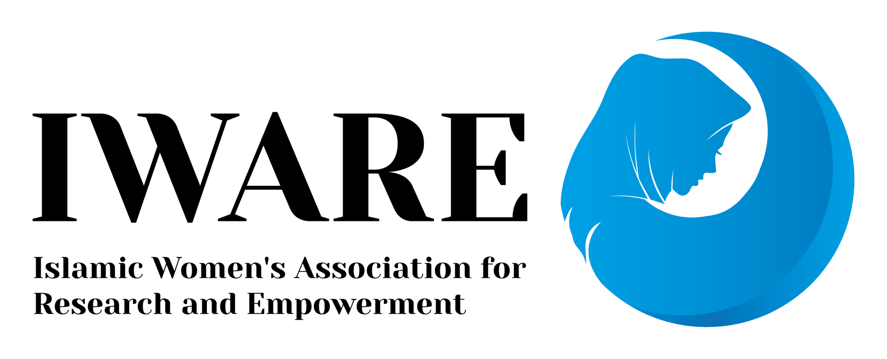
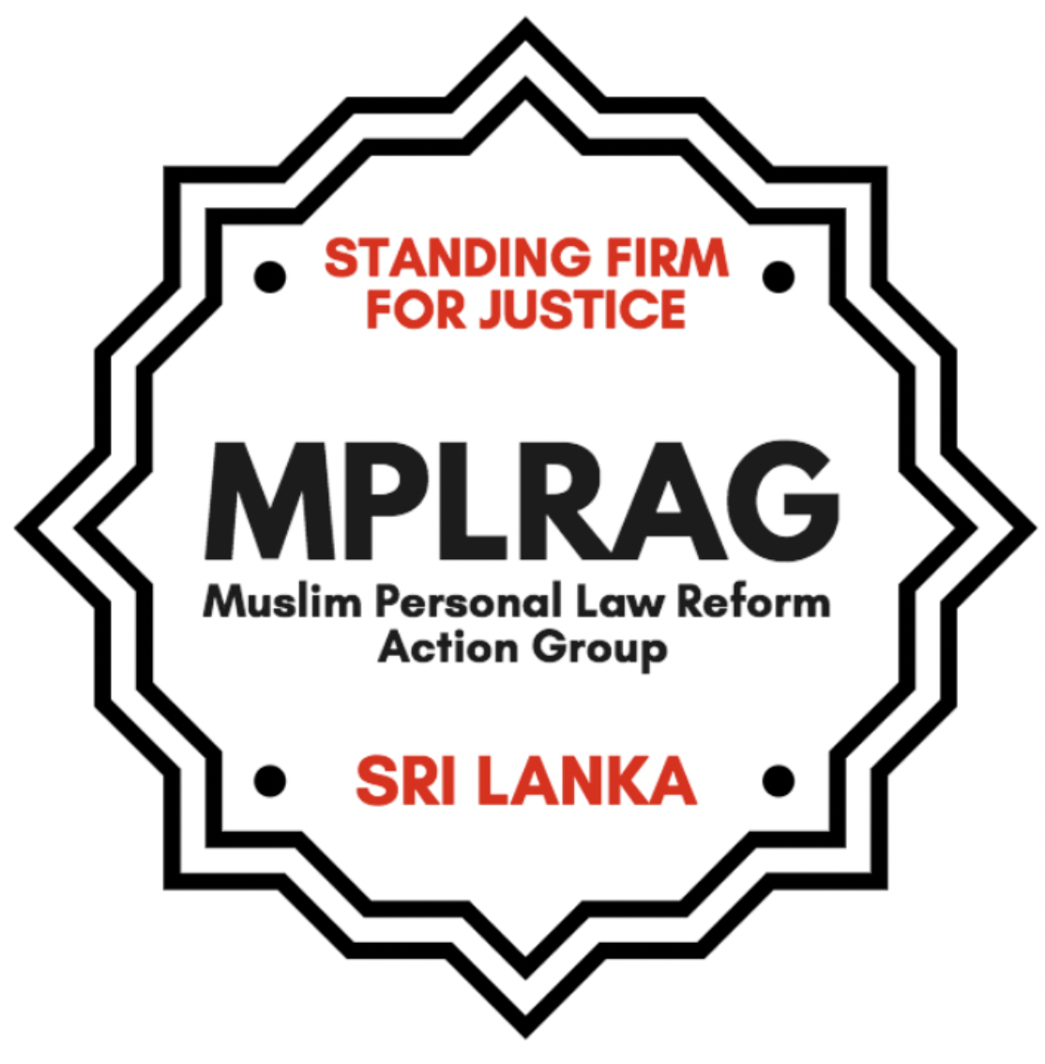

SUBMITTED BY Muslim Personal Law Reforms Action Group (MPLRAG), Islamic Women's Association For Research And Empowerment (IWARE) and Human Elevation Organisation (HEO)
MPLRAG is an independent advocacy group of Sri Lankan Muslim women who are primarily rights advocates, lawyers, researchers and writers. MPLRAG is advocating that Muslims in Sri Lanka, should have equal access to legal rights, justice and redress on matters of marriage and family. As well as the same protection of fundamental rights guaranteed by the Constitution. More information: www.mmdasrilanka.org
IWARE is a community-based organisation in the Eastern Province of Sri Lanka working with Muslim women headed households and community Muslim women and girls in advocating for their rights, including accessing justice in the Quazi system and advocating for MMDA reforms.
HEO is an organization based in the Eastern Province of Sri Lanka working with marginalized communities to secure the right to their land and livelihood and has assisted over 1000 victims with their complaints of domestic violence and claims for justice relating to the Muslim Marriage and Divorce Act of Sri Lanka.

TABLE OF CONTENTS

1. BACKGROUND 2

2. THE MUSLIM MARRIAGE AND DIVORCE ACT (MMDA) CONTINUES TO BE BLATANTLY DISCRIMINATORY AND UNJUST 2
● Child marriage is still legal. 3
● No women in MMDA administration. 3
● Brides cannot sign or formally consent to their own marriage 4
● Unequal divorce for women 4
- No guidelines for maintenance. 4
- Polygamy without any conditions. 4
- No provision for division of matrimonial property/ assets. 5

3. LACK OF ACCESS TO JUSTICE UNDER THE QUAZI SYSTEM 5

4. THE PENAL CODE FAILS TO PROTECT THE RIGHTS OF MUSLIM WOMEN
AND GIRLS 6

5. THE CONSTITUTION FAILS TO PROTECT THE RIGHTS OF MUSLIM WOMEN AND GIRLS 6

6. LONGSTANDING CALLS FOR REFORM 7

7. ISSUES AND CHALLENGES WITH REFORM 7

8. SUGGESTED RECOMMENDATIONS TO THE SRI LANKAN GOVERNMENT 9

BACKGROUND

Muslims in Sri Lanka constitute 10% of the population. They are governed by the general law of the land with the exception of the application of ‘personal laws’ which govern marriage, family, divorce and inheritance. There are also several different sects of Muslims in Sri Lanka and the personal law makes allowances for the nuanced application of the law of the Sect on selected issues.

THE MUSLIM MARRIAGE AND DIVORCE ACT (MMDA) CONTINUES TO BE BLATANTLY DISCRIMINATORY AND UNJUST
Sri Lankan Muslims are governed by a separate family law - the Muslim Marriage and Divorce Act (MMDA), enacted in 1951. There is also a separate Quazi (Muslim judge) system that administers the MMDA around the country. The 1907 Sri Lankan (General) Marriage Registration Ordinance (GMRO) is applicable to all citizens of the country with the exception of Muslims who marry within the faith. Kandyan Sinhalese have the option to marry under the 1952 Kandyan Marriage and Divorce Act, as well as the GMRO. Muslims do not have such an option and are compelled to contract marriages underthe MMDA.
The MMDA violates the rights of Muslim women and girls and limits access to justice, due process and redress in multiple ways. These concerns are with regard to substantive provisions within the Act itself as well as practical problems with procedures and implementation of the law by the Quazi.

Some of the serious infringement of rights in the substantive law:

Child marriage is still legal: The MMDA allows child marriage, as there is no stipulated minimum age of marriage. Under the MMDA, a Quazi can even permit the marriage of a child under the age of 12. However, all other citizens of Sri Lanka are protected by the general law which imposes a minimum age of 18 for marriage without any exceptions.
  - Women’s organizations working at the community level, as well as cases received by Quazis, indicate a practice of early marriage. Marriages arranged by guardians occur between 14 and 17 years of age, in Districts including Puttalam and Batticaloa. Records of Muslim marriage registration in Kattankudy indicate that 22% of all registered marriages were with a bride below 18 years of age in 2015. This is a considerable increase from 2014 when the figure was 14%. According to a Quazi for Colombo East, there are also many instances of early marriages happening in areas like Mattakkuliya and Maradana in Colombo.
  - A study conducted on child marriages in Muslim families in Batticaloa and Ampara in 2023 showed that child marriage took place in impoverished families, and that child brides had poor educational achievement, a high burden of housework (unpaid labour),did not have any authority and were hardly included in decision making. They faced financial destitution, and verbal, physical and sexual abuse within these marriages and most marriages ended in divorce and separation.³
  - Education of young women and girls who get married early is often discontinued, significantly limiting their higher educational and economic opportunities. Girls who are married before the age of 18 are compelled to drop out of school. Such women and girls face grave financial difficulties in the event husbands do not provide maintenance, death of husbands, polygamy, divorce or abandonment. There were increased reports of child marriage and school dropouts of girls during the first years of the pandemic, as well as the economic crisis of 2022-2023.
  - There is no official information on the number of children in marriages not merely for Muslims but also for other children in Sri Lanka. The abysmally poor access to national statistics is a serious failure by the State to monitor this harmful practice. Data is particularly not available for Muslim marriages given that the practice is legal. A recent request for ages of brides in marriages registered between 2019 and 2022 was refused by the Registrar General Department for the reason that “the bio data information related to every marriage in the years 2019-2022 had not been received from the relevant Districts”. Disaggregated child marriage data is crucial to understanding trends particularly during times of social hardship to enable State institutions to take appropriate measures.
  - National level discussions by State actors on ‘zero tolerance’ for child abuse or teenage pregnancies continue to neglect or deliberately fail to address the situation of child marriage in Muslim communities. Issues relating to the religious minority are routinely sidelined as ‘too complicated’ or ‘too sensitive’ without any efforts to engage communities and affected persons.

No women in MMDA administration: Women are not allowed to be Quazis, marriage registrars, jurors or Board of Quazi members under the MMDA. Section 8 of the MMDA on ‘Registrar of Muslim Marriages’, Section 12 on Quazis and Section 15 on Board of Quazis members all restrict these respective positions to ‘male Muslims’. Consequently, this restricts qualified Muslim women from applying for these positions. The position of Quazi is a state-salaried and tax-funded position that is allowed to discriminate against women simply on the basis of sex. Due to Article 16(1) of the Constitution, this State discrimination is legal and cannot be challenged before the domestic courts. The provision for whether or not Muslim women can be Quazis under the MMDA has been a highly contested issue within MMDA reforms.

Brides cannot sign or formally consent to their own marriage: The law, the MMDA, treats adult Muslim women as minors. The MMDA does not require a mandatory and written consent from the bride, hence a bride does not sign her own marriage documents;
  - For Sri Lankan Sunni Muslims, the MMDA does not require bridal consent as necessary for marriage to be contracted. As per the Act, the wali (closest male guardian) of the woman has the right to give a woman/girl in marriage. In cases where the woman has no wali, the Quazi is required to make an order authorizing the marriage. The marriage documents required for a Muslim marriage have no provision for the bride’s signature or thumbprint. The mandatory presence of a bride in her nikah/solemnization ceremony is also not a requirement.
  - Practically, the lack of mandatory provisions in ensuring the consent of the bride significantly increases the chances for women and girls to be coerced into marriage or forced to marry with or without their knowledge. The denial of women’s right to consent to marriage denies women their right to personhood and their civil rights.
  - The extension of the concept of wali to legal provisions and administration of marriage has restricted Muslim women’s individual and equal agency and autonomy in familial matters. While religious jurisprudence privileges women’s consent and choice, the law and practice in Sri Lanka reflects the patriarchal notion that women’s decision-making ability in marriage ought to be under the control and supervision of male members of her family and by extension - the community.

Unequal divorce for women: Under the MMDA, there are different conditions of divorce for men and women:
  - Husbands are granted the right to unilateral divorce without any reason (Talaq) and without ensuring effective notice to the wife. Such provisions lead to practices of abuse, whereby husbands have divorced wives to abandon financial obligations of maintenance, return of dowry and after squandering the wife's financial security and assets. Such practices leave Muslim women in financially and socially vulnerable situations. No appeal process is available for women.
  - Divorce by wives (fasah) is procedural and practically lengthy and arduous, requiring wives to submit reasons and evidence, witnesses and to attend multiple hearings. Husbands can also appeal against fasah divorces on procedural grounds, all the way to the Supreme Court.
  - Under the MMDA there is provision for the (unwritten) law of the sect to apply for fasah divorces. For Muslim women of the Shia sect there is no option to even initiate a divorce on their own or for the Quazi to grant her a divorce without the express permission or consent of the husband. As a result women would require ‘permission’ from their husbands for divorce no matter the circumstance. Therefore the provision for divorce is also not equal to women across sects in Sri Lanka.
5. No guidelines for maintenance: There is no criteria or guidance in the law for calculating wife and child maintenance and it is completely dependent on the Quazi (judge). Women and children often get very little maintenance as revealed in a study conducted in 2021-an average 13 USD per month for children and 15 USD per month for wives.

6. Polygamy without any conditions: The MMDA allows for a Muslim man to marry up to four wives legally without any stipulated conditions. Any subsequent marriage thereafter (after four) is not considered illegal, but ‘irregular’ (temporarily invalid without any legal repercussions).
- The law does not require consent of the current wife for subsequent marriages nor is an inquiry conducted to review the husband’s ability to maintain and provide for another wife. There is no review of whether the existing wife and children are well maintained or whether any harm would be caused to their well being.
- There have been several cases where Muslim women are surprised to find that they are in a polygamous marriage and have not been able to exercise any agency and autonomy on the matter. Their decision to divorce has also become difficult as the maintenance of the other family and the sharing of assets becomes a consideration that the women affected have to bear.
- There are no official records maintained by the State on legally registered polygamous marriages.
- For women, attempts at speaking out about the husband’s decision to take another wife have led to ill-treatment, domestic violence, abandonment and mental distress. In some instances, women are threatened and forced to live in plural marriages. Thus, there are also serious financial consequences for wives and children in polygamous marriages. Anecdotal evidence suggests men have engaged in plural marriages in order to obtain dowry (kaikuli) from the new bride.

7. No provision for division of matrimonial property/ assets: Under the current MMDA, there is no provision for the recognition and division of matrimonial property and assets.

3. LACK OF ACCESS TO JUSTICE UNDER THE QUAZI SYSTEM

Discrimination and ill treatment faced by Muslim women in the Quazi system
Muslim women’s access to justice is severely restricted in the Quazi system. Affected women have articulated in multiple forums that they are discriminated against by the sub-par Quazi system, which is significantly different from the civil court system.
- Women experience mistreatment and humiliation by Quazis and jurors; are not given equal treatment to their husbands; are unable to express their side without fear of being verbally abused, threatened and humiliated in courts throughout their case processes.
- Quazis are all male and are not required to have a minimum qualification or training and this severely disadvantages women. Legal representation is not permitted before the Quazi and the unfair system cannot be challenged by Muslim women litigants. Women are also vulnerable to financial and sexual bribery.
- There have been complaints of Quazis asking for and taking bribes in exchange for information or to proceed with cases, and also to delay giving women or child maintenance payments by husbands.
- Women who are in abusive marriages face additional barriers and challenges in obtaining divorce in terms of presenting evidence, witnesses and giving testimony before adjudicators who are male and also untrained.
- Women who have faced severe emotional abuse or psychological trauma and who may not have ready witnesses to support their case face significant problems in obtaining a divorce.
- Furthermore, women and girls presenting their cases in hearings, which could range from non-maintenance to serious physical and sexual abuse, are put through the additional traumatic task of articulating to an all-male panel, the members of which are not professionally trained to evaluate and give judgment in such cases.
These issues have further exacerbated during the COVID-19 pandemic and Sri Lanka’s economic crisis. Human Rights Watch reported the lack of MMDA reforms as one of the key women’s rights issues in 2022/2023 for Sri Lanka.

4. THE PENAL CODE FAILS TO PROTECT THE RIGHTS OF MUSLIM WOMEN AND GIRLS
According to the Section 363 of the Sri Lankan Penal Code sexual intercourse with a girl below 16 years of age, with or without consent, amounts to statutory rape. However, pushback from mainly Muslim religious leaders and politicians, during the time the Penal Code was being amended in 1995 to include statutory rape provisions, meant that the provision does not apply to married Muslim girls under the age of 16 and above the age of 12, unless judicially separated. As a result, in the case of Muslims, the relevant age for statutory rape is 12 years.
Furthermore, there is no provision for judicial separation in the event of a talaq divorce and the wife is required to stay at the husband’s residence for a period of up to three months (iddat period) after the first pronouncement of divorce. Women are not protected by the Penal Code provision even in the event that forced sexual intercourse (marital rape) occurs during this time.
On issues such as minimum age of marriage, the Sri Lankan government is mandated to establish an age that is suitable for all citizens and protect child rights and promote education, health and wellbeing. Putting perceived cultural and religious rights before gender equality and child rights and legally allowing for Muslim minors to be given in marriage at an earlier age and legally exempting their protection under the Constitution and Penal Code is a serious violation of this State responsibility.
According to the latest Sri Lankan State Party Report: ‘146. Once the amendment to Muslim Marriages and Divorce Act is approved a consequential amendment will be brought into amend the Penal Code.’ However, this too has been delayed along with the delay in reforms to the MMDA.

5. THE CONSTITUTION FAILS TO PROTECT THE RIGHTS OF MUSLIM WOMEN AND GIRLS
Article 16(1) of the Sri Lankan Constitution together with no constitutional provision for judicial review effectively precludes Sri Lankan Muslims, and Muslim women in particular, from utilizing the fundamental rights guaranteed under the Constitution. Article 16 proclaims any law dated prior to 1978, which includes Muslim personal laws, as being consistent with the fundamental rights provisions of the Constitution, including the equality provision, regardless of the explicit or implicit impact of the law. This has been the main barrier preventing Muslim women and girls from being protected by the Constitutional guarantees of equality and nondiscrimination, and rendering them second class citizens.
According to the Sri Lankan State Party Report - ‘21. The expert committee appointed by His Excellency the President to draft the new Constitution will look into the Repealing of Article 16 (1) of the Constitution. In addition, a subcommittee is appointed by the Ministry of Justice to look into the civil law reforms which are complementary to the new constitutional development….’

6. LONGSTANDING CALLS FOR REFORM
Over the past 40 years, various groups, especially Muslim women’s groups have been advocating and lobbying for reforms of the Muslim Marriage and Divorce Act (MMDA). They continue to do so in the face of serious reprisal, harassment and intimidation by conservative groups. Since 2016, MPLRAG has consistently been advocating for comprehensive reforms to the MMDA and the Quazi system.

State institutions, including the National Child Protection Authority and the National Human Rights Commission have not adequately responded to issues affecting Muslim women and girls - including intervening in child marriage complaints, often citing that such harmful practices have the legal cover of the MMDA. Despite very limited resources, community women’s groups being the first responders, have taken on the burden of supporting women and girls with legal information and counseling and guiding them through their divorce, maintenance and also domestic violence cases.

Since 1970, few official attempts at reforming the MMDA have been to no avail. The last significant attempt was a Committee appointed by the former Minister of Justice Ali Sabry in December 2020 to reform the MMDA. This committee submitted its report in July 2020. Following the report, a draft Bill was prepared. The then Minister of Justice Mr. Wijedasa Rajapakse is reported to have discussed the draft Bill with Muslim Members of Parliament in December 2022. The Bill has not been shared publicly and no steps have been taken to move the legal reforms through the legislative process. Elections in December 2024, ushered in a new government with a progressive mandate for social and economic welfare. However, despite broadbased support, the government is showing signs of the lack of willingness to proceed with reforming the MMDA with urgency, citing other political priorities.

Online and verbal attacks against Muslim women activists: In the last few years in particular, women activists across Sri Lanka have come under threat, from conservative Muslim individuals and groups, for advocating for reform to the MMDA. Abusive anonymous phone calls warning activists to ensure their wives, sisters and daughters refrain from pursuing this campaign have been received by family members of women activists. Muslim women activists have also been named and harassed in social media campaigns. These attacks, abuse and intimidation are organised and targeted against specific women’s rights activists. MPLRAG has noted online harassment campaigns through videos, memes and posts, as well as Friday sermons, protests and speeches organised by the conservative religious leaders and some associated mosque committees and groups, which has created a hostile climate of intimidation for Muslim women activists.

As the reforms are further delayed, these attacks become more frequent. Such actions have the potential to create dangerous conditions for activists, as the possibility of physical harm is high. Security and safety of Muslim women and groups pushing for MMDA reform is an utmost priority.

7. ISSUES AND CHALLENGES WITH REFORM

The State is failing to provide leadership and is evading responsibility:

Despite voices calling for reforms of the MMDA from within the Muslim community for the past many decades, the State has hesitated to engage with anyone beyond the usual primarily male conservative interlocutors who claim to represent the community and/or also claim to argue the “Islamic perspective”. State actors have placed the obligation on the Muslim community to come up with solutions to problems affecting Muslim women, as well as build consensus on reforms. Dissenting viewpoints within the Muslim community, both with regard to Islamic jurisprudence and public opinion, have been ignored by the State.

Concerns surrounding the MMDA have been raised repeatedly in Shadow Reports submitted to the CEDAW Committee by Sri Lankan civil society organizations. However, the State continues to put the onus of responsibility for MMDA reforms back onto the Muslim community, instead of proceeding with reforming the MMDA.

At the same time Muslim politicians, religious leaders, as well as some individuals and organizations in support of MMDA reforms believe that the minimum age of marriage for Muslims should be decided within the Muslim community and mandated by the MMDA. However, the minimum age of marriage is a contested topic even within the Muslim community and is highly subjective, dependent upon the theological viewpoint of the various parties supporting or opposing the establishment of a minimum age. Therefore, in the current context, it is unlikely that all the stakeholders in the Muslim community in Sri Lanka would agree and reach consensus on MMDA related reforms.
The Sri Lankan government has the primary duty to address issues faced by Muslims under the MMDA and the Quazi system, which was established, administered and is funded by the state. It has the foremost responsibility to ensure that State laws protect the rights of citizens and do not result in discrimination and injustice. It cannot suspend individual and fundamental rights of citizens in the name of the cultural and religious rights of any group.

On certain issues such as minimum age of marriage, the Sri Lankan government is mandated to establish an age that is suitable for all citizens and protect child rights and promote education, health and wellbeing. Placing perceived cultural and religious rights before gender equality and child rights and legally allowing for Muslim minors to be given in marriage at an early age and legally exempting their protection under the Constitution and Penal Code is a serious violation of the State’s responsibility.
The Sri Lankan government has the primary duty to address issues faced by Muslims under the MMDA and the Quazi system, which is administered and funded by the state. It has the foremost responsibility to ensure that State laws protect the rights of citizens and does not result in discrimination and injustice. It cannot suspend the individual and fundamental rights of citizens in the name of the cultural and religious rights of any group.

8. SUGGESTED RECOMMENDATIONS TO THE SRI LANKAN GOVERNMENT

8.1. URGENT REFORMS TO THE MMDA:
As per the previous Concluding Observations of the CEDAW Committee (2017) to Sri Lanka, family law reform was noted as a priority follow-up issue (COB 13(a) and 13(b)). However, no progress has been made with regard to law reforms pertaining to family laws.
We request the CEDAW committee to urge the government of Sri Lanka to prioritize MMDA reforms, including ensuring the following without any further delay:
- Raising the minimum age of marriage: Establishing a standard minimum age of marriage for all citizens as 18 without any exceptions for all citizens, including Muslims;
- Registration: Introducing registration of marriages as necessary for legal validity under the MMDA;
- Bride's consent: It must be mandatory for brides to give their consent and sign their marriage documents.
- Islamic marriage contracts: Pre-nuptial agreements / Islamic marriage contracts may be entered into by couples. This is a recognized Islamic tradition;
- Dowry/Kaikuli: Dowry and any other transactions of money or property exchanged at the time of marriage can be recovered by the party who gave the property in the event of divorce. In the interest of fairness, circumstances of the use of the property by the couple should be considered;
- Women in administrative positions: Women to be allowed as Quazi judges, marriage registrars and jurors;
- Marital property: Property acquired during the marriage should be fairly distributed at the time of divorce, including accounting for non-financial contribution and unpaid care work;
- Divorce: Divorce procedures including rights of appeal must be equalised for men and women. Mutual consent divorce must be recognized under the MMDA;
- Polygamy: Some organisations have recommended that polygamy be regulated with strict conditions, including ensuring that the husband has financial capacity and mandatorily informing all parties, while groups like MPLRAG recommend that the harmful practice of polygamy be abolished;
- Alimony: Mata’a (alimony/compensation) must be recognized with guidelines for calculation;
- Maintenance: Maintenance orders must be based on criteria that ensure that adequate maintenance is paid. To increase access to justice, applications for maintenance can be also made to a Magistrate court. The MMDA must make mandatory provision for payment of mata’a (compensation) by the husband to the wife in cases where fault of the husband has been established.
- Court system to improve access to justice:
  - The MMDA must set out appropriate qualifications and competencies for Quazis. Quazis must well trained in substantive and procedural aspects of administering the MMDA, and must be provided administrative support;
  - Introduce a hybrid model of Quazi and district court system for administration of MMDA cases, whereby if the case is not completed within a year before the Quazi, it will be transferred to the District Court;
  - Comprehensive training of Quazis before placement and regularly while in service must be provided. Proceedings before the Quazi must ensure privacy and security of all parties;.
  - All courts must have trained counselors, female and male, to support litigants during cases.
  - Establish a system for regular monitoring of Quazi proceedings and records;
  - Public accessing the Quazi must be made aware of procedures and of complaints mechanisms;
  - Complaints must be inquired into in a timely manner, update the complainant of the process and final decision, and where necessary take appropriate disciplinary action.
- Marrying under the MMDA: The MMDA can be used if both parties to the marriage are Sri Lankan or even if only one party is Sri Lankan. (Currently the law does not permit two Muslim to marry under the country’s MMDA if one party is a non Sri Lankan).

6.2. URGENT REFORMS TO RELATED LAWS:
Additionally, MPLRAG requests CEDAW committee to urge the government of Sri Lanka to ensure the following legal reforms:
- Reform to the General Marriage Registration Ordinance (GMRO): To allow for Muslim couples to have the option to marry under the general law;
- Reform to the Penal Code to ensure that the statutory rape provision covers marital rape regardless of age or family law;
- Repeal Article 16(1) of the Sri Lankan Constitution and enable judicial review of legislation post enactment.

Tegal, E & Cegu-Isadeen, H. Inside the Quazi Courts of Sri Lanka, Change Organization, (2021) https://www.mmdasrilanka.org/wp-content/uploads/2022/06/Inside-the-Quazi-Courts-System-in-Sri-Lanka-by-CHANGE-Humanitarian-Organization-English.pdf
MPLRAG Demands for MMDA reforms https://www.mmdasrilanka.org/demands/
[1] Section 363 of the Penal Code of Sri Lanka.
In 1995 after extensive lobby by civil society organizations including women and child rights groups, the Penal Code (Section 363) was amended for statutory rape to mean sexual intercourse with any girl below the age of 12, with or without her consent “...unless the woman is his wife who is over twelve years and not judicially separated from the man”, thereby applicable only to Muslim girls.
UNICEF Sri Lanka, ‘Emerging Concerns and Case Studies on Child Marriage in Sri Lanka, (July 2013) http://www.unicef.org/srilanka/2013_Child_Marriage_Case_Studies.pdf
[4] Divorce initiated by husband.
Ninth periodic report submitted by Sri Lanka under article 18 of the CEDAW Convention https://tbinternet.ohchr.org/_layouts/15/treatybodyexternal/Download.aspx?symbolno=CEDAW%2FC%2FLKA%2F9&Lang=en
See comments made by Minister Rauff Hakeem in March 2015 http://www.sonakar.com/?p=80151
Hasanah Cegu, Ermiza Tegal, and Nadia Ismail, Child Marriages in Muslim Families in Batticaloa and Ampara (2024, August 5). https://polity.lk/child-marriages-in-muslim-families-in-batticaloa-and-ampara-hasanah-cegu-ermiza-tegal-and-nadia-ismail/ “Wali - In the context of marriage, a marriage guardian. Usually recognized by some Schools as the father or paternal grandfather who has authority to contract the marriage on behalf of the bride”.(Source: Women Living Under Muslim Law 2006, Knowing our Rights: Women, Family and Law in the Muslim World http://www.mediterraneas.org/IMG/pdf/kor_2006_en.pdf )
MMDA Section 47(3) - In instances where the woman does not have a wali such as in the case of a female head of household with no male relatives, or a convert to Islam, the male Quazi is required to make an order authorizing the marriage.
Therefore, under a certain Shia sect there is no option for wives to even initiate a divorce on their own or for the Quazi to grant her a divorce without the express permission or consent of the husband.
Section 23 of the Muslim Marriage and Divorce Act (MMDA)
Hasanah Cegu, Ermiza Tegal, and Nadia Ismail, Child Marriages in Muslim Families in Batticaloa and Ampara, (2024, August 5). https://polity.lk/child-marriages-in-muslim-families-in-batticaloa-and-ampara-hasanah-cegu-ermiza-tegal-and-nadia-ismail/ and Hyshyama Hamin & Hasanah Cegu Isadeen, Unequal Citizens: Muslim Women’s Struggle for Justice and Equality in Sri Lanka, (2017) https://www.mmdasrilanka.org/unequal-citizens-study/
Human Rights Watch, World Report 2023 - Sri Lanka https://www.hrw.org/world-report/2023/country-chapters/sri-lanka
MPLRAG , About Article 16(1), (2016) https://www.mmdasrilanka.org/article-16/

