Submission to the Committee on Economic Social and Cultural Rights (CESCRs) in relation to the review of the Netherlands
78th Session (08 Sep 2025 - 26 Sep 2025)

The Netherlands’ obligations under the International Covenant on Economic, Social and Cultural Rights in light of the ICJ Advisory Opinion on the Occupied Palestinian Territories

Submitted by Third World Network (TWN), Al-Haq, Al-Haq Europe, Arab NGO Network for Development

- This submission focuses on the obligations of The Netherlands stemming from the International Covenant on Economic, Social, Cultural Rights (ICESCR), particularly as reviewed under General Comment 24, concerning the regulation of business conduct.

- This submission is focused on the consequences for the Netherlands in light of the International Court of Justice (ICJ) advisory opinion of 19 July 2024 on the Legal Consequences arising from the Policies and Practices of Israel in the Occupied Palestinian Territory, including East Jerusalem, which confirmed Israel’s prolonged breach of the Palestinian People’s right to self-determination- the peremptory norm incorporated in Article 1(1) of the ICESCR- and the systemic discrimination against the economic, social and cultural rights of the Palestinian People contrary to Article 2(2) of the ICESCR.

- The submission reviews what this entails for the Netherlands’ obligations under the Covenant, in regard to its own dealings with Israel and as a home State of companies involved with Israel and in the Occupied Palestinian Territory, in maintaining and entrenching Israel’s settler colonial apartheid regime and unlawful presence in breach of the Palestinian right to self-determination and the collective right of return.

** On 26 January 2024, the International Court of Justice concluded that there was a plausible risk of Israel committing acts of genocide in Gaza. The Genocide Convention obliges the Netherlands to take action to prevent genocide. While this submission focuses on obligations arising under the ICESCRs in light of the breaches confirmed by the ICJ in its advisory opinion of July 2024, the Netherlands faces further obligations already triggered under the Genocide Convention, which may interact with those covered under this submission.

Table of Contents

Home State Obligations in relation to business activities, in light of CESCRs General Comment 24 3
The International Court of Justice advisory opinion on the illegality of Israel’s presence in the Occupied Palestinian Territory and breaches of human rights law 4
Third States’ obligations in light of the legal consequences triggered by Israel’s wrongful acts as confirmed by ICJ and its interaction with obligations arising under the Covenant on Economic, Social and Cultural Rights 5
The Netherland’s economic and business engagements with Israel 7
The Netherland’s trade and investment relations with Israel 7
The Netherland’s military and other procurements from Israel 8
Ports in the Netherlands used to transport weapons to Israel 9
Companies domiciled in the Netherlands involved in Israel’s illegal settlements 10
Exposure of business entities and persons domiciled in the Netherlands to risks of causing or directly contributing to human rights violations by Israel 11
Actions required from the Netherlands, under the ICESCR, in regard to its own dealings and in its capacity as home State of businesses involved with or in Israel 13
Requirements from the Netherlands in regard to its own dealings 13
Requirements from the Netherlands as home State of companies that have dealings with Israel or have business relations in Israel 14
Annexes 16
Annex (1): The obligation to cooperate to bring an end to the breach and not to assist in maintaining the illegality 16
Annex (2): Clarification of third States’ obligations after the ICJ advisory opinion 16
Annex (3): About the Netherlands’ trade relations with Israel 19
Annex (4): Investments by Dutch Institutional Investors in Companies at risk of violating international human rights. (2021-2024) 20

Home State Obligations in relation to business activities, in light of CESCRs General Comment 24
- The realization of rights under the ICESCRs, part and parcel of which is the right to self-determination, requires that States ensure compliance with internationally recognized human rights norms and standards, including in relation to business activities that may negatively affect economic, social and cultural rights.
- The State’s obligations to respect, to protect and to fulfil apply both with respect to situations on the State’s national territory, and outside the national territory in situations over which States parties may exercise control (General Comment 24 of the Committee ESCRs). The Committee on economic, social and cultural rights (CESCRs) clearly stated that:
- Extraterritorial obligations arise when a State party may influence situations located outside its territory, consistent with the limits imposed by international law, by controlling the activities of businesses domiciled in its territory and/or under its jurisdiction, and thus may contribute to the effective enjoyment of economic, social and cultural rights outside its national territory.
- It has been well established in the work of the CESCRs that: States parties were required to take the steps necessary to prevent human rights violations abroad by corporations domiciled in their territory and/or jurisdiction (whether they were incorporated under their laws, or had their statutory seat, central administration or principal place of business on the national territory)[...].
- This, as pointed out by the CESCRs, is rooted in the pledge of Members of the United Nations “to take joint and separate action in cooperation with the Organization” to achieve the purposes set forth in article 55 of the Charter, including “universal respect for, and observance of, human rights and fundamental freedoms for all without distinction as to race, sex, language, or religion”. The Committee recalls in General Comment 24 that, in line with the Charter, the International Court of Justice has acknowledged the extraterritorial scope of core human rights treaties, focusing on their object and purpose, their legislative history and the lack of territorial limitation provisions in the text.
- A State party would be in breach of its obligations under the Covenant where the violation reveals a failure by the State to take reasonable measures that could have prevented the occurrence of the event, even in circumstances where other causes have also contributed to the occurrence of the violation, and where a State fail to take appropriate steps to investigate, punish and redress abuses by private actors when human rights violations occur.
- In discharging their duty to protect, States parties should also require corporations to deploy their best efforts to ensure that entities whose conduct those corporations may influence, such as subsidiaries (including all business entities in which they have invested, whether registered under the State party’s laws or under the laws of another State) or business partners (including suppliers, franchisees and subcontractors), respect Covenant rights.
- Further clarifying this, the Guiding Principle 7 provides that States should “ensur[e] that their current policies, legislation, regulations and enforcement measures are effective in addressing the risk of business involvement in gross human rights abuses”, and should “explor[e] civil, administrative or criminal liability for enterprises domiciled or operating in their territory and/or jurisdiction that commit or contribute to gross human rights abuses” (commentary of GP 7). GP 7 also provides that one action States should undertake is to “den[y] access to public support and services for a business enterprise that is involved with gross human rights abuses and refuses to cooperate in addressing the situation”.

The International Court of Justice advisory opinion on the illegality of Israel’s presence in the Occupied Palestinian Territory and breaches of human rights law

- In its advisory opinion (AO) of 19 July 2024 on the Legal Consequences arising from the Policies and Practices of Israel in the Occupied Palestinian Territory, including East Jerusalem (“the OPT case”), the ICJ undertook several foundational steps:
- determined that Israel's presence in the OPT is unlawful due to its sustained abuse as an Occupying Power, including through frustration of the Palestinian People’s inalienable right to self-determination, a peremptory norm of international law, which is firmly embedded within human rights law, and recognized as a foundational right of all peoples, and the prerequisite to all other rights;
- underlined that the centrality of the right to self-determination in international law is reflected in its inclusion as common Article 1 of the ICESCR and the ICCPR, the first paragraph of which provides: “All peoples have the right of self-determination. By virtue of that right, they freely determine their political status and freely pursue their economic, social and cultural development” (para. 233 of the AO). The ICJ said that the right to self-determination is the most fundamental and existential right for all human beings, as it pertains to the inherent capability of a people to exist and determine themselves as a people in a given territory, free from foreign control and occupation;
- affirmed that self-determination constitutes a peremptory norm of international law in cases of foreign occupation and emphasized the erga omnes character of Israel's breached obligations – meaning these obligations are owed to the international community as a whole and that “all States can be held to have a legal interest in [the] protection [of the rights involved]”;
- reviewed in detail the implications of the regime of policies and practices maintained by Israel on the Palestinian People’s civil, political, economic, social and cultural rights;
- found that legislations adopted and measures taken by Israel, in particular, its residence permit policy (para.195 of the AO); policies restricting freedom of movement (para.206 of the AO); issuance of building permits (para.222 of the AO); punitive demolitions of Palestinian property (para.213 of the AO) amount to systemic discrimination against the Palestinians in the OPT in violation of Article 2(2) of the ICESCR;
- in concluding that ‘Israel’s legislation and measures impose and serve to maintain a near-complete separation in the West Bank and East Jerusalem between the settler and Palestinian communities’, which constitute a breach of Article 3 of the Convention on the Elimination of Racial Discrimination that prohibits racial segregation and apartheid, (para 229) the Court relied, inter alia, on Israel’s ongoing violations of Article 2(2) and Article 10(1) of the ICESCR;
- affirmed that ‘a key element of the right to self-determination is the right of a people freely to determine its political status and to pursue its economic, social and cultural development. This right is reflected in resolutions 1514 (XV) and 2625 (XXV), and it is enshrined in common Article 1 of the ICCPR and the ICESCR [...] The dependence of the West Bank, East Jerusalem, and especially of the Gaza Strip, on Israel for the provision of basic goods and services impairs the enjoyment of fundamental human rights, in particular the right to self-determination’ (para 241);
- considered “that Israel’s policies and practices obstruct the right of the Palestinian people freely to determine its political status and to pursue its economic, social and cultural development” (para. 242);
- stressed that Israel remains bound to comply with its obligation to respect the right of the Palestinian people to self-determination and with its obligations under international humanitarian law and international human rights law and that all States must co-operate with the United Nations to put into effect modalities required to ensure an end to Israel’s illegal presence in the Occupied Palestinian Territory and the full realization of the right of the Palestinian people to self-determination (see page 6 summary of the AO);
- stressed that all States should ensure that any impediment, resulting from Israel’s illegal presence in the OPT, to the exercise of the Palestinian people of their right to self-determination is brought to an end, and underlined the obligation not to render aid or assistance in maintaining the illegal situation created by Israel;
- confirmed that given the peremptory nature of the norms violated, States have the obligation not to render aid or assistance in maintaining the illegal situation created by Israel, and that third States’ obligations include, inter alia, ,”to abstain from entering into economic or trade dealings with Israel concerning the Occupied Palestinian Territory or parts thereof which may entrench its unlawful presence in the territory” and to “… prevent trade or investment relations that assist in the maintenance of the illegal situation created by Israel in the Occupied Palestinian Territory (OPT)”.

Third States’ obligations in light of the legal consequences triggered by Israel’s wrongful acts as confirmed by ICJ and its interaction with obligations arising under the Covenant on Economic, Social and Cultural Rights

- In light of the ICJ’s determination of Israel’s serious breach of obligations under erga omnes and peremptory norms, including the right to self-determination of the Palestinian People, third States face legal obligations arising under the international law of State responsibility as reflected under the Articles on Responsibility of States for Internationally Wrongful Acts (ARSIWA).
- Article 41 of ARSIWA provides that:
1. States shall cooperate to bring to an end through lawful means any serious breach within the meaning of article 40.
2. No State shall recognize as lawful a situation created by a serious breach within the meaning of article 40, nor render aid or assistance in maintaining that situation.

[See more details in annex (1)]

- The duty of third States including the Netherlands not to aid and assist in maintaining the illegal occupation, and policies and practices of racial segregation and apartheid, incorporates the duty not to assist in Israel’s policies and practices that obstruct the right of the Palestinian People to freely determine their political status and to pursue economic, social and cultural development as well as the duty to cooperate to end policies and practices central to the overall illegality that Israel is involved in by ‘obstruct[ing] the right of the Palestinian people freely to determine its political status and to pursue its economic, social and cultural development’.
- This duty requires from States a review of their economic and other dealings with Israel and urgent and effective regulatory measures to ensure that businesses regulation of the dealings of businesses domiciled or operating in their territory and/or jurisdiction or are under their control do not aid or assist in maintaining Israel’s illegality.
- In relation to Israel’s illegal presence in the Occupied Palestinian Territory, States and business entities have been on notice for decades regarding the widespread and systematic nature of the human rights violations perpetrated there. The Special Rapporteur on the Situation of Human Rights in Occupied Palestinian Territory underlined in her recent report that “[i]n the occupied Palestinian territory, building on decades of documented human rights violations and crimes, recent judicial developments leave no room for doubt that corporate engagement with any component of the occupation is connected with violations of jus cogens norms and international crimes”.
- For the purposes of understanding the scope of action that could assist in the maintenance of the illegality, it is important to consider that historically in relation to apartheid, the UN General Assembly had affirmed that continued trade relations with a State committing grave violations of international law (1) assist that State to “defy world opinion”, (2) “aggravate the danger of violent conflict”, and (3) nullify “the efforts of the UN to solve the problem”. Read in this light, maintenance of normalized trade or other economic or commercial relations with Israel would undermine the fulfillment of third States’ obligation to ensure ending impediments to the Palestinian people’s right to self-determination resulting from Israel’s illegal occupation, and their rights under the ICESCR, and could contradict their obligation “not to aid or assist” in the maintenance of Israel’s illegality.

[See more details in annex (2) on the interpretation of these obligations under the UNGA resolution A/ES-10/L.31/Rev.1, by UN Independent Commission of Inquiry and by UN human rights experts]

- The duty to cooperate to end the serious breaches (as stipulated under Article 41 of ARSIWA), interacts with the duty stipulated under Article 2 (1) of the Covenant, which sets out the expectation that States parties will take collective action, including through international cooperation, in order to help fulfil the economic, social and cultural rights of persons outside of their national territories.
- The General Comment 24, paragraph 37, provides that: Consistent with article 28 of the Universal Declaration of Human Rights, this obligation to fulfil requires States parties to contribute to creating an international environment that enables the fulfilment of the Covenant rights. To that end, States parties must take the necessary steps in their legislation and policies, including diplomatic and foreign relations measures, to promote and help create such an environment. States parties should also encourage business actors whose conduct they are in a position to influence to ensure that they do not undermine the efforts of the States in which they operate to fully realize the Covenant rights[...].
- This, read together with the obligations stemming from ARSIWA reviewed above, points that States should take urgent and necessary domestic measures in regard to their own dealings and that of business dealings with Israel, and to cooperate in every relevant international fora to contribute towards ending the illegality propagated by Israel.
- It is significant to note that The Netherlands has acknowledged and endorsed the ICJ’s affirmation as to the application of the ICESCR’s right to self-determination to Palestinians. In its written intervention to the ICJ in the pending proceedings in Obligations of Israel in relation to the Presence and Activities of the United Nations, Other International Organizations and Third States in and in relation to the Occupied Palestinian Territory, The Netherlands stated ‘3.3 In the Advisory Opinion on the Policies and Practices of Israel in the OPT, the Court emphasised the centrality of the right to self-determination in international law as reflected in its inclusion as common Article 1 of the International Covenant on Economic, Social and Cultural Rights and the International Covenant on Civil and Political Rights’. The proceedings concern Israel’s banning of UNRWA, with widespread negative consequences for the fundamental economic, social, and educational rights of Palestinian refugees in particular, and the oral hearings took place as Israel moved to enforce an ever tighter genocidal blockade of Gaza.
- The Netherlands recognised the need for Third States to respond, submitting to the ICJ that: ‘If the occupying Power does not, or is not willing or able to, comply with its human rights obligations, the Kingdom of the Netherlands considers that the occupying Power should refrain from interfering with other parties that help ensure the enjoyment of “the basic rights of the human person” and other human rights for the population of an occupied territory. These include the rights to food, safe and clean drinking water and sanitation, health, and education.’ (para 4.3) However, rather than respecting its legal obligations as a Third State, to act to ‘help ensure the enjoyment of “the basic rights of the human person” and other human rights for the population of an occupied territory’, The Netherlands persists in contributing to the maintenance of the unlawful occupation.

The Netherland’s economic and business engagements with Israel

The Netherland’s trade and investment relations with Israel
- While the EU is Israel’s biggest trading partner (in 2024, the EU-Israel trade totaled €42.6 billion, significantly more than Israel’s trade with the US which amounted to €31.6), the Netherlands is Israel’s fourth largest trading partner from among EU Member States. Trade between the two countries appear to be unaffected by Israel’s genocidal attacks in Gaza and intensified human rights violations of the Palestinian people, as trade volume and pattern remains largely unchanged and even registered a marginal increase in 2024 from 2023.
- Of all EU member states, the Netherlands is the largest investor in Israel and is responsible for two-thirds of the EU investments in Israel (total EU member state investment reaching €72.1 billion compared to €39.2 billion from the United States), and is the largest single investor in Israel worldwide. As SOMO publication points out, “[n]o other country invests more in Israel than the Netherlands, exceeding even the United States and investing 10 times more than Germany does”. Also, the Netherlands has maintained its position as the primary destination for Israeli investment within the European Union, receiving €47.3 billion in 2023, seven times more than Israeli investment in the United States (€8.8 billion), which makes the Netherlands a critical financial gateway for Israeli investors’ access to European capital markets. The investment relationship has shown remarkable growth and resilience encompassing both portfolio investments and direct business investments across multiple sectors, from technology and healthcare to energy and agriculture.

[See more details in annexes (3) and (4)]

The Netherland’s military and other procurements from Israel
- According to comprehensive research by various monitoring organizations, Israel exported a wide variety of arms to the Netherlands between 2000-2019, including drones, air-to-ground missiles, battle management systems, and Reccelite systems.

Military equipment
- Recent data indicates that despite Israel’s genocide in Gaza, involving systemic and widespread gross violations of various human rights of the Palestinian people, the Netherlands has continued purchasing substantial quantities of Israeli military equipment. Over the past five years, Dutch procurement from Israeli defense companies reached nearly €2 billion worth of purchases, with half of these transactions occurring after October 2023. This makes the Netherlands one of Israel's largest military customers globally.
- The primary Israeli defense contractors supplying the Netherlands include Elbit Systems and Rafael Advanced Defense Systems. It has been reported that these companies have been identified as "testing" their weapons systems on Palestinians, with revenues from Dutch purchases contributing directly to the Israeli war chest.
- The Netherlands continues to make substantial new defense purchases from Israel. In September 2024, the Dutch government selected Israeli firm Rafael Advanced Defense Systems to supply upgraded anti-tank systems worth up to €250 million.

Cybersecurity
- Beyond conventional weapons, the Netherlands and Israel maintain extensive cooperation in cybersecurity, representing a growing dimension of their defense relationship. Approximately 25% of Netherlands' investment in cybersecurity flows to Israeli companies.
- The Israeli Dutch Innovation Center (IDIC), a public-private platform, facilitates cooperation between Israeli and Dutch technology companies, with cybersecurity as one of its four primary focus areas. This cooperation includes government-level exchanges, with formal startup delegations and bilateral forums signed during high-level visits.
- Israel Aerospace Industries (IAI) invested millions of dollars in Dutch cybersecurity company Inpedio BV in 2017, demonstrating the bidirectional nature of this technological cooperation. These investments create additional financial and strategic ties that complement traditional defense procurement relationships.

Ports in the Netherlands used to transport weapons to Israel
- Palestinian civil society groups have documented that the port of Rotterdam is frequented by shipments to Israel carrying F-35 parts for maintenance and assembly, making this port a central logistical hub for the manufacturing and maintenance of aircraft used by the Israeli military. The F-35 fighter jet has been used by Israel to bomb Gaza from the air. The Netherlands houses one of several regional warehouses containing U.S.-owned F-35 parts, which are then distributed to ‘partner countries’ including Israel. The shipping company Maersk operates a recurring shipping cycle between United States weapons manufacturer Lockheed Martin’s Fort Worth facility in Texas and Israel Aerospace Industries in Israel routed through Rotterdam (shown in shipment records from August 2021 to May 2024).
- In February 2024, the Hague Court of Appeal (on appeal to the Supreme Court), relying on the European Union (EU) Common Position on Arms Exports and the Arms Trade Treaty as they apply to Dutch law, had ordered the Dutch government to halt all exports and transit of F-35 components to Israel, citing a "clear risk" that these parts were being used in serious violations of international humanitarian law in Gaza.
- Transhipment of military goods through the Netherlands requires involvement of the Dutch authorities through issuance of permits. In regard to transit licence for military goods, the website of the Dutch government provides that “If you want to transship military goods in the Netherlands, you sometimes require a transit licence. A licence or consent is required for trading in light weapons and ammunition”. The Dutch Ministry of Foreign Affairs was responsible for issuing permits for the transhipment of military goods, while Port officials check vessel compliance with environmental and safety regulations for shipping on behalf of the government and municipality of Rotterdam. Through this licensing regime, the Dutch government could exercise control over the transshipment of military equipment to Israel through Dutch jurisdiction, which is currently not exercised.

Companies domiciled in the Netherlands involved in Israel’s illegal settlements
- Several companies domiciled in the Netherlands are involved in Israel’s illegal settlement enterprises in varying ways.
- For example, several companies domiciled in the Netherlands are listed in the UN database of business enterprises involved in the illegal Israeli settlements. The database lists companies involved in activities detailed in paragraph 96 of the report of the independent international fact-finding mission to investigate the implications of the Israeli settlements on the civil, political, economic, social and cultural rights of the Palestinian people throughout the Occupied Palestinian Territory, including East Jerusalem.
- Booking.com B. V., Tahal Group International B.V. and Kardan N.V. are listed as enterprises involved in the provision of services and utilities supporting the maintenance and existence of settlements, including transport. As documented by SOMO and reflected in the report of the Special Rapporteur on the Occupied Palestinian Territory, “Booking.com may label properties as “Palestinian territory, Israeli settlement”, but it continues to profit from the colonies and faces criminal complaints in the Kingdom of the Netherlands for laundering proceeds”. Taking part in the the broader settlement enterprise and its maintenance entails some of the most serious violations of international humanitarian and human rights law, including breaches of the right to self-determination of the Palestinian people, breaches of the prohibition of racial segregation and apartheid on both sides of the Green Line, and the prohibition on the use of force to acquire territory.
- These companies were listed in the database in a report released in 2020. None of these companies were removed from this list in the update to the report released in 2023. This indicates that the required steps from both the Netherlands and the business itself were not fulfilled. The standard of proof for removal from the database, according to the OHCHR, requires a business enterprise to provide information proving that it is no longer involved in a listed activity.
- This shows that the Netherlands fails to take necessary steps, using its policy, regulatory and other legislative tools, to ensure protection and respect for human rights, including by ensuring that all business enterprises domiciled in its territory and/or jurisdiction are not involved in the illegal Israeli settlements. The Netherlands does not clarify how it will ensure that those affected by human rights violations and abuses in which companies domiciled in its territory and/or jurisdiction are directly or indirectly involved, in the illegal Israeli settlements.
- Given the heightened risks of human rights harms in conflict affected areas, businesses must apply enhanced due diligence. To identify, prevent and mitigate such risks, home States, like the Netherlands should provide “assistance to business enterprises to assess and address risks; denying access to public support and services for a business enterprise that is involved with gross human rights abuses and refuses to cooperate in addressing the situation; and ensuring that their current policies, legislation, regulations and enforcement measures are effective in addressing the risk of business involvement in gross human rights abuses”.

Exposure of business entities and persons domiciled in the Netherlands to risks of causing or directly contributing to human rights violations by Israel

- In her recent report, the Special Rapporteur on the OPT recalled, in reference to the Guiding Principles, that a corporate entity’s responsibility depends primarily on whether its activities or relationships throughout its supply/value chain risk, or are in fact causing, contributing to, or are directly linked to human rights violations. Causation would arise in case of a business undertaking activities that are essential for the human rights abuse to occur. Contribution to violations through business activities – either directly or through some outside entity (government, business or other), would entail any activity or relationship where a causal link can be established between the corporate entity’s actions and the resulting violation. Direct links to violations could emerge through a business’s operations, products, services or corporate relationships, although the business entity need not itself be contributing to the abuses.
- The exports of certain companies domiciled in the Netherlands can be directly linked to human rights violations committed by Israel against the Palestinian people. For example, the Dutch civil society organization SOMO documented evidence of significant risk that police dogs exported by companies domiciled in the Netherlands are used by the Israeli army in international law abuses, including systematic use to brutalize Palestinian civilians, including toddlers, the elderly, and persons with disabilities. Evidence shows that the Israeli army, police, and prison services often deploy such dogs during raids, arrests, home invasions, and in detention centers, from Gaza to the West Bank. They have been used to terrorise families and torture detainees.
- In 2015, Al-Haq wrote an open letter to the Dutch Foreign Minister, warning that the supply of attack dogs by the Netherlands to Israel, may incur individual responsibility of Dutch corporations in the supply chain, for aiding and abetting Israel’s commission of war crimes against the protected Palestinian population. Despite this notice, the Dutch government has allowed this trade to continue, even after documented evidence linked such dogs to unlawful attacks, and after members of the parliament have expressed their opposition to these exports. The Netherlands Food and Consumer Product Safety Authority, part of the Ministry of Agriculture, Fisheries, Food Security and Nature, issued between October 2023 and February 2025 110 veterinary certificates required for the export of dogs by Dutch military/police dog companies to Israel.
- The Dutch state also anchors a financial system that allows capital to flow freely into the Israeli economy in support of the settler colonial apartheid regime, illegal occupation and genocide. Several of the largest financial and non-financial corporations domiciled in the Netherlands have maintained significant operations and investments in Israel, creating deep business and commercial relationships with entities connected to Israel’s violations.
- For example, DAF Trucks N.V. is among the Dutch companies that have locations in Israel, and VDL maintains close connections with Israeli companies. DAF and VDL are reported to have extensive connections with Israeli companies through their relationship with the Livnat Group, which operates multiple enterprises including Ta'avura Holdings. This company imports DAF trucks and VDL buses through its subsidiary Ta'avura Tashtit Division. Controversially, Ta'avura Tashtit supplied materials used in constructing the wall separating Israel from Palestine, which the International Court of Justice has declared illegal.
- In its Advisory Opinion on the Legal Consequences of the Construction of a Wall in the Occupied Palestinian Territory (2004), the International Court of Justice, declared that all States had obligations through joint and separate action to promote the right of self-determination, and to respect and ensure respect for international humanitarian law. This requires that States, not recognise the illegal situation as legal, and that they “are also under an obligation not to render aid or assistance in maintaining the situation created by such construction. It is also for all States, while respecting the United Nations Charter and international law, to see to it that any impediment, resulting from the construction of the wall, to the exercise by the Palestinian people of its right to self-determination is brought to an end”. Further all States Parties to the Geneva Conventions are obliged “to ensure compliance by lsrael with international humanitarian law as embodied in that Convention”.
- The Dutch financial sector maintains the most extensive and financially significant relationships with Israel, though these have come under increasing scrutiny and pressure from civil society organizations. ING Group emerges as the largest Dutch investor in Israeli settlement-related activities, with nearly €7.8 billion in investments in companies operating in or having business relations with illegal Israeli settlements in the occupied West Bank, including East Jerusalem. ING's investments include major holdings in companies like Caterpillar (machinery), Cemex (cement), and Siemens (trains and traffic systems), which are listed on the OHCHR database for companies involved in the illegal Israeli settlements.
- Dutch pension funds represent another major category of institutional investors with substantial exposure to connections with Israel’s violations of the Palestinian People’s human rights. For example, ABP (Algemeen Burgerlijk Pensioenfonds), the largest pension fund in the Netherlands serving civil servants, teachers, and healthcare workers, faced significant pressure regarding its Israeli investments. The fund previously held €923 million in shares across 21 companies involved in Israeli settlement activities. Following sustained campaign pressure, ABP divested from Israeli banks Hapoalim and Leumi in 2020, citing human rights policy concerns. However, ABP continues to hold investments in companies on UN OHCHR database, with €674 million in various companies that supply weapons and equipment to Israel. Other major Dutch financial institutions with significant exposure through investments in Israel include ABN Amro, Rabobank, Van Lanschot Kempen, Aegon, ING Group, and various other pension funds including BpfBouw (€42 million in weapons suppliers), PME, PMT, Pensioenfonds Detailhandel, and BPL Pensioen.

Actions required from the Netherlands, under the ICESCR, in regard to its own dealings and in its capacity as home State of businesses involved with or in Israel

- Based on the clarifications of home State obligations under General comment 24 by the Committee as well as clarifications of State obligations under the Guiding Principles on Business and Human Rights, the following is a non-exhaustive list of actions that would be required from the Netherlands in order to fulfil its obligations under the ICESCR, and which the Netherlands fails thus far to undertake.
- It is worth noting that in a recent case in front of the District Court of The Hague (Al Haq and others), the State of the Netherlands agreed in court that Israel’s occupation of Palestinian territories violates international law (para. 2.1) and admitted that there is a “clear risk that weapons [supplied to Israel that could contribute to Israel’s activities in Gaza or the West Bank] in the present context contribute to serious violations of international humanitarian law” (para. 4.14, emphasis added).

Requirements from the Netherlands in regard to its own dealings

The Netherlands must:
- impose an arms embargo on Israel until Palestinian human rights are respected and Israel ends its illegal occupation of the Palestinian territory as rapidly as possible and its genocidal attacks against the Palestinian people in Gaza. Until then, the Netherlands must halt trade dealings (including by private entities in its jurisdiction) with Israel concerning weapons, military technology or dual-use items, such as technology and civilian heavy machinery. The Netherlands should not purchase military goods from Israel. Further, the Netherlands should cooperate with other Members of the international community to impose a collective embargo on Israel in regard to arms, munitions, military fuel, related military equipment, and dual-use items;
- set up a mechanism (or, where available, utilize existing review mechanisms such as under investment or other agreements) to review its own trade, investment and other business dealings with Israel (such as through public procurement contracts, public-private partnerships, as shareholders, or through public pension funds and other investments), with companies incorporated in Israel, and with companies implicated or potentially implicated in Israel’s illegality through their own business relations with Israel, in Israeli illegal settlements, or with companies incorporated in Israel. These include but are not limited to relations related to the illegal settlements. End all such dealings and contracts that may entail certain form of direct or indirect assistance to the maintenance of Israel’s settler colonial apartheid regime and illegal occupation of the Palestinian territory (including, for example, through maintaining normalized preferential treatment extended to Israel under trade and investment agreements);
- end its so-called “Discouragement Policy” regarding Dutch companies as this policy is clearly incompatible with the findings of the 2024 ICJ Advisory Opinion. The Discouragement Policy enables Dutch companies to continue operating in the illegal settlements without evaluating its effectiveness or compliance with international law, in disregard of the obligations set out in the ICJ Advisory Opinion which requires that states must prevent any trade or investment contributing to Israel’s illegal activities in the occupied Palestinian territory;
- terminate such relations that may contribute to assisting in the maintenance of the illegal situation. The assessment of potential assistance ought to undertake a precautionary approach, thus should not necessarily be based on a positive determination of assistance in maintaining the illegal situation, but rather on assessing the risk entailed in relation to assistance in maintaining the illegal situation. For example, the threshold of assessment ought to consider the extent to which these relations legitimize the settler colonial apartheid regime and root causes underpinning the prolonged illegality by Israel;
- recognise that the situation as set out in the ICJ 2024 Palestinian Advisory Opinion, constitutes a regime of prohibited racial segregation and apartheid, under which there is a Third State duty to condemn and not provide assistance to its maintenance under Article 3 of CERD. The Netherlands is obliged to not recognise as lawful the situations of racial segregation and apartheid in the Occupied Palestinian Territory, and on both sides of the Green Line breaches peremptory norms of international law which entail obligations erga omnes to bring the unlawful conduct to an end;
- refrain from recognizing any territorial or sovereignty claims made by Israel over the occupied Palestinian Territory or any parts of it, including under trade and investment agreements;
- ensure that all Dutch-Israeli settlers and those with dual Dutch nationality are removed from the illegal settlements in the Occupied Palestinian Territory, ceasing immediately all new settlement activities, and where relevant are prosecuted under Dutch law for international crimes related to the appropriation of Palestinian property, destruction, pillage, transfer in and other related crimes.
- cooperate with other UN Member States in the context of various relevant fora, such as the Human Rights Council and the General Assembly, as well as other regional and multilateral fora, such as the European Union and the World Trade Organization, to end the normalized status that Israel benefits from in these fora as long as Israel’s illegal occupation persist, and to collectively address the role of businesses in the context of Israel’s illegal practices confirmed by the ICJ advisory opinion, and agree further guidance in this regard.

Requirements from the Netherlands as home State of companies that have dealings with Israel or have business relations in Israel

The Netherlands must:
- clearly communicate with businesses and other entities domiciled or operating in its territory and/or jurisdiction or are otherwise under the Netherland’s control (such as through shareholding) what is required to ensure that business conduct does not cause, contribute or become linked to the violations undertaken by Israel, or contradict and undermine the State’s efforts in fulfilling its own obligations in this context, including in relation to assistance in the maintenance of the illegal situation. This should include the requirement of monitoring, assessing and reporting on engagements that could raise such risks of aiding and assisting with Israel’s illegality and ensuring the Dutch enterprises concretely remove their presence and end all business dealings both in the settlements and those that help maintain Israel’s unlawful presence. Such requirements should also apply to the conduct of natural persons domiciled in its territory (or carrying their nationality) and have business relations with Israel, or with entities domiciled in Israel, or entities that are engaged in relations with Israel and face the risk of complicity;
- enact legislation or undertake executive, administrative or other measures to ensure that the requirements from businesses are clearly established and attached to a clear enforcement regime in case of breach. Such measures should enforce accountability through an enforcement mechanism under civil, administrative or criminal regimes of liability, ensuring that corporate entities and executives face legal consequences for their involvement in serious violations of international law;
- investigate, and take necessary follow-up action, in relation to cases of potential or ongoing engagement by businesses domiciled or operating in the Netherland’s territory and/or jurisdiction in human rights violations by Israel, including but not limited to those undertaken in the context of illegal Israeli settlements.
- undertake a thorough due-diligence review of entities that might be exposed to links with Israel’s violations and ensure that they are not engaging in any business, activity or financial support that maintains the unlawful occupation, racial segregation and apartheid or contributes to maintaining it. Among the reasonable measures the Netherlands should consider in such cases is halting access to any public support in the form of subsidy or public contract and revoking a corporation’s articles of incorporation or revoking a non-profit organization’s registration in the its jurisdiction.
- ensure that all relevant governmental authorities, especially those engaging directly with business enterprises such as trade and investment ministries and investment and export promotion authorities, are well-informed of the requirements and able to effectively communicate it to business entities. The relevant governmental apparatus should be mobilized and well-coordinated to act in a coherent way. This issue is addressed by the Guiding Principles on Business and Human Rights (GPs).
- ensure that its acts as a Member State of the European Union reflect its obligations under international law, and be held responsible for decisions it makes in the context of the EU, where these decisions are incompatible with international law, including the 2024 ICJ Advisory Opinion – for example by ensuring the termination or suspension of the EU-Israel Association Agreement.

Annexes

Annex (1): The obligation to cooperate to bring an end to the breach and not to assist in maintaining the illegality
- The duty to cooperate as per Article 41 (1) ARSIWA sets a positive obligation on all States to take part in public action on behalf of the international community to protect common interests. The International Law Commission’s (ILC’s) commentary on Article 41 stresses that:
- States are under a positive duty to cooperate in order to bring to an end serious breach in the sense of article 40. [...]
- …It is… made clear that the obligation to cooperate applies to States whether or not they are individually affected by the serious breach. What is called for in the face of serious breaches is a joint and coordinated effort by all States to counteract the effects of these breaches.
- This obligation entails some form of collective response through the organized international community (such as UN action), but also “ensure that States support measures that fall short of being obligatory by a decision of the Security Council”. The duty also suggests that all States “are obliged to cooperate with individual States or regional groups employing ‘lawful means’” as per the Articles.
- The obligations not to render aid and assistance under Article 41(2) of the ARSIWA is a duty of abstention. What is addressed under this article extends beyond aid and assistance in the commission of the serious breach itself to aid and assistance in the maintenance of the situation created by that breach. The obligation not to assist the State responsible for the breach concerns acts that would assist in preserving the situation created by the breach. This provides basis for a State to legitimately avoid all types of international cooperation with the responsible State if it wishes to.

Annex (2): Clarification of third States’ obligations after the ICJ advisory opinion
- The UN General Assembly (GA) resolution on the “Illegal Israeli actions in Occupied East Jerusalem and the rest of the Occupied Palestinian Territory” resolution translated that into calling upon all States, among other measures, to “tak[e] steps to prevent trade or investment relations that assist in the maintenance of the illegal situation created by Israel in the Occupied Palestinian Territory, including with regard to the settlements and their associated regime;…”, “take steps to ensure that their nationals, and companies and entities under their jurisdiction, as well as their authorities, do not act in any way that would entail recognition or provide aid or assistance in maintaining the situation created by Israel’s illegal presence in the Occupied Palestinian Territory;…” and in connection with that “[t]o implement sanctions, including travel bans and asset freezes, against natural and legal persons engaged in the maintenance of Israel’s unlawful presence in the Occupied Palestinian Territory, including in relation to settler violence;…”. (For more details, see paragraphs para. 4(d) and para. 5 of the Resolution)

- The United Nations Independent International Commission of Inquiry on the Occupied Palestinian Territory, including East Jerusalem, and Israel (hereafter Commission of Inquiry) interpreted the ICJ’s statement that States must “abstain from entering into economic or trade dealings with Israel concerning the Occupied Palestinian Territory or parts thereof which may entrench its unlawful presence in the territory” (para. 278 of the AO) to mean that States “must cease all financial, trade, investment and economic relations with Israel that maintain the unlawful occupation or contribute to maintaining it. States must review their trade and economic agreements with Israel that involve products and produce of the unlawful settlements. The burden is on Israel to establish that any product or produce does not originate in the settlements”. Thus, the Commission of Inquiry envisages that “financial, trade, investment and economic relations with Israel that maintain the unlawful occupation or contribute to maintaining it” goes beyond “dealing with products and produce of the unlawful settlements” as it elaborates on further aspects of what this entails.

The Commission of Inquiry underlines that:

“State responsibility entails due diligence on the part of the State to examine private enterprises incorporated in the State and non-profit or non-governmental organizations registered in the State and their dealings with the State of Israel and the Occupied Palestinian Territory. These entities include trading firms, manufacturing enterprises, investment funds and banks facilitating money transfers. States must require thorough due diligence review of these entities and ensure that they are not engaging in any business, activity or financial support that maintains the unlawful occupation or contributes to maintaining it. If a State finds that such entities are engaging in activities that maintain the unlawful occupation, the State must take all reasonable measures to prevent the activities, such as revoking a corporation’s articles of incorporation or revoking a non-profit organization’s registration in that State”.

- In light of the advisory opinion and the UNGA resolution, UN special rapporteurs and other experts released a statement calling on States to take action in fulfilment of their obligations, clearly pointing to economic and trade measures to be undertaken in this context.

Experts noted that the ICJ provided unequivocal directions concerning the responsibilities of States and international organisations, with regard to Israel’s unlawful occupation. They stressed that “[b]y continuing to turn a blind eye to the horrific plight of the Palestinian people, the international community is furthering genocidal violence”.

Experts underlined that all States have a legal obligation to comply with the ICJ’s ruling and must promote adherence to norms that protect civilians. Therefore, States should:

a) Immediately review all diplomatic, political, and economic interactions with Israel to ensure they do not support or provide aid or assistance to its unlawful presence in the occupied Palestinian territory…,
b) Impose a full arms embargo on Israel, halting all arms agreements, imports, exports and transfers, including of dual-use items that could be used against the Palestinian population under occupation,
c) Ban goods and services emerging from both the colonisation of occupied Palestinian territory and other unlawful activities that may be detrimental to Palestinians' rights, from entering their territory and markets, and take measures to label and permit goods and services emerging from Palestinian individuals and entities in occupied territory;
d) Cancel or suspend economic relationships, trade agreements and academic relations with Israel that may contribute to its unlawful presence and apartheid regime in the occupied Palestinian territory;
e) Impose sanctions, including asset freezes, on Israeli individuals, entities including businesses, corporations and financial institutions, involved in the unlawful occupation and apartheid regime as well as on any foreign or domestic entities and individuals subject to their jurisdiction that supply goods and services that may aid, assist or enable occupation and apartheid […].

Annex (3): About the Netherlands’ trade relations with Israel

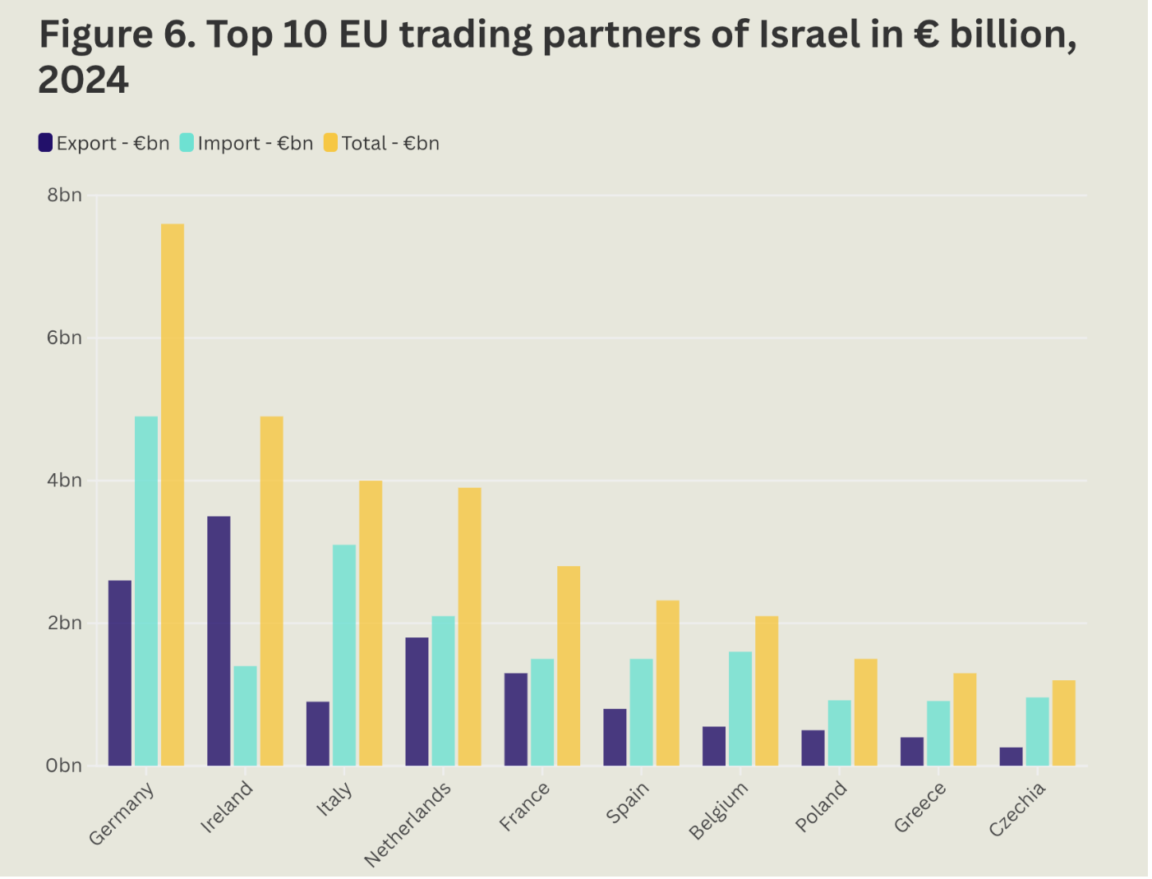

Source: Eurostat, collated and published by SOMO “Economic sanctions now: the EU is Israel’s largest investor (July 2025), available at: https://www.somo.nl/economic-sanctions-eu-is-israel-largest-investor/

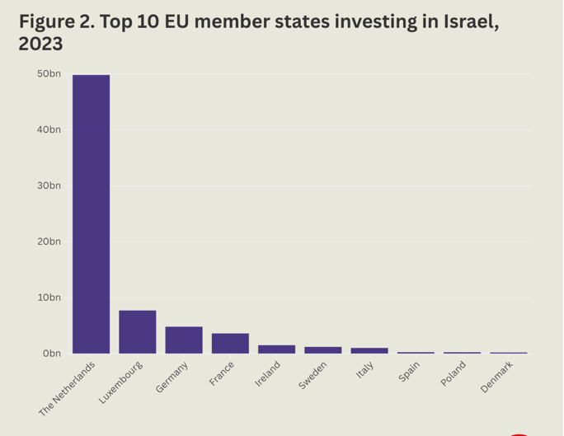
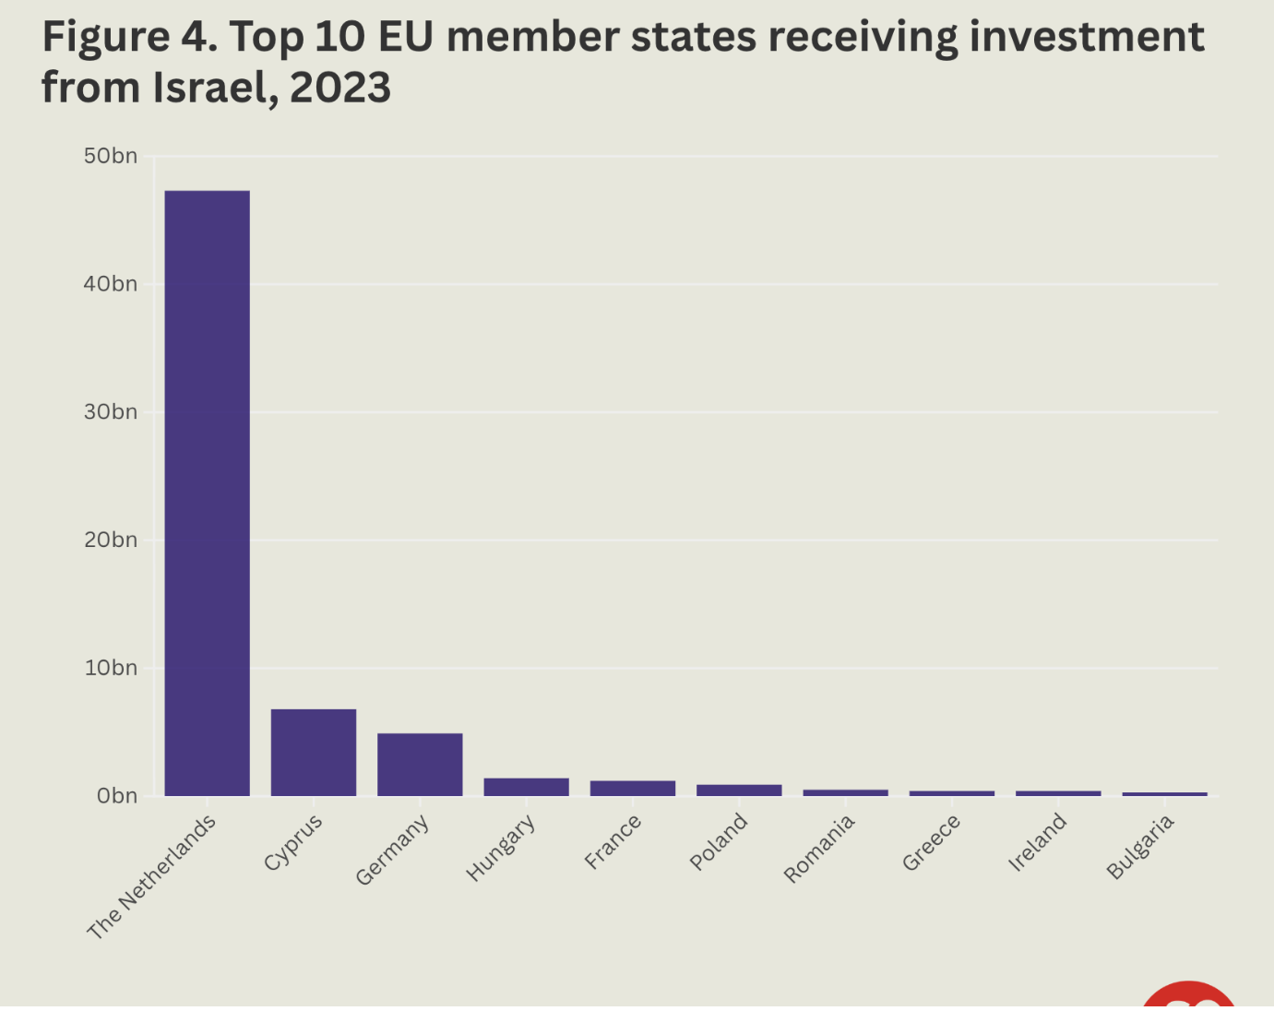

Source: Eurostat, collated and published by SOMO “Economic sanctions now: the EU is Israel’s largest investor (July 2025), available at: https://www.somo.nl/economic-sanctions-eu-is-israel-largest-investor/

Annex (4): Investments by Dutch Institutional Investors in Companies at risk of violating international human rights (2021-2024)

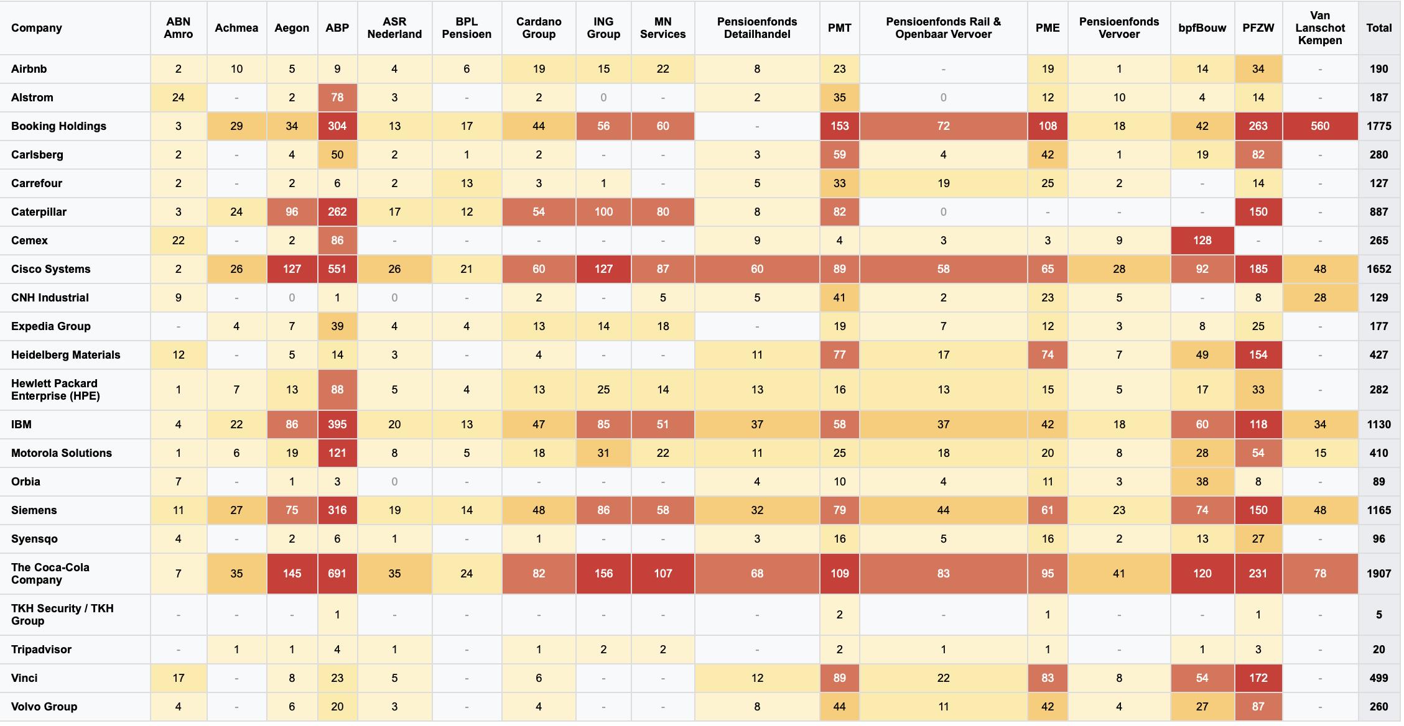

Source: ‘Don’t Buy Into the Occupation’ DBIO, PAX, The Rights Forum, BankTrack– Country brief Nederland, 26 Nov 2024, available here: https://paxforpeace.nl/publications/dont-buy-into-occupation/

Companies with documented violations of international law and human rights with which Dutch Institutional Investors are involved (see codes for proscribed activities below the table)
List of Companies | OHCHR Updated Database | Proscribed Activities. Identified by OHCHR | Documented in A/HRC/59/23 | Described violations in A/HRC/59/23 | DBIO 2024 Report | Proscribed activities determined by authors of the report
Airbnb | ✓ | e | ✓ | Para 70: listings linked to restricting Palestinians access to land and endangering nearby villages. | ✓ | e
Alstom | ✓ | e, g | - | - | ✓ | e, g
Booking Holdings | ✓ | e | ✓ | Para 70: see above  Para 71: profit from the colonies. Faces criminal complaints for laundering proceeds | ✓ | e
Carlsberg | - | - | - | - | ✓ | g
Carrefour | - | - | ✓ | Para 68, fn 231: apartheid through discriminatory service delivery | ✓ | e, g
Caterpillar | - | - | ✓ | Para 45: equipment used for mass demolitions and…burying alive wounded Palestinians  Para 50 & 51: equipment used to construct and expand illegal colonies, while excluding and segregating Palestinians | ✓ | a, c
Cemex | - | - | - | - | ✓ | a, g
Cisco Systems | - | - | - | - | ✓ | e
CNH Industrial | - | - | - | - | ✓ | a, c
Expedia Group | ✓ | e | - | - | ✓ | e
Heidelberg Materials | - | - | ✓ | Para 50: pillage millions of tons of rock from land seized in West Bank | ✓ | a, g
Hewlett Packard Enterprise (HPE) | - | - | ✓ | Para 38. ..continues to provide servers enabling the apartheid systems of Israel. | ✓ | b
IBM | - | - | ✓ | Para 38: Supports the discriminatory permit regime of Israel  Para 82: Contribute to producing the tools of surveillance, crowd control, urban warfare, facial recognition and targeted killing tools  Para 84: Runs the discriminatory Israeli Population Registry | ✓ | b
Motorola Solutions | ✓ | e, d | - | - | ✓ | b, d
Orbia | - | - | ✓ | Para 63: owns Netafim which has exploited Palestinians water resources, denied them water while assisting Israeli crop expansion | ✓ | e
Siemens | - | - | - | - | ✓ | e
Syensqo | - | - | - | - | ✓ | b
TKH Security / TKH Group | - | - | - | - | ✓ | b
Tripadvisor | ✓ | e | - | - | ✓ | e
Vinci | - | - | - | - | ✓ | e, g
Volvo Group | - | - | ✓ | Para 46: linked to the destruction of Palestinians property  Paras 50 &51 | ✓ | c, e
The Coca Cola Company | - | - | - | - | ✓ | g
Tahal Group International B.V. (Dutch Registered Company) | ✓ | e | - | - | ✓ | -
Kardan N.V. (Dutch Registered Company) | ✓ | e | - | - | ✓ | -
Compilation based on OHCHR updated database, Don’t Buy into Occupation report 2024, Report of Special Rapporteur on the situation of human rights in the Palestinian territories occupied since 1967, ‘From economy of occupation to economy of genocide’, (A/HRC/59/23),

Activity Codes Reference:
(a) Supply of equipment and materials facilitating construction and expansion of settlements and the wall
(b) Supply of surveillance and identification equipment for settlements, the wall and checkpoints
(c) Supply of equipment for demolition of housing and property, destruction of agricultural farms
(d) Supply of security services, equipment and materials to enterprises operating in settlements
(e) Provision of services and utilities supporting maintenance and existence of settlements, including transport
(f) Banking and financial operations helping to develop, expand or maintain settlements
(g) Use of natural resources, particularly water and land, for business purposes
(h) Pollution and dumping of waste in or transfer to Palestinian villages
(i) Captivity of Palestinian financial and economic markets, practices disadvantaging Palestinian enterprises
(j) Use of benefits and reinvestments of enterprises owned by settlers for developing settlements

Committee on Economic, Social, Cultural Rights, General comment No. 24 (2017) on State obligations under the International Covenant on Economic, Social and Cultural Rights in the context of business activities (2017), E/C.12/GC/24, available at: https://documents.un.org/doc/undoc/gen/g17/237/17/pdf/g1723717.pdf
Para. 28 of General Comment 24, E/C.12/GC/24.
Para. 26 of General Comment 24, supra n.1. The Committee affirmed that “extraterritorial obligations of States under the Covenant follow from the fact that the obligations of the Covenant are expressed without any restriction linked to territory or jurisdiction” (see para. 27 of the General Comment)
Charter of the United Nations, Article 56.
Para. 27 of the General Comment 24, supra n.1, referencing Legal Consequences of the Construction of a Wall in the Occupied Palestinian Territory, Advisory Opinion, I.C.J. Reports (2004), paras. 109-112.
Para. 32 of the General Comment 24 supra n.1. Reference made to the International Court of Justice, Case concerning application of the Convention on the Prevention and Punishment of the Crime of Genocide (Bosnia and Herzegovina v. Serbia and Montenegro) (judgment of 26 February 2007), I.C.J. Reports, paras. 430 and 461.
General Comment 24, supra n.1, Report of the Special Representative of the Secretary-General on the issue of human rights and transnational corporations and other business enterprises, ‘State responsibilities to regulate and adjudicate corporate activities under the United Nations core human rights treaties: an overview of treaty body commentaries’, A/HRC/4/35/Add.1 (2007), available at: https://docs.un.org/en/A/HRC/4/35/Add.1 ; Guiding Principles on Business and Human Rights UNGP principles 1 to 7, available at: https://www.ohchr.org/sites/default/files/documents/publications/guidingprinciplesbusinesshr_en.pdf
Para. 33 of General Comment 24, supra n.1. See also UNGPs, principle 13.
Legal Consequences Arising from the Policies and Practices of Israel in the Occupied Palestinian Territory, including East Jerusalem, Advisory Opinion, 19 July 2024, I.C.J. Available at: https://www.icj-cij.org/sites/default/files/case-related/186/186-20240719-adv-01-00-en.pdf
ICJ Advisory Opinion supra n.9, including para. 257.
ICJ Advisory Opinion supra n.9, paras. 230-233, para. 255; See also report of the Special Rapporteur on the situation of human rights in the Palestinian territories occupied since 1967, A/77/356, 2022, paras. 16-18. See also report of Special Rapporteur on the situation of human rights in the Palestinian territories occupied since 1967, ‘From economy of occupation to economy of genocide’, (A/HRC/59/23), para 47, page 38, referencing common Article 1 of both the International Covenant on Civil and Political Rights (ICCPR) and the International Covenant on Economic, Social and Cultural Rights (ICESCR), A/RES/637(VII); CCPR General Comment No. 12 (1984), UNGP- Commentary to GP19.
The ICJ based its review on the reports of the independent international fact-finding mission to investigate the implications of the Israeli settlements on the civil, political, economic, social and cultural rights of the Palestinian people (https://www.ohchr.org/en/hr-bodies/hrc/regular-sessions/session19/israeli-settlements-in-the-opt), the reports of the Independent International Commission of Inquiry on the Occupied Palestinian Territory, including East Jerusalem, and Israel (https://www.ohchr.org/en/hr-bodies/hrc/co-israel/index) , the reports of UN Special Rapporteurs, and several treaty monitoring bodies, including the Human Rights Committee, the Committee on Economic, Social and Cultural Rights and the CERD Committee (see for example paragraphs 113, 128 and 129 (in relation to access to water), 219, 233, 241, 242 of the Advisory Opinion).
The Court recalled that the protection offered by human rights conventions does not cease in case of armed conflict or of occupation. Legal Consequences of the Construction of a Wall in the Occupied Palestinian Territory, Advisory Opinion, I.C.J. Reports 2004 (I), p. 178, para. 106). The Court noted: Some rights may be exclusively matters of international humanitarian law; others may be exclusively matters of human rights law; yet others may concern both these branches of international law. See para. 99 of the Advisory Opinion.
ICJ AO, supra n.9, para. 278.
ICJ AO, supra n.9, paragraphs 233, 274, 278 and 279.
Available at: https://legal.un.org/ilc/texts/instruments/english/draft_articles/9_6_2001.pdf
Restated in International Law Commission 2022 Draft conclusions on identification and legal consequences of peremptory norms of general international law (jus cogens), available at: https://legal.un.org/ilc/texts/instruments/english/draft_articles/1_14_2022.pdf
ICJ AO, supra n.9, para. 242.
Report of Special Rapporteur on the situation of human rights in the Palestinian territories occupied since 1967, ‘From economy of occupation to economy of genocide’, (A/HRC/59/23), para. 30 of the Annex.
Ibid.
UN Doc. A/RES/2054(XX), “The policies of apartheid of the Government of South Africa” (1965-12-15), UN Doc. A/RES/2202(XXI)[A], “The policies of apartheid of the Government of South Africa” (1966-12-16), UN Doc. A/RES/2506(XXIV)[B], “The policies of apartheid of the Government of South Africa” (1969-11-21), preamble.
ICJ AO, supra n.9 paras. 278 and 279.
UNGA resolution A/ES-10/L.31/Rev.1, September 2024, available at: https://documents.un.org/doc/undoc/ltd/n24/266/48/pdf/n2426648.pdf.
Legal analysis and recommendations on implementation of the International Court of Justice, Advisory Opinion…” (October 2024), para. 29, available at: https://www.ohchr.org/sites/default/files/documents/hrbodies/hrcouncil/coiopt/2024-10-18-COI-position-paper_co-israel.pdf
“UN experts warn international order on a knife’s edge, urge States to comply with ICJ advisory opinion”, available at: https://www.ohchr.org/en/statements/2024/09/un-experts-warn-international-order-knifes-edge-urge-states-comply-icj-advisory
See Article 40 ARSIWA, https://legal.un.org/ilc/texts/instruments/english/draft_articles/9_6_2001.pdf
Para. 36 of the General Comment 24, referencing Olivier De Schutter and others, “Commentary to the Maastricht Principles on Extraterritorial Obligations of States in the area of Economic, Social and Cultural Rights”.
Written Statement of the Kingdom of the Netherlands, 28 February 2025 Para 3.3. https://www.icj-cij.org/sites/default/files/case-related/196/196-20250303-wri-03-00-en.pdf.
One-third of Israel’s total trade in goods with the world in 2024 was with the EU. Source: Jasper van Teeffelen “Economic Sanctions Now: the EU is Israel’s Largest Investor”, available at: https://www.somo.nl/economic-sanctions-eu-is-israel-largest-investor/
Based on 2024 goods trade balance data. In 2023, bilateral trade reached significant volumes with Israel exporting $1.92 billion to the Netherlands while importing $1.57 billion in Dutch goods. According to latest data from Observatory of Economic Complexity, in April 2025, the Netherlands exported €204M and imported €128M from Israel, resulting in a positive trade balance of €76M (https://oec.world/en/profile/bilateral-country/isr/partner/nld). Goods trade between the two countries shows a diversified and deep economic relationship spanning a wide range of goods from agriculture produce to transport machinery to high-end electronics. Israel's primary exports to the Netherlands center on industrial chemicals, energy products, and advanced medical technologies. Electrical and electronic products leads Israeli exports at $318 million, followed by medica and optical instruments (HS2) at $253million and by fuel products at $233 million. Dutch exports to Israel are mainly advanced technology components and agricultural products. Integrated circuits (HS4) top the list at $157 million, followed by delivery trucks at $146 million, and vaccines, blood, antisera, toxins and cultures at $57.2 million. Source: https://oec.world/en/profile/bilateral-country/isr/partner/nld. The 2024 export breakdown shows continued emphasis on technology, with electrical and electronic equipment reaching $398.92 million, optical, photo, technical, medical apparatus at $398.69 million, and machinery, nuclear reactors, boilers at $298.82 million. Source: https://tradingeconomics.com/netherlands/exports/israel
Ibid.
Jasper van Teeffelen, “Economic sanctions now: the EU is Israel’s largest investor (July 2025), available at: https://www.somo.nl/economic-sanctions-eu-is-israel-largest-investor/
Ibid.
Ibid.
Source: https://nltimes.nl/2025/06/17/dutch-submarines-get-european-tomahawk-alternative-military-buying-israeli-missiles, https://consortiumnews.com/2025/07/01/eu-buying-weapons-tested-on-palestine/, https://www.defensenews.com/global/europe/2024/09/04/netherlands-picks-israels-rafael-to-supply-upgraded-anti-tank-systems/, https://slguardian.org/netherlands-signs-175-million-arms-deal-with-israeli-firm-elbit/ https://www.timesofisrael.com/israel-inks-first-of-its-kind-305-million-sale-of-artillery-systems-to-netherlands/. For an overview of history of Netherlands and Isreali military ties, see: https://dimse.info/netherlands/#
Ibid.
Netherlands procures $305m supply of PULS rocket systems, 18 May 2025. https://www.army-technology.com/news/netherlands-procures-puls/ . Netherlands Signs $175 Million Arms Deal with Israeli Firm Elbit, 21 Jan 2025. https://slguardian.org/netherlands-signs-175-million-arms-deal-with-israeli-firm-elbit/#google_vignette . Netherlands picks Israel’s Rafael to supply upgraded anti-tank systems, 4 Sept 2024. Defense News. https://www.defensenews.com/global/europe/2024/09/04/netherlands-picks-israels-rafael-to-supply-upgraded-anti-tank-systems/
EU Buying Weapons Tested on Palestinians, 1 July 2025. Consortium News. https://consortiumnews.com/2025/07/01/eu-buying-weapons-tested-on-palestine/
The contract covers upgrades to more than 200 medium-range anti-tank missile launchers, switching to Rafael's Integrated Command Launch Unit capable of firing Spike LR2 missiles with a 5,000-meter range. The Dutch Defense Ministry justified this decision by emphasizing that "Dutch policy toward Israel allows for the acquisition of defense equipment from an Israeli company" and that procuring "the best equipment possible" serves Dutch security interests. Source: Netherlands picks Israel’s Rafael to supply upgraded anti-tank systems, 4 sept 2024. DefenseNews. https://www.defensenews.com/global/europe/2024/09/04/netherlands-picks-israels-rafael-to-supply-upgraded-anti-tank-systems/ ) The ministry noted that Germany and other European nations have made similar purchases, supporting a parliamentary request for equipment standardization .(Source: https://www.defensenews.com/global/europe/2024/09/04/netherlands-picks-israels-rafael-to-supply-upgraded-anti-tank-systems/)
The Database of Israeli Miliary and Security Export: On Netherlands. https://dimse.info/netherlands/#f+10820+1+12.
Ibid
Ibid
The Database of Israeli Miliary and Security Export: On Netherlands. https://dimse.info/netherlands/#f+10820+1+12. IAI Invests in two Cyber Companies in Holland and Hungary, 27 June 2017. https://www.iai.co.il/iai-invests-two-cyber-companies-holland-and-hungary
Dutch Supreme Court advised to uphold export ban of F-35 components to Israel, 29 Nov 2024. Reuters. https://www.reuters.com/world/dutch-highest-court-advised-uphold-ruling-export-ban-f-35-components-israel-2024-11-29/
Palestinian Youth Movement, Technical Briefing on Dutch Ports and Maersk: Sustaining the Israeli Military's F-35s Mask off Maersk Campaign (May 2025) maskoffmaersk.com, available at: https://static1.squarespace.com/static/664aed65d320123f2b3ab647/t/683a9c2428f3073023844cd9/1748671526098/Technical%2520Briefing%2520on%2520Dutch%2520Ports%2520and%2520Maersk-%2520Sustaining%2520the%2520I.pdf https://www.aljazeera.com/news/2025/6/5/netherlands-still-backs-israeli-f-35-supply-chain-of-death-report
Case brought by Oxfam Novib, Vredesbeweging PAX Nederland and The Rights Forum. See: https://www.rechtspraak.nl/Organisatie-en-contact/Organisatie/Gerechtshoven/Gerechtshof-Den-Haag/Nieuws/Paginas/The-Netherlands-has-to-stop-the-export-of-F-35-fighter-jet-parts-to-Israel.aspx and León Castellanos-Jankiewicz, ‘Dutch Court Halts F-35 Aircraft Deliveries for Israel: A “clear risk” of abuse’, available at: https://verfassungsblog.de/f-35/ . The Dutch government is appealing the court of appeal decision that requires them to halt the export of F-35 fighter jet parts to Israel within seven days. This appeal is being made to the Dutch Supreme Court through cassation. https://www.government.nl/latest/news/2024/02/12/state-lodges-appeal-in-cassation-against-judgment-on-distribution-of-f-35-parts-to-israel#:~:text=The%20court%20ruled%20this%20morning%20that%20the,of%20American%20F%2D35%20parts%20is%20not%20unlawful .The recommendation given by the Advocate General recommended to the Supreme Court provided that the Hague Court of Appeal’s ruling that the State of the Netherlands must cease exports of F-35 parts to Israel can be upheld. According to the Advocate General, the Court of Appeal was justified in finding that there is a clear risk that Israel’s F-35 fighter jets are being used to commit serious violations of international humanitarian law in the Gaza Strip. Under various international regulations to which the Netherlands is a party, exports of military goods must be banned if such a clear risk exists. https://www.hogeraad.nl/actueel/nieuwsoverzicht/2024/november/advocate-general-recommendation-to-supreme-court-court-appeal-decision/
https://www.government.nl/topics/export-controls-of-strategic-goods/question-and-answer/when-do-i-need-a-transit-licence-for-military-goods. According to this website, limited exception grounds for the license requirement are as follows: “No licensing requirement: You do not need to apply for a licence for military goods that are transported through Dutch territorial waters or airspace without docking or landing. Nor is a licence required for the transit of NATO materiel or military goods that originate in an EU member state and are destined for another EU state”, according to the website of the Dutch government”.
See website: https://www.government.nl/topics/export-controls-of-strategic-goods/question-and-answer/when-do-i-need-a-transit-licence-for-military-goods (where it is noted that the responsible authority is Ministry of Foreign Affairs).
https://www.aljazeera.com/news/2025/6/5/netherlands-still-backs-israeli-f-35-supply-chain-of-death-report
Information and report pertaining to the database are available here: https://www.ohchr.org/en/hr-bodies/hrc/regular-sessions/session31/database-hrc3136
https://www.ohchr.org/sites/default/files/documents/hrbodies/hrcouncil/sessions-regular/session31/database-hrc3136/23-06-30-Update-israeli-settlement-opt-database-hrc3136.pdf
Report of Special Rapporteur on the situation of human rights in the Palestinian territories occupied since 1967, ‘From economy of occupation to economy of genocide’, (A/HRC/59/23), para. 70 and 71, available at https://www.ohchr.org/en/documents/country-reports/ahrc5923-economy-occupation-economy-genocide-report-special-rapporteur , and referencing SOMO, “Booking.com accused of laundering profits from Israeli war crimes in Palestine” (May 2024) www.somo.nl/booking-com-accused-of-laundering-profits-from-israeli-war-crimes-in-palestine/.
Article 23, Concluding observations on the combined seventeenth to nineteenth reports of Israel (12 December 2019), https://www.alhaq.org/cached_uploads/download/2019/12/21/cerd-cos-1576920588.pdf
A/HRC/43/71, available at: https://www.ohchr.org/en/hr-bodies/hrc/regular-sessions/session31/database. See also OHCHR, “OHCHR update of database of all business enterprises involved in the activities detailed in paragraph 96 of the report of the independent international fact- finding mission to investigate the implications of the Israeli settlements on the civil, political, economic, social and cultural rights of the Palestinian people throughout the Occupied Palestinian Territory, including East Jerusalem” (2023), available at: www.ohchr.org/sites/default/files/documents/hrbodies/hrcouncil/sessions-regular/session31/database- hrc3136/23-06-30-Update-israeli-settlement-opt-database-hrc3136.pdf. See also: GLAN and SOMO report (2021), “Tainted Tourism”, available at: https://www.somo.nl/tainted-tourism/
UN OHCHR, Statement on the implications of the Guiding Principles on Business and Human Rights in the context of Israeli settlements in the Occupied Palestinian Territory (6 June 2014) p. 5. https://www.ohchr.org/sites/default/files/Documents/Issues/Business/OPTStatement6June2014.pdf
Report of Special Rapporteur on the situation of human rights in the Palestinian territories occupied since 1967, ‘From economy of occupation to economy of genocide’, (A/HRC/59/23), para, 9 of the annex, pages 29 and 30, referencing: Rachel Davis, “The UN Guiding Principles on Business and Human Rights and Conflict-Affected Areas: State Obligations and Business Responsibilities”, Int’l Rev. Red Cross, vol. 94, No. 887, (2012), p. 973; Tara Van Ho, “Defining the Relationships: ‘Cause, Contribute, and Directly Linked to’ in the UN Guiding Principles on Business and Human Rights”, Human Rights Quarterly, vol. 43, No. 4, (November 2021), p. 634; Note by the Chair of the Negotiations on the 2011 Revision, Regarding the Terminology on “Directly Linked”, OECD Guidelines for Multinational Enterprises (2011 Revision), https://mneguidelines.oecd.org/global-forum/GFRBC-2014-financial-sector-document-3.pdf, among other references
Ibid.
See: Lydia de Leeuw and Maria Hengeveld, “Unleashing terror: Dutch dogs in Israel’s war crimes”, SOMO, available: https://www.somo.nl/unleashing-terror-dutch-dogs-in-israels-war-crimes/
Ibid, SOMO. See also: https://euromedmonitor.org/en/article/6383/Gaza:-Israeli-army-systematically-uses-police-dogs-to-brutally-attack-Palestinian-civilians,-with-at-least-one-reported-rape , and https://www.newarab.com/analysis/new-palestinian-testimonies-reveal-horrors-israels-prisons
Al-Haq, Jenin: IOF Military Dogs Attack and Injure 73 Year-Old Man in Night Raids (20 May 2018), https://www.alhaq.org/monitoring-documentation/6205.html
Netherlands Food and Consumer Product Safety Authority https://english.nvwa.nl/
Lydia de Leeuw and Maria Hengeveld, “Unleashing terror: Dutch dogs in Israel’s war crimes”, https://www.somo.nl/unleashing-terror-dutch-dogs-in-israels-war-crimes/
https://www.daf.com/en
https://www.vdlgroep.com/en/vdl-groep/about-vdl
https://eindhovennews.com/news/2024/03/brainport-parties-maintain-ties-to-israel-despite-relentless-violence/
Legal Consequences cf the Construction of a Wu11 in the Occupied Palestinian Territory, Advisory Opinion, I. C. J. Reports 2004, p. 136, para. 159, https://www.icj-cij.org/sites/default/files/case-related/131/131-20040709-ADV-01-00-EN.pdf
https://paxvoorvrede.nl/wp-content/uploads/2024/11/NL-Country-Brief-2024.pdf https://dontbuyintooccupation.org/wp-content/uploads/2024/11/2024_DBIO-IV_Company-list.pdf https://paxforpeace.nl/wp-content/uploads/sites/2/2024/11/2024_DBIO-IV-report.pdf https://paxforpeace.nl/publications/dont-buy-into-occupation/
https://paxvoorvrede.nl/wp-content/uploads/2024/11/NL-Country-Brief-2024.pdf https://dontbuyintooccupation.org/wp-content/uploads/2024/11/2024_DBIO-IV_Company-list.pdf
Ibid
Ibid
Ibid
Ibid
Ibid. PFZW (Pensioenfonds Zorg en Welzijn), the healthcare sector pension fund with €255 billion in assets, previously held €149 million in companies supplying weapons to Israel, had sold all its listed investments in Israel and several other Middle Eastern countries in spring 2024, citing concerns about growing threat of conflict expansion in the region. Source: PFZW Divests from Israel, 17 Oct 2024. IPE Netherlands. https://www.ipe.com/news/pfzw-divests-from-israel/10076283.article
Judgment of the District Court available at the following link: https://uitspraken.rechtspraak.nl/details?id=ECLI:NL:RBDHA:2024:20828&showbutton=true&keyword=al%2Bhaq&idx=3. For more analysis, see: Dion Kramer and Kri van Douwen, “After the International Court of Justice: Business as Usual? Al-Haq and Others versus the Netherlands: District Court The Hague” (13 December 2024), available at: https://opiniojuris.org/2025/01/15/after-the-international-court-of-justice-business-as-usual-al-haq-and-others-versus-the-netherlands-district-court-the-hague-13-december-2024/. For update on the case, see: https://www.somo.nl/dutch-state-accused-of-failing-to-prevent-genocide/
Ibid, Dion Kramer and Kri van Douwen.
SOMO, Coalition appeals Dutch court ruling for failure to uphold obligations under international law (25 March 2025), https://www.somo.nl/coalition-appeals-dutch-court-ruling-for-failure-to-uphold-obligations-under-international-law/
ICJ Advisory Opinion, supra n.9, para. 285.
Position Paper of the United Nations Independent International Commission of Inquiry on the Occupied Palestinian Territory, including East Jerusalem, and Israel (18 October 2024) https://www.un.org/unispal/document/position-paper-commissionof-inquiry-18oct24/ (para. 30). See also Guiding Principles 7.
The Guiding Principles note that “To achieve greater policy coherence and assist business enterprises adequately in such situations, home States should foster closer cooperation among their development assistance agencies, foreign and trade ministries, and export finance institutions in their capitals and within their embassies, as well as between these agencies and host Government actors; develop early-warning indicators to alert government agencies and business enterprises to problems; and attach appropriate consequences to any failure by enterprises to cooperate in these contexts, including by denying or withdrawing existing public support or services, or where that is not possible, denying their future provision”. See GPs commentary to Principle 7, available at: https://www.ohchr.org/sites/default/files/documents/publications/guidingprinciplesbusinesshr_en.pdf
The commentary is available at: https://legal.un.org/ilc/texts/instruments/english/commentaries/9_6_2001.pdf
The Law of International Responsibility, edited by James Crawford, Alain Pellet, and Simon Olleson, Oxford Commentaries on International Law, 2010, Oxford University Press, page 697.
Ibid, The Law of International Responsibility.
Nina HB Jorgensen, Chapter 48 “The Obligation of Cooperation’, in The Law of International Responsibility, edited by James Crawford, Alain Pellet, and Simon Olleson, Oxford Commentaries on International Law, 2010, Oxford University Press. See: The Declaration on Principles of International Law Concerning Friendly Relations and Co-operation among States in accordance with the Charter of the United Nations (Annex to GA Resolution 2625 (XXV), 24 October 1970, which provides evidence of the consensus among UN Member States on the meaning and elaboration of the principles of the Charter, among which is the principle on the duty of States to cooperate with one another in accordance to the Charter.
See para. 4 of commentary of the ILC on Article 41(2) ARSIWA, available at: https://legal.un.org/ilc/texts/instruments/english/commentaries/9_6_2001.pdf.
Ibid, para. 11.
Nina HB Jorgensen, Chapter 47 “The Obligation of Non-Assistance to the Responsible State”, in The Law of International Responsibility, edited by James Crawford, Alain Pellet, and Simon Olleson, Oxford Commentaries on International Law, 2010, Oxford University Press, page 691.
GA Resolution entitled ‘Advisory opinion of the International Court of Justice on the legal consequences arising from Israel’s policies and practices in the Occupied Palestinian Territory, including East Jerusalem, and from the illegality of Israel’s continued presence in the Occupied Palestinian Territory’, A/ES-10/L.31/Rev.1, 13 September 2024, available at: https://documents.un.org/doc/undoc/ltd/n24/266/48/pdf/n2426648.pdf
Ibid, GA Resolution A/ES-10/L.31/Rev.1.
UN Independent International Commission of Inquiry on the Occupied Palestinian Territory, including East Jerusalem, and Israel, Legal analysis and recommendations on implementation of the International Court of Justice, Advisory Opinion, Legal Consequences arising from the Policies and Practices of Israel in the Occupied Palestinian Territory, including East Jerusalem (18 October 2024), para. 29. Available at: https://www.ohchr.org/sites/default/files/documents/hrbodies/hrcouncil/coiopt/2024-10-18-COI-position-paper_co-israel.pdf
Ibid, Commission of Inquiry, para. 30.
See: UN experts warn international order on a knife’s edge, urge States to comply with ICJ advisory opinion, available at: https://www.ohchr.org/en/statements/2024/09/un-experts-warn-international-order-knifes-edge-urge-states-comply-icj-advisory

