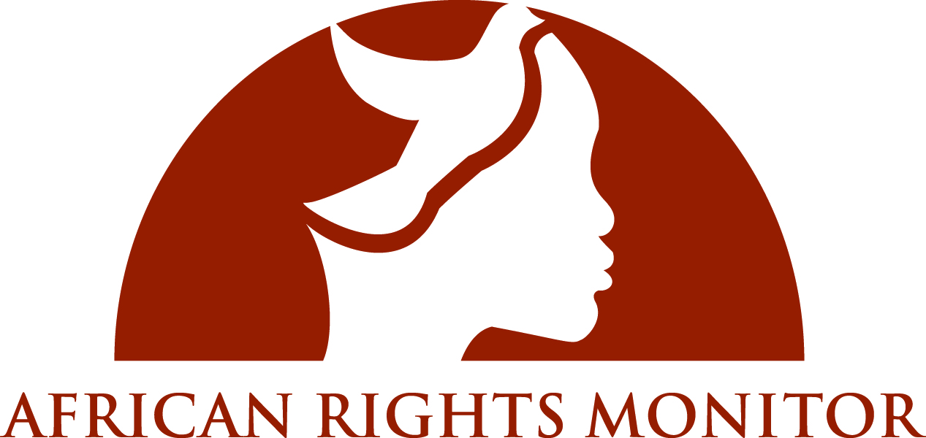

Submission from African Rights Monitor
to the Committee of Economic, Social and Cultural Rights
May 2012, Geneva

Related to the discussion of the country situation in Ethiopia
and its performance in upholding the
Convention on Economic, Social and Cultural Rights

African Rights Monitor Contact Details
(+1) 202.642.4493
africanrightsmonitor@gmail.com
125 S. Reynold St Apt #J501, Alexandria, VA, 22304, United States of America.

Table of Contents

Executive Summary 1
Background of the author 3
Methodology of work 3

Substantive Part
Article 3: Equal rights for men and women 5

Article 9: The right to social security 7

Article 10: Protection and assistance for the family 8

Article 11: The right to an adequate standard of living 8

Article 12: The right to the highest attainable standard of health 10

Articles 13 and 14: The right to education 14

Concluding recommendations 16

Works cited 18

Executive Summary

The following submission to the Committee on Economic, Social and Cultural Rights in review of the adherence of the Federal Democratic Republic of Ethiopia to the provisions of CESCR has been completed by African Rights Monitor, a non-governmental advocacy organization created to monitor human rights violations in conflict and post-conflict African territories. The report is intended to act as a complement to Ethiopia’s official submission to the Committee, and to underscore various violations and issues that remain unreported by the Government.

While Ethiopia has adopted the provisions of CESCR into its national Constitution and multiple legal codes, violations of the Convention’s principles occur unchecked throughout the country, particularly in conflict zones within the Ogaden and Oromia regions. The ethnic groups in these regions make up 46% of the population of Ethiopia, and yet its residents are routinely marginalized politically and socially, with limited legal, health, and education services available to residents. Overall, there is a critical lack of de facto implementation of the de jure measures Ethiopia has made to ensure the economic, social and cultural rights of its citizens. Discrepancies between policy and reality exist under each of the Articles of CESCR, but are particularly severe as related to Article 3 (Equal rights for men and women), Article 10 (Protection and assistance for the family), and Articles 12-14 (Rights to health and education).

This report collates relevant available data and first hand accounts to corroborate the charges of rights violations within the country, concluding with eight recommendations for the consideration of the Ethiopian Government, including:

1. In order to achieve more de facto equality for women in Ethiopia, more concerted and comprehensive efforts to sensitize and educate local authorities, community councils, woreda (district-level) courts and other judiciaries on any and all de jure measures which ensure women’s participation and equality in regards to their legal rights to

a) register land under their own name,
b) access education to the university level,
c) participate in political processes which affect them,
d) receive support upon dissolution of marriage,
e) access to family planning services, and
f) protection from harmful traditional practices, including FGM,

A concrete and strategic plan must be designed and implemented to guarantee these rights within 18 months.

2. To accompany the implementation of more comprehensive sensitization campaigns, we call on the Federal Government of Ethiopia to oversee a more stringent system of evaluation and retribution of local authorities and courts, including suspension, fines and other minor forms of punishment for those officials who do not implement de jure measures which guarantee the full equality and freedom of women, in particular the revised Criminal Code of 2005, in addition to the Ethiopia National Policy on Ethiopian Women and revised Family Codes.

3. Regional discrepancies which can be witnessed from various indicators of women’s development, but are perhaps most marked in the figures of health service utilization and presence of medical personnel. More concerted efforts to recruit and train medical personnel in marginalized regions, particularly the Ogaden, must be made as soon as possible to help address the severe health ramifications occurring as a result of continued conflict in the area.

4. Specifically address the discrepancies between participation in ante-natal care and labour and delivery services through educational outreach to mothers on the potential risks incurred at childbirth.

Background of the author

The following submission to the CESCR Committee has been completed by African Rights Monitor (ARM), a Washington, DC-based non-governmental advocacy organization created to monitor human rights violations in conflict and post-conflict African territories. Currently ARM is conducting monitoring projects in Ethiopia, Somalia, and Kenya, with plans to expand to Sudan and the Great Lake Countries next year (2013). With the understanding that democracy is underpinned by the participation of robust civil society, ARM strives to educate civil society groups on democracy, human rights and the rights of the press through workshops and seminars that address these issues as related to Africa. The organization aims to advocate for the protection of human rights in African countries by investigating and exposing human rights violations and holding abusers accountable for their inhumane actions. ARM can be contacted by telephone at (+1) 202.642.4493, or through mail at 125 S. Reynold St Apt #J501, Alexandria, VA, 22304, United States of America.

African Rights Monitor has recently focused on the precarious situation for human rights in Ethiopia, particularly in relation to conflicts in the Ogaden region. There is substantial documentation of various rights abuses committed at the hands of the Ethiopian Government by other human rights organizations including Human Rights Watch, the International Crisis Group, Amnesty International, Genocide Watch, Ogaden Human Rights Committee, International Committee of the Red Cross and the United States State Department. In addition to the reporting from international non-governmental organizations (NGOs), ARM contributes an extensive understanding of violations of women’s rights in nation states within a legal background and framework and is in a unique position to report on the reality of the situation in Ethiopia.. ARM grew out of the intellectual and grassroots civil societies movement from Africa and was founded to offer an African perspective to international human rights bodies and forums.
Methodology of work
African Rights Monitor has completed this submission after extensive background research into all available data and eyewitness accounts collected in the last decade by UN bodies, academia, and NGOs from women both in Ethiopia and the diaspora on conditions of human rights in Ethiopia, with a particular focus on regional discrepancies in CEDAW implementation. The writing of the report relied mainly on firsthand reporting of events as transmitted to civil society organizations, academia, the United Nations (UN), and government sources.
Statistical information and analyses of State programs and policies were retrieved mostly from reports produced by Demographic and Health Surveys (DHS) in coordination with Ethiopia’s Central Statistical Agency, in addition to UN and other academic and civil society sources. Description of specific events, including instances of arrest and rape, are derived from eyewitness accounts as reported by independent academic and non-governmental sources, including Human Rights Watch and Amnesty International. These organizations have considerable networks within Ethiopia and the diaspora, and work to collect personal accounts and experiences of rights violations and abuses occurring in Ethiopia. The unique role ARM is able to offer in producing this report is to comprehensively present these accounts, offering commentary based on understanding and knowledge about the nation within the legal framework which were used to form the main substantive part of this text.
Any and all legal reporting was collected directly from Ethiopian state reports and legal codes, including the FDRE Constitution and the nation’s first official submission to the CESCR Committee, though we are still awaiting the list of responses to the issues posted to the country this year. The Substantive Part of the report will address the multiple rights violations occurring in Ethiopia as they relate to each of the most relevant Articles of CESCR, focusing in on discrepancies between de jure and de facto rights and policies, while also noting the grave differences in implementation figures based on region.

Substantive Part

Article 3: Equal rights for men and women

Issue 5 – Guaranteeing of land rights and elimination of gender stereotypes: In Ethiopia there is a clear separation between de jure and de facto rights and equality for women. As the Internal Displacement Monitoring Centre (IDMC) explains, “though gender equity has achieved support and respectability in high-level policy making, as witnessed by the Constitution and other both national and regional policies, concerns remain over the persistent gap between government intentions as provided for in legislation or in policy documents and their implementation.” As one former regional court judge from Ethiopia asserts, "If [the federal government] followed the law, it would be good, but even the law they’ve created is not being followed." As regards land, while certain de jure changes in women’s inheritance rights have occurred, women still rarely participate in de facto land rights registration process and generally hold disfavourable positions in land disputes, as evidenced in a recent unpublished study by the EWLA. The study, as cited by the World Bank, explains how women’s unequal access to land contributes to their overall poverty, identifying several problems encountered by women in obtaining equal land distribution and rights guaranteed in the FDRE Constitution. As the report asserts, most rural women are farmers relying on the land, but official registries continue to list their husbands or male relatives as chief proprietors. Upon divorce or the husband’s death, the land remains the legal property of the male’s family, leading to widespread eviction of women and children from the property. While regional efforts to amend land certifications to include women’s names have been instituted mainly by NGOs with some success, progress has been slow. As the EWLA concludes, “women’s marginalization and lack of secure access to land are critical obstacles to development because: (a) if women were able to control the land they farm and use the produce for economic gain, aggression would decrease and personal security would increase, and (b) women’s access to land would contribute to the reduction of poverty and increase food security.”

Comparatively low literacy rates also impact the ability of women to understand their rights to land, and enhance the oppressive effect of those discriminatory customs which inhibit female participation in court and legal proceedings. While across Ethiopia literacy rates demonstrate high urban/rural disparities and a clear gender bias with male literacy at 49.9% and female literacy at 26.6%, the disparity is especially high in areas of conflict, such as the Ogaden region, where “service delivery, including education, remains extremely limited; [and] the on-going conflict has decimated enrolment in schools.”

Despite de jure guarantees of eliminating gender discrimination mentioned by the State Party, including the National Policy on Ethiopian Women (NPEW), historically women have often been considered inferior to men and have been subjected to de facto discrimination in multiple forms, including forced and early marriage, FGM, and domestic violence. The rate of FGM in Ethiopia is still incredibly high and, as one population survey conducted in 2005 showed, the nationwide prevalence of FGM was 74%, with notable discrepancies based on region: the highest rates in the country are found in the Afar and the Somali Regional States (91.6% and 79% respectively).

Such deep-rooted patriarchal traditions persist in Ethiopia, as it remains the case that generally “male power-holders, including religious leaders, define the norms of social conduct that limit the social space of women. In particular, religious leaders, Christians, Muslims and traditional believers, have power to define appropriate social behaviour and conduct, a capacity that, for instance, severely limits the social space of women in Ethiopia.” Thus while laws may be in place to support women, many leaders on the ground still hold traditional discriminatory beliefs which prevent their proper de facto implementation: the Norwegian University of Life Sciences published a report in January 2008 stating that “social court judges typically make decisions based on traditions rather than according to the law. This may make it difficult for women to get support according to the law. It may also be difficult for women to take their case to the [district-level] woreda court. Social pressures on women may be very heavy if they take their cases to court and many give up for that reason."

Specifically, religious laws and traditions are used to justify oppressive systems and practices. As a World Bank report confirms, “a concurrent issue for women is the application of Islamic law through Sharia Courts to personal and family disputes. By some interpretations, Islamic laws do not afford women equal rights as defined by the Constitution. In order for religious courts to adjudicate personal and family matters, the Constitution requires both parties to voluntarily submit to their jurisdiction. Absent that consent, a court within the official system should hear the matter. In practice, however, considerable social and family pressures are reportedly exerted to coerce women to accept the jurisdiction of the Sharia Courts. Thus, the voluntariness of their submission may be questionable.”

It is deeply concerning that gender-based violence such as rape, FGM and domestic abuse are commonplace, and most women do not trust in their “legal rights” or have the resources or awareness to appeal for legal help. As highlighted in a special report from IDMC, “gender-based violence, including abduction of girls, early forced marriage and female genital mutilation, leads to health complications and an extremely high maternal mortality rate throughout Ethiopia. It affects the entire population and is partly due to a social structure which places women and children at the bottom of the hierarchy. Most women whose rights have been violated do not dare seek legal help, particularly in rural areas.” In eliminating discriminatory practices based on gender stereotypes, the Government of Ethiopia must ensure that women are educated about their legal rights, while also eradicating exclusionary judiciary procedures.

Article 9: The right to social security

Issue 11 – Universal social security programme: According to the Transformation and Growth Plan adopted by the Ethiopian government in 2010, all private-sector companies must offer their employees a social security plan. This, in addition to the civil servants' pension scheme already in place, should theoretically give all government and private-sector paid workers access to social security after a minimum of 10 years worked. While this is an admirable step towards universal social security, it is still insufficient to protect the majority of the Ethiopian population. This is in part due to the vast number of Ethiopians who work in the informal sector: according to the Demographic and Health Survey (DHS) from 2005, over 50% of workers in Ethiopia are unpaid, meaning that this sector of the economy would never be eligible for social security benefits within the current system.

Regarding minimum pension rates, the lowest pension rate for a public-sector employee was raised in January 2011 from ETB 160/month (approximately USD 9.25) to ETB 294/month (USD 17). While this represents a major increase in pension rates, it is important to note that this is the first time in 50 years that pension amounts have been changed, indicating that the government does not regularly review pension rates to adjust for inflation. Furthermore, an income of USD 17 per month is still well below the international poverty line of USD 1.25 per day (or ~USD 37.5 per month), thus not ensuring pensioners an adequate standard of living.

Issue 12 – Informal economy: Currently, workers in the informal sector are not covered by any type of old age pension scheme. Social security programs for the informal sector are minimal, but do include a number of free health services such as family planning, HIV testing, pre- and post-natal care (including prevention of transmission of HIV/AIDS from mother to child), certain immunizations for mothers and children, and disease management of tuberculosis, leprosy and fistulas.

While the above-mentioned services are admirable, their success must be considered in the context of accessibility to these services, something which is clearly lacking, especially in rural areas. Data from the DHS (2005) indicate that over 97% of rural women encounter “serious problems” in accessing health care. The number is slightly better for urban women (over 88%), but still points to an extreme shortfall on the part of the Government to provide access to health care services.

Article 10: Protection and assistance for the family

Issue 14 – Birth registration: The percentage of births that are registered in Ethiopia varies with geographical location and income. Urban children are registered in 29% of births, while for rural children this number plummets to just 5%. In the richest 20% of the population, 18% of births are registered, with just 3% in the poorest 20% of the population. This is yet another example of the disparity that exists between urban (generally richer) and rural (generally poorer) populations in Ethiopia.

Issue 15 – Child labour: Child labour is very prevalent in Ethiopia, as evidenced by the 53% of children aged 5-14 who are working according to UNICEF.

Issue 16 – Street children: The State party's report fails to acknowledge the impact of the restrictive Charities and Societies Proclamation on services offered to street children. The law, which bans the human rights operations of any civil society organization that receives more than 10% of its funding from international sources, has forced organizations like Forum for Street Children to close their Child Protection Units (CPU's) in Addis Ababa, a service that used to provide “shelter, medical care, counselling, and reintegration assistance to girls victimized by trafficking.”

Article 11: The right to an adequate standard of living

Issue 17 – Poverty: Article 43 of the FDRE Constitution provides that “the basic aim of development activities shall be to enhance the capacity of citizens for development and to meet their basic needs.” Despite the billions of dollars that flow into Ethiopia from international donors like the Development Assistance Group (DAG), the basic needs of millions of Ethiopians are not being met. Furthermore, certain groups in Ethiopia continue to be marginalized and excluded from food aid and other development programs, especially if their political stance opposes that of the EPRDF.

Extreme poverty remains the unfortunate norm for most of Ethiopia's citizens. Over one third of the country (39%) live under the international poverty line of USD 1.25 per day, with a full three-quarters of the population (77.5%) living on less than USD 2 per day. Although Ethiopia receives billions of dollars of aid money annually (~USD 3 billion per year), the equal distribution of this aid continues to be undermined by the Ethiopian government. This politicization of aid contributes directly to food insecurity for those people whom the Government deems “undeserving” of aid.

Issue 19 – Safe drinking water: In 2010, the Government of Ethiopia launched its most recent villagization program, a massive undertaking that encompasses four regions (Afar, Benishangul-Gumuz, Gambella, and Somali) and affects hundreds of thousands of rural (and some urban) Ethiopians. The program's objectives are to voluntarily relocate approximately 1.5 million residents into villages where they will have access to services and infrastructure provided by the government. The government maintains that the program is voluntary, is in the best interests of its citizens, will help rural residents gain access to vital services, resources and infrastructure (housing, schools, health care facilities, land and infrastructure for growing and harvesting crops, water and sanitation, etc.) and will help mitigate food insecurity in the regions. However, reports from the regions affected by the villagization program paint a very different picture of what is actually happening on the ground.

The most recent Human Rights Watch report about Ethiopia concerns the implementation of the villagization program in Gambella region (this region is the most advanced in the process), and provides evidence that the program is not attaining its goals, and is in fact making things worse for rural residents in terms of human rights protection, access to resources and food security. The violations of human rights taking place in the context of the villagization program are direct violations of numerous articles in the CESCR, as well as the Ethiopian Constitution. These are outlined below.

First, evictions were forced, not voluntary as the villagization plan purports. “Virtually all of the villagers interviewed by Human Rights Watch said that their move was an involuntary, forced process”, the HRW report states. This is a direct violation of the constitutional right of every Ethiopian to freedom of movement. Secondly, the evictions were often carried out under the threat of force. Residents who opposed being moved were often arrested, beaten, raped or even killed. These are gross violations of the right to life, the security of person and liberty protected by the Constitution of the FDRE (Articles 14, 15, 16 and 17).

Third, the villagization program is also a violation of Article 11 of CESCR since it has effectively lowered the standard of living of those people it was designed to help. The promises of the villagization plan (housing, access to water, food aid, seeds, oxen, school and health care facilities) have been realized in only a minority of villages in the program, leaving most residents in conditions that are very much worse than those they had been forced to leave. The scarcity of food in the new villages was identified as the most urgent and life-threatening problem in the new villages, indicating a dire insufficiency in the government's efforts to mitigate food insecurity in rural regions .

Although the government denies it, there is a sinister motive behind the villagization program. Many of those affected live in informal settlements: they are pastoralists or shifting cultivators, and as such the government has declared that the land they use is either “uninhabited” or “underutilized”. Upon eviction, their land has been offered for lease to foreign investors who use it to cultivate crops that are sent out of the country once harvested. Money earned from the leasing of land is obviously not making its way back to the residents who have been displaced, as evidenced by the lack of promised food and infrastructure present in the new villages.

Article 12: The right to the highest attainable standard of physical and mental health

Issue 20 – Health-care coverage: The State Party has not yet provided the requested information regarding health-care coverage disaggregated by economic sector and geographic region, seen here below:

Table 1: Potential health service coverage:

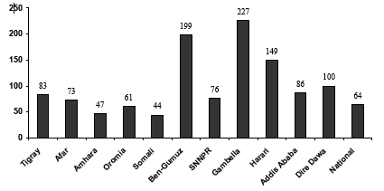

Table 2: Annual outpatient visit per capita

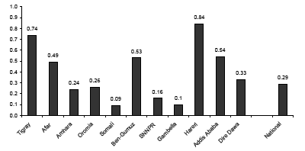

Aside from the utilization of health services, the actual number of health workers per capita likewise varies drastically by region, with the Somali-Ogaden region lagging behind most severely:

Table 3: Population per health worker 2003
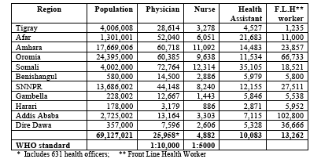

Such regional discrepancies point to larger trends of geographic and ethnic marginalization present in Ethiopia’s state policies and procedures. These discrepancies are not recognized or admitted by the Government in their official submission to the Convention’s Committee, but are nonetheless still critical obstacles faced by the nation in implementing CESCR and its principles. While the State mentions measures including the Health Extension Worker programme, the effects of the programme have varied considerably based on region, as is evident in the following section when comparing maternal health indicators by region.

Issue 22 – Maternal mortality: There is a remarkable lack of maternal health care in Ethiopia, particularly in the most vulnerable regions as evidenced from the DHS (2011) graph below:

Table 4: DHS 2011 - Maternal care indicators
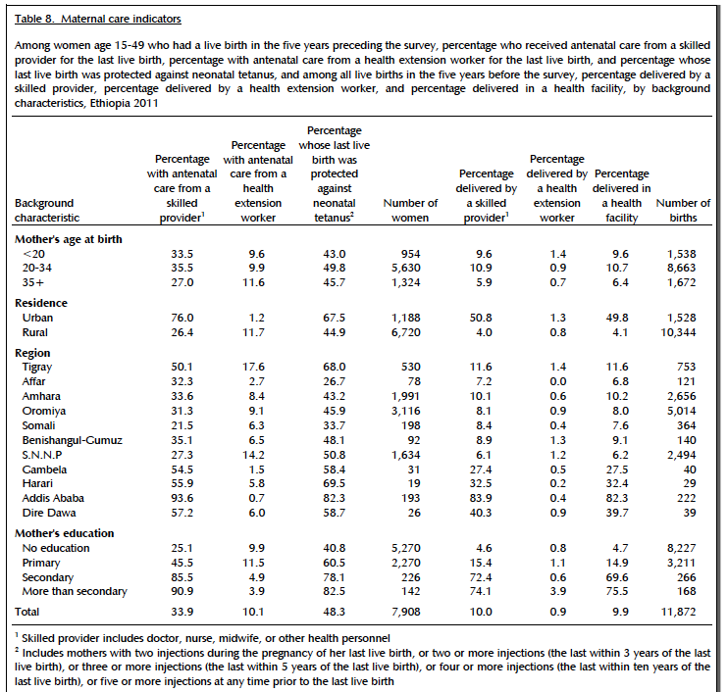

It is notable how the figures from 2011 have improved from the 2005 DHS report, but again, this improvement is highly region specific: the percentage of women who received ante-natal care from a Health Extension Worker reached 17.6% in Tigray, but was a mere 2.7% in Affar and 1.5% in Gambela, both highly vulnerable regions. There is clearly an uneven distribution of the effects of the Health Extension programme, in addition to a significant drop between those women who receive antenatal care and those who deliver with a skilled attendant. In addition to dealing with regional discrepancies, specific efforts to combat this drop-off in care must be a feature of the Health Extension program as it moves forward.

Aside from provision for care in pregnancy and delivery, discrepancies remain for women in accessing reproductive health services as the following DHS (2011) graph clearly indicates:

Table 5: DHS 2011 - Need and demand for family planning among currently married women

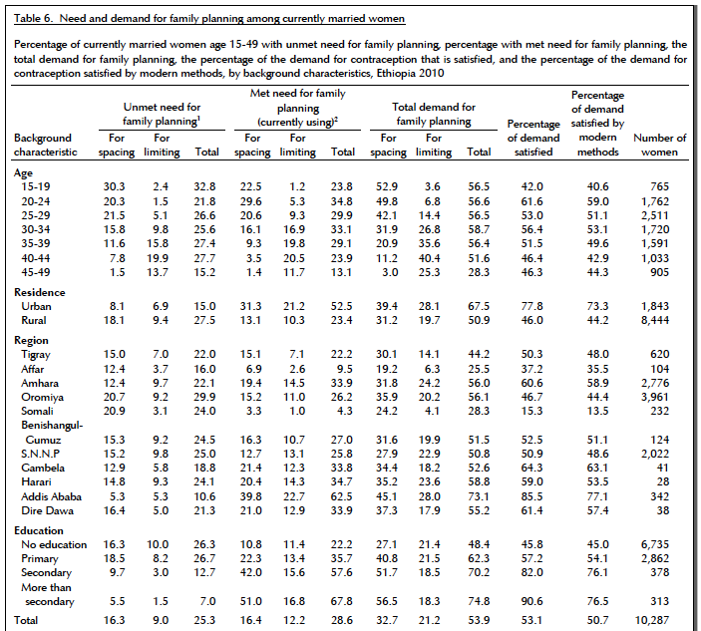

While merely 5.3% of women in Addis Ababa have an unmet need for family planning, this figure jumps to 20.9% in the Ogaden, indicating a further unequal distribution of health services. Furthermore, in comparing this table to figures from the 2005 DHS report, figures have improved in only four regions: Addis Ababa, Tigray, Amhara, and S.N.N.P. In the rest, demand for family planning has increased, signifying a potential increase in knowledge about contraception among the population, but showing clearly how services are still lacking.

Articles 13 and 14: The right to education

Issue 23 – Primary enrolment: Over the last decade, the Government of Ethiopia has launched a series of Education Sector Development Programs (ESDP) aimed at increasing primary enrolment rates, many of which directly address the gender gap in educational development.

According to independent observers, there has indeed been marginal improvement in the access of education to the Ethiopian population since the ESDP were initiated, though figures from 2011 are still unavailable:

Table 6: Education figures from 2000

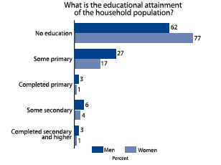

Table 7: Education figures from 2005

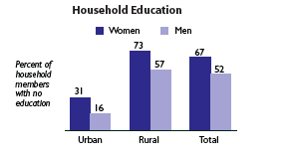

As evident from the graphs above, the percentage of women who have had no education dropped from 77% in 2000 to 67% in 2005. This increase is mostly due to efforts to increase primary enrolment, with 8.1 million pupils enrolled in 2001/02 and 11.4 million in 2004/05. Such figures represent an 18.2% increase in the gross enrolment rate (GER) and are due mostly to an improvement in school construction.

However, discrepancies based on region and gender still remain critical issues: more men are still educated than women, and huge gaps in access to education between rural and urban communities have been persistent despite Government programs. While there was substantial increase in the GER, the percentage of girls in primary school rested at 70.9%, while the percentage of boys in school increased to 87.3%. In addition, figures drop off considerably in terms of students attending secondary school: the GER remains low at 29.2%, with a 15% discrepancy between the percentages of boys and girls in attendance.

While the increase in primary schooling is notable, without proper consideration for continuing education at the secondary level, the impact becomes moot. At the same time, the differences in attendance along both gendered and regional lines must be more seriously considered by the Ethiopian state. To decrease the future political and economic marginalization of women in Ethiopia, proper educational opportunities must be afforded them, particularly in consideration of the provisions for educational equity contained in the CESCR. Female education must not stop at the primary level, and special support systems for women and girls, including girl-friendly schools with separate toilet facilities and female staff could aid in abating the female drop-out rate.

Concluding recommendations

1. In order to achieve more de facto equality for women in Ethiopia, more concerted and comprehensive efforts to sensitize and educate local authorities, community councils, woreda (district-level) courts and other judiciaries on any and all de jure measures which ensure women’s participation and equality in regards to their legal rights to

a) register land under their own name,
b) access education to the university level,
c) participate in political processes which affect them,
d) receive support upon dissolution of marriage,
e) access to family planning services, and
f) protection from harmful traditional practices, including FGM,

A concrete and strategic plan must be designed and implemented to guarantee these rights within 18 months.

2. To accompany the implementation of more comprehensive sensitization campaigns, we call on the Federal Government of Ethiopia to oversee a more stringent system of evaluation and retribution of local authorities and courts, including suspension, fines and other minor forms of punishment for those officials who do not implement de jure measures which guarantee the full equality and freedom of women, in particular the revised Criminal Code of 2005, in addition to the Ethiopia National Policy on Ethiopian Women and revised Family Codes.

3. Increase the pension provision for civil servants to insure they receive an actual living wage. Continue adjusting the pension in conjunction with inflation figures.

4. Make more rigorous efforts to develop a birth registration system, particularly to marginalised rural and lower socioeconomic communities through the inclusion of Health Extension Workers in the birth registration system.

5. Cease the villagization program and its system of forced evictions and discrimination against pastoralist communities.

6. Regional discrepancies which can be witnessed from various indicators of women’s development, but are perhaps most marked in the figures of health service utilization and presence of medical personnel. More concerted efforts to recruit and train medical personnel in marginalized regions, particularly the Ogaden, must be made as soon as possible to help address the severe health ramifications occurring as a result of continued conflict in the area.

7. Specifically address the discrepancies between participation in ante-natal care and labour and delivery services through educational outreach to mothers on the potential risks incurred at childbirth.

8. Amplify efforts to provide family planning services to women, particularly in regions where the percentage of un-met needs for contraception is rising, notably Oromia, Harari, Somali and Gambela.

Works Cited

Central Statistical Agency, Ethiopia Demographic and Health Survey 2000: Key Findings, Demographic and Health Survey, Addis Ababa, Ethiopia and Calverton, Maryland, 2000.

Central Statistical Agency and ORC Macro, Ethiopia Demographic and Health Survey 2005, Addis Ababa, Ethiopia and Calverton, Maryland, September 2006.

Central Statistical Agency and ORC Macro, Ethiopia Demographic and Health Survey 2011 Preliminary Report, Addis Ababa, Ethiopia and Calverton, Maryland, 2011.

Committee on Economic, Social and Cultural Rights, Combined Initial, Second and Third Periodic Reports Submitted by States Parties under Articles 16 and 17 of the Covenant: Ethiopia, E/C.12/ETH/1-3, 28 March 2011.

Committee on the Elimination of Discrimination against Women, Consideration of reports submitted by States parties under article 18 of the Convention on the Elimination of All Forms of Discrimination against Women: Combined sixth and seventh periodic report of States parties: Ethiopia, United Nations Convention on the Elimination of All Forms of Discrimination against Women CEDAW/C/ETH/6-7, 10 November 2009.

Constitution of the Federal Democratic Republic of Ethiopia, Federal Negarit Gazeta, Addis Ababa: 21st August 1995.

Ethiopian Ministry of Finance and Economic Development, Ethiopia: Building on Progress: A Plan for Accelerated and Sustained Development to End Poverty (PASDEP), Ministry of Finance and Economic Development, Addis Ababa, September 2006.

Family Health Department, National Strategy for Child Survival in Ethiopia, Federal Ministry of Health, Addis Ababa, Ethiopia, July 2005.

Gambella Peoples’ National Regional State, Villagization Program Action Plan (2003 EFY), August 2002 E.C.

Gebreselassie, E. New pension includes private sector, 13 June 2011, allafrica.com, available at: <http://allafrica.com/stories/201106150429.html>.

Human Rights Watch, Ethiopia: Army Commits Executions, Torture, and Rape in Ogaden, HRW, New York, June 2008 <http://www.hrw.org/en/news/2008/06/12/ethiopia-army-commits-executions-torture-and-rape-ogaden>.

Human Rights Watch, Development without Freedom: How Aid Underwrites Repression in Ethiopia, Human Rights Watch, October 2010.

Human Rights Watch, Waiting Here for Death: Forced Displacement and “Villagization” in Ethiopia's Gambella Region, HRW, 2012.

Internal Displacement Monitoring Centre, Ethiopia: Human Rights Violations and Conflicts Continue to Cause Displacement, 3 September 2009, <www.internal-displacement.org>.

International Social Security Association, New private-sector social security scheme and pension rate increases, ISSA. <http://www.issa.int/Observatory/Country-Profiles/Regions/Africa/Ethiopia/Reforms/New-private-sector-social-security-scheme-and-pension-rate-increase>.

UNICEF, Ethiopia Statistics: Economic Indicators, Updated 2 March 2010, available at: <http://www.unicef.org/infobycountry/ethiopia_statistics.html>.

US Department of State, 2010 Human Rights Report: Ethiopia, Bureau of Democracy, Human Rights and Labor.

U.S. Department of State, Background Note: Ethiopia, United States Government, 2010, <http://www.state.gov/r/pa/ei/bgn/2859.htm>.

World Bank, Ethiopia: Legal and Judicial Sector Assessment, The World Bank, Washington DC, 2004.

World Social Security Report 2010/11: Providing coverage in times of crisis and beyond, International Labour Office – Geneva: ILO, 2010.

U.S. Department of State, Background Note: Ethiopia, United States Government, 2010, <http://www.state.gov/r/pa/ei/bgn/2859.htm>.
Internal Displacement Monitoring Centre, Ethiopia: Human Rights Violations and Conflicts Continue to Cause Displacement, 3 September 2009, <www.internal-displacement.org>, p. 131.
Human Rights Watch, Ethiopia: Army Commits Executions, Torture, and Rape in Ogaden, HRW, New York, June 2008 <http://www.hrw.org/en/news/2008/06/12/ethiopia-army-commits-executions-torture-and-rape-ogaden>.
World Bank, Ethiopia: Legal and Judicial Sector Assessment, The World Bank, Washington DC, 2004, 34.
Internal Displacement Monitoring Centre, Ethiopia: Human Rights Violations and Conflicts Continue to Cause Displacement, 3 September 2009, <www.internal-displacement.org>, p. 119-120.
Committee on Economic, Social and Cultural Rights, Combined Initial, Second and Third Periodic Reports Submitted by States Parties under Articles 16 and 17 of the Covenant: Ethiopia, E/C.12/ETH/1-3, 28 March 2011.
Committee on the Elimination of Discrimination against Women, Consideration of reports submitted by States parties under article 18 of the Convention on the Elimination of All Forms of Discrimination against Women: Combined sixth and seventh periodic report of States parties: Ethiopia, United Nations Convention on the Elimination of All Forms of Discrimination against Women CEDAW/C/ETH/6-7, 10 November 2009, Article 5.31.
Internal Displacement Monitoring Centre, Ethiopia: Human Rights Violations and Conflicts Continue to Cause Displacement, 3 September 2009, <www.internal-displacement.org>, p. 126.
Internal Displacement Monitoring Centre, Ethiopia: Human Rights Violations and Conflicts Continue to Cause Displacement, 3 September 2009, <www.internal-displacement.org>, p. 130.
World Bank, Ethiopia: Legal and Judicial Sector Assessment, The World Bank, Washington DC, 2004, p. 33.
Internal Displacement Monitoring Centre, Ethiopia: Human Rights Violations and Conflicts Continue to Cause Displacement, 3 September 2009, <www.internal-displacement.org>, p. 94.
International Social Security Association, New private-sector social security scheme and pension rate increases, ISSA. <http://www.issa.int/Observatory/Country-Profiles/Regions/Africa/Ethiopia/Reforms/New-private-sector-social-security-scheme-and-pension-rate-increase>.
Central Statistical Agency and ORC Macro, Ethiopia Demographic and Health Survey 2005, Addis Ababa, Ethiopia and Calverton, Maryland, September 2006, pp. 44-45
International Social Security Association, New private-sector social security scheme and pension rate increases, ISSA. <http://www.issa.int/Observatory/Country-Profiles/Regions/Africa/Ethiopia/Reforms/New-private-sector-social-security-scheme-and-pension-rate-increase>.
UNICEF, Ethiopia Statistics: Economic Indicators, Updated 2 March 2010, available at: <http://www.unicef.org/infobycountry/ethiopia_statistics.html>.
Gebreselassie, E. New pension includes private sector, 13 June 2011, allafrica.com, available at: <http://allafrica.com/stories/201106150429.html>.
Committee on Economic, Social and Cultural Rights, Combined Initial, Second and Third Periodic Reports Submitted by States Parties under Articles 16 and 17 of the Covenant: Ethiopia, E/C.12/ETH/1-3, 28 March 2011
Central Statistical Agency and ORC Macro, Ethiopia Demographic and Health Survey 2005, Addis Ababa, Ethiopia and Calverton, Maryland, September 2006, pp. 120-122
UNICEF, Ethiopia Statistics: Economic Indicators, Updated 2 March 2010, available at: <http://www.unicef.org/infobycountry/ethiopia_statistics.html >
UNICEF, Ethiopia Statistics: Economic Indicators, Updated 2 March 2010, available at: <http://www.unicef.org/infobycountry/ethiopia_statistics.html >
US Department of State, 2010 Human Rights Report: Ethiopia, Bureau of Democracy, Human Rights and Labor, p.55
Constitution of the Federal Democratic Republic of Ethiopia, Federal Negarit Gazeta, Addis Ababa: 21st August 1995, Article 43, para 4
Human Rights Watch, Development without Freedom: How Aid Underwrites Repression in Ethiopia, Human Rights Watch, October 2010.
World Social Security Report 2010/11: Providing coverage in times of crisis and beyond, International Labour Office – Geneva: ILO, 2010, p.188
Human Rights Watch, Development without Freedom: How Aid Underwrites Repression in Ethiopia, Human Rights Watch, October 2010, p.4
Gambella Peoples’ National Regional State, Villagization Program Action Plan (2003 EFY), August 2002 E.C., pp. 1-5
Human Rights Watch, Waiting Here for Death: Forced Displacement and “Villagization” in Ethiopia's Gambella Region, HRW, 2012.
Gambella Peoples’ National Regional State, Villagization Program Action Plan (2003 EFY), August 2002 E.C., p. 1
Human Rights Watch, Waiting Here for Death: Forced Displacement and “Villagization” in Ethiopia's Gambella Region, HRW, 2012, p. 29
Constitution of the Federal Democratic Republic of Ethiopia, Federal Negarit Gazeta, Addis Ababa: 21st August 1995, Article 32, para 1
Human Rights Watch, Waiting Here for Death: Forced Displacement and “Villagization” in Ethiopia's Gambella Region, HRW, 2012, pp. 32-28
Constitution of the Federal Democratic Republic of Ethiopia, Federal Negarit Gazeta, Addis Ababa: 21st August 1995, Articles 14-17
Human Rights Watch, Waiting Here for Death: Forced Displacement and “Villagization” in Ethiopia's Gambella Region, HRW, 2012, p. 39-53
Human Rights Watch, Waiting Here for Death: Forced Displacement and “Villagization” in Ethiopia's Gambella Region, HRW, 2012, p. 4
“Potential” refers to the degree of health coverage if available services were fully utilized by the population. Family Health Department, National Strategy for Child Survival in Ethiopia, Federal Ministry of Health, Addis Ababa, Ethiopia, July 2005, p. 23.
Family Health Department, National Strategy for Child Survival in Ethiopia, Federal Ministry of Health, Addis Ababa, Ethiopia, July 2005, p. 24.
Family Health Department, National Strategy for Child Survival in Ethiopia, Federal Ministry of Health, Addis Ababa, Ethiopia, July 2005, p. 23.
Central Statistical Agency and ORC Macro, Ethiopia Demographic and Health Survey 2011 Preliminary Report, Addis Ababa, Ethiopia and Calverton, Maryland, 2011, p. 14.
Central Statistical Agency and ORC Macro, Ethiopia Demographic and Health Survey 2011 Preliminary Report, Addis Ababa, Ethiopia and Calverton, Maryland, 2011, p. 9.
Central Statistical Agency, Ethiopia Demographic and Health Survey 2000: Key Findings, Demographic and Health Survey, Addis Ababa, Ethiopia and Calverton, Maryland, 2000, p. 1.
Central Statistical Agency, Ethiopia Demographic and Health Survey 2005: Key Findings, Demographic and Health Survey, Addis Ababa, Ethiopia and Calverton, Maryland, 2005, p. 2.
Ethiopian Ministry of Finance and Economic Development, Ethiopia: Building on Progress: A Plan for Accelerated and Sustained Development to End Poverty (PASDEP), Ministry of Finance and Economic Development, Addis Ababa, September 2006, p. 7.
Ethiopian Ministry of Finance and Economic Development, Ethiopia: Building on Progress: A Plan for Accelerated and Sustained Development to End Poverty (PASDEP), Ministry of Finance and Economic Development, Addis Ababa, September 2006, p. 7.
Ethiopian Ministry of Finance and Economic Development, Ethiopia: Building on Progress: A Plan for Accelerated and Sustained Development to End Poverty (PASDEP), Ministry of Finance and Economic Development, Addis Ababa, September 2006, p. 7.
Ethiopian Ministry of Finance and Economic Development, Ethiopia: Building on Progress: A Plan for Accelerated and Sustained Development to End Poverty (PASDEP), Ministry of Finance and Economic Development, Addis Ababa, September 2006, p. 8.

