BRIEFING ON BELGIUM FOR THE COMMITTEE AGAINST TORTURE, SESSION 71- July 2021
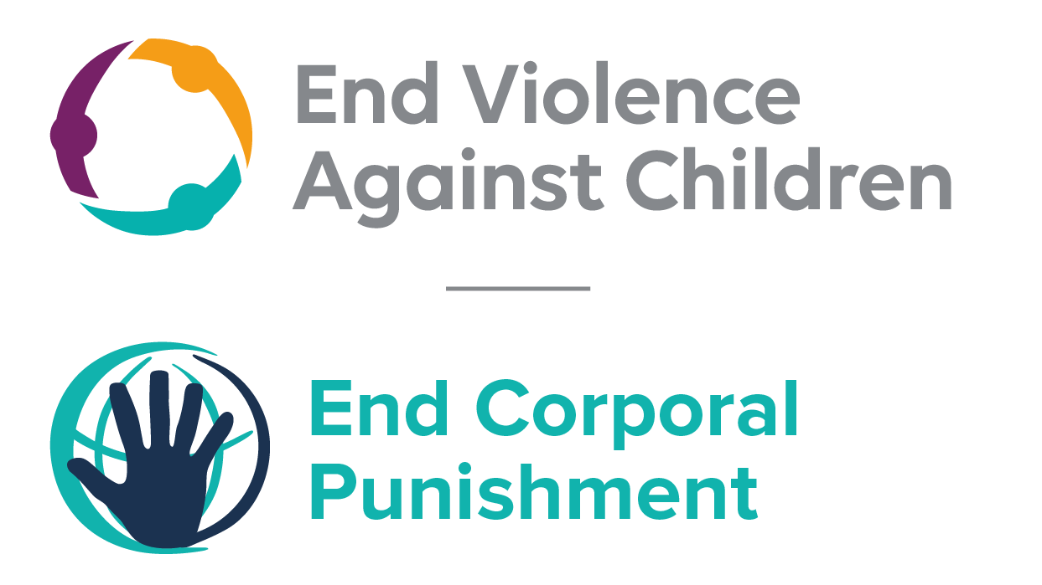
The Global Partnership to End Violence Against Children, June 2021

This briefing describes the legality of corporal punishment of children in Belgium. In light of the obligation under international human rights law to prohibit all corporal punishment of children, the recommendation of the UN Secretary General’s Study on Violence against Children, the repeated recommendations to prohibit all corporal punishment made to Belgium by the Committee Against Torture, the Committee on the Rights of the Child, other human rights treaty bodies and during the Universal Periodic Review in 2011 and 2016, as well as the global commitment to ending all violence against children in the context of the 2030 Agenda for Sustainable Development, we hope the Committee will:
• in its concluding observations on the fourth report of Belgium, recommend that legislation is immediately enacted to explicitly prohibit corporal punishment of children, in all settings including the home.

Note: Belgium is a federal state based on cooperation. There is no hierarchical distinction between federal laws and the laws of the federated entities: there is a procedure for prior consultation or subsequent judicial control, including through the Constitutional Court, as to whether the regulations of one entity might be detrimental to the interests or competences of another.

1 The report of Belgium to the Committee Against Torture
  - The fourth periodic report of Belgium states that several provisions under its civil and criminal law apply to corporal punishment, these include article 371 of the Civil Code and article 22 bis of the Constitution.
  - The report highlights that discussions to bring Belgian civil legislation into line with article 17 of the European Social Charter are under way. A Bill which aims to prohibit all corporal punishment has been introduced. The prohibition would concern persons who hold parental authority, as well as legal guardians and other persons responsible for the care and upbringing of a child.

- The legality of corporal punishment in Belgium
  - Summary: Corporal punishment of children in Belgium is unlawful in penal institutions and as a sentence for a crime. It is considered unlawful in schools but as yet legislation has not been reformed to include explicit prohibition. Corporal punishment is not fully prohibited in the home, in alternative care and day care settings.

  - Home: Corporal punishment is lawful in the home. The Civil Code states that the parent-child relationship should be one of “mutual respect” (art. 371), but this is not interpreted as prohibiting parental corporal punishment. A Constitutional amendment in 2000 (art. 22bis) provides for the protection of the child’s moral, physical and sexual integrity but does not explicitly prohibit all corporal punishment. Provisions against violence and abuse in the Penal Code as amended by the Law Concerning the Penal Protection of Minors 2000 are not interpreted as prohibiting all corporal punishment in childrearing.
  - Following a complaint against Belgium brought in 2003 by the World Organisation Against Torture under the Collective Complaints procedure of the European Social Charter, the European Committee of Social Rights concluded that Belgium was in violation of article 17 of the Charter because there is no explicit prohibition in law of corporal punishment of children by parents and other carers (including non-institutional childcare facilities and arrangements). In the following years, a number of legislative proposals were introduced to amend the Civil Code to prohibit all corporal punishment but these were never discussed in Parliament.
  - In 2011, the Government rejected the recommendation to prohibit corporal punishment by law in all settings made during the Universal Periodic Review of Belgium, stating that while corporal punishment is not a specific offence, a number of provisions in criminal law are applicable to such acts. In reporting to the Committee Against Torture in 2012, the Government similarly indicated that existing law offers adequate protection to children from corporal punishment but also confirmed that corporal punishment is “not an offence as such”. The report draws attention to a circular of 21 October 2008 which reminds prosecution services that “depending on the circumstances, corporal punishment of children is liable to be treated as punishable assault and/or degrading treatment”. Again, in 2013, in response to a question by the Committee on Economic, Social and Cultural Rights about prohibition, the Government asserted that existing legislation adequately protects children from corporal punishment.
  - In February 2013, a second collective complaint – submitted by the Association for the Protection of All Children (APPROACH) Ltd – was registered by the European Committee of Social Rights, alleging that there is no explicit prohibition of corporal punishment in the family, alternative care settings and schools throughout all communities in Belgium. The complaint was declared admissible on 2 July 2013; the Committee published its decision on 29 May 2015. The Committee concluded that the situation in Belgium is in violation of the Charter because there is “no adequate and effective prohibition [of corporal punishment] in law”.
  - In responding to recommendations to prohibit corporal punishment made during the Universal Periodic Review of Belgium in 2016, the Government accepted one recommendation to prohibit corporal punishment in all settings including the home but delayed its response to another similar recommendation. Subsequently, in apparent contradiction to earlier remarks on the issue, the Government stated that it could not commit to implementing the recommendation to introduce a law prohibiting corporal punishment in all settings, that the current legal framework already punishes violence towards children, and that a study is under way to determine whether adjustments to the framework are necessary or desirable.
  - A Bill was introduced in April 2016 to amend the Civil Code, adding a new article 371/1 (unofficial translation): “Children have a right to care, safety and a good education. They must be treated with due respect to their person and their individuality and cannot be subjected to degrading treatment or any other form of physical or psychological violence.” Although the Bill does not use the term “corporal punishment”, its explanatory memorandum refers to Belgium’s obligation to explicitly prohibit all forms of corporal punishment and in particular to the multiple recommendations received from UN treaty bodies and the European Committee of Social Rights. It also states that this provision would be intended to apply to parents but also all others caring for a child. As at August 2018, the Bill had not yet been discussed in Parliament. Belgium’s 2017 state report to the Committee on the Rights of the Child does not mention the Bill and does not address corporal punishment.
  - Belgium declared in November 2018 that domestic legislation already applied to corporal punishment of children, including in the family setting, but stated that discussions were underway to bring national civil legislation in conformity with article 17 of the European Social Charter. The Government further stated that it considered violent discipline as unacceptable and that a ban would apply to all with parental authority as well as guardians and those caring for a child.

  - Alternative care settings: Corporal punishment is prohibited in some but not all alternative care settings. In the Flemish Community, corporal punishment is prohibited in institutions in article 28 of the Decree of the Flemish Council (7 May 2004) and articles 11 and 13 of the Flemish Government Decree of 13 July 1994 concerning grants to institutions for youth, but there is no prohibition in relation to non-institutional care. To our knowledge, there is no explicit prohibition of corporal punishment in alternative care settings in the French Community or the German-speaking Community. This was confirmed in relation to the French Community by the Government in 2018.

  - Day care: There is no explicit prohibition of corporal punishment in all early childhood care and in day care for older children.

  - Schools: Corporal punishment is considered unlawful in schools under case law relating to provisions against assault in the Criminal Code, but there is no explicit prohibition in legislation.

  - Penal institutions: Corporal punishment is unlawful as a disciplinary measure in penal institutions. The Act concerning the principles of the administration of prison establishments and the legal status of detainees 2005 does not include corporal punishment among its provisions for disciplinary regimes. A federal Bill amending legislation on youth protection and addressing juvenile justice was adopted in 2006 but we have no details of its provisions. The Government reported to the UPR in 2015 that a law of 5 May 2014 had reformed the regime applicable to internees: we have yet to see the full text of this law.

  - Sentence for crime: Corporal punishment is unlawful as a sentence for crime. It is not a permitted punishment under the Criminal Code.

Recommendations by human rights treaty bodies and during the UPR
  - CAT: The Committee Against Torture has twice recommended that legislation be enacted to explicitly prohibit corporal punishment in all settings: in its concluding observations on the second report in 2009 and on the third report in 2014.

  - CRC: On three occasions, the Committee on the Rights of the Child has recommended to Belgium that legislation be enacted to explicitly prohibit corporal punishment in all settings: in its concluding observations on the state party’s initial report in 1995 on the second report in 2002, and on the third-fourth report in 2010.

  - CESCR: The Committee on Economic, Social and Cultural Rights recommended that the Government enact a legislation to prohibit corporal punishment in all settings: in its concluding observations on Belgium’s third report in 2007 and on the fourth report in 2013.

  - ECSR: The European Committee on Social Rights repeatedly recommended that the Government prohibit corporal punishment in all settings: in 2001, in 2005, in 2007, in January 2012 (Conclusions 2011) and in March 2020 (Conclusions 2019).

  - UPR: At the first cycle of the Universal Periodic Review of Belgium in 2011, the Belgian Government rejected a recommendation to adopt legislation explicitly prohibiting corporal punishment. During the second cycle UPR in 2016, the Government accepted a recommendation to prohibit in all settings, categorizing it as already implemented or in the process of implementation. Subsequently, the Government stated that it could not commit to implementing the recommendation to introduce a law prohibiting corporal punishment in all settings, and that the current legal framework already punishes violence towards children.

9 November 2015, A/HRC/WG.6/24/BEL/1, National report to the UPR, para. 5
7 January 2019, CAT/C/BAL/4, Fourth periodic report of Belgium, paras. 156 and 157
Resolution ResChS(2005)10, Collective complaint No. 21/2003 by the World Organisation against Torture (OMCT) against Belgium, adopted by the Council of Ministers on 8 June 2005
20 August 2003 proposal by Sabine de Béthune, 17 February 2007 proposal by Clitilde Nyssens and Christian Brotcorne, 16 January 2007 proposal by Magda Raemaekers and 14 July 2008 proposal by Christian Brotcorne
11 July 2011, A/HRC/18/3, Report of the working group, paras. 63 and 103(10)
19 November 2012, CAT/C/BEL/3, Third state party report, para. 152
19 November 2012, CAT/C/BEL/3, Third state party report, para. 152
28 October 2013, E/C.12/BEL/Q/4/Add.1, Reply to list of issues, para. 147
Collective complaint No. 98/2013, Association for the Protection of All Children (APPROACH) Ltd v Belgium
Collective Complaint No. 98/2013, Association for the Protection of All Children (Approach) v Belgium, Decision on the Merits, Adoption 20 January 2015, Notification 28 January 2015, Publication 29 May 2015
3 February 2016, A/HRC/WG.6/24/L.6, Draft report of the working group, paras. 139 (15) and 140(30)
1 June 2016, A/HRC/32/8/Add.1, Report of the working group: Addendum, paras. 6 and 10
See http://www.dekamer.be/kvvcr/showpage.cfm?section=flwb&language=fr&cfm=/site/wwwcfm/flwb/flwbn.cfm?dossierID=1778&legislat=54&inst=K, accessed 2 August 2018
[July 2017], CRC/BEL/5-6, Fifth/sixth report
19 November 2018, CRC/C/BEL/Q/5-6/Add.1, Reply to list of issues, paras. 15 and 16
19 November 2018, CRC/C/BEL/Q/5-6/Add.1, Reply to list of issues, para. 19
9 November 2015, A/HRC/WG.6/24/BEL/1, National report to the UPR, para. 13
19 January 2009, CAT/C/BEL/CO/2, Concluding observations on second report, para. 24
3 January 2014, CAT /C/BEL/CO/3, Concluding observations on third report, para. 27
20 June 1995, CRC/C/15/Add.38, Concluding observations on initial report, para. 15
13 June 2002, CRC/C/15/Add.178, Concluding observations on second report, paras. 23 and 24
18 June 2010, CRC/C/BEL/CO/3-4, Concluding observations on third/fourth report, paras. 7, 8, 39 and 40
3 December 2007, E/C.12/BEL/CO/3, Concluding observations on third report, paras. 19 and 33
23 December 2013, E/C.12/BEL/CO/4 Draft, Concluding observations on fourth report, para. 17
1 January 2001, Conclusions XV-2 vol. 1, pages 109-112
July 2005, Conclusions XVII-2
2007, Conclusions XVIII-1, vol.1
11 July 2011, A/HRC/18/3, Report of the working group, para. 103(10)
11 April 2016, A/HRC/32/8, Report of the working group, para. 139(15)

