NGO information to the
United Nations Committee on the Rights of Persons with Disabilities
For consideration when compiling
the Concluding observations on the initial report of the
European Union
Under the Convention on the Rights of Persons with Disabilities

Submitted by the
CENTER FOR LEGAL RESOURCES
14 FEBRUARY 2022

On behalf of the organisation,
Ms. Georgiana Pascu, programme manager at Center for Legal Resources, gpascu@crj.ro, +40729 881 159
Ms. Oana Dodu, programme assistant at Center for Legal Resources, oana.dodu@crj.ro. +40749893120

INTRODUCTION
This written submission provides an outline of issues of concern with regard to the European Union’s implementation of the Convention on the Rights of Persons with Disabilities (“the CRPD”). In particular, it provides information to the Committee on the Rights of Persons with Disabilities (“the CRPD Committee”) for consideration when drafting and adopting the List of Issues Prior to Reporting (“LOIPR”) in respect of European Union’s second period review.
This submission has been written by the Foundation Centre for Legal Resources (CLR), a Romanian non-governmental organisation for the defence and promotion of human rights established in 1998 by the Open Society Foundation. Since 2003, through the programme "Advocacy for Dignity" - https://bit.ly/3uO52pf , using data collected through unannounced monitoring visits to residential centres and psychiatric hospitals, interviews with people with disabilities at risk of institutionalisation, makes recommendations to the responsible institutions, facilitates their contact with other specialists at international level and represents victims with disabilities before national courts and the European Court of Human Rights (e.g. "CLR on behalf of Valentin Câmpeanu v. Romania", information on the case is available here: https://bit.ly/35w5Og5 ). The aim of these actions is to contribute to the implementation of the provisions of the United Nations Convention on the Rights of Persons with Disabilities (CRPD). We also mention that we are an organisation with ECOSOC consultative status.

EXECUTIVE SUMMARY
This submission provides information in seven sections related to different articles of the CRPD.
On Article 19: Living independently and being included in the community, we explain that there has been little change in the numbers of people with disabilities who are still institutionalised, even after the use of european funds for deinstitutionalisation across european countries, with regars to Romania’s situation. The rate of deinstitutionalisation is slow, or in some cases it doesn’t exist at all, and the government continues to deny people with disabilities the right to choose where and with whom they live on an equal basis with others; and the government continues to invest vast sums of European money in institutional settings to the detriment of investments into community-based services. In some cases, “deinstitutionalisation schemes” are actually resulting in trans-institutionalisation.

On Article 35: Reports by states parties, we highlight how important it is for the European bodies to carefully monitor the implementation of the CRPD provisions by the national authorities of State Members of the European Union (with special regard to Romanian), as often the lack of the mandatory National Report submitted by the States member of the Convention shows a poor usage of the European funds and mismanagement.

RESPONSE TO LIST OF CONCLUDING OBSERVATIONS

This submission covers the following Articles of the CRPD and the following paragraphs of the Concluding Observations :
- Living independently (art. 19) – paragraphs 50-51, Concluding observations.

After almost 4 years, Romania has spent less that 4 milion Euros out of the approximately 38 milion Euros initially allocated for the deinstitutionalisation of only 604 (out of 16.756 institutionalised adults with disabilities) confined in residential facilities under the control of the Romanian General Directorates for Social Assistance and Child Protection.
We mention this as we consider that the European Commission has not fulfilled its obligation under the UN Convention towards the rights of persons with disabilities to independeltly live in their communities. The allocated money, as well as the unspent amount of 34 million Euro should urgently be allocated to provide immediate contracting of housing and community support services for at least 3100 people with disabilties (calculation based on the maximum annual cost for a person living independently and having access to services in the community, approx. 61,000 Romanian national Currency - 12334,32 Euros).
For months, the Centre for Legal Resources has been collecting information on how much and in what ways Romania spends European funds intended for the deinstitutionalization of people with disabilities, in large centres throughout the country. We have knocked on many doors in these months, including that of the Ministry of Investment and European Projects (MIEP/MIPE) which was getting ready to send the European Commission the priority guidelines for the Operational Programme for Inclusion and Social Dignity (POIDS) (details : here and here – în Romanian only. See also the Full CLR – MIEP correspondence here ).

The Operational Programme Inclusion and Social Dignity (POIDS) is the programme that will secure another tens of millions of euros for the Romanian government, funds that among others things are also supposedly used for the deinstitutionalization of adults with disabilities, using the same type of investment (building smaller centres called “sheltered housing” connected to a day centre, mostly replicating on a smaller scale the living conditions in residential centres without respecting the right to independent living in the community of people with disabilities who are still institutionalized).

Nothing illustrates this better than the figures attached to the submission (as Annex 1), for the counties that have accessed and contracted European money for deinstitutionalization: prices far above the maximum standard cost for sheltered housing (which, as mentioned before, should not be the solution for independent living anyway!), delayed or even non-existent construction work, with the added suspicion of overlapping funding for the same infrastructure. A scenario that looks good on paper (tens of millions of euros for people with disabilities!), but the ground reality is far from it.

An illustrative example of how these “investments” are handled is the case of Călinești, in Prahova county, documented by CLR. The Centre for Legal Resources (CLR) was made aware that on 1st August 2021, two elderly people with disabilities, institutionalized in the residential Centre of Calinești, Prahova County, were heavily beaten and humiliated by an employee of the Centre. At the time of the offence, at least 30 other residents and another employee, who attempted to intervene, but without success, were present. Following the incident — one of the two elderly people with disabilities died.
More details on the case and measures taken, here : https://bit.ly/3oNS5Iq .
From the visit of the CLR in the Centre in Calinești, it was noted that people with disabilities, institutionalised on the basis of the decision of the ‘Commission establishing the degree of disability’ under the responsibility of the Prahova County Council, did not have access to the telephone or email to ask for help and report any beatings, humiliation and emotional abuse. In addition, the employees, who were obliged to urgently report the incident, did not call the emergency 112 service.

More info about the Centre for Recuperation, Neuropsychiatric Rehabilitation for Adults with Disabilities Calinești (CRRNPAH Calinești): The Centre in Calinești is composed of four pavilions and provides services to around 120 residents. According to the legal provisions, the centre, which also has legal personality, should have been restructured and reorganised since 2018, which has not yet taken place.

The centre was expected to undergo a restructuring process, which had also foreseen building 2 sheltered homes/small group homes for 20 people and 1 day centre that were supposed to be completed by 31 December 2021 through the use of the European Regional Development Funds. At the moment, no construction has started, the designated land is not marked and indicated according to the standards required by the European funds and there is no information on the state of the project ( https://bit.ly/3BlBf8J ). These sheltered homes/small group homes do not correspond to Romania’s obligations under the United Nations Convention on the Rights of Persons with Disabilities. The Convention provides that independent living in the community can only take place outside residential institutions of all kinds. European and national funds must therefore be used to build community services, individual social housing with adequate equipment and personal assistants. European funds have been blocked since 2018 on this project which has not even started and which, moreover, would lead to building micro-institutions with the same medical staff and social assistance, therefore perpetuating the institutional culture, which is not in line with the requirements of the Convention.

Besides the criminal complaint sent by CLR to the Prosecutor’s office, we requested a national television to help us document and investigate more about the bad usage of the European funds in the Center in Călinești. Therefore, a national television programme, ProTV, sent its field reporters to set off on the trail of the millions of euros that had supposedly been used since the end of 2020, according to data obtained by CLR, to build housing for the residents of the massive centre in Călinești. In reality, the site of the alleged 5 sheltered housing units and 2 day centres is an empty lot, with no sign of any construction work. The CLR team traced the leads from the contracts and found out that the bid for the construction work was only being planned for the month of September, of the year of 2021. More details on the investigation, here : https://youtu.be/lEZNayfANfg.
The case of Călinești is not singular and Prahova is not the only county that makes minimum efforts for a lot of money and achieves practically nothing for people with disabilities. The other counties are not better off – those that even ventured as far as to write up projects for European funds. We mention again the case of residents from a Centre for Neuropsychiatric Recovery and Rehabilitation (CRRN) located in Răcăciuni, Bacău Country (Romania), where CLR organised an unannounced monitoring visit on 27 january 2020.

From the analysis of the admission documents of the residents in the CRRN Răcăciuni, the discussions with the staff of the centre and with the residents, it also emerged that there are several situations likely to indicate ill-treatment of people with institutionalized disabilities, violation of the right to life in the community (art. 19 of the Convention on the Rights of Persons with Disabilities, Law no. 221/2010), arbitrary deprivation of liberty, restriction of the right to privacy, abuse of some of the residents with psychosocial and intellectual disabilities (especially people in Module M4), overcrowding and unhealthy and poorly lit or ventilated spaces. More details about the findings, here : https://bit.ly/3GNFknk

In November 2021, CLR did a follow-up visit in the CRRN Răcăciuni, to discurss with the residents and employees about the situation of the houses that are going to be built using european funds. A part of the sheltered housing built with European funds is located in the vicinity of the centre, on the left side of it, separated only by a very large wire fence, which encloses and encloses the complex of 4 houses. The other complex is located in the locality of Tamași, about 30 km from the current location of the CRRN Răcăciuni. The residents of these 8 houses (4 in Răcăciuni and 4 in Tamași) are to carry out activities in a Day Centre, about 10 km from the location of the CRRN Răcăciuni, but we were not given further details about this Day Centre, or how the residents will have access to it, or how other people with disabilities in the community will benefit from these services.

The housing near Răcăciuni was due for completion in February 2021. However, at the time of our visit (end of November) we were told that furniture would be brought into the centre in the next period (around 1 December), and that the 24 eligible residents are not expected to be transferred by Christmas, most likely after 1 January. After a follow up call at the beginning of February 2022, we understood that untill this moment there are still some things to be done in the houses, so maybe by the end of March residents will be able to move in.

The accommodation is built as very large villas, with 2 single rooms on the ground floor and 2 double rooms upstairs, a living/dining room where residents will be able to socialise, a kitchen where they are to prepare their meals, and the rooms have individual bathrooms. All of these support people with disabilities to be able to learn independent living skills. Asking to be allowed access to see what the housing looks like on the inside (since at the time of arrival, it was still daylight outside, we could see that the outside of the housing was finished), we were told that this is only possible with the accompaniment of the site manager (who has the building keys), who comes once a week (on Wednesdays) with the project team, to see the state of the work - the very next day some of the furniture shipment is due to arrive.

In the 8 houses (4 in Răcăciuni and 4 in Tamași) 48 residents are to be transferred. The CLR team wanted to find out how they were informed about independent living, the change of environment, whether they were able to choose with whom they would live in the room. From the discussions with the staff of the centre, it appeared that the information of the staff is done regularly, that the residents to be transferred were selected. We have sincere doubts that residents were correctly and adequately involved in the process of deciding where and with whom to leave, so there is a constant breach of art. 19, supported by the misuse of european funds.

Moreover, Romania is about to engage again in the same kind of practice: a lot of money invested in building some walls and lost in bids and contracts over the course of years. The intended beneficiaries of these funds remain, year after year, still within the crumbling walls of overcrowded centers throughout the country. Waiting for the much-anticipated inclusion in the community, some end up dying in these dreadful residential centers. A detaild map with the use of European money can be found here : https://bit.ly/3sLLrUm

In Romania deinstitutionalization done with European funds means lots of money allocated for buildings, many located on the edge or even outside the community, that are less crowded or moldy than the usual segregated facilities but are nowhere close to an actual step forward in the direction of giving access to independent living.

Real deinstitutionalization should have meant using the resources to subcontract services or engage actors in the community; instead of contracting out the construction of sheltered housing (in reality just multi-roomed houses, mostly located at the edge of a field) attached to other renovated old buildings pompously called Day Centres (former medical offices, abandoned schools, etc), the funds should have been invested, for example, in rent vouchers or the purchase of social housing.

The same resources could also have been used to fund mobile support teams and to facilitate easy access to services for all members of the community, not just to finance ineffective plans limited to those in sheltered, satellite housing. However, all these possible strategies will have to wait, because there is no indication that Romania will change anytime soon its strategy for allocating European funds for people with disabilities and will most likely continue, through POIDS (the Operational Programme for Inclusion and Social Dignity), to waste the money on building new walls around these people, literally.

In relation to article 35, Romania ratified the Convention on the Rights of Persons with Disabilities (CRPD) in 2010 and had the obligation to submit at least 3 country reports within almost 11 years. In order to fulfill the obligation set out in above-mention article, "Reports of States Parties", Romania had to submit a comprehensive report on the measures taken to implement its obligations under the CRPD, with the consultation and involvement of persons with disabilities and non-governmental organisations. The reports submitted would have highlighted the factors and difficulties affecting the degree of fulfilment of the obligations under the UN Convention. Furthermore, the EU has ratified the United Nations Convention on the Rights of Persons with Disabilities, which provisions are therefore an integral part of the European Union's legal system.

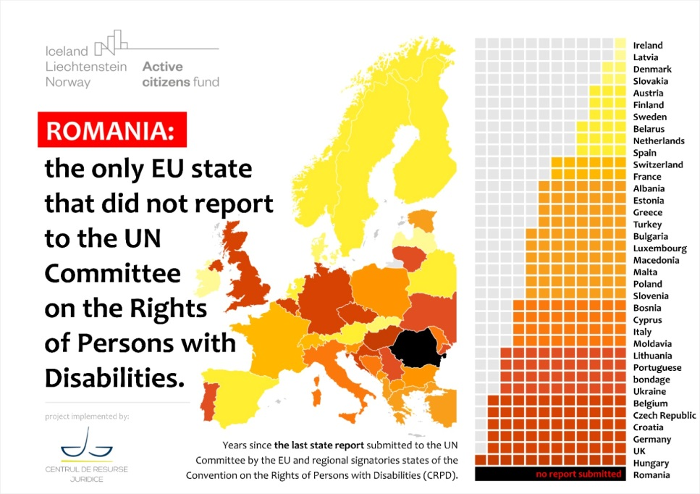

Looking at the map above, it becomes clear that Romania is no longer concerned with building or maintaining a reputation as a responsible State in relation to the commitments it has made as a State that has ratified the CRPD. Nor towards the UN Committee on the Rights of Persons with Disabilities, and even less towards persons with disabilities in Romania. So we will not say that Romania is in danger of embarrassing itself at European and international level, it is belated and redundant.

However, we will say what Romania is at risk when it comes to MONEY, because we know there is interest here. The Romanian Government is being monitored on the implementation and application of the Convention on the Rights of Persons with Disabilities in both the National Recovery and Resilience Plan (PNRR) and the European Funds 2021-2017. Implementing the Convention on the Rights of Persons with Disabilities has become a horizontal enabling condition for accessing European funds.

What happens if the horizontal enabling condition - implementation and application of the UN Convention on the Rights of Persons with Disabilities - is not met?

The implementation and application of the Convention on the Rights of Persons with Disabilities (CRPD) has become a horizontal enabling condition for accessing EU funds for the period 2021-2027 (Council Decision 2010/48/EC). Failure to comply with the horizontal enabling condition will result in the restriction of funding in accordance with the provisions of the Common Provisions Regulation. Its implementation will be monitored throughout the funding period.

In order not to lose money from European funds, Romanian Government must demonstrate that it meets the fulfilment criterion, namely:

"The existence of a national framework for the implementation of the CRPD with two components:
- Objectives with measurable targets, a data collection and monitoring mechanism.
- Ensuring that accessibility policies, legislation and standards are adequately reflected in the preparation and implementation of programmes" (Annex III, Common Provisions Regulation).

Romania has received an allocation of €29.2 billion through the NRRP (National Recovery and Resilience Plan).

"Member States should explain how the reforms and investments supported by the National Plan will contribute to overcoming the identified equality challenges, by answering the following questions:
How does the PNRR ensure respect for the rights of persons with disabilities in line with the UN Convention on the Rights of Persons with Disabilities and the rights of other disadvantaged and marginalised populations?
In this regard, Member States are invited, for example, to explain how the PNRR ensures that reforms are inclusive with people with disabilities in education, labour market and health sectors, accessibility of buildings, services and websites, and the transition from institutional to community-based services." - Commission Staff working document guidance to member states recovery and resilience plans.

The Romanian government has at least three solutions on the table:

- Publishes, after a public debate with people with disabilities, the State Report and forwards it to the UN Committee on the Rights of Persons with Disabilities
- adopts the government decision and budget for the implementation of the National Disability Strategy (mandatory requirement in point 2, Annex III, RDC)
- Ensures that all operational programmes for the period 2021-2027 are revised to be in line with the CRPD, the State Report and the National Disability Strategy.

In conclusion, allowing investments to be made to renovate or build smaller residential institutions violates both Article 12 and Article 19 of the Convention. In the context of deinstitutionalisation, Article 12 requires immediate recognition of the right of persons with disabilities to choose where and with whom to live, without such right being subject to progressive realisation. Article 19 recognises the right to living independently and being included in the community. Those articles require that the European Union:
- Urge the Member States to recognise and give effect to the will and preferences of persons with disabilities in choosing their place of residence on an equal basis with others;
- stop funding to institutions with European Money;
- immediately reallocate these resources to the development of individual and community based services which enable inclusion in the community; and
- Adopt of a comprehensive, European deinstitutionalisation plan, with concern on countries that have not fulfilled their obligations, for all persons with disabilities, including a reasonable timeframe for achieving this.

Annex 1 - Below are a few examples that illustrate, in figures, the flawed interpretation of what deinstitutionalization and support for independent living should mean for people with disabilities in Romania:

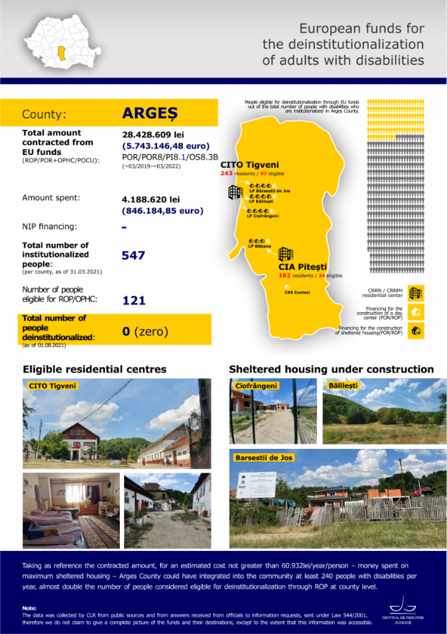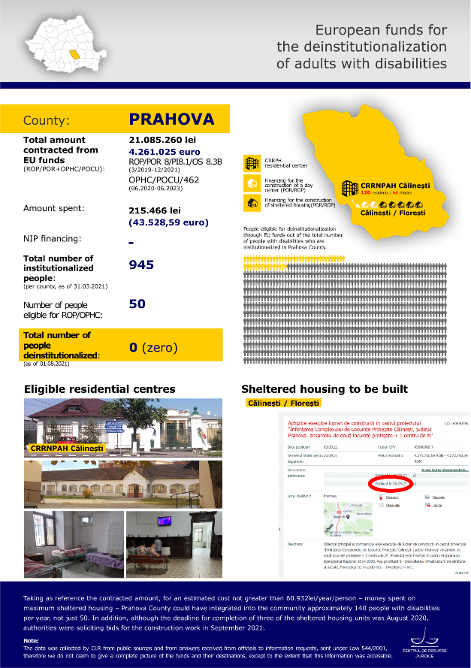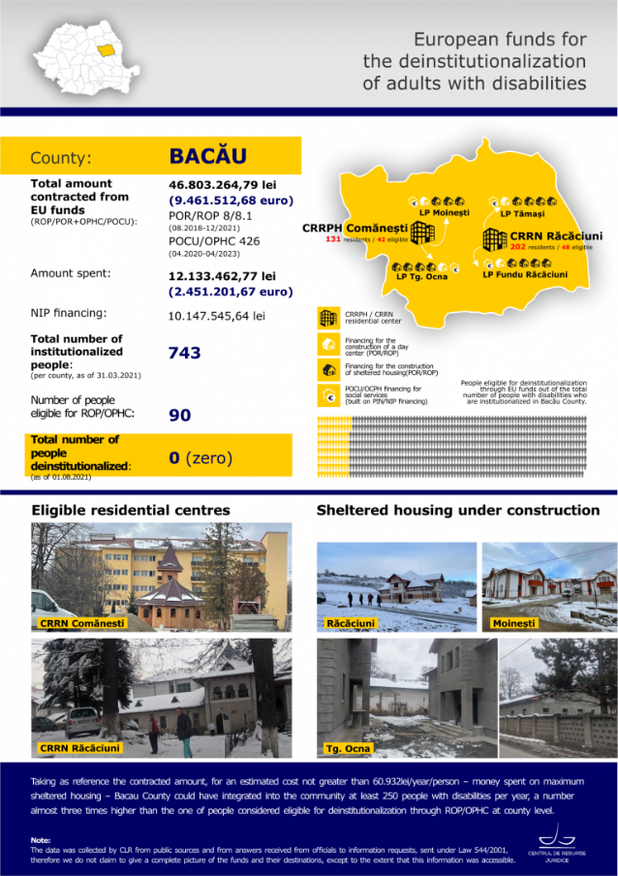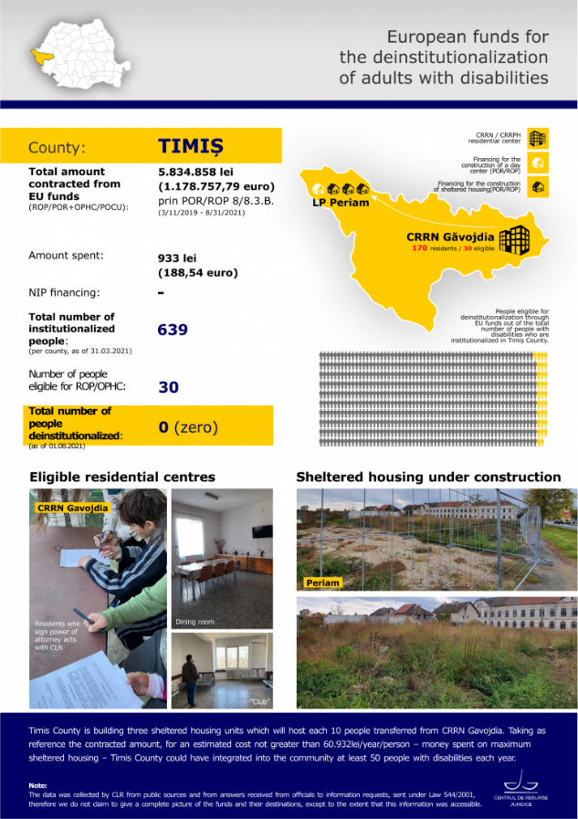

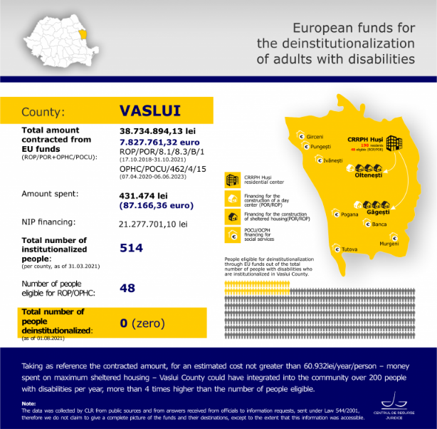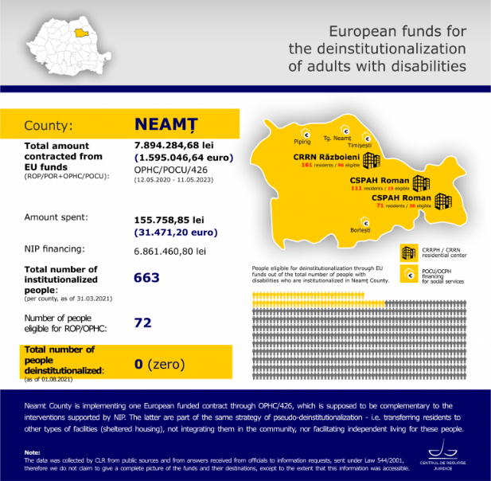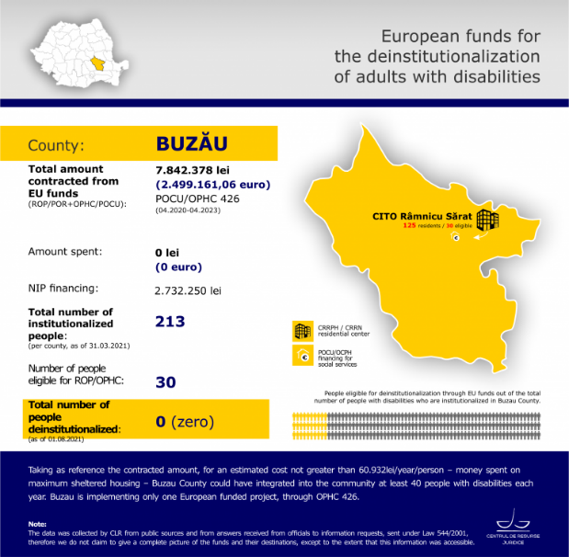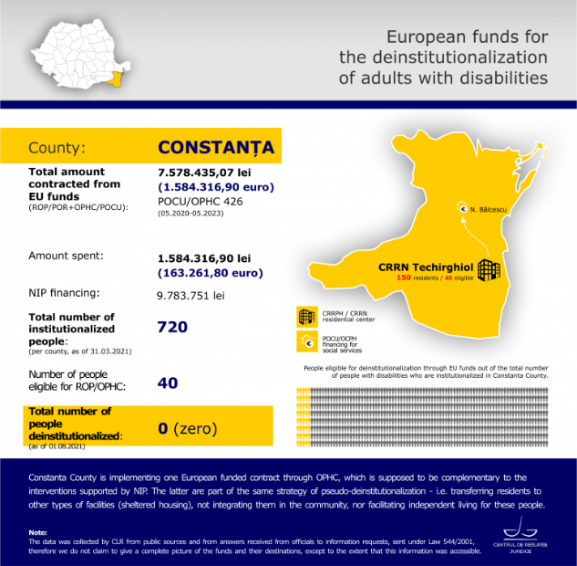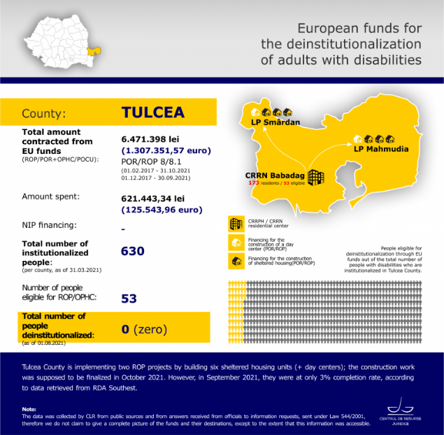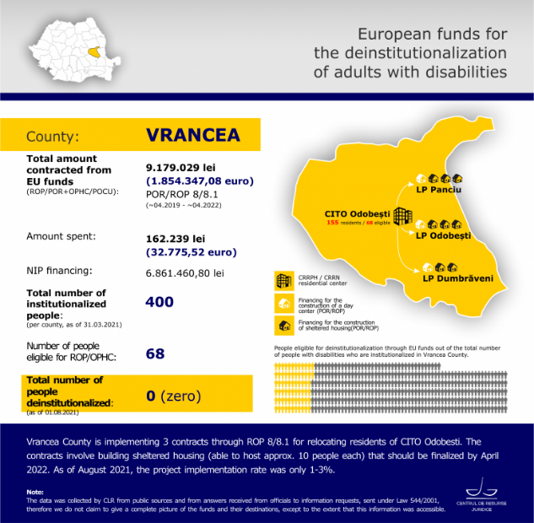

Adopted by the Committee at its fourteenth session (17 August-4 September 2015), as it is seen here : https://documents-dds-ny.un.org/doc/UNDOC/GEN/G15/226/55/PDF/G1522655.pdf?OpenElement
Statistics available from the Ministery of Labour, on 09 july 2021 - https://bit.ly/366osvj
Details here : https://bit.ly/3JsbA0S
More details on CLR’s analysis of the implementation of CRPD by Romania, here : https://bit.ly/3sBTFhv

