Supplementary Information for the Adoption of the List of Issues on Pakistan
for Consideration by
Pre-Sessional CEDAW Working Group
and by the Committee in its 75th session
Joint Stakeholder Submission
11 June 2019
Submitted by Young Omang Pakistan
Young Omang aims to be an effective voice for young people’s sexual and reproductive health and rights (SRHR) in Pakistan. It comprises of ten member organizations that bring with them a combination of regional diversity and unique strengths.
The members’ organizations include: Aahung, Aware Girls, Blue Veins, Bargad, Chanan Development Association (CDA), Forum for Dignity Initiatives-(fdi), Idara-e-Taleem-o-Aghai (ITA), Indus Resource Center (IRC), Rahnuma-Family Planning Association (R-FPAP), and Youth Advocacy Network (YAN).

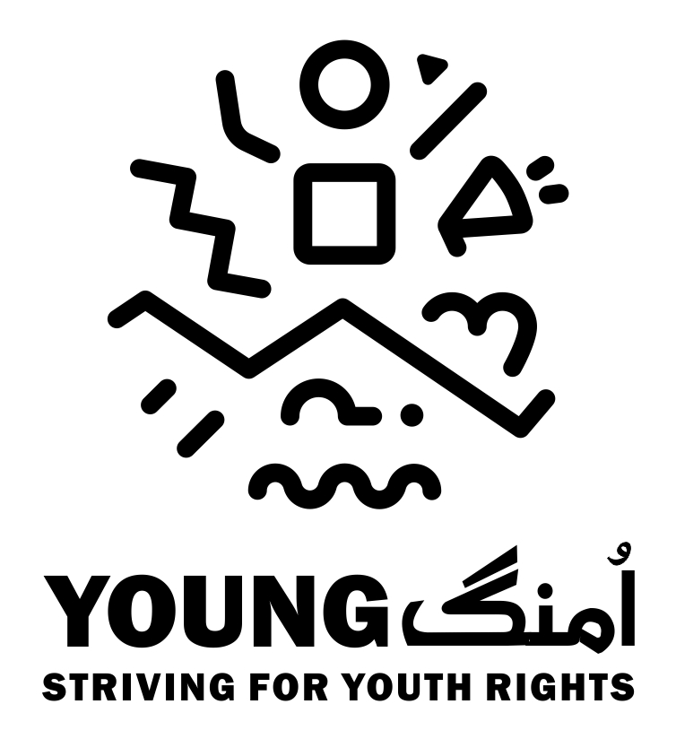

ISSUES & QUESTIONS FOR CONSIDERATION BY CEDAW PRE-SESSIONAL WORKING GROUP FOR LIST OF ISSUES ON PAKISTAN:

Young Girls (Both cisgender & Transgender) Health Issues
Background- Currently Pakistan has the largest population of youth in its history (55% of the population are under the ages of 25 years) with subsequent cohorts predicted to be even larger.
The lack of awareness and information about sexual and reproductive health and rights (SRHR) is the most significant behavior to young people’s health and wellbeing, together with the need for youth friendly health services and gender (including transgender) sensitive SRHR services. The government needs to focus in increasing access to SRHR information and services for young people. There is a dire need to establish adolescent and youth friendly health services centers throughout the country.
Early age marriage is highly prevalent in Pakistan. According to PDHS, the median age of marriage for girls in Pakistan is 19.5. Approximately half of Pakistani women are married before the age of 18 and 9% of girls begin childbearing between the ages 15-19 years. Early and forced marriages often result in early pregnancy, which can increase the risk of maternal mortality and morbidity (276 per 100,000 live births), multiple miscarriages and malnutrition (mineral and calorie deficiency) in young mothers and also impedes their social and economic potential.
The violation of girls’ SRHR takes many forms. Young girls in many tribal and rural areas face harmful cultural practices i.e. Vanni, Swara, Sang Chatti, Badal, Bazo, Watta Satta and Pait lakaei. All of these harmful cultural practices are anchored in a deeply patriarchal culture of treating girls and women sexual objects or property of the family which is in accordance with the convention on the right of the child (Articles 19 & 34) constitutes a form of sexual exploitation and/or abuse of children, adolescent girls and young women. The practice of Swara has been made illegal for a long time but it still a common practices, Swara is a Pashtun tradition that involves child marriage to settle a blood feud among the men.
There is an urgent need for the government to address youth sexual and reproductive health (SRH) issues in policies and programmes including mass awareness campaigns. Youth friendly and gender sensitive with particular attention to vulnerable groups including transgender youth; life skill based education LSBE for in and out of school youth; and legislation to address sexual and gender based violence (SGBV), harmful cultural practices and discrimination.
Transgender population in Pakistan was recognized under the category of third gender in 2009 by the Supreme court of Pakistan. Pakistani laws regarding the identity of TGs recognizes the rights of “transgender man” and “transgender women”. In 2018 Pakistani government passed its first ever law “the Transgender Persons Protection Rights Act 2018”. The law under its section 12 provides for the equal protection of right to health of TGs without any discrimination. Section 4 of the Act also prohibits any kind of discrimination on the basis of gender identity and on the denial and unfair treatment in healthcare facilities. Unfortunately, despite the legal protection discrimination, denial and unequal access to healthcare still remains an issue for transgender persons and gender non-confirming people especially when it comes to their Sexual and Reproductive health rights.
There is lack of trans inclusive policies, programs, strategies, healthcare facilities and clinics where they can receive competent healthcare services with regard to their sexual and reproductive health. In particular, they face significant barriers to accessing sexual and reproductive health care. While they are at the highest risk of sexually transmitted infections and diseases in particular. Government needs to make transgender inclusive policies and programs so that they can be provided friendly and equal access to information and services regarding sexual and reproductive health as per the international standards of health.
CEDAW & State Party Report-In reference to CEDAW Articles 12 and 16 referring to state parties to take all appropriate measures to eliminate discrimination against women in the field of health and matters relating to marriage and family relations on the basis of equality of men and women. Acknowledging the measures and efforts put by the state to improve the health indicators concerning women’s health and wellbeing and issues around family planning information and decision making as mentioned in fifth periodic report by the state. Some of the gaps concerning the youth constituency of young girls both cisgender & transgender are as following;
- All the measures mentioned in the state party report in the field of health only covers “mother & child” health which excludes the sexual and reproductive health and rights of young unmarried girls
- All nutrition related measures are also specific for “mother & child” and it again excludes young unmarried girls’ needs of health and nutrition
- There is no provision for youth friendly & gender sensitive (including transgender) health care centers for young girls. Only small scale services are available for young girls in some parts of the province of Sindh through private-public partnership with local NGOs
- There is no provision of services for pre and post abortion care or information around safe abortions. The absence of these services and information also excludes the health of young girls who are victim of early & forced marriages
- There is no mention of transgender women health whereas the Transgender Protection of Rights Act 2017 under its article 17: Right to Health guarantees SRHR to transgender persons
- There is no mention of transgender women’s right to marriage and found a family neither in the state report nor in the Transgender Protection of Rights Act 2018
- There is no mention of Life Skill Based Education (LSBE) to be included in school curriculum despite the initiative to integrate LSBE in school curriculum by the Sindh Government
- There is no mention of measures taken or planned by the government to integrate LSBE in school curriculum in other parts of the country
- There is no mention of provision of information to in school young girls. Moreover, at primary level the enrolment of young girls is very low which means health related information provision to out of school young girls must also be part of the govt programs.
- There is no mention about any particular youth center or healthcare facility providing easy and safe access to young unmarried girls and women for their sexual and reproductive healthcare information and services while provincial youth policies clearly provide for the establishment of youth centers.
- The report only mentions about the family planning, while ignores other components of sexual and reproductive health like access to safe abortion services, Sexual health information, education, and counseling, inclusion of adolescents in planning and implementation of services and programs.

