INTERNATIONAL COVENANT ON ECONOMIC, SOCIAL AND CULTURAL RIGHTS

THE ALTERNATIVE (thematic) REPORT

TO THE FOURTH PERIODIC PERIODIC REPORT OF REPUBLIC OF ARMENIA, SUBMITTED TO THE UN COMMITTEE ON ECONOMIC, SOCIAL AND CULTURAL RIGHTS

Implementation of the International Covenant on Economic, Social and Cultural Rights 69 Pre-Sessional Working Group (18 Oct 2021 - 22 Oct 2021)


Citizens' Labor Rights Protection League,
Baku AZ1078, A. Huseynov str.,7, quarter 1061, entrance # J, apt.,347,
e-mail: sahib.mammadov@gmail.com
office@labourrights-az.org
http: //labourrights-az.org/en


Human Rights Education and Research Public Association
Azerbaijan, Baku, S.Orujov Street, building 1, aprtm. 21
Email:hrtrpa@gmail.com

Brief historical information
The Republic of Armenia destroyed thousands of historical and cultural monuments belonging to the Azerbaijani people including religious temples, and armenialized some of them by making serious structural changes in its territories and in the territories of Azerbaijan recognized by the UN and the world powers which it occupied in 1990-1993 and controlled until November 2020 (former Nagorno-Karabakh Autonomous Region and 7 surrounding administrative territories).
Armenia has been massively deporting Azerbaijanis from the UN-recognized territories of itself for many years. Zangazur and a number of other lands of Azerbaijan were proclaimed the territory of the Armenian SSR in 1920. When the USSR was established, these lands were declared the territory of the Armenian SSR. In the following period Armenia resorted to new ways in order to further expand the policy of deportation of Azerbaijanis in the respective regions.
To this end, they achieved the acceptance of the special decision “On the resettlement of collective farmers and other Azerbaijanis from the Armenian SSR to the Kur-Aras lowland of the Azerbaijani SSR” of the USSR Council of Ministers dated December 23, 1947 and the mass deportation of Azerbaijanis from their historical lands in 1948-1953. More than 100,000 Azerbaijanis have been deported from their historical lands.
In 1988, 250,000 people were forcibly deported from Armenia within a week. At present, the Azerbaijani population in Armenia is 0%.
Thousands of geographical names, toponyms, as well as the names of all administrative-territorial units located in the territories historically inhabited by Azerbaijanis, which are now Armenian territories, have been changed and armenialized. Historical and architectural monuments, as well as religious temples belonging to the Azerbaijani people in the territory of Armenia have been completely destroyed. Geographical names including mountain, river, lake, etc, the names of natural places have been changed. There is not a single name of Azerbaijani origin left in Armenia.
Aftermath, this policy was continued in the territories of Azerbaijan which were occupied and annexed by Armenia, and in the territory of the former Nagorno-Karabakh Autonomous Region and 7 adjacent occupied regions.
All historical, cultural and architectural monuments, including religious facilities In the territories under the control and administration of the Republic of Armenia were either destroyed or armenialized with constructive changes. This process intensified during the reporting period. All geographical names in the Karabakh volcanic plateau and the Lesser Caucasus Mountains were changed to Armenian names.
The Republic of Armenia took hostages of civilians in the territories under its control which violated the customs and traditions of war, and others were deported from the territories.
In 1992-2020, no civilians of Azerbaijani origin lived in the territories effectively controlled by Armenia. 700,000 Azerbaijanis were deported from these areas and all residential and non-residential buildings and infrastructure, fauna and flora were destroyed. After the liberation of the territories, it was unveiled that 40,000 museum treasures, more than 900 historical and cultural monuments, 403 historical and religious sites, 67 mosques, 144 temples and 192 shrines were destroyed in those areas. According to the preliminary research, more than 30,000 graves have been excavated. The purpose was to remove the gold teeth of the deceased. For this purpose, special groups of gold searchers were formed in Armenia and extensive work was carried out to search for gold in cemeteries.

The destruction and deliberate disruption of historical and cultural monuments in the territories of Azerbaijan occupied by Armenia and controlled until November 2020 contradict the 1954 Hague Convention for the Protection of Cultural Property in the Event of Armed Conflict, the 1992 European Convention for the Protection of the Archeological Heritage, the 1972 UNESCO Convention concerning the Protection of World Cultural and Natural Heritage.
According to Article 1 of the Covenant
The Republic of Armenia refers to the self determination of the Armenian people by marking the territories of Azerbaijan occupied by the armed forces in 1992-1994 as sovereign states to the 5.6 and 7 paragraphs of the introductory part of the periodic report. However, according to the above-mentioned resolutions of the UN Security Council, these territories had to be evacuated by the Armenian Armed Forces in 1993. There are numerous decisions of international organizations on the effective control of these territories by the Armenian state. The military conflict which was launched by Armenia in September 2020 to seize new territories, ended with the defeat of Armenia. Prior to the 44-day Second Karabakh War, the political and military leadership of Armenia declared these territories as the Armenian territory and “a new war for new territories”.
The seized of the territories by the armed forces of the Republic of Armenia and the implementation of management (effective control) in those territories were also confirmed by the “Case of Chiragov and others v. Armenia” adopted by the Grand Chamber of the European Court of Human Rights on December 12, 2017.
Pashinyan, the Prime Minister of the Republic of Armenia said in his speech at the opening of the sports event "All-Armenian Sports Games" organized in the occupied territories: “Thus, Armenian capital has a homeland, because its owners have a homeland - Armenia, and Artsakh is Armenia, and that is all ”. Thus, in the report of Armenia on Article 1 of the Covenant, the territory presented by Armenia as the "Nagorno-Karabakh Republic" was the territory occupied by Armenia, controlled and managed by its army until 2020, and its presentation as a de facto subject of international law does not reflect the truth. Even after the liberation of the territories, the Armenian state continues to consider the territories inhabited by the Armenian population as an integral part of Armenia.
Armenian Prime Minister Nikol Pashinyan sent his son to serve in the Azerbaijani territories and met him in the military unit of the Armenian Armed Forces where he served in those territories.
During the 44-day war, the Armenian and Azerbaijani armies fought, and a tripartite statement on the cessation of hostilities on November 10 (November 9, Russian time) was signed by the heads of state of Armenia, Russia and Azerbaijan.

Thus, the Armenian state does not correspond to the truth shown in paragraphs 5 and 6 of the introductory part of the periodic report. There is no state with the name mentioned in paragraph 6 of the introductory part of the report of the Armenian state, and these territories are the territories of Azerbaijan recognized by the UN and the whole world. The territory that Armenia calls a state in the occupied territories has not been officially recognized by Armenia itself. After the liberation of the territories, the population of Armenian origin continues to live in those areas. The state of Azerbaijan has given the population of Armenian origin the opportunity to freely use their language, culture and natural resources and has recognized all the rights of the minority. The Armenian state exists and the Armenian people established a state in 1991, exercising their right to self-determination in accordance with Article 1 of the Covenant. Like all other peoples living in Azerbaijan, the Armenian ethnic minority has constitutional rights to ensure its cultural autonomy.

Violation of international law

The destruction of existing monuments belonging to other nations, cultures and religions in the territory of the Republic of Armenia and in the territories of Azerbaijan, which Armenia has kept under control until November 2020, and artificial assimilation of some to the Armenian people, culture and Gregorian church by means of constructive changes, is a serious violation of Article 15 of the Covenant and basic principles of the following documents:
The Hague Convention on the Protection of Cultural Property in the Event of Armed Conflict (1954),
European Convention for the Protection of Archaeological Heritage (1992)
UNESCO Convention for the Protection of the World Cultural and Natural Heritage (1972),
The Convention for the Protection and Promotion of the Diversity of Cultural Expressions (UNESCO, 20 October 2005)
The Convention for the Protection of the Architectural Heritage of Europe (October 3, 1985).
The Republic of Armenia not only failed to provide the protection of cultural and other facilities in the territories of the Republic of Azerbaijan which it invaded and controlled until November 2020, but also turned them into Armenian cultural monuments during the armed conflict and the entire period of the effective control over these lands. It also contradicts the requirements of the 1954 Hague Convention for the Protection of Cultural Property in the Event of Armed Conflict. The first part of Article 5 of the Convention states that “if the High Contracting Party has fully or partially occupied the territory of the High Contracting Party, then it has an obligation to support, as far as possible, the efforts of the national authorities of the occupied territories for the protection and maintenance of cultural values”.
However, Armenia also destroyed the cultural, historical and religious monuments of the Azerbaijani people and caused irreparable damage to nature in the territories of Azerbaijan occupied by the Republic of Armenia and ruled until November 2020.
The purpose of the policy pursued in Armenia is to prove that no other nation ever lived in the territories that are now considered the territory of the Republic of Armenia in the past, especially in ancient times. For this purpose, all historical and ancient cultural monuments, religious places are either destroyed or subjected to constructive changes to be attributed to the Armenian-Christian culture.

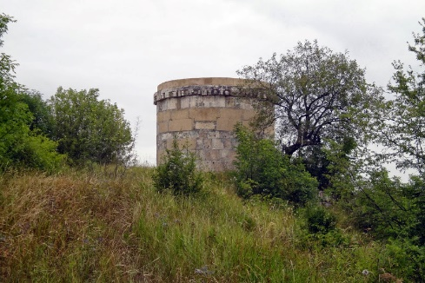 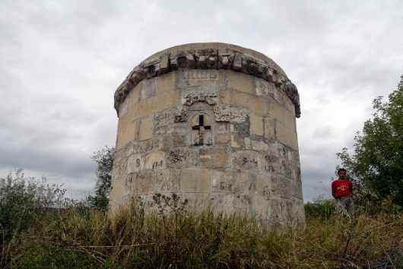
Situation before intervention to the tomb and after the intervention made a few years ago

Gullubulag village was the largest village of Amasya (Aghbaba) region of Western Azerbaijan. Until 1988, Azerbaijanis lived in this village. After the deportation in 1988, Armenians from the Bogdanovka region of Georgia settled in the village of Gullubulag. The village is located on the border with the Turkish village of Gizildash (now Sunguderesi). There were toponyms associated with the names of folk heroes such as Koroglu cave, Nigar gorge, Nabi meadow, etc. in Gullubulag. There were also mosques, shrines and sanctuaries in the village.
The population had its own folklore and customs. In 2007, the village was renamed Burakn

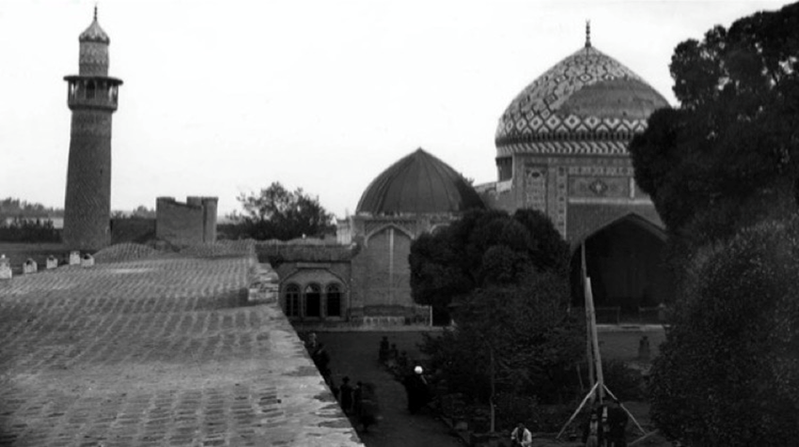
Blue Mosque, Yerevan

The construction of the Blue Mosque which is considered one of the rare examples of Eastern architecture, began in 1760 and was completed in 1765 during the reign of Huseynali Khan. Located opposite the central covered bazaar in Yerevan, the mosque resembled the Juma Mosque built in 1616 in Ganja during the reign of Shah Abbas, in its composition and the shape of its main temple.
Although it is currently used as a mosque, it is presented as an example of Persian architecture. Armenia's presentation of the Azerbaijani architectural example as an architectural example of another nation is also part of the discrimination and anti-Azerbaijani (Turkish) campaign. At the same time, it is disrespectful to the cultural rights of other peoples.

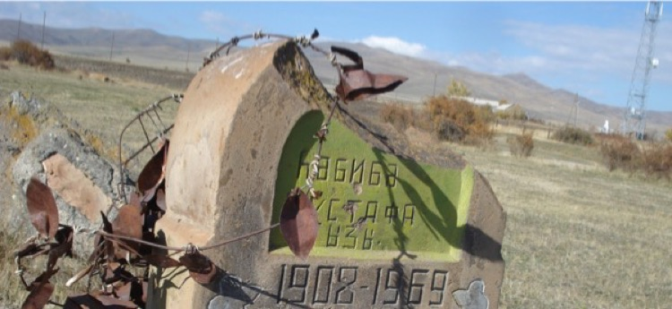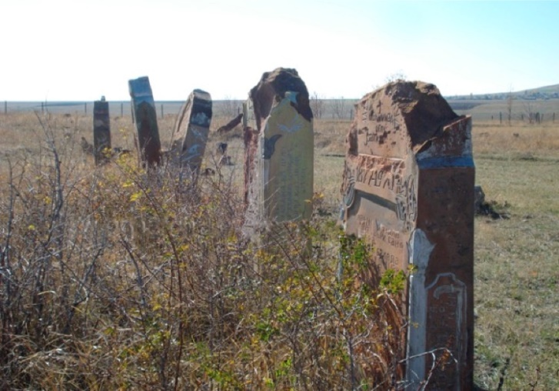
Destroyed cemeteries

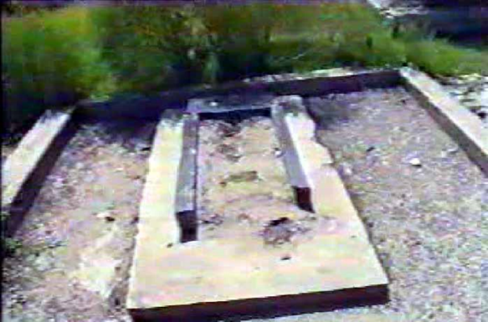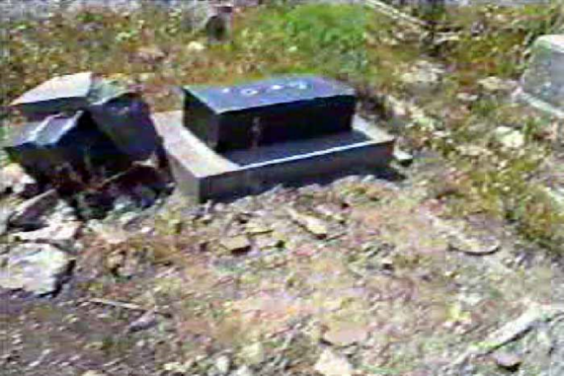

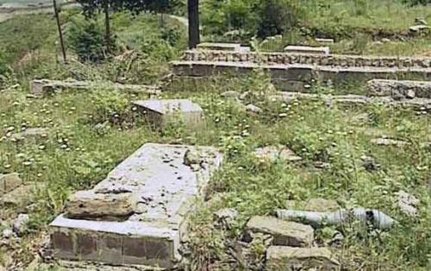
Cemetery belonging to Azerbaijanis in Gullubulag village
Shusha cemetery
Between 1992 and 2020, hundreds of gold-searching groups operated in cemeteries in Armenian controlled areas. Because the majority of the local population had gold teeth, the graves of the dead were excavated and the teeth on their bodies were removed. So far, more than 30,000 graves have been destroyed in search of gold. The identification process is currently underway. On the Armenian side, these graves were ironically called "gold fever".
Destruction of cultural, religious monuments and cemeteries in the territories of Azerbaijan under the effective control of Armenia
The former Nagorno-Karabakh Autonomous Region and 7 adjacent administrative districts included in the administrative territory of the Republic of Azerbaijan were seized by the armed forces of the Republic of Armenia from 1990 to the end of 1993. The territories remained under Armenian control until the end of 2020. Although in the past Armenia claimed that the territories controlled by itself were managed by the unrecognized Artsakh Republic, in recent years official statements have not only concealed the annexation of the territories to Armenia, but also de facto annexation of the territories to Armenia by all means. Speaking at the opening ceremony of sports competitions in the Armenian occupied territory in August 2019, Armenian Prime Minister Nikol Pashinyan said: “I am sure that many of you now question: why nothing has been said about Karabakh? The answer is one: Karabakh is Armenia, and period”. Earlier, the Prime Minister made this statement when he sent his son to military service in these areas. It was clearly mentioned in the documents of international organizations that the former Nagorno-Karabakh Autonomous Region and 7 adjacent regions were under the effective control of the Republic of Armenia.
In the court decision on the case of “Chiragov and others v. Armenia” (Application no. 13216/05) European Court of Human Rights announced on June 16, 2015, the presence of effective rule and control over these territories was explained and indicated in detail.
The 58th session of the UN Committee against Torture (CAT) on 28 November 2016 also stated that the Republic of Armenia is responsible for what happened in the territories, including the investigation and court proceedings. In the occupied territories of Azerbaijan 13 world-famous - 6 architectural and 7 archeological, 292 nationally important - 119 architectural and 173 archeological and 330 local important - 270 architectural, 22 archeological, 23 gardens, parks, monumental and memorial monuments, 15 examples of decorative art history and cultural monuments remain. Part of Armenia's policy of destroying cultural heritage in the occupied territories of Azerbaijan is the looting of unparalleled historical exhibits, valuable art and cultural samples kept in museums left in these territories.
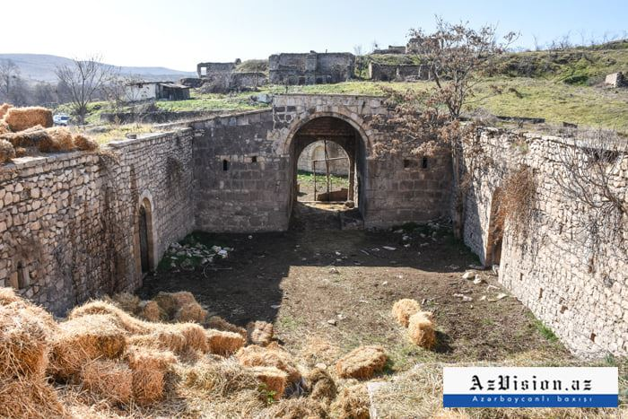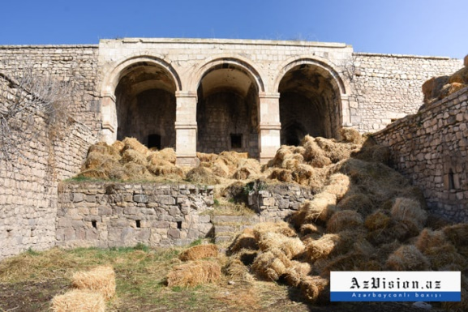
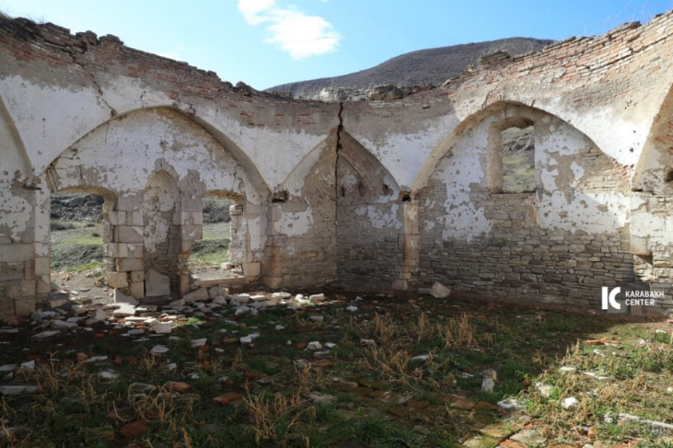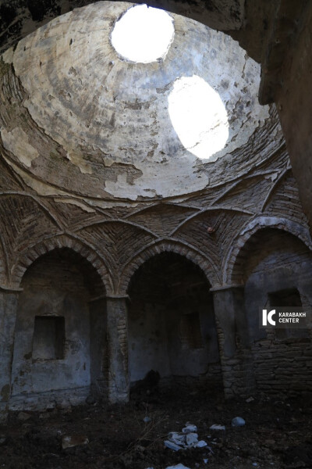

Violation of Article 15 of the Covenant and interference in the cultural environment in the territories of the Republic of Azerbaijan occupied by the Republic of Armenia.
All non-Armenian population living in the territories were deported, the ones who were unable to leave were taken hostage, and inhuman, degrading treatment and punishment were imposed on them.
The seized territory of the Nagorno-Karabakh region and seven adjacent districts (Kalbajar, Lachin, Gubadli, Zangilan, Jabrayil, Fuzuli and Aghdam) as well as the seven villages of the Gazakh region, far from the Nagorno-Karabakh region on the border with Armenia, and the Karki village of Nakhchivan together with 738 historical monuments, 28 museums consisting of more than 83,500 exhibits, 4 photo galleries, 14 memorial complexes, and 1891 cultural resources consisting of 1107 cultural institutions led to a great cultural loss for Azerbaijan.
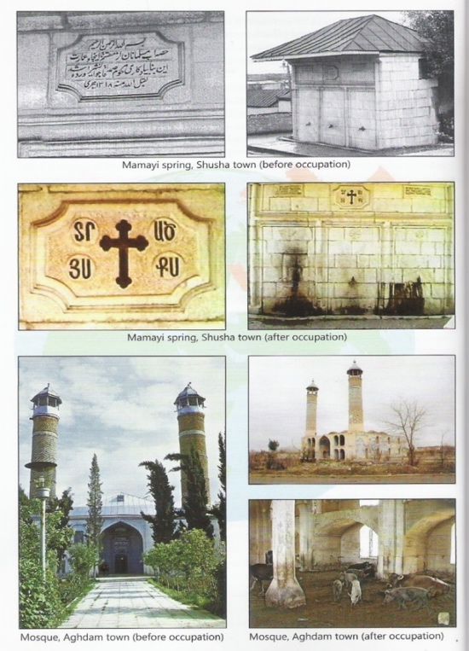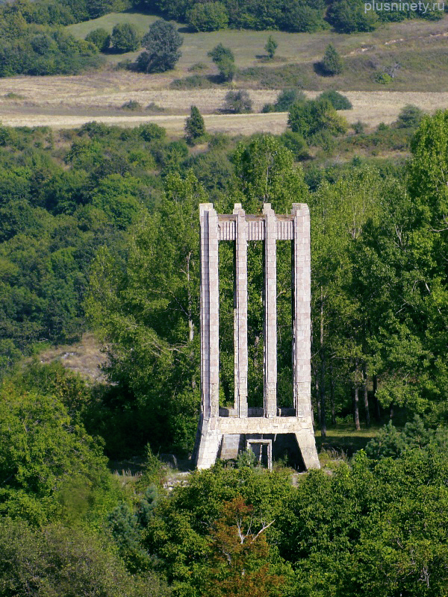

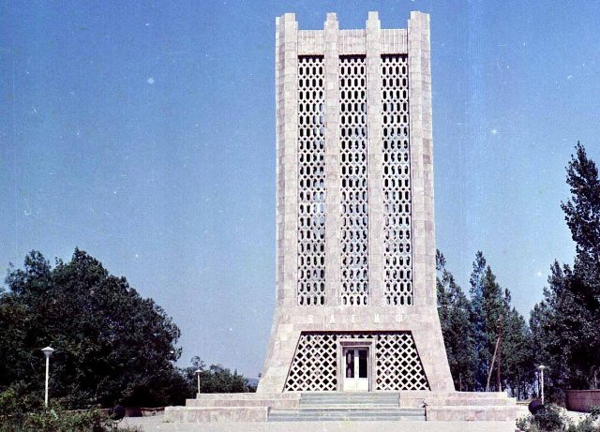
The mausoleum of the Azerbaijani poet and thinker Molla Panah Vagif in Shusha - before and after the seized of the territory. After the liberation of Shusha, all monuments including the Armenian "Gazanchy Church" are restored to their original appearance.
The “Yukhari Govhar agha” Mosque (The Upper Govhar Agha Mosque)

A brief historical reference: The construction of the “Yukhari Govhar Agha” Mosque was carried out in four stages. The first mosque in the area was built of cane in about 1750, parallel to The Palace of Karabakh Khans, by the order of the Panakhali khan, the founder of the Karabakh khanate and Shusha fortress. After Ibrahimkhalil khan came to power, it was rebuilt from the stone on the site of the cane mosque during 1768-1769. In the first half of the 19th century, with the financial support of Govhar Agha, the third mosque with two minarets was built on the site of the dilapidated mosque of Ibrahimkhalil khan. In 1883, the fourth and last Juma Mosque in Shusha was built on the site of the third mosque with the financial support of Govhar Agha.

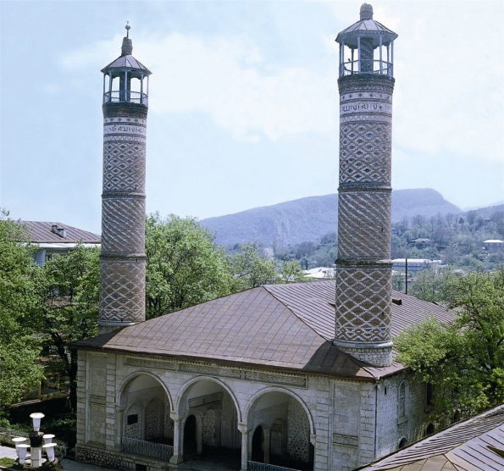
“Yukhari Govhar Agha” Mosque before the seized of Shusha by Armenia

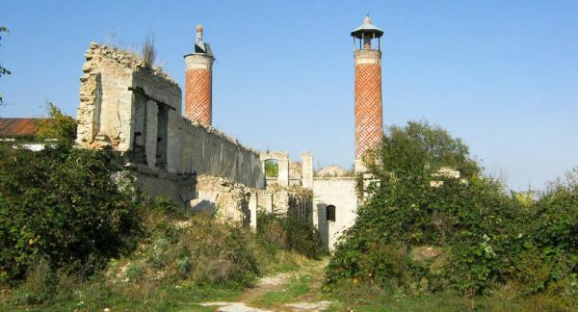
“Govhar Aga” mosque in Shusha. After the seized of the territory by Armenia
The religious and cultural monument belonging to the people of Azerbaijan was restored during the reporting period (2018) with the help of the Iranian side, underwent constructive changes, and became a Persian monument.
In fact, the restoration the “Yukhari Govhar Agha” Mosque and some other Islamic facilities in the occupied territories with serious constructive changes is a cynism. It is an act of vandalism that does not respect Islam. The religious object is also considered as the cultural heritage of a nation. The aim is to artificially “prove” in the long run that cultural object belongs to another nation and these territories do not belong to Azerbaijan. This is not only a violation of cultural rights, but also a falsification of history. At present, all the religious and cultural objects including the ones that belong to Christianity, are being restored in the liberated city of Shusha.

The list consisting of some of the world-famous immobile historical and cultural monuments destroyed in the territories of Azerbaijan which were under the effective control of Armenia from 1992 to 2020.
ARCHITECTURAL MONUMENTS

The name of the monument | Date | Location
The tomb of Kutlu Musa oglu | 1314 | Aghdam district, Khachindarbatli village
Ganjasar monastery | 1216-1238 | Kalbajar district, Vangli village
Khudavang monastery | XIII century | Kalbajar district, Vangli village
The 11-arched Khudafarin bridge | XI—XII centuries | Jabrayil district, Gumlag village
The 15-arched Khudafarin bridge | XIII century | Jabrayil district, Gumlag village
Shusha Historical and Architectural Reserve | XVIII-XIX centuries | Shusha city

ARCHITECTURAL MONUMENTS
The name of the monument | Date | Location
The Azykh cave camp | Paleolithic period | Khojavend District
The Taghlar cave camp | Paleolithic period | Khojavend District
The Uzerliktapa settlement | Bronze Age | Rajab Gozalov Street on Aghdam-Agjabadi road
The Khojaly mounds | Bronze Age- early Iron Age | Khojaly city
The Niftali mounds | Bronze Age | Jabrayil district

List of some museums demolished in Azerbaijani territories under effective authority and control of Armenia

- History-Ethnography Museum. Khankendi city.
- State Art Gallery. Khankendi city.
- Shusha History Museum. Shusha city.
- House-Museum of Uzeyir Hajibeyov. Shusha city.
- House-Museum of Bulbul. Shusha city.
- Shusha Branch of State Museum of Azerbaijani Carpets and Applied Art. Shusha city.
- Karabakh State History Museum. Shusha city.
- Karabakh Literature Museum. Shusha city.
- House-Museum of Mir Mohsun Navvab. Shusha city.
- State Art Gallery. Shusha city.
- Aghdam History-Ethnography Museum. Aghdam city.
- Bread Museum. Aghdam city.
- Memorial Museum of Qurban Primov. Aghdam city.
- Battle Honour Museum named after Rahib Mammadov. Aghdam city.
- Aghdara History-Ethnography Museum. Aghdara city.
- Fuzuli History-Ethnography Museum. Fuzuli city, exhibits of subsidiary fund.
- National Applied Art Museum. Fuzuli city.
- Hadrut History-Ethnography Museum. Hadrut city.
- Qubadli History-Ethnography Museum. Qubadli city.
- State Art Gallery. Qubadli city.
- Lachin History-Ethnography Museum. Lachin city.
- State Art Gallery. Lachin city.
- Memorial Museum of Sari Ashigh. Gulabird village, Lachin district.
- Kalbajar History-Ethnography Museum. Kalbajar city.
- Jabrayil History-Ethnography Museum. Jabrayil city.
- Zangilan History-Ethnography Museum. Zangilan city.

Use of water as a means of warfare
Armenia, by using water as a means of warfare, also infringed the norms of International Humanitarian Law. For nearly 30 years, inhabitants of frontier regions adjacent to the occupied Azerbaijani territories have been deprived of water supplies.
According to the Additional Protocols to the Geneva Conventions of 1949, it infringes the norms of International Humanitarian Law by intentional damage to the nature in the war zones as well as impairing people’s water supplies and irrigation systems, by actions of damaging people’s food supply and nature (green spaces, sown areas). Per article 14 of Additional Protocol (II) to the Geneva Conventions of 12 august 1949 (adopted on 8 June 1977), “Starvation of civilians as a method of combat is prohibited. Therefore, it is prohibited to attack, destroy, remove or render useless, for that purpose, objects indispensable to the survival of the civilian population such as foodstuffs, agricultural areas for the production of foodstuffs, crops, livestock, drinking water installations and supplies and irrigation works.”
Article 55 of Additional Protocol (I) to the Geneva Conventions of 12 august 1949 is entitled “Protection of the natural environment”. According to the article, “(1) Care shall be taken in warfare to protect the natural environment against widespread, long-term and severe damage. This protection includes a prohibition of the use of methods or means of warfare which are intended or may be expected to cause such damage to the natural environment and thereby to prejudice the health or survival of the population. (2) Attacks against the natural environment by way of reprisals are prohibited.”
Article 11 of Global Framework Convention on the Right to Water is entitled “Right to Water in the event of Armed Conflicts”. According to the article, “(1) The Right to Water of communities subject to oppression, domination and occupation shall be guaranteed in accordance with the principles and rules of international law for armed conflicts. (2) The Right to Water shall not be infringed in the event of international or non-international conflict. (3) Water shall not be used as a means of waging war or as a target in armed conflicts. Any breach of this rule should be declared crime against humanity.”
On 26 January 2016, in reference to the relevant provisions of abovementioned Conventions, Parliamentary Assembly of the Council of Europe adopted a resolution entitled “Inhabitants of frontier regions of Azerbaijan are deliberately deprived of water”.
The resolution condemns intentional restriction on people’s use of water supplies in the frontier regions adjacent to the territories occupied by Armenia.
The resolution condemns intentional restriction on people’s use of water supplies in the frontier regions adjacent to the territories occupied by Armenia.
In the resolution, considering significant humanitarian problems, Armenian armed forces are called to leave the regions in question and ensure an on-site investigation by independent engineers and hydrologists.
On several other international documents, too, damaging nature, plundering and destructing natural resources in war zones and occupied territories as a method and means of warfare are prohibited. Nonetheless, by violating requirements of International Humanitarian Law, relevant conventions of UN and that of UNESCO (a UN body specialized in science, culture and education), for nearly 30 years, Republic of Armenia has exploited natural resources, plundered forest riches in occupied territories, either destroyed or restricted use of water supplies in the regions adjacent to the occupied territories. During the seizure of territory, irrevocable damage has been carried out to flora and fauna. It has contaminated surface and subsurface layers of soil with nuclear waste. Moreover, some parts of Azerbaijan’s water supplies are formed in territories of Armenia. In this regard, Armenia carries on contaminating the Aras river, the Okhchuchay River and others with chemical and toxic waste. Currently, the Okchuchay River, one of the affluent rivers, is completely contaminated and contamination process continues. Species in the river have already vanished.
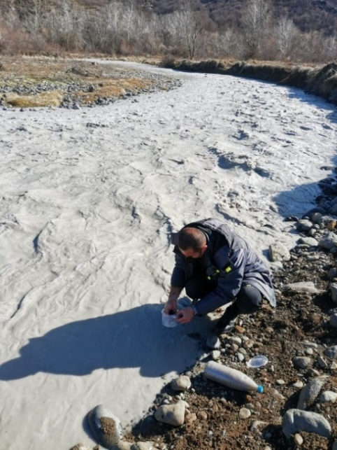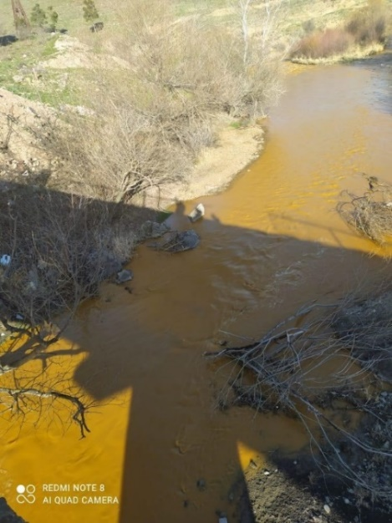
Ohkchuchay River contaminated by chemical waste

Policy of racism and hatred

Hatred towards other cultures also leads to hatred towards other nations. During the reporting period, a statue was erected to the honor of Soghomon Tehlirian of Armenian origin, who brutally murdered a Turkish general in Germany. On the monument, head of the decapitated Turkish general is placed at the murderer’s foot.
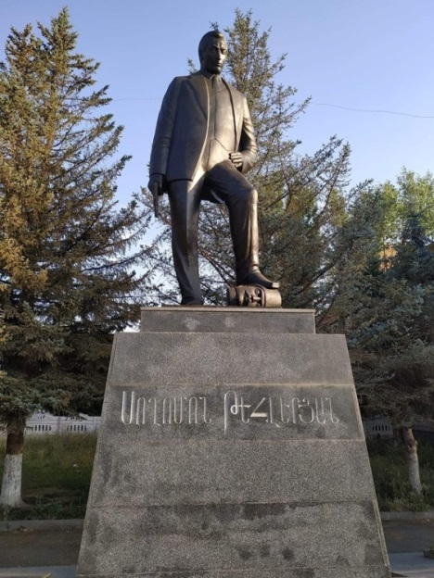
A statue of Soghomon Tehlirian, murderer of Turkish general Talaat Pasha, was erected in Shirak district, Armenia.
Decapitated head of Talaat Pasha is depicted at the foot of the statue. It is worth mentioning that Talaat Pasha was assasinated by an Armenian terrorist, Soghomon Tehlirian, on 15 March 1921 in Berlin within the scope of Operation Nemesis organized by Dashnaktsutyun Party. The arrested assassin was acquitted on the grounds of mental disorder (3 June 1921). Now, a statue is dedicated to him in Armenia.

Recommendations
Party to the Covenant (Armenia) must put an end to the policies directed at the destruction of cultural monuments pertaining to the Azerbaijanis and to the “Armenisation” by constructive changes or by ascribing to other nations. The member state of the Committee must be called to abide by the article 15 of the Covenant;
Besides the cultural monuments, Hatred and racism towards the nation that these monuments belong to, must end in Armenia, and activities of state’s official propaganda institutions must be investigated;
Humiliating and insulting writings in Armenian textbooks engendering hatred towards other nations, especially Azerbaijanis (Turks), must be evaluated, and the member state must be called to terminate such a policy. Racism-based education system of Armenia must be changed, textbooks must be revised;
The Committee must make efforts to create a competent international commission in order to investigate the ongoing facts of vandalism.

http://www.un.org/en/ga/search/view_doc.asp?symbol=S/RES/822(1993) http://www.un.org/en/ga/search/view_doc.asp?symbol=S/RES/853(1993) http://www.un.org/en/ga/search/view_doc.asp?symbol=S/RES/874(1993) http://www.un.org/en/ga/search/view_doc.asp?symbol=S/RES/884(1993)
https://www.virtualkarabakh.az/en/post-item/52/2871/the-second-karabakh-war.html
https://www.virtualkarabakh.az/en/post-item/52/2871/the-second-karabakh-war.html
http://1905.az/en/order-that-deported-100000-azerbaijanis-from-armenia/#more-32083
Although the ethnic composition of the population in the Armenian Soviet Socialist Republic, which was formed during the formation of the USSR (1922), is diverse, modern Armenia is considered one of the most monoethnic countries in the world. Thus, at present, the population of Armenia consists of 98.1% Armenians, 1.1% Yezidi Kurds, 0.7% other ethnic groups and peoples. In fact, over the last 100 years, the number of Azerbaijanis (Turks) has steadily decreased and now stands at 0%. At the time of the 1979 census in the USSR, the Azerbaijani population in Armenia was 6.5% of the total population, whereas in the early 20th century this figure was close to 50%. In 1988, the Azerbaijani population was more than 250,000 Azerbaijanis. The population was forcibly deported and currently stands at 0%.
At that time, gold teeth were widely used among the local population.
https://www.arabnews.com/node/1772911/azerbaijan-restoring-its-territories-liberated-armenian-occupation%C2%A0
https://whc.unesco.org/en/conventiontext/
https://hudoc.echr.coe.int/eng#{%22itemid%22:[%22001-179554%22]}
https://www.panorama.am/en/news/2020/07/09/Pashinyan%E2%80%99s-son-back-home/2324835
https://en.president.az/articles/45923
http://portal.unesco.org/en/ev.php-URL_ID=13637&URL_DO=DO_TOPIC&URL_SECTION=201.html
https://armenianvandalism.preslib.az/en_armenia.html
http://www.un.org/en/ga/search/view_doc.asp?symbol=S/RES/822(1993) http://www.un.org/en/ga/search/view_doc.asp?symbol=S/RES/853(1993) http://www.un.org/en/ga/search/view_doc.asp?symbol=S/RES/874(1993) http://www.un.org/en/ga/search/view_doc.asp?symbol=S/RES/884(1993)
https://eurasianet.org/pashinyan-calls-for-unification-between-armenia-and-karabakh https://ru.armeniasputnik.am/politics/20190805/19946257/Artsakh--eto-Armeniya-i-vse---Pashinyan-vystupil-v-Stepanakerte.html
https://hudoc.echr.coe.int/eng-press#{%22itemid%22:[%22003-5948032-7599775%22]} file:///C:/Users/Sahib%20Mammadov/Downloads/Grand%20Chamber%20Judgment%20Chiragov%20and%20Others%20v.%20Armenia%20-%20just%20satisfaction.pdf
Summary record of the 1484th meeting Held at the Palais Wilson, Geneva, on Wednesday, 23 November 2016, at 10 a.m. https://digitallibrary.un.org/record/850296?ln=ru
Source: http://modern.az/az/news/71678#gsc.tab=0
https://www.icrc.org/ru/doc/resources/documents/misc/6lkb3l.htm
https://www.icrc.org/ru/doc/assets/files/2013/ap_i_rus.pdf
http://www.cawater-info.net/bk/water_law/pdf/water_right_global.pdf
http://assembly.coe.int/nw/xml/XRef/Xref-XML2HTML-en.asp?fileid=22429&lang=en
The State of Armenia has buried radioactive waste of Metsamor Nuclear Power Plant, otherwise one of the sources of danger to humanity, in the territories occupied and controlled for 30 years. Various Armenian citizens have cultivated narcotic plants in these loosely overseen territories, and their products have been discreetly exported to foreign countries.
https://1news.az/news/20210430112952816-The-Okhchuchay-River-contaminated-to-a-dangerous-level-the-German-CRONIMET-is-threatening-the-ecology-of-Karabakh?fbclid=IwAR3RC8xtvSYvs5WEYebD2lH-QwGEuXRD25TabdXaysrVy-gQXniwagYnQJs https://azerfocus.com/okhchuchay-river-which-flows-from-armenia-to-azerbaijan-is-unfolding-environmental-catastrophy/#more

