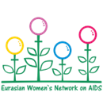 | 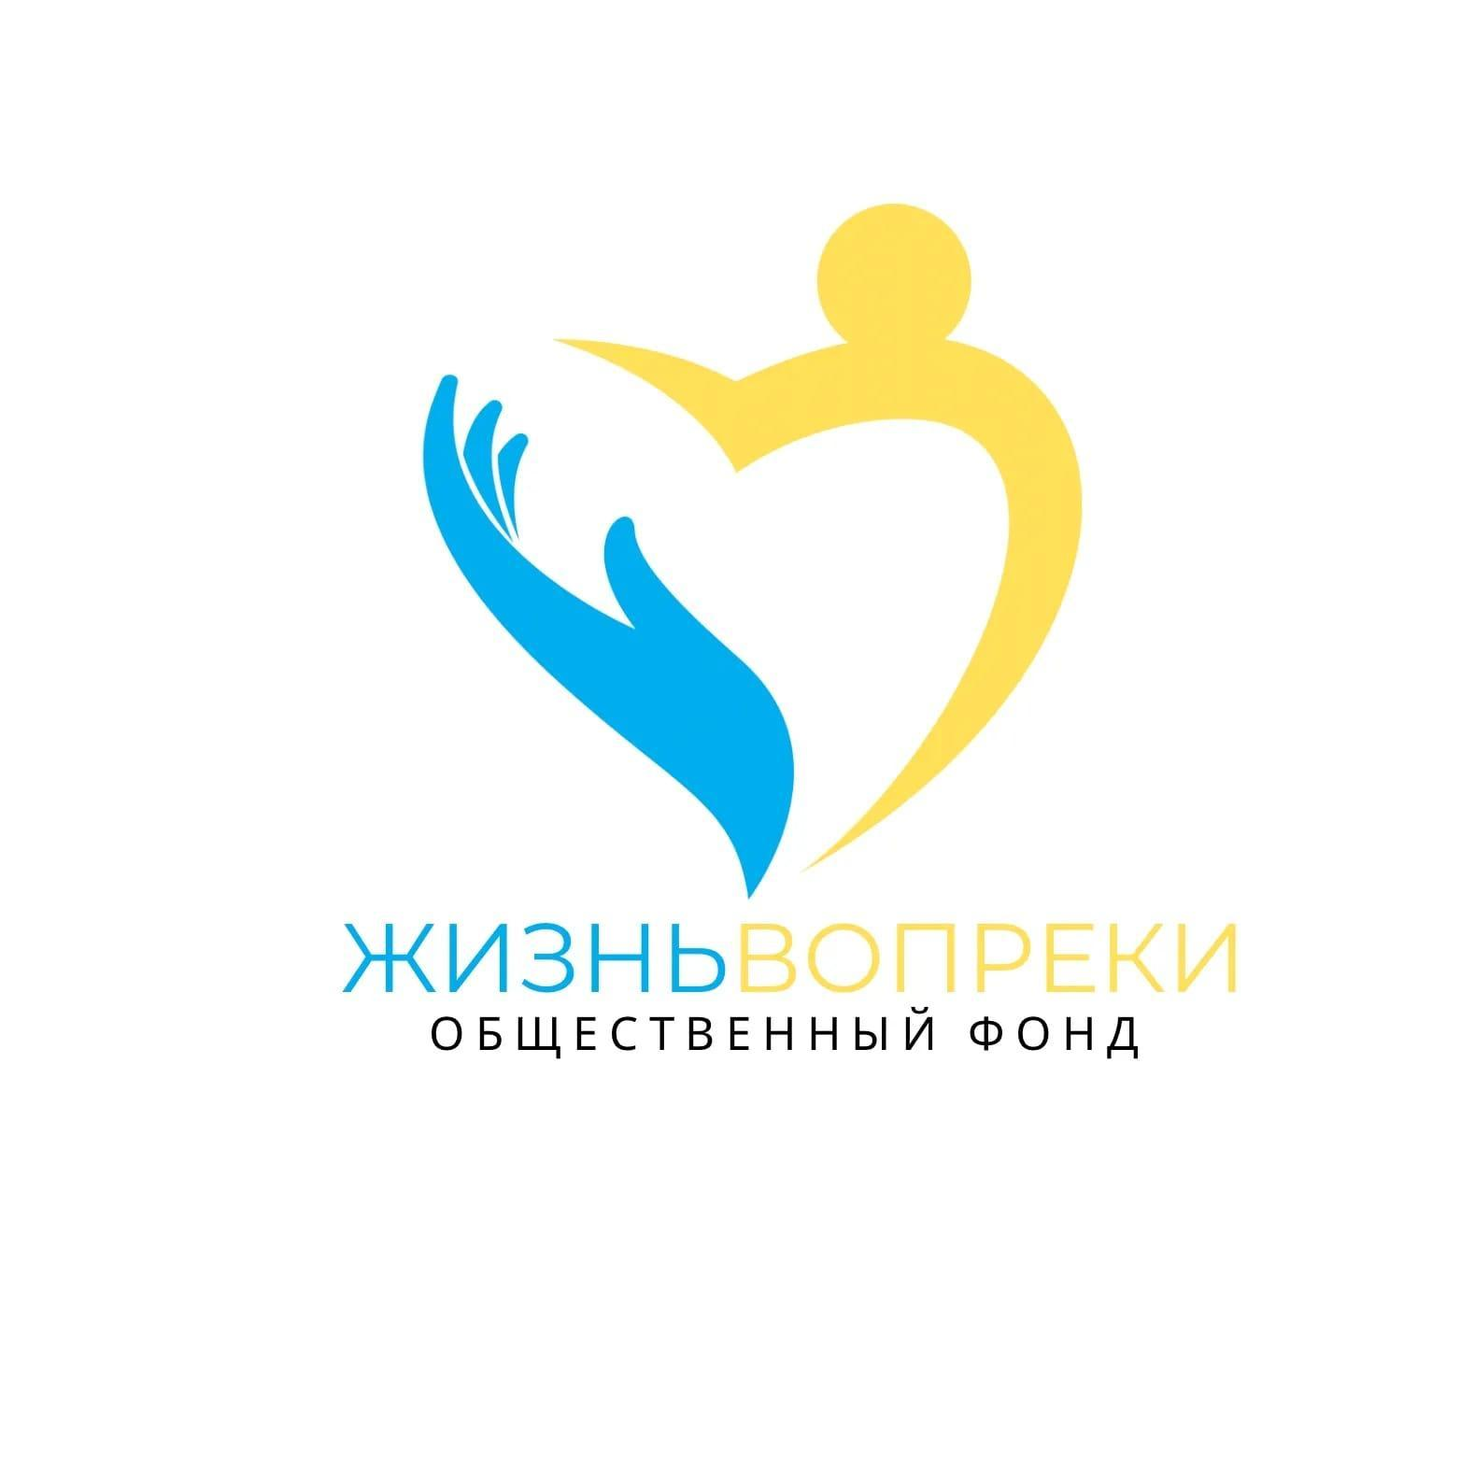 | 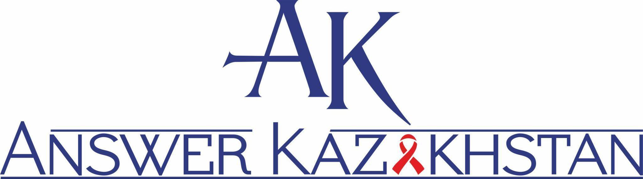 | 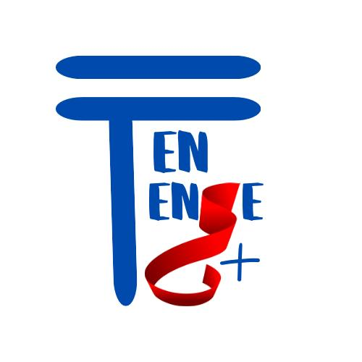

Shadow Report
On violence and discrimination against women living with HIV in Kazakhstan
Written submission for the Pre-Sessional Working Group
for the 93rd session to the CEDAW Committee
Submitted by the Coalition of women-led organisations including Eurasian Women's Network on AIDS, non-governmental organization “Zhizn Vopreki”, association of legal entities "Answer-Kazakhstan Association", non-governmental organization "Equal to Equal plus" based on community-led monitoring and research.

- Introduction
This submission presents updated evidence on the harms of institutionalized criminalization of women living with HIV (criminalization of HIV exposure and transmission), gender-based violence (GBV) and discrimination against women living with HIV in Kazakhstan, drawn from:
- HIV Criminalisation scan in the countries of Eastern Europe and Central Asia;
- How countries address barriers to HIV services for women living with HIV, sex workers and women who use drugs. Women-led gender assessment;
- Types of Violence Against Women Living with HIV in Kazakhstan”;
- Express assessment of the impact of the Law of the Republic of Kazakhstan “Ensures of Women’s Rights and Children’s Safety” on women from key groups.
The report highlights urgent concerns regarding the pervasive violence experienced by women living with HIV, the barriers they face in accessing support services, and the systemic discrimination embedded in legal, healthcare, and social service systems. The findings reaffirm and expand on the concerns already expressed in the CEDAW Committee’s Concluding Observations to Kazakhstan in 2019, specifically the lack of shelter and crisis support for women with HIV, and the discriminatory denial of services.
The evidence stems from 130 individual interviews with women living with HIV from seven regions of Kazakhstan (Almaty, Astana, Kokshetau, Pavlodar, Taldykorgan, Temirtau, and Oskemen), selected through primary screening for medium-to-high risk of domestic violence. The women’s lived experiences offer critical insights into the intersection of HIV status, gender inequality, and violence. It also includes findings from studies and assessments led by women activists representing the community of women living with HIV.
- Background and Legal Context
Kazakhstan has made formal commitments to addressing GBV, including its expressed intention to accede to the Istanbul Convention. However, key contradictions remain. Until mid-2023, women living with HIV were legally excluded from access to crisis centres. Although this clause was repealed in June 2023, women with HIV still face de facto barriers to shelter, legal, medical, and psychosocial support. Article 118 of the Criminal Code, which criminalises HIV transmission and exposure, continues to contribute to stigma, coercion, and fear among women diagnosed with HIV. In 2022, Kazakhstan removed legal barriers for people living with HIV to adopt children.
Whilst the state regulations include sexual and reproductive health and rights and have a focus on preventing and controlling cervical cancer, especially in women living with HIV, they do not include attention to adolescent girls, women who experience menopause, GBV, and the Human Papillomavirus (HPV) vaccination. Strategies and roadmaps to counter stigma, discrimination and advance the rights of women living with HIV are actively promoted by NGOs but are not included in government strategies and policies.
Kazakhstan has its National HIV and TB Council (Global Fund Country Coordinating Mechanism - CCM) serving as a formal system of accountability that enables community representatives and civil society to monitor the priority-setting process and spending on gender equality. The CCM established a dedicated working group that is focused on achieving gender equality, which includes women living with HIV and women from key groups.
Kazakhstan’s health care system follows international guidelines and ensures that pregnant women living with HIV continue taking ART post-delivery. The cluster on pregnant women included in the national clinical protocol for HIV diagnosis and treatment in adults. As a part of comprehensive approach, breast-milk substitutes are provided to women living with HIV by the primary healthcare, free of charge. Women living with HIV and women who use drug participate in developing policies and strategies to prevent vertical transmission of HIV (prevention of mother to child transmission) through the national working group to validate the elimination of mother-to-child transmission.
The People Living with HIV Stigma Index reveals persistent discrimination against women living with HIV, particularly in reproductive healthcare. In Kazakhstan (2022), 15% (51 women) reported being advised to terminate their pregnancy due to HIV. Pressure was also reported regarding delivery methods (7%) and infant feeding choices (9%).
Comprehensive and ongoing counselling is offered to children to support them in their journey of disclosing their HIV status as well as providing support to parents on how to disclose a child’s positive HIV status to them. Counselling is carried out by the AIDS centres’ psychologists according to the developed guideline. Adolescent girls living with HIV are also supported within activities organized by the Teenergizer (2019) and “Equal to Equal Plus” and UNICEF (2022) using the Teenergizer methodology.
In 2022, Kazakhstan developed guidelines on pre-exposure prophylaxis (PrEP) against HIV, which is available for women free of charge in Kazakhstan.
According to the clinical protocol for HIV treatment in adults, women living with HIV are included in the list of indications for screening for cervical cancer. However, no data is available for women living with HIV screened for cervical cancer. Whilst the comprehensive cancer plan (2018-2022) highlights HPV vaccination for adolescents and a study on HPV was conducted in Kazakhstan, there is also no data on girls living with HIV who are vaccinated against HPV.
In 2024, a law known as the “Saltanat’s law” or two important laws signed by the President came into force in Kazakhstan: “On Amendments and Supplements to Certain Legislative Acts on Ensuring Women’s Rights and Children’s Safety” and “On Amendments and Supplements to the Code of Administrative Offenses”. The Law introduces specific changes to legal acts to improve the protection of women and children and is an important step in Kazakhstan.
Activists of the feminist movement, which includes women living with HIV, submitted 15 requests to the Almaty city administration to hold a rally and 15 requests to hold a march on March 8, 2024 and March 8, 2025, as well as countless requests to hold peaceful assemblies in defence of women’s rights on other dates. The akimat routinely refused all of them, citing threats to public order.
The state system does not ensure equal protection or access to justice. Women living with HIV, especially those who also use drugs or engage in sex work, experience compounded discrimination that deters them from seeking help from law enforcement or medical institutions.
Community-led services continue to fill critical gaps in protection and care. However, these are not systemically supported or integrated into national GBV response frameworks.
- Violence against women living with HIV
Based on the findings of the community-led study “Types of Violence Against Women Living with HIV in Kazakhstan”, civil society reports that women living with HIV are subjected to multiple and intersecting forms of violence. These include psychological, economic, physical, and sexual violence, often compounded by HIV-related stigma, social exclusion, and systemic discrimination. The data reveals an alarming pattern of abuse that remains largely invisible to state institutions and unaddressed by existing protection mechanisms.
Psychological violence: 90% of women interviewed experienced psychological violence. This includes verbal humiliation, threats, intimidation, manipulation, and emotional control often linked to their HIV status. Disclosure frequently triggered ongoing emotional abuse in intimate and family relationships. Women also faced barriers in accessing state assistance and lacked information on available support services, partly due to fear of stigma or disclosure.
“I am constantly told that I am sick, not normal. That I am no longer a woman, that I am worthless.” — womаn living with HIV, Almaty.
Using children as a means of manipulation: 40% of HIV-positive women reported psychological, physical or other influence on their children with the purpose of hurting the woman. One in six said they had been fought over custody of their children, and one in five reported that their children had been held to intimidate or force the woman to do something. Almost half of women have experienced a situation where children or other close people were used to put pressure on them.
“I was diagnosed with HIV during pregnancy, and he does not have HIV. At first, he humiliated me, after the birth of the child he began to beat me, then he took the child to his mother and did not allow me to see him. According to Muslim customs, he made a “talaq bain” refusal to marry me. All my attempts to see the child end either in me being beaten or simply in nothing” - womаn living with HIV, Almaty.
Physical violence: 62% of women experienced physical violence, including beatings, forced confinement, and physical intimidation. In many cases, this violence escalated after disclosure of HIV status. A third of women who have experienced physical violence connect it with their HIV status. Women’s testimonies show how violence is justified by woman’s HIV-positive status, including by women themselves due to internalised stigma.
“He beat me when he found out I had HIV. He said I had humiliated him.” — womаn living with HIV, Temirtau.
Barriers to protection included the refusal by police to register complaints and threats of child removal when women sought help. These actions further reinforced a climate of fear and silence.
“Instead of helping me, the police told me: “You’re a Muslim, you read prayers, wear a hijab, you have children, why are you writing a statement against him, you chose him yourself”. — woman living with HIV, Almaty
“At that time there was Covid and the police rejected my statement, saying that being beaten was not the worst thing that could happen. I wrote a statement, but the police began to put pressure on me and I took it away”. — woman living with HIV, Oskemen.
The vast majority of women who had experienced physical violence did not seek assistance (81%) for the following reasons:
- Not believing that the assistance would be provided – 55%
- Lack of confidence in the justice system – 52.3%
- Feeling of shame – 45.9%
- Fear of publicity and public condemnation – 41.3%
- Fear for personal security – 35.8%
- Full (financial) dependence on the partner – 24.8%
- HIV status – 24.8%
- Lack of awareness of rights – 22%
- Fear to lose family and/or children – 19.3%
- Reluctance to tell male police officers about intimate issues – 12.8%
- Lack of financial resources – 12.8%
- Seeking assistance goes against the religion, culture or traditions – 9.2%.
Economic violence: 71% of women experienced economic violence. Civil society notes that women were regularly denied access to income, forbidden to work, or had their financial autonomy taken away—especially following disclosure of HIV status. This economic control often trapped women in abusive environments and made them dependent on violent partners or relatives. Women also faced barriers in accessing state assistance and lacked information on available support services, partly due to fear of stigma or disclosure.
“I was left without any means. He took my bank card. He said: ‘Now you’re sick — what do you need money for?’” — woman living with HIV, Pavlodar
Sexual violence: 38% of women reported experiences of sexual violence, including marital rape and coerced sex. In several cases, HIV status was weaponized by partners to justify sexual coercion. Women also shared cases of sexual exploitation by officials or service providers. Civil society notes that most women did not report these crimes due to fear of prosecution under HIV criminalisation laws, as well as widespread stigma and lack of institutional trust
“I didn’t want sex. He said: ‘You’re lucky I still want you, even with your HIV.’” — womаn living with HIV, Taldykorgan.
- Barriers to Protection, Justice and Essential Services
Women living with HIV in Kazakhstan face serious barriers to accessing protection, legal remedies, and essential services. These barriers are rooted in stigma, legal restrictions, and institutional inaction.
4.1. Exclusion from Crisis Centers and Lack of Referrals
Despite efforts and some legislative changes, legal restrictions on women living with HIV staying in crisis centres remain. Shelters still frequently deny services to HIV-positive women, stating that they “do not work with such categories of clients.” There are no HIV-sensitive procedures in place, and no established referral system between AIDS centers and crisis centers. HIV service organizations are not included in the referral mechanism for survivors of gender-based violence. As a result, women are left without access to support and without protection mechanisms. The existence of medical restrictions on access to services is also acknowledged in the State party’s Sixth Periodic Report under Article 6 (Exploitation of women); however, the report fails to address how these restrictions impact women living with HIV and their ability to receive support.
4.2. Stigma and Fear of Disclosure
Women fear disclosing their HIV status when seeking help due to the high level of stigma. In small towns, disclosure may lead to shame, discrimination, and rejection by society or family. Disclosure is also associated with the risk of losing child custody, which is often used to manipulate or silence women. Because of this, many women choose to remain silent and not seek help or services, even when experiencing violence.
4.3. HIV Criminalization and Legal Risks
Article 118 of the Criminal Code creates criminal liability for HIV transmission. Women fear being prosecuted if they report sexual or physical violence. Abusive partners often threaten to report women to the police for “knowingly exposing them to HIV”. This creates a situation where women are afraid to go to law enforcement, even in emergencies, and increases their dependency on violent partners. The results of women-led researches, as well as the examples of documented cases, clearly prove that HIV criminalisation not only fails to protect women from contracting HIV, but, on the contrary, worsens their position in society. Laws that criminalise HIV make women more vulnerable to growing HIV-related violence and structural inequalities.
4.4. Discrimination in Healthcare
Women report that healthcare workers display stigmatizing attitudes, refuse to provide services, or avoid physical contact. In some cases, women were denied cancer screening or told: “Why do you even need it? You have HIV.” Such discrimination leads to delays in seeking medical help and worsens women's psychological state. There are no trauma-informed or integrated services for HIV-positive women experiencing violence.
4.5. Lack of Information and Support
Most women are not aware of their rights or services available to them. There is no support system in place to help them navigate legal or social services. Peer support services are not integrated or officially recognized. Women report feeling alone, unprotected, and unable to get help due to a lack of access to accurate information and trained staff.
- Recommendations
We ask the CEDAW Committee to recommend to the Kazakhstan Government to:
- Eliminate all legal and institutional restrictions that prevent women living with HIV from accessing shelters, crisis centers, and other protection services, including discriminatory residency policies and medical exclusion criteria. Article 2 (non-discrimination), Article 6 (trafficking and exploitation of women), Article 12 (access to healthcare), Article 15 (equality before the law)
- Establish a formal referral and coordination mechanism between AIDS centers and gender-based violence (GBV) services to ensure comprehensive and timely support. Article 2 (policy measures), Article 12 (health), Article 16 (family relations)
- Provide mandatory training for healthcare and social workers on HIV-related stigma, human rights, gender-based violence, and confidentiality. Article 5 (gender roles and stereotypes), Article 12 (health), Article 10 (education)
- Ensure the participation of women living with HIV and civil society organisations in the design, implementation, and evaluation of policies addressing HIV and GBV. Article 7 (political and public life), Article 2 (participation and non-discrimination)
- Repeal Article 118 of the Criminal Code, which criminalizes HIV transmission and exposure, as it undermines women’s access to protection and justice. Article 2 (law reform), Article 15 (equality before the law), Article 16 (freedom from coercion)
- Guarantee confidentiality of HIV status in all healthcare, legal, and social service settings. Article 12 (health), Article 16 (privacy and dignity)
- Support and institutionalize peer-led services for women living with HIV, including psychosocial support and assistance in navigating protection systems. Article 2 (access to justice), Article 12 (health)
- Implement public awareness campaigns to combat HIV-related stigma and discrimination, especially in rural and remote areas. Article 5 (elimination of stereotypes), Article 14 (rural women)
- Ensure access to gynaecological and oncological services without discrimination, including screening for cervical and breast cancer. Article 12 (access to healthcare), Article 14 (rural women)
- Integrate specific indicators on the needs of women living with HIV into the monitoring and evaluation of national action plans on gender-based violence and violence against women. Article 2 (state accountability), Article 18 (reporting and follow-up)
- Ensure freedom of peaceful assembly for activists of women’s movements, in particular the holding of rallies and marches dedicated to International Women’s Day. Article 5(a) (elimination of gender stereotypes), Article 7(b, c) (participation in public and political life).

https://academy.hivjustice.net/wp-content/uploads/2023/04/EWNA-HIV-Criminalization-Scan-2023_eng.pdf
https://ewna.org/wp-content/uploads/2023/07/ewna-gender-assessment-report_2023_eng.pdf
https://ewna.org/wp-content/uploads/2024/01/ewna_gbv-clm-final-report_kazakhstan_2023_eng-1.pdf
https://ewna.org/wp-content/uploads/2024/12/eo_ravnyj-ravnomu-plyus_kazahstan_2024-2.pdf
https://kodeksy-kz.com/ka/ugolovnyj_kodeks/118.htm
https://www.stigmaindex.org/
On Amendments and Supplements to Certain Legislative Acts of the Republic of Kazakhstan on Ensuring Women's Rights and Children's Safety. Law of the Republic of Kazakhstan dated April 15, 2024 No. 72-VIII ЗРК
The Story of a Women's March. Why is the State Against Feminists? (in Russian)

