Annex 3 – Labour market activity by disability status

Labour market activity by disability status, people aged 16 to 64 years, as of June 2024

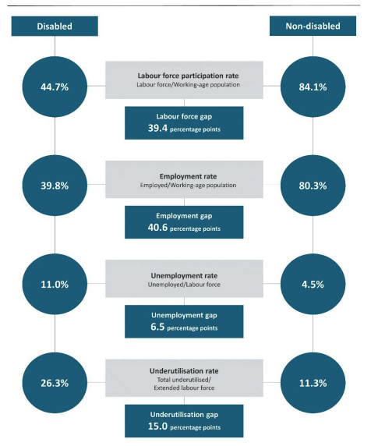

Data supplied by Stats NZ

