

Situation of persons with Intellectual Disabilities in Cyprus

Submission for the List of Issues on Cyprus in the Absence of a State Report
Session of September 2025

June 2025

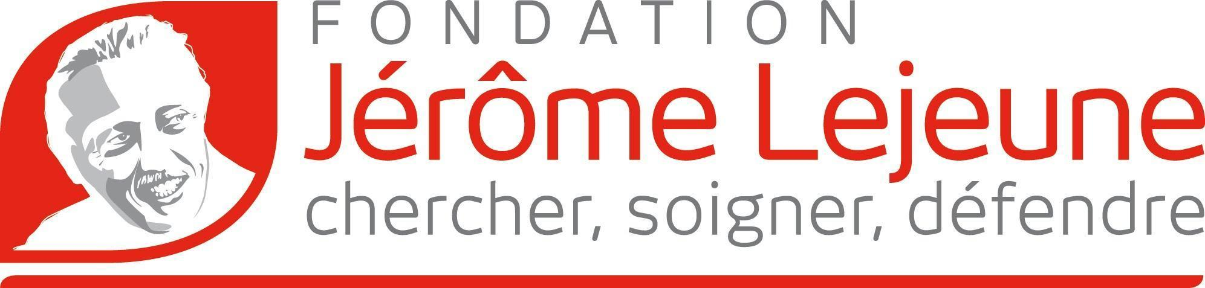

Special Consultative Status with the Economic and Social Council since 2020

Introduction
The Jérôme Lejeune Foundation is an international foundation with headquarters in Paris, France. Created in 1995, after the death of Professor Jérôme Lejeune, the doctor who co-discovered the chromosomal origin of Down syndrome, it has been recognised as an organisation of public benefit since 1996. The Lejeune Foundation has delegations in Spain, Argentina, and in the United States of America, all being at the service of the right to health of persons with intellectual disabilities of genetic origin: Fragile X, Rett and Angelman syndromes, etc. The most common and best known is Down syndrome (also called trisomy 21). The Jérôme Lejeune Foundation has three missions:
- medical research aimed at facilitating daily life and autonomy of persons with disabilities.
- make the right to health a reality by offering medical consultations with qualified doctors.
- protect the dignity of persons with disabilities.
The Jerome Lejeune Foundation is a global expert and leader advocate for the rights of persons with genetic intellectual disabilities.
This submission aims to assist the Committee on the Rights of Persons with Disabilities in its evaluation of Cyprus’s compliance with the CRPD, particularly concerning the rights and well-being of persons with intellectual disabilities. It highlights areas where Cyprus must significantly improve in order to meet its obligations under the Convention.
Please note that in Cyprus, there is no consensus amongst stakeholders regarding the definition of the term ‘disability’; there is also no accurate data on the number of children with disabilities.
Article 5 – Equality & Non-Discrimination
Cyprus’s current prenatal screening protocols are flagrantly misaligned with human rights standards, veering into a quasi-eugenic terrain. Non-invasive prenatal testing (NIPT) and invasive diagnostics such as amniocentesis and CVS have become prevalent, yet the State has entirely failed to collect or publish data on how many pregnancies are terminated after a diagnosis of Down syndrome or other disabilities—thereby violating Article 31’s mandates for transparency and accountability. Though specific statistics for the Republic remain elusive, Cyprus’ numbers must be aligned with the European-wide of up to 90% of such pregnancies are terminated.
Moreover, Northern Cyprus’s permissive attitude toward non-medical pre-implantation genetic diagnosis (PGD) enables discrimination based on sex and disability. According to a Daily Mail article, British couples consult with a number of health centres who work with In-Vitro Fertilization clinics around the world, including Cyprus, in order to guarantee the sex of a child during pregnancy. French couples also go to Cyprus to choose the sex of their baby. The clinics offering this service are very well established in Cyprus.
Cyprus perceives prenatal diagnosis and prenatal sex selection as sources of money and wealth as the global prenatal testing market size was valued at USD 11.26 billion in 2023. The global market is expected to expand at a CAGR of 14.88% from 2024 to 2029 and be worth USD 39.24 billion by 2032 from USD 12.94 billion in 2024.
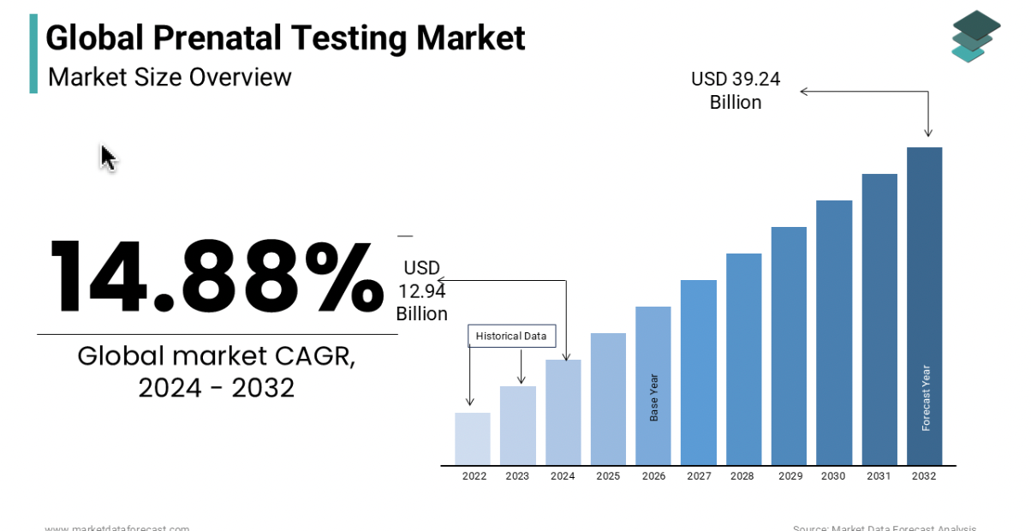
Source : https://www.marketdataforecast.com/market-reports/prenatal-testing-market-report

Questions for the List of Issues:
- Can the State Party provide disaggregated data on the number of pregnancies terminated following a prenatal diagnosis of Down syndrome or other disabilities?
- What measures are in place to prevent discrimination against persons with disabilities during prenatal screening and genetic selection processes?
- Has the State Party taken steps to prohibit non-medical pre-implantation genetic diagnosis (PGD), particularly for sex or disability selection?
- What steps is Cyprus taking to ensure prenatal counseling is balanced, non-directive, and respectful of the rights of persons with disabilities?
Article 8 – Awareness-Raising
Disability in Cyprus is persistently framed in terms of “risk,” casting intellectual and psychosocial conditions as burdens to be feared rather than experiences to be embraced. This stigmatizing narrative thrives in the absence of meaningful, state-sponsored counter-narratives. There are no national campaigns or platforms that present persons with Down syndrome or other intellectual disabilities as contributing members of society—living full, dignified, and productive lives.
As it was pointed in this report , Cyprus authorities use demeaning language in official texts when speaking about persons with intellectual disabilities: “one cannot ignore the choice of demeaning language used to describe persons with mental or intellectual disabilities, which suggests that persons with intellectual disabilities are viewed more like a pathological problem stripped of rights and less like a subject of rights”.
It is important to point out that Cyprus does not have a reliable recording system. The report “identified the absence of a single registry of all children with disabilities which would contain data disaggregated by individual demographic features such as the state of their health, targets and expenditure, coordination of the agencies with competence in the field, the development of an overall action plan, the implementation of laws and policies and monitoring mechanisms. The lack of availability of individual parameters for children with disabilities in the statistical data, such as type of disability, age, sex, place of residence (whether institutionalised or not), education, and care, is a major gap and obstacle in the development of a framework to secure their rights”.
This reality demonstrates that if Cypriot authorities were genuinely committed to combating social stigma and dismantling ableist attitudes—particularly toward persons with intellectual disabilities—they would begin by ensuring visibility. It is impossible to protect the rights of people you do not count. A first essential step is to know who these individuals are, how many live in the country, and where they reside. Without this foundational data, the State cannot design or implement targeted policies, allocate appropriate resources, or measure progress. True inclusion begins with recognition.
Questions for the List of Issues:
- What public awareness campaigns has the State Party initiated to combat stigma and promote positive perceptions of persons with intellectual and psychosocial disabilities?
- How does the State Party ensure the use of respectful, non-discriminatory language in its official communications and legal frameworks?
- What measures are being taken to establish a centralized, disaggregated registry of children and adults with disabilities, including information necessary for effective policy-making?
Article 9 – Accessibility
Approximately one in five Cypriots lives with a disability, yet the built environment remains woefully inaccessible. Sidewalks are obstructed by illegal parking, public buildings lack ramps and elevators, and public transport fails to accommodate wheelchairs. Digital infrastructure—including e-government portals and educational platforms—remains largely non-compliant with the EU Accessibility Act.
When it comes to rules on accessibility, Cyprus does not even provide clear legislative texts. For instance, “the law on persons with intellectual disabilities provides, in a rather vague and general manner, for the duty of the State to provide for the care, education and, if necessary, institutionalisation of persons with intellectual disabilities in as far as this is possible, without specifying the criteria that need to be met in order for care and assistance to be provided. The law does not distinguish between children and adults with intellectual disabilities and, to a large extent, reproduces stereotypes about the perceived limits and restrictions in the skills of these persons and in their ability to integrate.”
Questions for the List of Issues:
- What concrete steps is Cyprus taking to ensure full accessibility of the built environment, including transportation, public buildings, and sidewalks?
- How is the State Party ensuring compliance of digital platforms and government websites with EU and CRPD accessibility standards?
- Does the legal framework differentiate the needs of children versus adults with intellectual disabilities when defining access to services and support?

Articles 13 & 16 – Justice & Freedom from Violence
For individuals with intellectual or psychosocial disabilities, the justice system is often a place of exclusion and disempowerment. Courts and tribunals offer no access to communication supports, easy-read documentation, or trained intermediaries—leaving many unable to participate, contest abuse, or access remedy. Meanwhile, institutional settings operate with minimal independent oversight, trapping vulnerable individuals in spaces where violence and abuse go unchecked.
According to the extensive report by the European Institutions about the situation of persons with disabilities in Cyprus, “there is no legislation that deals specifically with violence against children with disabilities. Various thematic laws provide that violence against a child with disabilities is an aggravated offence that carries a higher sentence, but no provision is made for adapted substantial or procedural rules for the child’s protection or rehabilitation in light of the special vulnerability of the victim. The legal framework does not pay special attention to the vulnerability of girls with disabilities nor does it impose any particular duties upon parents of children with disabilities to protect their disabled children from violence.”
Suggested List of Issues for the Committee:
- What procedural accommodations are in place to ensure equal access to justice for persons with intellectual or psychosocial disabilities?
- Has Cyprus introduced legislation specifically addressing violence against children with disabilities, including gender-specific protections and remedies?
- What oversight mechanisms exist to monitor institutional settings and prevent violence, abuse, or neglect of persons with disabilities?
Article 19 – Independent Living
Despite the introduction of supported living programs in 2017, hundreds of persons with disabilities remain confined to institutions or residential homes—simply because community-based alternatives and personal assistance schemes are severely underfunded. Cyprus allocates only 0.7% of its GDP to disability support, markedly lower than the EU average of 2.2%. This shortfall prolongs segregation, undermines autonomy, and perpetuates dependency. Themis Anthopoulou, the chairwoman of Cyprus Confederation of Disability Organisations (Kysoa), said “This means … that disabled people are being led to impoverishment. It means that invisible people are living among us, people who are deprived of their basic human rights, their right to a dignified and independent life, to respect for their inherent dignity”. She added that this is a “shame for a modern, well-governed European State”.
The chairwoman also highlighted that Cyprus have the second-best economy in the eurozone, a budget surplus of over €1 billion, it gives pay rises amounting to €54 million to civil servants, for example, but at the same time, Cyprus is second last in the EU for social welfare for people with disabilities.
Cyprus is not putting in place enough measures to help persons with disabilities construct and thrive independently as was pointed out by Themis Anthopoulou: “The fact that we live in a society which is not inclusive, where if you differ from the ‘standard’ of the whole, you are automatically marginalised, and, yes, the barriers to accessibility in the labour market are another huge gap which we are working … to bridge, together with the labour ministry”.
The Cyprus law on “Mentally Retarted Persons” which includes persons with intellectual disabilities does not mention the right of persons with intellectual disabilities “to family life and to maintain ties with their parents if and when they are institutionalised or placed in care. This obvious gap in the law may partly be attributed to the fact that Cypriot society does not have a culture or practice of forced institutionalisation of family members and hence the legislator did not perceive a need to fill in a gap; on the contrary the trend appears to be overprotection of parents towards their disabled children”.
This reflects a failure to recognize the vital role families play in supporting their child’s journey toward independence and autonomy. Families should be seen as partners in fostering the autonomy of persons with disabilities, providing essential emotional and physical support throughout their lives.
Questions for the List of Issues:
- What is the current allocation of national funding toward personal assistance and independent living services for persons with disabilities?
- What measures has the State Party adopted to phase out institutional care and invest in community-based alternatives?
- How does the State Party ensure that persons with disabilities in institutional care maintain family ties and are supported to reintegrate into community life?
- What programs are in place to recognize and support families as partners in the autonomy and independence of their children with disabilities?

Article 24 – Inclusive Education
Inclusive education remains aspirational rather than operational in Cyprus. Many children with disabilities are still educated in specialized classrooms or segregated units, with meaningful inclusion hinging entirely on private funding or specific school initiatives. Teachers receive no mandatory training in inclusive pedagogy, and there is no national system to track or evaluate the implementation of individualized education plans.
The law in Cyprus “provides a rather vague obligation to take reasonable measures to ensure access for persons with disabilities to inclusive education in accordance with their needs, without specifying procedures for implementation or monitoring”.
The European Parliament in its report on Cyprus have concluded that “inclusive schools are not ready to receive children with disabilities because of a lack of suitable training for teachers; the presence of escorts which alienates children with disabilities from other children; prejudice against children with mental and intellectual disabilities; a lack of sign language interpretation for deaf students; and several other features which often render the inclusive school an unsuitable space for children with disabilities. This has resulted in the tendency of placing children with disabilities in special units within inclusive schools”.
Suggested List of Issues for the Committee:
- What steps has the State Party taken to train teachers in inclusive pedagogy and reasonable accommodation in mainstream classrooms?
- How is the implementation of individualized education plans monitored and evaluated on a national level?
- What is being done to offer alternatives to segregated education and ensure the full participation of children with disabilities in inclusive education settings?
- How does the State Party ensure the provision of sign language interpretation, accessible learning materials, and inclusive school infrastructure?
Conclusion
Despite being a Member State of the European Union and a signatory to the UN CRPD, Cyprus continues to perpetuate a system that marginalizes, institutionalizes, and invisibilizes persons with disabilities—particularly those with intellectual disabilities. The combination of legal gaps, discriminatory practices, inadequate data, inaccessible infrastructure, and chronic underinvestment reveals a pattern of systemic exclusion rather than isolated shortcomings.
Cyprus should move beyond symbolic commitments and urgently adopt structural reforms. These include disaggregated data collection, genuine inclusion in education, community-based services, and a cultural shift away from stigma and eugenic mindsets. The Committee must hold Cyprus accountable for its omissions, ensuring that persons with disabilities are recognized, protected, and empowered as full subjects of rights.

With a general interest mission.
EP, Country Report on Cyprus for the Study on Member States' Policies for Children with Disabilities, 2014 (page 10). https://www.europarl.europa.eu/RegData/etudes/STUD/2014/519198/IPOL_STU(2014)519198_EN.pdf
KNEWS, Sex selection in Cyprus raises ethical issues, 2018. https://knews.kathimerini.com.cy/en/news/sex-selection-in-cyprus-raises-ethical-issues
Le Figaro, Chypre, l’île où on peut choisir le sexe de son futur bébé, 2019. https://www.lefigaro.fr/international/chypre-l-ile-ou-on-peut-choisir-le-sexe-de-son-futur-bebe-20190701
An example among others: https://www.cyprusivf.co.uk/gender-selection-cyprus/
https://www.marketdataforecast.com/market-reports/prenatal-testing-market-report
EP, Country Report on Cyprus for the Study on Member States' Policies for Children with Disabilities, 2014. https://www.europarl.europa.eu/thinktank/en/document/IPOL_STU%282014%29519198?utm
EP, Country Report on Cyprus for the Study on Member States' Policies for Children with Disabilities, 2014 (page 31). https://www.europarl.europa.eu/RegData/etudes/STUD/2014/519198/IPOL_STU(2014)519198_EN.pdf
EP, Country Report on Cyprus for the Study on Member States' Policies for Children with Disabilities, 2014 (page 15). https://www.europarl.europa.eu/RegData/etudes/STUD/2014/519198/IPOL_STU(2014)519198_EN.pdf
https://commission.europa.eu/strategy-and-policy/policies/justice-and-fundamental-rights/disability/union-equality-strategy-rights-persons-disabilities-2021-2030/european-accessibility-act_en
EP, Country Report on Cyprus for the Study on Member States' Policies for Children with Disabilities, 2014 (page 32). https://www.europarl.europa.eu/RegData/etudes/STUD/2014/519198/IPOL_STU(2014)519198_EN.pdf
EP, Country Report on Cyprus for the Study on Member States' Policies for Children with Disabilities, 2014 (page 29). https://www.europarl.europa.eu/RegData/etudes/STUD/2014/519198/IPOL_STU(2014)519198_EN.pdf
Cyprus Mail, Cyprus’ disabled people are ‘invisible’ and ‘deprived of their basic human rights’, 2025. https://cyprus-mail.com/2025/02/16/cyprus-disabled-people-are-invisible-and-deprived-of-their-basic-human-rights
Cyprus Mail, Cyprus’ disabled people are ‘invisible’ and ‘deprived of their basic human rights’, 2025. https://cyprus-mail.com/2025/02/16/cyprus-disabled-people-are-invisible-and-deprived-of-their-basic-human-rights
Cyprus Mail, Cyprus’ disabled people are ‘invisible’ and ‘deprived of their basic human rights’, 2025. https://cyprus-mail.com/2025/02/16/cyprus-disabled-people-are-invisible-and-deprived-of-their-basic-human-rights
Cyprus Mail, Cyprus’ disabled people are ‘invisible’ and ‘deprived of their basic human rights’, 2025. https://cyprus-mail.com/2025/02/16/cyprus-disabled-people-are-invisible-and-deprived-of-their-basic-human-rights
EP, Country Report on Cyprus for the Study on Member States' Policies for Children with Disabilities, 2014 (page 31). https://www.europarl.europa.eu/RegData/etudes/STUD/2014/519198/IPOL_STU(2014)519198_EN.pdf
EP, Country Report on Cyprus for the Study on Member States' Policies for Children with Disabilities, 2014 (page 27). https://www.europarl.europa.eu/RegData/etudes/STUD/2014/519198/IPOL_STU(2014)519198_EN.pdf
EP, Country Report on Cyprus for the Study on Member States' Policies for Children with Disabilities, 2014 (page 10). https://www.europarl.europa.eu/RegData/etudes/STUD/2014/519198/IPOL_STU(2014)519198_EN.pdf

