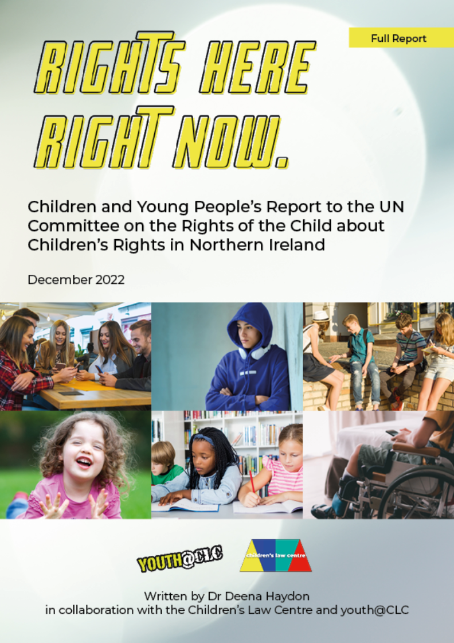

CHILDREN’S LAW CENTRE

Children’s Law Centre is an NGO established in 1997. Founded on the principles laid down in the United Nations Convention on the Rights of the Child [UNCRC], the Children’s Law Centre works to give effect to the UNCRC and other international children’s rights standards in Northern Ireland. Its vision is: A society where all children can participate, are valued, their rights are respected and guaranteed without discrimination and every child can achieve their full potential.
The Children’s Law Centre is based at: Rights House, 2nd Floor, 127-137 Ormeau Road, Belfast, BT7 1SH.
Tel: 0044 2890 245704 Fax: 0044 2890 245679

The Director of the Children’s Law Centre is Paddy Kelly.
Email: paddykelly@childrenslawcentre.org

Youth@CLC is the youth advisory panel to the Children’s Law Centre. Involving a group of young people aged 13-17 from a range of backgrounds across Northern Ireland, Youth@CLC carries out peer research and consultations, runs rights-based projects and campaigns to inform the work of the Children’s Law Centre and government policy, encourages children and young people to advocate for their rights.
The Youth Participation and Advocacy Worker at the Children’s Law Centre during this project was Sinead McSorley.

For further information about the RIGHTS HERE, RIGHT NOW Report, please contact Claire Kemp: Claire@childrenslawcentre.org

ACKNOWLEDGEMENTS
The Children’s Law Centre would like to thank all the children and young people who participated in the online survey and workshops carried out to inform this Report, and the organisations who facilitated their involvement. In particular, ‘thank you’ to: Include Youth, Voice of Young People in Care [VOYPIC], Barnardo’s, South Tyrone Empowerment Programme [STEP], Conway Education Centre, Simon Community, Cara-Friend, PlayBoard, Woodlands Juvenile Justice Centre, Beechcroft In-patient Child and Adolescent Mental Health Unit, Lakewood Secure Care Centre.
Jerome Finnegan, Senior Policy and Advocacy Advisor at Save the Children, provided helpful support with survey data analysis and presentation.
Within the Children’s Law Centre, Sinead McSorley organised the workshops and played a major role in developing associated materials. She contributed to development of the survey and its analysis. Most significantly, she co-ordinated the involvement of Youth@CLC in the whole process of planning and carrying out the survey and workshops, as well as co-facilitating many of the workshops. We wish her ‘Good Luck’ in her new role at NSPCC and will miss her contribution to the work of the Children’s Law Centre. Sam Nelson kept plans on track, designed and produced materials, publicised the survey via the website and social media, and ensured wide dissemination of the Report findings and recommendations.
Dr Deena Haydon was commissioned to write the Rights Here, Right Now: Children and Young People’s Report. She worked with colleagues in the Children’s Law Centre to develop the online survey and supporting materials, plan workshop discussions and co-facilitate meetings with detained young people, analyse the information gathered and present it in various formats.
CONTENTS
INTRODUCTION 6
RIGHTS HERE, RIGHT NOW REPORT 6
RIGHTS HERE, RIGHT NOW SURVEY 7
RIGHTS HERE, RIGHT NOW WORKSHOPS AND MEETINGS 8
ANALYSIS OF THE INFORMATION GATHERED 10

EXECUTIVE SUMMARY: KEY ISSUES AND RECOMMENDATIONS 11
PARTICIPATION 11
NON-DISCRIMINATION 16
SURVIVAL AND DEVELOPMENT 20
KNOWLEDGE ABOUT CHILDREN’S RIGHTS 28
CHILDREN AND YOUNG PEOPLE’S MESSAGES FOR GOVERNMENT 31

THE VIEWS AND EXPERIENCES OF CHILDREN AND YOUNG PEOPLE 32

PARTICIPATION 32
Participation in home life 32
Participation in educational settings 35
Participation in policy making 41
Participation in decision-making by professionals 49

NON-DISCRIMINATION 59
Differential treatment of children and young people 59
Discrimination experienced by specific groups 66

SURVIVAL AND DEVELOPMENT 71
Help and support required for development and to gradually become
more independent 71
Care and protection needed to feel well, cared for and safe 76
Available services and support 78
Meeting the needs of particular groups 94

KNOWLEDGE ABOUT CHILDREN’S RIGHTS 106
Children’s rights 106
UN Convention on the Rights of the Child [UNCRC] 109
Northern Ireland Commissioner for Children and Young People [NICCY] 111
Personal knowledge about rights 113

CHILDREN AND YOUNG PEOPLE’S MESSAGES FOR GOVERNMENT 118

APPENDICES 120
Appendix 1: Guidance for teachers and youth workers 120
Appendix 2: Activities to support completion of the online survey 126
Appendix 3: Template for recording group discussions 137
Appendix 4: CLC website information about the online survey 143
Appendix 5: Rights Here, Right Now Survey 145
Appendix 6: Survey respondent demographics 157
Appendix 7: Workshop information for children and young people 162
Appendix 8: Workshop consent form for children and young people 164
Appendix 9: Consent form for person with parental responsibility 165
Appendix 10: Activities to support involvement in a workshop or meeting 166
Appendix 11: Workshop and meeting participants 177
Appendix 12: Workshop and meeting questions 179
INTRODUCTION

RIGHTS HERE, RIGHT NOW REPORT
The Rights Here, Right Now: Children and Young People’s Report to the UN Committee on the Rights of the Child was compiled and written by Dr Deena Haydon on behalf of the Children’s Law Centre, in collaboration with Youth@CLC.
The Report is part of the process of periodic reporting to the UN Committee on the Rights of the Child [the Committee] about implementation of children’s rights in the UK and devolved administrations. Following receipt of the Committee’s List of Issues Prior to Reporting in March 2021, the UK Government submitted its sixth and seventh State Party Report to the Committee in June 2022. The Rights Here, Right Now Report was submitted to the Committee in December 2022, alongside a Northern Ireland NGO Stakeholder Report 2 and Stakeholder Report 2: Evidence, to inform a Pre-sessional meeting of the Committee in February 2023 and examination of the UK Government by the Committee in May 2023.
The Rights Here, Right Now Report has been informed by an online survey for 12-17 year olds across Northern Ireland and consultation workshops or meetings with specific groups of children and young people. It focuses on four topics, reflecting the general principles of the UN Convention on the Rights of the Child [UNCRC]: participation; non-discrimination; survival and development; knowledge of children’s rights.
Rights Here, Right Now highlights a range of issues concerning implementation of children’s rights in Northern Ireland and the actions required to address these issues in policy, legislation, administrative and judicial proceedings. It will ensure that the views and experiences of children and young people from Northern Ireland inform the Committee’s understanding about devolved issues which are the responsibility of the Northern Ireland Executive and Assembly, as well as non-devolved matters which remain the responsibility of the UK Government.
Following an outline of the processes used to gather information and analyse data from the survey, workshops and meetings, an Executive Summary identifies key issues and actions required by the Northern Ireland Executive, relevant government Departments and public authorities. The Report then provides more extensive analysis of the views and experiences of the children and young people involved in relation to each topic. Where relevant, recommendations made by the UN Committee on the Rights of the Child following its last examination of the UK Government and devolved administrations in 2016 have been included to enable assessment of progress made in implementation of children’s rights in Northern Ireland during the reporting period [2016-2022].

RIGHTS HERE, RIGHT NOW SURVEY
The RIGHTS HERE, RIGHT NOW survey was constructed to gather information from 12-17 year olds across Northern Ireland.
Schools and organisations working with children and young people were notified about the RIGHTS HERE, RIGHT NOW survey one month before it went live, with an ‘It’s coming’ email. Two weeks before the survey went live, they were sent a more detailed email, accompanied by Guidance (see Appendix 1) and Activities (see Appendix 2) for teachers and youth workers to support completion of the survey, plus a Template that they could use to record discussion (see Appendix 3). This information was also available on the Children’s Law Centre website, where young people were encouraged to complete the survey and access additional information about the UNCRC and periodic reporting process (see Appendix 4).
A follow-up email was sent to schools and organisations when the survey went live, with a reminder sent two weeks before the survey closed, asking organisations to inform the children and young people with whom they worked about the survey and encourage them to take part. The survey was also publicised through a comprehensive, two-month social media campaign. A range of social media graphics, developed by the Children’s Law Centre in consultation with Youth@CLC, were shared across multiple platforms (including Twitter, Facebook and Instagram), with links to the survey and additional capacity building resources for children and young people.

The survey was in five sections (see Appendix 5). The first section provided demographic information, using a comprehensive and inclusive range of options for respondents (intended to minimise the selection of ‘other’). Definitions were provided in relation to some terms. In this section, information was collected about respondents’ age; gender; sexuality; ethnic background; religion; disability or special educational need; eligibility for free school meals (a proxy for children living in poverty and therefore economically disadvantaged); residence; area and county lived in.
The next sections focused on 4 topics:
- Participation (UNCRC Article 12): in education, their home life, their community, and government decision-making.
- Non-discrimination (UNCRC Article 2): adult responses to children and young people in their local area.
- Survival and development (UNCRC Article 6): whether respondents have the help and support they need for their development and to gradually become more independent; whether they are given the care and protection they need to feel well, cared for and safe (including access to health services, help and support); who they would talk to if they had a worry, wanted help or support; whether they think they receive adequate information about specific (listed) topics in school.
- Knowledge about children’s rights (UNCRC Article 42): whether respondents had heard about children’s rights, the UNCRC, or NICCY before doing the survey; where they had heard about children’s rights, the UNCRC or NICCY; their knowledge about children’s rights; whether they think children and young people should learn about their rights and, if so, where.
The RIGHTS HERE, RIGHT NOW survey, live between 14th March and 14th April 2022, was submitted online via Survey Monkey. 1,026 responses were received from children and young people with a diverse range of backgrounds and circumstances (see Appendix 6). A large proportion of respondents were aged 12-13 (41%), with similar numbers of 14-15 year olds (26%) and 16-17 year olds (29%). In terms of gender, 61% of respondents defined themselves ‘girl, including trans girl’, with 30% defining themselves ‘boy, including trans boy’; 2% as ‘non-binary’; 2% preferring not to say; and 5% replying that they ‘use another term’. The majority: 70% identified as ‘straight/ heterosexual’, with 18% classifying themselves ‘gay/ lesbian’, ‘bisexual’, ‘pansexual’ or ‘fluid’. In relation to ethnic background, 85% described themselves as ‘white’. Defining their religion or faith, 71% were Christian (54% Catholic, 17% Protestant), 10% responded that they did not believe in God and 8% that they had no religion. Although 10% replied that they had a disability or special educational needs, 9% responded ‘don’t know’ to this question. Just 17% responded that they were eligible for free school meals. Most: 94% lived with their parents, with 4% responding that they were ‘in care (with members of their family, foster parents or residential care)’. More than half of respondents: 59% lived in a ‘town’ or ‘city’, 26% lived in the ‘countryside’ and 15% in a ‘village’. While not replicating the characteristics of the population of children and young people in Northern Ireland, the survey provides a valuable insight into the views and experiences of the 1,026 young people who chose to submit a response.

RIGHTS HERE, RIGHT NOW WORKSHOPS AND MEETINGS
Information was also gathered from children and young people who are among the most disadvantaged or vulnerable in Northern Ireland. In addition to being less likely to complete the online survey, the views and experiences of these children and young people are not always evident in ‘mainstream’ (school-based) or generic consultations and the Children’s Law Centre was keen to gather their perspectives.
NGOs working directly with specific groups were emailed information about the workshops, plus Workshop Information (see Appendix 7) and a Workshop Consent Form (see Appendix 8) for children and young people who were interested in participating. Where relevant, they were also sent a Consent Form for the Person with Parental Responsibility to complete (see Appendix 9). A leaflet suggesting Activities to support involvement in a workshop or meeting was provided to each organisation (Appendix 10), with the Template for recording discussion (see Appendix 3).
The workshops and meetings included: detained young people (in custody, an in-patient child and adolescent mental health unit, secure care); young people who had been in conflict with the law and were taking part in a scheme for those not ready to participate in training, college or work; care experienced young people; young people with disabilities; children and young people from minority ethnic communities; LGBTQ+ young people; young children (aged below 12); refugee and asylum seeking young people; Traveller children.
In total, 8 meetings (5 with individuals, 3 with pairs) and 12 workshops were conducted, involving a total of 127 children and young people. Most participants ranged in age from 6-18. In the small number of groups which involved over-18s, these young people expressed retrospective views - referring to childhood experiences which occurred during the reporting timeframe (see Appendix 11).
Once organised, each workshop was facilitated by the Children’s Law Centre Youth Participation and Advocacy Worker and one or two members of Youth@CLC. In a few cases workshops were facilitated by staff within the organisation who then forwarded their notes, on a completed Template, to the Children’s Law Centre. Rather than a group setting, with detained young people (ie those in custody, the in-patient mental health unit and secure care) individual or paired meetings were arranged with the Youth Participation Worker and the Researcher commissioned to write the Report. While these meetings involved just one or two young people, they tended to be more in-depth than workshop discussions, providing opportunities to explore the views and experiences of those who participated.
Workshop or meeting facilitators used the same set of questions with each group. These were based on the topics covered in the survey, with participants encouraged to provide examples of the issues they raised without relaying personal details or breaching the confidentiality of others (see Appendix 12). Where necessary, the facilitator spent time explaining anything participants had not heard about or did not understand (e.g. about the UNCRC, NICCY and the periodic reporting process). In some meetings or workshops, organisational staff members remained present. Occasionally these staff provided contextual information and, in the workshop with disabled children and young people, enabled the involvement of individuals. Where relevant, comments or contributions by staff have been included.
ANALYSIS OF THE INFORMATION GATHERED
Children’s and young people’s views and experiences have been gathered for this Report through combining analysis of responses to the online survey with notes of discussion during consultation workshops or meetings with individuals/ pairs.
As they were informed on the front page that they did not have to answer every question, some survey respondents ‘skipped’ particular questions. The analysis of survey responses in the Report is based on the actual number responding to each question (which ranged from 737-908 in the sections focusing on the main topics). Significant findings have been drawn from the wealth of data. Tables demonstrating the range of responses to each question have been included throughout the Report (these have also been collated in a separate document, available at: https://childrenslawcentre.org.uk/?mdocs-file=6027). Where significant, comparisons on the basis of age, disability, and eligibility for free school meals have been highlighted. There were few gender-based differences in responses.
During each workshop and meeting, the facilitators took notes so that direct quotes from the participants could be used in this Report. Where two facilitators were present, these notes were cross-checked to ensure accuracy. Quotes and summaries of the key issues raised in consultation workshops or meetings have been used to highlight commonalities as well as identify significant differences between specific groups.

EXECUTIVE SUMMARY:
KEY ISSUES AND RECOMMENDATIONS

The Executive Summary provides an overview of the key issues arising from analysis of 1,026 responses to an online survey of 12-17 year olds across Northern Ireland, which was live from 14th March until 14th April 2022, and information gathered during consultation workshops and meetings involving 127 participants from some of the most vulnerable and disadvantaged groups between April and October 2022.
Both the survey and workshops or meetings focused on the general principles of the UNCRC: participation; non-discrimination; survival and development; and knowledge about children’s rights. The key issues identified in relation to each of these topics are based on relevant survey data and qualitative information from workshops or meetings. The actions required by the Northern Ireland Executive, relevant government Departments and public authorities to address current rights violations are detailed in associated recommendations.
It is clear that the contexts of individuals’ lives affect realisation of their rights. As in the previous submission to the Committee from children and young people in Northern Ireland in 2015, those in disadvantaged and vulnerable groups continue to experience less realisation of their rights than others who are not disadvantaged by circumstances which affect opportunities and access to services or support. Many of the required actions echo those made in 2015, demonstrating continued failure to implement children’s rights.

PARTICIPATION
UNCRC Article 12: The right of every child to express their views freely in all matters affecting them, with the child’s views being given due weight in accordance with their age and maturity
Key Issues
- Children and young people did not consider their views would be taken seriously by adults beyond their home lives, least of all by politicians.

- Most children and young people considered that they were able to participate in decisions in their homes and were listened to by their parents/ carers.

- The majority of children and young people did not consider that teachers sought their opinions about what they learnt, how they were taught, or decisions concerning school/ sollege policies. A key issue was that some individuals did not feel able to approach teachers about bullying, or did not consider that bullying was appropriately addressed. While some provided examples of changes in policy or practice as a result of issues being raised by children at School Councils, others considered that very little change had occurred via this formal mechanism.

- Children and young people did not consider that the adults in their community would listen if they gave their opinion and were rarely consulted about services or activities in their local areas. Most considered that priorities were identified by adults and did not reflect the views or preferences of children and young people.

- Very few children and young people considered that they would be listened to by politicians if they gave their opinion. Few had been asked their views about issues affecting them or plans in their local area. Some noted that they lacked experience or opportunity to talk to politicians.

- Many of those experiencing significant intervention in their lives (in care, secure care, custody, or the in-patient mental health unit) did not consider that they were involved in decision-making by professionals. In particular, they were critical of social workers who did not enable them to express their views, listen to them, or act on what they said. A recurring issue among these young people was that they did not consider they were ‘given a chance’ to demonstrate they and their behaviours had changed. They considered it inappropriate that decisions, interventions or treatment were based on previous events at a particular time or in specific circumstances, which did not take into account progress made or changes in their circumstances, understanding or maturity.

- Experiences of participation differed within specific groups:
  - Younger children (under-12s) were generally more positive about being listened to than older young people. In their homes, their participation was affected by parents/carers being busy or not having time to give them attention. In school, some felt that young children are not taken seriously. A few commented that they did not raise issues with teachers because their views were not sought, they did not feel confident or comfortable about asking questions or complaining. Some considered that teachers do not listen to the victims of bullying or minimise its impact. They reported that they were not involved in community decision making. Nor were they consulted by politicians, which they considered was wrong. A few stated that they would not vote when they had the opportunity because they assumed they would not make good decisions.
  - Older young people (16+) were less likely than younger children to consider that they were listened to in every aspect of their lives. Some did not feel respected in their home life, where they considered that they were infantilised, patronised, or that their parents made decisions for them. In school or college, teachers did not ask their opinions, particularly about what they learnt. Lack of participation regarding exams included feeling pressured to study specific subjects and limited knowledge about forthcoming exams. Some found it challenging to express their views in school/ college, did not consider that teachers effectively addressed bullying, and felt infantilised or ignored by teachers. On the rare occasions when young people were consulted about local community services or facilities, fulfilment of their suggestions was dependent on the backing of adult decision-makers. Some young people mistrusted politicians and most agreed that politicians rarely consulted with them. They argued that politicians should take seriously the issues of importance to young people (including trans rights, gay marriage, abortion, homelessness, support for drug and alcohol users). Some did not anticipate voting because they did not understand the process or questioned whether their vote would make a difference. Others were keen to vote and a few advocated lowering the voting age to 16.
  - Children and young people with disabilities were less likely than those without disabilities to consider that they were asked their opinions or taken seriously. In school, they considered that teachers did not ask their opinions, particularly regarding rules and what they learnt. They were not given the option of taking GCSEs or deciding where they might enroll when they reached school leaving age. For some, the only option provided was attendance at ‘daycare’ (for 18-65 year olds) as they were informed that colleges were unable to accommodate their needs. Also reported was not being listened to about required learning support, for which funding had not been received as a result of changes in government funding and contracts.
  - A group of female refugees considered that, at home, their brothers had more independence than them and were less regulated by their parents. They expressed a desire for greater freedom. Some considered that their culture and religion influenced responses to them in school where they were not taken seriously because they were Muslim and wore a hijab.
  - In a group of eight LGBTQ+ young people only one was able to participate at home because they lived in a family that was accepting of them and had a good relationship with their parents. Participation in community decision making was affected by prejudice and the homophobic attitudes or behaviours of other community members.
  - Some young people in conflict with the law stated that they had found it challenging to express their views in school/ college, and were either unable to approach teachers about bullying or did not consider that appropriate measures were taken to reduce the chances of bullying re-occurring.
  - Some care experienced young people considered that they were listened to by their foster carers or staff in residential homes. Some described being infantilised, dismissed or stigmatised in school by teachers who promised to help them but didn’t, were dismissive of their situations, or assumed that their behaviours were a result of them being in care. They were clear that not being listened to or taken seriously by social workers led to their needs not being met.
  - Young people in secure care considered that their voices were not heard; conversations or decision making about their lives occurred between adults, particularly regarding their placement in secure care. Key issues included: lack of understanding about, or disagreement with, the risk assessment leading to their placement in secure care; repeat admissions; lack of involvement in the process (including attendance at the Panel for Admission to Secure Care or opportunity to meet the judge making the decision about whether they should receive a Secure Accommodation Order). Regarding participation within Lakewood Secure Care Centre, issues raised by young people included: restriction on watching 12+ movies for older young people when a 12 year old was in the Unit; rules about clothing for females; preference for ‘trusts’ to be instigated after two, rather than four, weeks.
  - In the in-patient child and adolescent mental health Unit, concerns were raised about: the right to participation being ‘over-ruled’ for those detained under a Mental Health Order, who are not considered to have the capacity to make decisions, including about medication; the opinions of young people being discounted in care planning meetings; those experiencing use of restraint during nasogastric tube feeding not being listened to by staff; issues raised in House Meetings not being addressed as many concerned established ways of responding to patients by staff (eg during use of restraint).
  - Young people in custody identified lack of choice over lessons in the Juvenile Justice Centre [JJC] school as an issue and questioned the expectation that those above school leaving age should attend, particularly as non-attendance led to them being locked in their room with no TV or electricity. A ‘progressive regime’ determined access to facilities (eg swimming pool, gym, football pitch) and equipment (eg DVD player), money, bedtime, jobs, and number of phone calls. Once the highest level had been reached there were no additional incentives, which was frustrating for those detained for a long period. Each person’s regime was reviewed weekly and ‘adverses’ - given for ‘language’ (ie swearing), being late to class or not attending class - could lead to a reduction in regime level for a week. While understanding the reasons for receipt of an ‘adverse’, these were criticised as “stupid”. It was reported that sometimes there was no explanation by staff about what would happen in response to certain behaviours or warning of a sanction being imposed (eg losing access to a TV following use of restraint or being ‘locked’ after an incident). Staff were described as sometimes being too busy, or unwilling to make the effort, to take individuals to a facility or for a walk in the outside area during the evenings. Young people commented on inconsistent application of rules, and did not understand the reason for some restrictions. Young people detained on remand were not able to leave the JJC. Those nearing the end of a sentence had ‘mobility leave’ in preparation for leaving custody, but questioned how visits to the town close to the JJC were useful preparation for release to their home town.

Recommendations
The Northern Ireland Executive, relevant government Departments and public authorities should:
- Ensure that Article 12 of the UNCRC is incorporated into legislation, policy and practice in Northern Ireland; systematically promoting and implementing the principle of respect for the views of the child and supporting the development of mechanisms to enable children to express their views on all matters affecting them – both as individuals and as collective groups.
- Ensure that programmes for parents and carers emphasise the importance of making time to listen to children and young people, involving them in decision-making and taking their opinions seriously.
- Ensure that every school has an anti-bullying policy, and that all pupils know who they can contact about bullying as well as sources of support and procedures they can follow if concerns or complaints have not been addressed.
- Ensure that the initial training and professional development of teachers, social workers and health professionals emphasise the child’s right to participation in decisions about matters affecting them, with an emphasis on development of skills and approaches that enable meaningful participation. This should include effective ways of explaining how the child’s views will be taken into account, the reasons underpinning final decisions (including those with which the child or young person does not agree), and potential opportunities for review.
- Make School Councils a mandatory requirement for every school and college, with Inspection bodies ensuring that the structures and practices of educational institutions are democratic, inclusive, and provide opportunities for children’s/ young people’s views to be given due weight in decision-making processes.
- Ensure that consultation mechanisms established in places of detention take into account the opinions and suggestions of those detained (particularly in relation to rules and restrictions); address the issues or concerns they raise; and provide a clear explanation or rationale when changes are not possible.
- Adequately resource the development of shadow Youth Councils in all councils to ensure that young people’s voices are heard and taken into account in their communities and local councils.
- Continue to support the development of Northern Ireland’s Youth Assembly; ensuring that its priorities (the school curriculum, youth mental health, children’s rights, climate change) and recommendations are taken into account by MLAs and reinforced in government decision-making.
- Ensure that public authorities and government Departments fulfil their duty under Section 75 of the Northern Ireland Act 1998 to promote equality of opportunity in respect of children and young people; directly consulting with children and young people when developing legislation, policies, strategies and services which affect them, as well as providing feedback about how their views and suggestions were taken into account.
- Ensure that government officials at both council and Assembly level engage with children and young people to seek their views when decisions are being made in communities and by government Departments; collaborating with civil society organisations to increase opportunities for meaningful participation without delegating this responsibility to such organisations or to NICCY.
- Establish a consultation about lowering the voting age to 16 and ensure provision of political education so that young people understand political systems and their potential influence as voters.

NON-DISCRIMINATION
UNCRC Article 2: the right of every child to be treated fairly and without discrimination of any kind, irrespective of the child’s (or their parent’s/ guardian’s) race, colour, sex, language, religion, political or other opinion, national/ ethnic/ social origin, property, birth or other status
Key Issues
- Children and young people provided examples of differential treatment on the basis of their age, including: age restrictions on video games and access to YouTube; age-related responsibilities; under-18s not being eligible for a Spend Local card from the government, despite some working during the pandemic.

- Some suggested that children may be treated differently for their benefit (e.g. to protect them from harm). However, both children and young people challenged differential treatment or exclusion based on assumptions about children’s or young people’s incompetence or lack of understanding. They also disputed negative stereotypes about young people.

- Some survey respondents considered that adults in their communities were pleased to see children playing out, that they and their friends ‘got on well’ with the adults in their area, and that young people in their area trusted the police. Others disagreed with these descriptions, suggesting variability in regulation of children’s presence in public spaces and in relations with the police.

- Two thirds of survey respondents considered that under-18s are negatively stereotyped in the media and many in workshops agreed.

- Children and young people across workshops were aware of the prejudice and discrimination experienced by specific groups on the basis of physical or learning disability and neuro-diversity, race and culture, religion, gender and sexuality, ‘being different’ (e.g. small, fat, wearing different clothes).

- Specific groups provided examples of the discrimination they personally experienced:
  - When considering negative ways in which children are treated differently, younger children focused on what they perceived to be the privileges of teenagers and adults. They were less likely than older young people to agree that children and young people are told to ‘move on’ in public spaces, and more likely to think that young people in their area trusted the police.
  - Lack of respect for young people was a significant issue for older young people, who noted contradictory adult perceptions of young people as either immature or overly-mature. Young people argued that teenagers and young adults experience discrimination and prejudice because they are viewed as being ‘troublesome’ or ‘dangerous’, leading to negative reactions in response to the way some dress or when they are enjoying themselves with friends in public places. Some described feeling judged. They questioned whether there were safe places in their communities for them and their friends to hang out and some reported being told to ‘move on’ when with friends at the shops or in parks. They were far less likely than younger children to agree that young people in their area trusted the police. Some considered that the police anticipate trouble from young people, provoke young people to behave negatively, or that police presence can worsen a situation. Most young people considered that the media negatively stereotypes children and young people.
  - Care experienced young people considered that adults have negative attitudes towards, and assumptions about, young people - looking at them suspiciously in shops, expecting them to be trouble, stereotyping them as rowdy or wanting to fight.
  - Young people in conflict with the law argued that the media often portrays young people negatively (e.g. in relation to anti-social behaviour), believing that this heightens and encourages the discrimination experienced by young people. They also noted that there are few articles showing the positive contributions young people are making to their local communities (e.g. through voluntary work).
  - Some young people with disabilities were marginalised in mainstream education - unable to socialise because they had a classroom assistant; being isolated, attending for short time periods, being taught a limited curriculum by a classroom assistant separately from their class. Young people described the negative impacts of wheelchair inaccessibility on their social lives and leisure opportunities, involvement in school activities, and access to further education. They recounted being targeted with disablist comments and verbal abuse when in public situations or on the streets.
  - Discussing community safety, a group of migrant children stated that they would speak to the police if they did not feel safe in their community, and would feel confident doing this. Personal examples demonstrated both helpful and limited police responses following incidents affecting families. Migrant children mentioned being treated differently when speaking their native language on the estate where they lived and in school. They described negative reactions to migrants, including being ignored, disliked and told: ‘Go back to your country’.
  - Refugee young women considered that they experienced prejudice and discrimination in school as a result of their religion (being Muslim) and what they wore (a hijab). They also considered that their gender led to differential treatment in their community, where they reported that females are treated worse and have less freedom than boys.
  - Travellers stated that particular groups experience prejudice and discrimination in the community on the basis of age, language barrier, and being Travellers.
  - Despite considering that society is becoming more relaxed about gender identification, young people were aware of the prejudice and discrimination experienced by those who are trans. A group of LGBTQ+ young people provided examples of the verbal and physical abuse they experienced, stating that they would never walk alone in the nearest town for fear of being targeted by others of a similar age from local schools.
  - Care experienced young people commented on the stigma associated with being in care or a care leaver, not being listened to as much as other young people, being judged or negatively represented when they are often dealing with many emotions. Young people in custody and in secure care stated that those in children’s homes have restrictions placed on them which are not imposed on peers who are not in care.
  - In the in-patient mental health Unit it was reported that young people with eating disorders were defined by their illness, referred to as ‘eating disorders’ (e.g. staff commented: ‘Let eating disorders do yoga first’). Although not treated unfairly on the basis of their age, it was suggested that responses to young people differed according to staff status, with ‘higher bands’ [more senior staff] more likely to treat young people as if they were a child or patient while others chatted to them as if they were a friend or ‘normal person’.
  - Young people in conflict with the law considered that their reputation follows them and affects interactions with the police for other family members.

Recommendations
The Northern Ireland Assembly Executive, relevant government Departments and public authorities should:
- Ensure that, in all legislation, children and young people under the age of 18 are protected from discrimination on the basis of age.
- Ensure that all children and young people, particularly those who are vulnerable or disadvantaged as a result of their circumstances, experience equal realisation of their rights; taking affirmative action where appropriate for specific groups.
- Ensure that children and young people are not negatively stereotyped in any government policies or media discussion involving MLAs/ council officials, and that the positive contributions of children and young people to their communities are highlighted.
- Ensure positive, inclusive representation of children and young people from different cultures in government policies/ strategies and resources produced for professionals.
- Ensure that all schools and youth services deliver anti-discriminatory practice, including opportunities to celebrate cultural and linguistic diversity, different genders, sexualities and abilities.
- Provide funding for development of intergenerational projects aimed at reducing negative stereotyping of, and responses to, young people by adults in their communities.
- Ensure that, in any interactions with young people, police officers are respectful and do not act on negative assumptions or stereotypes about young people/ specific groups (including those from minority ethnic communities, care experienced young people or young people who have been in conflict with the law).
- Ensure implementation of inclusive policy and practice for children and young people with disabilities in mainstream educational settings, play and recreational facilities, youth and community services.
- Ensure that safeguarding policies and procedures are clearly understood by looked after children and young people, including measures to ensure their protection from harm (e.g. child sexual exploitation, drug and alcohol misuse, involvement in criminal activities), with an emphasis on staff maintaining positive relationships and demonstrating care rather than implementation of monitoring and reporting procedures.
- Ensure that detained young people receive necessary and appropriate treatment or intervention which: avoids labelling; respects their rights to participation, decisions being made in the best interests of the child, non-discrimination, survival and development; recognises progress; addresses the issues they consider important as well as professional concerns in care plans and reviews.
- Ensure that children and young people receive age-appropriate information about how they can report discrimination, including details of organisations which can assist them and bodies to which complaints (regarding education, health and social care, policing, youth and community services, legislation, media, government policy) can be submitted.
- Ensure that Departments, bodies, agencies and organisations have developed child-friendly complaints processes.
- Ensure that reported cases of discrimination experienced by individual children, young people or specific groups are recorded and effectively addressed by relevant Departments, bodies, agencies and organisations.

SURVIVAL AND DEVELOPMENT
UNCRC Article 6: the right of every child to life, survival and development to the maximum extent possible – giving them the care, help and support they need to develop and protecting them from violence or exploitation
Key Issues
- Children and young people considered that, to be healthy, under-18s need: healthy food; health care (including mental health); sleep; play, leisure and recreational activities; somewhere to live (a house or home). In addition:
  - Migrant children identified: a suitable environment (outside, at school, at home); no noise from neighbours late in the evening; longer breaks and being allowed to wear suitable winter boots at school. Discussing play and leisure activities, they advocated more locally available activities; better playgrounds and free youth clubs offering a variety of activities. They valued a ‘Saturday Language Club’ where they could speak their native language while doing art and craft activities.
  - Refugee young women added that children and young people need clothes, shoes, money, friends and family to be healthy.
  - Travellers stated that they also need to stay up to date with vaccines, daily exercise and reduced screen time.
  - Care experienced young people emphasised need for: education, learning and training; information (internet); role models and a support network.
  - Some older young people considered that social media platforms such as Facebook and Instagram can have a negative impact on individuals’ mental health and wellbeing.

- To develop to their fullest potential, children and young people identified need for: education; a safe home; loving parents and family; caring people and role-models; opportunities for play, leisure and social activities; appropriate support. In addition:
  - Migrant children suggested need for safe living and learning environments. Further requirements included: more practical and life-giving activities in school; work experience; acceptance of migrants’ home language as a second language in colleges; opportunities to learn and develop their native language, present and celebrate their home country traditions/ culture; and involvement in wider community life.
  - Refugees suggested a good education and support such as that provided by Conway Education [Homework Club].
  - Also important to Travellers was the need to encourage independence.
  - Care experienced young people suggested need for: jobs; money; information; a sense of self/ identity/ family history; safety; security and stability.

- Considering what children and young people need in preparation for living independently, emphasis was placed on practicalities: better access to computers; information about opportunities to develop ‘life experience’; driving lessons; access to College; learning how to manage money and budgeting; gaining work experience; help from the government until they start a job; improving home skills (cooking, cleaning, managing a household); finding out about organisations that might be of help.

- The majority of survey respondents considered that they received the help and support they needed for their development and to gradually become more independent. However, workshop discussions revealed awareness that this is affected by economic inequalities – those in poorer families often do not have the support they need.
  - In the survey, children and young people with disabilities were less likely than those without disabilities to agree that they received the support they needed for their development and to become independent.
  - During workshop discussions, a few older young people stated that they did not receive necessary help and support, commenting that they “learned the hard way”, without being taught “how to actually live”.

- Specific groups identified the factors supporting or negatively affecting wellbeing and development:
  - Discussing the factors supporting children’s wellbeing and development, migrant children noted: support (from parents and other adults around them); having enough money for living expenses; a safe environment; time to relax; and positive attitudes towards children. For them, circumstances negatively affecting wellbeing and development included: parents working long hours and having no time to spend holidays or weekends together; neglect and bad living conditions; school hours being too long, leaving them feeling tired; having too much homework and too many responsibilities at school; bullying at school and on the street; noise at school and from neighbours at night; drugs, alcohol and negative influences; not sleeping enough; being unhealthy; and bad weather. They also highlighted: “Too much adult control over us and lack of own choices.”
  - Considering factors which negatively affect children’s wellbeing and development, refugees focused on the responses of others: bullying and making fun of people; people not respecting each other.
  - Travellers emphasised opportunities for playing outside, “being creative”, “joining in” and “stop rushing” to support wellbeing and development. When identifying circumstances negatively affecting wellbeing and development they focused on specific harms: child maltreatment; abuse; neglect; family stress and poor nutrition.
  - Care experienced young people emphasised personal, social and environmental factors affecting children’s wellbeing and development: “resilience”; “stability”; “security”; “having good people around you”.

- Identifying what children and young people need to feel safe and protected, some provided very practical suggestions while others identified need for protection from abuse. In addition to parents, family, well-behaved adults, and friends, children and young people suggested that safety and protection are provided by the police, health care, schools and social workers.
  - Care experienced young people focused on the issues children and young people need to be protected from - interpersonal and online abuse, drugs, alcohol - and the people or places that can provide protection: a safe place (home); a responsible adult; police; and better social workers.

- Most survey respondents considered that they were given the care and protection they needed to feel well, cared for and safe.
  - In the survey, children and young people with disabilities were less likely to agree that they received the care and protection they needed than those who did not have a disability.
  - For one group of younger children, therapists and talking to their friends provided the support they needed. They also mentioned specific techniques they had been taught by therapists or their parents to use when feeling anxious.

- Only half of the survey respondents agreed that they could easily access things to do and places to go in their area. The proportion was lower among older young people and those with disabilities. In workshops, children and young people noted that access to play and leisure provision was dependent on parents registering or transporting them to facilities. This was a particular difficulty for those with disabilities. In addition to need for sports, playgrounds, opportunities for play and social activities, necessary youth and community provision included: community centre/ facilities; more information about activities for children; free access to local youth clubs offering a range of activities (e.g. art, dance, theatre, sports, cooking).

- While three quarters of survey respondents agreed that they could afford to access places such as the cinema or leisure centre, those on free school meals were less likely to agree that this was the case, as were those with disabilities and older young people.

- Almost three quarters of survey respondents agreed that they could easily access a doctor or health worker when physically unwell, although the proportion was considerably lower for older young people, those with disabilities and those on free school meals. Necessary health support identified by children and young people in workshops included regular check-ups and vaccinations. Significant issues were difficulty accessing an appointment with a doctor and long waiting lists for those waiting to be assessed or trying to access specialist services. Young people emphasised the importance of non-judgemental and confidential responses from health professionals.

- Less than half of all survey respondents agreed that they could quickly see a counsellor or specialist when they needed support for their mental health and the proportion was even lower among older young people, those with disabilities and those on free school meals. In workshops, children and young people identified long waiting times as a major problem. Some reported that they had been waiting years to receive the treatment they required and that their mental health had deteriorated during this time, with insufficient support when they experienced a mental health crisis. CAMHS [Child and Adolescent Mental Health Service] was criticised by many, who reported: appointments being cancelled and rescheduled; inadequate time being devoted to talking with or helping individuals; young people not being taken seriously unless showing physical signs that they needed help (ie self-harming); difficulties experienced by young people with disabilities in accessing sufficient mental health support. Under-resourcing was considered an issue in terms of both ‘early intervention’ and intensive ‘specialist’ provision.

- Almost two thirds of survey respondents agreed that they knew where to go for help and support if they wanted to talk to someone about a problem or worry. However, just under half agreed that they would feel confident to ask for help or support if they needed it. This suggests that, despite knowing what is available, many children and young people lack confidence in accessing existing sources of help and support. The proportions in relation to both issues were lower among 16-17 year olds than among those aged 12-13.

- Two thirds of survey respondents agreed that they would know who to contact if they did not feel safe or properly cared for. However, the proportion was considerably lower among those aged 16-17 and those with disabilities.

- In both the survey and workshops, most children and young people reported that they would talk to their parents or friends if they had a worry or wanted help.
  - Younger children were more likely to talk to parents and relatives, although a few noted that relatives (particularly siblings) were not necessarily the most helpful source of support.
  - Older young people were more likely to talk to friends.

- Just a quarter of all survey respondents replied that they would talk to a teacher if they had a worry or wanted help – a relatively low number given their daily contact with teachers. Free helplines were identified as a source of support by 13% of all respondents, with 11% selecting ‘school counsellor’ and less than 10% selecting professionals including ‘doctor’, ‘youth worker’ or ‘social worker’. It is clear that children and young people are more likely to rely on those with whom they have close personal relationships for help and support than professionals with specialist knowledge or roles.

- Reasons for not asking for help provided by individuals in the survey included: fears about lack of confidentiality; not being understood or taken seriously; and being judged. Some lacked trust or faith in available services, some assumed that talking to someone would make the situation worse or add to the problems faced by others (particularly their parents). These responses indicate a concerning lack of trust that the adults responsible for children’s development, care and protection will listen, take seriously and appropriately respond to those seeking help or support.

- Less than half of the survey respondents considered that they received adequate information in school about: organisations offering confidential help and support regarding issues faced by children and young people, family support, Relationship and Sex Education, and gambling. The proportions were lower among 16-17 year olds and disabled respondents.
  - Lack of Relationship and Sex Education [RSE] was raised as a significant issue in a workshop involving young people with disabilities.

- Reflecting on necessary school-based help and support, during workshops children and young people focused on teachers’ attitudes and emphasised need for teachers who listen, are approachable, helpful and fair. Also considered important was diversity of teaching approaches, including more educational games; art and craft; 1:1 support; practical work; and opportunities to develop individuals’ skills and talents. Some suggested additional health-related support in school, including: good school counselling, with more sessions; access to a medical room and more health advice; regular check-ups by a school nurse; nutritious, healthier food; access to more fresh air, PE and outside play.
  - Among migrant children, school-based suggestions for help and support included: a fruit and vegetable trolley in school; additional support for some difficult subjects at school (eg English); activities in after school clubs; access to a library.
  - Young people in conflict with the law considered that there is insufficient support in mainstream schools for individuals who experience behavioural issues or mental health conditions, which can affect their learning. Some individuals had struggled with large groups in school environments. They considered that teachers were unaware of their preferred learning methods because of the large groups, and they had found it difficult to learn the content being taught.

- Specific groups identified the help and support they require:
  - For one group of younger children this focused on concerns about environmental issues rather than personal needs, including: more natural resources (eg trees); picking up rubbish on beaches; provision of more grass at school.
  - Key issues for young people with disabilities centred on the right to privacy and the difficulties involved in living independently. Poor staff retention in social services was raised as an issue, leading to constant changes in personnel and lengthy periods of time without a social worker to provide information about available services (particularly important when young people reached 18 and previous provision was no longer available). Lack of access to appropriate transport limited social opportunities for young people in their communities, especially in rural areas. The prohibitive cost of transport was also an issue. Young people with disabilities had limited access to leisure opportunities, including accessible sport and recreational activities. Their opportunities to socialise or date were inhibited by over-protective parents, not being able to travel and participate in activities, and limited funding due to lack of employment options.
  - Migrant children considered the range of support needed within families. Relevant for all families, this included: children receiving psychological support from their family (encouragement, love, listening); help with homework and opportunities to discuss successes and issues at school; good relations between family members. They highlighted the importance of parents having the time to teach necessary skills and help children choose activities as well as the finances to provide support. Of particular relevance to migrant families, they commented that children require help to learn their native language, practice their own traditions and culture.
  - Some LGBTQ+ young people decribed poor relationships with doctors and were critical of both CAMHS and school counselling services. They provided examples of poor trans healthcare, not being listened to, being told they were over-exaggerating, and being mis-gendered. Long waiting lists for services resulted in many having to ‘go private’, leading to unequal access for those not able to afford payment for treatment. Access to LGBTQ+ services was also affected by geographical location.
  - Care experienced young people noted that more support is needed for the parents and families of children in care. They were critical of the support provided by social workers, noting that changes in social worker were disruptive. Arguing that more foster carers are needed, they stressed that there should be an emphasis on the ‘carer’ element of this role. Some had been unable to access counselling or therapy, and questioned a focus on the current situation rather than trying to deal with underlying problems or harmful previous experiences. Insufficient support when preparing to leave care was a significant issue. They considered that preparation for living independently should include: financial security; practical skills (eg laundry, cooking, paying bills, budgeting); coping strategies to deal with times when things go wrong; education and training; housing.
  - According to a young person in secure care, the support needed by looked after children is love and attention. They described how children’s homes can be chaotic and unsettling, criticising the process of monitoring and reporting young people ‘missing’ and calling for staff to spend quality time with individuals. While secure care provided structure, safety and 1:1 support from staff who listened, they considered that the restrictions and social isolation experienced when locked in a room from 10pm until morning were not good for young people’s mental health. Additional issues included difficulties accessing CAMHS (both in the community and while in secure care) and over-use of medication.
  - Considering the help and support required by young people in the in-patient mental health Unit, suggestions included: more activities that interest or motivate young people; need for every individual to have a care plan which changes to reflect progress; more staff to ensure that every young person receives regular input from a consultant.
  - Young people in conflict with the law stressed the importance of support being provided in local communities for young people. They were aware that a lack of funding has made it challenging for organisations to support individuals who would benefit from earlier intervention. They also stressed the need for inclusive organisations where young people are able to express their views and opinions, without judgement or stereotyping, regardless of their background or upbringing.
  - Issues raised by young people in custody included: waiting for health assessments; lack of drug rehabilitation facilities in Northern Ireland; difficulties contacting their social workers; lack of choice about the location of future accommodation; homelessness and not being able to apply for bail because they did not have an address; difficulties accessing legal advice and representation.

Recommendations
The Northern Ireland Executive, relevant government Departments and public authorities should:
- Ensure that children and young people have access to inclusive, safe, affordable play and leisure facilities for all ages (including 14-17 year olds) in their communities - offering a range of sport and recreational activities, artistic and cultural events, safe spaces to socialise with friends, access to information and sources of support - which are available in the evenings, at weekends and during school holidays.
- Ensure that parenting and family support programmes are easily accessible, including for those whose children are on the edges of/ in care.
- Ensure that looked after children and care leavers have access to: the internet; positive adult role models; support networks; opportunities to access their personal information and explore their family history (if this is in their best interests).
- Ensure that the right to an adequate standard of living is realised for every child, with provision of financial assistance to families which are unable to afford basic necessities.
- Implement policies to reduce waiting times for appointments to see a doctor and waiting lists for those requiring a health-based assessment or access to specialist services.
- Ensure that children and young people have access to: health professionals who provide non-judgemental, confidential services; information about potential sources of advice and support concerning health, mental health and wellbeing, sexual health and reproductive services, drug and alcohol treatment and support services – including information targeted at 14-17 year olds, young people with disabilities, children living in poverty, LGBTQ+ young people, looked after children and care leavers.
- Urgently address the crisis in mental health funding andprovision for children and young people; reducing the stigma associated with poor mental health and encouraging individuals to seek support when they need it.
- Ensure access to mental health support for all ages and abilities in schools, via free helplines and social media, as well as adequately resourced provision of community-based CAMHS services and specialist in-patient treatment.
- Ensure provision of accurate, sensitive information for parents and other adults working with children and young people about the emotional wellbeing and mental health of children and adolescents, typical anxieties and ways of responding to these, sources of available support and specialist services.
- Ensure that schools deliver the curriculum using a range of methods and approaches to suit different preferred learning styles, maintain interest and motivation; provide additional support for individuals with emotional, behavioural and social difficulties or mental health conditions.
- Ensure the post-primary school curriculum includes: ‘life skills’; opportunities for work experience; access to information and external professionals promoting health and wellbeing.
- Make Relationship and Sex Education a mandatory element of the curriculum in every school and educational setting (including special schools), with age-appropriate information provided about: negotiation of respectful relationships, including consent; genders and sexualities; contraception; confidential sexual and reproductive healthcare services; prevention of sexual bullying, abuse or exploitation.
- Ensure that schools, colleges and youth services provide information within their curricula about: gambling, sources of family support, and organisations providing confidential advice, help and support to those experiencing difficulties and also signpost to sources of further information or direct support.
- Ensure provision of additional support in schools and community groups for children and young people for whom English is an additional language (including migrants, children from minority ethnic communities, Travellers, refugees and asylum seekers), alongside opportunities for them and their families to practice and celebrate their native languages and cultures.
- Implement policies to recruit and retain social workers and foster carers whose roles are based on provision of care and support grounded in the principles of the UNCRC.
- Ensure that appropriate accommodation is provided for homeless young people; those leaving care; refugees and asylum seekers.

KNOWLEDGE ABOUT CHILDREN’S RIGHTS
UNCRC Article 42: making the principles and provisions of the UNCRC widely known to adults and children – incorporating the UNCRC into school curricula and into the training of all adults who work with/ for children
Key Issues
- Despite the UNCRC coming into force in the UK in 1992, thirty years ago, one quarter of survey respondents had not heard of children’s rights, and over half had not heard of the UNCRC. This was also the case in some workshops and meetings, particularly among the most marginalised (young people in secure care and the in-patient mental health Unit, some of those in care or in conflict with the law). Some children and young people had heard of children’s right and attended groups where discussion about rights was an element of the group’s activities. Among those who had heard about children’s rights this was mainly at school in ‘careers’ or ‘Home Economics’ classes. Knowledge of the UNCRC was very limited, with a few stating that they had heard of the Convention in primary school or during Politics/ Home Economics classes in post-primary school.

- The office of the Northern Ireland Commissioner for Children and Young People [NICCY] was established by legislation in 2003. However, almost twenty years later 70% of survey respondents had not heard of NICCY. Only two workshop and meeting participants had heard of NICCY (one in the in-patient mental health Unit, the other in school).

- Among survey respondents who had heard of children’s rights, the UNCRC or NICCY, for most the source of this information was school. 16-17 year olds were more likely to have heard about the UNCRC in school, suggesting that this is a topic in the Key Stage 4 curriculum of some schools. Other sources included the internet, media, and parents/ carers/ guardians. Among those with disabilities, youth clubs/ community groups were also a relevant source of information.

- In terms of personal knowledge and understanding about rights, less than half of the survey respondents agreed that they knew a lot about their rights. Although just over half agreed that they knew where to gain information about their rights, understood what children’s rights meant in their life and knew who to contact if they were treated unfairly, less than half agreed that they were confident in making a complaint if treated unfairly. The proportion of 16-17 year olds who agreed with these statements was considerably lower than that for those aged 12-13, particularly in relation to knowing who to contact if they were treated unfairly. Those eligible for free school meals were less likely to know about their rights or feel that they understood what rights meant in their lives. Those with disabilities were far less likely to agree that they knew who to contact if they were treated unfairly or to be confident in making a complaint.

- Some specific groups considered what rights children and young people should have:
  - Refugees listed the rights to: play; freedom; food; freedom of expression; education. Some did not consider that their right to education was protected. Undertaking GCSEs in English while still learning the language, they believed that they would pass their exams if they could take them in their native language. Not being able to do this was considered a potential barrier to future entry into higher education or employment.
  - Travellers listed rights to: development, protection, education, relationships, express their opinion, health, freedom of thought, non-discrimination, identity, privacy. They considered all these rights are protected and promoted in Northern Ireland.
  - Care experienced young people prioritised the right to access personal information.

- Most survey respondents and workshop participants agreed that children and young people should learn about their rights. Individuals in specific groups provided reasons:
  - A care experienced young person considered that young people should learn about their rights “because they might be able to make better decisions on things.”
  - Two young people in secure care were clear that children and young people should learn about their rights because “you have the right to know” and “they should know more about their rights, like in certain situations [such as] being put in here, being institutionalised.”
  - However, a young person in a group for LGBTQ+ young people argued that knowing your rights does not affect anything because there’s nothing you can do about other people’s responses or behaviours: “it doesn’t really impact anything, like it’s not going to change people”.

- Schools were identified by almost all survey respondents as the place where children should learn about their rights. Nearly half also identified organisations such as UNICEF, Amnesty International, NICCY, the NI Human Rights Commission and social media as sources of information. Workshop participants provided a range of suggestions about where children and young people should learn about their rights - from schools, parents and community groups to the specific groups they attended. Specific groups identified the following sources of information:
  - A group of younger children proposed: schools; nurseries; after school clubs; churches; community groups like YMCA; and people from organisations (eg Children’s Law Centre) speaking to them.
  - Young people with disabilities suggested: school; daycare; groups like Barnardo’s Disabled Children and Young People’s Participation Project, stating that they would prefer to learn by talking about rights.
  - In a workshop with migrants the consensus was school or parents.
  - A care experienced young person proposed schools, as that is where most young people are, and residential homes.
  - A young person in secure care considered young people should learn about their rights from “the person in charge” (e.g. in school or in Lakewood).
  - Some participants in a workshop involving LGBTQ+ young people suggested that school may not be the best place to learn about rights as teenagers would not take the subject seriously.

Recommendations
The Northern Ireland Executive, relevant government Departments and public authorities should:
- Ensure that education about children’s rights, the UNCRC and other international human rights standards, the Northern Ireland Commissioner for Children and Young People and other independent human rights institutions, are elements of the statutory curriculum in primary and post-primary schools plus the youth work curriculum.
- Provide funding for the development of easily accessible resources about children’s rights, the UNCRC and complaints mechanisms regarding rights violations for children and young people of different ages and abilities, including those not in school/ college or not engaged in youth work activities. Ensure that these are available in a variety of formats, using the most commonly spoken languages in Northern Ireland, and are disseminated to schools, residential children’s homes, the Secure Care Centre, the JJC, the in-patient mental health Unit, community groups, NGOs, churches, as well as via independent human rights institutions and social media.
- Provide funding for the development of resources for parents/ carers about children’s rights, their role in promoting and protecting children’s rights, and sources of support.
- Develop and implement an adequately resourced strategy to ensure that all professionals working with children and young people receive information and training about children’s rights, the UNCRC and rights-based practice.
- Ensure that all those working in public authorities, statutory bodies and government Departments receive information and training about children’s rights and their obligations as duty bearers to promote and protect the general principles of the UNCRC (non-discrimination; the best interests of the child as a primary consideration; survival and development; participation) as well as relevant provisions and protections.

CHILDREN AND YOUNG PEOPLE’S MESSAGES FOR GOVERNMENT
The messages for Government from workshop and meeting participants were diverse. These focused on:
- promotion of inclusion and human rights
- proposals to improve provision of play and leisure facilities, and safety, in local communities
- efforts to address concerns for the environment
- changes in the way schools operate and in curriculum content
- prioritising mental health provision
- recruitment of more social workers, who care about young people and are trained to effectively interact with young people
- recruitment of more foster carers, with an emphasis on their caring role
- increased exam and employment options, support, social and leisure opportunities for young people with disabilities
- allocation of funding to charities and local organisations supporting young people
- specific prohibitions (on swearing, use of electronics, conversion therapy for trans young people)
- consultation with, and participation of, children and young people.

THE VIEWS AND EXPERIENCES OF
CHILDREN AND YOUNG PEOPLE

This part of the Report provides a detailed overview of children’s and young people’s views and experiences, combining analysis of the online survey data with quotes from consultation workshops and meetings. Also included are relevant recommendations from the Committee on the Rights of the Child’s 2016 Concluding Observations, which clearly articulate expected actions to ensure implementation of children’s rights in UK jurisdictions.

PARTICIPATION
Survey respondents were asked a series of questions about whether the adults in different areas of their lives – at home, in their place of education, their community and politicians – would ask their opinion about specific issues and listen to them if they gave their opinion (ie take what they said seriously).
The consultation workshops and meetings provided an opportunity to more fully explore children and young people’s experiences of participation. Across the groups there were strong reactions from some in response to a question about whether they felt young people are able to share their views in matters affecting them:
“Absolutely not”, “Never”, “You just get shot down.” (LGBTQ+ young people, aged 15-18)
“No, adults say ‘You don’t know enough, you’re too young’ and discard your opinion. You then think ‘Maybe I shouldn’t say anything, maybe I don’t know anything and won’t be listened to’.” (Care experienced young person, aged 16-18)

Participation in home life
Being asked their views and having these taken into account when decisions are made in their home life is a significant issue for children and young people.
Survey findings: whether children and young people thought the adults in their home life (ie those they lived with) would listen to them if they gave their opinion
Asked whether they thought the adults in their home life (ie those they lived with) would listen to them if they gave their opinion, 79% of the 909 who responded to this survey question said ‘Yes’ (8% replied ‘No’, 13% did not know) (see Pie Chart, Q14). The proportion was lower among those aged 16-17 (72%) than among 12-13 year olds (82%), and also among those who had a disability (71%) compared with those without disabilities (82%).
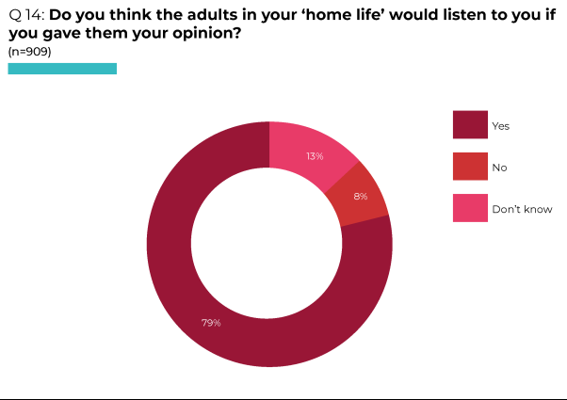
Workshops and meetings
In workshops, most participants considered that they were able to participate in decisions at home. A young person who lived in a residential setting considered that she was listened to and could talk with staff about things affecting her, a disabled young person living with a foster family felt he was listened to and taken seriously, a young person in secure care considered that she was listened to by her foster parent:
“If I was having problems with things I would go to my foster Mum and she would listen to me. She would give me ideas of what to do, like she’d say ‘take a bath’ or she’d take me out.”
One in a group of eight LGBTQ+ young people said that they were able to participate at home as they live in a family that is accepting of them and have a good relationship with their parents.
Survey findings: participation in their home life
Among the 910 who answered survey questions about participation in their home life, the majority agreed or strongly agreed that the adults they lived with: allowed them to give their opinion (83%); made it easy for them to give their opinion (71%); asked for their opinion when deciding things (66%); and talked to them about how decisions are made (63%) (see Table, Q13). Older respondents (16-17 year olds) were less likely than 12-13 year olds to agree that this was the case in relation to each question, and respondents with disabilities were less likely than those without disabilities to agree or strongly agree that they were asked about each of these issues.
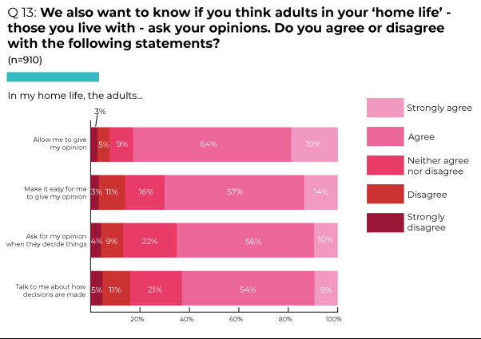
Workshops and meetings
Individuals across the workshops and meetings described being encouraged by parents to be “independent” (Young person in in-patient mental health Unit) and stated that they “trust” their parents (Migrant Polish child, aged 8-12). Comments included:
“My Dad always listens to me.” (Refugee, aged 13-15)
“Mum cares for the whole family.” (Care experienced young person, aged 12-18)
“My parents listen and support me.” (Migrant Polish child, aged 6-15)
Some gave specific examples of being asked their opinion or listened to by their parents/ carers:
“When I wanted my hair dyed, my Mum listened.” (Care experienced young person, aged 12-18)
“Swimming and your hobbies.” “If you’re injured.” “On Christmas.” (Migrant Russian and Lithuanian children, aged 9-15)
“Asking me where I want to go for a trip.” “What food I like.” “Which school I would like to attend.” (Migrant Polish children, aged 6-15)
In a group of Travellers aged 7-10, while four felt that their views were heard and taken into account in their families, with one stating “Parents often listen to what we have to say”, five children did not consider this to be the case.
Times when they may not be listened to were generally when parents were “in the bathroom”, “on the phone” or “busy doing things” – for example ““when my dad’s on the PS4 he tells me to go away” (10 year olds).
Parents’ lack of time was raised by participants in other workshops:
“Mum doesn’t have time.” (Care experienced young person, aged 12-18)
“Parents work too long.” “They have not enough time for me.” (Migrant Polish children, aged 6-15)
Some young people did not feel respected within their home life:
“My parents don’t always listen and treat me like a child.” (Refugee, aged 13-15)
“My family talk down to me.” (Care experienced young person, aged 12-18)
“Parents making decisions for me.” (Migrant Polish child, aged 6-15)
Parental decision-making occurred without consultation in certain aspects of childrens lives, such as choosing which school they would attend and whether they had to attend, or the vaccinations they received (Young people in conflict with the law, aged 19-22).
In a group of young women refugees aged 13-15, some mentioned that their brothers had more independence than them and that, as girls, they were told what to do by their parents more than their brothers. They expressed a desire for greater freedom within their families.

Participation in educational settings
Children and young people spend a significant amount of time every week in educational settings, where opportunities for participation occur during everyday interactions. In addition, School Councils provide a potential forum for involvement in decision-making about institutional policies and practices.
Survey findings: whether children and young people thought the adults in their place of education would listen to them if they gave their opinion
Asked whether they thought the adults in their place of education would listen to them if they gave their opinion, only 41% of 910 survey respondents relied ‘Yes’ (30% responded ‘No’, 29% did not know) (see Pie Chart, Q12). However, there were clear age-related differences - while 50% of 12-13 year old respondents considered that they would be listened to, the figure was 33% among 16-17 year olds. There were also differences in relation to disability, with 43% of those without disabilities replying that they would be listened to compared with just 31% of respondents with disabilities.
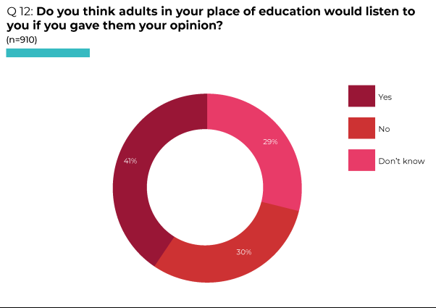
Workshops and meetings
During workshop discussions, younger children were generally positive about being listened to in school, citing examples such as, “when you’re feeling bad”, “seeing the school counsellor” and “teachers noticing when something is wrong” (10 year olds).
Individuals provided examples of being listened to in school:
“I wanted to move classes and got moved” (Care experienced young person, aged 12-18)
“School listened to me and helped me.” (Care experienced young person, aged 12-18).
“We get asked about some things that can get changed and some things that don’t.” (Migrant Polish child, aged 8-12)
“Teachers listening to me when I want to have my class assembly [sitting] separately from others.” (Migrant Polish child, aged 6-15)
“Two of my teachers support and help me.” (Refugee, aged 13-15)
Survey findings: participation in educational settings
Among the 908 who replied to survey questions about participation in educational settings, less than half agreed or strongly agreed that their teachers asked their opinions about: how they were taught (34%), the rules they were expected to follow (42%), what they learnt (43%), how decisions concerning school/ college policies were made (47%) or how to improve their education (48%) (see Table, Q11). The proportion of 16-17 year olds agreeing that they were asked their opinions by teachers was far lower than that for 12-13 year olds in response to each issue, but particularly regarding what they learnt. The proportion of those with disabilities agreeing that they were asked their opinions about each issue was lower than among those without disabilities, particularly in relation to what they learnt and rules
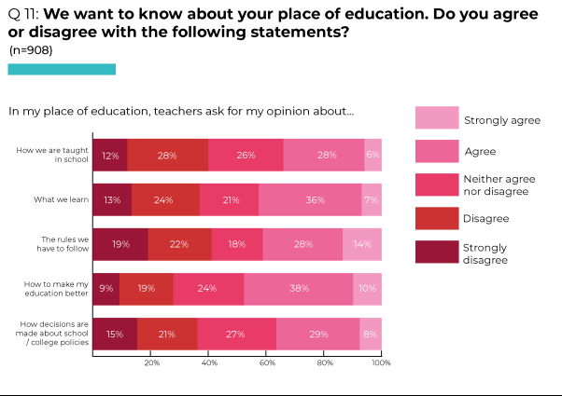
Workshops and meetings
One young person noted that levels of participation in schools depend on individual teachers: “with some you’re able to get a point across” (Young person in in-patient mental health Unit).
Regarding younger children, participants in a workshop of Polish migrant children aged 6-15 provided a number of examples illustrating that children were not listened to in school:
“Teachers do not take younger children seriously.”
“No access to toilet facilities in school for little ones or at designated times.”
“Children are not equally tolerated according to their abilities.”
In a different workshop one child stated:
“Sometimes they [teachers] might not be able to listen to you, not in a mean way but if they are busy doing something else.” (10 year old)
One group provided an example of lack of participation over the timetabling of different lessons:
“If it’s raining in the morning when we have P.E., it is cancelled for the day and we do English or Maths instead - we don’t get to change the timings.” (Migrant Russian and Lithuanian children, aged 9-15)
Some in a group of migrant Polish children aged 6-15 reported that they did not raise issues because their views were not sought, they did not feel confident or comfortable about asking questions or complaining:
“I do not say my opinion because they do not ask and listen.”
“Struggling with school rules and questions.”
“I do not feel safe enough to make a complaint to teacher.”
Although seven of the ten participants in a workshop of 7-10 year old Travellers considered that teachers did listen to their views, one of the three who did not think this was the case commented that teachers do not listen “until it’s a really big problem.”
A migrant Polish child (aged 8-12) stated “…they [teachers] never solve the problem.”
Some considered that teachers do not listen to the victims of bullying, or minimise its impact:
“When fighting in school because they always listen to the person who started it and take their side.” (Migrant Russian and Lithuanian child, aged 9-15)
“Teachers dismissing bully’s actions: no consequences.” (Migrant Polish child, aged 6-15)
Among older young people, participants in a workshop of 15-18 year old LGBTQ+ young people did not think that young people were able to share their views in school.
For some older young people, lack of participation regarding exams was an issue:
“Schools are the main one [place where children are listened to], but school can be very restricting as well sometimes …You don’t have a say about exams – you get the date, but are kept in the dark until a month before.”
Although able to choose GCSEs, one young person considered that staff put some pressure on students: “Last year you didn’t have to do a language, but some of the teachers were very adamant that you had to do a language. I didn’t want to because I don’t plan to travel outside the UK.” He felt that certain teachers were “disapproving” of his choice not to study a language (Young person in in-patient mental health Unit).
In a small group of young people who had been in conflict with the law, participants discussed how they had found it challenging to express their views when they were attending school or college. Some were unable to approach teachers about bullying in school or, if they had approached teachers, did not believe that appropriate measures were taken to reduce the recurrence of bullying. One described how the bullying she had experienced became so severe that it resulted in her having to change schools.
Among care experienced young people aged 12-18, examples of not being heard in school focused on feeling infantilised, ignored or stigmatised:
“You get treated like a child, they [teachers] act like they know better.”
“They promise to help, but they don’t help.”
“They are dismissive of us and the situations.”
“Teachers say we get on like that because we are in care.”
Indicating the impact of not being heard, one stated: “Don’t have an opinion because no-one will listen anyway.”
A young woman in a group of 13-15 year old refugees considered that their culture and religion influenced responses to her:
“People in my school don’t take my opinions seriously – because I’m Muslim and wear a hijab [head covering].”
15-16 year old young people with disabilities gave numerous examples of lack of participation in school. Lack of qualification options was a key issue. A staff member was given permission by one young woman to share her experiences: “[Name] wasn’t even asked when she was in high school ‘Would you like to do GCSEs?’ She was just told ‘You’re doing this instead … not listened to, not asked.” The member of staff affirmed: “There’s a lack of choice for all our [disabled] young people who don’t seem to have their right to be able to choose the same way as anybody else can.” Many young people verbally agreed with this statement. (See section: ‘Discrimination experienced by specific groups’).

One young person stated “They don’t even talk to me about things.” She was not comfortable speaking out and agreed that a staff member could share her story: “[Name] was promised learning support. Because of government funding and government contracts being changed, it should have started last September … it still hasn’t happened [the following April].” The young person stated: “We’re just ready to give up … mummy’s trying to get in touch with Mencap.” When asked what kind of impact this had on her, she replied that she felt she was being dismissed:

“It’s really hard to do the course. The person says ‘You’re not struggling’ but I am struggling. I know I’m struggling. I know, I’m me … I said to my mum the other day and she said ‘Don’t be worrying, you’re out of that place soon’ and I said ‘You’re right, I am, ’cos I can’t do it.”

Another young person considered that he was receiving adequate help and support. He stated: “… while I don’t have a classroom assistant, I have a mentor who checks over my work and makes sure I have it all spelled correctly and helps me understand things.” Although this was different to the support he had received in primary school, he felt it was helpful: “Nowadays I have to figure these things out on my own, which is fine because the course I’m doing is very creative.” However, the software needed to complete the course can only be accessed in college, which means it is difficult to get work completed on time. He preferred the school environment as it helps individuals retain focus: “I can get distracted really easily … I would need a bit of extra time because sometimes I either get distracted ... or I don’t have great time management skills.”

Some young people with disabilities reported that they were not involved in decisions about their options when they reached school leaving age. One stated: “They all went to tech, I was sitting there doing geography. Just sitting there by myself.” When asked what she would have preferred to do, she replied: “Work with children.” Another recounted:

“Nobody talked to me and in my last year I got no choice. All of my friends going to go out but me … You have to go to Daycare, no other choice for you. It has to be Daycare because they can’t take me because there’s no choice for me to go to tech.”

A member of staff stated: “All the colleges and places [Name] could have gone to said no, they couldn’t accommodate her needs because of the chair, because of toileting facilities, because of all those things. The only thing she was offered is Daycare, which goes from 18 to 65 … not with anyone her age or with anybody that’s into the same kind of things.”
Some workshop participants referred to School Councils as formal mechanisms for involvement in decision-making: “they [pupils] can bring up issues they’d like to talk about” (Young person in in-patient mental health Unit). However, among participants in a workshop of migrant Russian and Lithuanian children aged 9-15, there was a mixed response to the perceived benefits of School Councils:
“Barely anything changes.”
“Yes, more water stations and we are allowed to wear earrings now and do things.”
In a meeting, one individual suggested: “School Councils from different schools should all come together for the youth voice” (Young person in the in-patient mental health Unit).

Participation in policy making
Raising concern about children’s views not being systematically heard in policy making on issues that affect them, in 2016 the Committee recommended that the State party: ‘Establish structures for the active and meaningful participation of children and give due weight to their views in designing laws, policies, programmes and services at the local and national levels, including in relation to discrimination, violence, sexual exploitation and abuse, harmful practices, alternative care, sexual and reproductive education, leisure and play. Particular attention should be paid to involving younger children and children in vulnerable situations, such as children with disabilities’ (para 31a, emphasis added).
The Committee also recommended that the government ‘Fully involve children in planning, designing and monitoring the implementation of play policies and activities relevant to play and leisure at the community, local and national levels’ (para 75c, emphasis added).

Survey findings: whether children and young people thought the adults in their community (ie the area they lived in) would listen to them if they gave their opinion
Asked whether they thought the adults in their community (ie the area they lived in) would listen to them if they gave their opinion, 35% of 902 survey respondents answered ‘Yes’, 25% replied ‘No’ and 40% did not know, indicating uncertainty about whether these adults would take them seriously (see Pie Chart, Q16). Age-related differences were clear, with just 20% of 16-17 year olds responding that they considered they would be listened to compared with 44% of 12-13 year olds. The proportion of those with disabilities considering that they would be listened to by adults in their community was 28%, compared with 36% among those without disabilities.
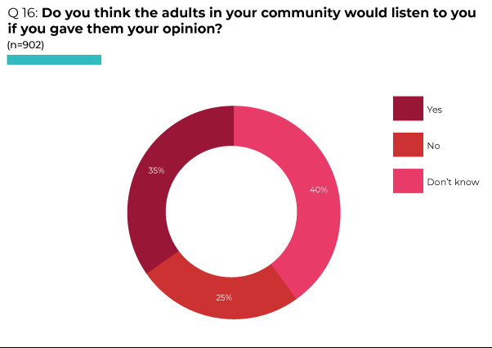

Survey findings: participation in decisions regarding community provision and services
Among the 906 who responded to survey questions about participation in decisions regarding community provision and services, approximately one third agreed or strongly agreed that the adults in their community asked them about: how happy they were with things to do in their area, such as youth clubs, libraries, sports centres (39%); how happy they were with the services in their area, such as transport, health centres and schools (37%); new activities or services they needed (34%); or how to make their community safer (34%). Similar proportions disagreed or strongly disagreed (31-35%) that they were asked about these issues by the adults in their community, with almost one third (28-32%) neither agreeing nor disagreeing (see Table, Q15). Again, older respondents were far less likely to agree that they were asked about any of these issues – the responses of 16-17 year olds in agreement ranged from 18-25% compared with 48-55% of those aged 12-13. Those with disabilities were less likely to agree that they were asked about these issues than those without disabilities, although the difference was not as marked (ranging from 23-31% in agreement among those with disabilities and 34-39% among those without disabilities).
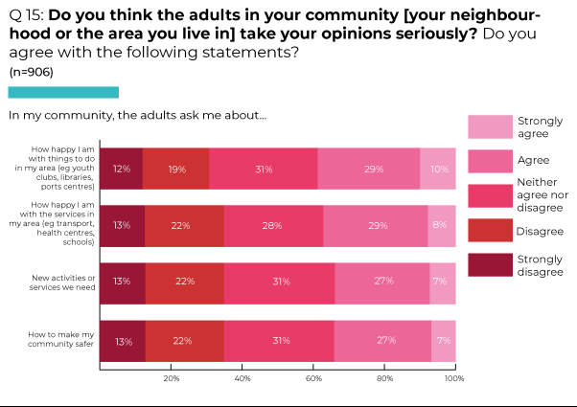
Workshops and meetings
Children and young people are often marginalised in community decision-making, with decisions predominantly taken by adults in local Community or Residents Forums, Neighbourhood Partnerships and formal structures such as councils.
One young person proclaimed: “The youth should have a voice in their community. It’s where they’re growing up” (Young person in in-patient mental health Unit).
However, participants in a range of meetings or workshops indicated that young people’s priorities are usually dependent on the backing and action of adults when decisions are made in their community:
“There was talk about a skate park being built, which a lot of young people wanted, but the only people who can push for it is adults.” (Young person in in-patient mental health Unit)
“If a new building was being built it would be financed by someone and just built.” (Young person in in-patient mental health Unit)
“Originally the new Omniplex cinema was supposed to become part of a bowling alley but this was rejected as residents thought it would be too loud.” [Workshop participants commented that they wished it had become a bowling alley, but were not consulted.] (LGBTQ+ young people, aged 15-18)
Younger children did not feel involved in community-based decision making:
“Outside, adults ignore when we want to play”.
“[Adults in communities listen] only in emergency cases: fire, serious sickness.” (Migrant Polish children, aged 6-15)
Within a group of ten Travellers aged 7-10, six did not consider that they were listened to in their community. Among the four that did, one stated: “Yes, because at the end of the day all we do is protect our own or country.”
In a workshop for migrant Russian and Lithuanian children aged 9-15, participants were unsure who would ask them about changes in their community. One young person talked about a new community garden that was built in his estate, saying that he was asked about it before this project began.
Highlighting the exclusion experienced by care experienced young people, their responses included:
“Don’t feel involved in the community.”
“They don’t help homeless people.”
“VOYPIC [Voice of Young People In Care] are the only ones who listen.”
The responses and attitudes of others impact on opportunities for young people to participate in their communities, and these are not just age related. One young person in a group of LGBTQ+ young people stated: “I come from the farming community, which is generally closed minded”. This limited their participation in their community.
Survey findings: whether children and young people thought politicians would listen to them if they gave their opinion
Asked whether they thought politicians would listen to them if they gave their opinion, only 15% of 900 survey respondents answered ‘Yes’ (51% replied ‘No’, 34% did not know) (see Pie Chart, Q18). At just 9%, the proportion responding ‘Yes’ among 16-17 was far lower than that among 12-13 year olds (19%).
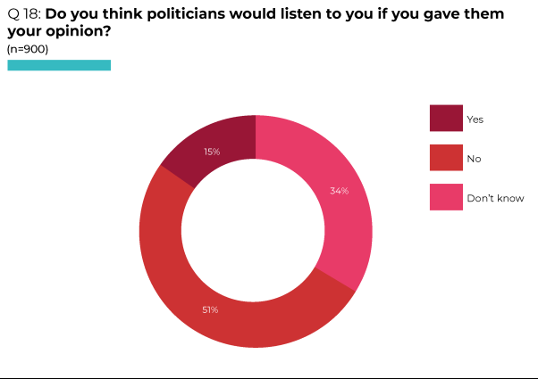
Workshops and meetings
Some young people in workshops or meetings articulated a mistrust of politicians:
“There’s good ones out there. But there are 3 people you wouldn’t trust – politicians, salesmen and, I dunno, mechanics. You wouldn’t fully trust them.” (Young person in in-patient mental health Unit)
“They only care about the money” (Care experienced young person, aged 12-18)
“Politicians are just talk and no action.” (Young person in conflict with the law, aged 19-22)
Others highlighted personal lack of experience or opportunity to talk to politicians:
“I do not know how to be heard.” “We do not have an opportunity to pass our opinions, feelings, and suggestions to them.” “No experience how to express opinion to politicians.” (Migrant Polish children, aged 6-15)
“I’ve got no experience of politicians.” (Young person in secure care)
Survey findings: interaction with politicians
Among the 898 who answered survey questions about their interaction with politicians, less than one quarter agreed or strongly agreed that politicians asked them about: issues that affect them or other young people in their area (17%); plans or changes in their area (21%); or how to get young people involved in decision making (25%) (see Table, Q17). Again, older respondents were less likely to agree that they were asked about any of the issues, with the proportion agreeing that this was the case ranging from 10-17% among 16-17 year olds compared with 23-33% among those aged 12-13. Those with disabilities were less likely to agree that they were asked about issues than those without disabilities, but the proportions were not as markedly different.
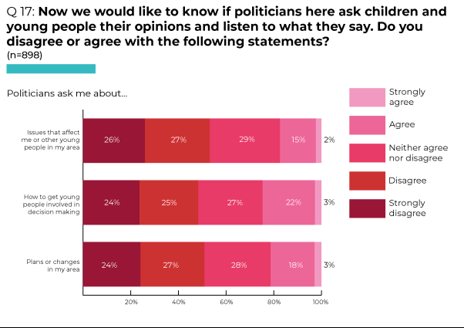
Workshops and meetings
Those involved in meetings or workshops affirmed that politicians rarely consulted with them or sought their opinions:
“They need to, but they don’t.” (Young person in in-patient mental health Unit)
“No, they don’t care.” (LGBTQ+ young person, aged 15-18)
“No, they never come to speak to us.” (Migrant Russian and Lithuanian children, aged 9-15)
“They’re probably very set in their own views. There’s probably more they could do – they never come into schools.” (Young person in in-patient mental health Unit)
“They are making decisions without children’s influence.” “Our feelings of no importance and influence.” (Migrant Polish children, aged 6-15)
Reflecting the importance of politicians taking seriously the issues and concerns prioritised by young people, one young person in an LGBTQ+ group mentioned a particular politician who was “really nice and was interested in trans rights and trans clinics leading up to the election”. During discussion about political Party lines regarding gay marriage and abortion rights, one person in this group commented: “The DUP are dickheads.” [The Democratic Unionist Party is anti-abortion and opposed same sex marriage.]
Participants in a group of12-18 year old care experienced young people stated that politicians “Don’t help or support homeless people” and that there should be “more help for drug users and alcoholics”.
Highlighting the experiences of younger children, a group of 10 year olds knew who politicians were, stating they were “people who make really big decisions” and naming some local politicians (including those their parents had voted for in recent elections). When asked if they understood what kinds of decisions politicians made, they replied “who gets homes” - as they had recently heard on the news that money was being given to homeless people, “who can get jobs” and “who can have parties” - based on recent media stories concerning the former Prime Minister, Boris Johnston, and “lockdown parties”. Asked if they felt politicians listen to children, they said no but they should listen to children about “everything”, including about “rights” and “disabilities”, and that “they should stop thinking they are better than everyone”.
Also aware of what politicians do, the recent election and who their local counsellors/ MLA’s [Members of the Legislative Assembly] were, a group of 9-15 year old migrant children from Russia and Lithuania felt that politicians did not speak to young people or take them seriously.
A few did not consider that they were old enough to be consulted by politicians:
“Too young to be heard” (Migrant Polish child, aged 6-15).
“If they’re young they [politicians] are probably gonna, like, say … questions to them that they [children] don’t know [the answers to].” (Migrant Polish child, aged 8-12)
In a group of 7-10 year old Travellers, one child who disagreed that politicians take into account their views stated: “Not all the time as we vote but our vote never doesn’t always come.” It was unclear whether this related to members of the Travelling community not being registered to vote, or to the outcome of voting not reflecting the choices made by those who had voted.

At the time of the Committee’s last examination of the UK Government, a youth parliament had not been established in Northern Ireland and the Committee recommended ‘the establishment of youth parliaments in all devolved administrations … as permanent forums for children’s effective engagement with national legislative processes on issues that affect them’ (para31c).
After many years of lobbying by NGOs, a Northern Ireland Youth Assembly finally was established in 2021. When told during a meeting that the Youth Assembly had recently been set up, one young man said: “That should be the way of the youths’ voices being heard” (Young person in in-patient mental health Unit, aged 17).
In 2016, the Committee noted increasing demands from children for a right to vote from the age of 16 (and that, in Scotland, the voting age has been extended to 16 and 17 year olds for local and Scottish Parliament elections). It encouraged the State party and devolved administrations to: ‘conduct consultations with children on the voting age. Should the voting age be lowered … ensure that it is supported by active citizenship and human rights education in order to ensure early awareness of children that rights are to be exercised as part of citizenship, with autonomy and responsibility, and that the measure does not lend itself to undue influence’ (para 33).
Among workshop and meeting participants, there was some disagreement about the value of voting in elections.
Some did not think they would vote when they have the opportunity because voting was not relevant to them: “No, I don’t understand anything about that.” (Young person in secure care) or questioned whether their vote would have any impact: “No, it doesn’t make a difference anyway” (LGBTI+ young person, aged 15-18).
Among 9-15 year olds in a group of migrant Russian and Lithuanian children, some stated that they would not vote because they “wouldn’t make good decisions”. However, asked if they would vote if there was a vote only for young people, many responded “yes”, particularly about issues that affect them in school and the community.
Others advocated voting:
“Yes [I’d vote], to stop old people getting their way.” (LGBTQ+ young person, aged 15-18)
“I’d like to vote because I have the capacity to. The voting age should be 16, like the age of consent. At 16 I know enough about problems.” (LGBTI+ young people, aged 15-18)
A few considered that the voting age should be lowered:
“Aye, it should be lowered to 16, maybe 15. There are some people who wouldn’t care and some who do. It’s entirely up to them.” (Young person in in-patient mental health Unit, aged 17)
One care experienced young woman commented that she would like to vote at 16/17 if she knew more about it.
In a group of 8-12 year old migrant Polish children, while some considered 16-17 year olds should be able to vote, one was of the view that the voting age should remain 18 “because they [16-17 year olds] might make stupid decisions which might be bad for the future.”
Discussing whether young people in his community had ever been consulted by politicians, one young man said: “You have to have an interest in it”, commenting “you’re not taught it in school”. He went on to say that he was from Derry: “there’s not a person in Derry who wouldn’t be into politics [although] people my age don’t have any interest in politics – you need to be taught about it” (Young person in in-patient mental health Unit).
Although participants in a group of 16-18 year olds who had been in conflict with the law were not very forthright about what politicians could do to engage with young people and make them more interested in politics, their workers considered that “young people look at old faces on election boards and can’t relate” to these representatives. They mentioned that members of the group had previously talked about a 26-year-old MLA with some enthusiasm.

Participation in decision-making by professionals
The Committee noted in 2016: ‘many children feel that they are not listened to by their social workers, reviewing officers, paid carers, judges, personnel working with children in conflict with the law or other professionals in matters affecting them, including in family proceedings’. It recommended that the State party: ‘Ensure that children are not only heard but also listened to and their views given due weight by all professionals working with children’ (para 31d).
Workshops and meetings
Young people in specific groups which receive significant intervention by professionals (care experienced young people, those detained in secure care, an in-patient mental health Unit and custody) were asked about their involvement in decision-making about matters affecting their lives.
Care experienced young people across different workshops were generally critical of social workers dealing with their cases:
“They don’t listen at all. They think they know everything, you don’t get an opinion. If you speak out, they threaten you with separation or something. It just makes you feel like ‘Why do I bother?’ ‘Why call them at all?’ … [Social workers] don’t communicate well with kids – they’re not given options or encouraged. They just expect you to do it: ‘You’re good on your own’. They expect us to tell them things. Like, we can’t read minds. Then they make you feel stupid.” (Care experienced young person, aged 16-18)
“Social workers have the view: ‘we chose to look after you’.” (Young person in conflict with the law, aged 19-22)
Young people emphasised the importance of ensuring that they are able to give their opinions and suggestions. One young woman recounted how she was unable to express her view at times because of the trauma she had been through, which made her feel uncomfortable about voicing her opinions.
Having their views about any issues or concerns taken into account and given due weight is also vital. They stressed that, if their views are not listened to, their holistic needs are not met fully.
Care experienced young people noted that NGOs such as the Voice Of Young People in Care [VOYPIC] help to protect individuals in care and ensure that their views are considered.
Young people in the secure care were also of the opinion that social workers do not listen to, or act on, their views:
“Sometimes … when social workers asks questions you feel like they’re not listening - nothing ever happens, things never change.”
“They certainly listen to what you have to say. But, it’s really hard for me to talk about it, you have to live it. The conversations are between the adults. I don’t feel like my voice is heard. It’s always down to the adults.”
Told that she could not return to live with their foster parent when she left the Secure Care Centre, one felt that her social worker did not listen to her views about not wanting to go to a children’s home:
“I haven’t been given another chance to go back. The social worker doesn’t listen to me so I just don’t talk to her any more. I tried to talk to her about it in the car and she turned the radio on. She asked if I wanted a different social worker … She’s taking it the way I used to be, 3 months ago – drink and drugs and that. She’s said I can have overnights but I don’t want that. I want to stay there. Being in a children’s home is what made me do that in the first place.”
Asked what could be done differently, she responded: “Give young people a chance and listen to them.”
One young person talked specifically about lack of involvement in decisions underpinning their placement in secure care:
“Being put in here – I think I should be listened to. Sometimes the risks are not that high for me to be put in here. Certain people should be in here – kids that are struggling, if they are at immediate risk of death, if they have mental health problems or are self-harming. I’m in here for criminal reasons – I should be in the JJC [Juvenile Justice Centre]. I’d have more understanding about that.”
Asked whether she had an advocate, she replied:
“In different meetings. I have a key worker but they don’t talk for me. They just talk to other adults about what I’ve been doing in here [Secure Care Centre]. No matter what, I never get a choice about what’s best for me. It’s my life. I know what will make me better or worse. I know how my head works. I keep coming in and out of here – I’ve been in four times.”
This young woman was clear that decision-makers did not understand her situation or the negative impacts of a secure placement:
“They - social workers and judges - should think more about how Lakewood [Secure Care Centre] affects some young people. It does benefit some, but it affects my mental health. The judge doesn’t see your daily struggles. They get a piece of paper saying all the bad things you’ve done. They don’t work in the homes. You don’t go to Court when you’re being sent here.”
In response to a question about whether she had a chance to meet the judge who was making the decision about whether she should receive a Secure Accommodation Order, she questioned her lack of participation in the decision-making process:
“No. You can write a letter, but you don’t see the judge. I didn’t go to the Panel [Regional Multi-Agency Panel for Admission to Secure Care] or to see the judge. That’s one thing I would love, to be at that [Panel] and fight my side. I’ve never had that chance.”
Considering their involvement in decision-making within the Secure Care Centre, each individual was asked whether there is a regular meeting when young people can to talk to staff about any issues or things they want to happen. One young person replied: “If I have any issues, I just go to staff.”
A member of staff who was present in one of the meetings stated that there is a Young People’s Meeting every week in each Unit. Young people gave examples of the topics discussed in these meetings:
“Fans for the gym, more games, the food.”
“We’ve raised a few things and change has happened. Like, we asked ‘Can we get a Play Station for the living room?’ In the X-Box room it used to be just 2 young people at a time - we asked if 3 could go in and that was agreed.”
However, one noted that some requests are denied:
“We’re only allowed to watch ‘12-rated’ movies because we have a 12 year old in the Unit. But there are 15-16 year olds in the Unit. We’ve asked about this but everything is restricted (Netflix, Disney channels, YouTube) because there’s a 12 year old in the Unit. You’d think they could do something with the 12 year old while the older ones watch a 12+ film, but that doesn’t happen.”
Comments about food in the Centre were disparaging: “It’s just stinking!” “It’s shite”, “The food is terrible in here, I mean bogging!” There was no choice over what was provided, although young people did have the opportunity to cook for themselves:
“It’s whatever they make. You can go in and make your own food [but people don’t do that often].”
“It’s the same stuff. In [children’s home] we had our own chefs, good cooks. We can cook ourselves but the supplies are terrible. Staff have to go out and buy things for us.”
The member of staff commented that new menus were about to be published. She said young people have ‘Cook It!’ links [a nutrition programme developed for use in local communities] and sometimes cooking is an evening activity - either planned by staff or requested. At other times young people decide to make something. The Advocacy Worker noted that one House does a lot of baking and makes pancakes.
Two young women separately raised the issue of rules concerning clothing for young women:
“If you’re showing flesh or a bit of a boob, that’s not allowed. Like, a crop top. If you didn’t pull it down you’d be sent to your room. You’re told it’s not appropriate.”
“Kids are very sexualised in here. You’re not allowed to wear belly tops. It’s a free world. Shouldn’t we be able to wear what we want? … Clothes are your choice. If you don’t feel comfortable in them, don’t wear them. You should have a choice about what clothes to wear.”
The Advocacy Worker explained: “They understand the arguments put forward for these rules, but sometimes girls feel this is a girl’s issue - keeping girls safe is for everyone, so what is the reason this [clothing] is not appropriate?” The young woman involved in this meeting responded: “We should be able to wear what we want.” The member of staff stated: “There’s various ages [of children] in the Centre. Having younger ones in led to a change. Staff have rules about what they can wear too.” The young woman retorted:
“[Advocacy Worker], your skirt would be too short, [Researcher]’s top would be too low! You’re told, ‘You’re not coming out of your room until you’ve changed’. I have a nice pink top and they’re saying it’s underwear so it’s being kept in ‘property’ in the office until I leave!”
Two young people who had not attended mainstream education for some time discussed educational provision within Lakewood. One valued the intensive support provided by Centre staff alongside flexibility over timing of school sessions:
“Centre staff support me going to school every day. I can go after lunch. I speak to the teachers, express how I’m feeling to them. Staff in here are good listeners.”
The other commented: “I go to school here. I like it [especially Maths].” Asked whether the school in the Centre linked up with her school in the community, she replied:
“Yeah, I’ll be starting at [Alternative Education Project] … when I leave here. They sent Maths and literacy assignments to Lakewood school for me to do.”
In terms of phone calls and visits, two young people commented on access to the phone and staff’s efforts to enable calls to be made:
“You can use the phone whenever it’s free. Staff try to get that for you.”
“You have phone calls before 9pm, as many as you want, as many as you need. And you have visits after school and at weekends [unless it’s professionals coming to see you – they can come during the day].”
Asked about ‘trusts’, and whether they had a say in the activities they did, one young person affirmed: “Yeah. I can choose what I want to do.” The staff member noted that young people don’t have ‘trusts’ for the first 4 weeks that they are in the Centre, to which the young person responded: “That 4 weeks felt like fucking forever. It should only be 2 weeks.” The member of staff explained “It moved from 2 to 4 weeks so that young people have a chance to build relationships with staff and get used to Lakewood.” Another young person stated:
“Yes, I go on community outings, trusts. I’m in for absconding [from children’s home]. Why would I run away from here and get an extra Order?”
Describing evening and weekend activities, one young person said:
“We have pamper nights, games in the sports hall or home [Unit], yoga … there’s loads of fucking things you can do in here.”
She then commented: “I think we should have a TV in the living room with Netflix on it. The TV got moved into the visitors’ room.”
One young person described the difficulties involved in sharing accommodation with people you don’t choose to live with, in a situation where there are limited options about places to go as movement is severely restricted:
“I don’t like the other young people in my home [Unit]. I’m missing my pals. [Young person] bangs her head and keeps everyone up at night, [young person] doesn’t stop talking, he’s annoying and pokes you … There’s not a lot of places you can go – the X-Box room, your own room, the living room, the visitors’ room.”
Another commented: “I’m so much better independently than I am with others. When I’m 17, my idea is to get my own house.”
During meetings with young people in Northern Ireland’s in-patient child and adolescent mental health Unit, two individuals mentioned the limited food options:
“I’ll say 3 words: soup and sandwiches! … I don’t like the food in here. It’s either ham or bread sandwich”.
“Dinner time [4.30-5.30pm] is always soup and sandwiches … Lunch is usually 2 dishes – chicken curry or veg curry – but there are days when there’s just one thing, like a wrap with chicken and salad.”
In terms of rules, participants understood the need for some limitations:
“I’d like to go outside more but I understand some don’t want to do that. You can’t pick and choose – they’ll open the door for an hour. I understand why – in case someone runs away – so I wouldn’t complain about that. Staff do try their best. Sometimes there would be people on obs [close observation, with restricted movement].”
One individual noted that they were in the Unit voluntarily, but this was not the case for everyone.
Asked whether children and young people are supported to express their views in matters affecting them, one young person replied: “In most cases, yes.” Giving examples of when this does not happen, their response stressed the limited participation experienced by detained young people, especially in meetings:
“… Once you’re detained in here, no-one listens to what you say. They say, ‘Yes, we’re listening’ but nothing changes. They don’t really care. It’s meant to be patient-centred care, but it’s not. Your opinion doesn’t matter … The past month has been very difficult for myself. No matter how many times I ask for changes to my care plan, it is shut down with no reasons given. Because they [young people in the Unit] are detained, they no longer have a say in anything.”
Describing the personal frustration of not being listened to, they explained:
“We have to follow a care plan and do what the Consultant says. That’s understandable in some circumstances. But when you say you don’t feel listened to, you’re told ‘You are heard, but we are just not doing what you want’. I’m not listened to in care planning - maybe by my parents and [Advocacy Worker]. It’s a two-sided meeting – me, my parents and [Advocacy Worker] against them. My past experiences are used against me. That means I’m in floods of tears. Everything either stays the same or gets worse.”
In relation to use of restraint for nasogastric tube feeding, one young person commented:
“If a person needs to be restrained … I know that needs to happen, but they [staff] don’t have to hurt them. If the person is really upset, they are going to react. In restraint young people aren’t listened to. It may need to happen, but it’s not a nice thing.”
They claimed that young people are “made to feel worthless.” If they get upset while being restrained “they are told by staff ‘It’s so early in the morning, you’re selfish disturbing other people.’” Asked if staff explain what will happen as a result of certain actions: ‘If you do/ don’t do this, we’ll have to do this…’, the young person said:
“Young people kind of know what to expect, but in that moment they’re really distressed and don’t really care. Things aren’t very well explained, not the process.”
Asked whether there were regular opportunities for young people to talk about any issues they had in the Unit, one young person said there were “detention forums”. However, they stated:
“another patient has been told that the Consultants can do whatever they want. You’re told you have no mental capacity, so can’t make decisions.”
Noting that “There are meant to be house meetings, but there hasn’t been one in maybe a month”, they did not consider that issues raised by young people in house meetings were addressed:
“They write things down and then they disappear. Nothing has changed. A lot is to do with how certain people [staff] act or treat patients. They’re set in their ways – how they treat them. For example, in restraint they [young people] need support. It’s not handled the way it could be.”
Meetings with young people in custody in Woodlands Juvenile Justice Centre [JJC] revealed their awareness of regulations concerning the presence of an ‘appropriate adult’ when being interviewed by the police. One young man stated: “If you’re in police care, you’re supposed to have an adult in when you’re being interviewed.” Asked if this had been the case for him, he said it was. Another young man noted: “You’re meant to have an appropriate adult in the court room too”. He said that sometimes this meant an interview being put back when no-one was available: “You have to go up and down and then up again. Every time I have an interview I have to wait on them.” Asked whether the appropriate adult was helpful, he said they “Just ask if you’re OK and that”, and stated there had been times when there had not been an appropriate adult present during interviews and meetings. Asked whether his solicitor explained what was going to happen in court, and whether he was able to tell the solicitor what he wanted her to say, the young man replied that this did happen.
Discussing whether they were asked their opinions and felt listened to while in the Juvenile Justice Centre, one young person said there was “no choice” over what food they ate at meal times. Although alternative options were available for those who didn’t eat meat or certain other foods, there was a set menu. Another young person commented: “We should get to pick what we have for dinner, but there’s no option at all.” A third wryly noted: “There was a change when the Inspectors were here – we had a double chicken burger and raspberries!”
Noting restrictions, one young person said: “You can choose tuck,” however, if items were in the freezer these could not be accessed after 9.30pm. He also stated: “You should be able to have your own juice in your room at night – you can have 2 cups. Once they’re done, you can’t have any more.”
Asked about whether they had a regular meeting to discuss any issues or requests, one young person replied:
“There’s a Youth Forum, which is meant to be every week. They do listen to you and do try to do what we ask for.”
Giving an example, another said: “I asked for KP nuts in the Tuck Shop and they got those.”
A teacher present during the meeting explained that education was statutory for anyone of school age [ie, up to age 16] in custody. Woodlands school hours were 9.15am – 3.30pm, Monday to Friday. They studied literacy, numeracy, ICT and personal development. Vocational classes included mechanics, catering, beauty, barbering, and horticulture. One young person complained that there was “no choice” over lessons, commenting “Some lessons are stupid as fuck … Music is not a lesson I need to know.” Asked whether they thought the education classes were appropriate, a different young person replied: “You should be able to pick your own timetable, without it being an award.” They considered that “All the classes in here are enough. We’re trying to get less!”
Young people questioned the expectation of attendance at school in the JJC for those above school leaving age:
“People over 16 shouldn’t have to go to school [while in custody].”
“On the outside, you don’t have to go to school once you’re over 16.”
One young person stated:
“If you don’t go to school, you’re locked in your room with no TV and the electric is turned off … One time the water was turned off too because I was blamed for breaking the toilets, which I didn’t do.”
Explaining the ‘progressive regime’, a teacher stated that this was “more about sanctioning bad behaviour than rewarding good behaviour”. Everyone started on Silver when they entered the Centre and automatically progressed up through the levels unless given an ‘adverse’. Commenting on the different regime levels, one young person said: “If you’re on Silver, you can go to the swimming pool, if you’re on Gold you can have a DVD player and more money”. Moving up the regime also included an extra half hour at bedtime. Another young person noted: “When you’re on Platinum+ [the highest level], there’s no difference whatsoever. You get a different bedtime and can get jobs, but that’s it.” This was particularly frustrating for young people in custody for a long period of time.
Two ‘adverses’ could lead to a reduction in regime level for a week. There was a weekly review of each young person’s regime. One young person explained that ‘adverses’ were given for “language [ie, swearing]”, commenting: “It’s stupid – that’s how you talk outside, it’s habit”. A teacher interjected that an adverse would usually be given in response to the way such language was being used, or if it was being directed to staff. The young person continued: “You can be moved down a level for being late to class, or not going to class.” Asked if they were told why they were being given an adverse, and understood the reasons, their response was: “They do tell you, but it’s still for stupid reasons.”
Discussing sanctions, one young person explained: “If you’re involved in restraint, you get your TV dropped.” Another mentioned being involved in an incident which led to them being “locked for 2 weeks”. One commented: “There’s no warning sometimes. They don’t explain what will happen.”
Asked about their leisure time during evenings and weekends, two participants replied that they could go to the gym, swimming pool, football pitch “but you have to be on a certain level [in the progressive regime]”. One stated that the PT room [gym] had been closed for 6 months. A teacher said this was the result of some misbehaviour in there when equipment was broken. In a different meeting another young person commented on one of the gyms being closed, saying: “It’s now April, but they haven’t looked at it.”
One young person stated: “There should be more activities. I don’t want to play football.” Another said: “They won’t buy a pool table”. While one commented “I just float about the Unit”, the other said that they “go to sleep” in the evenings. In response to a teacher suggesting that they can go to ‘wellbeing’ or to the swimming pool with a key worker, one replied: “I wanted to do that but the key worker was too busy doing assessments”. The teacher affirmed “Of course it’s dependent on staffing”.
Underlining the relevance of staff motivation and availability, one young person commented:
“Some of the staff can’t be bothered to get off their hole [backside] to go to the courtyard … Not all staff let you go for a walk, [although] there is nowhere to walk because out the back is a mess, so you can’t go there.” [They explained that the area is being developed to enable young people to camp out as part of the Duke of Edinburgh’s Award but if young people from the other Units are out in the main courtyard, their Unit has to use the back yard.]
Discussing access to phone calls, one young person stated: “It depends on the progressive regime – if you’re on Gold you can have 2, if you’re on Platinum you can have 3. Because of COVID we were allowed more.”
One young person complained about a lack of privacy:
“One member of staff was hanging over the door to get me off the phone. Other ones don’t do that … There’s no privacy in the Units – staff are up your hole to listen to everything you’re saying to each other.”
They also commented on reduced visits, noting that they used to have visits from more family and friends but now only see their mother and siblings. When a teacher commented that this was because of COVID restrictions, the young person replied: “but restrictions have been lifted now and nothing has changed.”
Talking about property not being properly looked after when they were moved from one House to another, one young person said:
“My phone was left in House 1 office when I was moved. That could have been claimed by anyone. It happens with your phone, your clothes. Staff should know where they’ve put them. It must cost a lot to replace them all the time. It would save money if they just knew where they’d put them.”
Rules concerning clothing were noted. Remarking that “You can only wear certain clothes”, one young person explained: “the rules are you can only have 3 sets of clothes.” A teacher expressed surprise about this, commenting that young people seemed to be wearing different clothes whenever he saw them. A different young person affirmed: “No, it’s just 3 sets. I’m still wearing my confirmation jeans!”
Inconsistent application of rules was raised as an issue:
“I asked for Oasis drinks in the Tuck Shop and was told that wasn’t allowed because it’s in a bottle. But we have bottles of shampoo, shower gel – my room’s full of them!”
Another young person said: “Our rules [in a different House] are stricter. You’re not allowed more than one toilet roll.” The young people joked about this being a potential problem if you suffered the after effects of eating the curry or hot tacos served up in the Centre!
A teacher explained that, if sentenced and nearing the end of their sentence, young people have ‘mobility leave’ – visits to the community in preparation for leaving custody. However, this does not apply to those on remand, who are not able to leave the Centre.
Discussing restrictions linked to mobility leave, one young person questioned how this was preparing them for leaving custody when it was conducted in the town close to the Centre rather than their home town:
“I’m on mobility leave to prepare me for going out. I can go out in [local town, with a worker] but they won’t let me go out in [home town] because I have a [x-year] restraining order so I can’t go there. How is that preparing me for leaving here? I don’t know anyone in [local town]. They don’t know me and I don’t care what they think of me if they do. But they stop me going out on mobility leave in [home town]. If I bump into [the victim of their crime], I have to know how to react. Being in here isn’t helping me to do that, and going out in [local town] isn’t helping … I should be being prepared to go round my own area, where I live.”

NON-DISCRIMINATION
Differential treatment of children and young people
Workshops and meetings
Examples of children and young people being treated differently included:
“[Children] not allowed to play video games which are for older audience” and “Age restrictions to use YouTube” (Migrant Polish children, aged 6-15)
“Different responsibilities.” (Migrant Russian and Lithuanian children, aged 9-15)
“Why did I not get a Spend Local card from the government? I am 17 and I worked during the pandemic, but you had to be 18 to get the card. That’s unfair and it makes me really cross.” (Care experienced young person, aged 12-18)

Some workshop participants suggested that children being treated differently is sometimes for their benefit:
“… good because, like, a 5-year-old can’t go to prison.” (LGBTI+ young person, aged 15-18)
“It’s good that young people can’t smoke legally and are discouraged from taking drugs.” (LGBTI+ young person, aged 15-18)
“Getting a children’s menu” [although this was challenged by a couple of individuals who felt they could eat the same as adults!] (10 year old)
“[Sometimes children need to be treated differently] because adults already know what we have been through … [they] experience more hurt in their lives than us.” (10 year old)
A group of 10 year olds considering negative ways in which children are treated differently focused on what they perceived to be the privileges of teenagers and adults: “they get to play in different football leagues,” “stay up later”, “get to drive”, “boss us around”.
The group of 6-15 year old migrant Polish children also discussed differential treatment between age groups: “Older children feel more powerful and often bully youngers.”
Assumptions about children’s incompetence or lack of understanding were raised by some workshop participants:
“Sometimes people think because we are underage we don’t usually understand different situations.” (Traveller, aged 7-10)
“When there’s a problem between parents and other adults and you ask what is wrong they say ‘you’re too young to understand’.”
“Adults trust other adults more than children. They should trust children more, like, they are their children.”
(Migrant Russian and Lithuanian children, aged 9-15)
Workshop participants were clear about the range of negative ways in which young people are treated differently.
They noted contradictory responses of adults in which young people are perceived as either immature or overly mature:
“You’re expected to act like a grown-up but get treated like a child [around age 14-16] … like in school, if you come in on a bad day you get told ‘You come to my class and you need to treat me this way’ whereas if an adult came in in a bad mood it would just be ‘Oh they’re having a bad day’. They forget that we’re not just robots to teach, we’re real people.” (LGBTI+ young person, aged 15-18)
“You’re either too mature or immature.” (Care experienced young person, aged 12-18)

“They expect us to act mature when we are just children.” (Care experienced young person, aged 12-18)

“They [adults] say things like ‘Oh, I didn’t expect you to know that’ or ‘I didn’t think you were so mature’ - it seems like a compliment, but it’s not.” (Care experienced young person, aged 12-18)

A young person who was the youngest apprentice in their workplace resented being treated as if they are less competent: “They assume I know nothing and tell me to go and get someone with a bit of sense” (LGBTI+ young person, aged 15-18).
One workshop participant who was a single mother to a baby recounted experiencing judgement when attending groups such as ‘Mothers and Toddlers’, as she was younger than most of the other mothers. This made her angry: “I’m just as good a mother as the others and my child is healthy and well cared for”. This young woman also felt that she had swayed from her parents’ plans for her life - by having a child at a young age, without being settled in married life or having completed her education, people deemed her to have "ruined her future". In contrast, she perceived it a "great achievement" that she has started a family of her own as a young woman (Young person in conflict with the law, aged 19-22).
Regarding social media platforms, such as Facebook, workshop participants discussed how they experience stigma or judgement about what they post online. A young mother recounted how individuals had personally approached her asking why she was posting information about, and photographs of, her child. Others discussed how, when posting information regarding their mental health online, there was a response of "wise up, don’t post that". They considered that this undermines their right to freedom of speech, increases stigma regarding mental health and prevents awareness being shared (Young people in conflict with the law, aged 19-22).
Survey findings: how adults in their communities respond to children and young people
Of the 853 who responded to a range of survey questions about how adults in their communities respond to children and young people, the majority agreed or strongly agreed that: adults in their area were pleased to see children playing out (65%); they and their friends got on well with the adults in their area (65%); adults in their area were respectful to young people (59%). The proportion of those on free school meals agreeing with these statements was lower than for those not on free school meals. The proportion of 16-17 year olds in agreement with the statements was much lower than for those aged 12-13, particularly in relation to adults respecting young people. Those with disabilities were also less likely to agree with these statements than those without disabilities, especially regarding adults being pleased to see children playing out and adults being respectful to young people.
Just over one third (37%) of all survey respondents agreed or strongly agreed that children and young people are often told to move on when hanging out with their friends at the shops or in parks in their area (32% disagreed/ strongly disagreed and the same proportion neither agreed nor disagreed suggesting variability in regulation of children’s presence in public spaces). Those aged 16-17 were more likely than 12-13 year olds to agree that children and young people are told to move on (47% compared with 29% respectively) (see Table, Q19).
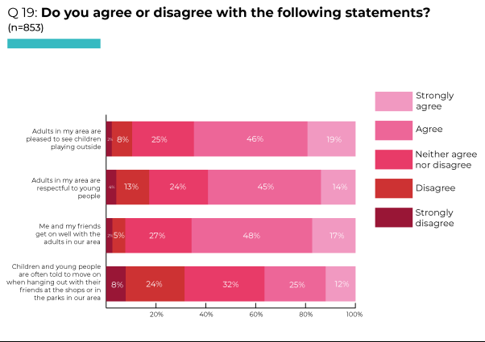
Workshops and meetings
One young person in a workshop of young people in conflict with the law (aged 19-22) suggested that not having enough activities to attend may lead to some young people becoming involved in anti-social behaviour. Another spoke of herself and her friends being asked to move from local public places, such as parks, as others assumed they would cause trouble. She explained:
"There are activities for young children to do in local communities, like play parks, but not enough areas for young people."
In workshops, lack of respect for young people was an issue, particularly among older participants:
“Older people have no respect for us.” (LGBTQ+ young person, aged 15-18)
“Adults often say things like ‘16? Wait till you’re my age, then you’ll know what problems are’.” (LGBTI+ young people, aged 15-18)
“[When an old person] falls on the street everyone is keen to help them back onto their feet but when a young person falls there is not the same support” (Young person in conflict with the law, aged 19-22).
Most participants in a group of 19-22 year olds who had been in conflict with the law emphasised that teenagers and young adults experience discrimination and prejudice because young people are viewed as being troublesome or "dangerous". One young woman had experienced items being thrown at her and her friends, and rude remarks from older generations, as well as being refused entry to specific areas.
In 2016, the Committee repeated previous concerns about negative attitudes towards children and young people, recommending that the State party ‘take urgent measures to address the “intolerance of childhood” and general negative public attitude towards children, especially adolescents, within society including the media’ (para 23).
Survey findings: responses to young people
Of the 853 who responded to survey questions about responses to young people, the majority agreed or strongly agreed that there were safe places for them and their friends to hang out in their area (63%). The proportion of 16-17 year olds agreeing with this statement was much lower than for those aged 12-13. Those with disabilities were also less likely to agree with this statement than those without disabilities.
While 38% of all respondents agreed or strongly agreed that young people in their area trusted the police, 31% disagreed/ strongly disagreed and 32% neither agreed nor disagreed, again suggesting variability in relations with the police within different communities. Only 23% of those on free school meals agreed or strongly agreed that young people trusted the police in their areas compared with 41% of those not on free school meals, and only 22% of 16-17 year olds agreed/ strongly agreed with this statement compared with 51% of 12-13 year olds.
The majority (66%) of survey respondents agreed or strongly agreed that children and young people are negatively stereotyped in the media. Only 12% disagreed or strongly disagreed that this was the case. The proportion in agreement was much higher among 16-17 year olds (78% compared with 56% among 12-13 year olds) and among those with disabilities (72% compared with 66% of those without disabilities) (see Table, Q20).
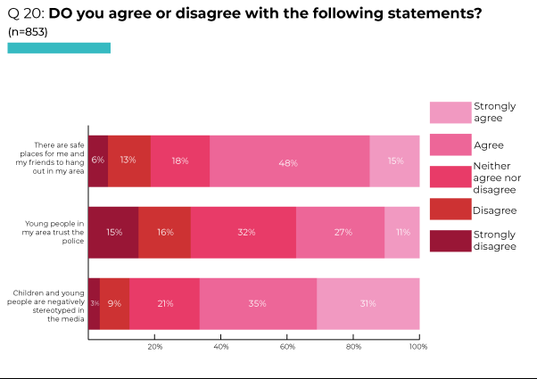
Workshops and meetings
Negative attitudes towards, and assumptions about, young people was raised as an issue, across workshops:
“Young people get categorised into stereotypes, they don’t get listened to - you’re just rowdy or want to fight.”
“Adults look at young people and expect them to be trouble.”

“People look at you in shops, really suspiciously.”
(Care experienced young people, aged 12-18)
“Young people in uniforms are asked to leave their school bags outside shop doors (issues with safety as anyone could lift your bag) but adults are not – young people are assumed to be stealing.” (LGBTQ+ young person, aged 15-18)
Negative reactions can occur in response to the way some young people dress, or when they are "just having a laugh with friends". One young woman emphasised how such reactions made her angry and upset as she was not doing anything unlawful or causing any trouble (Young person in conflict with the law, aged 19-22).
Older young people considered that the police anticipate trouble from young people:

“PSNI expects us to be bad - always look at us suspiciously.” (Care experienced young person, aged 12-18)
In one workshop discussing negative experiences of the police in their local communities, a young woman recounted how she had been experiencing a mental health crisis and the police were contacted. During this encounter, the police lacked understanding about her situation and handled her roughly, leaving her with bruises. Another young person considered that the police often provoke young people to behave negatively, or make the situation worse (Young people in conflict with the law, aged 19-22).
Discussing community safety, a group of 8-12 year old migrant Polish children stated that they would speak to the police if they did not feel safe in their community, and would feel confident doing this. However, the examples they provided revealed differing experiences and perspectives. One boy recounted: “About 2 years ago there was people with alcohol who came to our car and took bottles and smashed the side of it. The car’s good now, but it still has the big bang on the door.” He said that he had felt “scared … and after that the police came.” In this instance, the police were helpful. A girl described how “our neighbour is very rude to my mum” following an incident with a cat and “one time he tried crashing his car into her.” Understandably, this made her feel unsafe. She commented that the police “don’t really do that much, they just contact you once in a while about situations.” Asked whether the police could do anything to make them feel safer, one participant said: “if they go around they look scary when they put the lights on. I know they aren’t scary because one time they came up to our estate and gave colouring books to all the little kids.”
One workshop involving young people in conflict with the law (aged 19-22) noted that the media often negatively portrays young people (e.g. in relation to anti-social behaviour), believing that this heightens and encourages the discrimination experienced by young people. They also mentioned that there are few articles showing the positive contributions young people are making to their local communities (e.g. through voluntary work).
One 13-15 year old refugee young woman was aware of discriminatory coverage in the media: “Some media is sexist against girls.”

Discrimination experienced by specific groups
Recognising the discrimination and social stigmatisation experienced by certain groups (including Roma, gypsy, Travellers and children of ethnic minorities; children with disabilities; children in care; migrant, asylum seeking and refugee children; LGBTQ+ children), in 2016 the Committee recommended that the State party: ‘Strengthen … awareness-raising and other preventive activities against discrimination and stigmatisation and, if necessary, take temporary special measures for the benefit of children in vulnerable situations’ (para 22c).
Workshops and meetings
Asked whether they thought particular groups experienced discrimination or were treated differently, workshop participants were aware of the prejudice and discrimination experienced by people on the basis of disability, race and culture, religion, gender and sexuality, or ‘being different’.
A group of 10 year olds mentioned: “disabled people”, “handicapped people” [a conversation ensued about these being the same], “bullies” - people don’t want to play with bullies because they are mean, “tall people”, “small people”, “fat people”, “different races”, “people who wear different clothes” - other people might not like their choice of clothes and treat them as if they are weird, “LGBT” and “gay people.”
An LGBTQ+ group of 15-18 year olds listed: “females and people that are non-binary”, “Trans people”, “LGBTQ+”, “neuro-divergent people”, “people with learning difficulties”, “anyone not ‘normal’”, “people with bad mental health”, “people of different races and cultures”. They considered that these groups were most likely to experience discrimination “in school” and at “The Grange [a local public park]”.
A group of 12-18 year old care experienced young people were aware of the prejudice and discrimination experienced by those who are “care experienced”; “People with a disability or special needs”; “People who are ‘different’ – have a different ethnicity or religion, etc.”; “LGBTQ+ young people, especially trans”.

In a group of 9-15 year old migrant children from Russia and Lithuania, those they considered are treated unfairly included: “disabled people” and “teenagers”, with differential treatment experienced by some on the basis of: “Gender”, “Religion”, “Your beliefs”, “If you’re born in another country”, “Making fun of your name”. One young boy in this group talked about another boy in his class who was not allowed to play a game in school by a group of other children because of his skin colour. Another young person recounted a time where he and friends were called names and had sticks thrown at them by a group of teenagers who were trying to make them leave the park (although this appeared to be more related to age than to ethnicity).

Workshop participants also recounted examples of discrimination experienced by specific groups, including personal experiences.
Asked whether there are any particular groups who experience prejudice or discrimination, the following interchange between two young people illustrated the kinds of stereotyping experienced by some minority ethnic communities:
YP1:“Travellers, Gypsies … I don’t think they’d be interested [in rights]. Most are angry and just want to fight. I’ve got a friend who comes from the Philippines – he gets it tight sometimes. It isn’t racist, it’s not that they hate him, they’re slagging him.”
YP2: “Stereotyping?”
YP1: “Yeah, they say things like ‘Are you working in the rice fields?’ and that. Gingers [red-haired people] get it tight too.”
YP2: “It’s how you grow up.”
One young person noted the racist assumptions made by some members of staff about their BAME colleagues within the in-patient child and adolescent health Unit:
“A few staff members make comments about ‘coloured’ staff, saying ‘Those kinds of people don’t know what they’re doing’ – making comments based on race. It’s very few staff members, most are fine. But it shouldn’t happen.”
The group of ten 7-10 year old Travellers all agreed that particular groups experience prejudice and discrimination in the community on the basis of “language barrier, age, Travellers.” Three considered this to also be the case in school and in the media.
Discussing how certain groups are discriminated against in their communities, a group of 12-18 year old care experienced young people noted that “race makes you a target”. In addition, they considered that children and young people are treated differently on the basis of their perceived ‘political’, ‘religious’ or ‘national’ identity:
“If people know your family or your history.”
“Religion.”
“Being English, or even just talking with an English accent.”
In a group of 8-12 year old migrant Polish children, one mentioned being treated differently due to speaking their native language and stated that this happens a lot. Others in the group agreed that they too have experienced this. Asked where these incidents happened, one replied: “in my estate”, another “in school”.
Participants in a group of 6-15 year old migrants from Poland commented on negative reactions to migrants:
“Migrants treated not fairly.”
“If your family came from a different country we could hear ‘Go back to your country!’”
“Some people ignore and do not like migrants.”
Four of the five in a group of 13-15 year old refugee young women considered that they experienced prejudice and discrimination in school as a result of their religion and what they wear:
“SO much! Every day as Muslim girls. We get stared at.”
They also considered that their gender led to differential treatment in their community:
“Being female – you are treated worse than boys and we don’t have as much freedom.”
Asked whether any particular groups of children and young people are treated differently or discriminated against, one young person in custody mentioned care experienced young people: “[those in] care homes.” He found this frustrating, especially as it led to restrictions being placed on ‘looked after’ young people which are not imposed on friends who are not in care:
“When I was 15, my conditions included not being allowed to be by myself. I wasn’t allowed to leave the home without a member of staff. If I went out, they were following me … I was 15 and wasn’t allowed to be by myself because I’m a criminal with a tag.”
Care experienced young people discussed “the stigma of being in care or being a care leaver”:
“a lot of care kids get discriminated … being called names, like not being with your family and all.” (Young person in conflict with the law, aged 16-18)
“People in the care system, they’re not listened to as much. Some have bad representation … Young people are dealing with so many emotions, but they’re getting judged from the start [for being in care].” (Care experienced young person, aged 16-18)
One young person in the in-patient child and adolescent mental health Unit noted that ‘eating disorders’ includes “a group of illnesses”, and was clear that an individual or group should not be defined by their illness. However, they stated:
“Some people with eating disorders are literally referred to as ‘eating disorders’. Staff say ‘Do her first and then do the eating disorders’ or ‘Let eating disorders do yoga first’.”
Although they did not consider that young people in the Unit experience unfair treatment on the basis of their age, one young person observed that responses differ according to staff status:
“… the majority of staff get along with the patients. The higher up bands are more likely to treat you like you’re a child or a patient. But other staff, like Band 6’s, just sit and chat [with young people] in the Hub – as if they’re a friend, a normal person.”
One young man in custody considered that young people in conflict with the law are treated differently; their reputation follows them and affects interactions with the police: “If any of my family are stopped, the police ask ‘Where’s [name]? Is he still in the JJC?”
Considering examples of not being discriminated against or marginalised, a group of 19-22 year old young people in conflict with the law agreed on the importance of inclusive organisations where they were able to express their views and opinions without judgement or stereotyping, regardless of their background or upbringing. This made them feel comfortable. The examples they provided were: Include Youth, Belfast Central Mission, the Family Resource Centre and The Link Family and Community Centre.
Examples of the verbal and physical abuse experienced by LGBTQ+ young people were provided by 15-18 year olds who attended an LGBTQ+ group. These included having water thrown at them by other young people and being verbally assaulted in the town bus depot “because we look different”, “we look like typical queer people … there’s a gayness about us.” They said they would never walk alone in the town for fear of being targeted by others of a similar age from local boys’ grammar and secondary schools.
In various workshops, young people were aware of the prejudice and discrimination experienced by those who are trans. A young person in a workshop for disabled young people commented:
“My friend came out as trans and yesterday I mentioned it to someone in my class [who] actually told me no longer to speak to him because of it. And then he just said something that was incredibly rude and it was ‘You only have one gender and it’s the one you’re born with’, which I found completely ignorant.”
Children and young people with disabilities are marginalised in mainstream education:
“I couldn’t make friends or socialise with anyone at school because I had a classroom assistant.” (Care experienced young person, aged 12-18)

“For the last couple of years … I’ve not able to be with anybody in school and I find that very difficult … and I don’t stay to the time I want to – it’s just 9.30-12 … It’s not a bad place, like, just it’s not giving me ... what I want … I’m by myself all the time, alone.” (Disabled young person)

Asked if he felt he was able to speak to anyone about this, this young man responded: “Yeah, my Mum and stuff. But not really anyone in school ’cos I’ve tried that.” A staff member in the group continued: “Even when he’s getting dropped off in the morning, it’s not the same entrance as other pupils.” During the conversation it was revealed that this young person does not have access to his teacher in the same way other children do - he is taught by his classroom assistant, separate from the class, and his curriculum is much more limited (without subjects including history, science, and geography).

One young person who was unable to attend the workshop involving children and young people with disabilities prepared a statement in advance. This revealed the impacts of lack of wheelchair accessibility on his social life, leisure opportunities and school activities:

“… I am 16 years old and I am a full time wheelchair user. I find when I am out, not everywhere is accessible for me. I understand why, but it does not stop me getting frustrated that I can’t just go everywhere I want to. We ring ahead a lot to check if I can get in places and, if we are eating out, Mum needs to explain about my wheelchair. Some places have just put me at the bottom of the table with hardly any room and no chair for me to transfer across to. I have found in school sometimes I don’t get to go on trips as it is so expensive to pay for a wheelchair accessible bus. It usually ends up I stay at home and this has happened a few times. Sometimes I feel my Mum has to fight for everything for me. She even had to ring and write letters to get me the appropriate classroom assistant hours I need. Toilets are another issue I come across when I am out, especially in some parks. Now I am transferring from High School and we are looking at schools, but thankfully wherever I choose to go will be made accessible for me. I think, being 2022, places should be, and most are, [accessible] and I understand why not everywhere can be. I just want to go out and thank goodness most people are understanding of this. Other than these few things, I find I can manage as places that are not accessible usually try to accommodate me in some other way. Thank you.”

Describing the disablist comments of others, one young person said:

“People laugh. I tell everybody, ‘Listen, god made you, don’t listen to no-one’. I can’t move my hands to eat, move my mouth to eat my dinner, but a woman came over to my friend and told her ‘Oh, eating like a dog’… I was like, ok … don’t let anybody get you down.”

A staff member recounted that when she was working with a group of children the previous day, most of whom were in wheelchairs, a lot of them were saying “if they can get out, they can’t go out without being verbally abused by people in the street.”

SURVIVAL AND DEVELOPMENT
The right to ‘life, survival and development’ is connected to many other rights in the UNCRC, particularly in relation to play and leisure, health and welfare, as well as provisions and protections for specific groups (children with disabilities; children in care, including secure accommodation; children in custody; refugees and asylum seekers).

Help and support required for development and to gradually become more independent

Workshops and meetings

Considering what children and young people need to be healthy, the focus among workshop participants was on basic necessities, including:
Healthy food:
“Get healthier food at school.” (Migrant Polish children, aged 6-15)
“Children need to be fed.” (Travellers, aged 7-10)
“Food, protein, drink, water, healthy food, fruit, vegetables.” (Refugees, aged 13-15)
“Healthy food (cheaper food is more available, which isn’t always healthy).” (Care experienced young people, aged 12-18)
Health care:
“Proper and faster health care.” (Migrant Polish children, aged 6-15)
“Health care (NHS)” and “Good mental health.” (Care experienced young people, aged 12-18)
“Stay up to date on vaccines.” (Travellers, aged 7-10)
Sleep:
“Good sleep.”
(Migrant Polish children, aged 6-15; Travellers, aged 7-10; Care experienced young people, aged 12-18)
Play, leisure and recreational activities:
“Access to good sport and leisure activities when parents are working and not available to take children in”; “Sport activities”; “Better, facilitated playgrounds.” (Migrant Polish children, aged 6-15)
“Exercise daily” and “Reduce screen time.” (Travellers, aged 7-10)
“Sport, exercise.” (Refugees, aged 13-15)
Somewhere to live:
“House, home.” (Refugees, aged 13-15)
“A house.” (Care experienced young people, aged 12-18)
A group of migrant Polish children, aged 6-15, identified some very specific issues:
“Healthy and suitable environment everywhere: outside, at school, and at home.”
“No noise from neighbours late evening.”
“Longer breaks in school.”
“Allow to wear suitable winter boots at school.”
The group of refugees aged 13-15 added: “Clothes, shoes”; “Money” “Friends, family.”
In addition to basic necessities, care experienced young people aged 12-18, emphasised: “Education, learning and training”; “Information (internet)”; “Role models” and “A support network.”

Asked what children and young people need to develop to their fullest potential, workshop participants emphasised:

Education:

“Provide right education for children.” (Migrant Polish children, aged 6-15)
“Going to school.” (Travellers, aged 7-10)
“Good education.” (Refugees, aged 13-15)
“Education.” (Care experienced young people, aged 12-18)
A safe family life and care:
“Safe living and learning environment.” (Migrant Polish children, aged 6-15)
“Having a safe home”; “Loving parents and family.” (Travellers, aged 7-10)
“Caring people and role-models.” (Care experienced young people, aged 12-18)
Opportunities for play and leisure:
“Playing.” (Travellers, aged 7-10)
“Opportunities for social activities” and “Play.” (Care experienced young people, aged 12-18)
“Support” (Refugees, aged 13-15; Care experienced young people, aged 12-18)
In addition, migrant Polish children aged 6-15 highlighted specific requirements:
“To get more practical and life-giving activities in school.”
“Work experience.”
“Accept migrants’ home language as second language in Colleges.”
“Get an opportunity to learn and develop their home language and celebrate their own traditions and culture.”
“Involvement into wider community life.”
A group of Travellers aged 7-10 identified the need to “Encourage independence.”
For care experienced young people aged 12-18, also important were:
“Sense of self / identity / family history.”
“Safety and security.”
“Stability.”
“Jobs.”
“Money.”
“Information.”
In response to a question about what children and young people need in preparation for living independently, responses from a group of Polish migrants generally were practical:
“Children need to know all the opportunities.”
“Better access to computers.”
“Getting known with neighbourhood and organisations in my town that might help me.”
“More life experience education activities.”
“Provide more information about opportunities to be involved in life experience activities.”
“Learn to manage money and get work experience.”
“Improve home skills: cooking, cleaning, serving food.”
(Migrant Polish children, aged 6-15)
A group of 13-15 year old refugees listed: “Budgeting”; “Driving lessons”; “College”; “Help from government until I get a job.”
For younger children, factors supporting wellbeing and development included support at home, in school and in the community:
“Support from parents and other adults around us.”
“Not enough money for living expenses.”
“Safe environment. Get time to relax.”
“Fruit and vegetables trolley in school would be very good.”
“Get additional support for some difficult subjects at school (like English for migrant children).”
“To take into account children’s skills and talents - get an opportunity to develop these.”
“Activities in after school clubs.”
“People’s positive attitude towards children.”
“For some of us library is too far.”
(Migrant Polish children, aged 6-15)

The group of 7-10 year old Travellers emphasised opportunities for play and leisure: “Playing outside”; “Being creative”; “Join in”; “Stop rushing!”
Care experienced young people aged 12-18 focused on personal, social and environmental factors: “Resilience”; “Stability”; “Security”; “Having good people around you”.
19-22 year old young people in conflict with the law considered that social media platforms such as Facebook and Instagram can have a very negative impact on individuals’ mental health and wellbeing.
A group of 6-15 year old migrant Polish children provided clear examples of negative factors affecting wellbeing and development in families, at school, and in communities:

“Too much adult control over us and lack of own choices.”
“Parents working too long hours and no time to spend holidays or weekends together.”
“Neglect and bad living conditions.”
“School hours are too long, feeling tired.”
“Too much homework. Too many responsibilities at school.”
“Bullying at school and on the street.”
“Noise at school and from neighbours at night.”
“Drugs, alcohol, bad influences.”
“Not sleeping enough, being unhealthy.”
“Bad weather.”
7-10 year old Travellers identified specific harms: “Child maltreatment”, “Abuse”, “Neglect”, “Family stress” and “Poor nutrition.”
Refugees focused on the responses of others: “Bullying – making fun of people” and “When other people don’t respect each other.”
For care experienced young people aged 12-18, negative impacts on wellbeing and development were linked to lack of personal or economic support: “Not enough support for young people with confidence/ self-esteem issues”, “Limited resources” and external influences such as “Social media”; “Advertisements, marketing – body image” and electronic/ video games: “X-Box, gaming”.
Survey findings: whether children and young people thought they had the help and support they needed for their development and to gradually become more independent
Asked whether they thought they had the help and support they needed for their development and to gradually become more independent, 65% of 801 survey respondents replied ‘Yes’ (16% replied ‘No’, 19% did not know) (see Pie Chart, Q21). The proportion of those with disabilities agreeing that this was the case (56%) was lower than among those without disabilities (70%).
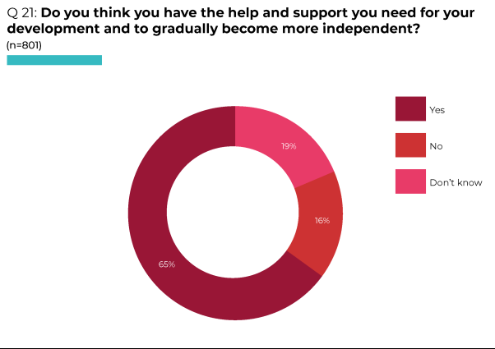
Workshops and meetings
Workshop participants recognised the impact of economic inequalities. When asked whether children and young people have the help and support they need, one in a group of 10-year-olds responded: “It depends if you’re poor or rich”. A participant in a workshop of 9-15 year old migrant Russian and Lithuanian children also commented that “not all” young people have the support they need “like poorer families”. As noted, in a workshop involving migrant Polish 6-15 year olds, “Not enough money for living expenses” was one of the factors identified as negatively affecting children and young people’s wellbeing and development.
Providing examples of the help children might need to become more independent, the group of 10 year olds focused on “not getting your parents to do everything for you” and “sharing”. Asked where they might learn these things, their responses included: “schools”, “churches”, “at home - parents teach you what’s right and wrong and can teach you life skills”. Another example was “people who have stutters might need help to communicate”.
A few young people did not consider that young people have necessary help and support:
“We don’t have any support so we just learn the hard way.” “We aren’t taught how to actually live.” (LGBTI+ young people, aged 15-18)

Care and protection needed to feel well, cared for and safe

Workshops and meetings

Asked what children and young people need to feel safe and protected, migrants in one workshop provided practical suggestions about personal safety:
“Have phone in pocket and know emergency contacts.”
“Look around on street and wear safety clothes.”
“To know where and who to ask for help in case you need it.”
“To be familiar with home electricity or gas appliances. Not use them without adults’ supervision.”
“Continuous learning about protection from drugs and alcohol.”
They also advocating for “More police around which take care of security” and “Good, behaved adults around” (Migrant Polish children, aged 6-15).
12-18 year old care experienced young people focused on the issues young people need to be protected from, and the people who can provide protection:
“To be protected from abuse.”
“Protected from drugs and alcohol.”
“Protected online.”
“To have a safe place (home).”
“To have a responsible adult.”
“Police.”
“Better social workers.”
For the group of 13-15 year old refugee young women, safety and protection was linked to key social agencies: “Family protects you”; “Parents”; “Health care”; “Good school”; “Police.”
Survey findings: whether children and young people were given the care and protection they needed to feel well, cared for and safe
In response to a survey question about whether they were given the care and protection they needed to feel well, cared for and safe, 85% of 800 respondents replied ‘Yes’ (7% responded ‘No’, 8% did not know) (see Pie Chart, Q22). The proportion was lower among those with disabilities (76%) than among those who did not have a disability (88%).
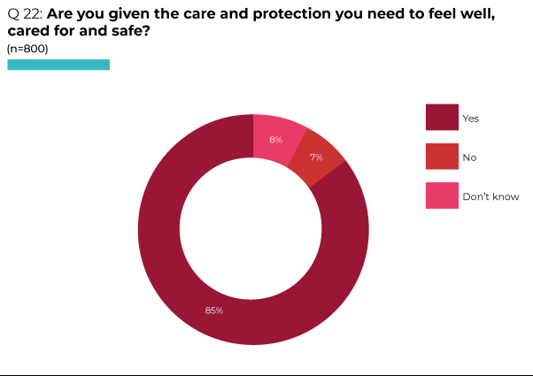
Workshops and meetings
In a consultation meeting, one young person noted:
“It depends on their parents … Parents can put parental locks on phones to shield their children [from harm] as long as possible … some parents are very extreme and put locks on phones, doors, etcetera … I didn’t have a mobile phone until I was 12. I was allowed to have my own computer and i-pads, but my parents were very good at encouraging me to go outside” (Young person in in-patient mental health Unit).
Considering who or what gave children support to feel well, healthy, safe and cared for, the responses of a group of 10-year-olds included: “Here, YMCA”, “Therapists”, “I talk to my friends”. Some mentioned specific actions: “breathing” - a method therapists taught regarding mindfulness and breathing exercises, “drawing on my palm” - a method suggested by a parent to help when a child was feeling anxious, “[talking to] stuffed animals because they can’t judge you” and “talking to a wall because it can’t see you or judge you.”
In a workshop involving 9-15 year old migrant Russians and Lithuanians, several members of the group stated that they felt safe and well because of support from their “friends or best friends”.

Available services and support
In 2016, the Committee recommended that the State party and devolved administrations: ‘Strengthen … efforts to guarantee the right of the child to rest and leisure and to engage in play and recreational activities appropriate to the age of the child’ (para 75a) and ‘Provide children, including those with disabilities and children in marginalised and disadvantaged situations, with safe, accessible, inclusive and smoking-free spaces for play and socialisation’ (para 75b).
Survey findings: available facilities and services in their area
Survey respondents were asked a range of questions about available facilities and services in their area. Half (51%) of 801 respondents agreed or strongly agreed that they could easily access things to do and places to go in their area, with almost one third (31%) disagreeing or strongly disagreeing that this was the case. Those aged 16-17 were far less likely to agree with this statement than 12-13 year olds (34% compared with 66% respectively) and the proportion was 40% among those with disabilities compared with 52% of those without disabilities.
Three quarters (75%) of all respondents agreed or strongly agreed that they could afford to go to places like the cinema or leisure centre (13% disagreed or strongly disagreed). Not surprisingly, those on free school meals were less likely to agree or strongly agree that this was the case (57% compared with 80% of those not on free school meals). Older respondents aged 16-17 were also less likely to agree with this statement than 12-13 year olds (65% compared with 83% respectively) as were those with disabilities (65% compared with 78% of those without disabilities) (see Table, Q23).
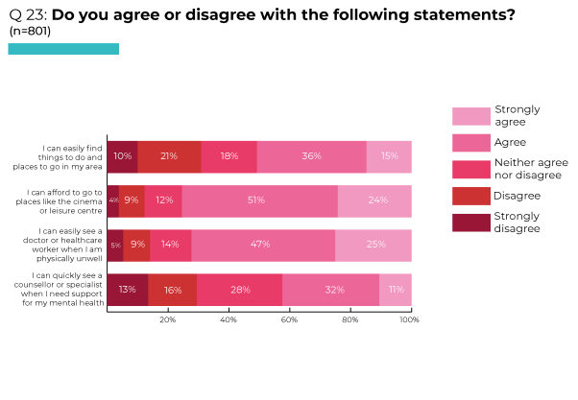Workshops and meetings
During a consultation meeting, one young person stated that access to play and leisure provision is often dependent on parents: “There’s loads of different football, basketball teams etcetera in Derry, but it’s up to their Ma’s and Da’s to put them up for it.” (Young person in in-patient mental health Unit)
As evidenced elsewhere in this Report, children and young people are rarely consulted about play and leisure activities at local levels.
Access to social and recreational activities is restricted for children and young people with disabilities, particularly as a result of not being able to access appropriate transport.
In addition to need for “sports activities”, “better playgrounds”, opportunities for “play” and “social activities” to support their health and development, some groups identified necessary youth and community provision:
“Community centre/ facilities” (Travellers, aged 7-10)
“More information about activities for children.”
“Free access to youth clubs in the area.”
“Various activities in the clubs: art, dance, theatre, sports, cooking, etc.”
(Migrant Polish children, aged 6-15)
One participant in this group of migrant Polish children commented:
“Saturday Language Club is the best because I can speak my language, doing arts and crafts activities.”
Asked if they were involved in any community groups outside school, the majority of 8-12 year olds in a different group of migrant Polish children responded “No”. Some mentioned sports-related groups, such as soccer, Gaelic, gymnastics, hurling and swimming. They commented that they would like to do more activities if these were available, and did not have a preference whether these were mixed or only for those who speak Polish:
“More stuff to do … we have the traditional pitches for Gaelic, football, basketball but there’s nothing for anything else and, if there is, it’s not in a 10 mile radius”.
The Committee recommended in 2016 that ‘the governments of the devolved administrations … develop comprehensive and multi-sectoral strategies on child health … with a strong focus on eliminating inequalities in health outcome and in access to health services’ and ‘addressing underlying social determinants of health’ (para 59b and c).
Survey findings: access to healthcare
Among 801 survey respondents, 72% agreed or strongly agreed that they could easily access a doctor or health worker when physically unwell (14% disagreed or strongly disagreed, 14% did not know). The proportion agreeing that this was the case was lower among those on free school meals (63%) than for those not on free school meals (75%); among those with disabilities (57%) in comparison with those without disabilities (75%); and among 16-17 year olds (54%) compared with 12-13 year olds (86%).
Of concern, less than half of all survey respondents (43%) agreed or strongly agreed that they could quickly see a counsellor or specialist when they needed support for their mental health (29% disagreed or strongly disagreed, 28% did not know). The proportion agreeing was lower among those on free school meals (36% compared with 44% of those not on free school meals); those with disabilities (28% compared with 46% among those without disabilities); and older respondents (27% among 16-17 year olds compared with 54% among 12-13 year olds) (see Table, Q23).
Workshops and meetings
In consultation workshops or meetings, participants noted that a doctor is generally “easy to see but can be hard if all appointments are booked” (Migrant Russian and Lithuanian children, aged 9-15) or that “it’s hard to get an appointment” (Migrant Polish child, aged 8-12). One individual described how receptionists were like “bouncers” when they were attempting to access their doctor. This was uncomfortable, particularly when they wanted to discuss a personal matter with their doctor (Young person in conflict with the law, aged 19-22).
Young people were aware that children sometimes have to wait a considerable amount of time to be assessed or access specialist services:
“People with problems have to wait a long time on waiting lists. It takes a very long time to get the help they need.” [The example given was this young person’s brother, who had been waiting since primary school and was now in 3rd year at secondary school but still had not been assessed]. (Young person in custody)
“Some services are difficult to access due to long waiting times. Mental health or abuse-related services, such as Women’s Aid, also have long waiting times.” (Young people in conflict with the law, aged 19-22)
“Faster access to doctors and medicine.” (Migrant Polish child, aged 6-15)
Young people emphasised the importance of non-judgemental and confidential responses from health professionals:
“Medical people should be non-judgemental and understanding. They told me I was overweight.”
“Young people should be able to access the GP or nurse in private. It should all be confidential.”
(Care experienced young people, aged 12-18)
In addition to suggestions about health-related support in school, necessary health support identified by workshop participants included:
“Regular health check-ups.” (Migrant Polish child, aged 6-15)
“Vaccines being up to date” (Travellers, aged 7-10)
In 2016 the Committee recommended that the State party: ‘Rigorously invest in child and adolescent mental health services and develop strategies at … devolved levels, with clear time frames, targets, measurable indicators, effective monitoring mechanisms and sufficient human, technical and financial resources. Such a strategy should include measures to ensure availability, accessibility, acceptability, quality and stability of such services, with particular attention to children at greater risk, including children living in poverty, children in care and children in contact with the criminal justice system’ (para 61b). The Committee also recommended that the government ‘Support and develop therapeutic community-based services for children with mental health conditions’ (para 61c).
Workshop participants considered that they were judged negatively when they tried to access mental health support. Building up the courage to seek help can be challenging for fear of judgement from older generations, despite the stigma associated with people receiving mental health treatment easing in recent years and individuals now being encouraged to access treatment (Young people in conflict with the law, aged 19-22).
One young person mentioned that she felt “others believe young people are the cause of their own problems”, not recognising the external factors that may have contributed to an individual’s mental health issues (e.g. they may have experienced external trauma, or their background may have contributed towards their poor mental health) (Young person in conflict with the law, aged 19-22).
Long waiting times to receive mental health treatment was a significant issue. Some workshop participants discussed how they had been waiting years to receive the treatment they needed. Their mental health deteriorated during this waiting time and there was not enough effective support when they were experiencing a mental health crisis. One young woman discussed how she had been on the waiting list to receive Dialectical Behavioural Therapy (DBT) for over 2 years and felt her mental health had been negatively affected by this long waiting time (Young person in conflict with the law, aged 19-22).
CAMHS [Child and Adolescent Mental Health Service] was criticised by participants in a number of workshops. Participants in a group of 16-18 year old young people in conflict with the law stated:
“CAMHS is shite, they put no time into helping you.”
“They never put time into appointments or to talk to you. I was told ‘You have 5 hours left’ [with a focus on the amount of time this person had to receive support from the service rather than speaking to her during the time she was there]: “You may as well talk to a wall. I just gave up on them in the end.”
They were disdainful about “being asked to ‘rate your mood from 1-10’ and using emojis to say how you’re feeling”.
Highlighting the practical difficulties involved in accessing CAMHS, young people in the in-patient child and adolescent mental health Unit referred to re-scheduling of appointments:
“CAMHS, they listen. But some young people find them awful … They cancel appointments and reschedule all the time. If they [a young person] really want to get something off their chest that day, they feel dismissed.”
“They do reschedule. You can have an appointment on Monday and then they change it to Wednesday.”
A care experienced young person (aged 16-18) was clear that: “people who are mentally suffering are not taken seriously”. Specifically referring to the CAIT [Crisis Assessment and Intervention Team] she commented that, unless a young person is showing physical signs that they need help, they are not taken seriously. This results in them ‘showing signs’ (i.e. self-harming). Suggesting that “staff only work with people who are willing”, she questioned what happens with those who are not willing. She was also critical of consistent focus on single events:
“Young people do one thing bad and they are stereotyped so hard. People can change, especially when they are young, but they make it [the bad thing] their entire personality.”
Under-resourcing was an issue in terms of both ‘early intervention’ and intensive ‘specialist’ provision. Some young people discussed lack of funding for organisations working directly with young people in an inclusive way, and considered that more could be done to protect young people's mental health and wellbeing in the community if greater levels of funding were available (Young people in conflict with the law, aged 19-22).
A young person in the in-patient mental health Unit highlighted lack of funding for in-patient CAMHS:
“There needs to be more funding for in-patient CAMHS – this is the only one in Northern Ireland. People say ‘You’re going to the best place’, but it’s the only place, not necessarily the best! There are loads of CAMHS teams, but they can’t get staffing in those either.”
In a workshop involving young people with disabilities, participants agreed that it was not easy for young people with disabilities to receive sufficient mental health support. One young person stated:
“They have given me the help but it’s not a lot actually - I only get 5 sessions with counsellors every term. Since I only have 2 terms a year, it’s not enough … I would prefer to have more sessions, or maybe just longer sessions … I feel as if we only scratch the surface of everything as I suffer from a lot of mental health issues.”
Survey findings: whether children and young people are given adequate information in school about specific topics
Asked about whether they thought children and young people are given adequate information in school about specific topics, among the 801 survey respondents replying to this question over half replied ‘Yes’ in relation to career options (60%); drugs, alcohol and substance use (59%); life skills (58%) and 50% replied ‘Yes’ regarding mental health. Less than half of respondents replied ‘Yes’ in relation to information about organisations offering confidential help and support about issues faced by children and young people (42%) and family support (39%). Just 17% answered ‘Yes’ regarding gambling (see Table, Q26). The proportion of 16-17 year olds considering that they received adequate information was far lower than the proportion of 12-13 year olds in relation to these topics, especially regarding mental health, life skills, and career options. The proportion of disabled respondents who thought they received adequate information was lower than among those without disabilities for every topic, particularly in relation to mental health, life skills, career options and family support.
Only 35% of survey respondents replied ‘Yes’ when asked whether they thought children and young people are given adequate information in school about Relationship and Sex Education [RSE]. Among 16-17 year olds, 69% replied ‘No’ to this question compared with 30% of 12-13 year olds; among those with disabilities 57% replied ‘No’ in comparison with 47% of those without disabilities (see Table, Q26).
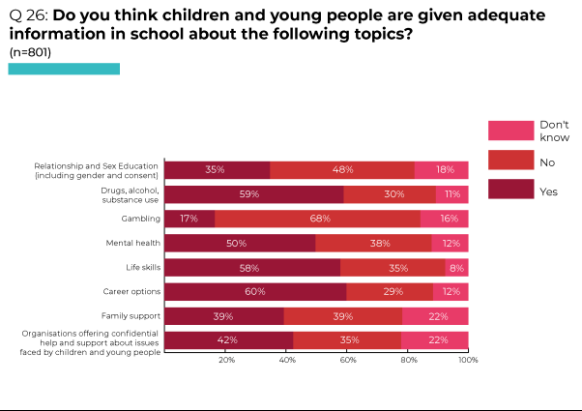
In 2016 the Committee noted that Relationships and Sexuality education is not mandatory in all schools, the content and quality of this subject varies depending on the school, and LGBTQ+ children do not have access to accurate information about their sexualities. It recommended development and adoption of ‘a comprehensive sexual and reproductive health policy for adolescents, with particular attention to reducing inequalities and with participation of adolescents’ (para 65a). It also recommended that the State party ‘Ensure that meaningful sexual and reproductive health education is part of the mandatory school curriculum for all schools, including … special schools and youth detention centres, in all areas of the State party’. This education should provide ‘age-appropriate information on: confidential sexual and reproductive health-care services; contraceptives; the prevention of sexual abuse or exploitation, including sexual bullying; the support available in cases of such abuse and exploitation; and sexuality, including that of lesbian, gay, bisexual, transgender and intersex children’ (para 65b).

Workshops and meetings

Lack of RSE for young people with disabilities was raised as a significant issue by a member of staff in the workshop with disabled young people: “The assumption is, if you have a disability you’re not going to want to have sex or a relationship.” This assumption was clearly disputed by one young woman:

“I want to go out dating. You know me, I want to get a boyfriend … I want to meet a boy, fall in love and live happily ever after … I said ‘Mummy listen, I am going on a date online/ app because I can’t get out to meet boys … you need to let me grow up, be my own woman’.”

Reflecting on the help and support needed by children and young people in schools to develop to their fullest potential, responses in workshops focused on teachers’ attitudes:
“Teachers who actually listen.”
“Teachers should be more approachable and helpful.”
“More fairness – not getting blamed for everything.”
(Care experienced young people, aged 12-18)
“[Children need] to be heard.” (Traveller, aged 7-10)
Teaching approaches were discussed and participants in one workshop suggested:
“More art and craft classes, not working with a book only. Should be more education games, and different actions.”
“Good teachers so that pupils want to go to school, that give fun lessons.”
“1:1 teacher support.”
“Less tests and more practical work in school.”
“Take into account children’s skills and talents - get an opportunity to develop these.”
(Migrant Polish children, aged 6-15)
Suggested health-related provision in schools included:
“More support for young people with a disability or special needs.”
“Good school counselling, and more sessions.”
“Have a medical room in school, and more health advice at school.”
(Care experienced young people, aged 12-18)
“Get healthier food at school”
“Fruit and vegetables trolley in school would be very good.”
“Nutritious healthy food, not school meals! More often explain and encourage, especially younger children, to take more fresh fruit and vegetables.”
“Access more fresh air at school.”
“Get to go outside and play.”
“More PE activities at school.”
(Migrant Polish children, aged 6-15)
“A school nurse could come in every couple of weeks to check up on everyone.” (Migrant Polish child, aged 8-12)
Complaints included:
“School hours are too long, feeling tired.”
“Too much homework. Too many responsibilities at school.”
“Bullying at school and on the street.”
(Migrant Polish children, aged 6-15)
“In school you pay too much for food.” (Migrant Russian and Lithuanian children, aged 9-15)
“Not enough breaks” makes it more difficult for young people to concentrate on the work they needed to complete. (Young people in conflict with the law, aged 19-22)
Practical suggested changes included:
“Longer breaks in school.”
“Allow to wear suitable winter boots at school.”
“Additional education programmes, sport and after school clubs.”
(Migrant Polish children, aged 6-15)
“More school trips so we can see more things.” (Migrant Russian and Lithuanian children, aged 9-15)
Participants in a number of workshops suggested need for ‘life skills’ education:
“Get more practical and life-giving activities in school.”
“More life experience education activities.”
“Extracurricular activities to develop life skills.”
“Improve home skills: cooking, cleaning, serving food.”
“Learn to manage money and get work experience.”
(Migrant Polish children, aged 6-15)
A group of 19-22 year old young people in conflict with the law criticised the lack of skills classes teaching individuals how to live independently and manage different aspects of their lives. This can be especially challenging for young people who grow up in care as they may not have sufficient support from social workers or foster carers to prepare them to live independently. The skills they considered would be beneficial for young people to be taught in school included: “managing finances; managing a household; developing resilience, self-esteem and relationships”. One young person described how, when she left the care system, she was unable to live independently and relied on support from organisations such as the Belfast Central Mission to effectively develop these skills. Living independently can also be challenging for individuals with a disability or mental health illness. Although there are organisations outside education which support young people to live independently, the group considered that more action is required in schools.
Two groups also argued for work experience while at school:
“Get work experiencece.” (Migrant Polish children, aged 6-15)
“More opportunities for work experience” because “schools … mostly prepare for exams, not for the future.” (Migrant Russian and Lithuanian children, aged 9-15)
As noted earlier, in some workshops participants specified additional educational support required by particular groups.
For migrants, this centred on extra support to learn English as well as opportunities to learn their home language and celebrate their culture:
“Get additional support for some difficult subjects at school (like English for migrant children).”
“Accept migrants’ home language as second language in colleges.”
“Get an opportunity to learn and develop their home language and celebrate their own traditions and culture.”
“Respect to children and culture differences.”
“International events to get an opportunity to present home country and native culture.”
(Migrant Polish children, aged 6-15)
A group of 13-15 year old refugees identified need for “Support, like Conway Education [Homework Club]”.
A group of 19-22 year old young people in conflict with the law considered that there is insufficient support in mainstream school settings for individuals who experience behavioural issues or mental health conditions which can affect their learning. Support available outside school settings for children or young people with disabilities is often through NGOs (such as Action for Children). Some individuals struggled with large groups in school environments. They considered that teachers were unaware of their preferred learning methods because of the large groups, and they found it difficult to learn the content being taught.
Two young people in secure care, both aged 15, stated that they had not attended school:
“I’ve not been in school for ages, 4-5 months. I only went in and left after 10 minutes.”
“I’ve never been in school, only on and off. I stopped in my first year [of High School], went back in the second year – went for 3 weeks but haven’t been back since I left.”
One described the range of issues that had contributed to her previous non-attendance:
“I want to go to school, but my anxiety is really bad and getting up in the mornings is hard. I’ve never had a routine for 3 years, so it’s hard to get up and I don’t sleep at night, especially in the children’s home. I can’t sleep until everyone’s home. Kids are out ’til 5am so I’m up ’til 5am and then I sleep all day.”
Survey findings: accessing help and support
Of the 800 who responded to a range of survey questions about accessing help and support, the majority agreed or strongly agreed that: if they wanted to talk to someone about a problem or worry, they knew where to go for help and support (63%). However, just under half (47%) agreed or strongly agreed that they would feel confident to ask for help or support if they needed it. This suggests that, although they knew what was available, they would not feel confident accessing existing sources of help and support. The proportion of 16-17 year olds agreeing with each of these statements was 17-20% lower than the proportion for 12-13 year olds who agreed or strongly agreed.
The majority (66%) of survey respondents agreed that they would know who to contact if they did not feel safe or properly cared for. However, this proportion was lower (56%) among those aged 16-17 than among those aged 12-13 (76%), and among those with disabilities (50%) compared with those without a disability (70%) (see Table, Q24).
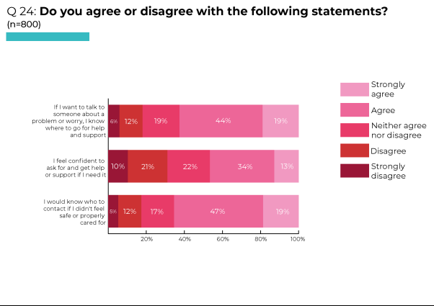
Workshops and meetings
During a consultation meeting, when asked what support children and young people need and who should provide this, one young person responded:
“Maybe just guidance - a step in the right direction - but I don’t know who from. From home, you definitely get guidance. From school, you’re not looked after – the teacher is just sitting there on the computer. People carry on [misbehave] to get attention. They’re messing about because they’re looking for guidance from the teacher.” (Young person in in-patient mental health Unit)
Survey findings: who children and young people would talk to if they had a worry, wanted help or support
In response to a survey question about who they would talk to if they had a worry, wanted help or support, the majority of the 800 respondents selected ‘parents’ (77%), with many selecting ‘friends’ (65%). ‘Relatives’ were also an important source of support for almost half (46%). Younger respondents (12-13 year olds) were more likely to talk to parents and relatives than those aged 16-17, while the older age group was more likely to talk to friends.
One quarter (26%) of all survey respondents replied that they would talk to a ‘teacher’ – a relatively low number given that every child and young person has daily contact with teachers.
Highlighting the significance of free helplines, 13% selected this option. This was a higher proportion than those selecting professionals whose roles would generally be considered an important source of help and support for children and young people - only 11% replied that they would talk to a ‘school counsellor’; 8% to a ‘doctor’; 6% to a ‘youth worker’; 5% to a ‘religious leader’, 3% to a ‘social worker’ (see Table, Q25).
Respondents were not asked why they selected particular options – it may be because they don’t have contact with certain professionals (e.g. youth workers, religious leaders) or because individuals are generally referred to them (e.g. school counsellors, doctors, social workers). This requires further exploration.
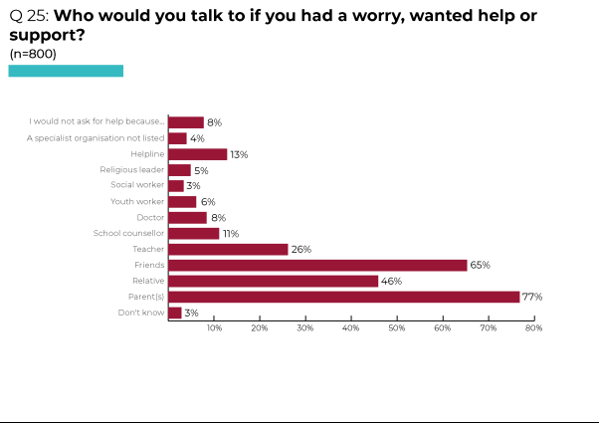
Workshops and meetings
Providing an insight into reliance on those to whom they are close, one young person responding to a question about whether he had been able to gain the help and support he needed, replied: “Do you mean, like, talking to your parents or friends?” When asked if he would know who else he could approach for help he said: “I wouldn’t have a clue.” He was aware of “social services” and the “school counsellor” but commented:
“You wouldn’t want to talk to them, they’re a complete stranger. It’s made clear in school that they’re there for you. But a young person isn’t going to go up to a teacher and say ‘I’m really stressed’ or ‘I’ve got a drug problem’.” (Young person in in-patient mental health Unit)
One young person in custody stated: “I don’t need any help because I have my family.”
In a group of 9-15 year old migrant Russians and Lithuanians, several participants said they would talk to their friends as they trust them and see them all the time. In this group, one young person also talked about there being a box in school to put your name in, which would lead to referral to the school counsellor. They felt this was an easy way of seeking support.
Asked who she would talk to about the help and support she needed, a young person in secure care replied: “I wouldn’t speak to my social worker. I’d speak to staff in Lakewood, and my foster Mum, and my sister.”
However, a few workshop participants noted that relatives were not necessarily the most helpful source of support. In a group of 8-12 year old migrant Polish children, one commented: “Last time I told my brother that I was upset, they were just, like, ‘Get over with it’ and I was like ‘How does that help?’” Another agreed: “I feel the same.” These children were not aware of any services they could contact.
A group of young people in conflict with the law stressed the importance of support in local communities for young people. They were aware that a lack of funding has made it challenging for organisations to support younger individuals who would benefit from earlier intervention.
Among survey respondents, 8% selected the option ‘I would not ask for help because…’ Their reasons were diverse. For some this was due to a lack of trust in others: “I don’t trust people”, “I don’t trust nobody.” For others it was a lack of faith in available services:

“From hearing friends talk about their experience with things like counsellors or CAMHS, it seems like it would make me feel worse or not work.”

“I feel like a lot of these options are people who wouldn’t truly care about my mental health.”

“When you ask for help from services like the PSNI, they don’t do anything.”
“I do not believe they could help me.”
“Nothing would happen.”

Concern about potential responses was a key issue: “Worried about what they'll say”; “[They] might not understand.” In particular, fear of being judged was an inhibiting factor:
“I feel like people would judge me if I tell them how I truly feel.”

“I am too scared on what people think.”
“I am scared that I'll be judged for not knowing how to do certain things or asking for help.”

“People won’t believe me, may judge me or not take me seriously.”

A few expressed anxiety about seeking help: “I would be nervous”; “I'm scared”; “I'm worried”.

For some, fear of others finding out about their situation prevented them asking for help:
“I would want to deal with it on my own and try to face it. I wouldn’t like the idea of that person telling more people and I would be nervous in case my family would find out I was struggling with mental health, especially more distant family (cousins, aunts etc.).”

“There's no confidentiality, everything has to be told to those around you.”

Some were concerned about worsening the situation:

“It makes things worse”

“I’m scared to speak about my emotions. When I get picked on in school I stay quiet because it'll get worse.”

Worryingly, a number considered that they would not be taken seriously or would be belittled:
“No one would listen.”

“I think people won’t believe me.”

I would think that, depending on the issue, certain people (not selected) wouldn't take me seriously.”

“My issues are always invalidated.”

“Every time I have tried to ask for help I've been embarrassed or ridiculed for it.”

“Adults tell us were too young to be sad - to ‘just enjoy life’.”

“They would just tell me to get over it and not offer any help or support so there’s no point in asking.”

A few individuals responded that it depended on the perceived severity of the problem they were experiencing:
“It could be hard to, depends on what it is.”

“It depends if it’s serious or not.”

“The feeling may be small and it will not be a long term problem compared to something that is long term like a sore back for an entire week.”

“I wait until I really, really need help.”

Others stated that they did not seek help or support because they did not want to add to the problems being faced by others:

“Mum has too many of her own problems sometimes and I don’t want to tell a counsellor certain things.”

“I don’t want to worry others about my worries because that just makes the problem worse.”

“I don't like to dump my problems on others.”

Some considered that they did not need to ask for help, feeling that they could ‘deal with’ any issues themselves:

“I am a strong independent individual.”

“I’d deal with it myself.”

“It's my problem, not anyone else’s.”

“I’ve been raised to hide my emotions and just ‘deal with it’ so I suppose that I just don’t feel the need to.”

“I personally do not like talking about my mental health and like to deal with issues on my own.”

“I don't like having to ask others to help with my worries and like to deal with them myself.”

“I'm able to manage my own problems and I'm the one who people can rely on with their troubles. My predicaments are easy to deal with alone.”

“I deal with things better on my own.”

Meeting the needs of particular groups
Workshops and meetings
Younger children
Asked about services they require, the responses of a group of 10 year olds reflected their concern about environmental issues, rather than personal needs: “more natural resources like trees”, “picking up rubbish on beaches.” In addition to “school supplies”, they discussed the need for “more grass” at school. Their reasoning was that the only sport they are currently able to play is basketball, but with grass they could play more sports and less people would get hurt. They also felt sport was good for mental health and that “more children would be active” if there was more grass to facilitate activities.
LGBTQ+ young people
Workshop participants considered that society is becoming more relaxed about gender identification. Consequently, they felt able to express views on how they identify with less judgement than would have occurred in the past (Young people in conflict with the law, aged 19-22).
One young person in an LGBTQ+ group of eight reported that they had good experiences with doctors in the past. However, others described poor relationships with doctors:
“I hate doctors, they don’t listen. I went 3 times and they didn’t do anything just said there’s no cure, get fucked.”
“[My mother took me to the doctor to get a sick note for school as I had something wrong with my heart.] The doctor said ‘Sometimes I feel sick, but I still have to go to work’ [and I was not given the note]”.
Specifically discussing services for LGBTQ+ young people, participants in the LGBTQ+ group were critical of both CAHMS and school counselling services:
“Trans healthcare in NI is awful - my GP knew nothing about it but tried to mansplain it to me.”
“CAMHS is terrible. They made the situation a lot worse … I tried to take my life twice. The first time CAMHS told me I was over-exaggerating so I tried again and my parents pulled me out. They need to listen to young people, you can’t trust them.”
“School counselling service is worse than CAMHS … they kept mis-gendering me. Every Tuesday I would get so anxious and scared.”
In contrast, one young person explained that their therapist [in private therapy outside school] “is really nice and she is a lesbian, so I can relate to her”.
The group argued that waiting lists for all services, including CAMHS and school counsellors, result in most people having to ‘go private’. This leads to a situation where those without money are unable to access the same services as those who can afford to pay for treatment. One young person confirmed: “It takes 5+ years to wait for hormones. If you have money, it’s easier.”
Access to services is also affected by geographical location – those in rural areas may require transport or have to travel to Belfast or Derry to attend groups. They considered it unfair that they have to travel to meet friends with whom they can connect. Reinforcing the importance of locally available support, when asked who they would speak to if CAMHS and other mental health services were insufficient, several of the young people pointed to the group co-ordinator. Some also talked about speaking with their friends, particularly other members of the LGBTQ+ group.
Asylum-seeking, refugee and migrant children and young people
In 2016, the Committee recognised that ‘asylum-seeking, refugee and migrant children and their families face difficulty in gaining access to basic services, such as education and health care, and are at high risk of destitution’ (para 76f), recommending that the State party ‘Provide sufficient support to migrant, refugee and asylum-seeking children to access basic services’ (para 77f).
In a workshop involving migrant Polish children aged 6-15, participants identified the range of support they considered was needed within families, much of which would be relevant for all families:
“Psychological support from family (encouragement, love, listening).”
“Help with homeworks. Talk about successes and issues at school.”
“Good relations between family members.”
“Having time to teach necessary skills and having the finances to give best support.”
“Parents allow for skills enhancement of favourite activities, helping to choose what skills to develop.”
“Parents should have more time for their children.”
Particularly relevant to migrant families is the requirement: “to learn native language and practice own traditions and culture.”

Children and young people with disabilities
The Committee’s 2016 recommendations included:
‘… adopt a human rights-based approach to disability, set up a comprehensive strategy for the inclusion of children with disabilities’ (para 57);
‘Ensure full respect of the rights of children with disabilities to express their views and to have their views given due weight in all decision-making that affects them, including on access to and choice of personal support and education’ (para 57a);
‘Provide children with disabilities with a comprehensive and integrated package of services for transition to adulthood, from a sufficiently early stage, by coordinating legislation, policy and programmes across sectors, and ensure fully informed decisions by children with disabilities on their personal choice in the transition, by involving them in the design of services and by providing advice and information on available options’ (para 57c).

Discussing whether they received appropriate help and support to become more independent, key issues raised by disabled young people centred on the right to privacy and the difficulties involved in living independently. A staff member explained: “There is some independent supported housing available but that’s for people who actually have more needs than our young people have, so they actually end up not getting a lot of the assistance that they need for things and are expected to just get on with it, which is difficult.”

Two young people expressed the tensions involved when they need on-going support but want to live independently:

“I would like to move out and get a home. I am an independent woman. I can’t see myself living at home, but mummy can. I think: ‘It’s not your life, it’s my life. Let me find out for myself. I need you in my life but I don’t need you making every decision for me, it’s my life’ … I am definitely moving out.”

“A thing happened last Saturday where my sister moved out and it got me more or less thinking that - not now but maybe, like, after next year and tech - I could move out ’cos I would love to go to a university in London or just somewhere overseas. But because of, like, the fact I do have a learning difficulty alongside autism and ADHD, I do find it hard to do certain things and … I can’t work at the minute.”

Poor staff retention in social services was raised as an issue. Not having a social worker means there is no support or knowledge about available support. One young person stated:

“Social workers aren’t very good. I’ve had social workers since I was younger and they would come to my house and introduce themselves to me and then they’d say: ‘Right, we’ll be back out in a month or two’. Then I’d go: ‘Where are they?’ in a month or two and mum goes: ‘Oh, they left’. Me going: ‘They’ve left?’ Then I’d get another letter: ‘This is your new social worker, blah blah blah’. They come out and meet me, then about a week later you get a letter saying they’ve left. I says to mummy: ‘Is it just me? Do they not like me?’”

Staff in the workshop highlighted that, once young people turn 18, all services provided by social workers stop. Barnardo’s [the organisation facilitating the workshop] are currently ‘plugging a gap’ with their services and trying to identify people who don’t have a social worker, those whose social workers are not working with them, and lack of access to services.

Children and young people with disabilities noted that lack of access to appropriate transport means it is “definitely harder” for them to socialise in their communities:

“I am in a chair … I can’t go out on my own. If my friend goes out on a night out, I can’t because [there are] no taxis out there. I find it very hard to get out … I can’t do that because I can’t walk at all, that is a big, big, big, big, problem for me.”

“What I don’t get is, why does transport have to stop at 19 ... When I was younger I used to get taxis to and from school. As soon as I hit 19, on the dot, that was it and it was very stressful.”

They explained that transport in particular towns [rural areas] runs 9am-5pm on a ‘first come, first served’ basis and is usually taken up by elderly people going to appointments. There is no service available for young people who want to do something in the evenings. A member of staff affirmed that this issue affected all the young people in the group “because we provide the transport for them … really they’d rather go to the cinema or go out to a pub or do something like that and get the transport for that. But nobody’s providing transport for those things and the best they are getting is coming here, which is obviously not the same thing.”

The prohibitive cost of transport was another issue. When young people do not feel comfortable travelling by bus, and buses are neither regularly available nor are they reliable in rural areas, taxis are the only option. However:

“Taxis are absolutely ridiculous, the prices keep sky rocketing and keep changing every time.”
“I can’t go down to Belfast because there’s no transport. It’s like, if I go down Mummy has to pay the taxi. If I go down, it’s costing me too much … If I want a night out I couldn’t go because there’s no transport down and back.”
Asked if there were services they required, workshop participants replied: “Better transport”.

Discussing limited access to leisure opportunities, one young person said: “I haven’t got any access to sport for a while, I’d like to do swimming a lot more, boxing.” A member of staff explained the young people need access to services that are not ‘run of the mill’ as many cannot do these activities and want something different. Some programmes run for a set period of time, such as a 6-week soccerbility programme, leaving gaps between activities. There used to be a disco for young people with additional needs but it was stopped during COVID and has not yet resumed.

In terms of inhibited social life, some young people also discussed meeting others of their age and dating. Staff noted that while young people with disabilities experience restrictions on their freedom, they have the same needs and wants as other young people. They are hindered by their parents wanting to protect them, not being able to participate in activities, and limited finances due to lack of part-time work.

Care experienced young people
Young people who were care experienced noted that “More support is needed for the families/ parents of children in care - parents need to be educated on how to look after their children”.

Recognising the negative impacts of frequent changes of social workers and experience of multiple family placements for children in care, in 2016 the Committee recommended that the State party: ‘Take all measures necessary to provide stability for children in care, including efforts to retain social workers and to avoid unnecessary changes in placement’ (para 53e). It also recommended that the State party: ‘Inform and consult with children from an early stage on plans for their care and transition and provide sufficient support for care leavers, including for accommodation, employment or further education’ (para 53f).
Across different workshops, care experienced young people were critical of the support provided by social workers:
“I taught everything to myself. [In care] you feel like you’re forced to become more independent and social workers are so bad that you have to learn yourself about things – about what social workers can or can’t do or help with. You get told something, then it gets taken back … I take care of myself. When I don’t get the care I need, I do it myself. Social workers expect you to tell them everything.” (Care experienced young person, aged 16-18)
They emphasised that “social workers should be doing the job because they care about children, not just for the money”, arguing for “more” and “better social workers” (Care experienced young people, aged 12-18).
One young person stated: “Foster care was the best thing that could happen to me – recruit more foster carers.” While agreeing that more foster carers are needed, care experienced young people aged 12-18 emphasised the need to maintain and improve the ‘standard’ of foster carers. Prioritising the ‘carer’ element of the role, they emphasised selection of “Foster carers who actually care about the children, and aren’t just in it for the money”. Concerned about the number of children a foster carer can look after at any one time, they suggested that some individuals approach the role on the basis of “more children = more money”. Mentioning media articles about, and awards being given to, “people who foster dozens (even hundreds) of children over their lives”, some questioned “how can one carer build meaningful, supportive, lasting relationships with so many children?”
A young woman had been unable to access counselling or therapy and questioned a focus on current issues rather than underlying problems:
“I’ve been in care 6 months and I’m still waiting. They only help you by saying things like ‘You’re not going to kill yourself are you?’ They only talk about present stuff, they don’t go back and fix all of the older stuff which is still there. I’m nearly 18 and they are only getting round to it now. I’m persevering, but if I was 16 I would have given up.”
This young person mentioned Jigsaw [Community Counselling Centre in Belfast], where she had accessed Art Therapy, commenting that it was “a good service” (Care experienced young person, aged 16-18).
Those who had been in care also felt that they were not provided with enough support when they were preparing to leave the care setting.
In response to a question about what young people need in preparation for living independently, care experienced young people aged 12-18 responded:
“Financial security, income.”
“Practical skills (e.g. laundry, cooking, paying bills, budgeting – how to be an adult).”
“Coping strategies to deal with times when things go wrong.”
“Education and training.”
“Access to housing (there aren’t enough houses for young people leaving care).”
Young people in secure care
The Committee’s 2016 recommendations included: ‘Ensure that secure accommodation in Northern Ireland is only used as a measure of last resort and for the shortest possible period of time, address the reasons for repeated or lengthy stays in such accommodation and develop alternatives to secure accommodation’ (para 53d).
A young woman in Lakewood Secure Care Centre was very articulate about her own situation, providing a valuable insight into the experiences of a vulnerable individual with complex needs in the care system – experiences similar to those of many young people placed in secure care for ‘welfare’ reasons.
Drawing on her experiences, she considered that the support needed by young people in care is love and attention:
“It depends on the young people. I think what young people lack is love. I don’t have anybody – my Mum’s a drug addict, my Dad doesn’t want me. I feel I don’t have anybody. Staff in the [children’s] home are my family. They are doing things like what a family would do. Staff show love by spending time with you.”
Despite this appreciation of residential care staff, she described how chaotic and unsettling a children’s home can be:
“I just need to go home, to have some sort of ‘normal’ life - not to have constant drama, constant shit. In the children’s home I’ve got someone banging their head in one room, someone smashing the window in another room, someone going missing all night.”
She was particularly critical of the process of reporting individuals as ‘missing’:
“When I leave Lakewood [Secure Care Centre] I don’t have enough freedom. Staff [in the children’s home] have to see me face to face and then half an hour later they have to talk to me by phone, then see me, then phone me – every half hour. I’ve been reported missing so many times. I was reported missing within an hour of going from the home. I was the young person who went missing the most times in Northern Ireland at one point – some reputation to have, that is!”
Asked by the Advocacy Worker how staff in the children’s home could care for her without being overly-restrictive, she emphasised need for staff to spend quality time with young people:
“There are moments that you can have with staff – trips, activities, spending time with them doing normal things, things you’d do in a family.”
Describing the disruptive context of her life, she had been placed in secure care on four occasions in three years:
“I’ve been in [children’s home], then at my Dad’s, in and out for 2 years. It’s starting to beat me up. I almost feel I can’t make mistakes … I want to change in my own time. I feel I’m being put in Lakewood every time I make a mistake. The social worker has visited once in 5 months to see me. They’ve been in once since I’ve been in Lakewood [2 weeks]. I’ve had 6 social workers in 2 years. It messes you up - you get used to one person and they have to learn about me, and then it changes again. I’ve been in care 7 years tomorrow – for my own safety, neglect, being in an abusive household. I enjoy going to Lakewood. It’s ‘normal’ time for me. But that should not be normal. I shouldn’t feel Lakewood is my home. I’ve spent over a year of my life in here.”
Asked what support or help she needed personally, she replied:
“I don’t know. They keep saying what I need is talking therapies. But my family are the only people that help me … I know what my issues are. It’s just about being able to do what I need to do. It’s hard to break the cycle.”
She articulated contradictory emotions - frustration about being deprived of her liberty while considering that she benefitted from placement in secure care:
“In Lakewood you’re 1 on 1 with staff. I can talk to staff and tell them how I’m feeling. In children’s homes staff are out chasing all the others. All the kids have each other’s backs. Young people in Lakewood all speak to each other about our issues.”
For her, the benefits of being in secure care included routine and stability:
“Structure, safety, it can give people better views. It has helped me in little ways. It helped with my self-harm – I haven’t self-harmed for more than a year. I don’t have suicidal thoughts any more – I have low mood but now I’m depressed, not suicidal. I’ve got older and my brain has matured.”
However, the restrictions and social isolation were problematic:
“You’re given so much time to sit and think. I’m a young woman sitting in my room at 10pm at night, locked in. I can watch movies and listen to music. But lots of thinking is not good for anyone’s mental health. There’s not much to do during the day - you’re not active. There are so many [locked] doors in this place.”
She recalled the fear she experienced on her initial placement in secure care:
“It was frightening at night time when I was 12 [first time in Lakewood]. I tied ligatures and self-harmed for attention. There’s only 2 night staff, and they can’t always be with you. There’s just a TV and four walls, you can’t sleep. You’re put on meds – that’s not good for you.”
She questioned the value of repeated placements in secure accommodation:
“I feel I’m being re-traumatised every time I go in here … Stop institutionalising me. (I like that word, I’ve just found out what it means, but I can’t always say it!) I spend my time in the community worrying about coming back here. I feel like I can’t make mistakes. As a child I went through a lot of things growing up. My way of dealing with things is taking drugs.”
Regarding support for drug and alcohol misuse, she stated:
“In Lakewood drug use and alcohol work is the first thing they do with you. I don’t drink, I’m not a drinker. I know plenty about drugs – I did a lot of research to understand my Mum’s addiction. I’ve done the programmes in Lakewood four times now!”
Asked about other agencies, she criticised access to mental health support:
“Like CAMHS? Any mental health teams at the moment are terrible. I haven’t had an appointment in a year. I’ve been 2 weeks in Lakewood and have not heard from CAMHS yet – that should be a priority for any young person in here. I had an appointment yesterday but didn’t get it. The key worker is chasing that up.”
In her opinion, medication is over-used:
“They dose kids up on meds. That happens too much in here. Meds are dished out to anyone. There’s a 14 year old in here on Diazepam. When the meds stop, how is that child gonna cope, when they’ve been on it from a young age?”
Children and young people requiring in-patient mental health treatment
The Committee’s 2016 recommendations included ‘review [of] current legislation on mental health to ensure that the best interests and the views of the child are duly taken into account in cases of mental health treatment of children below the age of 16 years, in particular with regard to hospitalisation and treatment without consent’ (para 61e).
Application of the ‘best interests’ principle for those receiving mental health treatment is not an issue only for those aged under-16. Asked what their messages for government would be, one young person in the in-patient child and adolescent and mental health Unit replied:
“Every child’s right can be over-ruled with a Mental Health Order. That person’s very sick, but the right [to participation] is denied because the law was written by adults. There’s no right of speech freedom, deciding what medication goes into them. Individuals need to be listened to more. You can’t over-rule them just because they are struggling.”
Discussing activities in the Unit, the young person said:
“There’s OTs [Occupational Therapists]. They do a lot of art stuff. Lots of people are tired and don’t go because it’s done to death. There need to be more things that spike people’s interest or motivation. Otherwise you have a lot of people lying around all day, and that’s not good for them mentally.”
Noting that young people with eating disorders were able to “go outside on the swing, go over to the Rec Hall … go out on bus runs, do art projects, play badminton”, they considered that each individual “needs a plan” which changes to reflect progress:
“… when there’s a sign that you’re steadily improving, you should be able to do more activities. You’re treated differently depending on your weight. It’s OK [not to do much] for the first few weeks because you come in physically compromised. There’s a lot of limitations with safety. They’re planning on doing gardening, but then you’re constantly being reminded ‘You’re not allowed to do that because you’re not allowed to move’ … Everything is seen as exercise, but it’s actually tiring [constantly being told you can’t do things]. The other day I was looking for a ladybird and was told to go and sit down. You don’t do things that are just enjoying life. I just go to my Mum and cry. There’s no aspect of normal life.”
Asked whether young people receive the help and support they need for their physical, social and emotional development while detained in the Unit, one young person replied:
“Food is always provided, it’s always there, always offered. With personal hygiene, staff offer to change your towels and bedding. Psychologically, it’s good for some but very poor on the level of input for others. One person who’s been in five times may not see a Consultant once, another person who’s been in five times might be seen by a Consultant regularly. But there are two Psychologists covering both wards. They need more to cover everyone.”
Young people in custody
In 2016, the Committee recommended that the State party ‘Immediately remove all children from solitary confinement, prohibit the use of solitary confinement in all circumstances and regularly inspect the use of segregation and isolation in child detention facilities’ (para 79f, emphasis added).
Comments by detained young people revealed that use of isolation is not restricted to detention facilities. Two young people described responses in schools:
“If you get into a scrap [fight] or something, you can get isolation detention – you’re put in two boxes in the same room for 2 hours and told: ‘Sit there, don’t speak’.” (Young person in the in-patient mental health Unit)
“In [an EOTAS: Education Other Than At School Centre] I went to in Key Stage 2 [aged 7-11] there was a ‘Safe Room’ and you were locked in the room if you were kicking off.” (Young person in custody)
Asked whether young people had the health services they needed while in custody, one young person responded:
“Not really, they forgot about me … I took a fit in here and the nurse said I should have a brain scan but nothing’s happened. My name’s got lost in the list. I haven’t had a scan. They’ve forgotten about me.”
Another stated: “I’m waiting for a diagnosis. I was meant to be tested for autism.”
A different young person replied “You can’t see a GP in here.” One of their peers suggested that this was: “because the GP doesn’t have their own PPE [Personal Protective Equipment] – the Dentist can come in because they bring their own PPE.” Discussing other impacts on health provision during the imposition of COVID restrictions, this young person complained:
“I had to take pictures of what was wrong with me and send them to a GP. All the things they gave me didn’t work. How can they tell what’s wrong with you when you send them a photo?”
A teacher commented that this was the process also adopted in the community during COVID restrictions.
Talking about the introduction of a smoking ban throughout the Centre, one young person recounted: “At the start, they wouldn’t provide me with nicotine patches because you had to be over 16.”
Discussing support for those using drugs, one young person was of the opinion that: “The DAISY [Drug and Alcohol Intervention Service for Youth] service is really good.”
Another stated: “There’s no rehab over here [in Northern Ireland].” He noted that staff from the DAISY project and Belfast Trust DAMHS [Drug and Alcohol Mental Health Service] come into the Juvenile Justice Centre, but “they just talk”. He said:
“If you’re 17, they put you in [Secure Care Centre] with all the self-harmers an’ all … They should have a rehab centre, where you agree to go in [ie, it’s voluntary]. They have a couple down south [in the Republic of Ireland] … If you’re under 18, they don’t give you anything to get you off drugs.”
Yet this young man commented that no available help and support would have influenced his drug use:
“I would have used drugs anyway … If I was to get out today, I’d be taking drugs … that’s what 16 and 17 year olds do.”
He proposed that the government should “legalise cannabis, legalise MSJ’s [‘blues’: valium/ diazepam] and lower the price.” In response to being asked whether he thought children and young people needed more information about drugs and alcohol, he said: “10 year olds know about drugs – they know more than the chemists!” Asked if he believed young people were aware of the harms caused by drugs, this young man commented: “You can have someone who doesn’t drink, doesn’t take drugs, doesn’t do anything wrong and then gets knocked over by a car – if you were worried about all that, you’d never go outside your door!”
Asked if they had people to support them, one young person said: “I’ve had a social worker from the Youth Justice Agency for 3 years, she’s OK.” However, highlighting difficulties in contacting their social workers, others commented:
“They throw you in here and forget about you. Social workers don’t care … Last time I was in here, they gave me a social worker. But they didn’t check with me. They won’t answer the phone – said they were sick and then they had COVID. Seems like excuses to wait ’til I’m 18.”
“The social worker won’t come up [to the Centre].”
Discussing community-based responses to his criminal behaviour, one young man argued that there should be “No curfews. All my crimes were done during the day, so it makes no sense to be locked up 8 [at night] ’til 8 [in the morning].” He found it frustrating that “If you’re back late people grass on you and you have someone knocking on your door.” Also frustrating were “Random drug tests”. Asked if there was any particular help that might stop him returning to custody, he replied “No … Youth Justice talk to you, say ‘Can’t you change your friends?’ an’ all, but you’re not gonna do that.”
Commenting on having no choice about future accommodation, one young person stated: “16 year olds should be able to have more say in their life, like where they live.” Told he will be placed in Belfast when he leaves custody, he thought he should be able to return to his home town:
“I won’t be safe there, in Belfast. There’s no support and I’ll be back on the drugs. I can get more tablets there than anywhere else! I’ll be found dead in a flat up there … If I’m not safe in Belfast, why let me go there?”
A different young person stated: “I’m not allowed to apply for bail because I don’t have an address … The social worker should have to find you an address if you’re under 18.” His peer explained that this young man was in custody “For arson. No hostel will take you if you’re high risk.” In their opinion, social workers should do more to help find appropriate accommodation for young people in this situation.
The young person who had no address to go to stated “The social worker said they’re not letting me out until I have an assessment.” However, according to a member of staff who was present during the consultation meeting, psychiatric evaluations cannot be completed in the Juvenile Justice Centre. If a young person is not granted bail, they cannot be evaluated in the community and are therefore “stuck in a loop”.
In terms of access to legal advice and representation, one young person stated: “Your solicitor doesn’t want to know you once you’re sentenced.” They stated that their mother had contacted the Children’s Law Centre but was “told they couldn’t do anything as it was a criminal justice issue”. They did not think this was right, or very helpful, saying: “The Children’s Law Centre should have been able to help us.” Another young person stated that they planned to contact the Children’s Law Centre about “getting bail”.
KNOWLEDGE ABOUT CHILDREN’S RIGHTS
Children’s rights
Survey findings: whether children and young people had heard about children’s rights
Asked whether they had heard about children’s rights before doing the survey, among 743 respondents half (51%) replied ‘Yes (and I knew what children’s rights meant)’; one quarter (25%) responded ‘Yes (but I wasn’t sure what children’s rights meant)’; one quarter (24%) answered ‘No (I hadn’t heard of children’s rights)’ (see Pie Chart, Q27).
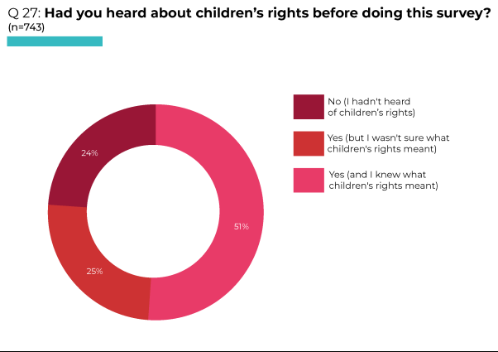
Workshops and meetings
In some workshops and meetings, participants stated that they had not heard of rights. They were young people who were the most marginalised: young people in the Secure Care Centre; some of those who had been in conflict with the law; a young person detained in the in-patient mental health Unit; and another who was homeless. One young person in custody simply stated: “We don’t have much rights.”
However, others stated that they had heard of children’s rights and attended groups where discussion about rights was an element of the group’s activities (e.g. the Barnardo’s Disabled Children and Young People’s Participation Project, the PlayBoard YMCA After School Club, STEP Language groups for migrant Polish, Russian and Lithuanian children and young people).
Definitions of children’s rights from across the workshops and meetings included:
“[Children’s rights are] about being treated right, being able to do things freely, making sure they’re safe.” (Young person in in-patient mental health Unit)
“Free speech … health and social care … rights for elderly people.” (Care experienced young person, aged 16-18)
“Something you’re allowed to do.” (Migrant Russian and Lithuanian child, aged 9-15 )
“They’re the basic necessities that all children should have and the bare minimum of how they should be treated. Things like speech, shelter, food, saying their opinions.” (Young person in in-patient mental health Unit)
“To have a say in your life ... about having food, water, an education.” (Young person in custody)
The examples of rights provided by a group of 10 year olds included:
“Going outside and getting fresh air”, “disabled people having rights to go and do the things that other people do”, “right to food”, “right to life”, “right to work (for adults)”, “right to be healthy and have good hygiene”, “right to clean water”, “right to help and medicine”, “right to not be bullied”, “right to go to school and get an education”.
Those in a disabled children and young people’s participation project (aged 15-16) gave the following examples:
“You have your own words to say.”
“Freedom of speech.”
“Respect what people are.”
“Don’t judge people.”
“Having your own ideas and your own opinions.”
One group of 16-18 year old young people in conflict with the law defined rights in relation to what young people are able to do once they reach ‘adulthood’:
“You are allowed to do more things when you’re 18 like going out and stuff and not being reported missing.” [This was a reference to curfews placed on young people in care, who are reported ‘missing’ to the police if they do not return to their residential home at a specified time.]
“When you’re 18 you have more independence. You can go out to night clubs and bars, and you’re allowed to drink [alcohol].”
A small group of 19-22 year olds who had been in conflict with the law considered that rights should be entitlements: “education”, “safety”, “food” and “health services (e.g. to see a doctor)”.
An example of rights given by a young person in secure care was: “To make your own decisions.”
Asked what rights children and young people should have, a group of 7-10 year old Travellers listed: “development, protection, education, relationships, express their opinion, health, freedom of thought, non-discrimination, identity, privacy”. They considered that these rights are all protected and promoted in Northern Ireland.
In response to the same question, a group of six 13-15 year old young women who were refugees listed key rights and noted the number considering that each right was protected: right to play (6); right to freedom (4); right to food (6); freedom of expression (6); right to education (3). The school curriculum was mentioned a few times in their discussions and described as very stressful. Although they were learning the language, the young women were taking GCSEs in English. They believed that they would pass GCSEs if able to take the exams in their native language, but were unable to do this. They considered this a potential barrier to future entry into higher education or the world of work. Discussing what advice they would give to the government to make things better for children and young people, they stated:
“We are overwhelmed at school. We struggle with English but still have to take lots of GCSEs that we don’t understand due to the language barrier. We think education needs to be reformed.”
The only right noted by 12-18 year old care experienced young people was: “Right to access personal information”.
Survey findings: where children and young people had heard about children’s rights
In response to a survey question regarding where they heard about children’s rights, 72% of the 585 who answered replied ‘school’. Other sources included: the internet (39%); media (TV, radio, social media) (29%); parents/ carers/ guardians (23%); friends (14%), and youth clubs or community groups (8%); 7% other (Youth Assembly/ Youth Parliament, NIYF [Northern Ireland Youth Forum], TV, NICCY Youth Panel, own research/ taught myself through books) (see Table, Q28).
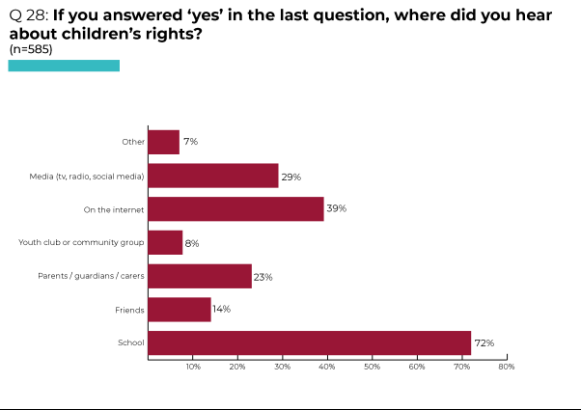
Workshops and meetings
In workshops too, among those who had heard about children’s rights this had been mainly at “school”, including in “careers” and “Home Economics” classes. A group of 10 year olds, who all attended the same primary school, had completed some rights-awareness sessions in school.
One care experienced young woman stated that she learned about her rights from her social worker. Living in supported accommodation and recently reaching the age of 18, she was struggling with the transition between youth and adult services for those in care (Young person in conflict with the law, aged 16-18).

UN Convention on the Rights of the Child [UNCRC]
Survey findings: whether children and young people had heard about the UNCRC
Of the 740 respondents to a question about whether they had heard about the UNCRC before doing the survey, over half (55%) answered ‘No (I had not heard of the UN Convention on the Rights of the Child). One quarter (26%) replied ‘Yes (and I knew what it was)’, 19% responded ‘Yes (but I wasn’t sure what it was)’ (see Pie Chart, Q29). Older respondents were more likely to have heard of the UNCRC and know what it is (33% of 16-17 year olds compared with just 16% of 12-13 year olds).
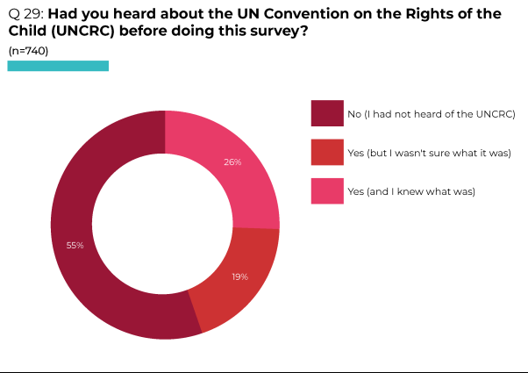
Workshops and meetings
Among participants in consultation workshops and meetings, knowledge of the UNCRC was limited with only five participants stating that they had heard of the Convention.
Survey findings: where children and young people had heard about the UNCRC
Asked where they heard about the UNCRC, school was the main source for the majority of survey respondents (66%). While half (55%) of 12-13 year olds had heard about the UNCRC in school, this increased to 72% of 14-15 year olds and 77% of those aged 16-17, suggesting that this is a topic covered in the Key Stage 4 curriculum of some schools.
Other sources included: the internet (27%); media (15%); parents/ carers/ guardians (14%); other (12%) (student council, Youth Assembly, books, NIYF, NICCY Youth Panel, self through books/ research); youth clubs and community groups (7%) and friends (6%) (see Table, Q30). A higher proportion of those with disabilities cited youth clubs/ community groups a relevant source of information (18% compared with 6% of those without disabilities respectively).
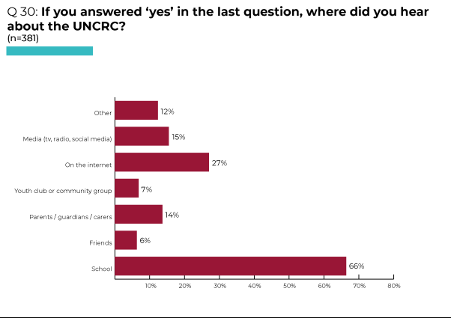
Workshops and meetings
In consultation workshops and meetings, those who had heard of the UNCRC stated that this was in school:
“I just know about it. In primary school there was a poster with children’s rights on the wall.” (Young person in in-patient mental health Unit)
“In Politics class.” (LGBTQ+ young person, aged 15-18)
“In Home Economics class.” (LGBTQ+ young person, aged 15-18)

Northern Ireland Commissioner for Children and Young People [NICCY]
Survey findings: whether children and young people had heard about NICCY
In response to a question asking whether they had heard of the Northern Ireland Commissioner for Children and Young People [NICCY], the majority (70%) of 738 respondents replied ‘No (I hadn’t heard of NICCY). 15% responded ‘Yes (but I wasn’t sure what it was)’. Just 14% answered ‘Yes (and I knew what it was)’ (see Pie Chart, Q31).
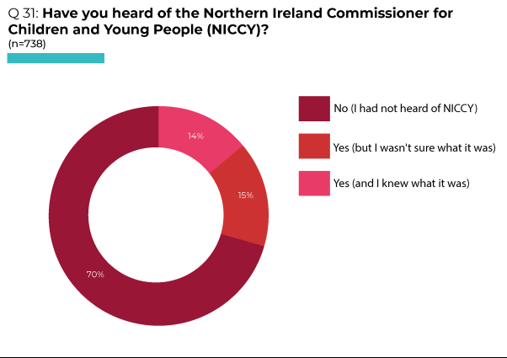
Workshops and meetings
In workshops and meetings, only two participants had heard of NICCY. A group of younger children asked “So her name’s not Niccy?”, and wondered: “How does she know the problems if she doesn’t come speak to us?”
Survey findings: where children and young people had heard about NICCY
Among the 276 who responded to a question asking where they heard about NICCY, 45% replied school; 23% the internet; 21% media; 20% other (Youth Assembly, NICCY Youth Panel, involvement in surveys); 15% parents/ carers/ guardians; 10% friends; 8% youth club or community group (see Table, Q32).
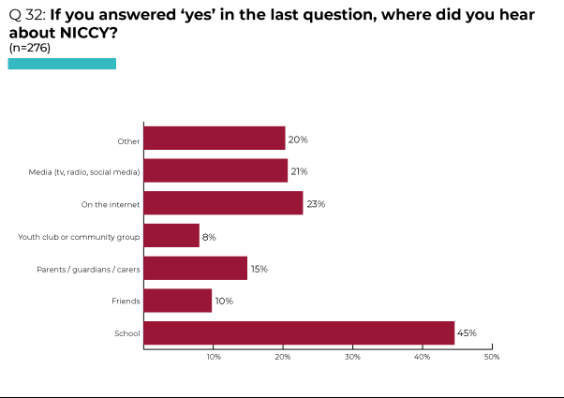
Workshops and meetings
In consultation workshops and meetings, one who knew of the Commissioner had been informed while in the in-patient child and adolescent mental health Unit. Asked what the Commissioner does, they responded: “Makes sure children in Northern Ireland are getting their rights.”
Another young person responded that they had heard about NICCY in school, but could not recall anything about the Commissioner.

Personal knowledge about rights
Survey findings: personal knowledge and understanding about their rights
In response to survey questions exploring personal knowledge and understanding about their rights, less than half (45%) of the 745 respondents agreed or strongly agreed that they knew a lot about their rights. Just over half agreed or strongly agreed that: they knew where to get information about their rights (52%); understood what children’s rights mean in their life (53%); and knew who to contact if they were treated unfairly (54%). However, less than half (44%) agreed or strongly agreed that they were confident in making a complaint if treated unfairly (see Table, Q33). The proportion of older respondents (16-17 year olds) agreeing with each of these statements was lower than among those aged 12-13, particularly in relation to knowing who to contact if they were treated unfairly - while 71% of 12-13 year olds agreed or strongly agreed that they would know who to contact, just 39% of those aged 16-17 gave this response. Those eligible for free school meals were less likely to know about their rights or feel that they understood what rights meant in their lives than other respondents. Those with disabilities were far less likely to agree that they knew who to contact if they were treated unfairly than those without disabilities (35% compared with 60% respectively), or to be confident in making a complaint if they were treated unfairly (31% compared with 47% respectively).
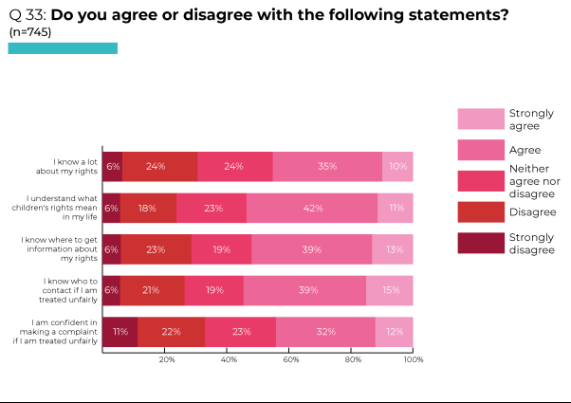
Workshops and meetings
One reason for not making a complaint is the perception that this will not achieve anything. For example, one young person in custody recounted making a complaint about police behaviour:
“If there’s something we do, the police should try to take it easy on us. They’re so aggressive, and that means we’re just aggressive back … The police poured drink all over me … The Police Ombudsman didn’t do anything about it when I wrote to them … There’s no point going to the Police Ombudsman because police officers are interviewed and then nothing happens. They might have come back to me once and that was it.”
In 2016 the Committee repeated its previous recommendation that the State party: ‘Make children’s rights education mandatory’ (para 73g).

Survey findings: whether children and young people agreed or disagreed with the statement ‘Children and young people should learn about their rights’
Asked whether they agreed or disagreed with the statement ‘Children and young people should learn about their rights’, an overwhelming majority: 86% of the 741 who responded to this question agreed (58% of them strongly). This rose to 93% among those aged 16-17 (compared with 83% among 12-13 year olds). Just 7% of all respondents disagreed that children and young people should learn about their rights (5% of them strongly), with 6% neither agreeing nor disagreeing (see Pie Chart, Q34).
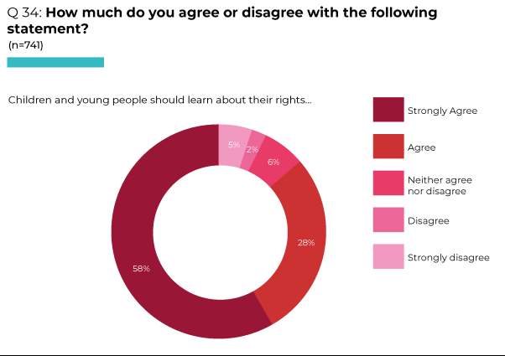
Workshops and meetings
The majority of participants in consultation workshop and meetings considered that children and young people should learn about their rights. One young person in the in-patient mental health Unit commented: “Aye, I don’t see why not” before stating more categorically: “Everybody should know about their rights. Aye, 100% they definitely should.” A group of children and young people with disabilities agreed: “Yeah, definitely”.
A care experienced young person (aged 16-18) considered that young people should learn about their rights “Because they might be able to make better decisions on things. Because some people might not think they are in the position to say anything or have the right to.”
In the Secure Care Centre, two young people were clear that children should learn about their rights:
“You have the right to know.”
“They should know more about their rights, like in certain situations [such as] being put in here, being institutionalised.”
However, in response to being asked whether children and young people should learn about their rights, one young person in the LGBTQ+ group replied:
“Not really … it doesn’t really impact anything, like it’s not going to change people.” [i.e. knowing your rights doesn’t have any benefit because there’s nothing you can do about other people’s responses or behaviours]
Survey findings: where children and young people should learn about their rights
In response to a survey question about where children and young people should learn about their rights, nearly all: 94% replied ‘schools’. Almost half replied: organisations like UNICEF, Amnesty International or NICCY (49%); social media (49%); NI Human Rights Commission (47%) and Colleges (46%). Youth clubs (38%) and libraries (23%) were also potential sources of information, although less frequently selected (see Table, Q35). Within the ‘other’ category (3%), suggestions included: parents/ at home, Orange Halls, religious settings, charity, and organisations coming into schools, youth clubs, church groups.
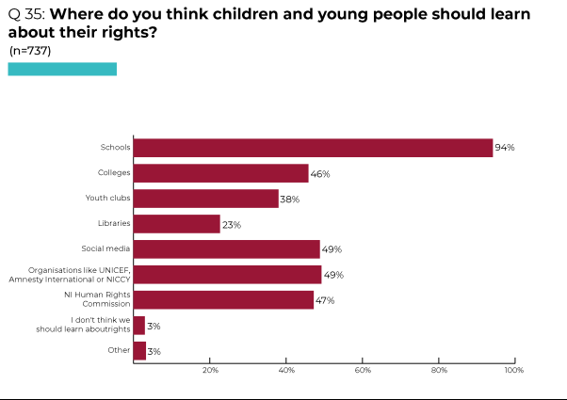
Workshops and meetings
Participants in consultation workshops and meetings provided a range of suggestions regarding sources of information about children’s rights. One group of younger children aged 10 proposed: “schools”, “nurseries”, “after school clubs”, “churches”, “community groups like YMCA”, and “by people like you [Children’s Law Centre] coming to speak to us.”
In a group of young people with disabilities, suggestions included: “anywhere”, “in school”, “Daycare”, “groups like Barnardo’s DCYPPP”. They stated that they would prefer to learn by talking about rights.
A care experienced young person considered that young people should learn about their rights in “schools” as that’s where most of them are, or in “residential homes”.
A young person in secure care considered they should learn about their rights from “The person in charge [eg in school or in Lakewood].”
In a workshop with 9-15 year olds migrants from Russia and Lithuania, the consensus was that children and young people should learn about their rights “in school” or “from parents”.
A group of 15-18 year old LGBTQ+ young people suggested that “school may not be the best place to learn about rights”. Whilst acknowledging that school is probably the easiest place to learn, as most young people attend school, they agreed with the comment of one participant: “Our age group would ‘take the piss’ [i.e. not take it seriously].” One young person in this group considered that “parents should teach you about rights”, although it was clear from workshops that not all young people have a good relationship with their family (including some who are LGBTQ+, in care or care leavers).

CHILDREN AND YOUNG PEOPLE’S MESSAGES FOR GOVERNMENT

The messages for Government from workshop and meeting participants were diverse. Key topics included:

Promotion of inclusion and human rights:
- “Give people their human rights, like freedom and acceptance.”
- “Be aware of language intolerance.”
- “No judgement when being different (nationality, religion, skin colour, etc).”
- “Governments should not allow children under 18 to join the army.”
- “Cut down parents’ work hours to get more time for us.” “Give an opportunity for parents to work shorter hours and get enough money for living expenses.”

Community facilities and safety:
- “More leisure and sport activities for personal development”.
- “More child-friendly equipment in parks.” “More playparks.”
- “Build a children and young people’s ‘Activities Park’ in Dungannon.”
- “More speed humps, especially arounds schools.” “More speeding cameras.”
- “More safety cameras around the town and schools.”
- “Police should ensure children’s safety outside on the streets.”

Concerns for the environment:
- “Planting more trees and less littering.”
- “More cycle lanes.” “More cycle routes.”
- “See how you have to eat so they kill animals, but they forget that animals, like, have a life and then you just kill them and their life already goes away but you can still eat different stuff … More variety of food in school [including vegan and vegetarian options].”

Schooling:
- “Only have school on 2 days, have 5 days off.”
- “Stop all homework.” “Not giving homework to children if they didn’t wanna do it.”
- “Only do fun stuff.”
- “Get more outdoor supplies.”
- “Make teachers listen to you.”
- “Dress-codes” [in relation to school uniforms] “Change uniforms.”
- “More trips, not just learning in the classroom.”
- “More scientific places for children to explore.”
- “More workshops for life skills in schools like cooking, general wellbeing, being independent, how to take care of yourself … the older you go in school the less stuff you have to do. More workshops showing the impact of alcohol and vaping, which drains NHS resources.””
- “Have right to choose religion classes, if any, in school.”
- “Change menu for better quality school meals.”
- “Update school’s curriculum to give best education, including more physical activities and shorter classes.”
- “Developing properly integrated education in Northern Ireland would help to create more diversity and reduce stereotypes or discrimination.”
Healthcare priorities:
- “Mental health.”
- “Make all health care staff, like CAMHS providers, take a test to make sure they are qualified and recruit younger staff that we can relate to.”
- “Every child’s right [to participation] can be over-ruled with a Mental Health Order … Individuals need to be listened to more. You can’t over-rule them just because they are struggling.”

Social workers:
- “More social workers.”
- “Better social workers, who actually care about young people.”
- “Train social workers. They just threaten kids ’til they give up. It’s ridiculous.”
- “Get more social workers that know how to interact and speak to young people. They have this professional barrier and keep their distance so they don’t feel guilty, but it doesn’t work.”

Foster carers:
- “Foster care was the best thing that could happen to me - recruit more foster carers.”
- “Change the rules around foster care – to make sure they care about the children and aren’t just doing it for the money.”

Support for young people with disabilities:
- “More support.”
- “More understanding.”
- “More transport.”
- “More opportunities.”
- “That people with special needs get a choice to do their GCSEs.”
- “I want to be able to consider any type of job I want.”

Allocation of resources:
- “Give more money to charities like cancer support.” “Give more money to charities.”
- “Make better public transport that’s free, like in Scotland.”
- “More funding being provided for local organisations supporting young people.”

Specific prohibitions:
- “No swearing” [examples included being out in public and disliking people swearing around them, particularly older teenagers].
- “Ban electronics for a day” [while some in a group of 10 year olds felt very strongly about this, others said they would “let all kids play games”].
- “Ban conversion therapy. It was banned for gay people, but not for trans.”

Participation:
- “Give us a voice. The citizens see more than the politicians. It should be citizens at press conferences – if they [politicians] listened to citizens more, they’d understand more. Civilians would make more sense than Boris Johnston [Prime Minister at the time].”
- “Organise consultations with children and take into account their suggestions.”
APPENDIX1: GUIDANCE FOR TEACHERS AND YOUTH WORKERS 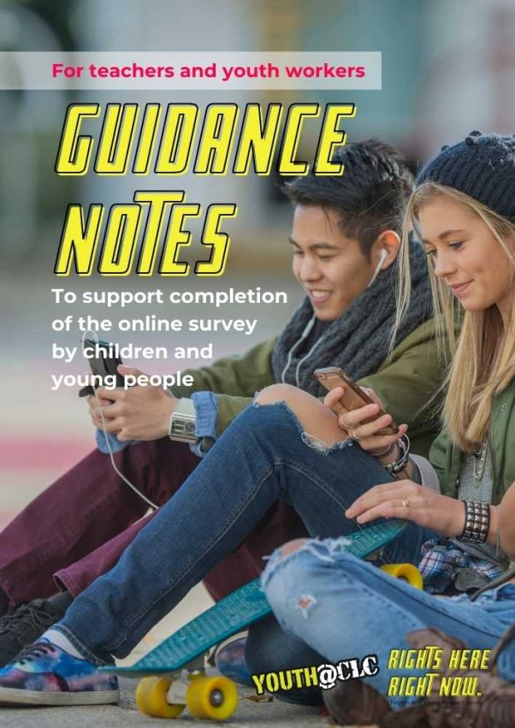
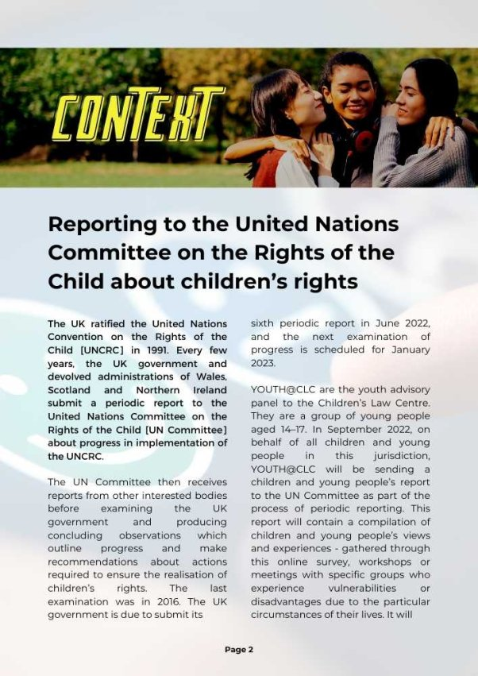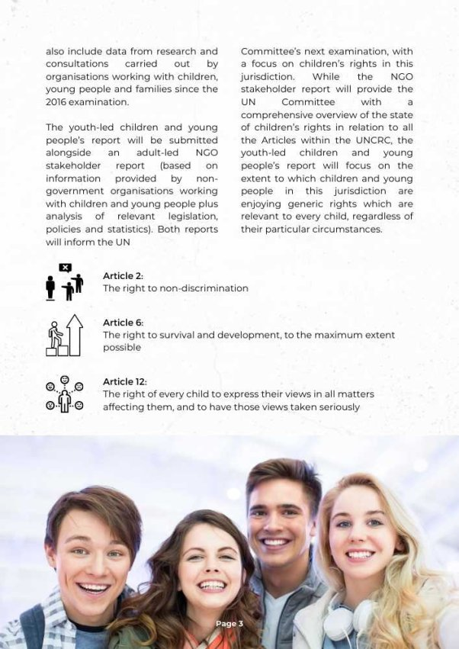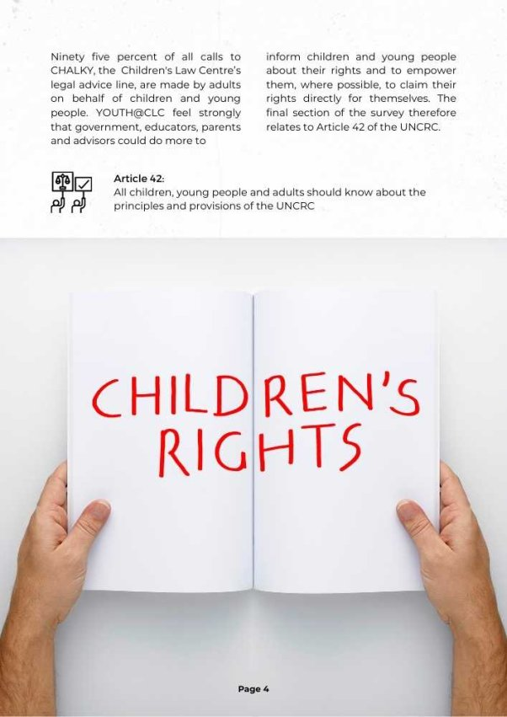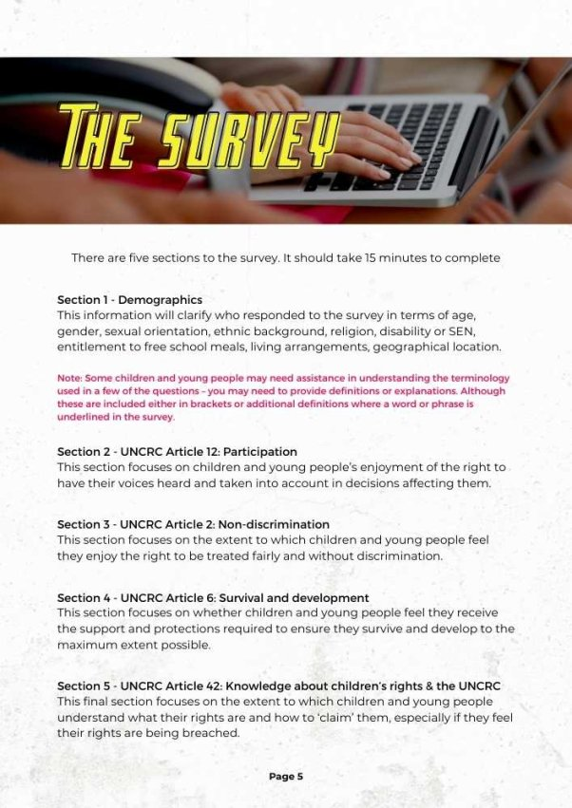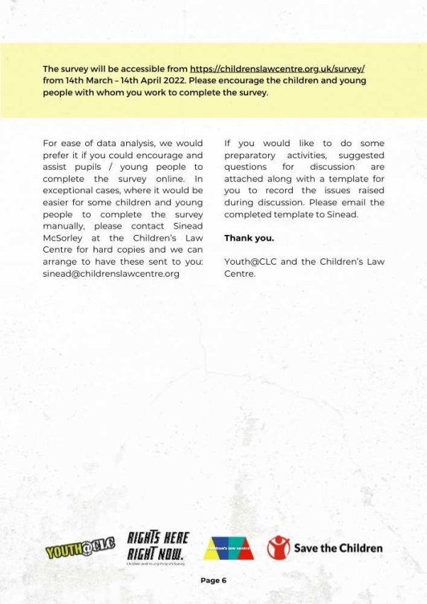

APPENDIX 2: ACTIVITIES TO SUPPORT COMPLETION OF THE SURVEY 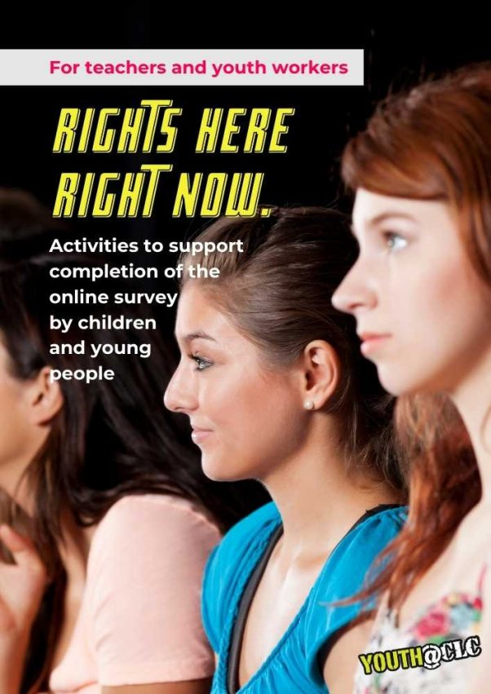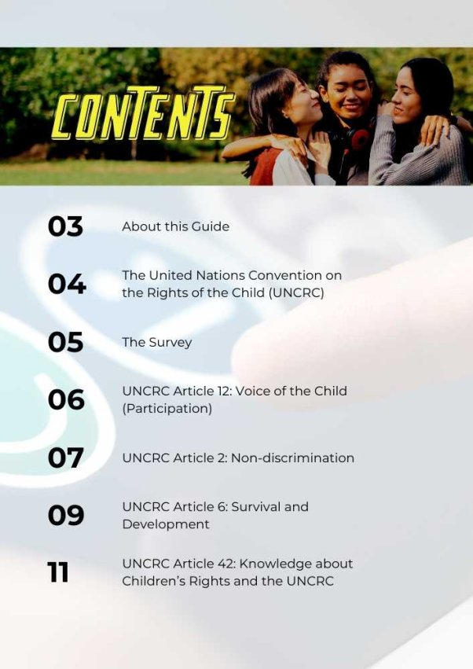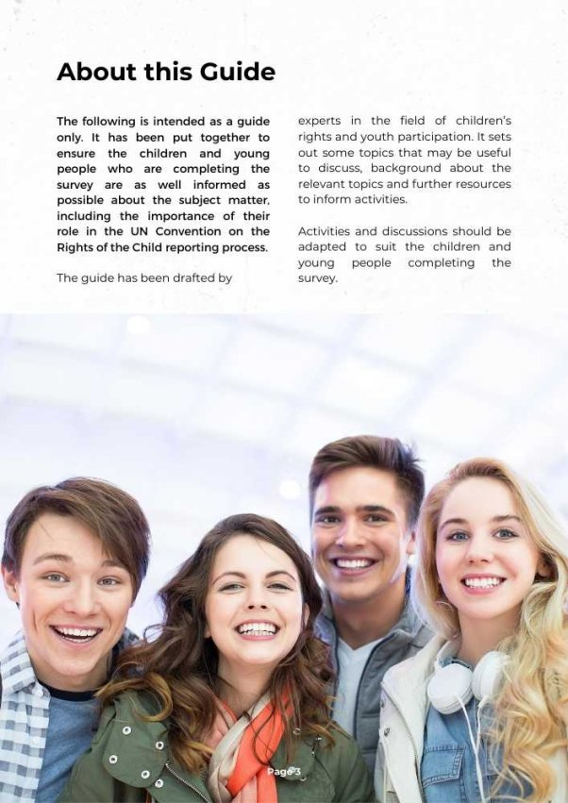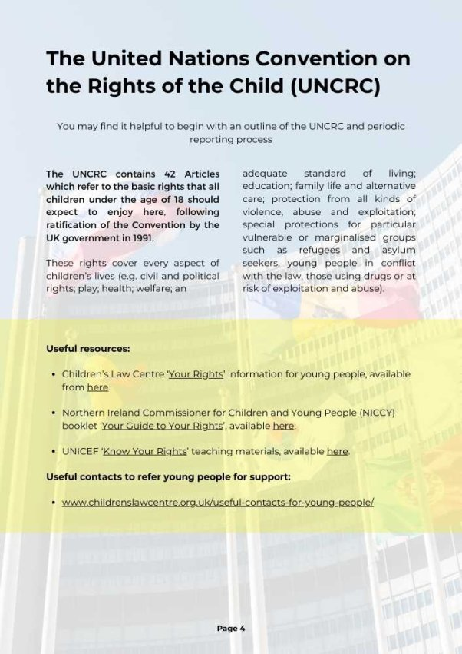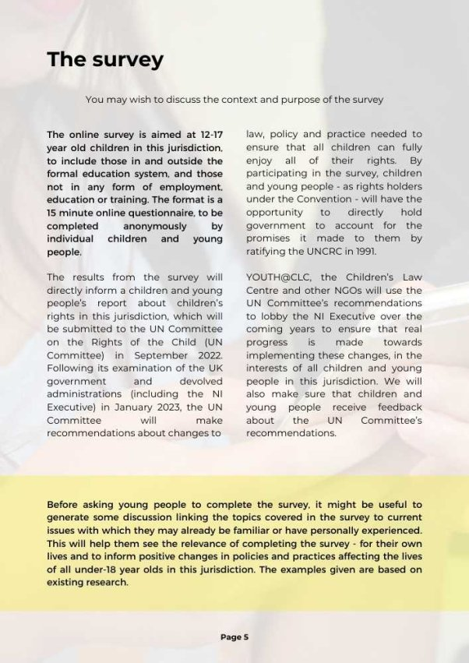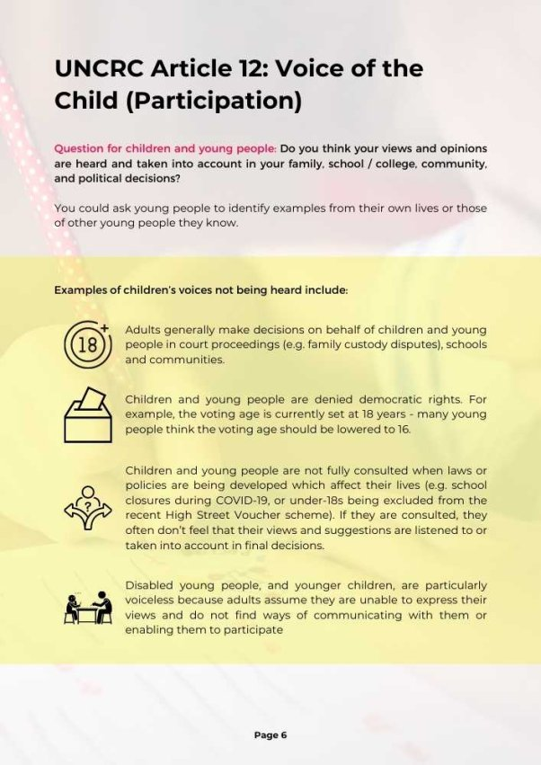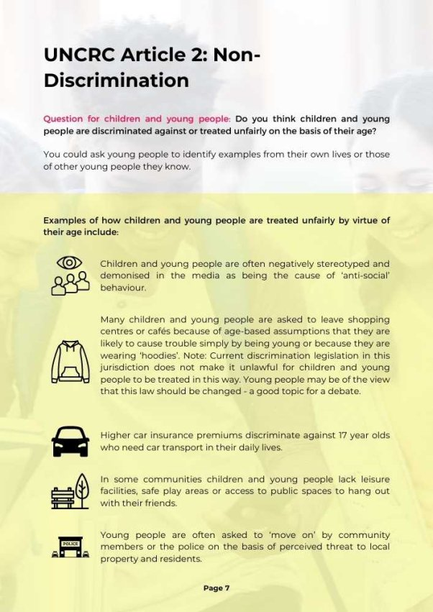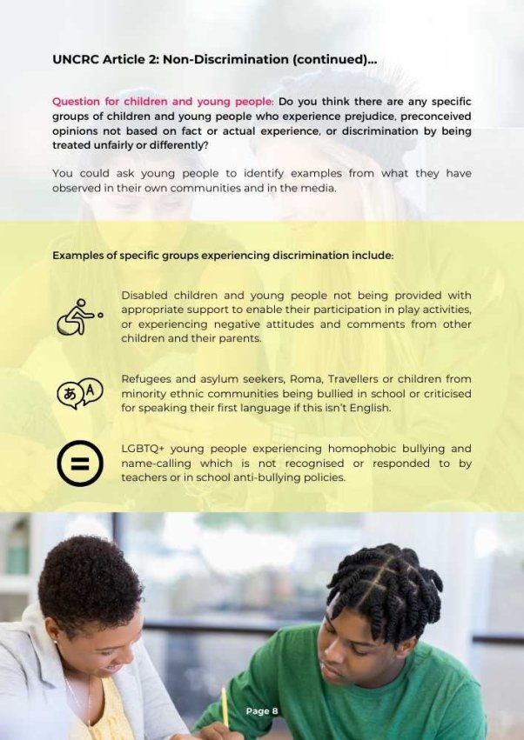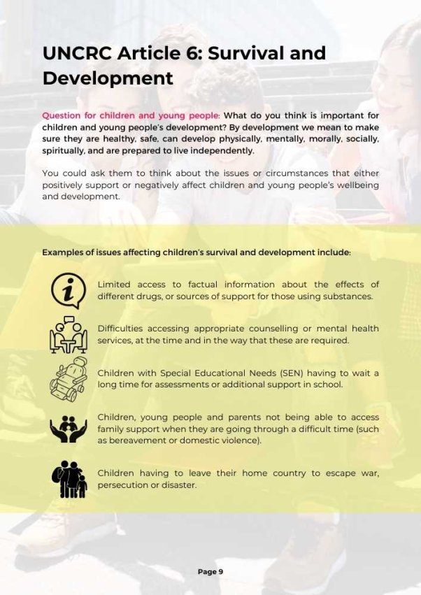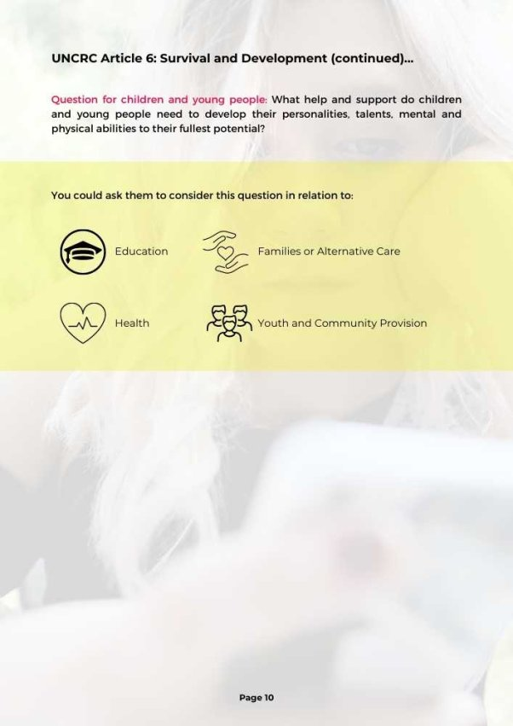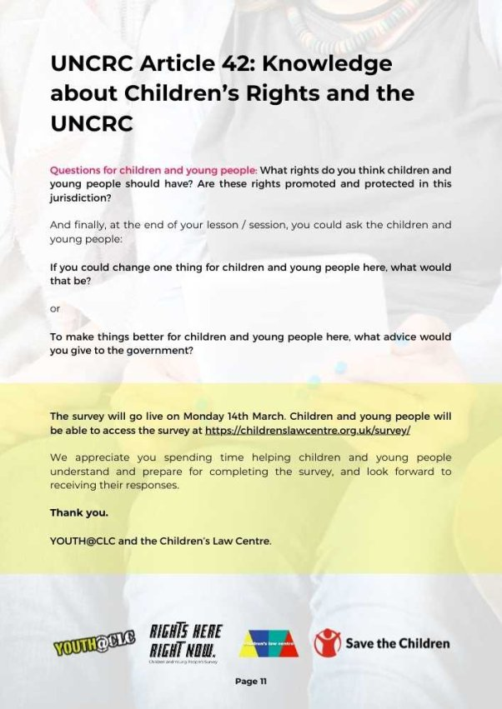

APPENDIX 3: TEMPLATE FOR RECORDING GROUP DISCUSSIONS


This template can be used to record the issues raised during discussions with children and young people in preparation for their individual completion of the online survey.
If you decide to record the examples or issues they raise, you can complete relevant sections of this template and email it to Sinead McSorley at Children’s Law Centre: sinead@childrenslawcentre.org and this information will be incorporated into the children and young people’s report.
Note: Please enter your notes and observations in the boxes provided. You can extend the size of the boxes if you need more space.

School or organisation: …………………
Number of children / young people in session: ….
Age range: ……..



UNCRC Article 12: Voice of the Child (Participation)
Question for children and young people: Do you think your views and opinions are heard and taken into account?
In your family? | Yes (number):  Examples (please list) | No (number):  Examples (please list)
At school / college? | Yes (number):  Examples (please list) | No (number):  Examples (please list)
In your community? | Yes (number):  Examples (please list) | No (number):  Examples (please list)
In decisions made by politicians? | Yes (number):  Examples (please list) | No (number):  Examples (please list)

UNCRC Article 2: Non-Discrimination
Question for children and young people: Do you think children and young people are discriminated against or treated unfairly on the basis of their age?
Yes (number):  Examples of age related discrimination (please list): | No (number):  Examples (please list):

Question for children and young people: Do you think there are any specific groups of children and young people who experience prejudice [preconceived opinions, not based on fact or actual experience] or discrimination [being treated unfairly or differently]?
In school? | Yes (number):  Examples (please list) | No (number):  Examples (please list)
In the community? | Yes (number):  Examples (please list) | No (number):  Examples (please list)
In the media? | Yes (number):  Examples (please list) | No (number):  Examples (please list)

UNCRC Article 6: Survival and Development
Question for children and young people: What do you think is important for children and young people’s development?
What do children and young people need to be healthy? | Examples (please list):
What do children and young people need to be safe and protected? | Examples (please list):
What do children and young people need to develop to their fullest potential? | Examples (please list):
What do children and young people need in preparation for living independently? | Examples (please list):
What circumstances support children and young people's wellbeing and development? | Examples (please list):
What circumstances negatively affect children and young people’s wellbeing and development? | Examples (please list):

Question for children and young people: What help and support do children and young people need to develop to their fullest potential?
In their families or alternative care? | Examples (please list):
Education? | Examples (please list):
Health? | Examples (please list):
Youth and community provision? | Examples (please list):

UNCRC Article 42: Knowledge about Children's Rights and the UNCRC
Question for children and young people: What rights do you think children and young people should have?
List each right: | Is this right promoted and protected here?
 | Yes (number): | No (number):
 | Yes (number): | No (number):
 | Yes (number): | No (number):
 | Yes (number): | No (number):

Question for children and young people: If you could change one thing for children and young people here, what would that be?
Suggestions (please list):

Question for children and young people: To make things better for children and young people, what advice would you give to the government here [NI Executive]
Suggestions (please list):

APPENDIX 4: CHILDREN’S LAW CENTRE WEBSITE INFORMATION ABOUT THE ONLINE SURVEY

Youth@CLC Launch Children and Young People’s Survey

14 March 2022

Youth@CLC, the youth advisory panel at the Children’s Law Centre, has launched an important survey to collect opinions and first-hand experiences of children and young people as part of the UK reporting process to the UN Committee on the Rights of the Child. The survey will be used to tell the UN Committee what matters to under-18s here, how their rights can be better protected, and their lives improved.

The survey can be found here and is open between 14th March and 14th April 2022. The results of the survey will inform a children and young people’s report to the UN Committee as part of the 2022-2023 reporting process. It will influence the outcome of the UN Committee’s examination of the UK government in 2023.
Children and young people can click here to find out more about children’s rights, the UNCRC and the survey.
CLC Youth Participation Worker, Sinead McSorley said: “This is a very important way for children and young people in this jurisdiction to feed into the UNCRC reporting process. Their experiences and opinions are key to understanding if the UK government is fulfilling the obligations it signed up for when it ratified the UNCRC in 1991. We know children’s rights have a massive impact on the lives of children and young people, from education and healthcare to leisure and youth justice. However, we can’t fully understand how well these rights are being protected, or where the gaps are, unless we get the views of as many under-18s as possible. The last UNCRC report was sent to the Committee in 2015, but so much has happened since then, including the UK’s decision to exit the European Union and the outbreak of COVID-19. It’s our experience, and the experience of a wide number of children’s organisations, that the gap in children’s rights here has grown into a chasm. It’s vital that we gather the views of children and young people to better inform our understanding.”

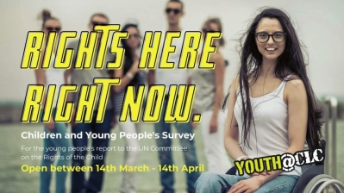

Wren, a member of Youth@CLC, said: “As part of the children and young people’s report, we will be carrying out a survey and holding workshops with some of the most vulnerable children and young people here to better understand where the government might be failing in its obligations. It’s really important that we gather as many views as possible to give children and young people a real voice. The reporting process doesn’t come around every year, so please make sure you don’t miss this opportunity to have your say.”

We have developed some materials for teachers and youth workers to prepare and assist children and young people to complete the survey:
- Guidance to support children and young people with completion of the survey
- Activities to support children and young people with completion of the survey
The ‘Rights Here, Right Now’ survey is being conducted by Youth@CLC, with assistance from the Children’s Law Centre, Dr Deena Haydon and Save the Children NI


APPENDIX 5: RIGHTS HERE, RIGHT NOW SURVEY

Youth@CLC 2022 Children’s Rights Survey
We are Youth@CLC – a group of young people who give advice to the Children’s Law Centre. We want to find out what 12-17 year olds think about children’s rights in Northern Ireland.
The survey is anonymous. You can find out more about it in our information sheet here.
You don’t need to answer every question if you don’t want to, but please make sure you click the ‘done’ button at the end to submit your survey.
This is your chance to have your voice heard and make children’s lives better.
Information about you
We would like to know about you. This will help us describe who took part in the survey.
- What is your age? (please select one)
- 12-13
- 14-15
- 16-17
- Other (please state)

- How would you describe your gender? (please select one – responses are confidential)
- Girl (including trans girl)
- Boy (including trans boy)
- Non-binary
- I use another term (please describe your gender)
- Prefer not to say

- How would you describe your sexual orientation or sexuality – who you are attracted to? (please select one)
- Bisexual (attracted to both males and females)
- Straight / Heterosexual (attracted to people of the opposite sex)
- Pansexual (attracted to a person, whether the person is male or female, gay or straight)
- Gay / Lesbian (attracted to people of the same sex)
- Fluid (attraction changes over time or depends on the situation)
- Asexual (not attracted to other people)
- Don’t know
- Other (please describe your sexuality)
- Prefer not to say

- How would you describe your ethnic background? An ethnic group has a shared culture, religion, customs and language (please select one)
- Mixed or multiple ethnic backgrounds
- Arab
- White
- Black or Black British/Irish (African, Caribbean)
- Roma
- Asian or Asian British/Irish (Indian, Pakistani, Bangladeshi, Chinese)
- Irish Traveller
- Don’t know
- Other (please say what this is)

- How would you describe your religion or faith? (please select one)
- Sikhism: I am Sikh
- Islam: I am Muslim
- Buddhism: I am Buddhist
- I have no religion
- Christian: I am Catholic
- Hinduism: I am Hindu
- Judaism: I am Jewish
- Atheist: I don’t believe in God
- Christian: I am Protestant (eg Presbyterian, Church of Ireland, Methodist, Baptist)
- Don’t know
- Other (please say what this is)
- Prefer not to say

- Do you have a disability or special educational needs?
- Yes
- No
- Don’t know

- Are you eligible for (entitled to) free school meals?
- Yes
- No
- Don’t know

- Where do you live at the moment? (please select one)
- In care (with members of my family, foster parents, or residential care)
- On my own
- In a hospital
- In secure care (Lakewood)
- In a hostel
- With my parent(s)
- With friends or a partner
- In custody (Woodlands)
- In a child and adolescent mental health unit (Beechcroft)
- Other (please say where)

- Which word best describes the area where you live? (please select one)
- Town
- City
- Village
- Countryside

- Which county do you live in? (please select one)
- Antrim
- Londonderry / Derry
- Armagh
- Down
- Fermanagh
- Tyrone
- Don’t know

UNCRC Article 12: Participation
We would like to know whether the adults in your life ask your opinions, listen to you and take what you say seriously – about your participation.
- We want to know about your place of education.
Do you agree or disagree with the following statements? (please select one answer for each statement)
In my place of education, teachers ask for my opinion about…
 | Strongly disagree | Disagree | Neither disagree nor agree | Agree | Strongly agree
How we are taught
What we learn
The rules we have to follow
How to make my education better
How decisions are made about school/ College policies

- Do you think the adults in your place of education would listen to you if you gave them your opinion? (please select one answer)
- Yes
- No
- Don’t know

- We also want to know if you think the adults in your ‘home life’ – those you live with – ask for your opinions.
Do you agree or disagree with the following statements? (please select one answer for each statement)
In my ‘home life’, the adults…
 | Strongly disagree | Disagree | Neither disagree nor agree | Agree | Strongly agree
Allow me to give my opinion
Make it easy for me to give my opinion
Ask for my opinion when they decide things
Talk to me about how decisions are made

- Do you think the adults in your ‘home life’ would listen to you if you gave them your opinion? (please select one answer)
- Yes
- No
- Don’t know

- Do you think the adults in your community [your neighbourhood or the area you live in] take your opinions seriously?
Do you agree or disagree with the following statements? (please select one answer for each statement)
In my community, the adults ask me about…
 | Strongly disagree | Disagree | Neither disagree nor agree | Agree | Strongly agree
How happy I am with things to do in my area (eg youth clubs, libraries, sports centres)
How happy I am with the services in my area (eg transport, health centres, schools)
New activities or services we need
How to make my community safer

- Do you think the adults in your community would listen to you if you gave them your opinion? (please select one answer)
- Yes
- No
- Don’t know

- Now we would like to know if politicians [decision makers like MLAs, MP, councillors and government Ministers] here ask children and young people their opinions and listen to what they say.
Do you disagree or agree with the following statements? (please select one answer for each statement)
Politicians ask me about…
 | Strongly disagree | Disagree | Neither disagree nor agree | Agree | Strongly agree
Issues that affect me or other young people in my area
How to get young people involved in decision making
Plans or changes in my area

- Do you think politicians would listen to you if you gave them your opinion?
- Yes
- No
- Don’t know

UNCRC Article 2: Non-discrimination
The next set of questions ask your opinion on whether you feel children and young people are treated fairly or not.
- Do you agree or disagree with the following statements? (please select one answer for each statement)
 | Strongly disagree | Disagree | Neither disagree nor agree | Agree | Strongly agree
Adults in my area are pleased to see children playing out
Adults in my area are respectful to young people
Me and my friends get on well with the adults in our area
Children and young people are often told to move on when hanging out with their friends at the shops or in the parks in our area

- Do you agree or disagree with the following statements? (please select one answer for each statement)
 | Strongly disagree | Disagree | Neither disagree nor agree | Agree | Strongly agree
There are safe places for me and my friends to hang out in my area
Young people in my area trust the police
Children and young people are negatively stereotyped in the media [newspapers, TV, radio, social media] – it is assumed that they misbehave or are ‘anti-social’

UNCRC Article 6: Survival and development
These questions are about whether you think children and young people are given the help they need to survive [live well] and develop to their fullest potential [the best they can].
- Do you think you have the help and support you need for your development and to gradually become more independent [able to do things for yourself]? (your answers are anonymous)
- Yes
- No
- Don’t know

- Are you given the care and protection you need to feel well, cared for and safe? (your answers are anonymous)
- Yes
- No
- Don’t know

- Do you agree or disagree with the following statements? (please select one answer for each statement)
 | Strongly disagree | Disagree | Neither disagree nor agree | Agree | Strongly agree
I can easily find things to do and places to go in my area
I can afford to go to places like the cinema or leisure centre
I can easily see a doctor or health worker when I am physically unwell (eg if I feel ill or have a pain somewhere on my body)
I can quickly see a counsellor or specialist when I need support for my mental health (eg if I am worried, anxious or depressed)

- Do you agree or disagree with the following statements? (please select one answer for each statement)
 | Strongly disagree | Disagree | Neither disagree nor agree | Agree | Strongly agree
If I want to talk to someone about a problem or worry, I know where to go for help and support
I feel confident [able] to ask for and get help or support if I need it
I would know who to contact if I didn’t feel safe or properly cared for

- Who would you talk to if you had a worry, wanted help or support? (please select all that apply – you can choose more than one)
- Parent(s)
- Relative [brother, sister, grandparent, aunt, uncle, cousin]
- Friends
- Teacher
- School Counsellor
- Doctor
- Youth Worker
- Social Worker
- Religious Leader [Priest, Nun, Vicar, Imam, Rabbi, Pastor]
- Helpline [free phone or online]
- A specialist organisation not listed
- I would not ask for help because… (please explain)
- Don’t know

- Do you think children and young people are given adequate [good enough] information in school about the following topics? (please select ‘yes’, ‘no’ or ‘don’t know’ for each topic)
 | Yes | No | Don’t know
Relationship and Sex Education (including gender and consent)
Drugs, alcohol, substance use
Gambling
Mental health
Life skills [learning to cook, being creative, problem solving, understanding other people, being able to work in groups]
Career options [different types of jobs]
Family support [extra help for parents and children]
Organisations offering confidential help and support about issues faced by children and young people

UNCRC Article 42: Knowledge about children’s rights
Do children and young people know about the UN Convention on the Rights of the Child [UNCRC]?
You can find out more about the UNCRC here.
- Had you heard about children’s rights before doing this survey?
- Yes (and I knew what children’s rights meant)
- Yes (but I wasn’t sure what children’s rights meant)
- No (I hadn’t heard of children’s rights)

- If you answered ‘yes’ in the last question, where did you hear about children’s rights? (please select all the answers that apply – you can select more than one)
- School
- Friends
- Parents/ guardians/ carers
- Youth club or community group
- On the internet
- Media (TV, radio, social media)
- Other (please state)

- Had you heard about the UN Convention on the Rights of the Child (UNCRC) before doing this survey?
- Yes (and I knew what it was)
- Yes (but I wasn’t sure what it was)
- No (I had not heard of the UN Convention on the Rights of the Child or UNCRC)

- If you answered ‘yes’ in the last question, where did you hear about the UNCRC? (please select all the answers that apply – you can select more than one)
- School
- Friends
- Parents/ guardians/ carers
- Youth club or community group
- On the internet
- Media (TV, radio, social media)
- Other (please state)

- Have you heard of the Northern Ireland Commissioner for Children and Young People (NICCY)?
- Yes (and I knew what it was)
- Yes (but I wasn’t sure what it was)
- No (I hadn’t heard of NICCY)

- If you answered ‘yes’ in the last question, where did you hear about the NI Commissioner for Children and Young People? (please select all the answers that apply – you can select more than one)
- School / College
- Friends
- Parents/ guardians/ carers
- Youth club or community group
- On the internet
- Media (TV, radio, social media)
- Other (please state)

- Do you agree or disagree with the following statements? (please select one answer for each statement)
 | Strongly disagree | Disagree | Neither disagree nor agree | Agree | Strongly agree
I know a lot about my rights
I understand what children’s rights mean in my life
I know where to get information about my rights
I know who to contact if I am treated unfairly
I am confident in making a complaint if I am treated unfairly

- How much do you agree or disagree with the following statement?
Children and young people should learn about their rights. (please select one answer)
- Strongly disagree
- Disagree
- Neither disagree nor agree
- Agree
- Strongly agree

- Where do you think children and young people should learn about their rights? (please select all the answers that apply – you can select more than one)
- Schools
- Colleges
- Youth clubs
- Libraries
- Social media
- Organisations like UNICEF, Amnesty International or the NI Commissioner for Children and Young People (NICCY)
- Northern Ireland Human Rights Commission (NIHRC)
- I don’t think we should learn about children’s rights
- Other (please say where)

Thank you for completing our survey
Don’t forget to hit ‘done’ to submit your answers.
If you would like advice about your rights, you can visit REE Rights Responder at reerights.com



APPENDIX 6: SURVEY RESPONDENT DEMOGAPHICS
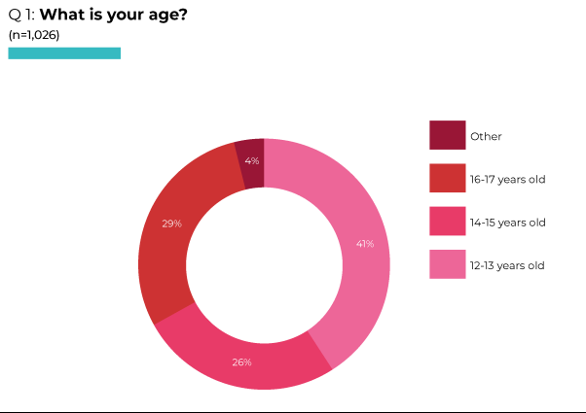
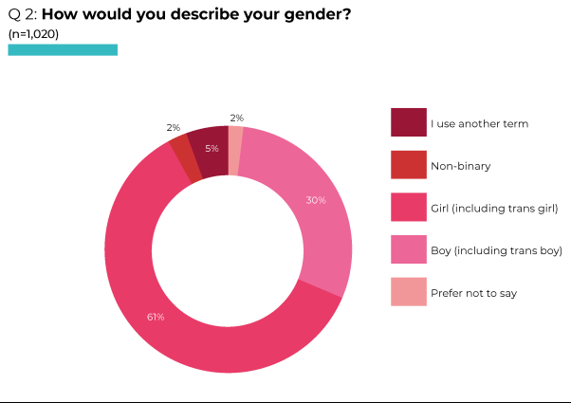
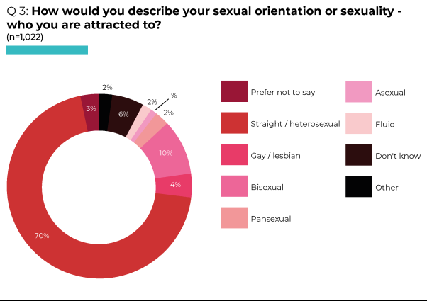
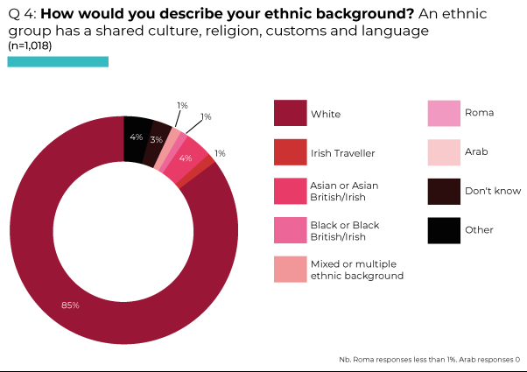
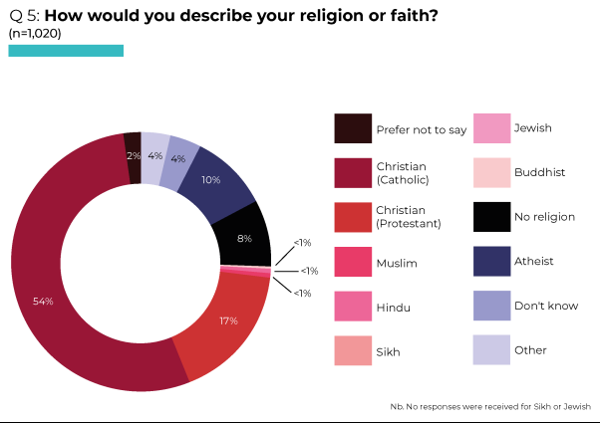
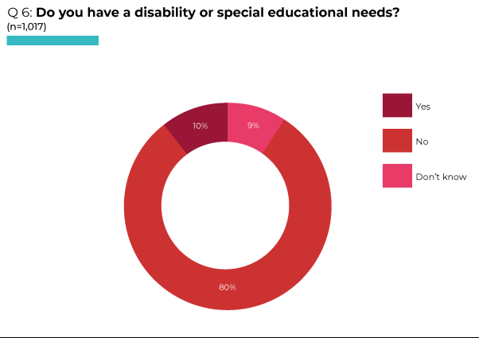
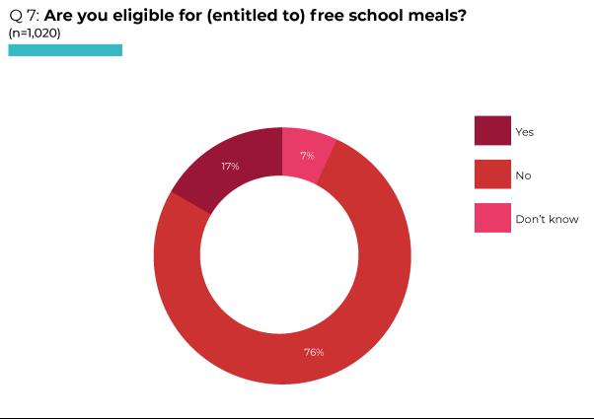
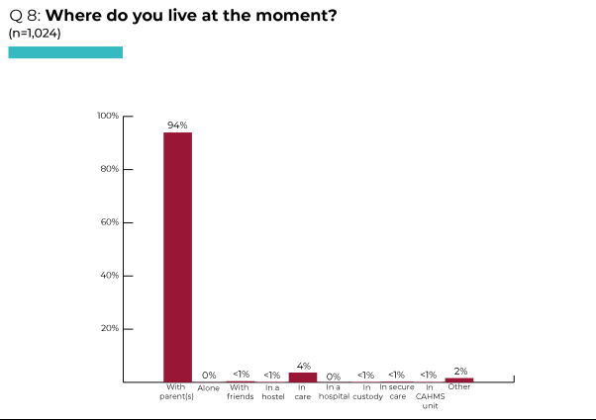
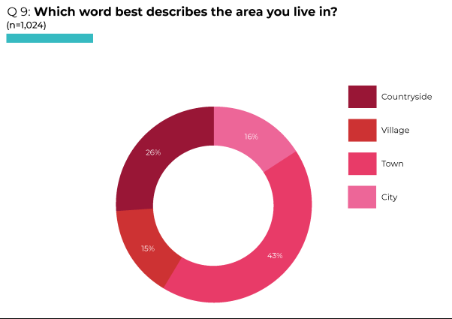
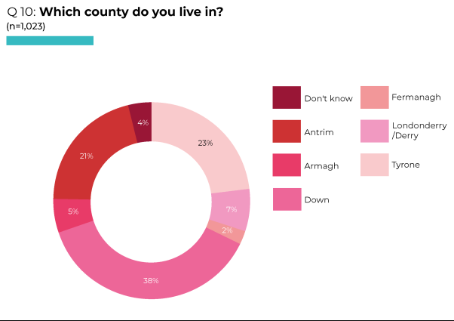
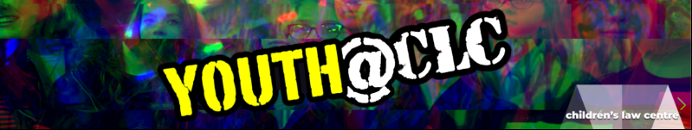
APPENDIX 7: WORKSHOP INFORMATION FOR CHILDREN AND YOUNG PEOPLE

RIGHTS HERE, RIGHT NOW
INFORMATION FOR CHILDREN AND YOUNG PEOPLE

What are ‘Rights’?
‘Rights’ are sometimes known as ‘entitlements’ – something you should have or be able to do. For example, you have a right to live, to be able to get the health services you need, to have an education, to have a say and be listened to about things that affect you.

Signing up to children’s rights

In 1991, the UK Government signed up to the United Nations Convention on the Rights of the Child (UNCRC), which explains the rights every child should have.
In the Convention, a ‘child’ is everyone under 18 years old.
By signing the Convention, the Government promised:
- to protect children’s rights – make sure children and young people are allowed to do what their rights say, and
- to promote children’s rights – make sure people know what rights children have.

Keeping the promise – reporting to the United Nations Committee on the Rights of the Child

Every few years, the UK Government write a report about how well it is doing at keeping the promise to protect and promote children’s rights.
This report is sent to a group of experts – the United Nations Committee on the Rights of the Child.
Non-government organisations (eg charities and community groups) also send reports about how they think the Government is doing. They make sure that the Committee hear the views of children and young people.

What’s next?

The UK Government will send their report to the Committee in June 2022. It will include information from Northern Ireland, Scotland, Wales and England.

The Children’s Law Centre (CLC) is a charity that works to protect the rights of all children living in NI. Youth@CLC, youth advisory panel of CLC are writing a Children and Young People’s Report which will be send to the Committee in September 2022.

As part of this report, Sinead McSorley (Youth Participation and Advocacy Worker in CLC) and Deena Haydon (Researcher) would like to speak to you.
We will ask what you know about your rights, whether you think your rights are being promoted and protected at school or college, in your family or where you live, in your community, by the people who work with you and by politicians.

We will write about your answers in our report, but anything you say will be anonymous. This means that we will tell people what you said, but not who said it. For example, we might say “some young people think…” or we might use your words, but we won’t use your name or include any details about you.
This means you don’t have to worry or feel embarrassed because no-one outside of the group will know what you said.

We hope you agree to talk to us, and we look forward to meeting you!

Sinead and Youth@CLC



APPENDIX 8: WORKSHOP CONSENT FORM FOR CHILDREN AND YOUNG PEOPLE

RIGHTS HERE, RIGHT NOW
CONSENT FORM
Youth@CLC, Youth Advisory Panel of the Children’s Law Centre, are writing a report to the United Nations Committee on the Rights of the Child and want to speak to you about Children’s Rights in Northern Ireland.
I understand that:
- I don’t have to take part if I don’t want to
- If I do take part, I will be asked what I know about rights and I have been given an information sheet about this
- I don’t have to answer anything I don’t want to
- There are no wrong answers
- If I want to stop or leave the meeting this is ok and I don’t have to give a reason
- Some of the things I say might be used in reports or presentations about children’s rights in Northern Ireland, but my name will not be used
- If our discussion is recorded, it will only be listened to by the people writing the report
- Any information about me will be kept private, unless there are worries about my safety or wellbeing – Sinead has explained anonymity and confidentiality
- If I have any worries or questions I can talk to Sinead or one of the project workers


I agree to take part in the group
Name: ……………………………. Age: …….. Group: ………………….

Signature: ………………………………………. Date: …………………….
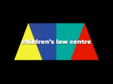
APPENDIX 9: CONSENT FORM FOR PERSON WITH PARENTAL RESPONSIBILITY
RIGHTS HERE, RIGHT NOW
INFORMATION & CONSENT FORM FOR PERSON WITH
PARENTAL RESPONSIBILITY
Dear Parent/Guardian,
Youth@CLC, Youth Advisory Panel of the Children’s Law Centre are writing a report about children’s rights in Northern Ireland. We want to find out whether the Government are doing everything they should to make sure that children and young people are healthy, safe, cared for, able to learn, have access to leisure and recreational activities, involved in making decisions, respected and know about their rights.
Deena Haydon (an experienced researcher working with the Children’s Law Centre) and Sinead McSorley (Children’s Law Centre Youth Participation and Advocacy Worker), would like to speak to young people in [organisation] in the following weeks.
They will ask young people, in small groups or individually, their views and opinions. What the young people say might be included in the report and in future publications or presentations on the issues they raise, but their names will not be used. It is important to hear from all young people, including those in [location], so we would be grateful if you would give permission.
If you agree, please fill in this form and send it back to Sinead by email: sinead@childrenslawcentre.org
If you would like more information, or have any questions, please contact Sinead at the Children’s Law Centre. Tel: 02890245704, Email: Sinead@childrenslawcentre.org
Thank you.
CONSENT FROM PERSON WITH PARENTAL RESPONSIBILITY
I give permission for __________________ to take part in a meeting with Deena Haydon and Sinead McSorley from the Children’s Law Centre on [organisation] premises.
I understand that their name will not be used in any publications or presentations about what young people from [location] have said.
Young person’s name: ………………………………………… and age: ………
Name of person with parental responsibility: ………………………………………..
Date: ………………….

APPENDIX 10: ACTIVITIES TO SUPPORT INVOLVEMENT IN A WORKSHOP OR MEETING
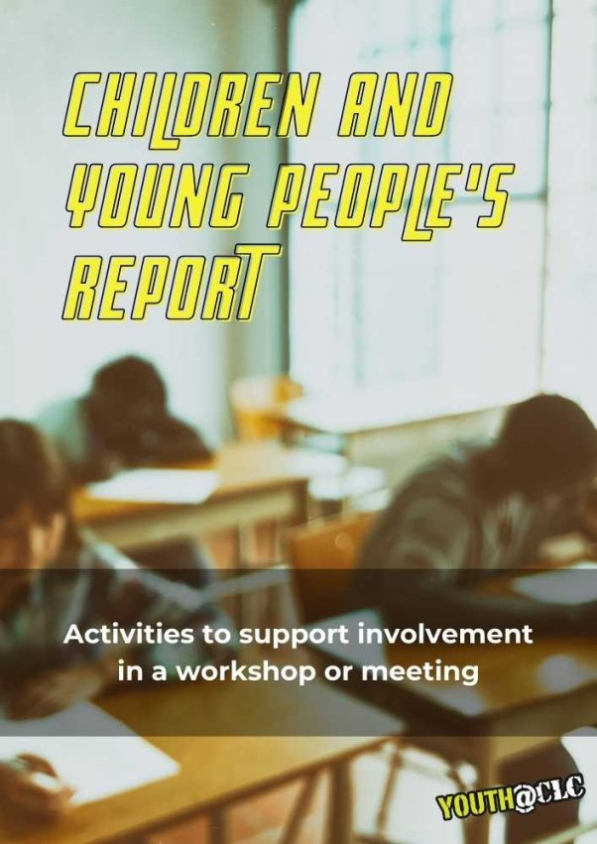
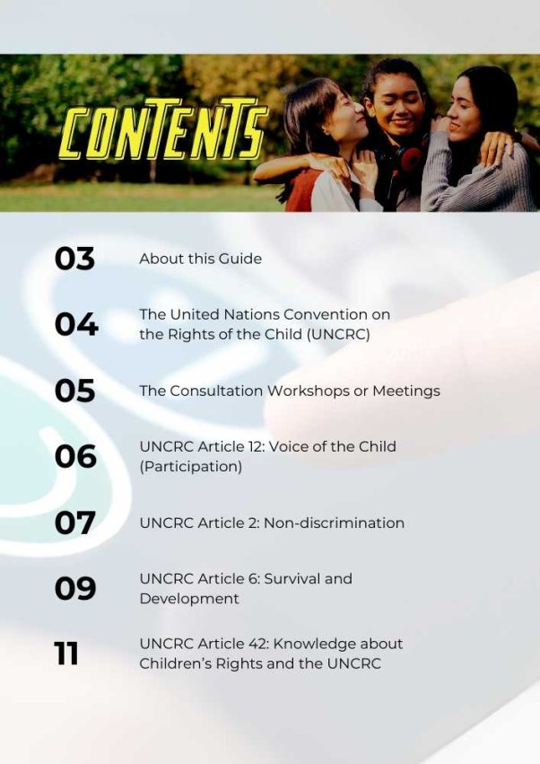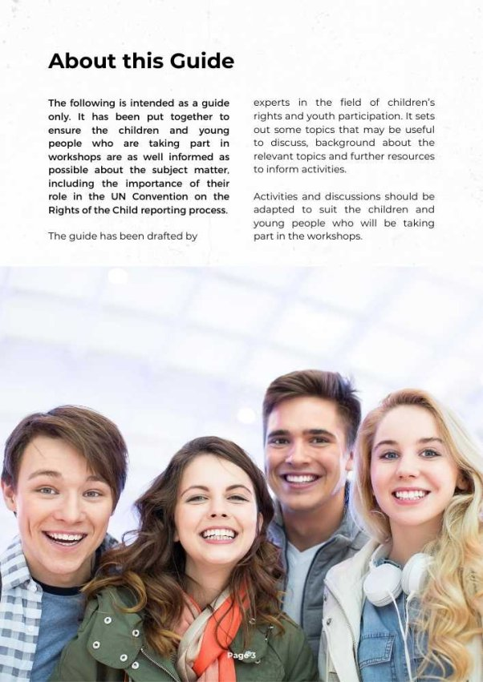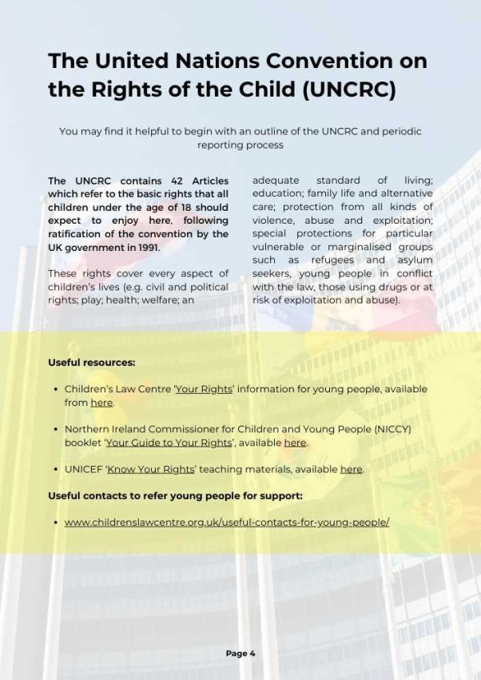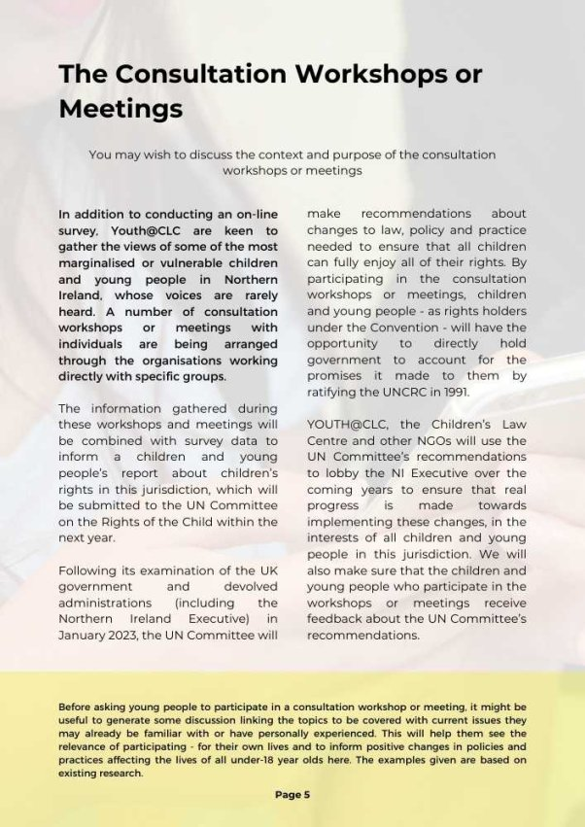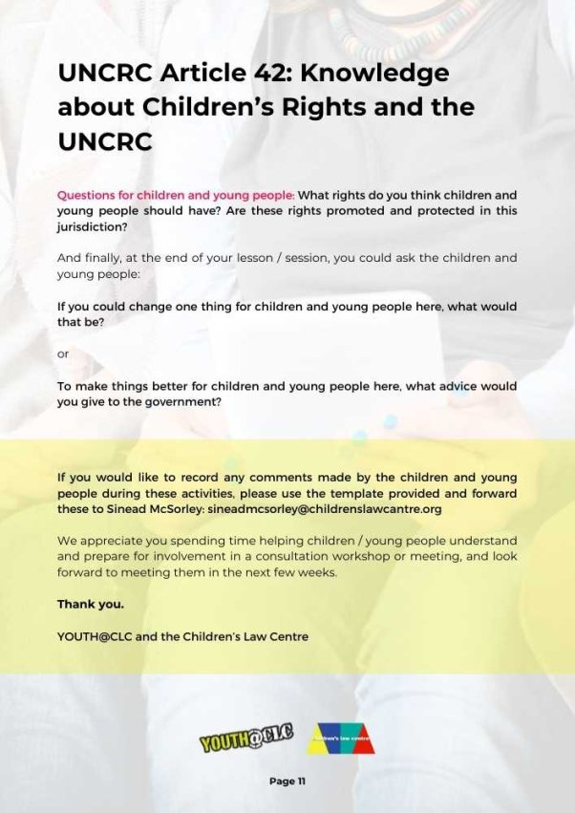

APPENDIX 11: WORKSHOP AND MEETING PARTICIPANTS
12 workshops and 8 meetings (5 with individuals, 3 with pairs) were held with children and young people between April and October 2022.
These focused on the views of ‘vulnerable’ or ‘disadvantaged’ groups - who were less likely to complete the survey and who have specific needs or experiences which are not necessarily reflected in generic consultation processes.
In total, 127 children and young people were involved in consultation workshops or meetings in various locations across Northern Ireland, including: Belfast, Bangor, Omagh, Dungannon, Coalisland, Craigavon, Ballymena, Derry/ Londonderry, Newtownards.
Group of children/ young people | No | Gender | Age | Location | Organisation | Date
Young people in custody | 4  (2 mtgs) | 1 female,  3 males  + 2 T’s | 16-17 | Bangor | Woodlands Juvenile Justice Centre | 8.4.2022
Young people with significant mental health issues | 3  (2 mtgs) | 1 female,  2 males  +  VOYPIC  Advocacy Worker | 16-17 | Belfast | Beechcroft  In-patient Child and Adolescent Mental Health Unit | 25.4.2022
Young people in conflict with the law | 6 | 4 females, 2 males | 16-18 | Ballymena | Give and Take Scheme,  Include Youth | 26.4.2022
Young people in conflict with the law | 3 | 2 females, 1 non-binary | 19-22 | Newtownards | Give and Take Scheme,  Include Youth  *Workshop discussion by organisation | 26.4.2022
Looked after children and  care leavers | 10  (2x 5) | 7 females, 3 males | 12-18 | Ballymena and  Derry/ Londonderry | Voice of Young People in Care [VOYPIC]  *Workshop Template | 12.4.2022 and 14.2.2022
Children and young people with disabilities | 7 | 3 females, 4 males  + 3 staff  1 female aged 24 | 15-16 | Craigavon | Barnardo’s Disabled Children and Young People’s Participation Project [DCYPPP] | 27.4.2022
Children and young people from minority ethnic communities (migrants) | 30 | 14 females,  16 males | 6-15 | Dungannon | Polish Language Club, South Tyrone Empowerment Programme [STEP]  *Workshop Template | 9.4.2022
Children and young people from minority ethnic communities (migrants) | 11 | 4 females,  7 males  + 3 staff | 8-12 + 1x 16 | Dungannon | Polish Group,  South Tyrone Empowerment Programme [STEP] | 30.4.2022
Children and young people from minority ethnic communities (migrants) | 20 | 11 females,  9 males  + 3 staff | 9-15 | Dungannon | Russian and Lithuanian Group, South Tyrone Empowerment Programme [STEP] | 21.5.2022
Traveller children and young people | 10 | 4 males, 6 females | 7-10 | Coalisland | An Tearmann Travellers’ Homework Club,  South Tyrone Empowerment Programme [STEP] | 11.10.2022
Refugee and asylum seeking young people | 6 | 6 females | 13-15 | Belfast | Homework Club,  Conway Education Centre  *Workshop Template | 13.10.2022
Homeless young people  (looked after) | 1  mtg | 1 female | 17 | Belfast | Simon Community | 14.6.2022
LGBTI+ young people | 8 | 2 females, 2 males, 2 identifying as ‘they’, 2 unspecified  + 1 staff | 15-18 | Omagh | Cara-Friend | 8.6.2022
Young children | 5 | 1 female, 4 males | 10 | Bangor | PlayBoard  YMCA After School Group | 7.6.2022
Young people in secure care | 3  (3 mtgs) | 1 male, 2 females  + NIACRO IR worker + 1 staff | 13-15 | Bangor | Lakewood Secure Care Centre | 11.10.2022

APPENDIX 12: WORKSHOP AND MEETING QUESTIONS
The workshop or meeting facilitators used the same set of questions with each group, pair or individual. These were based on the topics covered in the online survey:
KNOWLEDGE ABOUT CHILDREN’S RIGHTS
Just to get us started, we’re going to spend a bit of time thinking about children’s rights

- Do you know what Rights are?
‘Rights’ are sometimes known as ‘entitlements’ – something you should have or be able to do. For example, you have a right to live, to be able to get the health services you need, to have an education, to have a say and be listened to about things that affect you.

- Have you ever heard of Children’s Rights?
*TRAFFIC LIGHT: Red = no, Green = yes, Amber = don’t know, not sure
Children’s rights are for all children and young people aged under 18

- Can you give us some examples of children’s rights?

- Do you think children and young people should learn about children’ rights?
*TRAFFIC LIGHT: Red = no, Green = yes, Amber = don’t know, not sure
- If so, where should they learn about children’s rights?
- How should they learn about children’s rights?

- Have you heard of the Northern Ireland Commissioner for Children and Young People – sometimes called NICCY?
- If so, how did you hear about the Commissioner?
- What do you think the Commissioner does?

- Have you ever heard of the United Nations Convention on the Rights of the Child – sometimes called UNCRC?
- If so, how did you hear about it?
- What do you think the UNCRC is?

ARTICLE 12: PARTICIPATION
This is about the right to share your views in all matters affecting you and for these to be given due weight (taken seriously).

- Do you think children and young people are helped to express (share) their views in all matters affecting them?

- Do the adults in your life ask your opinions, listen to you, and take what you say seriously?
- At home/ where you live?
- In your place of education (eg school, college, training centre)?
- In your community – the area where you live?
- In decisions made by politicians?

ARTICLE 2: NON-DISCRIMINATION
This is about your right to be free from discrimination (unfair treatment based on your race, colour, sex/gender, language, religion, political opinion, background, ability etc).

- Do you think children and young people are treated differently from adults?
Can you give any examples of unfair treatment?

- Do you think any particular groups of young people are treated unfairly or experience discrimination? For example:
Disabled children and young people?
Looked after children and care leavers?
Poor children and young people?
Refugees and Asylum Seekers?
LGBTQ+ young people?
Travellers?
Children from other countries or cultures?
Irish speaking children and young people?
Young parents?
Young people in trouble with the police?
Any other group?

In their place of education (eg school, college, training centre)?
In their community – the area they live?
In the media – TV, radio, newspaper, online?

ARTICLE 6: RIGHT TO LIFE, SURVIVAL AND DEVELOPMENT
This is about your right to life and to opportunities to help you develop to your fullest potential. The government has a responsibility to do as much as it can to make sure you are healthy, cared for and safe.

- Do you think all children and young people receive the help and support they need for their development and to gradually become more independent (able to do things for themselves)?
- If not, which children and young people don’t have the support they need?
- What support do these children and young people need?
- Who should provide this support?
- When, where and how should they receive this support?

In their families or alternative care?
In schools/colleges?
In health services?
In youth and community groups?

- Do you think all children and young people are given the care and protection they need to feel well, looked after and safe?

- If not, which children and young people don’t have the care and protection they need?
- What support do these children and young people need?
- Who should provide this support?
- When, where and how?

In their homes?
In their schools?
In the community
In youth and community groups?

- If you ever asked for help with personal problems, did you think the help you received was good enough?
*You don’t have to tell us what the problems were

- Are there any services you need which you can’t get?
- Who should provide these services?
- When, where and how?

MESSAGES FOR GOVERNMENT
- Choose either of these
If you were meeting politicians tomorrow to talk about children’s rights in Northern Ireland, what would your message be? OR
If you were the First Minister for a day, what would you do/ what would you change for children and young people?

The RIGHTS HERE, RIGHT NOW: Children and Young People’s Report, Northern Ireland NGO Stakeholder Report 2 and Stakeholder Report 2: Evidence, can be accessed on the Children’s Law Centre website: https://childrenslawcentre.org.uk/policy-work/
Woodlands Juvenile Justice Centre accommodates male and female 10-17 year olds, placed in custody under PACE (where the JJC is a ‘place of safety’ for a short period), on remand, or sentenced. Beechcroft in-patient child and adolescent mental health Unit accommodates under-18s requiring assessment or treatment for complex mental illness or as a result of acute risk – some voluntarily, others under a Mental Health Order. Under a Secure Accommodation Order young people aged 13-17 who are at risk of significant harm or injury to themselves/ others may be placed in Lakewood Secure Care Centre.
Campbell, E. and McMahon, D. (2015) Our Lives in Our Words. Northern Ireland Young People’s Report to the United Nations Committee on the Rights of the Child, Children’s Law Centre and Save the Children NI, p12
Linked to LAC [Looked After Children] reviews, ‘trusts’ are activities such as going out to coffee, to see a film or on a shopping trip with a member of staff – agreed between staff and the young person, then by other relevant agencies or the young person’s family. These are built up – from 30-45 minutes to an hour, then half day, etc.
UN Committee on the Rights of the Child (2016) Concluding observations on the fifth periodic report of the United Kingdom of Great Britain and Northern Ireland, CRC/C/GBR/CO/5, 12 July 2016
Linked to LAC [Looked After Children] reviews, ‘trusts’ are activities such as going out to coffee, to see a film or on a shopping trip with a member of staff – agreed between staff and the young person, then by other relevant agencies or the young person’s family. These are built up – from 30-45 minutes to an hour, then half day, etc.
Some patients with an eating disorder are given the nutrients and fluids they require using a tube which is inserted into their nose and goes from there into their stomach. If they resist, this can be carried out ‘under restraint’. Having been moved into a small room to conduct the consultation meeting by a member of staff who “needed to do a procedure”, during the meeting a young woman nearby could be heard screaming for approximately fifteen minutes, broken by a short period of silence. After the meeting, the facilitators were informed that this young woman had been given nasogastric tube feeding, obviously under duress.
The inspection also noted that “use of single separation presented as high and evidence extracted from … records … did not provide robust assessment of the necessity and proportionality of the use of single separation. There was no robust evidence that each single separation inspected was effective and achieved improved outcomes for the young people” (CJINI (2022) An Announced Inspection of Woodlands Juvenile Justice Centre, 22-28 January 2022, p9).
It was noted in a recent inspection of the Juvenile Justice Centre that, while young people “had access to a well-equipped library and other excellent facilities … Due to current restrictions and low numbers of children in custody, optimal use was not being made of these facilities” (CJINI (2022) An Announced Inspection of Woodlands Juvenile Justice Centre, 22-28 January 2022, p10).
The inspection noted that the impact of restrictions to mitigate against the risk of spread of the COVID-19 virus was evident throughout life in the Centre “and was adversely impacting on children in custody” (CJINI (2022) An Announced Inspection of Woodlands Juvenile Justice Centre, 22-28 January 2022, p8).
£100 card aimed at stimulating the Northern Ireland economy after the COVID-19 pandemic.
A man explaining something in a patronising or condescending way.
The most recent inspection of the Juvenile Justice Centre noted that it is “still being used too often as a place of safety because there are no available alternatives and children remain in custody because a suitable bail address isn’t available” (CJINI (2022) An Announced Inspection of Woodlands Juvenile Justice Centre, 22-28 January 2022, p4). Of the 10 young people held in the Centre at the time of the inspection, all but one were held on remand and “most had been granted bail but a suitable address had not been approved” (ibid: 6).
The Law Society (Northern Ireland solicitors’ regulatory body) regulations prohibit the Children’s Law Centre legally representing children in criminal justice court cases. Pre-COVID, a lawyer from the Children’s Law Centre arranged Advice Clinics in the Juvenile Justice Centre every two months to discuss issues of concern and provide advice to young people. These were due to recommence at the time of the consultation meeting.

