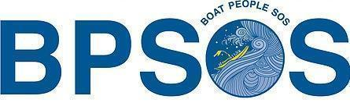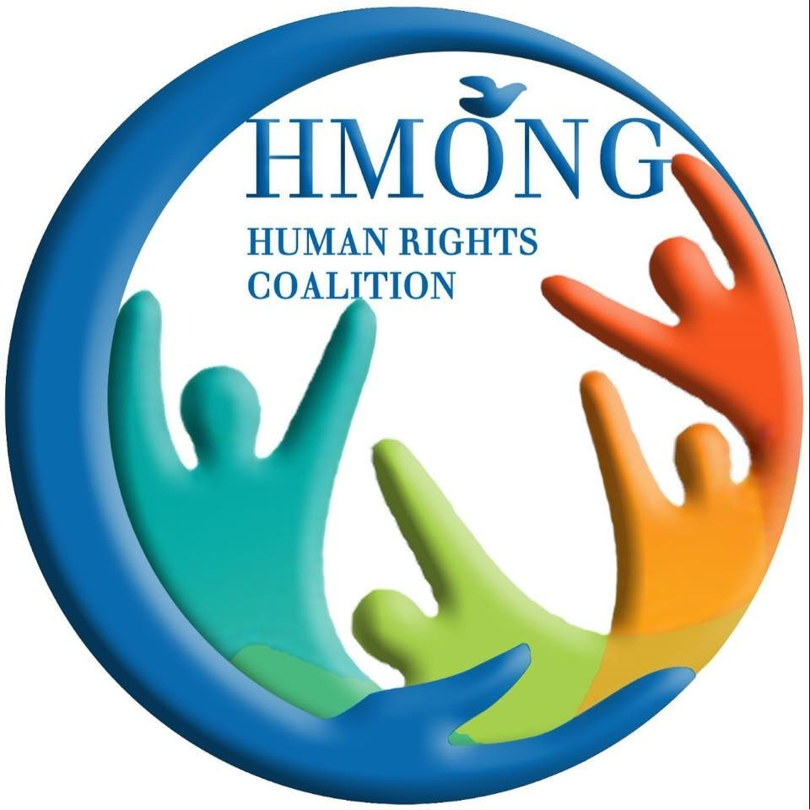

ALTERNATIVE REPORT
to the Committee on Elimination of Discrimination Against Women (CEDAW)
in addition to the Government of Vietnam’s 9th periodic report
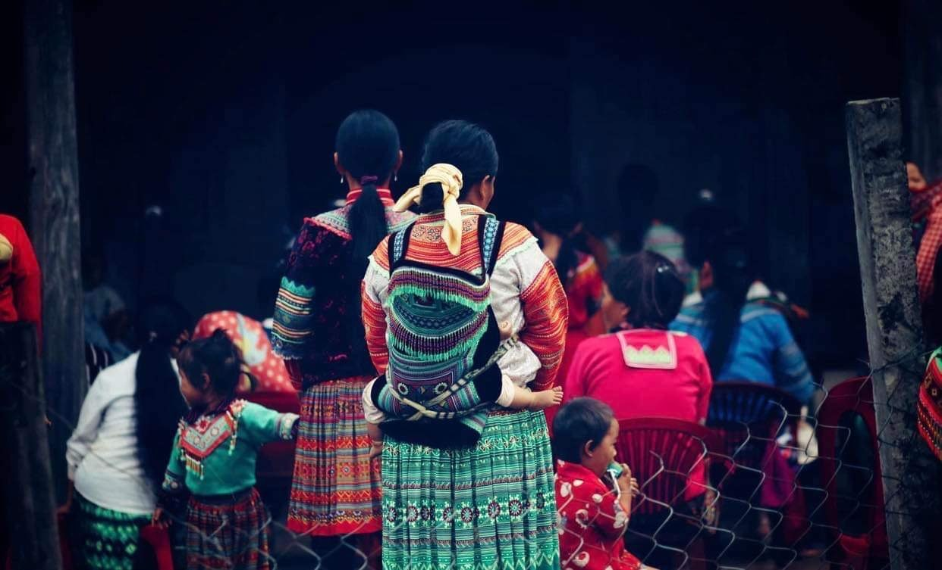
Discrimination against H'mong Women in Vietnam
December 2025

Prepared by:
Boat People SOS (BPSOS)
6066 Leesburg Pike, Suite 100
Falls Church, VA 22041, USA
(703) 538-2190
Email: info@bpsos.org
Website: https://www.bpsos.org/

In association with:
H'mong for Human Rights
Bangkok, Thailand
Email: hmonghrc@gmail.com
Website: https://hmonghrc.org

Key contacts:
Nguyen Dinh Thang, PhD
CEO & President BPSOS
Falls Church, VA, USA
Email: Thang.Nguyen@bpsos.org

Percy Nguyen
Email: percy@vncrp.org

Lu A Da
Bangkok, Thailand
Email: Villiam@vncrp.org

Giang A Chin
Bangkok, Thailand
Email: ceebtsheej02@gmail.com

Compiled by Percy Nguyen with contributions from H'mong for Human Rights
Table of contents
1. Introduction
2. Freedom of thought, conscience, and religion with H’mong women
2.1. Forced renunciation of Christianity toward H'mong Protestants in Northern Vietnam, particularly women
2.1.1. Report of Mrs. TTD, whom villagers nearly killed after converting to Protestantism
2.1.2. Report of four Protestant sisters from Kỳ Sơn District, Nghệ An Province
2.1.3. Report on Mrs. LYX in Kỳ Sơn District, Nghệ An Province
2.1.4. Denial of birth certificate to a baby girl to force her parents to renounce Christianity in Kỳ Sơn District, Nghệ An Province
2.2. Confiscating children’s birth certificates to force a parent to renounce her faith
2.3. Lai Chau Police attacked Hmong Christians of the Church of the Loving God on Mount Zion
3. Stateless H’mong Christians
4. Violation of the CEDAW
4.1. Article 2: Policy Measures
4.2. Article 3: Denial of full Development and advancement
4.3. Article 14: Rural Women
5. Recommendations
5.1. Streamlining Religious Registration and Making it Optional
5.2. Prompt Investigations into Reported Incidents of Forced Renunciation of Faith
5.3. Issue of personal documents, including citizenship IDs, marriage certificates, and birth certificates to Hmong Christians rendered undocumented because of their faith
5.4. Appeal to ECVN-South and ECVN-North to Provide Protection to Members, Report Violations, and Denounce Forced Conversion
5.5. Ensure Access to Justice:
5.6. Cooperate with International Bodies:
5.7. Stereotypes and discriminatory practices
5.8. Refugee, asylum-seeking, and stateless women

Introduction
This report is submitted in addition to the Government of Vietnam’s 9th periodic report in advance of Vietnam's review of the Committee on Elimination of Discrimination against Women (CEDAW) during the 89th session. This report highlights areas where Vietnam could improve its compliance with the International Convention on the International Convention on the Elimination of All Forms of Discrimination against Women (hereinafter referred to as “this Convention”), to which Vietnam is a State Party.
Even though Vietnam has been a party to the convention since 1982, the government authorities at different levels have not consistently implemented the convention, especially violating the Convention’s key provisions in Article 14, which mentioned women and girls in rural areas. This report highlights the alarming situation of H’mong women in Vietnam who were forced to abandon their religion, and some were evicted from their houses and villages and thus became internally displaced persons (IDPs). CEDAW should request the Vietnamese Government to reevaluate its policies and practices, ensuring alignment with international human rights standards, and to take substantive actions to protect and empower H’mong women.

Freedom of thought, conscience, and religion with H’mong women
The H'mong population in Vietnam, a historically marginalized indigenous ethnic minority, stands at approximately 1.3 million, making up around 1.3% of the country's total population. The H'mong reside primarily in the highlands of northern Vietnam, particularly in the provinces of Ha Giang, Lao Cai, and Lai Chau and, more recently, in certain areas in the Central Highlands of Vietnam.
The H'mong, especially H'mong Christians, face “double discrimination” stemming from both their ethnic identity and religious practices. In many instances, H’mong women were the first in the family to convert to Christianity, often hiding their new faith from relatives or even spouses. To these women, Protestantism promotes a healthy and happy family as it prohibits binge drinking and smoking and promotes equity between spouses. These women also face adversity from traditional belief and practice – they are often ostracized by their own family members and members of their own community.
This section critically highlights the shortcomings of the Vietnamese government in upholding Article 18 of the International Covenant on Civil and Political Rights (ICCPR). Not only has the State party failed to safeguard the rights of these ethnic minorities, but it has also blatantly violated Article 70 of the 1992 Constitution and Article 24 of the 2013 Constitution. While the Vietnamese government took a commendable step by introducing the “Law on Belief and Religion 2017,” effective from 1 January 2018, this law retains the critical flaws of the Ordinance on Belief and Religion 2004.
Instead of upholding the freedom of belief, this law and its subsequent 162/2017/NĐ-CP Decree have shifted into the territory of prohibitions and restrictions. This misguided approach has birthed a slew of inconsistencies in how the law is applied across various regions.
Thus, these loopholes have provided room for local authorities to violate the rights of ethnic minorities practically with impunity, especially toward women belonging to the Hmong ethnic minority.
The International Convention on the Elimination of All Forms [of] Racial Discrimination (CERD) indicated the same thing in the concluding observation on 27 December 2023:
“Reports of harassment, intimidation and threats faced by individuals belonging to ethno-religious minority groups who refuse to renounce their religion or belief or to join the State-controlled religious associations”. and “Ensure that all reports of harassment, intimidation and threats faced by individuals belonging to ethno-religious minority groups, in particular those who refuse to renounce their religion or belief or to join the State-controlled religious associations, are effectively investigated and prosecuted and that those found guilty are punished, regardless of their official status”

Forced renunciation of Christianity toward H'mong Protestants in Northern Vietnam, particularly women
The Vietnamese Government intends to misrepresent “True Religious Freedom.” In its 2021 report to the CERD (referenced under paragraph 73, page 13), the Government of Vietnam notably stated:
“In the Northern mountainous region, there are some 250,000 Protestant believers (95% of them are ethnic people, mainly from Hmong ethnic group), who are joining in religious activities in 14 branches and more than 1.600 groups. In this connection, the local authorities have granted certificates of registration of collective religious activities for more than 900 groups.”
The statistics cited by the government predominantly include the religious organizations that are, in essence, extensions of or submissive to the state apparatus. Such organizations, while numerically significant, are used strategically as instruments to execute or to cover up repression against independent-minded religious communities. In other words, these are not true embodiments of the religious freedom the government purports to support.
The churches operating under government control have enjoyed greater latitude under the “Law on Belief and Religion 2017,” but progress toward religious freedom cannot be measured by the number of religious organizations controlled by the government, particularly those used by the government to suppress the religious freedom of religious groups not approved by the government.
Drawing parallels with practices in China, the Vietnamese government has developed a modus operandi of proscribing authentic churches, only to replace them with government-controlled proxies, which were often created by the government for that purpose. They are “hybrid” religious organizations – consisting of people who genuinely want to practice their religion and believe that operating within the strictly controlled government system while making essential compromises with the government is the best or only way to do this.
The Evangelical Church of Vietnam–North (EVCN-North) and its southern counterpart, EVCN-South, stand as notable examples of these "hybrid" organizations. The recent revelations by BPSOS, which submitted numerous reports highlighting the persecution of H'mongs, cast a long shadow on ECVN-North's commitments to its own members. The reports repeatedly indicate an alarming pattern: ECVN-North turned a blind eye or offered only nominal support to its H'mong adherents who were subjected to forced renunciation of faith. At times, it colluded with the Government by expelling members who refused to renounce their faith.

Report of Mrs. TTD, whom villagers nearly killed after converting to Protestantism

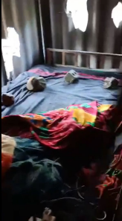
Mrs. TTD, an elderly woman who fortunately escaped death from the bricks and rocks thrown through the walls of her house

Ms. TTD, a 72-year-old H’mong Christian, belongs to a group of H’mong Christian believers, all members of ECVN-North. She and her group were denounced, humiliated, and assaulted by government employees and H'mong villagers for converting to Christianity. Many of those believers were beaten by villagers with support from local authorities until they were hospitalized. As she refused to renounce her faith, the villagers upped their ante by throwing rocks at her house late at night -- several landed on her bed, any of which could have maimed or killed her. There was no investigation after the incidents, and the local authorities did nothing to protect the Christian group. Furthermore, when Mrs. D joined a Sunday service in the house of another believer, the local authorities came to stop the service. They fined the group for practicing religion without permission. The fine was unlawful since the local authority did not provide any legal document for the fine but only a handwritten paper without citing any particular law or decree.
Links to the reports:
- Local villagers condoned a murderous attempt to physically hurt Ms TTD, a 72-year-old H'mong Christian, by throwing rocks that landed on her bed during nighttime: https://dvov.org/wp-content/uploads/2022/09/3rd-PROTHmong_En-Ban-Giang-update-29-May-2022-EvgChurchVN-Events-2022-Jan-Feb-May.pdf
- Government officials, supported by other perpetrators, disrupted Sunday worship in July 2022 and punished H'mong Christians in Lai Châu Province with fines of 1 million VND (43 USD) in July 2022. Church headquarters did not help: https://dvov.org/wp-content/uploads/2022/09/4th-PROTHmong_En-Ban-Giang-Chau-Van-Minh-Events-2022-July.pdf

Report of four Protestant sisters from Kỳ Sơn District, Nghệ An Province

Four sisters from the same Hmong family have been subjected to persecution by the police and rejection by their family members after converting to Christianity. They were all members of ECVN-North, which has been identified by the US Commission on International Religious Freedom (USCIRF) as a state-controlled organization that supports the government’s policies of religious suppression while deceiving the outside world that Vietnam has religious freedom.
In early 2022, LYT left EVCN-North after being forced by the police to pledge to recant Protestantism but did not receive any intervention from this government-approved church. After she refused to abandon God, her father-in-law immediately drafted a divorce application and asked her husband, who was working as a migrant worker in Japan at the time, to send home his signature. Her father-in-law then forced LYT to sign the divorce application that was written in Vietnamese. She was compelled to sign it out of fear without understanding its content because she couldn’t read Vietnamese. It turned out that, by signing it, she agreed to “willingly” leave her village while letting her husband keep her cash, motorbike, their jointly owned land and cattle, and her two children aged 17 and 13.
In July 2022, LYT went to Saigon (Ho Chi Minh City) to find a temporary place to live. She still received intimidating calls from her husband in Japan, and the police in her hometown announced that they would arrest her if she returned to Nghệ An Province. On February 2023, after being threatened by her own husband and in-laws that they would track her down to kill her “for the crime of betraying the family, humiliating the family, affecting the work of the father-in-law [who was a government employee],” LYT fled to Thailand and sought UNHCR protection.
Likewise, her younger sister, LYP, was forced to renounce Christianity, harassed, and interrogated by the police. She was forced to leave the village for a while. Fortunately, her husband spoke up and defended his wife. P was able to return home.
In early 2023, LYT’s two younger sisters, LYL and LYH, were beaten by their in-laws as they resisted the local government’s order to renounce Christianity. Both converted to Christianity in January 2018 but concealed their religious faith until the authorities found out five years later. In March 2023, the government punished LYH by not allowing her newborn daughter to have the same surname as the father according to traditional H’mong customs. Threatened by government authorities, beaten by their in-laws, and receiving no intervention or support from their Church, ECVN-North, they secretly left their respective homes at night, each with her own infant. LYL was able to bring her infant but left behind her two older children, 11 and 15 years old, who in early August 2023, managed to join her in Thailand. On August 20, 2023, Ms. LYL shared the stories of her, her sister LYH, and her sister LYT with UN Special Rapporteur on FORB Nazila Ghanea at a virtual conference hosted by BPSOS to mark the International Day Commemorating Victims of Acts of Violence Based on Religion or Belief.
The three sisters have all been recognized as refugees by the UNHCR.
Link to the reports:
- https://dvov.org/wp-content/uploads/2022/09/Final-PROTHmong_En-Lau-Y-Pa-Y-Tong-Events-2022-May-Jun.pdf
- https://dvov.org/wp-content/uploads/2022/09/FInal-2nd-PROTHmong_En-Lau-Y-Tong-July-2022-EvgChurchVN-Events-2022.pdf

Report on Mrs. LYX in Kỳ Sơn District, Nghệ An Province
Mrs. LYX converted to Protestantism in 2012, and since then, she has been summoned several times by the local government about her religion. In 2019, she decided to register with ECVN-North officially. According to the Law on Belief and Religion of 2016, Article 16 – Conditions for registration of group religious practice, “An organisation with a religious activity registration certificate shall register group religious practice for its members”. ECVN-North did not comply with this regulation – it gave all the documents to Mrs. LYX and told her to do it on her own. When Mrs. LYX tried to submit the registration application to the local government, its officials threatened to imprison her for registering as a Protestant. She was threatened by the villagers with rape and exile from the village if she did not renounce her religion. The officials also tried to force her husband to divorce and beat her, but he disagreed and was warned that he could lose his job as a primary school teacher.
Link to the report:
- https://dvov.org/wp-content/uploads/2022/09/Final-PROTHmong_En-Huoi-Mu-Ky-Son-Events-2022-June.pdf

Denial of birth certificate to a baby girl to force her parents to renounce Christianity in Kỳ Sơn District, Nghệ An Province
In July 2022, VBS and his wife, VYS, converted to Christianity as members of ECVN-North.i
They have a daughter named VNOM, born on 20 April 2022, who was not issued a birth certificate because of their Christian faith. On 26 June 2022, the baby was seriously ill, and the couple brought her to the hospital, where she was diagnosed with a very serious heart condition. According to the doctor who examined her, if she didn't have a birth certificate, the parents would have to pay a lot of money. As he had to stay with the baby at the hospital, VBS asked his brother VBP to request the communal governmental office to issue the birth certificate for the baby. On 28 June 2022, GBT, a civil judicial officer, responded that his supervisor did not allow him to issue a birth certificate to VBS’s child because the parents were Christians.
On 14 July 2022, VBS asked his sister-in-law CYC to make another attempt to obtain the birth certificate for the child. Once again, the local authorities at both the village and commune levels refused, citing the same reason. Mr. VNT, the Village Chief, told Mrs. CYC that the villagers did not want their family to stay in the village because they had converted to Christianity.
In August 2022, as he and his other family members did not agree to renounce Protestantism, a police officer came to his house and choked his neck to send the message that the police stood ready to use violence against him and his loved ones. He took his wife and the newborn daughter to flee to Thailand in October 2022. In November 2022, VBS went to Bali, Indonesia, to attend the Southeast Asia Freedom of Religion or Belief Conference (SEAFORB) and met Ms. Nazila Ghanea, Special Rapporteur on Freedom of Religion or Belief. The family is in the process of refugee status determination by the UNHCR.
Link to the report:
- https://dvov.org/wp-content/uploads/2022/09/PROTHmong_En-Vu-Ba-Sua-Events-upd-2022-Aug.pdf

Confiscating children’s birth certificates to force a parent to renounce her faith
Mrs. LYX raises her four children alone while waiting for her husband, KV, a U.S. citizen, to complete the immigration sponsorship needed for them to join him in the United States. In September 2022, discovering that she and her husband were Christians, the local police confiscated her children’s birth certificates to derail her emigration process. Her children were essentially U.S. citizens because their father was a U.S. citizen. The local government confiscated all of her and her children’s personal documents and threatened to banish them from the village while blocking their emigration. She appealed for intervention from her church, ECVN-North, with the help of a pastor in Hanoi, but received no support from ECVN-North. Threatened by the police with imprisonment if she did not abandon her Christian faith, Mrs. LYX took her four children into hiding while waiting for her husband in the United States to proceed with applying for US immigrant visas for her and their four children and Vietnam’s exit visas for the children.
In early 2023, Mrs. LYX and her children fled to Đắk Lắk Province to stay at the home of Pastor LVC, the leader of an unregistered parish. When, in April 2023, Pastor LVC fled to Thailand to seek refugee protection due to threats to his personal safety, Mrs. LYX and her children had to find another place of refuge. Thanks to the strong and persistent intervention by the US Congressman representing the district of her husband in Wisconsin, she and her children finally were able to migrate to the U.S.
See the full report at:
- https://drive.google.com/drive/folders/1gGj6kAXn9sO_UVAc0tUodpviCbN0g3J3?usp=sharing

Lai Chau Police attacked Hmong Christians of the Church of the Loving God on Mount Zion
The Church of the Loving God on Mount Zion is a house church established in 2017 with close to 800 members from 140 families in northern Vietnam and the Central Highlands. Its 23 worship groups meet weekly for prayer services. This church is the affiliation of a Hmong Church in the US. On 27 August, 2023, the Lai Châu Province government attacked over 80 adherents from 25 families, including disabled people, the elderly, children, and women, and confiscated their personal belongings. The police forced them to sign or fingerprint a pre-written renunciation statement. One woman, VTM, was hospitalized for several days after being beaten and handcuffed. Two other women, GTD and STD, were also beaten, but not that severely. Later on, the government visited the group multiple times and ordered them to abandon their religion.
Link to the report: https://drive.google.com/drive/folders/15THmJPfpGLnIx07G7rb_3C3bk3xFBpIu?usp=drive_link

Stateless H’mong Christians
The problem of forced religious renunciation toward H’mong people in Vietnam can be traced back to the 1980s. Until that time, there were few known H’Mong Christians in Vietnam’s Northwestern Mountainous Region. Responding to the rapid growth of the H‟Mong Christian population after they learned about Christianity from an evangelist radio program broadcasted from the Philippines, the government launched a series of measures, including policy directives and training manuals issued to local officials, to eliminate or discourage the practice of Protestantism among the H’mong population, which the government accused of being used by reactionary forces to oppose the government and undermine national solidarity.
Following eviction from their ancestral villages and years of wandering from locality to locality, many H’Mong Protestants formed new communities in uninhabited areas in nearby provinces; others migrated to the Central Highlands in search of a safe haven.
According to the official data of the Vietnamese government, between 2005 and 2017, a total of 25,732 households (totaling 91,703 individuals) had moved from the Northwestern Mountainous Region of Vietnam to the Central Highlands, not as part of the government's relocation plan. The migrants who moved to Central Highlands were not issued a national ID or household registration. Without these documents, they basically lived like stateless people and were not eligible for any social service programs, including education or hospitals. As a significant proportion of this population of undocumented Hmong were displaced involuntarily, they qualify as internally displaced persons (IDPs).
Subdivisions 179 and 181 in Lieng Sronh, Lam Dong Province, are cases in point of stateless H’mong. The Subdivision 179, with 700 residents, was founded approximately two decades ago by Hmong Christians who fled or were evicted from their home villages in the Northwestern Highlands because of their Christian faith. With few exceptions, they have remained undocumented for over two decades, from generation to generation.
Thanks to international attention, in early 2020, the Government of Dam Rong District, Lam Dong Province, signaled a positive policy shift towards the Hmong residents in Subdivision 179 of Lien Sronh Commune. In January 2020, the Dam Rong District Government announced its allocation of 76.78 billion VND (equivalent to US $ 3,311,297), with 77% contributed by the central government and the rest by the local government.
On June 4, 2020, the local authorities permitted the permanent resettlement of the Hmongs in Subdivision 179 and issued identity documents to the first 16 individuals. However, the authorities soon paused the issuance of ID cards to additional community members and, by late 2022 started to target community representatives who interacted with the government and worked closely with BPSOS on the advocacy effort.
Reprisals against residents of Subdivisions 179 and 181 who spoke out and reported violations to UN mandate holders consisted of police interrogations during which victims were beaten; a victim was beaten to unconsciousness. Many victims were threatened with imprisonment and forced to sign pledges to stop all contact with foreign entities, including Western diplomats.
More information on reprisals against Subdivisions 179 and 181 is available at: https://drive.google.com/file/d/12fCGneywJ83mMzB-xEvQS-yojVIg8OeK/view?usp=drivesdk
In December 2021, BPSOS sent a shadow report, Consequences of Statelessness on Hmong Christians: The Children of Subdivision 181 in Vietnam – a Case Study, to the Committee on the Rights of the Child (CRC). This document mentioned the failure of the local government to resolve the practical statelessness of this Hmong Chrisitan community, focusing on the educational barriers caused by statelessness. The government had not built a school for this community’s children who must live by themselves during the school week in shacks far from home but closer to the schools they attend. This practical statelessness still affected hundreds of H’mong women in Subdivision 179 and 181. In November 2023, the Youtube channel of Nhan Dan newspaper, the official newspaper of the Communist Party of Vietnam, posted a broadcast titled "The unnamed village of immigrants" about Subdivision 179, which finally acknowledged their plight as BPSOS had reported for years to the international community.
Even though the broadcast of the Nhan Dan newspaper indicated that the project to issue documents for the people in Subdivision 179 is ongoing, the fact is the opposite. Many of the people there, including hundreds of women, were turned away as they approached the local authorities to register their national ID. The Subdivision representatives were targeted by the government for contributing to the reports to the UN human rights mandate or speaking out about their situation. Many of them had to flee to Thailand to seek refugee protection.

Violation of the CEDAW

Article 2: Policy Measures
Different Government Authority levels have not consistently implemented the convention, especially regarding the rights of H’mong women. Meanwhile, this does not happen with the Viet (Kinh), the majority. This can be seen as a violation of Article 2, which requires states to take all appropriate measures, including legislation, to eliminate discrimination against women. The failure to consistently implement the convention indicates a lack of effective policy measures.

Article 3: Denial of full Development and advancement
Any actions or omissions by the state that result in the unequal development and advancement of women, such as forced abandonment of religion, eviction, and intimidation, hinder the full development and advancement of H’mong women, could be considered as Violation of Article 3. The reported incidents may suggest a failure to ensure the full development and advancement of H’mong women on an equal basis with women from the majority. They also suggest that the government is willing to turn a blind eye on violence against women, committed by their spouses, family members and/or fellow community members, when such violence supports its policy on forced abandonment of Christianity.

Article 14: Rural Women
Article 14 specifically addresses the rights of rural women and their right to enjoy adequate living conditions. The reported incidents suggest that H’mong women in rural areas are facing discrimination, including threats to their religious freedom and forced eviction, which goes against the principles of this article.

Recommendations

Streamlining Religious Registration and Making it Optional
It is imperative for the Vietnamese Government to immediately promulgate clear and transparent guidelines facilitating the registration of independent religious groups, especially “Article 16. Conditions for registration of collective religious activities” of the Vietnam Law on Belief and Religion and explaining that such registration is not mandatory for groups that do not intend to form a religious organization. While this article does not specifically require groups of followers to register their activities or seek the government’s approval for as long as they operate as a religious organization, in practice, they are not allowed to conduct religious activities unless such activities are registered with and approved by the government.

Prompt Investigations into Reported Incidents of Forced Renunciation of Faith
Reports of public security forces and government officials forcing Christian converts to renounce their faith, particularly within the Protestant community in Kỳ Sơn, Nghệ An Province, are deeply alarming. We request the Vietnamese government to conduct an immediate, comprehensive, and transparent investigation into these alleged incidents. Those found culpable should face stringent legal repercussions for violating not only international conventions and covenants that Vietnam is a state of but also Vietnam’s 2013 Vietnam Constitution and 2017 Law on Religious and Belief.

Issue of personal documents, including citizenship IDs, marriage certificates, and birth certificates to Hmong Christians rendered undocumented because of their faith
The UN High Commissioner for Refugees (UNHCR) should look into the plight of tens of thousands Hmong IDPs in the Central Highlands of Vietnam and work directly with the Vietnamese Government as well as other UN treaty bodies to resolve the practical statelessness that spans generations.

Urging ECVN-South and ECVN-North to Provide Protection to Members, Report Violations, and Denounce Forced Conversion:
In its policy to eradicate independent congregations of believers, the authorities either forced them to renounce their faith or to join a government-backed religious organization such as ECVN-South or ECVN-North. These two government-approved organizations have refrained from providing support and intervention to members who face intimidation and reprisals because of their faith, let alone reporting such incidents to higher-level government authorities or UN mandate holders. In many instances, these organizations even support the government’s forced conversion policy by admitting individuals who were ordered to leave their house churches and join ECVN-South or ECVN-North. We recommend that CEDAW and other UN mandate holders to communicate directly with these two organizations and warn them against further collaboration with the government to suppress religious freedom. As a first step, these two organizations should issue a policy statement denouncing forced renunciation of faith as a matter of principle and refusing to admit anyone who only joins them as a result of duress or coercion.

Ensuring Access to Justice:
The Vietnamese Government should establish mechanisms to ensure that individuals, particularly women, who have faced discrimination or human rights abuses have access to justice. This includes facilitating the reporting of violations and conducting impartial investigations into reported incidents.

Cooperation with International Bodies:
The Vietnamese government should cooperate fully with international human rights mechanisms, including providing transparent and timely information to UN mandate holders. This includes addressing any allegations of reprisals against individuals who report violations to UN bodies.

Elimination of Stereotypes and Discriminatory Practices:
CEDAW should ask the Vietnamese Government to address the persistence of patriarchal attitudes and deep-rooted gender stereotypes regarding the roles and responsibilities of women and men in the family and in society that overemphasise the subordinate and caring roles of women.

Tổng cục Thống kê. “Population and Household Census – General Statistics Office of Vietnam.” Tổng cục Thống kê, https://www.gso.gov.vn/en/category/population-and-houses-census/. Accessed 24 July 2023.
The term “double discrimination” is explained in General Recommendation No. 32 (2009) “The meaning and scope of special measures in the International Convention on the Elimination of All Forms [of] Racial Discrimination” available at: https://www.refworld.org/docid/4adc30382.html
BPSOS. “Consequences of Statelessness on Hmong Christians: The Children of Subdivision 181 in Vietnam – a Case Study.” ohchr, https://www.ohchr.org/sites/default/files/2022-01/Boat-People-SOS.pdf. Accessed 25 August 2023
“Bản làng không tên của những người di dân | Đảng với Dân.” ("The unnamed village of immigrants") YouTube, 10 November 2023, https://www.youtube.com/watch?v=9-IzKyQKGkw. Accessed 2 January 2024.

