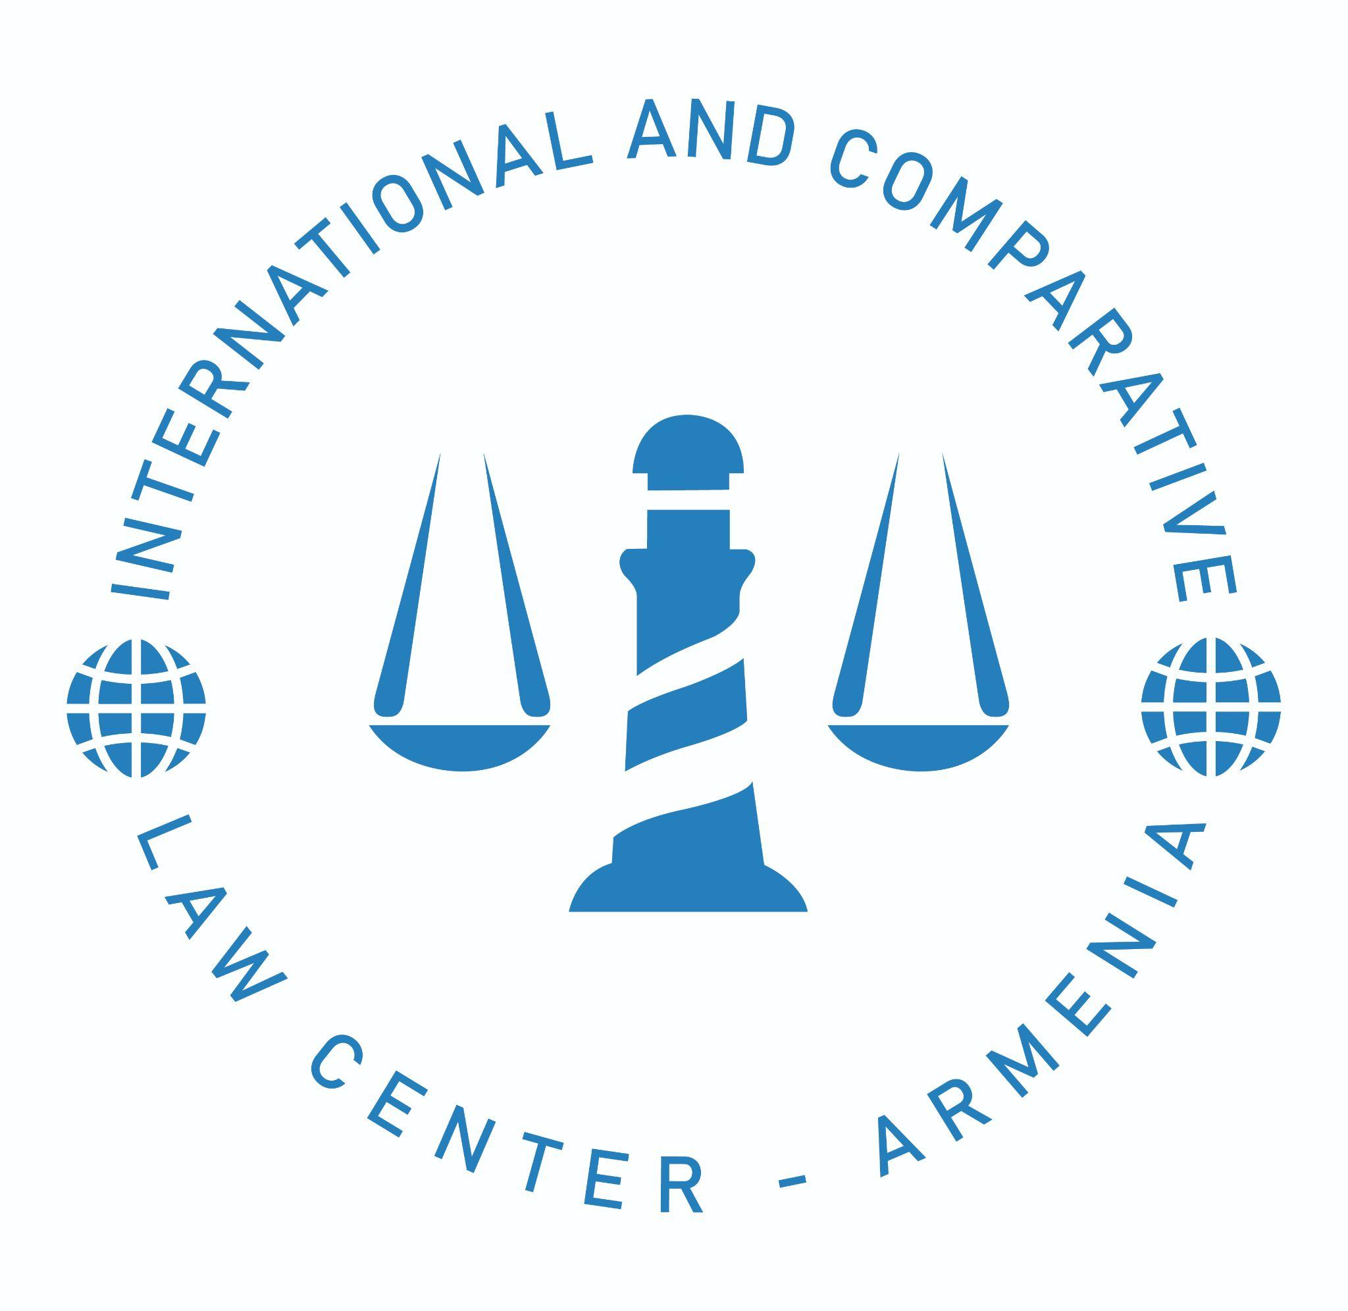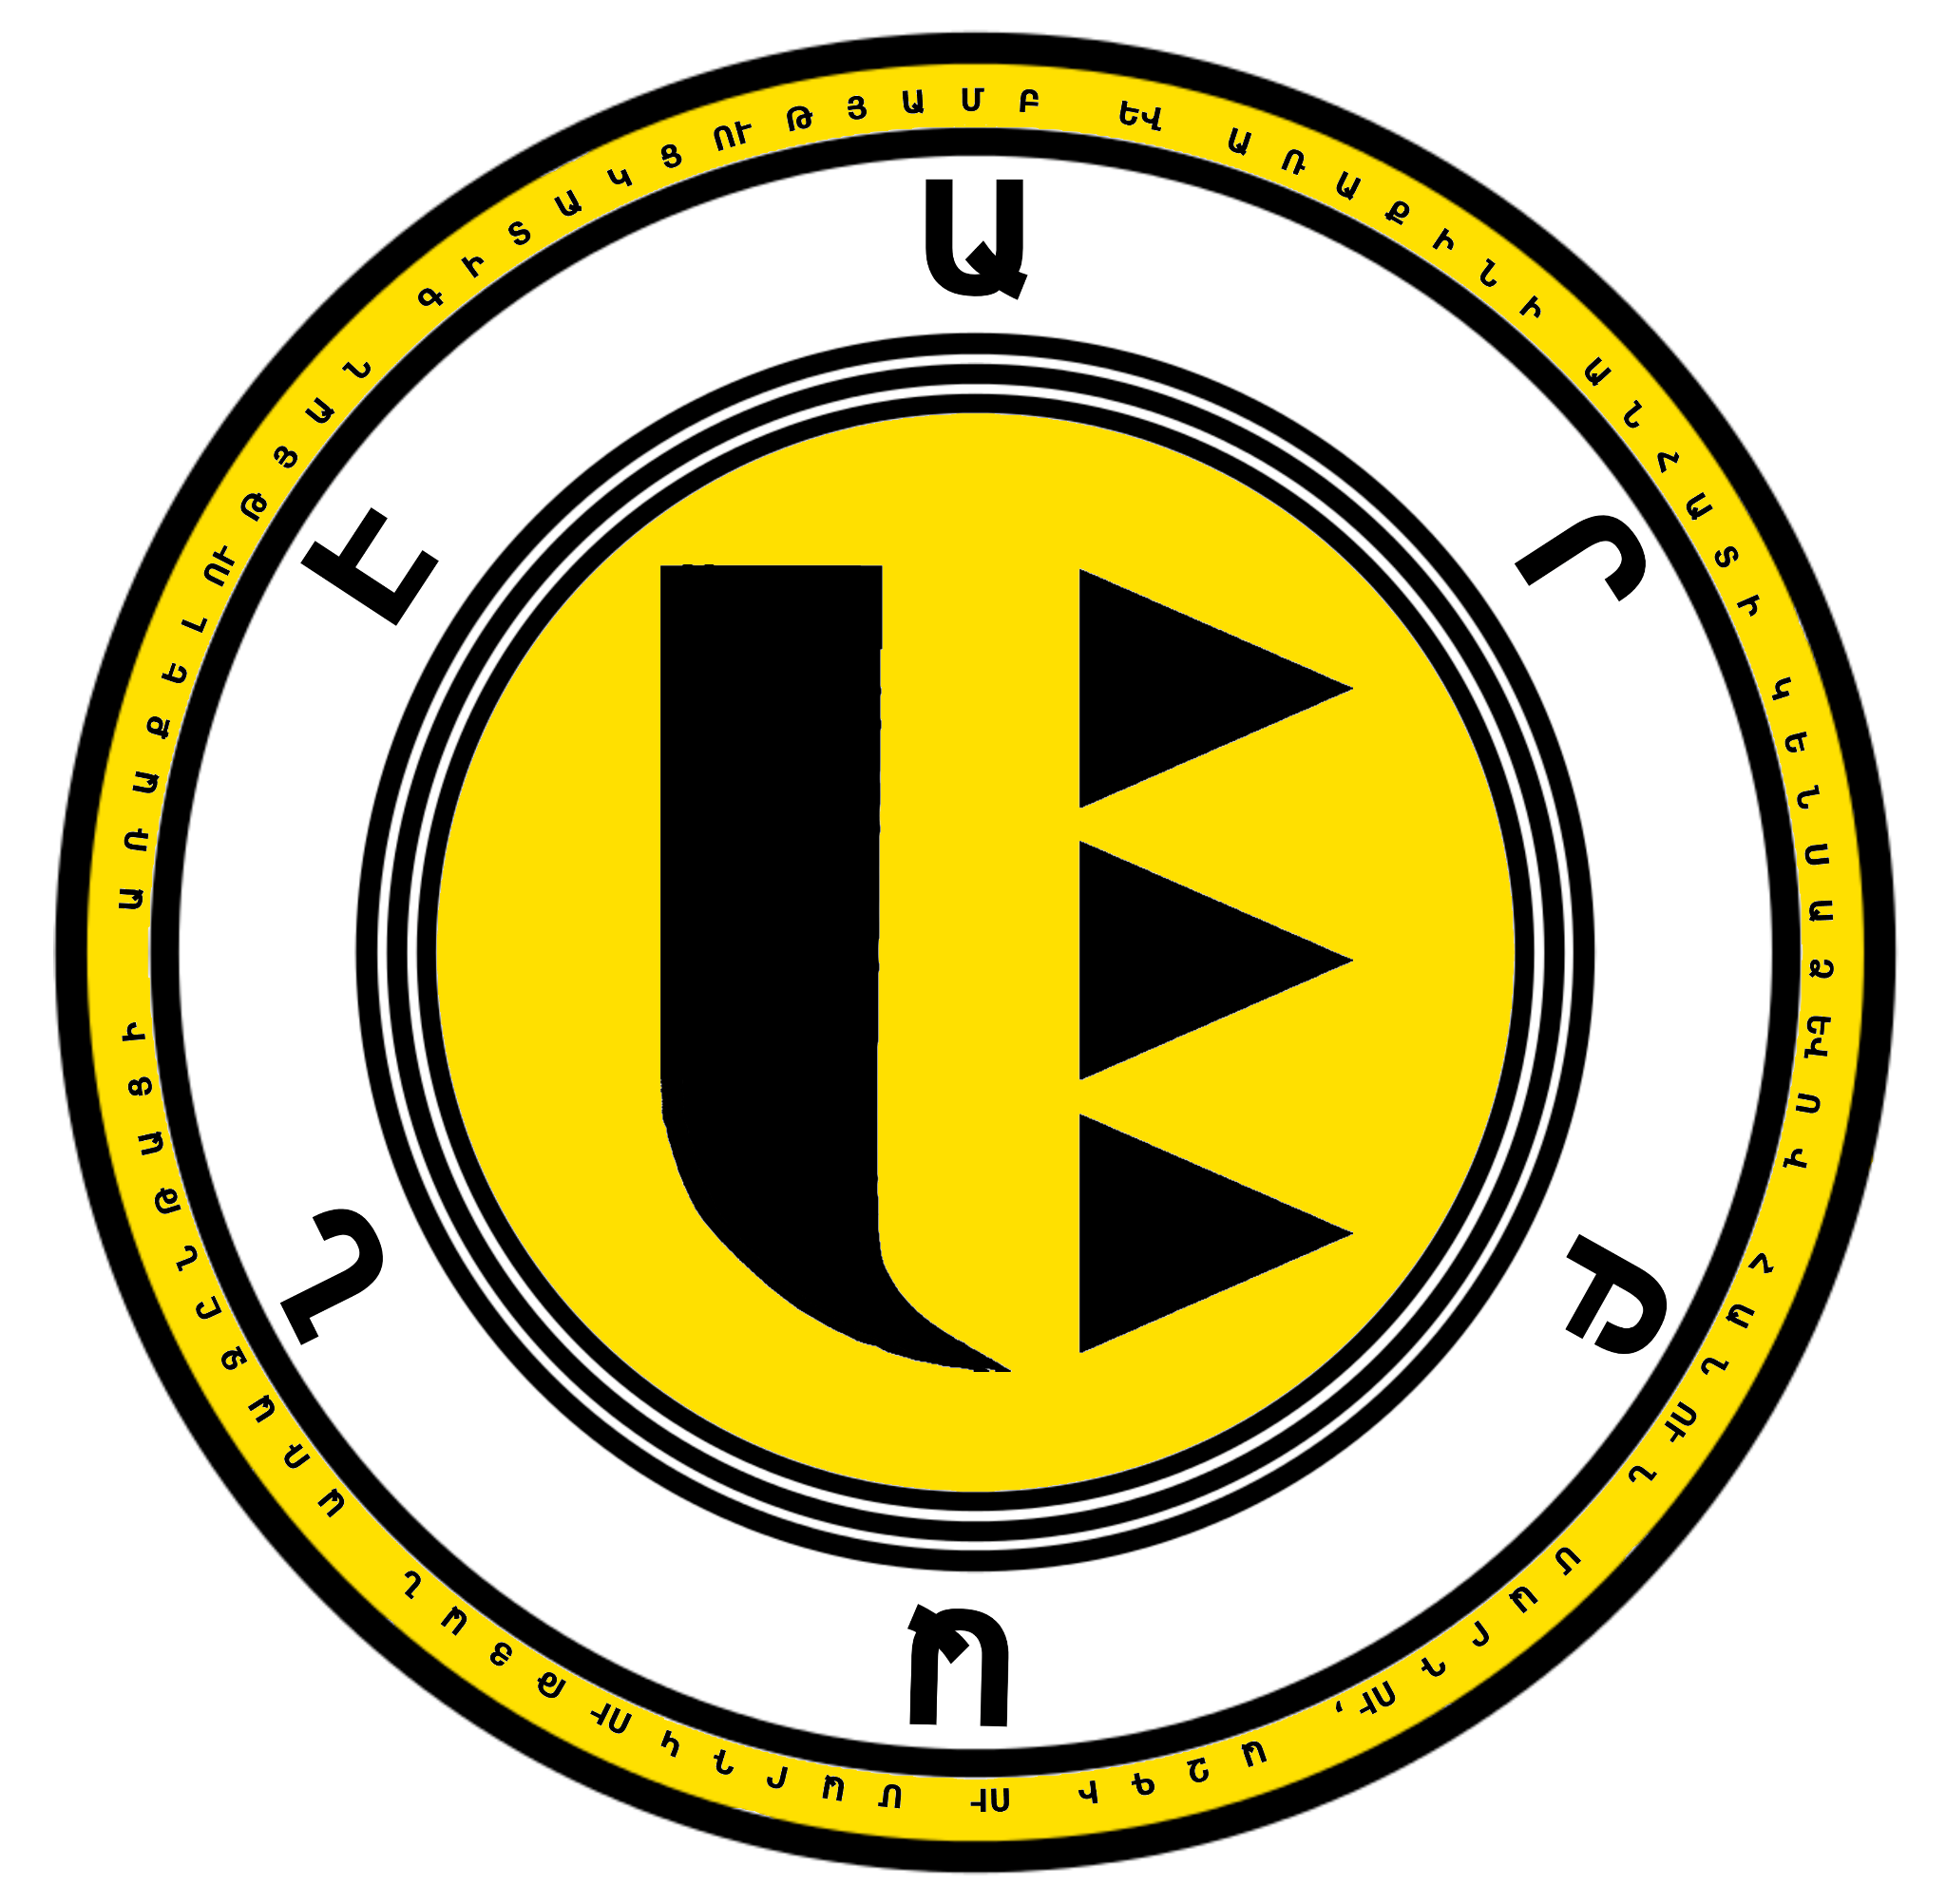

AZERBAIJAN’S VIOLATIONS OF THE CONVENTION AGAINST TORTURE AND OTHER CRUEL, INHUMAN, OR DEGRADING TREATMENT AND PUNISHMENT WITHIN THE CONTEXT OF RACIAL/ETHNIC DISCRIMINATION TOWARDS ARMENIANS
IN RESPONSE TO THE 5th PERIODIC REPORT OF AZERBAIJAN
79th session of Committee against Torture (CAT)
April 15, 2024 - May 10, 2024
Submitted on March 18, 2024

This joint report is submitted to the United Nations Committee against Torture by a Coalition of NGOs (International & Comparative Law Center – Armenia (“I.C.Law”), Center for Law and Justice “Tatoyan” Foundation, “Arbane” Foundation, Union for Protection of the Interests and Rights of the Artsakh People).
Union for Protection of the Interests and Rights of the Artsakh People is an organization based in Artsakh, the focus of which is raising awareness on human rights violations faced by the people of Artsakh. I.C.Law, “Tatoyan” Foundation and “Arbane” Foundation are organizations established in Armenia with a mission of protecting human rights, strengthening democracy and the rule of law.
Contact: International & Comparative Law Center – Armenia, info@iclaw.am

Table of Contents
- Introduction ………………………………………………………………………………………..3
- 2016 Artsakh War and Torture of Armenian Servicemen: Physical Torture of Soldiers and Psychological Suffering of Family Members ……………………………………………………. 4
- Torture and Beheadings of Armenian Servicemen ……………………………………………….5
- Torture and Ill-Treatment of Armenian POWs In Closed Institutions of Azerbaijan …………….9
- Beheadings and Ill-Treatment of Armenian Servicemen and Civilians Under the Control of Azerbaijani Armed Forces in the Course of the 2020 Nagorno-Karabakh War ………………...14
- Conclusion………………………………………………………………………………………. 16

This version of the report excludes Annexes depicting graphic content in relation to torture cases discussed below.

- Introduction

In light of the fifth periodic report of the Republic of Azerbaijan (“Azerbaijan”) which addresses improvements made by the Republic related to torture in the country for the period of 2016-2019, submitted to the United Nations Committee against Torture (“the Committee”), for consideration under Article 19 of the Convention against Torture and Other Cruel, Inhuman, or Degrading Treatment or Punishment (“the Convention”) at its 79th session, Coalition of NGOs based in Armenia and Artsakh have filed the following report which addresses torture cases systematically implemented by representatives of Azerbaijani origin against Armenian soldiers as well as civilians, with a case-by-case analysis leading to an identification of actions in question being motivated by systematic hatred based on racial discrimination and ethnic origin. Moreover, the report draws a separate connection between those cases and an exceptional level of impunity associated with the latter, indicating that Azerbaijan not only failed to fulfil its obligation to follow conventional provisions and follow up on preventing and punishing torture cases as such, but also, a continuous encouragement and fostering of such incidents may additionally be identified as a common, calculated pattern.

The report acknowledges torture endured by ethnic and national Armenians during this time period, including the beheadings of soldiers, as well as the mutilations of Armenian civilians and military servicemen, further inflicts pain and suffering on not only some of the affected persons themselves, but also their family members and Armenian society through numerous actions. These actions include spreading violent and graphic content on social media platforms, contacting family members of servicemen via phone, spreading humiliating video materials of Armenian military personnel as well as civilians, and failing to fulfill its humanitarian obligations, such as providing family members with a chance to be informed about the fate of their beloved ones or organize the return of the mutilated body parts (e.g. the head of a beheaded soldier). Actions concerning mutilation, humiliation, and ill-treatment towards civilians and military personnel of Armenian origin affected by Azerbaijani military actions while alive, are defined as torture under the United Nations Convention against Torture and Other Cruel, Inhuman, or Degrading Treatment or Punishment. Moreover, the instances of spreading photo and video materials on social media platforms with a step-by-step depiction of the actions taken against Armenians inflict additional pain and suffering, and are considered under the light of torture towards family members of soldiers and civilians in question — instances that shall be further discussed and analyzed in following sections of this report. Likewise, it is important to note that, although Azerbaijan has conventional obligations of investigating cases of torture, inhuman, or degrading treatment, and, in case of necessity, punishing perpetrators identified, the State did not seem to be fulfilling those responsibilities assigned, by not only failing to initiate thorough investigations, but also granting perpetrators with total impunity, as well as praising the latter through various means (e.g. granting medals, special events organized for “national heroes”) (see Annex A, Figure A1-A2), creating a ground of viewing the incidents under the light of racial and ethnic discrimination towards Armenians in particular.

This report focuses on the time period set between 2016 and 2019 - the one discussed in the fifth periodic report of the Republic of Azerbaijan to the Committee. However, it is of non-negligible importance that the Committee’s attention is brought to cases of torture from 2020 to present as well, as those crimes further demonstrate Azerbaijan’s disregard of its engagements in regard to the Convention, and its endorsement of a long standing pattern of ethnic and racially-motivated hatred towards Armenians. It is also important to highlight that, within the course of the long-lasting conflict between Artsakh (Nagorno-Karabakh) and Azerbaijan, numerous cases indicate Armenian POWs being subjected to humiliation and torture while being held in state institutions of Azerbaijan.

- 2016 4-Day War and Torture of Armenian Servicemen: Physical Torture of Soldiers and Psychological Suffering of Family Members

In the early morning hours of April 2, 2016, Azerbaijani military forces violated the May 1994 Ceasefire Agreement by launching an organized military attack on the entire Nagorno-Karabakh-Azerbaijan line of contact. Azerbaijan’s army employed tanks, military helicopters, Smerch whirlwind heavy weaponry, TOS-1 Solntsepyok multiple rocket launcher, drones, and various caliber weapons during the assault. In the morning of April 2, 2016, Azerbaijani armed forces captured several posts in the Tapkarakoyunlu-Talish direction, the Ministry of Defense of Azerbaijan declaring that the “village Seysulan and surrounding heights of village Talish were fully cleared of the enemy forces” and later that the heights of Seysuan and Horadiz were liberated. On April 3, 2016, the Nagorno-Karabakh Defense Army retook some positions lost on the first day, and on April 5, 2016, at noon, a ceasefire agreement was reached between the parties of the conflict as a result of which large-scale military operations ended.

Within the course of military operations at the time, numerous cases of breaching of the Convention Against Torture were recorded, a vast amount of Azerbaijan’s offenses being depicted through video materials and footage.

- Torture and Beheadings of Armenian Servicemen

Within the course of the 4-day War, two beheading cases varying in nature and details were revealed. Hrant Gharibyan and Hayk Toroyan, military personnel delivering supplies (see Annex B, Figures B1-3), were taken under the control of Azerbaijani armed forces, as a result of which two were beheaded and killed. Military and rescue operations revealed the bodies of two servicemen with their heads missing, medical examination later on revealing that Hrant Gharibyan was murdered by shooting and the decapitation of the head was conducted after his death. Hayk Toroyan was beheaded alive, with his wrists cut off as well. Bodies of the servicemen were also covered with abrasions, bruises and fractures.

A forensic medical examination of the corpse of Hayk Toroyan revealed teardrops were identified on the jacket of the latter, blue pen remnants inside the pocket, torn pants which appeared to be stained with blood. The head was missing from the upper half of the neck at the upper thyroid cartilage, and both wrists were missing at the level of the antebrachiocarpal joints. The preserved part of the neck was covered with dirt. Abrasions were found on the chest, right knee joint, right thigh, and right lower leg. A bone fragment of the 7th rib was identified on the floor.

The conclusion of the examination reads as follows:
Traumatic severing of the head at the level of the C5 vertebra, i.e. decapitation; full width cut wound of the middle third of the neck, cut injuries on the middle third of the neck of neurovascular bundles, muscle bundles and soft tissues, single-plain cut injuries of the articular process of C5 vertebra, tendon ligament system, dura mater, spinal cord, which were caused by the impact of sharp cutting instrument while the victim was alive (intra vita), seconds before death, which led to his death. Based on the circumstance of the absence of the head, it is currently impossible to determine whether there were injuries on the head that could be in causal relation with the immediate cause of death.
In addition, traumatic mutilation of both wrists was detected at the level of antebrachiocarpal joints, full width cut wounds at the level of antebrachiocarpal joints, neurovascular bundles, tendon ligament system, muscle bundles and soft tissues at the level of antebrachiocarpal joints, which were caused by sharp cutting instrument while the victim was alive. They have features of severe damage to the health of alive persons and have no causal relationship with the immediate cause of death. Based on the histological examination, the injury of the right forearm region was caused seconds before death, and the injury of the left forearm region had appeared during the agony.

The gunshot wounds were caused while the victim was alive, from about 30 minutes to 1.5-2 hours before death, were caused by the impact of a shot made from a bullet charged firearm. After receiving the gunshot wounds, H. Toroyan could make conscious movements.

While Hrant Gharibyan was beheaded postmortem, Hayk Toroyan was subjected to torture while still alive, after enduring the agony of having his wrists cut off and receiving multiple gunshots, wounds, and much more. The severed heads of Toroyan and Gharibyan were taken as war trophies and were never returned to the families. Moreover, the severed head was posted on social media by a member of the Azerbaijani Special Forces proudly claiming the “possession of one,” while another post shows the decapitated head as well as a severed hand laying on the ground while with a squatting soldier posing behind them and another post with Toroyan’s severed hand (see Annex B, Figures B4-6).

The case of Hayk Toroyan suggests that Azerbaijani armed forces subjected him to torture directly through beheading alive, whereas, in Gharibyan’s case, mental form of torture was indured by the family members, due to the acts of failing to return body parts of the servicemen, as well as the actions of spreading photos or videos on social media platforms inflicted further pain and suffering on family members of the serviceman in question. This also conveying elements of calculated, planned, and step-by-step implemented acts of violence, torture, as well as further encouragement of such actions.

The beheadings of Hrant Gharibyan and Hayk Toroyan were caused by ethnic hatred towards the victims. The beheadings, and its subsequent spread on social media, were done to intimidate the Armenian community as a whole, to send a message of hatred and intolerance to ethnic Armenians in Nagorno-Karabakh and Armenia. The impunity of such heinous crimes only reinforces the fact Armenian life is not valued enough within Azerbaijani policy for a crime committed against it to be thoroughly investigated and punished accordingly.

Beheading is deemed an “acceptable” and even encouraged conduct when it comes to the Azerbaijani military personnel, considering that this decapitation is not the first one to suffer no consequence under Azerbaijan’s judicial system - in addition to its perpetrator being regarded as a hero, and rewarded as such by the government. These are the grounds on which the latter was condemned by the ECHR in Makuchyan and Minasyan v. Azerbaijan and Hungary (17247/13), after Ilham Aliyev, the President of Azerbaijan, not only pardoned a man who had decapitated an Armenian while the latter was asleep with an ax -while the two were attending a NATO peace programme in Budapest, but also personally welcomed him at the airport. The man in question, Ramil Safarov, would then be promoted and receive several amenities from the State, namely to “compensate” his years of imprisonment outside of Azerbaijan.

Besides, the fact Safarov benefited from such a breach of justice despite having committed the crime in Hungary is inconsistent with the claim made on paragraph 309 of Azerbaijan’s fifth periodic report, which states that the country is only unable to uphold Human Rights in regions affected by the war in Nagorno-Karabakh. Not only does the paragraph in question constitute a fraudulent excuse for a Conventional violation, Safarov’s current freedom leads to believe that Azerbaijan’s dismissal of nonetheless fundamental rights occurs whenever the victim is Armenian. It is noteworthy that, recently, within the scope of the session of the Council of Europe Committee of Ministers, a resolution was adopted, requesting Azerbaijan to fulfill its conventional obligations to follow the Court ruling on the case of Makuchyan and Minasyan v. Azerbaijan, the exact act committed by Safarov. One can only consider unacceptable, especially in respect to Azerbaijan’s supposed engagements towards the CAT that such blatant disregard of international law, in favor of an ethnic discriminatory rationale should prosperate.

The cases discussed may be perceived as indicators showing systematic pattern of beheadings and torture being common methods of inflicting pain and suffering based on ethnic identity and racial discrimination.

Within the scope of the 4-day war in 2016, serviceman Kyaram Sloyan, age 20, was beheaded and his head was taken by the Azerbaijan military forces (see Annex C, Figure C1-2). One photo spread on social media shows Sloyan’s decapitated body with an Azerbaijiani armed serviceman’s foot on the torso of the body (see Annex C, Figure C3). Behind the body is another Armenian soldier with his pants pulled down to his knees and his abdomen covered with a white clothing (see Annex C, Figure C3). Sloyan's beheaded corpse was found in the military position N 116, and the Nagorno-Karabakh Republic Investigative Department initiated a medical forensic examination. In the medical forensic report, it was indicated that the death of Sloyan was a result of firearm and shrapnel injuries to different parts of his body, namely his chest and arms. It was also reported that Sloyan was beheaded after his death, and there was no causal link between the death and the separation of the head. In addition, the medical forensic expert concluded that the head was separated from the body by cutting at the upper part of the neck (under the chin to the top of the spinal cord) with a cutting tool.

During the time that the decapitated head was held by Azerbaijani military forces, such as in the morning of April 2, 2016, photos of Sloyan’s head were spread on social media, showing his head placed on the grass (see Annex C, Figure C4) as well as an Azerbaijani serviceman and intelligence officer, identified as Senior Scout Elnur Farzaliyev, in uniform posing with Sloyan’s head held by the ears (see Annex C, Figure C1-2). In a video spread on social media platforms, Sloyan’s head is on the ground surrounded by some flies before a male villager in a suit picks up Sloyan’s head by the left ear (while there is a child and another man in the background) and then lowers it to the ground to pick up his head with both ears. He then holds the head up to his shoulders height and looks at the camera. He holds Sloyan’s head for a few seconds before tilting Sloyan’s head and then displaying his head to someone to the right of the cameraman who has their phone out, as to take a picture or video. Next, the cameraman walks towards Farzaliyev, who during the video acknowledges to the villagers that he is the one who beheaded Sloyan.

Through the negotiation of the ICRC between the authorities of Azerbaijan and the Republic of Nagorno-Karabakh, on April 5 2016, Sloyan’s head was returned to the family. It is noteworthy that the overall situation inflicted continuous pain and suffering on family members of the latter, who were destined to see their loved one’s beheaded photos and videos all over the Internet. Moreover, further suffering was caused to both family members as well as efforts were made to publicly humiliate the Armenian nation as such through the following action: Sloyan’s head was also displayed to Azerbaijani villagers by the servicemen in question as a symbol of a victorious act and “war trophy.” In one video, a man partially takes Sloyan’s decapitated head out of a white plastic bag so that it can be displayed and he then raises the revealed head above the crowd, as to show the crowd the head. During some conversations, Farzaliyev receives words of blessings and gratitude for such an action. Here, the overall hatred towards a person with Armenian nationality is identified not for Azerbaijani military personnel solely, but also within the general public as well, taking into consideration the fact that the “excitement” for the actions committed by Azerbaijani servicemen, according to the video footage available, was mutually perceived as a heroic action by the ordinary Azerbaijani citizens as well. Moreover, Sloyan’s beheader, Farzaliyev, was awarded by the President of the Republic of Azerbaijan, Ilham Aliyev, for performing exceptional military service within the scope of the 4-day war (see Annex A, Figure A1).

Moreover, the systematic pattern observed within the Azerbaijani society of sharing humiliating photos of Armenian servicemen and civilians and filling online platforms with hateful content and comments, and, by doing so, inflicting further suffering and sense of humiliation on family members of persons in question, was also present in the case of Sloyan. On Sloyan’s beheader’s Instagram page, there are pictures of him with Sloyan’s head, Sloyan’s head, or him with an Azerbaijani flag with Farzaliyev’s comments inciting hatred for Armenians, such as “how delicious it is to make the enemy live in fear. They still do not know that this is only the visible part” (see Annex C, Figure C5), “brother, looking at this dishonorable face [Sloyan], you can't see that the blood is still on his face” (see Annex C, Figure C6), “let the courage of the enemy explode” (see Annex C, Figure C7), and “I have an enemy and he is Armenian” (see Annex C, Figure C8). Many Azerbaijanis in the comments not only give blessings to Farzaliyev for beheading Sloyan, but they also follow his sentiments and wishes for more Armenians to be killed (see Annex C, Figure C9-10). There is a noticeable impact of Farzaliyev being proud of his crime on others to feel more embolden and empowered to express their hatred for Armenians openly. By showing off his beheading of Sloyan and displaying it as a glorious righteous act, Farzaliyev implicitly encourages others to be proud of their hatred and inspires them to kill Armenians like him. He is perceived as noble, honorable, and a hero by those on social media not despite his horrific beheading, but rather for his horrific beheading (see Annex C, Figure C11).

The parading and publicizing of a beheaded Armenian national to civilians, along with the civilians glorifying this deed, and further the government’s approval, potentially signified a deep-seeded systematic dehumanization of Armenians in Azerbaijan, as well as deeply-rooted hatred based on racial and ethnic origin. By giving a pat on the back to Azerbaijani nationals who kill and torture Armenians, Azerbaijan signifies that not only will there be no punishment for an Azerbaijani to kill and torture an Armenian, but, on the contrary, the action is something to be awarded for. Allowing well-documented hate crimes to go without criminal investigation or judicial trial, there is no repercussions for torturing Armenians and their family members, as well as failure to follow conventional obligations implied.

Aside from this instance, on April 10, 2016, Azerbaijan returned the bodies of eighteen soldiers of the Nagorno Karabakh Defense Army. All of them, without exception, displayed signs of torture and mutilation, which was registered by the NKR State Commission on Prisoners of War, Hostages and Missing Persons, in the presence of the representatives of the International Committee of the Red Cross, as stated on the NKR Ministry of Foreign Affairs official website. According to pieces of research conducted, within the course of the 2016 April war, 90% of civilians as well as military personnel of Armenian origin that went under the control of Azerbaijan, were tortured, humiliated, and mutilated. This systematic incident shows a pattern of hatred against national origin and ethnicity, further suggesting that cases of torture and ill treatment that Armenians were subjected to have a distinctive element of racial and ethnic discrimination and hatred.

- Torture and Ill-treatment of Armenian POWs In Closed Institutions of Azerbaijan

All Armenian servicemen and civilians, with hardly any exceptions, taken captive by Azerbaijani military officers during the 2020 Artsakh War were systemically subjected to severe physical and mental abuse, torture and inhuman treatment throughout their term in captivity in full disregard of their health and dignity. During medical examinations that repatriates underwent following their arrival in Armenia, the vast majority was found to have health issues, both physical and mental, and almost none of them had received proper, if any, medical treatment in Azerbaijani hospitals.
The details provided in the testimony of victims after their repatriation make it abundantly clear that torture and ill-treatment were – and continue to be – widespread practices in Azerbaijan against Armenians.
The physical abuse and violence by Azerbaijani armed forces against Armenian PoWs would start from the very moment and place of captivity. The PoWs were also beaten by their captors inside the vehicles all the way to their final destination, that is, Baku. The torture, however, did not end there. Armenian PoWs continued to face abuse and degrading treatment on a constant basis, only this time by the guards of confinement facilities, state officials, even by the doctors who were supposed to treat the PoWs with injuries received during military activities. Within the course of fact-finding activities and witness statements (hereafter, WX) collected, a few examples of details provided by repatriated POWs shall be discussed in the following section of this report.
One repatriated PoW (hereafter, W1), states:
“The doctor was hitting me while dressing my wounds the first time. He was hitting me on the head and slapping me in the face throughout the entire process. If it were not for the commander, they would have probably finished me right away as they were threatening me with knives.”
W24 testimony provides:
“Three months after captivity, I underwent a medical examination, which was formal in nature. During the examination, I was not asked what complaints I had, they did not examine the wounds on my body, they only looked to see whether I was breathing or not. They grabbed me by the legs and tried to hit me in the testicles, but I somehow managed to get away with it. They tried to hit me in the testicles with a cord that had a plastic object like a mace on the end. One time during the beatings, I asked them in Russian why they were beating me, to which they said that Karabakh was theirs, etc.”
The PoWs were severely beaten on a daily basis, if not multiple times a day. The Azerbaijanis would utilize various types of objects, including batons, pliers, metal chains, belts, screwdrivers, gun butts etc. in order to inflict pain and suffering on Armenian captives. Some of the Armenian PoWs were also subjected to electroshock torture. An excerpt from the testimony of W56 reads as follows:
“The road to the intelligence office took 6 hours, and they were beating me up throughout those 6 hours. They did not calm down. They even stopped the car, opened the door and started beating me up again. They inserted their hands into my stomach wound causing me pain. They switched on a flashlight and shined it right into my eyes the whole way. They sprayed pepper spray in my eyes, and they burnt my hands. Apart from that, they also used batons to beat me. I was even subjected to electroshock torture several times.”
According to W124:
“They surrounded me in a circle, and it was as if I were a ball with which they were playing football (soccer) by passing me from one to another while I was on the ground. They were kicking me on all my body parts, even on my head. One of them picked my head up and the other kicked me hard in the face. My tooth broke then. My whole face was covered with blood. They beat me up there for two hours non-stop.”

Further evidence of ill-treatment and torture can be found is this next excerpt from W183:
“While we were there, we were allowed to sleep only for 3-4 hours. Then, they would come and hit you until to get up, which is when they would start beating you. About 15 people entered the cell and beat us. While beating us, they used pliers to pull our ears. They would beat us for half an hour to an hour.”
In another case, W15 provides:
“We were constantly beaten throughout our stay there. Three Azerbaijanis tried to break my jaw. Their commander ordered them to grab my arms and legs, and he tried to break my jaw with his fist. He hit the same spot so many times that my face was swollen. One of his subordinates asked me whether I had any children. When I said that I did not have any children, he demanded that I open my legs so that they would hit my testicles.”
These forms of torture were combined with different acts of humiliation. One young draftee was forced by Azerbaijani guards to crawl on all fours while getting beaten by the latter and being shouted and sworn at. W5 recalls:
“They made us lie down on the floor half-naked and started stepping on and walking over us.”
The Azerbaijani guards would enter their cells and force them to shout “Karabakh is Azerbaijan!” Compliant or not, they were subjected to brutal beatings.
According to W48, other forms of humiliation included:
“giving drinking water only in the types of bowls used by Muslims after using the restroom. The purpose of that was to show disrespect to our dignity.”
As W33 states:
“there were cases where they grabbed a prisoner’s coccyx (tailbone) with pliers, pulled off [cut off] another prisoner’s ear, pulled off facial hair and put it in the prisoner’s mouth, made prisoners stand in front of each other and spit on each other, burned their hands with lighters, forced the prisoners to kiss [their captors] feet.”
W115 quotes:
“They took us inside the station, beat us, then threw us in cells and tied our hands to the heating radiators. For a few days we were not fed, they did not allow us to take care of our sanitary needs. For example, I had no choice but to take care of my needs in my pants. We slept on the floor with our hands tied to the heating radiators for the first 3-4 days. I asked them for water, and they splashed cold water on me from a bucket. It was already cold outside and all my clothes got wet. They opened the window and made me lie down on the floor so that I would freeze in the cold. They beat us again and again. I lost consciousness 2 times. They were beating [name hidden] in the cell right next to me and we could hear them torturing him. We were in constant fear they were going to kill us.”
Physical abuse during interrogations was common practice. W12 states:
“I was beaten there with batons and then transferred to another place for interrogation. During the next interrogation, I was forced to tell them what military tasks I had performed because I manned a PK machine gun. There I was also beaten again and was then transferred to a place where I was staying with [name hidden] again. On one side of my body, I could not feel any pain at all, and my mouth was bleeding. The inhumane treatment I received was not limited to beatings: I was also electrocuted, and once had boiling hot tea poured on my left shoulder that left me completely burned.”
Many have stated that older PoWs were treated especially brutally as they were thought to have participated in previous military clashes between Artsakh and Azerbaijan, the Four-Day War in April 2016 and the First Artsakh War in particular. Several returnees have mentioned that W1: 1969, another correspondent who still remains in Azerbaijan to this day, was constantly being subjected to severe physical abuse given his age. Azerbaijani authorities refused to repatriate him as “he still has a lot to tell us.” Trials were later held against him, and Lyudvig was sentenced to twenty years in prison.
Psychological abuse and threats were also prevalent. The PoWs were forced to watch how other Armenians were being beaten. One draftee was told by the Azerbaijanis that they had killed his comrade (which did not correspond to reality) and he had to bury him. Another draftee was told to choose which one of his comrades whom they intended to kill, under the threat of being killed himself should he refuse to comply.
Solitary confinement for prolonged periods of time was also another form of mental torture. Apart from the foregoing, PoWs were made to sign various documents under threat, often despite not even knowing and understanding the content of what they were signing, as the documents were written in Azerbaijani language. W18 states:
“During interrogations, the investigator told us that we were terrorists. Each interrogation lasted approximately 10-15 minutes. During the interrogations, we were threatened with electric shock and beaten and forced to sign the documents they had given us. Those documents were pre-written.”
Civilian captives were also subjected to torture. One civilian prisoner states that he was severely beaten by intelligence officers during interrogations and was even subjected to electroshock torture. He was forced to provide information on his military service, and, when he told them that he was unfit for duty, the Azerbaijanis did not believe him and continued to torture him.
W13, a repatriated civilian, stated:
“Since they knew I was a local from Artsakh, I had become a thorn in their side. They beat me with special cruelty. Every 2-3 hours they would come in and hit me for several minutes in a row. They had beaten me so much that I could not eat anything during my days with the military police.”
In another case, a 72-year-old civilian describes in her witness account the brutal and violent way her husband was treated, which resulted in his death while still in Azerbaijan. She was not even given the chance to say her last goodbye to her husband.
Many other instances of violence and torture against Armenians are described in the ad hoc public report published by the Human Rights Defender of Armenia and ICLaw – Armenia.
A number of repatriated PoWs pointed out in their witness statement that the main motive and reason behind the cruel and inhuman treatment they were subjected to lies in the fact that they were Armenians. They would be beaten for the sole reason of being Armenian. Evidently, this is the direct result of the widespread Armenophobia, anti-Armenian propaganda, racial hatred and intolerance towards Armenians.
In this regard, W21 states:
“One of them did not communicate with me at all but he did try to persuade the other one to kill me because, as he said, “Armenians must die.” During my beatings, many others would say that I had to die because I was Armenian. They would say that I should be killed like a dog and that I should never be allowed to see the faces of my family members ever again.”
An excerpt from the testimony of W39 reads:
“Elderly tall women, old grandmothers came, spat on me, insulted me, cursed me and scornfully said that I was Armenian.”
W25 states:
“No matter your background and what your role was during the war, if any, you were going to get abused and beaten just because you’re Armenian. They hated us. There was no way to avoid their abuse. I’m sure they would’ve continued hitting us even after we were dead.”
The circumstances described above have had lasting detrimental effects on both the physical and mental health of Armenian PoWs, which is also confirmed by the results of the medical examinations they underwent after their repatriation.
In the course of the 2020 Nagorno-Karabakh war, the torture cases identified and revealed during the 2016 4-day war seemed to experience a pattern of continuation, with the new war 4 years later being not lesser in severity in regards to treatment of soldiers as well as civilians by Azerbaijani side. The following section of the report summarizes and analyzes instances of beheadings of Armenian, both soldiers and civilians that occurred within the course of the war. They have been recorded and spread by Azerbaijani soldiers themselves on various Telegram channels and other means of mass communication, further intensifying the hateful nature of crimes committed.

- Beheadings and Ill-Treatment of Armenian Servicemen and Civilians Under the Control of Azerbaijani Armed Forces in the Course of the 2020 Nagorno-Karabakh War

Within the course of the 2020 Artsakh (Nagorno-Karabakh) war, numerous incidents of inflicting pain and suffering on Armenian nationals and their family members were recorded. Notably, those cases were accompanied by acts of beheadings the entirety of which was shot on camera and spread online to cause torture and ill-treatment on family members of persons concerned and Armenians in general.

The following section presents an example of the beheading of Gennadi Petrosyan, sixty-nine-year-old civilian of Madatashen, Askeran region of Nagorno-Karabakh. In October of 2020, Azerbaijan’s armed forces entered the Madatashen village, taking the 69-year-old a hostage. After some time, a video depicting the killing of Genadi Petrosyan by soldiers of the Azerbaijani Republic was found in numerous Telegram channels. It is noteworthy that, during the time of the killing, Petrosyan’s clothes were partially taken off, the video later on identifying the process being implemented in a field full of dead pigs. In the video, one of the soldiers is seen to be placing a knife on Petrosyan’s throat, slowly cutting it off while still alive. Another soldier is seen to be placing his foot on the 69-year-old’s chest to prevent the latter from moving. The desecration does not stop there - after the head is cut off completely, it is placed on the body of a dead pig lying close to Petrosyan’s body (see Annex D, Figure D1).

The horrifying nature and scenery of Petrosyan’s death presents layers beside that of gratuitous and inhumane cruelty that should be underscored. This is a murder of an unarmed man, who is being subjected to torture and ill-treatment, taking into consideration that his throat was cut off while Petrosyan was alive and fully awake. His clothes had been taken off, partially revealing his underwear, and a soldier was stepping on his torso, both being clear infringements upon human dignity, accompanied by the infliction of disproportionate use of force. Moreover, the placing of the civilian’s head on a body of a dead pig is -beyond dehumanization- a sign of potentially racial as well as religious hatred, that is common within the context of Nagorno-Karabakh conflict, the dead pig, as a symbol, conveys extreme uncleanliness, and breeds repulsion, and is potentially used to further insult Christians and Armenians. Furthermore, the video depicts Azerbaijani soldiers squeezing Petrosyan’s head that was already cut off, with a pure intention of causing more bleeding. This can only be accounted for by incommensurable hatred, taking into consideration the fact that there was no need to inflict that amount of force and effort whether it be for the military or for self-defense purposes.

Those racially-motivated acts are in fact systematized, as shown by their repeated occurrence: in another case, Narek Babayan’s beheading was accompanied by the infliction of immense pain and suffering on his family members. According to Babayan’s uncle, he received a phone call from Narek’s phone in October, during military operations in Nagorno-Karabakh. Answering the phone, Babayan’s uncle found out that it was not Narek who was calling him. Instead, a voice on the other side of the phone said: “Your nephew is with us, we’re cutting off his head.” The incident happened twice, in both cases accompanied with laughter and humiliation directed at Babayan’s uncle. A few hours later, a photo was posted on Babayan’s Instagram account, where the dead body of the latter was depicted laying with a white clothing around his neck (see Annex D, Figure D2). According to Babayan’s uncle, this was yet another piece of evidence that what he had been told on the phone was right. This incident was just another way of inflicting pain and suffering, all the more so considering the Azerbaijanis were speaking in their native language, asserting superiority by trapping the relatives in the ignorance of what really happens to their loved one.

In an additional example of beheading, Zakar Sargsyan and Boris Hayiryan's corpses were found in Mariamadzor of Hadrut region of Nagorno-Karabakh, laying without clothes, with internal organs missing. (see Annex D, Figure D3-4). Here, it may be identified that the case might also be dealing with sexual violence. Moreover, the fact that the corpses were assessed to have internal organs missing may be further analyzed as indicative of the illegal selling of internal organs.

- Conclusion

The incidents discussed in this report reveal a systematic pattern of mode of action adopted by Azerbaijan, specifically directed towards persons with Armenian national and ethnic origins. Recorded cases indicate beheadings of soldiers and civilians being a widespread method of torturing both persons directly affected as well as their family members. Moreover, the failure to follow conventional provisions and investigating as well as the failure to punish potential torture perpetrators increases the level of impunity within Azerbaijan’s military forces and society in general. Additionally, the processes are further followed by praising and rewarding of perpetrators by high-ranking officials of the Republic of Azerbaijan, an action that only fosters the level of hatred towards Armenian nationals and assurance of avoidance of criminal liability.

Human Rights Defendant (Ombudsman) Interim Public Report, Atrocities Committed by Azerbaijani Military Forces Against the Civilian Population of Nagorno-Karabakh Republic and Servicemen of the Nagorno-Karabakh from 2-5 April 2016 https://www.eoi.at/wp-content/uploads/2018/09/Interim_Public_Report_NKR-Omb._FINAL-1.pdf
“At the same time, Azerbaijan is unable to fully implement its international obligations in the area of human rights protection nationally, in the territories of Azerbaijan occupied by Armenia, due to the longstanding Nagorno-Karabakh conflict between Armenia and Azerbaijan.”
ECHR Fourth Section, (February 9th 2023) LMNTSYAN AND SLOYAN v. ARMENIA JUDGMENT (Applications nos. 41973/19 and 51266/19), retrieved from https://hudoc.echr.coe.int/eng/?i=001-222914
Ibid
https://www.civilnet.am/news/171047/calling-out-human-rights-organizations-the-april-war-and-the-second-interim-report-of-the-nkr-ombudsman/
Ombudsman, Ad Hoc Public Report, Responsability of Azerbaijan for torture and inhuman treatments of Armenian captives: evidence-based analysis (the 2020 Nagorno-Karabagh war) https://www.ombuds.am/images/files/8f33e8ccaac978faac7f4cf10442f835.pdf

