Annex

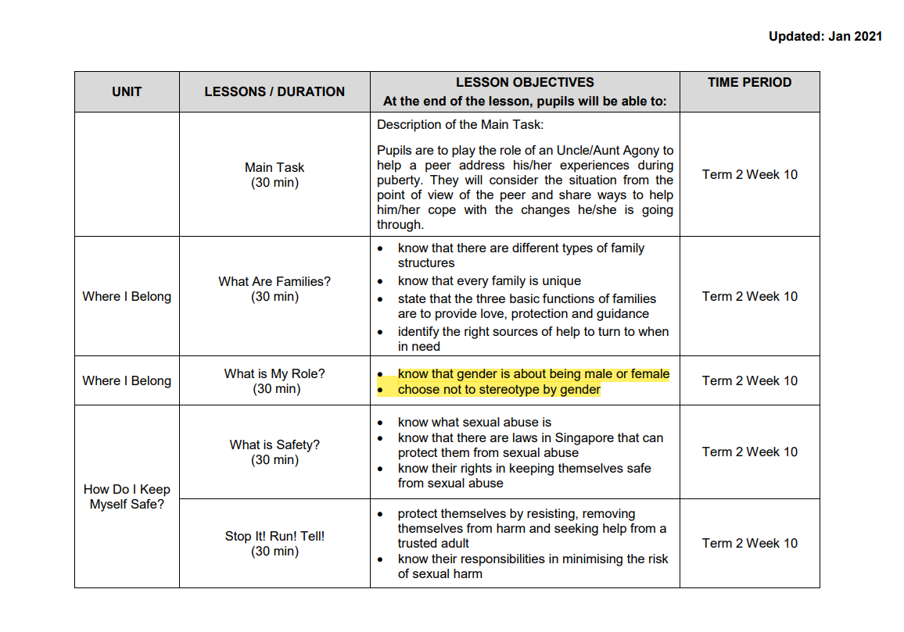
Fig 1. A section of MOE’s 2021 Growing Years curriculum for Primary 5 students

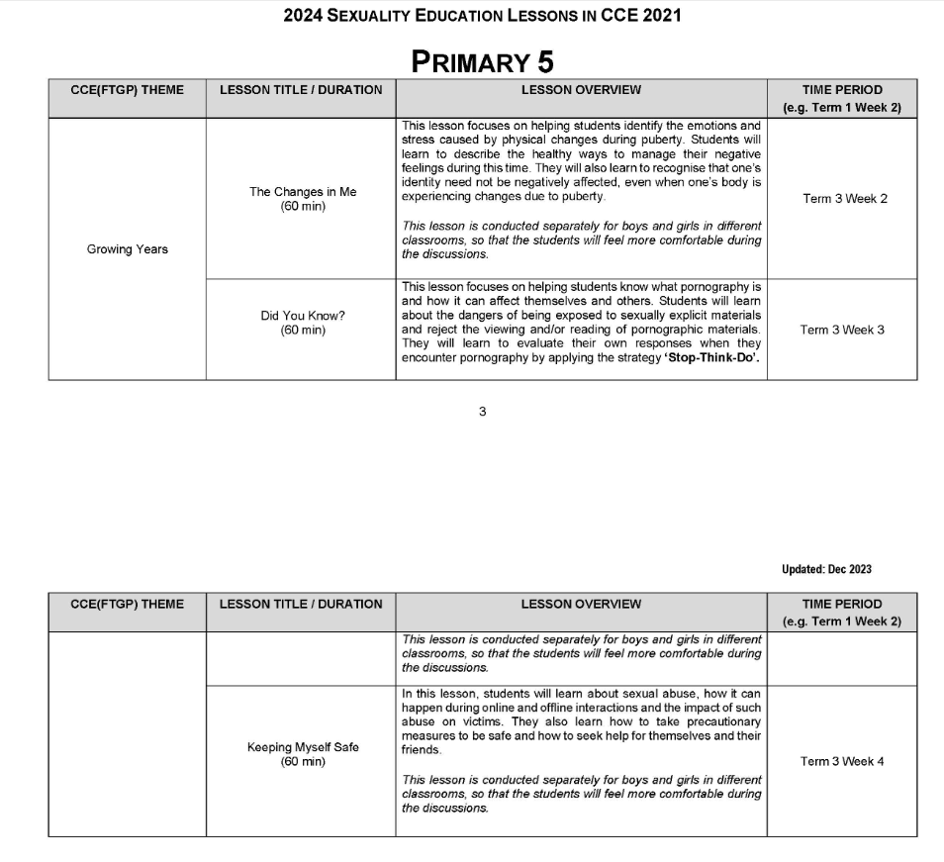
Fig 2. MOE’s 2024 Growing Years curriculum for Primary 5 students

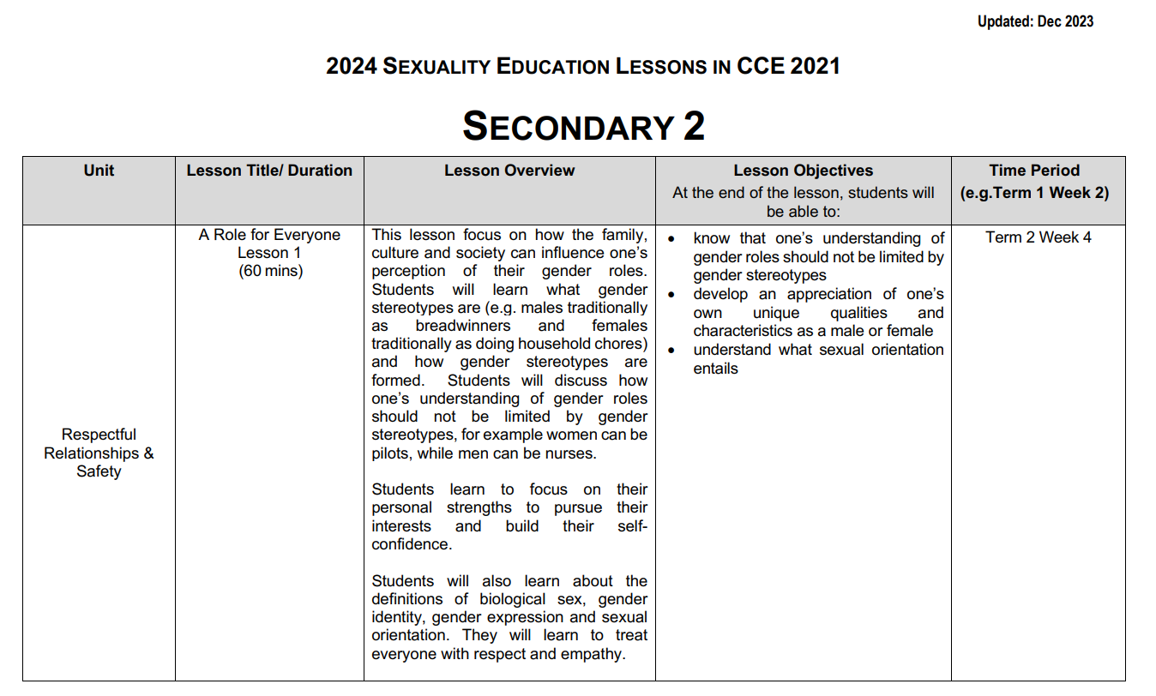
Fig 3. A section of MOE’s 2024 Growing Years curriculum for Secondary 2 students

Singapore Chinese Girls’ School (Primary), Singapore Chinese Girls’ School (Primary) - MOE Sexuality Education In Schools (Singapore: Singapore Chinese Girls’ School (Primary), 2021), 4, https://www.scgs.moe.edu.sg/files/Archive/Sexuality-Education-Information-Primary-2021.pdf
“Sexuality Education Programme for Primary 5”, CHIJ (Katong) Primary, 25 March 2024, https://www.chijkcp.moe.edu.sg/our-ij-experience/co-curricular/cce/sexuality-education-programme-2023-Primary5/
Raffles Girls’ School, 2024 SEXUALITY EDUCATION LESSONS IN CCE 2021 (Singapore: Raffles Girls’ School, 2023), 5, https://www.rgs.edu.sg/files/2024_Info_on_SEd_for_RGS_website___1_.pdf

