Additional Information
Brazil’s review to CEDAW

1 - Number of marriages of girls in Brazil

According to data from the Brazilian Institute of Geography and Statistics (IBGE), these are the numbers of marriages of girls in Brazil, disaggregated by age and years (from 2003 to 2022):

Year | Under age 16 | Between age 16 and 18
2003 | 2620 | 84308
2004 | 2658 | 101942
2005 | 2053 | 99345
2006 | 2063 | 97501
2007 | 1898 | 92160
2008 | 1575 | 89024
2009 | 1406 | 81880
2010 | 1284 | 85478
2011 | 1286 | 86533
2012 | 1003 | 85246
2013 | 990 | 83184
2014 | 1044 | 82304
2015 | 939 | 77402
2016 | 709 | 68825
2017 | 530 | 60514
2018 | 493 | 54502
2019 | 395 | 47410
2020 | 238 | 36274
2021 | 272 | 38257
2022 | 260 | 34332

It is observed that there are no official data on stable unions by age groups.

2- Policies and data on child exploitation and tourism

According to the National Observatory of Human Rights (ObservaDH), regarding the years 2021 and 2022, there was an increase in all crimes classified as non-lethal against children and adolescents, with emphasis on sexual exploitation, rape, abandonment of a person in need of care, and mistreatment. The crimes with the highest number of victims among children and adolescents were rape (about 142 victims per day), mistreatment (about 61 victims per day), and bodily injury in the context of violence (about 42 victims per day). Furthermore, it was verified that there were 764 records of sexual exploitation in 2021, and 889 in 2022.

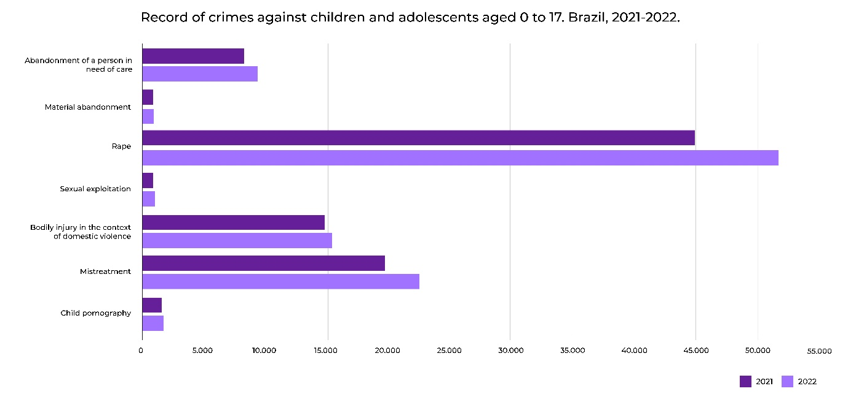

For further statistical information on violence and violations against children and adolescents, please access: https://experience.arcgis.com/experience/6a0303b2817f482ab550dd024019f6f5/page/CA---Viol%C3%AAncias-e-viola%C3%A7%C3%B5es/

The following tourism-related policies stand out:
Carnival Campaign
Annual awareness campaign for the prevention, reporting, and combating of various violations of the rights of children and adolescents during the Carnival period. The services provided take into account the most recurrent types of situations involving children and adolescents in large events, such as: sexual exploitation; child labor; use of alcohol and illicit drugs; children and adolescents living on the streets; physical violence; children in situations of neglect; lost children or those in situations of disappearance.
Brazil Code of Conduct Against the Sexual Exploitation of Children and Adolescents in Tourism
The objective of the Brazil Code of Conduct is to lead companies and tourism service providers to adopt commitments and an explicit position of repudiation against the sexual exploitation of children and adolescents in their internal policies. It also encourages that these actors promote the dissemination of information and training, aiming to provide their employees and commercial partners with a greater understanding of the topic and guidance on how to act when faced with suspected cases.

4 - Policies for transgender women

Brazil follows legislation such as the Maria da Penha Law, as well as jurisprudence, including the ruling by the Superior Court of Justice in the case of Special Appeal 1977124/22, which applies the law irrespective of sexual orientation and/or gender identity. Furthermore, the Supreme Federal Court has recognized gender self-determination through Declaratory Action of Unconstitutionality 28.

5- Number of female judges and appellate judges

The majority of male and female judges are white. Mixed-race (parda) women represent 12.7% of chief judges, 10.8% of substitute judges, and 10.5% of appellate judges. Black women account for 1.4% of chief judges, 2.1% of substitute judges, and 1.2% of appellate judges. Among male judges, mixed-race men represent 15.2% of chief judges, 15.4% of substitute judges, and 9.6% of appellate judges. The lowest percentages are for Black and Asian judges, with only 1.3% of Black chief judges, 1.4% of substitute judges, and 1.1% of appellate judges.
(Source: 2023 Census)

6 - List of national legislation regarding women approved since January 2023

In addition to the normative acts described in the annex submitted by Brazil to CEDAW in 2024, it is necessary to include the following:

- Law 14,847 of April 2024 on the provision of private and individualized care for women victims of violence in the Unified Health System services.
- Law No. 14,857, of May 2024, which amends the Maria da Penha Law, to determine the confidentiality of the victim's name in proceedings investigating crimes committed in the context of domestic and family violence against women.
- Law No. 14,649, of August 2023, and Law No. 14,796, of January 2024, respectively inscribe the name of Margarida Alves, heroine of the peasant leagues and rural workers of Brazil, and Dorina Nowill, blind educator and activist for accessibility for people with disabilities, in the Book of Heroes and Heroines of the Homeland.
- Law No. 14,834, of April 2024, established April 13 as the National Day of Women Samba Musicians, and honors the Rio de Janeiro singer and composer Ivone Lara.
- Decree No. 11,994, of April 2024, addresses the National Strategy for Female Entrepreneurship, "Elas Empreendem," and the Female Entrepreneurship Committee.
- Decree No. 12,009, of May 2024 enacts the texts of the ILO's Convention on Decent Work for Domestic Workers (No. 189) and the Recommendation on Decent Work for Domestic Workers (No. 201).

