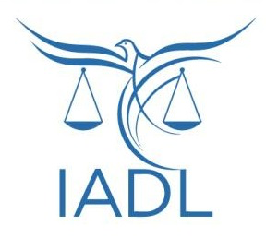
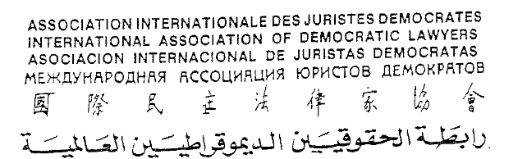

Contribution of the International Association of Democratic Lawyers to the Committee on the Elimination of Racial Discrimination (CERD) – Review of Cuba
CERD – 117th session (13 April 2026 – 1 May 2026)

1. Introduction
The International Association of Democratic Lawyers (IADL) is an international organization of jurists committed to the promotion of international law, human rights, and social justice. Founded in 1946, IADL has held consultative status with the United Nations since 1969 and has a long-standing record in the fight against racism and racial discrimination.
We present this submission with the aim of contributing elements to the periodic review of Cuba, highlighting relevant progress in the implementation of the International Convention on the Elimination of All Forms of Racial Discrimination (hereinafter, “the Convention”), even in a context marked by the adverse impact of the embargo imposed by the United States for more than six decades, which —as has been repeatedly noted by the international community— imposes structural limitations on the country’s development and on the full enjoyment of human rights.
We adopt a constructive approach, recognizing progress achieved while identifying areas that may be further strengthened, in line with the Committee’s recommendations.

2. Normative framework and State commitment
Cuba has consolidated a robust legal framework that explicitly incorporates the principles of equality and non-discrimination, in accordance with Articles 1 and 2 of the Convention.
The 2019 Constitution:
• Explicitly prohibits discrimination on grounds of race, skin color, or national origin.
• Establishes the State’s obligation to promote substantive equality.
• Reaffirms human dignity as a central principle of the legal system.
These developments are part of a historical trajectory of public policies aimed at promoting equality and social justice and are consistent with the recommendations of the Committee regarding the strengthening of the legal framework against racial discrimination (CERD/C/CUB/CO/19-21, para. 16). These developments are part of a historical trajectory of public policies
The State has demonstrated sustained commitment to the principles of the Convention, providing a solid legal basis for the design and implementation of inclusive public policies.

3. Public policies and universal approach
The Cuban State has developed universal policies in key sectors such as health, education, and social protection, which have contributed to substantially reducing structural inequalities and advancing social inclusion, in line with Article 5 of the Convention.
In particular:
• Universal and free access to health care, with comprehensive preventive and curative coverage.
• An inclusive education system, from primary education to higher education, ensuring equal opportunities for the entire population.
• Social protection programs that reach the entire population, including people of African descent.
These policies have had a significant positive impact on reducing historical inequalities, substantially improving living conditions and the social well-being of the most vulnerable groups.
The Committee has recognized the importance of these policies (para. 6), while recommending that they be complemented with specific measures to address persistent structural racial inequalities affecting the Afro-descendant population (para. 18). In this regard, the Cuban approach reflects a progressive move toward integrating universal policies with targeted measures to promote racial equality.

4. Institutional approach to racial discrimination and the “Color Cubano” program
In recent years, there has been a strengthening of the institutional approach to persistent racial inequalities, along with the adoption of targeted initiatives to address them.
In line with its long-standing commitment to equality, and consistent with the Committee’s recommendations, Cuba has promoted cultural and educational programs aimed at raising awareness among the population and increasing the visibility of racial discrimination, including broad spaces for academic and institutional dialogue.
In this context, the “Color Cubano” program is particularly noteworthy, aimed at:
• Making visible the racial diversity of Cuban society and promoting equality.
• Raising public awareness about racial discrimination.
• Promoting cultural transformations conducive to inclusion.
These initiatives represent concrete advances in the implementation of the Committee’s recommendations, particularly those related to the adoption of special measures to eliminate structural inequalities affecting the Afro-descendant population (para. 18). They also reflect the State’s commitment to addressing not only direct discrimination but also persistent cultural and social biases.

5. Implementation of Committee recommendations
Cuba has followed up on several key recommendations of the Committee, showing progress in different areas:
- National Programme against Racism and Racial Discrimination “Color Cubano”: the program, adopted in 2019, structures institutional actions to address racial discrimination nationwide, in line with the Committee’s recommendations on the adoption of special measures, the strengthening of public policies, and the promotion of public debate
- Access to justice: training of judicial officials and promotion of measures to ensure effective remedies in cases of racial discrimination (para. 22).
- Prevention of excessive use of force: implementation of measures to prevent abuses, ensuring investigation and sanction where appropriate (para. 32).
These efforts reflect significant progress in the implementation of the Convention, strengthening the protection of rights and access to remedies.

6. International context and structural challenges
The above developments must be assessed in light of a complex international context, marked by the persistence and intensification of the economic, commercial, and financial embargo unlawfully imposed by the United States of America, which has a significant adverse impact on the country’s economy and limits the availability of resources for the implementation of public policies.
Various United Nations mechanisms have recognized that unilateral coercive measures can negatively affect States’ capacity to comply with their human rights obligations. Against this background, it is particularly noteworthy that Cuba has maintained inclusive social policies and sustained efforts toward racial equality despite these constraints.

7. Recommendations
In order to consolidate the progress achieved, IADL identifies some areas for further strengthening that could contribute to advancing racial equality in Cuba:
• Continue improving the availability of disaggregated statistical data by race or skin color
• Continue developing special measures to address persistent racial inequalities
• Continue strengthening monitoring and evaluation mechanisms for public policies on racial equality
• Continue reinforcing public awareness campaigns on the effects of racial discrimination and persistent stereotypes

8. Conclusion
Cuba has achieved significant progress in promoting racial equality, supported by a solid normative framework, universal policies in education, health, and social protection, and the progressive development of specific initiatives such as the “Color Cubano” program.
These efforts reflect a sustained commitment to the principles of the Convention and are consistent with the Committee’s recommendations.
In a context of profound structural challenges, associated primarily with the persistence of the economic, commercial and financial embargo imposed by the United States, it is essential to recognize these advances and the efforts undertaken, and to encourage their continuation, with a view to further advancing substantive racial equality, in accordance with the obligations arising under the Convention.

