AFJV CAO DAI TAY NINH TEMPLES OF TEXAS
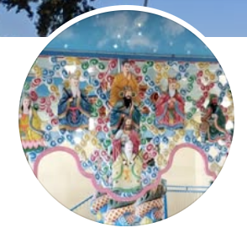

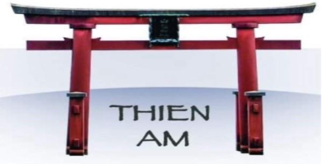 | 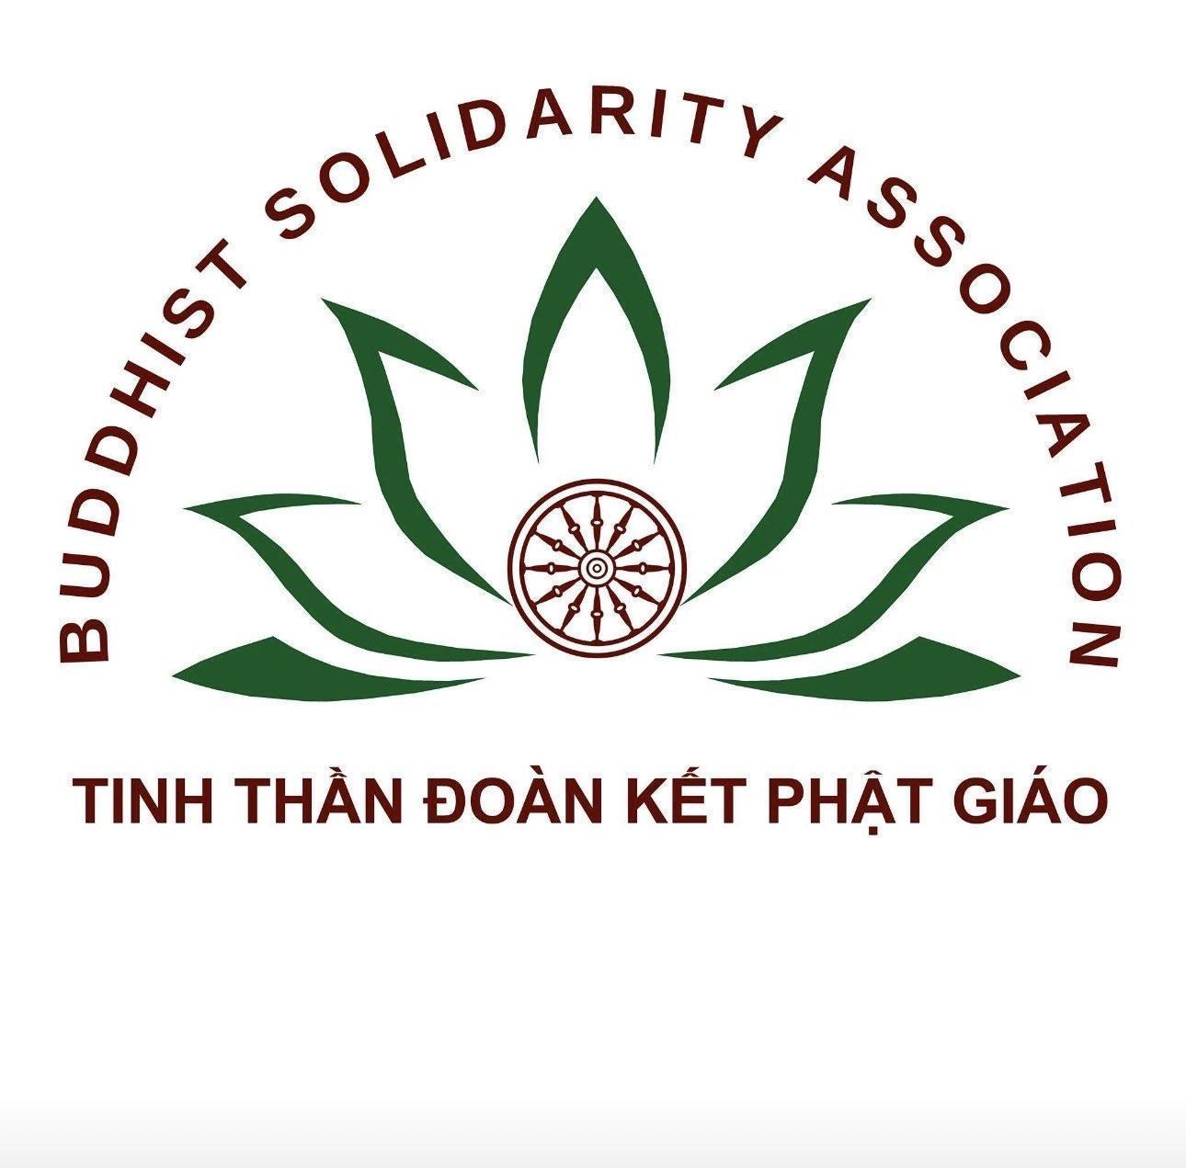
Integrated by: HUMAN RIGHTS FOR VIETNAM
Submitted in December 2025 For the 2026 CEDAW review of Vietnam
Boat People SOS (BPSOS), Advocates for Faith and Justice in Vietnam (AFJV), Buddhist Solidarity Association (BSA), Friends of Thien Am, Caodai Tay Ninh Temples of Texas, Montagnards Stand for Justice, and Hmong for Human Rights
Contact: Tien Nguyen, tien2bpsos@gmail.com
This document addresses the following CERD issues:
Access to justice
3. Please provide information on:
(a) The eligibility of women and girls to free legal aid under the Law on Legal Aid (2017) in cases of gender-based violence and discrimination against women, and trafficking or exploitation of women and girls;
(c) The number of investigations, prosecutions, convictions and the sentences imposed in cases of gender-based violence against women, the fines imposed in cases of discrimination against women, and the redress provided to victims (para. 18);
(e) The number of investigations, prosecutions and convictions and the sentences imposed in cases of corruption in the administration of justice.
Gender-based violence against women
8. Please provide information on the measures taken to raise public awareness of the criminalization of all forms gender-based violence, in particular sexual violence. Please also provide information on the number of investigations, prosecutions, convictions … What measures has the State party taken to: (a) increase recourse to legal proceedings in cases of gender-based violence against women; (b) reduce the rate of case attrition across all levels of the criminal justice process…
Vietnam’s replies don’t support the facts. Significant gaps include:
1. The government allows local anti-Christian violence to go unchecked in remote Hmong communities. Further, it encourages and supports domestic violence by husbands and family members of Hmong Christian women who refused to renounce their Christian faith.
2. The government turns a blind eye to tens of thousand internally displaced Hmong Christians who involuntarily relocated to the Central Highlands and remain undocumented for more than two decades -- not having access to basic services and benefits, women and children among this population of internally displaced persons (IDPs) are particularly disadvantaged and vulnerable. .
The above issues are addressed with more details in another December 2025 report submitted for this review of Vietnam, Alternative Report to the CEDAW Committee - Discrimination against H'mong Women in Vietnam.
3. The government abets trafficking in persons and does not provide assistance and protection to women experiencing exploitation after being sent under the state-run Labor Export Program to do domestic servant work in Saudi Arabia. Many victims who returned have received no assistance pursuant to Vietnamese law and the Palermo Protocol.
4. The government denies the existence of indigenous people, although Montagnards have been living in the Central Highlands and elsewhere long before the dominant Kinh race moved to the Central Highlands. Many Montagnard women who stood up for their indigenous rights have been targeted for persecution.
In addition to the above, three other points are also addressed in this document.
The Communist Party of Vietnam (CPV) uses state-controlled religious organizations to control religious life and to intimidate and pressure independent religious communities into submission. A state-controlled religious organization is a religious group or institution that operates under the direct influence, supervision, or control of the government. The government exercises significant authority over these organizations, including leadership appointments, property matters, religious practices, and even doctrinal interpretation. CPV used to rule only North Vietnam from 1954 to April 1975 during the existence of non-communist South Vietnam. After the end of the Vietnam War on 30 April 1975, the communist regime unified the country. CPV cracked down on South Vietnamese religious organisations and closed down (or put severe restrictions on) prayer halls, religious facilities, etc. of religious organisations including the Unified Buddhist Church of Vietnam, Cao Dai Church, Evangelical churches (primarily in the Central Highlands Montagnard communities), Hoa Hao Buddhist Church, and Khmer Krom Buddhist Church. The Catholic Church in South Vietnam was also viciously persecuted in the initial years following the Communist victory in April 1975. The new government confiscated many religious facilities (notably Cao Dai temples and Buddhist temples, hospitals, universities, and schools among others), exerted strict control over all religious activities, and many Catholics lived in fear. CPV also established its version of some banned religious organisations, including the Cao Dai Sect established in 1997 and Vietnam Buddhist Sangha (VBS) established in 1981, and gave them the use of properties confiscated from the Cao Dai Church and UBCV. Even now CPV maintains tight control over religious organisations in both North and South. In September 2024, US Commission on International Religious Freedom (USCIRF) identified six state-controlled religious and pseudo-religious organizations serving as instrument of religious control and suppression for the government.
A few cases can show that Vietnam did not tell the truth in its CEDAW document.
1. Indigenous Hmong Christian mothers were driven to seek asylum in Thailand with their infants under threat of detention and imprisonment.
LYH and LYL, sisters, fled with their infants from Nghe An Province, Vietnam in August 2023. They had joined the Evangelical Church of Vietnam – North (ECVN-North), one of the state-controlled churches identified by USCIRF. The local government and villagers pressured them to renounce their religion, yet their church did not intervene. Instead of defending them, the church expelled them when the government coerced them to renounce Protestantism. Finally, in August 2023, as the police were about to detain them, they had to seek asylum in Thailand
Earlier, their elder sister LYT in Nghe An Province had joined –ECVN-North. In 2022, the government banished her from the village, leaving behind her two children aged 14 and 16.
Ref: report submitted on 15 October 2023 to SR-FoRB with filename PROT Hmong_En Banished LYL Y Hua Events 2023 Jul Aug
Background
ECVN was founded in 1911 through the work of Christian and Missionary Alliance (C&MA) missionaries from North America. With the division of Vietnam into the communist North (Democratic Republic of Vietnam) and the anti-communist South (Republic of Vietnam), ECVN was split into two organizations: ECVN-North and ECVN-South.
In 1958, ECVN-North was recognized by the communist government but at a price: ensuring docility and obedience among church members towards government policies and speaking well of the regime to the international community.
In 2010, the government intensified its efforts to brutally force Hmong Christians in the Northwestern Highlands, including tens of thousands of ECVN-North members, to renounce their Christian faith. Those who showed resistance were evicted from their villages, denied household registration documents, and forced to live on the margin of society. In May 2011, some 5,000 Hmong Christians gathered in Muong Nhe Village, Dien Bien Province, to pray for religious freedom and an end to government expropriation of their homes and farmlands. The military and police moved in. Their bloody crackdown resulted in many demonstrators, including women, the elderly and children, being injured and at least a dozen deaths. Scores of demonstrators were detained or sent to prison.
2. Plight of Internally Displaced Hmong Christians:
Facing brutal government crackdown, tens of thousands of Hmong Christians fled the Northwestern Highlands and migrated to the Central Highlands, where they formed new communities of undocumented people in the middle of the forest and have no utilities, schools, roads, medical clinics, or ID documents. ECVN-North has maintained a deafening silence about their plight all along. Women and girls are particularly disenfranchised. They are not issued marriage certificates and cannot obtain birth certificates for their children; in rare instances where a birth certificate was issued, the child was listed as fatherless.
For Hmong Christians who don’t live in stateless communities, the case of the L sisters shows that Hmong Christians who are females are in a very difficult situation. The local authorities colluded with their husbands to mistreat those who refuse to renounce their Christian faith.
3. Female trafficking victims receive no help after repatriation from Saudi Arabia
The government abets trafficking in persons and does not provide assistance and protection to women experiencing exploitation after being sent under the state-run Labor Export Program to do domestic servant work in Saudi Arabia. Many victims who returned have received no assistance pursuant to Vietnamese law and the Palermo Protocol. Their plight in Saudi Arabia where they were exploited and mistreated by Saudi employers and threatened by Vietnamese Embassy personnel who should have helped them can be found in a communication from Special Rapporteurs to Vietnam. We have a confidential dossier for more than a dozen victims, including Ms. Huynh Thi Gam, a returnee who has written many times to the Vietnamese government to date but receives no help; her petitions were ignored or ridiculed by the police. Despite her requests for criminal investigation and prosecution over a period of nearly 30 months, the police have not even begun to investigate her traffickers. We will provide the committee with this information at our pre-review meeting.
4. Montagnard women and men are denied the status of indigenous people
The United Nations referred to the Montagnards in Vietnam as indigenous peoples The government denies the existence of indigenous people although Montagnards have been living in the Central Highlands and elsewhere long before the dominant Kinh race moved to the Central Highlands. As indigenous rights encompass access to and use of the ancestral lands, many Montagnards women who live off agricultural work have found themselves without livelihood due to land grab.
5. Disruption of a Cao Dai funeral held by a widow in Trường Hòa Commune, Tây Ninh Province, 31 October and 1 November 2024 by the government-established Cao Dai Sect, which was identified by USCIRF in its September 2024 report.wh. The government ignores complaints filed by the widow and other mourners because they belong to the original but banned Cao Dai Church.
The deceased was a follower of the Cao Dai Church founded in 1926. His widow followed his wish - he preferred that fellow church members participate in his funeral rite. The government-established Cao Dai Sect aggressively disrupted the event because the family did not invite the funeral group of the sect. The sect follows a doctrine that is not compatible with the 1926 Cao Dai Church and has been found to be an “organised criminal gang” by a court in Texas, USA. The Cao Dai Sect, established by the government in 1997, has a history of religious intolerance mirroring the Vietnamese government, its creator and protector. This latest event is one of the most egregious attacks against a family which follows the traditional, authentic Cao Dai Church established in 1926. Sect members used force to seize items needed for the funeral music. On the second day of the attack, sect members from other communes and thugs (suspected to be security police in civilian clothing), entered and used chairs to hit the widow and mourners. She called “113”, the local emergency call number, three times but the authorities ignored her calls. The victims managed to stay together until the attackers eventually departed. Video clip showing the attack (with English subtitles):
Minute 3:48 https://www.facebook.com/share/v/14bod93eVL/
See below excerpts from the report submitted to SR-FoRB in late 2024:

CD-BAOCAO-TAYNINH-16-11-2024
Vietnam: Over 100 members of the 1997 Cao Dai Sect (established by the government in 1997) forced their way into a private home and violently disrupted a funeral rite in Tây Ninh Province in November 2024 because the deceased’s family did not want sect members to lead the funeral rite. The Vietnamese police turned a blind eye to this massive violation.
To: Special Rapporteur on Freedom of Religion or Belief
United Nations at Geneva
(1) General Information
Summary
Trường Hòa Commune, Tây Ninh Province, 31 October and 1 November 2024: The deceased was a follower of the Cao Dai Church founded in 1926. His widow followed his wish - he preferred that their fellow church members participate in his funeral rite. The government-established Cao Dai Sect aggressively disrupted the event because the family did not rely on the funeral group of the sect. The sect (established in 1997 by the communist government) follows a doctrine that is not compatible with the 1926 Cao Dai Church and is deemed an “organized criminal gang” by a court in Texas, USA. The Cao Dai sect established by the government in 1997 has a history of religious intolerance mirroring the Vietnamese government, its creator and protector. This latest event is one of the most egregious attacks against a family which follows the traditional, authentic Cao Dai Church established in 1926. For example, sect members used force to seize items needed for the funeral music. On the second day of the attack, sect members from other communes and thugs (suspected to be security police in civilian clothing), entered and used chairs to hit the funeral guests invited by the widow. She called “113”, the local emergency call number, three times but the authorities ignored her calls. The victims managed to stay together until the attackers eventually departed.
(2) Identity of the persons concerned
In Addendum 1.
(3) Information on the alleged violation(s)
The family of Mr. LMC (deceased) followed his wish to have fellow church members from the 1926 Cao Dai Church participate in the rite for his funeral.
- 31 October 2024 - victim: widow TTL - a resident of Trường Hòa Commune, Town of Hòa Thành, and several invited guests
The governing committee of the 1997 Cao Dai Sect in Trường Hòa Commune came to demand the widow let the sect handle the funeral rite. The widow replied that her husband had expressed his desire to have only members of the traditional Cao Dai Church participate in the rite. The sect members did not leave when the widow asked them to do so. They caused trouble and seized stands used to hold the ceremonial drums needed for the funeral.
- 1 November 2024 - victim: widow TTL - a resident of Trường Hòa Commune, Town of Hòa Thành, and several invited guests
The governing committee of the 1997 Cao Dai Sect in Trường Hòa Commune, augmented with the governing committees of nearby communes and thuggish individuals came to the victim’s home to disrupt the funeral rite. The widow called the emergency reporting phone number three times. The police did not respond. The scuttle was so worrisome that another 1926 Cao Dai Church member, Ms. NXM in Vĩnh Long City, had to call the political officer of the US Consulate General in Ho Chi Minh City. While the consulate general officer encouraged the caller to share a report on the incident with the US, he did not call the local authorities. The attackers left fifteen minutes later. Only then could the funeral rite resume.
Video clip showing the attack (with English subtitles): https://www.facebook.com/share/v/14bod93eVL/
6. Criminal prosecution of a witness for testifying against Red Flag Association members who assaulted Catholic women:
While Communist Vietnam recognised the Catholic Church, the regime has been doing all it can to weaken and infiltrate the Church through its veto power blocking seminaries’ admission of those aspiring to become priests; funding and securing the loyalty of clergy members and followers, at times working around their bishops; and using thugs such as the Red Flag Association against those who dare speak out against government restriction of their religious freedom.
On 17 December 2017, a group of government employees and police officers of Hưng Tây Commune, Hưng Nguyên District, Nghệ An Province showed up to threaten female members of Kẻ Gai Parish who were working on an irrigation project on the croplands that their families had donated to their church. The government ordered a halt to the work. The women refused to comply with the absurd order. Shortly thereafter, more than 100 men descended from buses or arrived on motorbikes, all with red flags draped around them, and proceeded to attack the women in full view of the local officials and policemen. Under the direction of the chairman of Hung Tay Commune and the commune police chief, the group beat up and injured several victims. A few male parishioners who attempted to protect the women were beaten until they passed out. Rev. NDN, priest of Ke Gai Parish, requested the government representatives to explain the reason for the incident and to prepare an incident report. The priest also asked the parishioners to disperse so as to avoid a bloody crackdown as some 1000 or more rapid-response police officers with riot control gear, weapons, and police dogs arrived and were poised to attack. One male parishioner who witnessed the violent assault and provided an affidavit in support of his parish priest’s request for police investigation against the attackers was targeted for criminal prosecution; he had to flee to Thailand to be followed by his wife and two daughters later. All four have been recognized as refugees by the UNHCR in Thailand; yet, the witness continues to be under the Search and Arrest Warrant of the Ministry of Public Security. This case, where the government targets the witness instead while treating the perpetrators with absolute immunity, has been reported in the UN Secretary General’s annual report on intimidation and reprisals. To this day, none of those who committed violence against those women from Ke Gai Parish has been investigated, let alone prosecuted.
7. Wrongful conviction in May 2025 of two already imprisoned members of the Buddhist group known as Zen Meditation Centre at the Edge of the Universe, including a woman. Numerous intimidation instances, house searches, false accusations of group incest, and forced DNA and “virginity” tests against female believers. Prosecution of their defense attorneys who had to escape to the USA.
Approximately 30 group members, including the 92-year old founder, adult female and male monastics, child monastics, and lay followers are persecuted based on false accusations by VBS Monk TNT and another VBS monk. Six adults received prison sentences. Ten child monks and nuns lost their mentors and are being taken care of by those still free, but the police monitor their residence and enter anytime they want to. This resulted in trauma for the victims. May 2025 trials further punished the founder and one of the imprisoned victims. Four out of the five or six attorneys defending the victims had to escape from Vietnam. 2023 and 2024 because the government started to investigate them in preparation for unlawful trials to punish them.
A report from NGOs was submitted to the UN Committee on the Rights of the Child in 2022 and this committee issued its concluding observations. A 2025 report on this case focusing on female and child victims to the Special Rapporteur on Torture is attached.
Recommendations
We recommend that the CEDAW Committee:
- Request the Vietnamese Government to report its investigation of the perpetrators behind the forced virginity test against the young female monk of Zen Hermitage, the acts of violence against the two sisters LYH and LYL, and the Red Flag Association’s brutal attack on female members of the Ke Gai Parish.
- Ensure that Montagnard women who speak out for their and their community’s indigenous rights do not face reprisals by the Vietnamese government.
- Verify that Vietnamese women exploited and/or sexually abused during when sent to work as domestic servants in Saudi Arabia are identified as victims of human trafficking by and receive proper assistance from the Vietnamese Government and that their traffickers are investigated and prosecuted.
- Recognize the tens of thousands Hmong Christians who had to relocate to Vietnam’s Central Highlands because of their Christian faith come under the protection of the UNHCR as internally displaced persons.

Report to the Committee on the Elimination of Racial Discrimination Vietnam Targets its Largest Indigenous Group: Montagnards and Hmong, August 2023.
UA VNM 3/2022
Three ministers (Public Security, Foreign Affairs, Labor-Veterans-Social Affairs); four consecutive Presidents of Vietnam; Inspector-General of Ministry of Public Security; Police Departments of Hanoi and Ho Chi Minh City, etc.
https://www.ohchr.org/en/press-releases/2024/08/experts-condemn-misuse-counter-terrorism-law-against-montagnards-viet-nam
https://journals.openedition.org/rbnu/3009?lang=en#:~:text=Pour%20les%20uns%2C%20les%20Montagnards%20sont%20des,provenance%20de%20Chine%20et%20l'arriv%C3%A9e%20des%20Khmers.
Red Flag Associations: An emerging threat to Catholic communities in Vietnam, BPSOS, 27 March, 2018, available at: https://dvov.org/wp-content/uploads/2018/03/BPSOS-Report-on-Red-Flag-Associations-03-27-18.pdf
As above.
https://www.state.gov/reports/2023-report-on-international-religious-freedom/vietnam/
https://www.lawyersforlawyers.org/vietnamese-lawyers-dang-dinh-manh-dao-kim-lan-and-nguyen-van-mieng-forced-to-flee-their-country/
https://dvov.org/wp-content/uploads/2022/08/BPSOS-UNCRC-report-on-TABBVT-for-public-release.pdf
https://uhri.ohchr.org/en/document/8931c140-a935-416b-846c-5d474c30b47b

