Joint Civil Society Submission to the 91st Session of the CEDAW Committee on Thailand’s Implementation of the Convention on the Elimination of All Forms of Discrimination against Women, with a Focus on the Human Rights of Trans and Gender-Diverse People

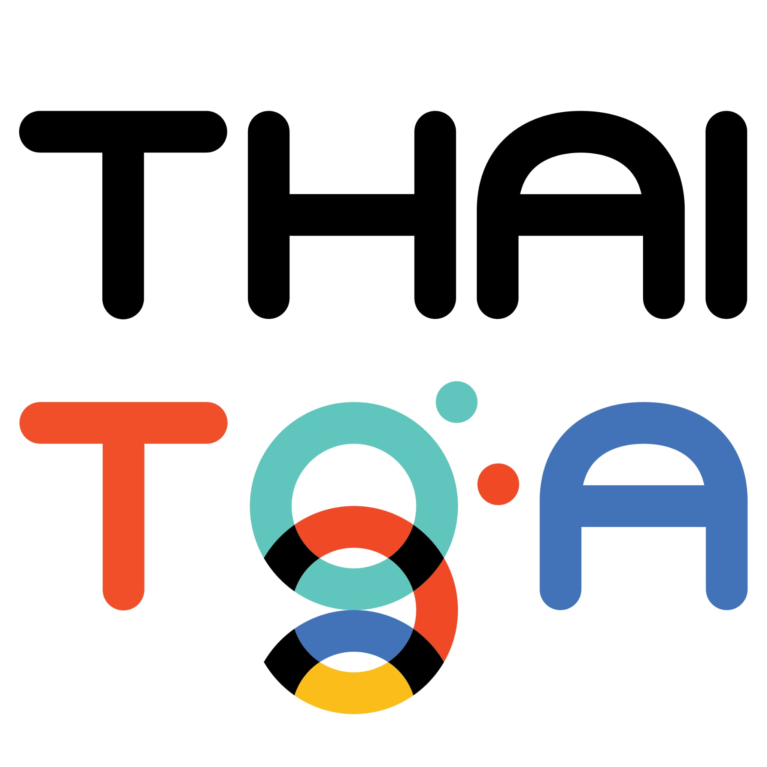
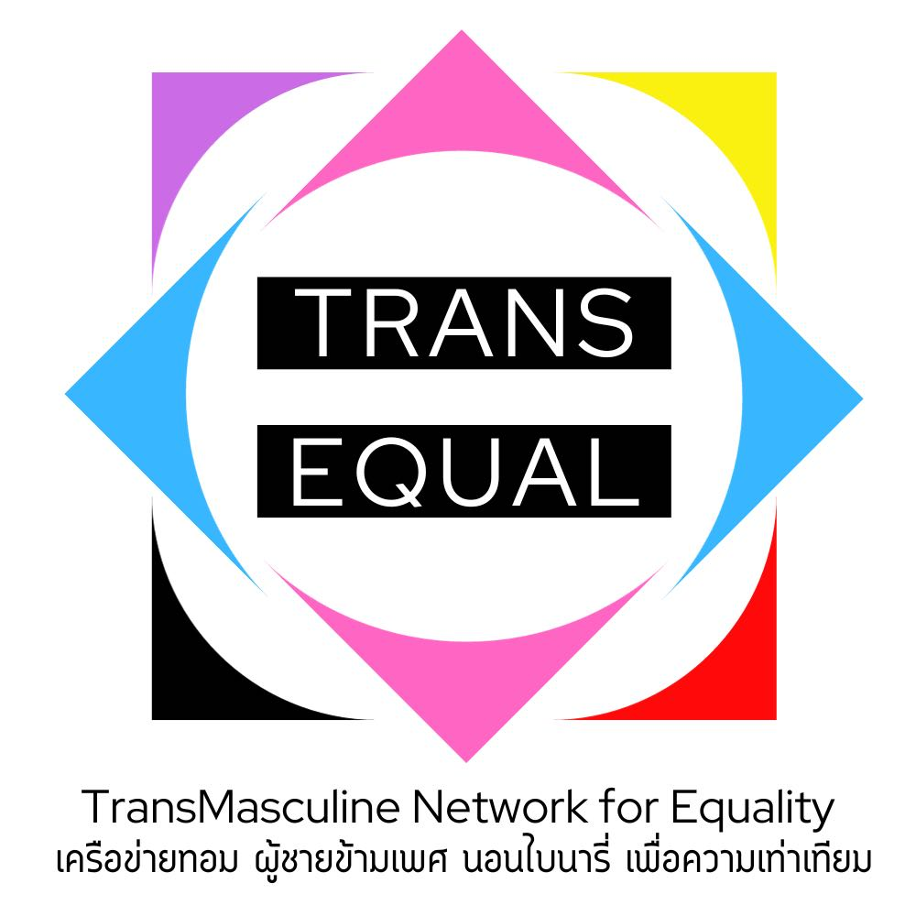
Members of working group for this partnership
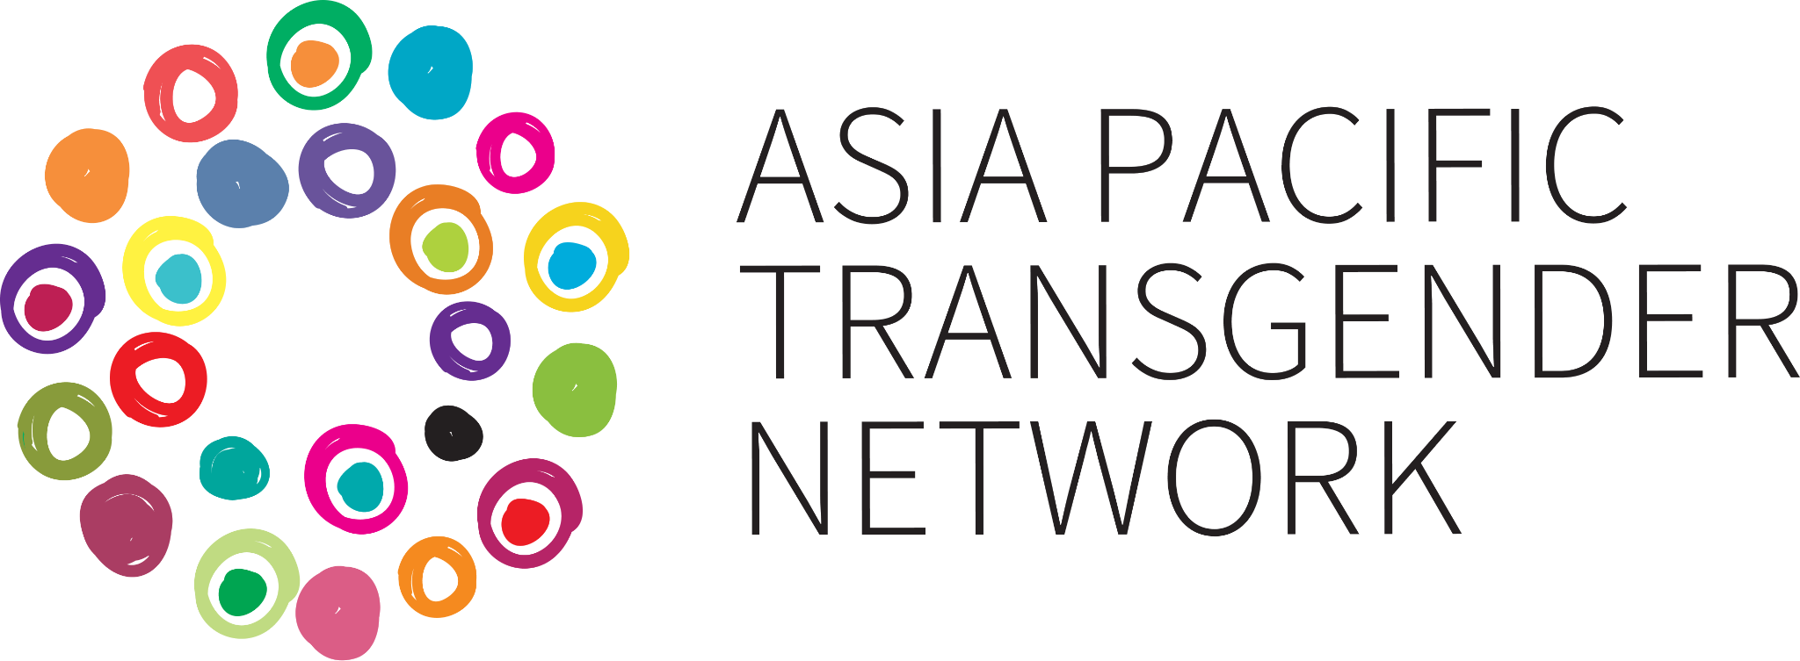


1. Asia Pacific Transgender Network (APTN)

Asia Pacific Transgender Network (APTN) is a regional network registered in Thailand. APTN advocates for the human rights of transgender people in Asia Pacific and has worked with 26 countries across the regions.

2.The Foundation of Transgender Alliance for Human Rights (ThaiTGA)

The Thai Transgender Alliance (Thai TGA) was established in 2010 to support trans women in Thailand and evolved into the Foundation of Transgender Alliance for Human Rights in 2016, aiming to improve the lives of all transgender people through a human rights-based approach. The foundation works to reduce stigma, discrimination, and violence by promoting social participation, policy reform, and public understanding of trans identities. In recent years, it has expanded its movement strategies to include trans men and non-binary individuals, continuing its work through partnerships with activists, academics, and civil society.

3.Transmasculine Network for Equality (TransEqual)

The Transmasculine Network for Equality (TransEqual) is an organization led by trans men, established in 2023. Its objective is to connect networks, strengthen capacities, and empower grassroots leaders who are toms, trans men, and nonbinary individuals in advocating for the rights of toms, trans men, and nonbinary people across four regions in Thailand.

4. YOUNG PRIDE FOUNDATION

Young Pride Foundation is a trans and youth-led community founded by trans survivors of unfair and transphobic discrimination in higher education in Thailand. Founded in 2018 and officially registered in 2024, we have been a leading force in promoting LGBTIQ+ rights and youth empowerment in Thailand. Through policy advocacy, community empowerment, and international collaboration, YPC has driven significant social changes.

Introduction

Since the last CEDAW review cycle, Thailand has made some progress in advancing the rights of trans and gender-diverse individuals. The adoption of the Marriage Equality Act marks a significant legal milestone for LGBTIQ+ rights broadly. However, many critical gaps remain in the protection and fulfillment of the rights of trans and gender-diverse people. Legislative proposals such as the Gender Recognition Act and Anti-Discrimination Bill remain stalled in Parliament. Meanwhile, reforms to the Gender Equality Act B.E. 2558 (2015) are under consideration but have yet to address key exemptions that allow discrimination on the basis of religion or national security.

This submission highlights the persistent structural, legal, and institutional barriers facing trans and gender-diverse individuals in Thailand. These include the gaps in Gender Equality Act B.E.2558, procedural delays in justice mechanisms, lack of legal gender recognition, failure to address anti-trans hate crimes, issues related to the military enlistment, lack of access to trans competent healthcare, systemic discrimination in schools, world of work and correctional facilities.

While the Thai government has shown signs of openness to legal reform, implementation remains fragmented, under-resourced, and slow. To ensure that the rights of trans and gender-diverse persons are meaningfully upheld in accordance with CEDAW and international human rights standards, urgent legal and institutional reforms are needed. This submission provides key evidence, case studies, and recommendations to support the Committee in holding Thailand accountable to its obligations.

Definition of discrimination (Articles 1, 2, 3, 5)

While the Convention on the Elimination of All Forms of Discrimination against Women (CEDAW) does not explicitly mention gender identity, the CEDAW Committee in turn has consistently affirmed that discrimination based on gender identity and gender expression falls within the scope of the Convention. In the landmark General Recommendation No. 28, the Committee clarified that States have an obligation to address intersecting forms of discrimination, including those faced by trans and gender-diverse persons. In its 2017 Concluding Observations on Thailand, the Committee specifically acknowledged trans people as among the groups of women human rights defenders who face harassment, violence, and intimidation. This inclusive interpretation ensures that trans people are recognized as rights-holders under CEDAW, particularly in areas such as access to justice, protection from violence, and equal treatment under the law. As such, Thai laws and policies on non-discrimination, gender recognition and gender justice must align with this interpretation to fully uphold the rights of all women, including trans and gender-diverse individuals.

The 2007 Constitution of Thailand guarantees that all individuals are equal before the law and entitled to equal protection of their rights, freedoms, and dignity. It lists “sex” (phet) as a prohibited ground for discrimination, but does not explicitly include sexual orientation, gender identity, or intersex status. However, an official interpretive document accompanying the 2007 Constitution clarified that “sex” was intended to cover gender-diverse individuals. In contrast, the 2017 Constitution, which replaced the 2007 version, does not provide any such clarification. As a result, it remains uncertain whether the term “sex” under Section 27 of the 2017 Constitution will be interpreted to protect LGBTQI+ people from discrimination. While the Constitution allows individuals to seek redress for rights violations, it also empowers the State to consider the specific needs of different gender groups in budget planning and to promote the exercise of rights and liberties for marginalized populations to advance fairness and dismantle structural barriers.

Thailand has established legal mechanisms to protect against unfair gender-based discrimination and to promote and monitor the human rights situation in the country. The Gender Equality Act B.E. 2558 (2015) is a landmark legislation aiming to protect against unfair gender-based discrimination, defined as any act or omission that results in segregation, exclusion, or restriction of rights and benefits, whether directly or indirectly, without legitimate grounds, due to a person being male, female, or expressing a gender different from their assigned sex at birth. However, Article 17. Paragraph 2 of the Act creates a significant legal gap by allowing exceptions to the prohibition of gender discrimination on the basis of religious principles or national security concerns.

In its submission to the CEDAW Committee, the Thai government reported in response to the LOIs that it has conducted an evaluation of the Gender Equality Act B.E. 2558 and acknowledged the need to amend Article 17, paragraph 2. The government stated its intention to align the definition of “discrimination based on gender” with international standards, including protections related to gender-based violence and sexual harassment. Relevant agencies such as the Law Reform Commission, the Office of the Council of State, and the Committee to Promote Gender Equality have reviewed the evaluation, and the Department of Women’s Affairs and Family Development plans to appoint a committee to consider the amendments. While these steps are welcome, progress remains slow and uncertain.

Recommendation

The CEDAW Committee should urge the Thai government to

- accelerate the amendment process without delay, ensuring that the revised Gender Equality Act removes all exceptions to the prohibition of gender discrimination and fully aligns with CEDAW obligations and international human rights standards, including protections for trans and gender-diverse individuals.

Access to Justice of trans individuals facing discrimination and violence (Articles 2, 3, 15)

Thailand has established two main legal mechanisms to address gender-based discrimination and human rights violations: the National Human Rights Commission (NHRC) and the Committee on Unfair Gender Discrimination under the Gender Equality Act B.E. 2558 (2015). The NHRC, mandated by the Organic Act B.E. 2560 (2017), is responsible for investigating human rights violations, reporting on the national human rights situation, and recommending measures to relevant authorities. Meanwhile, the Committee on Unfair Gender Discrimination, supported by the Department of Women’s Affairs and Family Development, is tasked with adjudicating complaints of gender-based discrimination under the Gender Equality Act. However, these mechanisms still fall short in holding the perpetrator accountable, and remediate the claimants.

On March 23, 2024, a trans man passenger was denied boarding at Suvarnabhumi Airport by airline staff, who cited a mismatch between his gender presentation and the gender marker on his official documents and visa. Despite the passenger's prior travel history to the United Arab Emirates and absence of any formal denial from the destination country's immigration authorities, the airline staff independently decided to refuse boarding. The passenger was also subjected to demeaning language during the encounter.

Complaints were filed to the National Human Rights Commission of Thailand (NHRC) and the Committee on Unfair Gender Discrimination under the Gender Equality Act. The NHRC ruled in February 2025 that the airline’s actions violated the passenger’s human rights, and issued non-binding recommendations for procedural reform, compensation, and policy guidance for the Civil Aviation Authority of Thailand (CAAT). In the hands of the Committee on Unfair Gender Discrimination under Gender Equality, the complaint remains pending as of May 2025, more than a year after the incident.

This case shows significant gaps in the Thai anti-discrimination system, particularly for trans individuals. Although the NHRC recognized the violation, its recommendations carry no enforcement power, leaving implementation at the discretion of the airline. Meanwhile, the Committee on Unfair Gender Discrimination has taken over a year to review the complaint, demonstrating procedural delays and a lack of urgency in addressing discriminatory practices. Furthermore, both mechanisms lack a clear pathway for ensuring accountability or legal remedy, highlighting the urgent need for reforms that guarantee timely, binding, and accessible justice for gender-diverse individuals facing systemic discrimination.

Recommendation

The CEDAW Committee should urge the Thai government to:

- Strengthen the enforcement authority of the National Human Rights Commission (NHRC) and the Committee on Unfair Gender Discrimination by ensuring their recommendations are legally binding and effectively implemented by relevant institutions, including state and private actors.
- Establish clear timelines and accountability measures for the resolution of discrimination complaints under the Gender Equality Act to prevent undue delays and ensure access to timely justice for trans and gender-diverse individuals.
- Ensure adequate redress and remedies for complainants, including compensation, public apologies, and institutional reform, and guarantee non-retaliation protections for individuals who file complaints.
- Mandate systematic follow-up on recommendations issued by both mechanisms and create monitoring systems to track institutional compliance, particularly in cases of discrimination based on gender identity or expression.
- Provide adequate funding and capacity-building to both bodies to ensure committee and staff members are trained in SOGIESC rights and equipped to handle cases involving trans and gender-diverse persons in a respectful, rights-affirming, and timely manner.
Hate crime and violence against trans and gender diverse individuals (Articles 2, 3, 5, 15)
The absence of comprehensive anti-discrimination laws, legal definitions of hate crimes, and additional corrective measures in the criminal code in Thailand has contributed to the prevalence of discrimination, violence, and crimes targeted trans and gender-diverse individuals. According to Trans Murder Monitoring by TGEU, which has tracked global data since 2008, 350 trans and gender-diverse people were reported murdered worldwide across 2023-2024, and 2 murders were in Thailand. Since the start of monitoring in 2008, 24 transphobic murder cases in Thailand have been documented so far.
The recent murder case of a young transgender woman in Pattaya in late April 2025 has sparked national outrage. W.P, a Thai Trans woman, was brutally murdered in an apartment, and her body was cut. In response, ThaiTGA and the Rainbow Sky Association of Thailand submitted a petition to the Parliamentary Committee on Children, Youth, Women, the Elderly, Persons with Disabilities, Ethnic Groups, and Gender Diversity, urging the State to recognize and address hate/bias-motivated violence.
Moreover, trans women, particularly those engaged in sex work, face significant barriers in accessing justice. Incidents of gender-based violence and sexual exploitation are rarely reported to authorities due to pervasive fear of arrest, stigma, and discriminatory treatment by law enforcement officials. These challenges are further compounded by the criminalization of sex work, which deters trans sex workers from seeking protection or redress, leaving them especially vulnerable to abuse and exploitation.
Recommendation
The CEDAW Committee should urge the Thai government to:
- Enact comprehensive anti-discrimination legislation that explicitly includes protections based on sexual orientation, gender identity and expression, and sex characteristics (SOGIESC), in line with international human rights standards.
- Enact legal definitions of hate crimes and hate speech into the Criminal Code, ensuring that crimes motivated by bias based on gender identity, gender expression, or sexual orientation are formally recognized and penalized with proportionate sentencing guidelines and additional corrective measures.
- Ensure justice in the trans murder cases of the young transgender woman in Pattaya or any comparable cases by conducting a transparent, timely, and rights-based investigation, while treating the case as potentially hate-motivated.
- Train law enforcement, prosecutors, and judicial officers on SOGIESC issues and the proper identification, documentation, and prosecution of hate crimes and gender-based violence against trans and gender-diverse individuals.
- Establish a national mechanism to monitor anti-trans violence and hate crimes, with participation from civil society and trans-led organizations, to ensure data collection, policy reform, and early response strategies.
- Ensure protection measures for high-risk communities, including trans women, sex workers, through community-based safety programs, legal aid access, and targeted support services.
Legal gender recognition for trans and gender diverse people (Articles 1, 2, 3, 5, 15)

Currently, Thailand has lacked legal gender recognition allowing trans and gender diverse people to change the gender markers and implication in legal documents, causing in many cases of discrimination and violence practices against trans and gender diverse citizens. As part of its submission to the CEDAW Committee, the Thai government reported progress on a draft Gender Recognition Act, which would allow trans individuals to obtain legal gender recognition upon presenting valid reasons and a medical certificate. However, this draft remains under review by the legal committee within the Committee for the Promotion of Gender Equality and does not align with international human rights standards which call for legal gender recognition based on self-determination and the removal of medical and psychiatric requirements. Forcing trans individuals to undergo medical procedures to obtain legal gender recognition may create a false perception that trans identity is a mental illness, perpetuating stigma and undermining the right to recognition without discrimination, and UN Special Rapportuer on Torture also considered these practice as the act of torture.

In contrast, the GEN-ACT draft law, developed by the GEN-ACT Committees, including the Foundation of Transgender Alliance for Human Rights (ThaiTGA) adopts a rights, self-determination, and depathologizing based approach to legal gender recognition for trans, nonbinary, and intersex individuals. The draft has key development partners such as UNDP and received support from over 11,768 Thai citizens.

Recommendation

The CEDAW Committee should urge the Thai government to

- Adopt the GEN-ACT framework and ensure legal gender recognition is accessible, non-discriminatory, and complies with its treaty obligations.
- Adopt Self-Determination principle as a core principle to develop legal gender recognition in Thailand

Issues related social perception of trans people through media (Articles 2, 3, 5)

In Thailand, media reports frequently use desensitized, disrespectful, and pathologizing language when covering transgender individuals, often reinforcing harmful stereotypes and social stigma. This trend not only undermines the dignity of trans people but also contributes to broader discrimination and incitement of hate in public discourse. On August 6, 2024, the Transmasculine Network for Equality (TransEqual) and Intersex Thailand filed a complaint with the National Human Rights Commission of Thailand (NHRC) regarding an online article that misrepresented the gender identity of I.K, an Algerian boxer. The article referred to her using derogatory and stigmatizing languages, including terms like “kathoey,” “sexually abnormal,” and “freak”, which incited hate and violated the dignity of transgender and intersex individuals. The complaint called on the NHRC to develop media standards grounded in human rights principles.

As a follow-up action, on January 15, 2025, the NHRC convened a multi-stakeholder meeting with civil society groups and media agencies, including UNDP, Thai PBS, and the Thai Media Fund to discuss strategies to address hate-inciting media coverage of gender-diverse individuals. Meanwhile, the case remains under NHRC review as part of its complaint process.

Recommendation

The CEDAW Committee should urge the State party to:

- Establish and enforce media guidelines that prohibit the use of derogatory, pathologizing, or sensationalist language in reporting on transgender and intersex individuals, in line with human rights and gender equality standards.
- Mandate national media regulatory bodies to monitor and respond to cases of hate-inciting or discriminatory reporting based on gender identity, gender expression, or sex characteristics.
- Support capacity-building for journalists and media professionals on ethical, rights-based reporting of gender-diverse issues, in collaboration with trans-led and intersex-led civil society organizations.
Discrimination of trans and gender diverse people in military conscription process (Articles 2, 3, 5, 11)
Under Thailand’s 1954 Military Service Act, military conscription is mandatory for all Thai men at the age of 21, with a typical service period of two years. The law is discriminatory against trans women, as it does not recognize their gender identity and continues to classify them as male for the purposes of conscription. Although trans individuals may apply for exemption by presenting a medical certificate, they are still required to report in person to the conscription unit, where they often experience forced disclosure, public humiliation, and emotional harm. The medical certification process is not based on self-determination and instead reinforces a pathologizing model of trans identities, requiring psychiatric diagnosis and medical justification.
Since 2013, the Foundation of Transgender Alliance for Human Rights (ThaiTGA), in collaboration with For SOGI Foundation, Sisters Foundation, M-Plus Foundation, Rainbow Sky Association of Thailand, and other LGBTQ+ groups, has monitored the conscription process to uphold the dignity of trans women. Persistent challenges remain, including the high cost of medical certificates - ranging from $45 to $90 - and indirect expenses such as travel. Access to certification can take months due to a lack of trans-competent providers. Additionally, trans women are often labeled in military records as having an “incurable illness,” requiring repeated appearances for up to three years.
Recommendations
The CEDAW committee should urge Thailand to
- Follow ThaiTGA and its partners’ recommendation that the Ministry of Defense coordinate with the Ministry of Public Health to reduce financial and procedural burdens, set price ceilings, and ensure standardized, respectful, and non-pathologizing language in official documents.
- Amend the 1954 Military Service Act to explicitly exclude trans women from conscription altogether in recognition of their gender identity, and to transition toward a voluntary military recruitment system that respects bodily autonomy, gender diversity, and international human rights standards.
Access to gender affirming care and mental health services (Articles 2, 3, 12)

Research shows that trans and gender-diverse people in Thailand face systemic barriers in accessing gender-affirming care, as well as broader sexual and reproductive health and general health services, including mental health related. For many years, hormone therapy was only available through out-of-pocket payments, making it prohibitively expensive for large segments of the trans community. As a result, the vast majority of trans people who use hormones in Thailand self-administer medication purchased from pharmacies without a prescription, rather than receiving care under medical supervision. This practice, while often necessary due to structural barriers, poses serious health risks, including incorrect dosage, side effects, and lack of routine monitoring. The prevalence of self-medication is largely driven by the lack of affordable options and the shortage of healthcare professionals trained in transition-related care, particularly outside of Bangkok.

Access to mental health services for trans and gender diverse people is similarly limited. A 2023 report by Save the Children Thailand, which surveyed over 3,000 youth aged 15–24, found that 58.2% had considered suicide, 15.6% had attempted it, and 25% had engaged in self-harm, with particularly high rates among transmasculine and bi/pansexual youth aged 15–18. Over 70% reported experiencing at least mild depression and anxiety, far exceeding national averages. These findings highlight the urgent need for specialized, accessible, and affirming mental health support tailored to the needs of LGBTIQ+ youth, especially trans and gender-diverse individuals.

In response to these persistent healthcare gaps, civil society groups such as the Thai Transgender Alliance (ThaiTGA) have led advocacy efforts to ensure that gender-affirming care is included under Thailand’s Universal Health Coverage. Following years of continuous pressure, the Ministry of Public Health allocated 145.63 million baht (approximately USD 4.3 million) to the National Health Security Office (NHSO) to fund hormone medication for 200,000 transgender people. While this marks a significant policy advancement, further investment, provider training, and inclusive mental health services are needed to ensure that trans people across all regions can access safe, informed, and comprehensive care.

Recommendation
The CEDAW Committee should urge the State party to:

- Ensure universal, affordable access to gender-affirming healthcare, including hormone therapy and surgeries, by integrating these services into Thailand’s Universal Health Coverage and eliminating out-of-pocket costs.
- Develop and implement national standards and clinical guidelines for gender-affirming care in collaboration with civil society, ensuring services are safe, evidence-based, and uphold human rights principles.
- Strengthen provider training across public hospitals and community-based clinics to ensure respectful, knowledgeable, and trans competent healthcare for trans and gender-diverse individuals.
- Increase access to mental health services for trans and gender-diverse people and youth by investing in inclusive, trauma-informed, and youth-centered mental health support across the country.
Discrimination and violence against trans and gender diverse people in educational sectors (Articles 2, 5, 10)
Outdated gender binary ideologies, deeply rooted in cultural and religious norms, continue to shape restrictive policies in Thai schools and universities, particularly in relation to uniforms and appearance. These policies in schools often force students to conform to the gender assigned at birth, with little to no recognition of their gender identity or expression. Therefore, the lack of inclusive school environments creates stress and psychological harm, limiting students’ ability to thrive academically and socially. Moreover, a 2014 study conducted by Mahidol University, UNESCO, and Plan International revealed that 55.6% of LGBT students in 15 Thai schools had experienced bullying within the previous month, while there is no regulation effectively addressing bullying.
Uniforms are mandatory for the majority of Thai students from kindergarten through university. The Ministry of Education’s 2008 Regulation on Student Uniforms, although primarily targeting basic education, continues to influence higher education through prevailing social and institutional norms. This regulation still imposes gendered uniform requirements based on sex assigned at birth. As a result, many educational institutions compel trans and gender-diverse students to wear uniforms and hairstyles that contradict their identity. While there have been recent updates allowing diverse hairstyles for all genders, implementation remains inconsistent and subject to each school’s discretion.
At the university level, institutions have the legal autonomy to set their own internal regulations, including dress codes, under their establishing laws or the University Autonomy Act. This gives them the power to either conform to or override the Ministry's 2008 regulation and issue more inclusive policies. Following complaints filed under the Gender Equality Act B.E. 2558 (2015), some universities have received recommendations to revise their uniform regulations and allow students to dress according to their self-affirmed gender identity. However, implementation remains fragmented. Some universities have complied, while others have resisted or rejected the recommendations.
As highlighted in The Rise of Rainbow in Education report by Young Pride Foundation, Thai universities can generally be grouped into three categories based on their stance and response to gender-inclusive uniform policies as followings,

- The first group includes universities that openly allow students to express their gender identity through their choice of uniform, without enforcing restrictive regulations prior to the enactment of the Gender Equality Act in 2015. After the Act came into effect, these universities updated their internal policies to align with its provisions and issued official statements affirming their commitment to inclusivity. So far, only four universities fall into this category: Thammasat University, Mahidol University, Srinakharinwirot University, and Naresuan University.
- The second group consists of universities that had unclear or unofficial stances on inclusive student uniforms prior to the enactment of the Gender Equality Act. However, after the Act was passed in 2015, these institutions formally revised and clarified their regulations through official university board decisions, making their support for gender-inclusive uniforms explicit and aligned with legal standards.
- Lastly, the third group comprises universities that were compelled to amend their policies only after legal action was taken against them for violating students' rights to enroll, attend classes, or graduate in uniforms that align with their gender identity.
An example of compliance can be seen in the case of Chiang Mai University. When the university’s Board of Directors initially rejected students’ requests to amend regulations allowing them to wear their preferred uniforms in their university transcripts, which include both academic records and a student's photo, Young Pride Club, formerly known as Young Pride Foundation, stepped in to support the students. Acting on their behalf, the organization filed a formal complaint through the mechanism provided by the Gender Equality Act B.E. 2558 (2015), the Committee on Unfair Gender Discrimination (Worlorpor committee). This process ultimately led to a revision of university regulations, removing the uniform regulations for the photo-taking process, aligning them with the recommendations outlined in the Act.
Although there has not yet been a direct case of rejection by the WorLorPor Committee, significant resistance still occurs at the university administrative level. Information from the investigation revealed that after lawsuits were filed against Suan Sunandha Rajabhat University, Nakhon Si Thammarat Rajabhat University, Udon Thani Rajabhat University, and Kamphaeng Phet Rajabhat University, there were only a few universities in the coalition of 38 Rajabhat universities, which had announced their stance on student attire and graduation dress codes in ways that enforced gendered clothing and did not align with gender identity. Moreover, the Suan Sunandha Rajabhat University filed a lawsuit against WorLorPor, which the court ruled that the university needs to allow students to dress according to their gender identity in graduation ceremonies. So the case remains unresolved. This example shows that some allowed it, others did not, within their coalition. In all cases, the students were required to dress according to the sex assigned at birth for graduation, internships, and university ceremonies.
As a result, the lack of a consistent, inclusive national policy has caused direct harm. Trans and gender-diverse students report being barred from attending classes, sitting exams, or participating in graduation ceremonies due to uniform non-compliance. One transfeminine student in Chiang Mai shared that they were forced to cut their hair on the first day of school or be denied entry to class - a degrading and traumatic experience they equated to physical abuse. The Rise of Rainbow in Education further highlights how these discriminatory practices at the university level cause significant emotional distress and academic disruption for LGBTIQ+ students across the country. These challenges are even more acute in rural and religiously conservative areas - such as Thailand’s Deep South or among hill-tribe communities - where cultural norms, institutional neglect, and social stigma compound the discrimination faced by queer and gender-diverse students, making educational spaces even more exclusionary.
In addition to this, there have been issues that have not been an official case to WorLorPor and receive less attention in the education sector. These include amenities in the university, such as dormitories, changing rooms, and gendered restrooms. For example, the interview with R, a transgender woman who is a graduate from a university in Khon Kaen Province. She described that the university told her to stay in the male dormitory, and had to randomly select a roommate and ended up living with a straight male, which made her very uncomfortable.

Recommendation
The CEDAW Committee should urge the State party to:

- Amend the Ministry of Education’s 2008 Regulation on Student Uniforms to explicitly allow students at all educational levels, including higher education, to wear uniforms and hairstyles that align with their self-affirmed gender identity and expression, regardless of their legal sex.
- Establish binding national guidelines for all educational institutions, including autonomous universities, to eliminate gender-discriminatory dress code policies and ensure uniform regulations comply with the Gender Equality Act B.E. 2558 (2015) and international human rights standards.
- Ensure effective enforcement and oversight mechanisms, including by mandating all universities and schools to report compliance with inclusive policies and respond to findings and recommendations issued by the Committee on Unfair Gender Discrimination.
- Integrate comprehensive SOGIESC education into teacher training, school curricula, and institutional policy manuals to eliminate gender-based stigma, raise awareness of students’ rights, and promote inclusive learning environments.
- Provide gender-inclusive amenities for LGBTIQ+ youth in educational institutions, including dormitories, changing rooms, and inclusive restrooms.
- Target marginalized communities in rural and religiously conservative areas, such as the Deep South and among hill-tribe populations, with anti-bullying and gender sensitive policies, and other proactive measures to prevent intersecting forms of discrimination against LGBTIQ+ students, and ensure equal access to safe, inclusive education nationwide.

Discrimination against trans and gender diverse people in the world of work
(Articles 2, 11)

Transgender women in Thailand face systemic discrimination throughout all stages of employment, from education and training to hiring, advancement, and access to social security and workplace benefits. Due to these persistent barriers, many trans individuals are pushed into informal, unsalaried, or precarious sectors, including manual labour and sex work, where legal protections and social security are limited or non-existent. Studies have shown that discrimination begins even before employment. Trans applicants, despite having equal qualifications, receive significantly fewer positive responses to job applications than their cisgender counterparts. One study found that cis women were 42.2% more likely to receive a positive response than trans women. Additional research by the International Labour Organization (ILO) revealed that trans job seekers are often subjected to invasive psychological testing and discriminatory questioning about their gender and sexuality during interviews, particularly in the private sector.
Discrimination continues even after employment, particularly in the public sector, where civil service dress code regulations force trans women to adhere to gender-specific uniforms based on their sex assigned at birth. This includes requirements to wear short hair or masculine wigs, denying their right to gender expression and dignity in the workplace. The World Bank has also documented that trans women in Thailand face the most severe levels of discrimination, more than gay or lesbian individuals, across multiple economic domains, including employment, education, public services, housing, financial services, and health insurance. While some cases of workplace discrimination are currently under review by the Committee on Unfair Gender Discrimination under the Gender Equality Act B.E. 2558 (2015), existing protections remain inadequate.
Trans Equal has recently received complaints from transgender individuals who faced discrimination when seeking leave entitlements for gender-affirming healthcare. While entitlements are not currently recognized under Thailand’s labor law, cisgender male and female workers are granted leave based on socially constructed gender roles, male workers may take 60 days for military service and 120 days for monkhood ordination, while female workers are entitled to leave for sterilization procedures and 98 days of maternity leave.
The exclusion of gender-affirming care from recognized medical leave significantly undermines the job security and wellbeing of transgender workers. For example, in the complaint received by Trans Equal, a trans man employed at a private company was denied appropriate leave for surgery. Despite the physical demands of the procedure, he was limited to 14 days of annual leave and 3 days of personal leave, and was prohibited from taking one month of sick leave because gender-affirming surgery is still classified as cosmetic rather than essential healthcare. Unable to return to work in time, he was terminated by the company.
Discrimination and violence against Trans Sex workers (Articles 2, 3, 5, 11, 15)

The criminalization of sex work under Thailand’s Prevention and Suppression of Prostitution Act of 1996 continues to undermine the rights and safety of sex workers, including trans sex workers. Rather than offering meaningful protection, the law reinforces stigma, discrimination, and social exclusion, and serves as a basis for punitive action against individuals engaged in consensual adult sex work. Those from marginalized backgrounds, such as trans sex workers, are especially vulnerable to abuse of power, extortion, and harassment by law enforcement.

Moreover, transgender individuals who are not engaged in sex work are also frequently targeted under vague and broadly interpreted laws, such as those concerning public nuisance and loitering. These terms are often cited by police to justify arbitrary arrests, especially in tourist-heavy areas, such as Pattaya and Phuket, on the grounds that trans people may “affect the image of tourism” or exhibit “suspicious behavior.” Such profiling and discriminatory enforcement practices contribute to a climate of fear, criminalization, and exclusion for trans communities across Thailand.

On March 21, 2025, there was a recent incident that received public attention, demonstrating the discriminatory and arbitrary implementation of anti-sex work legislation, driven by stigma against trans individuals. 37 individuals, most of them transgender women, were arrested in Soi Bangla, a well-known nightlife district in Phuket. Police officials claimed the operation was aimed at curbing “disruptive behaviour” that could negatively affect tourism and the province’s image. Despite no formal charges of sex work being publicly disclosed, authorities stated that the women’s conduct could be “classified as unlawful,” and proceeded to detain them for questioning and legal processing.

Recommendation

The CEDAW Committee should urge the State party to:

- Decriminalize consensual adult sex work by repealing the Prevention and Suppression of Prostitution Act of 1996
- Establish clear legal safeguards and accountability mechanisms to prevent the misuse of anti-sex work legislation for targeting or harassing transgender people, particularly in nightlife and tourism areas.
- Implement police reform measures, including mandatory training for law enforcement officers on gender diversity, human rights, and non-discrimination, with a focus on preventing profiling, abuse of power, and extortion against marginalized communities.
- Create independent monitoring and complaint mechanisms to investigate and address incidents of arbitrary detention, harassment, and abuse of trans individuals by police, with full protection for victims and whistleblowers.

Trans and gender diverse inmates (Articles 2, 12, 15)

According to the Department of Corrections Regulation on the Treatment of Detained Persons: Detention and Administration Procedure No. 24, male and female detainees must be held in separate facilities. However, in the absence of a legal gender recognition framework in Thailand, transgender individuals are typically assigned in correctional facilities based on their sex assigned at birth, rather than their gender identity. As a result, trans women and trans men are frequently placed in gender-inappropriate living conditions, exposing them to increased risks of discrimination, abuse, and psychological harm.

In addition to unsafe placement, transgender inmates in Thailand face significant barriers to accessing essential healthcare. Thai TGA submitted the complaint to NHRC and received positive response from the commission , and then to UN Independent Expert on SOGI, UN Special Rapporteur on torture, and UN Special Rapporteur on Health calling for the access to gender affirming care for trans inmates in 2024. Through the compliants with NHRC process, the findings are as follows,

The Department of Corrections (DOC) has stated that only individuals who began hormone therapy under medical supervision prior to incarceration are allowed to continue treatment while detained. This policy excludes the majority of transgender inmates, many of whom have either self-administered hormones or had no prior access due to systemic barriers in the healthcare system. As a result, transgender prisoners are effectively denied a basic aspect of gender-affirming care, in violation of their rights to health, dignity, and non-discrimination.

Furthermore, testimonies from incarcerated trans individuals indicate that DOC practices are even more restrictive in practice than the stated policy. Reports suggest that hormones are only provided to those who have undergone certain gender-affirming surgeries or obtained a doctor’s certification of having “changed their sex.” This approach contradicts international best practices and medical standards, which affirm that hormone therapy is an essential component of care for many transgender people, regardless of surgical status. Conditioning access to hormones on prior surgery or outdated certification practices unjustly denies trans inmates access to necessary and appropriate medical treatment.

One public case illustrating the impact of these policies involves a well-known transgender woman who has been detained since March 2023 while awaiting trial. Although she had undergone breast augmentation surgery and had been on hormone therapy prior to her detention, the Department of Corrections denied her access to hormones on the grounds that she did not meet the criteria of having received a doctor’s certification stating she had “changed her sex.” Her experience reflects that of many transgender detainees in Thailand who are systematically denied access to essential healthcare based on restrictive and outdated criteria.

Thailand’s National Human Rights Commission (NHRC) has acknowledged these concerns. In a statement issued on April 7, 2023, the NHRC recommended that the DOC work in coordination with the Ministry of Public Health and Ministry of Justice to eliminate existing barriers to gender-affirming healthcare in detention. However, to date, no substantive policy reforms have been enacted.

Recommendation
The CEDAW Committee should urge the State party to:

- Ensure that transgender detainees are assigned in facilities that correspond to their self-identified gender, by establishing a legal gender recognition framework that applies within the criminal justice and detention systems.
- Reform the Department of Corrections’ policies on hormone access to guarantee that all transgender detainees have non-discriminatory access to gender-affirming care, regardless of prior medical history, surgical status, or legal gender documentation.
- Align detention and correctional healthcare policies with international human rights standards, including the rights to health, dignity, and non-discrimination, as affirmed under CEDAW and the Yogyakarta Principles.
- Prevent all forms of violence, abuse, and discrimination against transgender detainees by implementing safeguarding protocols, independent monitoring mechanisms, and confidential complaint procedures in all detention facilities.
- Mandate the Department of Corrections, Ministry of Public Health, and Ministry of Justice to jointly revise internal policies to remove medical and administrative barriers to gender-affirming healthcare, and to ensure consistent application nationwide.
- Provide mandatory training for prison staff and healthcare providers on SOGIESC-sensitive approaches, human rights standards, and inclusive healthcare practices to promote dignity, safety, and equal treatment of all detainees.

UN Working Group on discrimination against women and girls. (2024, December 13). End of mission statement: Official visit to Thailand (2–13 December 2024). Office of the United Nations High Commissioner for Human Rights. https://www.ohchr.org/sites/default/files/documents/issues/women/wgdawg/statements/2024-12-13-eom-thailand-wgdawg-en.pdf
Ibid.
Committee on the Elimination of Discrimination against Women. (2010). General recommendation No. 28 on the core obligations of States parties under article 2 of the Convention on the Elimination of All Forms of Discrimination against Women (CEDAW/C/GC/28). United Nations. https://www.refworld.org/legal/general/cedaw/2010/en/77255
Committee on the Elimination of Discrimination against Women. (2017). Concluding observations on the combined sixth and seventh periodic reports of Thailand (CEDAW/C/THA/CO/6-7). United Nations.
See above 1.
Thailand. (2024, June 11). Eighth periodic report submitted by Thailand under article 18 of the Convention (CEDAW/C/THA/8). United Nations Committee on the Elimination of Discrimination against Women. https://tbinternet.ohchr.org/_layouts/15/treatybodyexternal/Download.aspx?symbolno=CEDAW%2FC%2FTHA%2F8&Lang=en
Human Rights Watch. (2021, December 15). “People Can’t Be Fit into Boxes”: Thailand’s Need for Legal Gender Recognition. https://www.hrw.org/report/2021/12/15/people-cant-be-fit-boxes/thailands-need-legal-gender-recognition
United Nations Development Programme (UNDP), & Asia Pacific Transgender Network (APTN). (2017). Legal gender recognition: A multi-country legal and policy review in Asia. https://www.undp.org/asia-pacific/publications/legal-gender-recognition-multi-country-legal-and-policy-review-asia
United Nations Development Programme (UNDP), & Ministry of Social Development and Human Security (MSDHS). (2018, May). Legal gender recognition in Thailand: A legal and policy review. https://www.undp.org/sites/g/files/zskgke326/files/migration/th/legal-gender-recognition-in-thailand-2018.pdf
Ibid.
Office of the United Nations High Commissioner for Human Rights (OHCHR). (2025, February). Preliminary conclusions of the Special Rapporteur on the right to health: Visit to Thailand. https://www.ohchr.org/sites/default/files/documents/issues/health/sr/SR-health-visit-thailand-preliminary-conclusions.pdf
See above 32.
See above 28.
Transgender Europe (TGEU). (2024, November). Trans murder monitoring update: Trans Day of Remembrance 2024. https://tgeu.org/files/uploads/2024/11/TGEU-TMM-TDoR2024-Table-2.pdf
Transrespect versus Transphobia Worldwide. (2025). Trans murder monitoring map. Transgender Europe. https://transrespect.org/en/map/trans-murder-monitoring/
Pupattanapong, C. (2025, April 27). Pattaya transwoman slain after refusing sex: Chinese suspect. Bangkok Post. https://www.bangkokpost.com/thailand/general/3012207/pattaya-transwoman-slain-after-refusing-sex-chinese-suspect
Tangsathaporn, P. (2025, May 8). Thai rights groups seek clarity on ‘hate crimes’. Bangkok Post. https://www.bangkokpost.com/thailand/general/3020990/thai-rights-groups-seek-clarity-on-hate-crimes
See above 1.
Kaleidoscope Human Rights Foundation, & Sexual Rights Initiative. (2021). Report on Thailand regarding the human rights of LGBTIQ persons: Universal Periodic Review, 39th session (Oct–Nov 2021). https://upr-info.org/sites/default/files/documents/2021-10/js12_upr39_tha_e_main.pdf
Government of Thailand. (2015). Gender Equality Act B.E. 2558 (2015). Royal Thai Government Gazette. https://www.ratchakitcha.soc.go.th/DATA/PDF/2558/A/018/17.PDF
Government of Thailand. (2017). Organic Act on the National Human Rights Commission B.E. 2560 (2017). Royal Thai Government Gazette. https://www.ratchakitcha.soc.go.th/DATA/PDF/2560/A/123/1.PDF
BBC News Thai. (2024, July 31). LGBTQ: สายการบินไม่ออกตั๋วเครื่องบินให้ผม เพราะคำนำหน้าว่า “นางสาว”. https://www.bbc.com/thai/articles/cd19j8yx1qqo
Suriyasarn, B. (2015). Gender identity and sexual orientation in Thailand. ILO Regional Office for Asia and the Pacific. https://www.ilo.org/sites/default/files/wcmsp5/groups/public/@asia/@ro-bangkok/@sro-bangkok/documents/publication/wcms_356950.pdf
Asia Pacific Transgender Network. (2019). Denied work: An audit of employment discrimination on the basis of gender identity in Thailand. https://www.weareaptn.org/resource/denied-work-an-audit-of-employment-discrimination-on-the-basis-of-gender-identity-in-thailand/
National Human Rights Commission of Thailand. (2025, February 11). Investigation report No. 43/2568. https://drive.google.com/drive/folders/1TY2WQoOTfAJfiWCjVR_V44FGZ92l10UN
National Human Rights Commission of Thailand. (2024, September 17). Response to complaint submitted by TransEqual, No. 314/2567. https://drive.google.com/drive/folders/11baSS29r2Uy67Lk3g29j4fsSGFn1dNQD
TransEqual. (2024, August 16). Complaint submitted to the Committee on Consideration of Unfair Gender Discrimination under the Gender Equality Act B.E. 2558 (2015). https://drive.google.com/drive/folders/1f7BOYFO9iRJcTjLbOOIZuVchkW1D2_Um
Isranews. (2024, August 8). Examining the Draft 'Gender Recognition Act': A Case for Inclusive Gender 'Title'. https://isranews.org/article/isranews-scoop/130742-isra-16.html
See above 7.
Ibid.
Thai Transgender Alliance. GEN-ACT: Gender Recognition Act Campaign. Retrieved May 19, 2025, from https://www.gen-act.org
The Active,Thai PBS. (2024, August 22). “เพศกำกวม” กับการรับรู้ทางกฎหมาย: ความท้าทายของร่าง พ.ร.บ.รับรองเพศสภาพ. Thai PBS. https://theactive.thaipbs.or.th/news/gendersexuality-20240822?fbclid=IwY2xjawKPoTBleHRuA2FlbQIxMABicmlkETFVQWV5VWFGZHJyb1dSRklHAR6AFa9iUEPlwLVLmlbQDxWNpqbEBysCCDLjNfOpp_A65ZGCdJ_69liz7lobnQ_aem_HdPm5Rp1HmI0JGrJPkES4w
TransEqual, & Intersex Thailand. (2024, August 6). Complaint to the National Human Rights Commission regarding discriminatory media coverage of Imane Khelif. [Formal letter]. https://drive.google.com/drive/folders/1XiBGu-LA06QEKQMqG2Um_dT47MTueGMc
National Human Rights Commission of Thailand. (2025, January 7). Invitation to multi-stakeholder meetings on human rights issues. [Formal letter]. https://drive.google.com/drive/folders/1wOeh32vzXzadQT1loE7Wpaw-zAxhB8yA
Working Group on Military Conscription Observation. (2024). Report and recommendations to the Military Conscription Department: Human rights situation of individuals whose gender identity does not match their sex assigned at birth in the 2024 conscription process in Thailand. Foundation for SOGI Rights and Justice. https://drive.google.com/drive/folders/18KlN2i9c8KXiAKN6BDoI54R14VKZ8ls7
Boonyapisomparn, N., Manojai, N., Srikummoon, P., Bunyatisai, W., Traisathit, P., & Homkham, N. (2023). Healthcare discrimination and factors associated with gender-affirming healthcare avoidance by transgender women and transgender men in Thailand: Findings from a cross-sectional online-survey study. International Journal for Equity in Health, 22(1), 31. https://doi.org/10.1186/s12939-023-01843-4
See above 19.
Save the Children Thailand. (2023). Study report: Mental health and well-being of children and youth with diverse SOGIESC in Thailand. Save the Children Resource Centre. https://resourcecentre.savethechildren.net/document/study-report-mental-health-and-well-being-of-children-and-youth-with-diverse-sogiesc-in-thailand/
Young Pride Club. (2024). สายรุ้งในรั้วมหาวิทยาลัย: คู่มือเพื่อการศึกษาที่เป็นมิตรและโอบรับทุกอัตลักษณ์ทางเพศ [The rise of rainbow in education: The guide to inclusivity for all gender diversity]. Young Pride Club. https://youngprideclub.com/rainbow-report/
UNESCO Office Bangkok. (2015). A brief on school bullying on the basis of sexual orientation and gender identity: LGBT [Programme and meeting document]. UNESCO. https://unesdoc.unesco.org/ark:/48223/pf0000227706_tha
See above 36.
Ibid.
Ibid.
Ibid.
Ibid.
Ibid.
Ibid.
Ibid.
World Bank. (2018). Economic inclusion of LGBTI groups in Thailand. https://documents1.worldbank.org/curated/en/269041521819512465/pdf/124554-WP-PUBLIC-LGBTI-Report2018-full-report-English-23March.pdf
Thailand. (1998). Labour Protection Act, B.E. 2541 (1998). Royal Thai Government Gazette. https://www.ratchakitcha.soc.go.th/DATA/PDF/2541/A/008/1.PDF
See above 1.
See above 28.
The Nation. (2025, March 22). 37 transgender women arrested at Phuket’s Soi Bangla. https://www.nationthailand.com/news/general/40047721
National Human Rights Commission of Thailand. (2023, April 7). NHRC weekly press briefing no. 14/2566: Recommendation to improve access to hormone therapy for transgender detainees [Press release]. https://drive.google.com/drive/folders/1qO_oCV3Udzso6y1huK2a-GvppAo25YmX
Foundation of Transgender Alliance for Human Rights, & UNC SOGIESC Human Rights Initiative. (2024, March 20). Complaint to UN Special Procedures Mandate Holders on denial of hormone therapy for transgender inmates in Thailand. https://drive.google.com/drive/folders/1rcgGkvroaoBLsYodGycexkt4D_xG6lrW
Ibid.
Ibid.
See above 57.
Ibid.
Thai Lawyers for Human Rights. (2023, December 21). ศาลยกฟ้องคดี “น.” ชี้ต้องตีความ “ดูหมิ่น-หมิ่นประมาท” โดยเคร่งครัดการ. https://tlhr2014.com/archives/62500

