Written Submission of the Lao People’s Democratic Republic for 89th Session of the CEDAW Committee
-----------------
- Legislation and policy framework for the protection against sexual harassment of women at workplace
The Lao Government notes the comments made by the CEDAW Committee regarding sexual harassment in the workplace. Currently, there is no specific provision in our existing laws addressing this issue. However, the Ministerial Decision on the Management of domestic workers (No. 4369/MOLSW, dated 2 November 2022) outlines relevant protections. Article 19, paragraph 2, of this Decision addresses abuse by employers, both direct and indirect, including physical abuse, harassment, or sexual misconduct, as well as violations of the fundamental rights of domestic workers that hinder them from performing their work. Additionally, Article 25 prohibits behaviours such as invasion of privacy, sexual harassment (including verbal, visual, text-based, and physical harassment), and other actions that compromise human dignity or cause physical or mental harm. As for measures against violators, Article 33 states that individuals, legal entities, or organizations found in violation of this Decision are subject to corrective education, documentation of their violations, and penalties such as warning or fine in accordance with legal process. We will take into consideration of the CEDAW Committee’s feedback and any suggestions in our future legislative review process, particularly in strengthening protection against sexual harassment and aligning with international standards.
- Medical treatment in detention center
In response to the questions raised during the interactive dialogue concerning Article 12, specifically regarding medical treatment in urgent cases in detenstion centers, the Lao PDR ensures that if an accused, defendant, or sentenced person experiences a sudden illness that cannot be treated by the detention center's medical staff, the head of the detention center is required to immediately arrange for their transfer to a designated hospital for appropriate care. A formal report must also be submitted to the head of the investigation body, the prosecutor's office, and the court within 24 hours to inform relevant authorities of the situation. According to the Decision of the Ministry of Public Security on the organization and functioning of provincial and municipal detention centers (No. 1180, dated 24 August 2012), the organizational structure is required to have medical services within each center. The Ministry’s Decision (No. 1186, dated 13 May 2024) further specifies that the “Ha-May-Sa” Hospital in Vientiane is designated as a specialized facility for the medical treatment of detainees, operating as a department within the Detention Center. Additionally, each detention center is equipped with a dedicated medical unit to ensure the timely and proper treatment of prisoners, including female detainees. As for statistics, at this stage we are not in a position to provide the most updated ones due to the fact that the concerned Ministry is in process of modernizing its database.

In respect to the information on data statistics regarding HIV, are provided as follows:
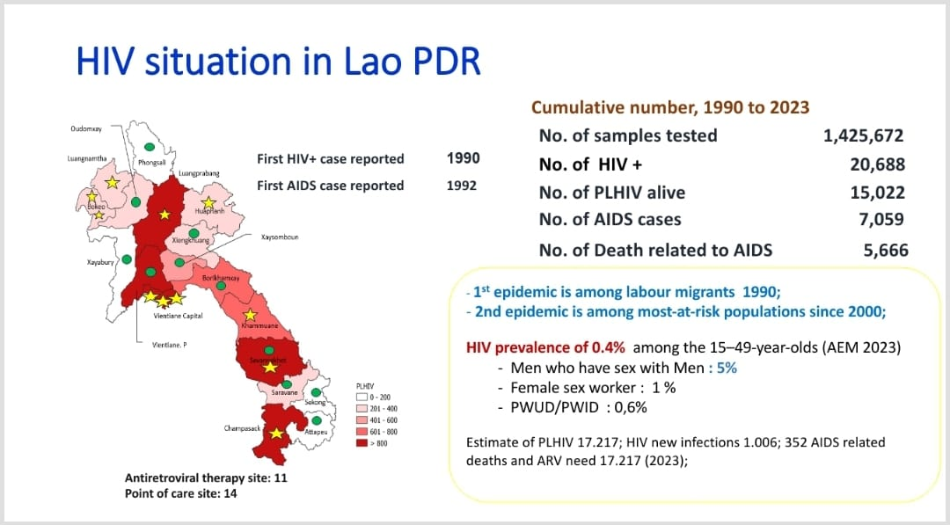
Picture 1. Overall situation of HIV in the Lao PDR

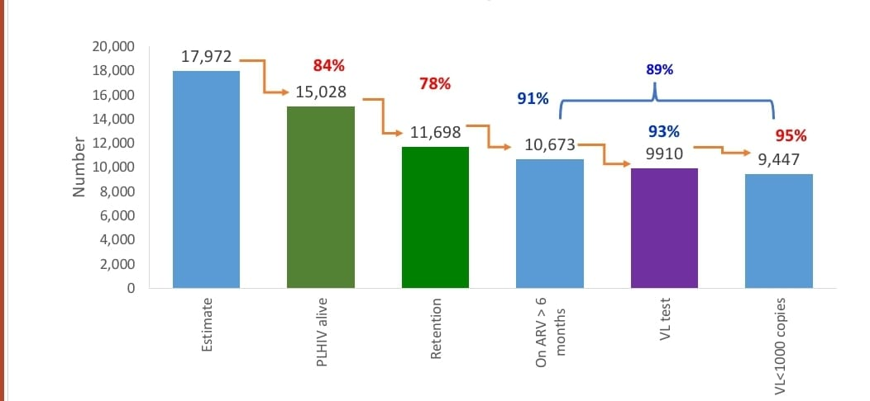
Picture 2. Category of HIV patients

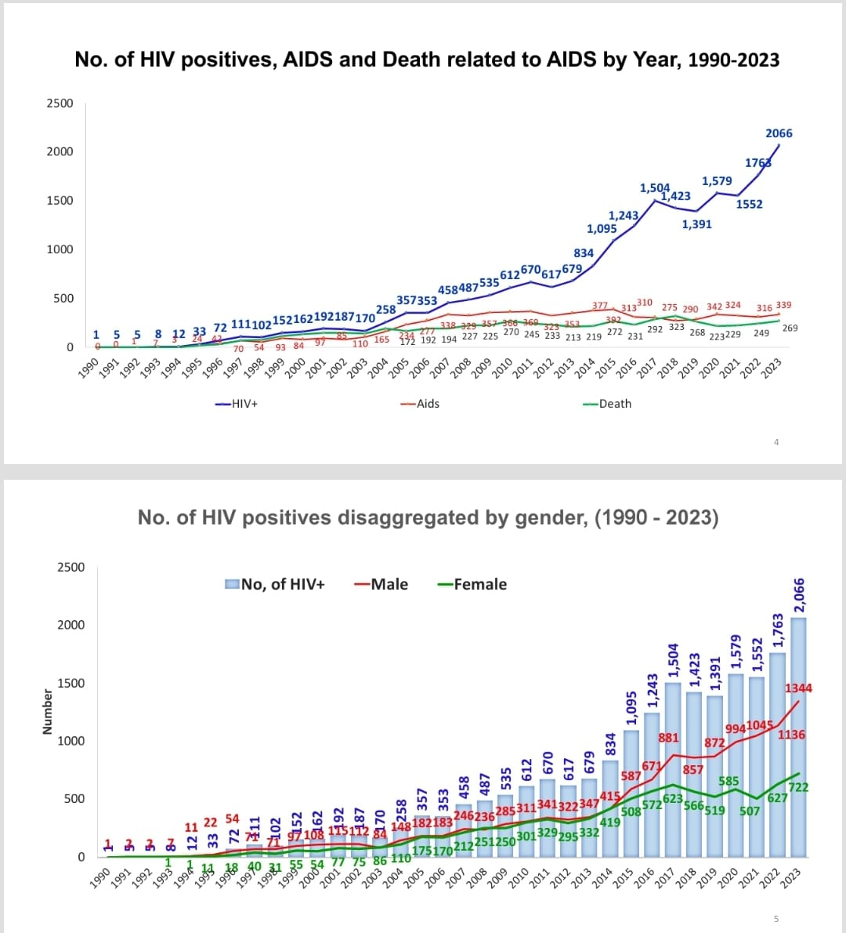
Picture 3. Number of HIV positives, AIDs and Death related to AIDs, year 1990-2023

Picture 4. Number of HIV positives disaggregated by gender, year 1990-2023

