Joint Contribution for the 89th Session of the Convention on the Elimination of All Forms of Discrimination Against Women (CEDAW)

Political Violence and Repression Against Women in the Public Sphere in Cuba

Report Led by: Civil Rights Defenders

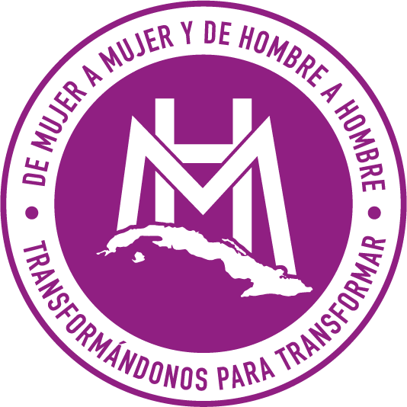
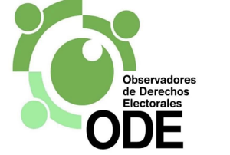

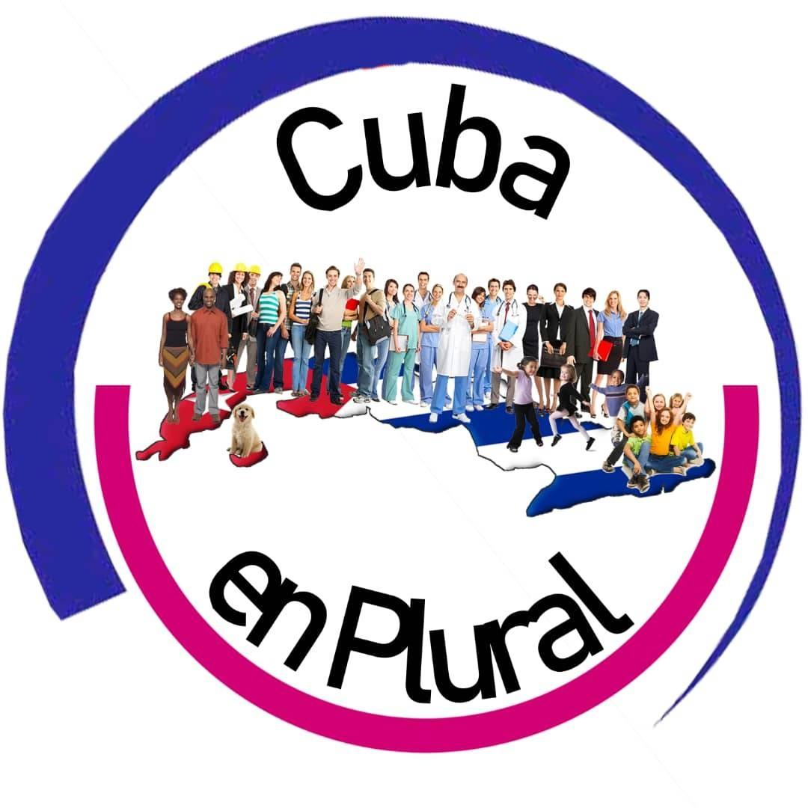

Authors: This report was written by Civil Rights Defenders in collaboration with Observatorio de Género Alas Tensas, Observatorio de Derechos Electorales, 4Métrica, De Mujer a Mujer y De Hombre a Hombre, Cuba en Plural.
Participation of Women in the Public Sphere: Organizations and Human Rights Defenders
- Active participation of women in the public sphere in Cuba faces serious limitations due to persistent political violence. This violence, based on gender reasons, restricts women's development in political life and hinders their right to engage in public affairs on equal terms with men. On the island, this form of violence affects not only women in public functions, whether elected or appointed, but also those with political interests in the public sphere, such as human rights defenders, activists, journalists, and those who organize independently to protest.
- According to a survey conducted by the Cuban Alliance for Inclusion, political violence against women in Cuba is a persistent issue. 96.8% of women engaged in activism on the island have faced various forms of this violence, with 93.8% experiencing psychological violence and 43.8% undergoing physical violence. Many of these women choose not to report their experiences due to fear of retaliation from their perpetrators, mistrust in the judicial system due to high levels of impunity, fear of being labeled as "counterrevolutionaries," and a lack of knowledge about the legal system.
- A clear example of repression in Cuba was the significant protests on July 11, 2021, which mobilized thousands of Cubans in over 60 locations across the island. These demonstrations emerged in response to dissatisfaction with the management of President Miguel Díaz-Canel’s government during the COVID-19 pandemic, exacerbated by shortages of food, medicine, and hospital infrastructure, in addition to decades of systematic human rights violations.
- According to data collected by the NGO Prisoners Defenders, at least 119 women, including transgender women, are detained or convicted for political and conscientious reasons in Cuba. Of these, approximately 58 are serving sentences for peacefully participating in the July 11 protests. This number does not include women who were already detained for political reasons before the protests, such as members of the organization Damas de Blanco.
- Regarding the above, it is important to note that any form of independent civil protest is clearly prohibited on the island. Members of feminist movements, observatories, and other initiatives not affiliated with the government face constant discrimination and persecution. For instance, Sissi Abascal, a member of the Damas de Blanco, was sentenced to six years in prison in December 2022 for peacefully participating in the July 11 protests in Matanzas. During the demonstrations, Sissi wrote "Patria y Vida" on a sheet while standing on a bench. Her mother, Annia Zamora, reported that in March 2023, she was detained and threatened by State Security in Havana after advocating for her daughter's release on social media. Additionally, she was assaulted during an official summons in Matanzas.
- Another imprisoned woman is Rosa Jany Millo, who was sentenced to six years for protesting in San Antonio de los Baños. She was interrogated in the Guatao prison by the Ministry of the Interior, where she was asked if she regretted her participation in the protests. Despite efforts to secure her release, her appeal was rejected in 2022. Additionally, María Cristina and Angélica Garrido were arrested in Quivicán during the July 11 protests, facing abuse and torture, and were sentenced to three and seven years in prison respectively, under extremely harsh conditions. Ten political prisoners in Guatao prison, Havana, signed a letter with their blood addressed to President Miguel Díaz-Canel, requesting that he respect Pope Francis’s wish to release the jailed protesters. This action led to a disciplinary trial that could worsen their sentences, which already total 14 years.
- Repression is not limited to the July 11 protests; in September 2022, amid blackouts caused by Hurricane Ian, sisters Yaima and Dayamí Villavicencio were arrested after protesting in Santa Clara. Yaima was threatened with losing custody of her child, who was with her at the time of the arrest. Repression has also extended to independent journalists such as Luz Escobar, who was forced to leave Cuba due to constant persecution, and Camila Acosta, who was arrested after covering the July 11 protests and remained under house arrest for five months.
- There are also cases such as that of the prominent dissident Martha Beatriz Roque, who for the past four decades has fought for human rights on the island, becoming a victim of harassment, constant surveillance, death threats, and defamation campaigns in state media.These tactics are designed to discredit her work and create an atmosphere of terror, not only for her but also for other activists who might follow her example. In early 2024, Roque was awarded the International Women of Courage Award 2024 by the U.S. Department of State. An award ceremony she was unable to attend because, since 2018, the Havana regime has placed her on a list of restricted individuals.
- As evidenced, in Cuba, independent defenders and organizations face a particularly challenging situation. The Cuban government discredits their work, criminalizes them, and labels them as "mercenaries" or "agents of foreign powers." In a context of severe restrictions on freedom of expression and association, defenders in Cuba experience significant vulnerability, and censorship limits the impact of their efforts on society. According to UNHCR, while Cuban legislation contains broad declarations of fundamental rights, other provisions grant the State extraordinary powers to penalize individuals attempting to exercise their rights to freedom of expression, opinion, press, association, and assembly. The Penal Code is an example of the Cuban repressive machinery that unreservedly criminalizes non-violent dissent.
- The described phenomenon is a widespread and long-standing reality, with the State being the primary responsible party. Addressing efforts to promote the participation and protection of women in public life, as well as the various human rights organizations, is complex, as it is precisely the State that acts against their rights. The Cuban Observatory of Human Rights (OCDH) has documented over 5,000 detentions of women between 2018 and 2022 due to their political opinions or social activism.
- Furthermore, by the end of 2023, the OCDH reported that of the 963 political prisoners at that time, 97 were women. However, the Cuban regime's repression against women is not limited to political imprisonment. According to the organization's data, 45% of the approximately 4,000 repressive actions recorded in 2023 were directed against women. This percentage increases when considering specific actions, such as arbitrary detentions, where 67% of the victims are women, or illegal house arrests, where women represent 52% of the cases. These figures could rise due to the growing prominence of women, who increasingly use protest as an effective tool to demand rights and obtain government responses.
- Measures to ensure active participation of women in public spaces and to promote violence-free environments have their shortcomings, even from a legal standpoint. The inclusion of violence against women as a crime in all its forms has been ignored by Cuban authorities. In 2019, a request for a Comprehensive Law against Gender Violence and a declaration of a state of emergency due to the situation of women on the island was presented to the parliament. Still, there has been no political will to implement it so far. Additionally, in 2022, the National Assembly of People's Power approved a new Penal Code, but it does not classify femicide, despite requests from independent feminist organizations and even from the Director of the National Center for Sexual Education, Mariela Castro. The Federation of Cuban Women, the only permitted women's organization in Cuba, supported the Assembly's decision.
- Gender violence remains an invisible reality. Legally, there is no clear concept or adequate assessment of this phenomenon, which manifests in various ways, with political violence being one of the most common. In line with this, the Cuban government shows no efforts to provide official and transparent data on femicides or gender violence situations. Although addressing gender violence is not limited to a punitive approach, Cuba requires a comprehensive law that promotes prevention and awareness across all areas to prevent further violence cases. The island continues to lack relevant strategies to recognize and confront machista violence, especially when it is perpetrated from power, which is crucial given the violations faced by women in the country.
- Although the Convention on the Elimination of All Forms of Discrimination Against Women (CEDAW) urges States, in Article 3, to adopt appropriate measures, including legislative ones, to ensure women's full development, guaranteeing their exercise and enjoyment of human rights and eliminating any form of discrimination and violation, efforts in the political and public spheres remain insufficient. There is no State recognition of the violence exercised against women in this domain, further limiting the implementation of adequate measures in response to the critical situation these women face on the island.
- The deficiencies of the Cuban government in implementing effective strategies are also reflected in practice. In Cuba, there is a prevailing lack of clear initiatives and strategies to address gender violence. There are not even official and updated statistics on this type of violence, including feminicide, whose recognition remains questionable by the authorities despite women's demands. Furthermore, any mobilization by feminist collectives and organizations to demand these measures is met with repression and harassment.
- Statements from women activists, journalists, and independent organizations are minimized, and the government has even claimed it is "difficult to know if there is a wave of femicides on the island," reflecting its inability to gather and handle truthful information in general. In the absence of State action, civil society has taken the initiative in the fight against gender violence. An example is Casa Palanca, a project led by and for independent women journalists, offering emotional and psychological support, as well as protection, in a context where journalism is a high-risk endeavor, criminalized by the government and without the state protection it should receive.
- At the beginning of 2021, the Plan for the Advancement of Women (PAM) was approved, aiming to establish actions for monitoring, evaluation, and control to eliminate all forms of discrimination against women. This plan covers areas such as economic empowerment, education, prevention, access to decision-making, and a normative framework to address and treat gender violence, among others. Although it theoretically represents an effort to address the situation of women on the island, in practice, gaps persist that hinder its effectiveness. For example, in the media sector, gender issues are addressed, but the political violence exercised by the State against independent women journalists is not recognized. The role of independent media and organizations, which have led initiatives to confront violence against women, is also not acknowledged.
- Within this framework, there is also the "Comprehensive Strategy for the Prevention and Care of Gender Violence and in the Family Setting," aimed at ensuring a comprehensive response for the effective prevention and care of gender violence. However, there have been no significant advances, nor has a clear measure been established to provide truthful information about these events. In relation to this strategy, the Federation of Cuban Women, a governmental entity, announced the creation of a Gender Observatory to record homicides of women for gender reasons and other forms of violence against women. As of July 2024, this observatory had counted 110 murders of women by their partners or ex-partners. However, information from the government remains scarce, and terms such as "femicide" or "machista crime" are not used. Additionally, only cases with a conviction are counted, revealing the insufficiency in addressing the documentation of femicides and analyzing machista violence adequately.
- Although action routes have been theoretically proposed to address gender violence, the lack of government transparency impedes adequate monitoring and evaluation of these measures' results. Access to truthful data and information remains an unmet obligation towards women. Regarding political violence, the situation is even more complex, as most complaints point to the State, through State Security and the police, as the primary perpetrators of this type of violence. Thus, women human rights defenders and the organizations many of them represent must operate under severe restrictions that affect their ability to defend and promote human rights.
- It is difficult to expect that measures for monitoring and addressing victims of this violence will be implemented when the State itself does not acknowledge the actions of harassment, persecution, and other manifestations that, from power, have undermined freedom of expression, association, and other freedoms of activists, journalists, and women who express themselves publicly. The work of defenders in Cuba remains crucial to challenging the status quo and demanding improvements in the promotion and protection of their rights, despite the adversities and the invisibilization of their efforts. Their work is essential for advancing towards a more equitable and just society, confronting an environment that constantly limits their ability to perform their work and protect those who defend their rights.
Participation of Women in Public Administration and High Government Positions
- The predominance of female participation in high government positions and parliamentary representation is a source of pride for the Cuban government, and it has been recognized internationally. However, it is important to note the dynamics surrounding this fact and how a high percentage of inclusion in spaces such as the National Assembly of People's Power (ANPP) should not be the sole indicator or criterion for evaluating women's participation in high government positions, given that practices persist that violate women's rights and transgress the very nature of popular representation.
- Firstly, it is necessary to refer to the inherent nature of the Cuban electoral system. In Cuba, there are no elections beyond those held to choose the Municipal Assemblies of People's Power, which lack real impact on the country's political life. Furthermore, other positions, including the deputies of the National Assembly of People's Power (ANPP), are chosen through ratification processes of individuals who have already been pre-selected by the Candidacy Commissions, a practice that completely removes the possibility for the population to have genuine representation of their demands.
- On the other hand, there is a monopoly of power centered around the Communist Party of Cuba (PCC), which, although it does not nominate or elect candidates for state positions, maintains a control that ensures the co-optation of power both from the Constitution and in practice. For instance, the Candidacy Commissions, which determine who can be elected, are composed of members of social and mass organizations created by the government itself: the Central Workers' Union, the Federation of Cuban Women, and the Committees for the Defense of the Revolution, among others. This implies, of course, that the electoral system lacks genuine competition.
- Under this status quo, the participation of women in high political positions is used by the government as a tool to maintain its power. Many of the women currently in the National Assembly do not respond to citizen demands but have been proposed due to their positions in certain state institutions, leading to a clear conflict of interest between what is expected by government entities and the public. Consequently, their real ability to address issues such as femicide or the approval of a Comprehensive Gender Violence Law is merely a fiction. The Cuban government's triumphalist rhetoric celebrating the guarantees provided to women for political participation and empowerment is just a façade that does not reflect the true mechanisms aimed solely at maintaining the status quo.
- Given the functioning and reality behind the participation of women in institutions such as the Parliament, it is not surprising that what is produced from these institutions does not directly address citizen demands. One of the government's flagships to show its interest in women's well-being is the so-called National Program for the Advancement of Women (PAM), which seeks, among other things, to promote gender equality across all sectors of Cuban society, including political representation and access to leadership positions for women from disadvantaged groups. However, its planning has lacked consistent participation from women, especially those in vulnerable situations, such as rural, Afro-descendant, and disabled women.
- Furthermore, its implementation has shown significant deficiencies. One of the main criticisms is its generic approach, which, while pursuing gender equality in general, does not adequately address the specific needs of women in different conditions such as Afro-descendants and those with disabilities. Despite official statements about the importance of inclusion, no effective mechanisms have been established to ensure these women have equitable access to positions of power—especially knowing that the system primarily operates to maintain Communist Party control. In many cases, the objectives and deadlines set by the PAM do not translate into concrete actions that benefit these groups, perpetuating their underrepresentation in political and administrative spheres.
- Another highlighted problem in PAM’s implementation is the lack of transparency and accountability in tracking the established objectives. Although progress in female representation has been announced in general, there are no disaggregated data to evaluate its impact on the inclusion of women in vulnerable or differential conditions, making it difficult to identify critical areas needing more specific and targeted interventions. It is paradoxical that while the government presents programs supposedly promoting political participation and women's empowerment in the public sphere, an entire institutional framework operates behind the scenes. Not to promote real participation but to serve its interests, with initiatives like PAM only acting as a façade to boast about precarious efforts and non-existent results.
- Based on the manifestations of political violence against women presented in this report, the involved organizations propose a series of recommendations to address the issue. First, it is crucial to end all policies and practices that threaten or violate women's rights to freedom of expression, association, and peaceful protest, without discrimination, and in all spaces, whether on the streets, social media, or the media, with the aim of fully guaranteeing their political rights.
- Additionally, the urgent release of all women imprisoned for political and conscientious reasons is necessary. Legally, it is fundamental to include feminicide as a criminal offense in the Penal Code. There is also a need for the implementation of a Comprehensive Gender Violence Law that specifically addresses political violence against women and establishes measures and spaces that allow them to express themselves freely, without fear of reprisals for criticizing or documenting government actions.
- Furthermore, there is a call to recognize the diversity of independent groups and organizations working for gender equality and highlighting violence against women, ending the exclusive monopoly of the Federation of Cuban Women in this work. The importance of developing clear strategies to address gender violence, including the participation of independent women such as journalists and activists, is also emphasized to achieve a plural and comprehensive perspective on the actions that need to be implemented.
- Finally, it is recommended to review existing strategies and sincerely address the situation of activists and journalists who have been harassed, proposing measures for their redress and comprehensive care. Additionally, the importance of recognizing the work of independent organizations and collaborating in the collection and publication of truthful data on gender violence is underscored.

Swedish non-governmental organization with international presence that supports actions and organizations in the defense of civil and political rights on 4 continents. Website: www.crd.org Contact: erik.jennische@crd.org
Created in 2019 as part of the Cuban feminist magazine Alas Tensas, it is dedicated to making visible and denouncing male violence in Cuba, reporting and recording cases of femicides. It arises from the lack of access to official statistics and the concealment of the problem by the State and seeks to have a political impact through reports and communication in networks. Website: www.alastensas.com Contact: contacto@alastensas.com
The Electoral Rights Observers Platform (ODE) is a chapter within the Citizens for Racial Integration Committee (CIR), established in 2017 with the goal of monitoring the electoral process from a citizen perspective as an active agent of change, defending the electoral rights of Cuban civil society. Contact: integracióncir@gmail.com Website: https://cir-integracion-racial-cuba.org
Non-Profit Entity (ESAL) formed by researchers from different countries, working on cooperation and consulting projects. They monitor and denounce human rights violations in Cuba. Website: https://www.4metrica.org Contact: contacto@4métrica.com
Visit: https://lista.prisonersdefenders.org/
To learn more, see: Cubalex: More than 100 political prisoners in Cuba this March 8. Retrieved from: https://www.cibercuba.com/noticias/2023-03-08-u1-e199894-s27061-cubalex-137-presas-politicas-cuba-este-8-marzo
Opposition civic movement in Cuba founded in 2003 that brings together wives and other relatives of Cuban political prisoners.
See: https://www.14ymedio.com/cuba/Sissi-Abascal-condenada-Patria-Vida_0_3312268753.html
Learn more at: https://www.14ymedio.com/cuba/EE-UU-extrajudiciales-Gobierno-Cuba_0_3499450026.html
See: https://www.cibercuba.com/noticias/2022-09-05-u1-e208574-s27061-quiero-mi-pueblo-sea-defendido-atendido-gobierno-presa-11j
https://www.infobae.com/america/america-latina/2023/03/01/tras-el-pedido-del-vaticano-un-grupo-de-mujeres-presas-en-cuba-exigio-al-regimen-la-liberacion-de-los-manifestantes-del-11j/
Get to know more at: https://eltoque.com/violencia-politica-contra-mujeres-en-cuba-la-misoginia-del-poder
See: https://www.martinoticias.com/a/martha-beatriz-roque-dedica-su-premio-a-los-presos-pol%C3%ADticos-y-al-pueblo-de-cuba-ellos-son-los-que-m%C3%A1s-sufren-/384408.html
See https://eltoque.com/tres-cosas-que-debes-saber-sobre-el-sistema-electoral-cubano
To know more visit: https://eltoque.com/paridad-de-genero-en-la-asamblea-realidad-politica-o-estadistica-vacia
An organization with a broad ecclesial framework of action on human rights issues, specifically focused on addressing gender-based violence in Cuba. Contact: apostolcristinarodriguez813@gmail.com Web: https://sites.google.com/view/demujeramujerydehombreahombre/inicio
A platform by and for citizen sovereignty from the Network of Community Leaders, continuing the work of Propuesta2020. Contact: cubaenplural@gmail.com Website: Cuba en Plural | Facebook

