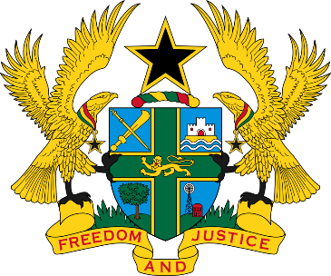
REPUBLIC OF GHANA
MINISTRY OF GENDER, CHILDREN AND SOCIAL PROTECTION

DATA ON THE NUMBER OF PERSONS TRAINED IN REHABILITATION CENTERS IN 2024 ACROSS THE COUNTRY

NAME OF REHABILITATION CENTER | MALE | FEMALE
Abor Rehabilitation Centre | 130 | 120
Ho Rehabilitation centre | 13 | 15
Bolgatanga rehabilitation centre | 30 | 27
Edwenase Rehabilitation Centre | 120 | 40
Jakyie Rehabilitation Center | 18 | 13
Accra Rehabilitation Center | 46 | 19
Ghana Society For Socially Disadvantaged | 21 | 19
Total | 378 | 253

SOURCE: MINISTRY OF GENDER, CHILDREN AND SOCIAL PROTECTION, JUNE, 2024

