

National Black Police Association

Submission to the United Nations Committee for the Elimination of Racial Discrimination

United Kingdom

- Introduction
The National Black Police Association (NBPA) is grateful to the Committee for the opportunity to be able to present its concerns prior to the oral examination of the UK Government on the 2-5 August 2016.

1.2 The NBPA was formed in 1999. We currently have 15,000 members who range from Police Officers, Police Community Safety Officers (PCSOs) and Police Staff.
1.3 The aim of the NBPA is to promote good race relations and equality of opportunity within the police services of the United Kingdom and the wider community. Our objectives are to:
- Advise, consult and intervene on matters of racism nationally, which have negative effects on communities.
- Work towards improving relationships between the police and Black and Minority Ethnic (BAME) communities within the United Kingdom.
- Influence the direction of policies nationally and in line with equality issues and anti discrimination.
- Work towards improving the recruitment, retention and progression of officers and police staff members within the Police Service
1.4 This submission outlines the main concerns of the NBPA on the Government via issues identified in paragraph 22 of the Committees’ concluding observations:

The Committee recommends that the State party vigorously pursue its efforts to close the existing employment gap in the personnel administration of the criminal justice system and other sectors between ethnic minorities and the wider population. […] the State party should also consider adopting such special measures to ensure that employment in the criminal justice administration reflects the diversity in the State party’s society.

  - It is structured thematically into the following areas; governance, racial disproportionality, discipline and complaints and racial discrimination. It also provides an overview of the conclusions, recommendations and our concerns of the recent Inquiry by the House of Commons Home Affairs Select Committee Inquiry into Police Diversity (HC27) published on the 21st May 2016. The main conclusion of which was that

‘Urgent and radical action is needed if the Home Secretary’s ambition, which we share, of all police forces reflecting the ethnic profile of their communities, is to be realised’. (HC27:51).

- Issues
2.1 On 25th September 1999 our previous leaders gave evidence to the Macpherson Inquiry, into the death of Stephen Lawrence. We assert that little has changed in the intervening years.

Unfortunately, what we see, at this moment in time is black people are invited into the organisation as sure. Our recruitment schemes, initiatives are second to nil, second to nil. However, once the black person becomes a member of the organisation then it becomes all too apparent to that individual that they must conform, conform to that, the norms which predominantly are white in these organisations. So, the black person is expected to become, if you like, a clone. I would say it is as severe as that. You are not asking a black person to come in to experience that persons views, cultures, etcetera, the different manner that he may do things or might perceive things, you are asking them to come into this organisation and to conform to the norm of the majority of the organisation. If you do not do so then you will feel, personally, very uncomfortable.

  - We acknowledge that it is important for the Police service to reflect the communities it serves and we applaud the Committee for recognising the importance of this issue through paragraph 22 of its concluding observations.

  - However, we believe, that the preoccupation with BME recruitment detracts from more significant concerns, which undermine the recruitment of BME police officers, PCSOs and staff and present serious risks for the future of policing and public confidence in the police. These concerns are identified as follows.

- Failure of Police organisations tasked with developing interventions aimed at understanding, identifying and addressing racial disproportionality; to involve those BME staff networks tasked with articulating the concerns of BME staff in its governance arrangements for those interventions.
- Racial disproportionality of BME police officers in the area of discipline and complaints;
- Failure of police forces to deal effectively with race discrimination cases.
- Lack of progression of BME officers and in particular BME female officers
- Bullying and harassment of BME police officers and staff
- Perceived vindictive and malicious criminal prosecutions, pursued against police officers who pursue race discrimination cases.

3 Governance

3.1 It is important that those organisations tasked with pursuing race issues in policing embrace the principles of participative governance; readily involve those organisations with the experience and understanding of race issues and the mandate to advocate in the interests of their members. This was a principle established by Lord Scarman (1981) and confirmed by the Macpherson Inquiry (1999). A failure to do so, only serves to demonstrate ‘lip service’ to participative governance.

3.2 Organisations such as the NBPA are tasked with advocating on behalf of their members. They play a vital role in articulating concerns and identifying solutions to enhance operational and race relations. Organisations such as the NBPA should be an integral part of the Police’s consultative framework and not an afterthought.

3.3 The role of the College of Policing is to give national guidance and steer on policing policy to police forces. As such they play a critical leadership role. Consideration should be given to formalising the consultative role of the NBPA with agencies such as the College of Policing and the Home Office.

3.4 It is important that Parliamentarians, Home Office, College of Policing and Police and Crime Commissioners engage proactively with the NBPA. Thereby ensuring that race is a priority and not a mainstream issue, in terms of employment, service delivery and community engagement.

4. Racial Discrimination
4.1 Despite numerous public inquiries into race in policing; Scarman (1981) Macpherson (1999), HMIC (2001) HMIC (2003) Morris et al (2004) Ghaffur (2004) CRE (2005) MPA (2010). Race issues are not dealt with effectively and are still an issue for a number of police officers and staff.

4.2 The 2012 survey into the state of the UK police survey by the Independent Police Commission of 14,000 respondents; (one in ten of all serving officers and up to the rank of Chief Superintendent). Identified the extent of bullying and harassment of BME police officers. It is important that the Committee urges the Government to undertake further work in this important area.

Figure 1. Percentage reporting being bullied ‘all’ or most of the time

4.3 We draw attention to the racism and sexism faced by female BME police officers and staff such as P.C. Ricky Haruna (Metropolitan Police) who are ‘invisible’ within the police organisation. It is important that the Committee encourages the Government to actively explore this issue.

4.5 We highlight to the Committee the impact of a recent high profile race discrimination case of a firearms officer, PC Nadeem Saddique. The case reveals a nuanced shift in the discrimination faced by Asian police officers; where they are subjected to racial stereotyping which equates them with being terrorists.

  - A number of NBPA members are currently on their 4th Employment Tribunal cases. This is the experience of DC Paul Bailey from Greater Manchester. This illustrates that lessons are seldom learned and action rarely taken against perpetrators. Instead a culture of protecting the perpetrators and victimising the victims seems to be prevalent.

  - We alert the Committee to the impact of out of court settlements in race discrimination cases. As liability is not admitted, lessons are not learnt and a cavalier attitude develops which undermines race relations within force areas. Fundamentally, this masks the true extent of racism within the Police.

  - We believe that the implementation of the Police Complaints and Misconduct (Amendment) Regulations 2008 which came into force on the 1st December 2008 is symptomatic of institutional racism and needs to be urgently addressed. This has created the situation whereby whilst the guidance from the National Police Chief Council states that racism is gross misconduct and is so serious that it warrants dismissal. Complaints about racism and other protected characteristics are ‘masked’ and labelled as misconduct. The Regulation is such, that once decisions are made they can’t be revoked or changed.

  - It is perceived that the Regulation is interpreted and implemented to benefit white officers, whilst it is used to the detriment of BME officers. This apparent double standard and failure to accurately, holistically and sensitively assess complaints is fuelling resentment and mistrust of procedures designed to promote fairness and equity. A review of the application of the Regulation with reference to Conduct would be welcomed by the Government.

  - We refer the Committee of the Concerns made by Her Majesty’s Inspectorate of Constabulary (HMIC) in its PEEL: Police Legitimacy Report 2015. A national overview.

HMIC is deeply concerned that there may be bias in the way that those from a Black, Asian and Minority ethnic background are treated, following a public complaint or an internal allegation of misconduct. We also have some evidence to support our earlier inspection findings that, following a complaint or allegation against a BAME officer or staff member, a pattern of behaviour seems to take place that makes it more likely for that complaint or allegation to be considered by the professional standards department.
We are extremely disappointed that, given the sensitivity and importance of this issue, forces have not done more to have robust and consistent processes in place for gathering and analysing data to assess for themselves whether all complaints or allegations against officers and staff are dealt with fairly and consistently.
5 . Transparency and Accountability

5.1 Whilst we recognise that the Equality Act (2010) does not place a specific duty on public authorities to gather equality data in relation to protected characteristics. We believe that the gathering and analysis of key data on staff with protected characteristics will facilitate an understanding and identification of disproportionality and facilitate strategies for addressing them. We therefore would welcome the Committee’s support in this matter.
5.2 We note a pattern, albeit not widespread, of perceived vindictive and malicious prosecutions of police officers who bring forward cases of race discrimination. In particular we highlight the cases of Carol Howard (Metropolitan Police) and Kashif Ahmed (West Yorkshire Police).
5.3 Whilst we welcome the introduction of the Code of Ethics. We are concerned, that there has historically been little appetite to apply or enforce ethical standards in cases of this nature.
5.4 A failure to tackle this issue effectively undermines public confidence in the police and impacts adversely on BME recruitment into the police. This issue is important especially when seen in the context of information produced by the College of Policing. This highlights that the BME population of England and Wales will be 16% of the total population by 2026. This will require the police service to recruit 17,000 BME officers over the next 10 years for the police to be reflective of the community it serves. Not tackling these issues are impediments to securing the Governments ambition of ‘one nation’ policing.

6 Race Disproportionality

6.1 A simple comparison of the achievements for female police officers in the aftermath of the Alison Halford case in 1992 highlights that the push from an Inquiry by the Equal Opportunities Commission had a subsequent impact on the treatment and experiences of women within the Police. It is important to note that the Equal Opportunities Commission submission to the Select Committee on Home Affairs in 1998 outlined concern regarding a ‘resistance to sex equality’.

6.2 We welcome the fact that the situation facing women in the Police has improved. Currently 28.2% of all officers are female.

- 35,738 female police officers in the 43 police forces on 31 March 2015 an increase of 85 (0.2%) compared with the previous year.
- The proportion of female police officers has increased from 22.3% in 2006 to 28.2% in 2015.
- 21.4% of female police officers are in senior ranks (Chief Inspector and above). A 1.9% increase since March 2014
- 30.2% of women are at Constable rank. An increase of 0.1% from March 2014.

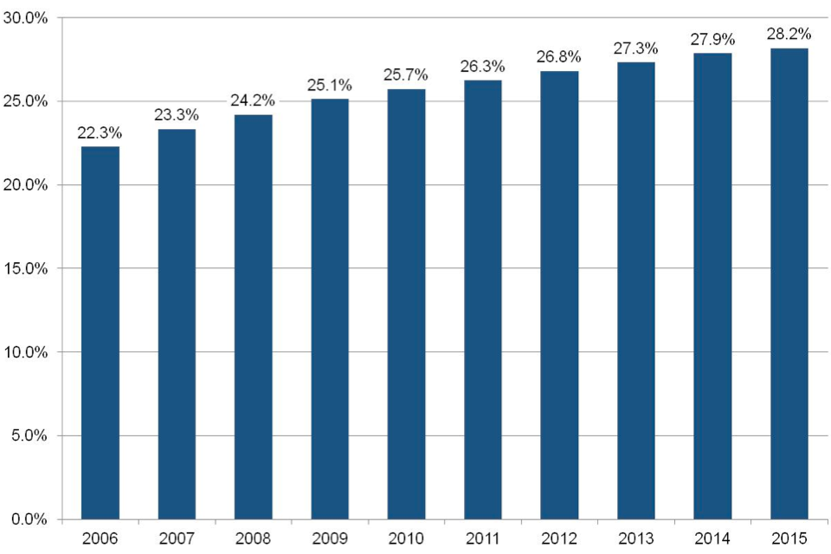

Figure 1: Proportion of police officers who are female, as at 31 March 2006 to 2015, England and Wales. Source: Home Office (16 July 2016), National Statistics, Police Workforce, England and Wales: 31 March 2015.

6.3 Whilst the situation for female police officers has improved. There has only been a slight increase in the numbers of BME police officers. It is the poor levels of progression which are concerning.

- There are currently 6,979 BME police officers in the 43 forces. This is an increase of 3.9% from the previous year.
- Whilst there has been an increase of the proportion of BME police officers from 3.6% in 2006 to 5.5% in 2015. BME police officers are disproportionately concentrated at the lower ranks.
- 3.4% of Chief Inspectors or above are from a BME background
- 6.0% of BME police officers are at Constable rank.
- BME Police officers in the police are from the following ethnic backgrounds; 40.0% Asian or Asian British, 29.0% Mixed, 19.7% Black or Black British and 11.2% Chinese or Other ethnic group.

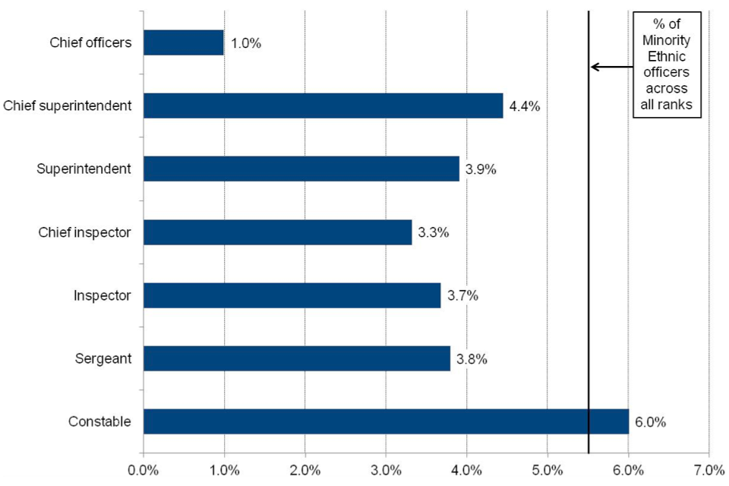
Fig 2. Proportion of police officers who are Minority Ethnic, by rank, as at 31 March 2015 England and Wales. Source: Home Office (16 July 2016), National Statistics, Police Workforce, England and Wales: 31 March 2015.

6.4 It is fair to say that despite all the interventions and policies, there is still ‘resistance to race equality’.

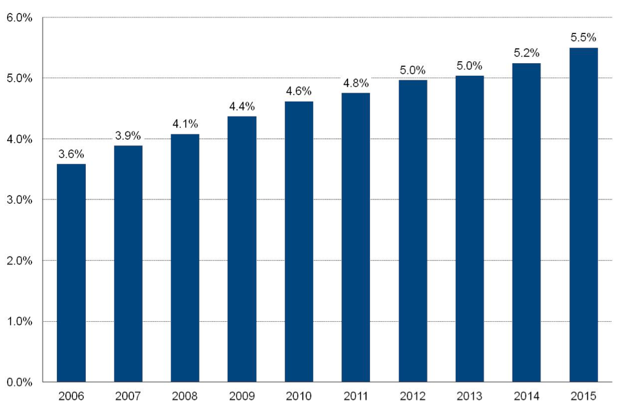
Figure 2: Proportion of police officers who are Minority Ethnic, as at 31 March 2006 to 2015, England and Wales. Source: Home Office (16 July 2016), National Statistics, Police Workforce, England and Wales: 31 March 2015.

7. Race Disproportionality in Discipline and Complaints
7.1The ‘resistance’ to race equality is best exemplified in the levels of racial disproportionality in the area of discipline and complaints. We believe that this issue is stagnating the progression of BME police officers. As time limitations placed on disciplinary sanctions have a knock on effect on an officer’s ability to apply for promotion.

7.2 In his 2004 ‘Thematic Review of Race and Diversity in the Metropolitan Police’, Assistant Commissioner Tarque Ghaffur identified;

It is of considerable concern that Black and Asian officers are one and a half times more likely to be the subject of internal investigations and written warnings. This finding is verified by the BPA report and through evidence of other staff associations. Some of the reasons for this include a tendency for managers to initiate formal processes quickly, a lack of knowledge of how to resolve complaints locally, and a difference in the interpretation of the codes of conduct by diverse groups within the organisation’ (Ghaffur 2004.4)

7.3 Despite reviews by Morris et al (2004) and Ghaffur (2004). Concerns still exist into the
prevalence of racial disproportionality of BME people in the area of discipline and complaints. The most recent research highlights

- ‘Statistically significant over-representation of BME officers and staff was identified in the GMP counter-corruption intelligence data. Asian officers and staff were 2.79 and 3.59 times more likely than White officers and staff, respectively, to be subjected to counter-corruption intelligence.
- The experiences and perceptions of BME officers interviewed were of a two-tier misconduct system in which they were subjected to unjust and punishing treatment and White officers were dealt with informally. There was broad consensus among interviewees of the preference of divisional managers and supervisors to refer BME officers to PSB.’
- Perceptions that disproportionality in internally raised misconduct proceedings are connected to the under representation of BME officers in the Professional Standards Unit. (Smith et al 2012:4).
7.4 We are concerned that despite the identification of racial disproportionality in this area, little action seems to be taken to address the root causes. The NBPA recommends to the Committee that the Government tackle these issues. As a failure to do so will impact adversely on the recruitment, retention and progression of BME officers and only sets people up to fail.
  - We believe that identifying, understanding and addressing racial disproportionality in discipline and complaints is key to tackling the stubborn lack of progression of BME police officers.

8. Background
8.1 On 21st May 2016, the Home Affairs Select Committee (HASC) published its Inquiry report into Police Diversity (HC27) (Annex 1). The NBPA gave oral and written evidence to the Committee (Annex 2 &3).
8.2 The HASC made a number of observations. The most significant of which is as follows;

In 2013, our predecessor Committee concluded that for too long lip service has been paid to diversity in the police service, but this was unmatched by action. It also believed that progress since the 1999 Macpherson report on the Metropolitan Police and the Stephen Lawrence case was disappointing; and that it was shameful that not a Chief Constable was Black or Asian. Three years have passed since the publication of that report, and progress has not been sufficient, but all of those conclusions are even more valid today and the need to address this problem has even greater urgency. Whilst there has been a steady increase in the overall proportion of officers and staff who are of a BME background, progress is painfully slow; there is a wide variation between forces; and increased numbers of BME officers remain overwhelmingly in the most junior ranks. Even allowing for appropriate career progression, the number of police officers above the rank of Inspector is very disappointing. We find this unacceptable. We believe it is time for concerted action, prioritised across all forces, policing bodies and Government. (HC27:12)

8.3 The NBPA generally welcomes the recommendations made by the HASC and are delighted that the HASC took on board the written and oral evidence presented by the NBPA, around a lack of accountability and leadership on the important issue of BME recruitment, retention and progression in UK policing. We are also encouraged that the HASC recognised that it was wrong for the College of Policing not to consult with the NBPA on its BME progression 2018 programme.

8.4 However, we do not feel that the recommendations made by the HASC will address stubborn issues at the heart of race inequality and policing; as they are not underpinned by a supportive public policy discourse around race equality and social inclusion. Which is the case with gender.

8.5 We believe that a supportive public policy discourse, which channels support for race equality and social inclusion is essential to ensuring that these recommendations are not only implemented but embedded within the police culture. In a climate where issues of immigration and radicalisation dominate the national and international media in a negative manner, the Government must do more than what is being recommended by the HASC.

8.6 At the heart of our concerns is the HASCs failure to state the words, race and racism, and its inability to acknowledge the continued existence of institutional racism within policing. Sadly, we believe this is reflective of a continued pattern of marginalisation and backlash against the terminology of race and racism in favour of the more conciliatory terminology of diversity and unconscious bias.

8.7 Furthermore, we feel that there is little within the report, which focuses fully on governance and accountability, save for apparent ‘light touch’ internal governance and accountability mechanisms. These omissions lend themselves to a range of interventions, which we feel we (the NBPA) are ideally placed to advise and influence, both at national and local level.

8.8 On face value whilst the report focuses primarily on race issues, it does not explicitly mention this term. The use of the term ‘diversity’ is confusing. We are concerned that the potentially deliberate usage of the term (diversity) could result in a dilution from a focus on race to the wider protected characteristics. It is imperative that the Government establishes what it means by the term ‘diversity’ in the context of the recommendations.

8.9 We believe that it is this, which will govern what is implemented at local and national level. From the NBPA perspective it is imperative that the Government focus is on race issues, as the HASC did not explore issues pertaining to other groups. If this is indeed the case, then, careful consideration needs to be made to ensure that there is no internal or external backlash for the focus on race issues.

8.10 We believe that the HASC has missed an opportunity to develop a range of recommendations aimed at tackling inherently structural issues, which are fuelling and exacerbating the experiences of BME personnel in the Police. It is these structural issues, which we identified in both oral and written submissions to the HASC. We offer to the Committee two recommendations; we feel the Government should adopt to tackle structural race issues in policing,

- That the College of Policing develop a more rigorous framework for scrutiny and oversight on race issues through setting standards on leadership and workforce development of BAME Officers and Police Staff.
- That Her Majesty’s Inspectorate of Constabulary (HMIC) develop an inspection framework with specific workforce and operational intrusive questions on race, which the NBPA would support through an advisory capacity.

8.11 Instead, we put it to the Committee that the HASC has developed a range of ‘soft’ interventions concentrated on ‘training /coaching/mentoring’ which whilst they may be beneficial are not ‘deep rooted’ enough to be able to facilitate and sustain changes in practice and decision- making. We make this statement on the basis that both the Scarman and Lawrence Inquiries, resulted in the introduction of training. This did not result in a decrease in discrimination cases and no significant / sustained reduction in racial disproportionality.

8.12 What we feel is missing from the Government is an accompanying public discourse, which explicitly acknowledges that racism and racial discrimination is still an everyday occurrence of British society. Instead the political climate is such that the use of these terms has been scorned upon because of their perceived combative nature. These words are not combative, but fact.

8.13 Whilst we believe that the recommendations are positive, they are unimaginative and it is unclear as to whether they will result in meaningful measurable outcomes. The HASC has not taken the opportunity to stress that the introduction of mentoring, coaching, training should be accompanied by performance related measurable outcomes and evaluated. Our concern stems from our experience, that the recommendations have the potential to involve contractors and consultants who are motivated solely by pecuniary advantage and not the longer-term issues of racial equality/inclusion. It is therefore crucial that there is careful oversight and transparency in the awarding and delivery of these contracts.

8.14 Training, Coaching, Mentoring
Training, coaching and mentoring plays a central part of the HASC recommendations, with the implication that previous training in the area of race has not been successful. This has the potential to mask organisational cultural issues, which impact on decision making in the areas of recruitment and discipline. It would be extremely helpful if the Government undertook an audit of the effectiveness of existing training, which takes into consideration costs and measurable outcomes.

8.16 Diversity Champions
The HASC has recommended that each force appoint a ‘workforce diversity lead’. Stating that the role must be at the rank of Deputy Chief Constable or equivalent level and that the Home Office appoint a national ‘Diversity Champion’. We are conscious that at present most UK Police forces have workforce diversity leads at Chief Officer level. However, we believe that those roles are not sufficiently underpinned by an accountability, delivery and transparency function.
We highlight to the Committee our concern that this recommendation could potentially be a ‘tick box exercise’. Where individuals are appointed to ‘boost’ their career prospects without being fully committed to the issues at stake. Furthermore, given that the roles of ‘force’ Diversity Champions will be of the grade of Police Chief Constable or equivalent rank’ (HASC 27:47). This will mean that the post-holders will invariably be white men and women. We are conscious that this recommendation is nothing new, as many Criminal Justice Agencies (CJS) have adopted the roles of Diversity leads/Champions to progress equality issues. However, what is not apparent from the report is clarity around what is meant by the term ‘diversity’, when there are nine protected characteristics.

8.17 Whilst we are aware that it is not the role of the HASC to specify the recruitment process and the appointment criteria of the identified ‘roles’. It is imperative that there is public trust and confidence in the recruitment process and ‘posts’ as this will do much to ensure the success of the recommendation. However, we believe it can be better achieved if consideration is given to an external independent appointment, especially for the role of national Diversity Champion.

8.18 Furthermore, for the appointments to be effective, consideration needs to be given to how success in the roles can be measured and how accountability can be ensured. It would be very easy for the role to be meaningless and superficial. We believe that the roles should focus primarily on trying to understand, identify and address racial disproportionality in the areas of recruitment, retention and progression in an evidence based manner. In which due consideration is given to the issues of accountability and transparency. The NBPA is happy to provide advice and assistance on the development and implementation of both roles at both local and national level.

8.19 BME senior leaders forum
The proposed BME senior leaders forum has the potential to provide a supportive BAME staff network at senior level. However, there is an element of vagueness in the recommendation. There is no clarity as to what constitutes a senior leader; the President and Vice President of the NBPA, could be termed as ‘senior leaders’. It is important that the HASC clarifies this terminology, so that it is as inclusive as possible.

8.20 For support networks to be successful they need to engender the trust and confidence of their members. As such they need to be developed by those they are aimed at supporting and not ‘imposed’. A failure to do so undermines the concept of participatory governance and erodes trust and confidence. It is imperative that such a network is developed with the oversight and direction of the NBPA and is not forced upon BAME staff. We stress that care needs to be taken to ensure that the forum is not dominated by Police Officers or men and that police staff, are actively involved.

8.20 Given the lack of diversity in the statutory staff support associations. The NBPA would like the Government to consider that NBPA is placed on an equal footing at both national and local level in engaging with Chief Constables and Police and Crime Commissioners.
8.21 The NBPA and the National Association of Muslim Police (NAMP) have an important role to play in the fight against extremism. The NBPA would like the Government to consider that the NBPA and the NAMP are proactively involved in work of this nature with police and communities at national and local level.
9. Conclusion
We recommend to the Committee that the Government should focus its attention on understanding and addressing the issues faced by BME police officers and staff. This requires an honest, proactive and mature approach, which is underpinned by the analysis of data and the genuine and active engagement and involvement of BME staff and staff support networks like the NBPA. The development of meaningful interventions, which contribute to understanding, identifying and addressing racial disproportionality in the police is, we believe, are key to addressing longstanding concerns in this area.

National Black Police Association
July 2016

Transcript of the Macpherson Inquiry (pg 218) Friday 25th September 1999. National Archives
Smith, G., Johnson HH and Roberts, C. (2012) Disproportionality in Police Professional Standards.
Black Wiltshire police officer was racially harassed (10th April 2015) BBC News
Bradford, B., Brown, J and Schuster, I (December 2012) Results of a Survey on the State of the Police Service in England and Wales, Independent Police Commission,
Unison (2016) Police Staff Bullying Survey
Scarman Lord (1981) The Brixton Disorders 10-12 April 1981. Report of an Inquiry by the Rt.Hon. The Lord Scarman, OBE. London: HMSO.
MacPherson of Cluny, Sir William (1999) The Stephen Lawrence Inquiry: Report of an Inquiry by Sir William MacPherson of Cluny. London: The Stationery Office.
Her Majestys Inspectorate of Constabulary (2001) Winning the Race Policing Plural Communities
Her Majestys Inspectorate of Constabulary (2003) Diversity Matters
Morris, W., Burden, A. & Weekes, A. 2004 The Report of the Morris Inquiry. An independent inquiry into professional standards and employment matters, The Morris Inquiry, London.
Ghaffur, T. (2004) Thematic Review of Race and Diversity in the Metropolitan Police Service
Commission for Racial Equality (2005) The Police Service in England and Wales
Metropolitan Police Authority (July 2010) Race and faith Inquiry Report
Source: Bradford, B., Brown, J., and Schuster, I. (2012) Results of a survey on the state of the Police Service in England and Wales. Independent Police Commission
Kate Middleston’s former police guard reinstated after wrongful dismissal, The Telegraph 17th March 2015.
N. Siddique and the Chief Constable of Cleveland Police (25th November 2015) Employment Tribunals Case Number 2501606/14
‘His oral evidence and many documents reveal he felt his being of Pakistani decent caused prejudice against him. Many people associate Pakistan with being sympathetic to Islamic terrorism. The claimant wrote at the time of one incident that he was considered a ‘security risk’ This is not to do with colour. Irish people complained of similar prejudice in the 1970s and 80’s when the threat to security came from the IRA’. Para 3.9 pg 17 N. Siddique and the Chief Constable of Cleveland Police (25th November 2015) Employment Tribunals Case Number 2501606/14
HMIC (February 2016) PEEL: Police legitimacy. A national overview. pp7.
Police officer Carl Howard v the Met: ‘ I was absolutely humiliated’ Rachel Williams Tuesday 9 September 2015, The Guardian.
Bradford Officer tells of his relief and now plans to go on a pilgrimage to reflect and recover, Steve Wright, 11th March 2011, Telegraph and Argus.
College of Policing – Code of Ethics
College of Policing (March 2015) Leadership review- Interim Report
Home Office (July 2015) National Statistics Police Workforce, England and Wales: 31 March 2015
Home Office, (16th July 2016) National Statistics, Police Worksforce, England and Wales: 31 March 2015
Morris, W., Burden, A., & Weekes, A. (2004). The Case for Change. The report of the Morris inquiry: An independent inquiry into professional standards and employment matters in the Metropolitan Police Service.
Ghaffur, T. (2004) Thematic Review of Race and Diversity in the Metropolitan Police Service.
Smith, G., Johnson HH and Roberts, C. (2012) Disproportionality in Police Professional Standards.
Scarman , Lord (1981) The brixton Disorders 10-12 April 1981. Report of an Inquiry by the Rt Hon. The Lord Scarman, OBE, London, HMSO.
Mcpherson of Cluny, Sir William (1999) The Stephen Lawrence Inquiry: Report of an Inquiry by Sir William Mcpherson of Cluny. London: The Stationary Office.

