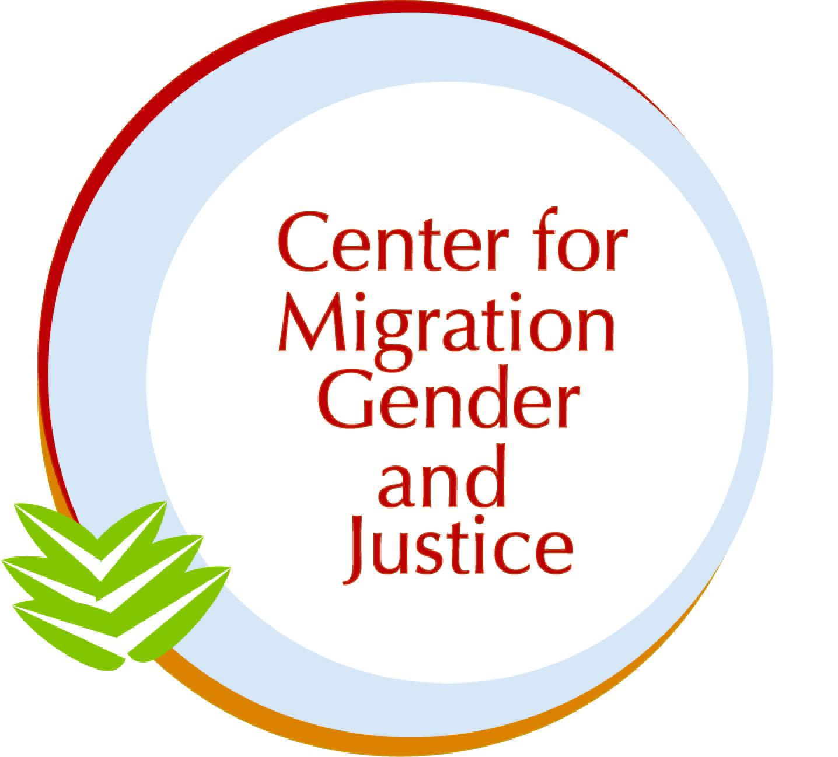

Submission to the Committee on the Elimination of Discrimination against Women (CEDAW)

SHADOW REPORT: Brazil

April 15, 2024

Authors: Gabriela Cardim, Carolina Cortes, Dr. Lara-Zuzan Golesorkhi

The Center for Migration, Gender and Justice (CMGJ) is a women-, migrant-, and youth-led non-profit, non-governmental organization that addresses human rights at the intersection of migration and gender through research, advocacy, and education. Within our areas of expertise, this shadow report speaks to Brazil’s implementation of CEDAW in light of the Committee’s 88th session (13-31 May 2024). Throughout the report, the names of any alleged victims, witnesses, and perpetrators have been anonymized, and no photographs of alleged victims, witnesses or perpetrators have been included.

In this CEDAW Report, we employ a working definition of migrant as a person who moves away from their place of usual residence, whether within a country or across an international border, temporarily or permanently, and for a variety of reasons (voluntary and/or forced). The term includes a number of legal statuses of persons, such as refugee, stateless, and undocumented. We identify the specific legal statuses when necessary and/or to amplify particular experiences.
Migration and Gender in Brazil’s Eighth and Ninth Periodic Reports:

Brazil is a transit- and destination country for inter- and intra-regional migration. 1.5 million migrants currently reside in Brazil, 510,000 of them from Venezuela. In 2023, Brazil became the third main destination country for Venezuelans, moving up from fifth rank previously.

Brazil is recognized for its safeguarding of immigrants’ and refugees’ rights. The country holds comprehensive legislative frameworks in this regard, notably the “Lei de Migração” (Migration Law) and the “Lei do Refúgio” (Refugee Law). The former entitles immigrants to basic rights and places them in a position of equality (i.e. right to education, health, social protection, and employment) while the latter addresses labor market access and integration of refugees as part of the country’s implementation of the 1951 Refugee Convention and its corresponding 1967 Protocol.

Moreover, Brazil is party to various international instruments that have positioned the country in a leading role in migration governance. Noteworthy here is the Cartagena Declaration, ratified in 1984, which is used by the national authority (Conare) to assess asylum claims in efforts to ease the refugee recognition process, as well as the International Labor Organization Convention 189 (Domestic Workers Convention), ratified in 2018. Since 2019, Brazil has also been a key partner in the Regional Migrant and Refugee Response Plan (RMRP) to the Venezuela situation.

Despite these legal-institutional frameworks in place, the intersection of migration and gender remains largely overlooked in terms of protections for women, girls, LGBTQIA+, and gender-diverse migrants as per the state party report. We must highlight here that CEDAW/C/BRA/8-9 was submitted at the end of 2021 when Brazil was governed by an administration that institutionalized anti-migration measures such as leaving the Global Compact for Safe, Orderly, and Regular Migration (GCM). The information presented thus reflects the negligence in matters of migration at the time.

Based on an analysis using our Gender-Migration Index (GMI), a guidance tool for gender-responsiveness and migration-inclusion in policy, we find that there is limited mention of, engagement with, and commitment to migration dynamics in CEDAW/C/BRA/8-9. The thirty-eight-page-long document refers to “migratory” and “immigrant” four times in total, and there is a complete absence of any reference made to asylum, asylum-seekers, immigration, migrant-inclusivity, migrant-specificity, and migrant-sensitivity. This said, we acknowledge that the current administration has taken steps to amend this regression, such as by rejoining the GCM, but we remain concerned about several distinct policy areas that affect women, girls, LGBTQIA+, and gender-diverse migrants in specific ways. These involve trafficking, labor, and gender-based violence (GBV).

In regards to trafficking, the UN Office on Drugs and Crime has identified Venezuelan migrants as especially vulnerable in Brazil given the precariousness of transportation, unemployment, lack of documentation, family separation, and loss of social bonds (UNODC, 2020). Relatedly, in the policy area of labor, marginalization is heightened as only 180,000 migrants were formally employed in Brazil in 2021, mostly in the agricultural and meat industry. This number represents slightly over 10% of the total population of migrants living in Brazilian territory (Cavalcanti, Oliveira, Silva, 2021). Finally, it is well-documented that migrant women and girls face risks of GBV in pre-route, during-route, and post-route moments, being subject to harm from a variety of perpetrators, especially at border crossings. In Brazil, this reality is prevalent as being one of the most dangerous countries for women in the world with about 245 registered incidents of GBV per day (Brasil, 2023).
As the country has recently rejoined the GCM, it is crucial to highlight that these three policy areas, trafficking, labor, and GBV, are addressed in the Compact through Objectives 6 “Recruitment and decent work,” Objective 10, “Eradicate Trafficking,” and in an intersectional approach towards GBV in Objective 7 “Reduce vulnerabilities”, Objective 16 “Inclusion and social cohesion,” and again in Objective 6. The return to this important global framework on migration shall signal a renewed attention to women, girl, LGBTQIA+, and gender diverse migrants.

Based on the information provided, we recommend that the Committee ask the Government of Brazil the following questions and that these enquires are included in the Concluding Observations:

- What measures has the government taken or plans to take to implement the above Objectives of the GCM (6, 7, 10, 16) that are of particular relevance to policy areas of concern (trafficking, labor, and GBV) in terms of gender?

- How has the government ensured that the GCM Guiding Principle of gender-responsiveness is applied in the implementation of the Compact, or how does it plan to do so?

- In what ways has the government aligned its implementation of the GCM with the RMRP-Venezuela on the noted policy areas of concern (trafficking, labor, and GBV), or how does it plan to do so?

Trafficking:

In the state party report, the section “Trafficking and Exploitation for Prostitution” (Section X, p. 21) reaffirms migrants’ rights, reassures protections of survivors and victims of trafficking, and emphasizes international cooperation. More concretely, the section references Law 13,344/16 which covers aspects of international trafficking in persons. The law entails full and transversal protection and comprehensive care of victims, including sheltering and access to legal, social, and health assistance, prevention of revictimization, and provision of legal and administrative information.
Said protection and care is guaranteed for migrants in the country, but also for Brazilian nationals living outside its territory, regardless of their migration status (Section X, p. 21). This falls in line with Brazil’s ratification of the Palermo Protocol which addresses trafficking, especially in women and children. The Protocol prioritizes three areas as a comprehensive strategy: crime prevention, victims protection, and international cooperation (United Nations, 2000).

Yet, human trafficking prevails as a chief challenge in the region. To this end, the National Secretariat for Women’s Policies developed regional and international mechanisms such as the Operation Protocol of the MERCOSUL Network which mainly focuses on data collection, an aspect also highlighted in the Palermo Protocol, stating that “law enforcement, immigration or other relevant authorities of States Parties shall, as appropriate, cooperate with one another by exchanging information, in accordance with their domestic law” (p.46).

Related to the issue of data collection is the issue of funding. In 2021, the Financial Tracking Service shows that only around 6% of the requested funding to address trafficking as part of the RMRP-Venezuela was received for projects that focus on expanding the capacity and response of Brazil’s Operation Welcome Strategy, amongst others (UNHCR & IOM, 2022, pg.16). This strategy relocates Venezuelan migrants to different Brazilian cities and provides them with documentation, work permits, and entry into the tax registration system (UNHCR, 2023).
In 2022, activities in the RMRP-Venezuela Integration Sub-Sector focused on training to support authorities in combating human trafficking aligned with the Response Plan’s objectives to improve access to regularization mechanisms, provide information to migrants to prevent trafficking, and to prosecute perpetrators of trafficking by working with key stakeholders such as service providers, law enforcement, and other authorities (UNHCR & IOM, 2023, pg. 43-44). Yet, persistent funding and data gaps have impacted the full realization of these objectives.

Based on the information provided, we recommend that the Committee ask the Government of Brazil the following questions and that these enquires are included in the Concluding Observations:

- What measures has the government taken or plans to take to address both the funding and data gaps in combating trafficking?

- With regards to victim and survivor protections, what measures has the government taken or plans to take to ensure that the resources and services provided are linguistically and culturally adaptive to migration contexts?

- What measures has the government taken or plans to take to dismantle international trafficking networks, especially those that are articulated from outside of the country’s territory, that affect women, girl, LGBTQIA+, and gender diverse migrants along migratory routes (border areas) and in Brazil?

Labor:

In terms of labor, CEDAW/C/BR/8-9 mentions state obligations towards migrants twice in relation to economic empowerment and domestic work. For example, migrant women are referenced in the context of a qualification project named Qualified Woman, aiming to “improve the employability of women in social vulnerability situations, through professional education and entrepreneurship” (Section VII, p.14). To this end, the Consolidation of Law (CLT) provides special protections to women regarding maternity, namely to “prevent firing on account of pregnancy, ensure temporary work stability and maternity leave, the right to breach work contract commitments when there is a risk to the pregnancy, removal from places and activities considered in predetermined situations, breastfeeding periods, temporary leave in cases of abortion” (Section XIII, page x). However, even with CLT in place, it only regulates protections for those who are formally employed, which is rarely the case for migrants (see above; only 10% of migrants formally employed in 2021).

The other context in which migration is explicitly referenced in the CEDAW/C/BR/8-9 involves a project developed by the Regional Superintendency of Labor and Employment in São Paulo regarding migrant domestic work. In 2022, data from the Slavery Eradicating Division illustrates that the number of migrants rescued from slave-analog conditions had more than doubled in a year, with some reports linking these conditions to companies mediated by the mentioned Operation Welcome Strategy (Brasil de Fato, 2023). In the recent list of employers prosecuted for keeping workers in slave-analog conditions, known as “the dirty list,” released by the Ministry of Labour and Employment, most refer to individual persons subjecting domestic workers to undignifying conditions in private houses (43 out of 248), followed by employers in the meat industry (Ministério Público do Trabalho, 2024). These sectors are known to be heavenly represented by migrants (of varied statuses).

Here, Brazil’s ratification of the Domestic Workers Convention (ILO C189) is important to highlight in light of the country’s still pending ratification of the Violence and Harassment Convention (ILO C190) which would further safeguard and expand labor rights in formal and informal as well as public and private employment. To be approved, C190 needs to pass through two legislative spaces, the Chamber of Deputies and the Senate, but the discussions stopped last year and the respective reporter to the Convention left the function this year. Additionally, Brazil has not ratified the 1990 International Convention on the Protection of the Rights of All Migrant Workers and Members of Their Families (CRMW).

In terms of labor measures as part of the RMRP-Venezuela, the 2021 End-Year Report for Brazil found that “almost 20,000 refugees and migrants were provided with humanitarian transportation, job placement support, family reunification, and temporary housing to facilitate their local integration” (UNHCR & IOM, 2022, pg. 10). As with the funding gaps in trafficking, employment initiatives in the Integration Sub-Sector also remain underfunded with less than 2% of the funding requirements met in 2024 so far (R4V, 2024). This, coupled with the discrepancies between people in need, people targeted, and people reached through these initiatives, has severely hindered the capacity of RMRP-Venezuela partners in Brazil to efficiently function.

Based on the information provided, we recommend that the Committee ask the Government of Brazil the following questions and that these enquires are included in the Concluding Observations:

- What measures has the government taken or plans to take to address labor exploitation in the informal sector and in areas with significant migrant populations, such as the Roraima border state, where poverty disproportionately affects migrant women?

- How does the government plan to close funding gaps for employment initiatives under the RMRP-Venezuela and amend the discrepancies between people in need, people targeted, and people reached with these initiatives?

- How does the government plan to move forward with the ratification of C190 given the recent disruption in the process?

Gender-Based Violence

In relation to GBV, there is no mention of, engagement with, or commitment to preventing, mitigating, and responding to this type of violence as it pertains to women, girl, LGBTQIA+, and gender diverse migrants. This raises alarms in light of the fact that at the national level, Brazil’s Maria da Penha Law “provides protection for female victims of domestic violence by offering urgent protective measures” as well as other forms of care and assistance in migration situations (UNHCR, n.d.). As such, the law applies to women, girl, LGBTQIA+, and gender diverse migrants. Still, migrants often face stigmatization against reporting incidents of GBV and limited support from institutional bodies responsible for responding to reports (Ibid.).

These patterns were also seen in the 2021 End-of-Year Report on Brazil’s implementation of the RMRP-Venezuela (UNHCR & IOM, 2022). Here again, underfunding and discrepancies between people in need, people targeted, and people reached through GBV programming can be highlighted. Implementing partners of the Response Plan have focused on providing direct support to survivors, training of authorities, and collecting data (Ibid).
Based on the information provided, we recommend that the Committee ask the Government of Brazil the following questions and that these enquires are included in the Concluding Observations:

- What measures has the government taken or plans to take to ensure that migrants are supported in reporting incidents of GBV and subsequently protected from retaliation?

- How does the government plan to close funding gaps for GBV prevention, mitigation, and response under the RMRP-Venezuela and amend the discrepancies between people in need, people targeted, and people reached?

- How does the government plan to improve collaborations with implementing partners of the RMRP-Venezuela, especially as it concerns training of authorities and data collection for GBV prevention, mitigation, and response?

References

Brasil de Fato. (2023, 27 de março). Por que dobrou o número de trabalhadores imigrantes resgatados do trabalho escravo no Brasil. Brasil de Fato. Recuperado de https://www.brasildefato.com.br/2023/03/27/por-que-dobrou-o-numero-de-trabalhadores-imigrantes-resgatados-do-trabalho-escravo-no-brasil

Brasil. Ministry of Women. (2023). Data on Call 180 - support to violence channel. Retrieved from https://agenciagov.ebc.com.br/noticias/202311/ligue-180-registra-mais-de-74-mil-denuncias-de-violencia-contra-mulheres-nos-primeiros-10-meses-de-2023

Cavalcanti, Oliveira, and Silva. (2021). Relatório Anual 2021 – 2011-2020: Uma década de desafios para a imigração e o refúgio no Brasil. Brasília, DF: Observatório das Migrações Internacionais; Ministério da Justiça e Segurança Pública/ Conselho Nacional de Imigração e Coordenação Geral de Imigração Laboral.

Ministério Público do Trabalho (MPT). (2024). Lista Suja: Cadastro de Empregadores. Retrieved from https://www.gov.br/trabalho-e-emprego/pt-br/assuntos/inspecao-do-trabalho/areas-de-atuacao/cadastro_de_empregadores.pdf

R4V. 2022. “RMRP 2023-2024.” R4V. https://www.r4v.info/en/rmrp2023-2024
Regional Inter-agency Coordination Platform for Refugees and Migrants from Venezuela (R4V). 2024. Funding. R4V. Available at https://www.r4v.info/en/funding

Thays Monticelli. (2021). Entre Avanços e Retrocessos na América Latina e no Caribe: reflexões sobre a ratificação da C189 da OIT no Brasil, Colômbia e Equador [E-book]. Retrieved from https://drive.google.com/file/d/15_wpsa6fi_EYpISTaJXrpFnIWc_84TVX/view
UNHCR. n.d. Women. UNHCR Brazil. https://help.unhcr.org/brazil/en/where-to-find-help/women/

UNHCR. 2023. After 5 years, Brazil relocation strategy benefits over 100,000 Venezuelans. UNHCR. https://www.unhcr.org/us/news/press-releases/after-5-years-brazil-relocation-strategy-benefits-over-100-000-venezuelans

UNHCR & IOM. 2022. RMRP 2021 End-Year Report. R4V. https://rmrp.r4v.info/eyr2021/#:~:text=RMRP%202021%20End%2DYear%20Report&text=The%202021%20End%2DYear%20Report,protection%20and%20socio%2Deconomic%20integration

UNHCR & IOM. 2023. RMRP 2022 End-Year Report. R4V. https://www.r4v.info/en/eyr2022#:~:text=The%20end%2Dyear%20report%20for,%2D2024%2C%20the%20first%20multi%2D

United Nations. (2000). Protocol to Prevent, Suppress and Punish Trafficking in Persons, Especially Women and Children, supplementing the United Nations Convention against Transnational Organized Crime. Retrieved from https://www.unodc.org/documents/treaties/UNTOC/Publications/TOC%20Convention/TOCebook-e.pdf

UNODC. (2020). Relatório Situacional Brasil [PDF]. Recuperado de https://www.unodc.org/documents/lpo-brazil/Topics_TIP/Publicacoes/Relatorio_Situacional_Brasil_T4T.pdf

Wilson Center. 2011. 15th Anniversary of the Maria da Penha Law: The Long Road Towards Protecting Brazilian Women. Wilson Center. https://www.wilsoncenter.org/article/15th-anniversary-maria-da-penha-law-long-road-towards-protecting-brazilian-women

