Committee on the Elimination of Discrimination Against Women (CEDAW)
71st Session
22 October–9 November 2018

SITUATION OF THE RIGHTS OF INDIGENOUS WOMEN IN NEPAL
Shadow Report for the Sixth Periodic Report of Nepal CEDAW/c/NPL/6

Submitted by
National Indigenous Women’s Federation (NIWF)
National Indigenous Women Forum (NIWF)
National Indigenous Disabled Women Association Nepal (NIDWAN)
Indigenous Women’s Legal Awareness Group (INWOLAG)

Submitting Organizations

- National Indigenous Women’s Federation (NIWF)
Address: Budhanagar-10, Kathmandu, Nepal
E-mail: niwf2057@gmail.com Website: www.niwf.org.np

- National Indigenous Women Forum (NIWF)
Kathmandu Metropolitan-35, Old Sinamangal, Pepsicola
Kathmandu, Nepal
E-mail: niwfnepal@gmail.comWebsite:www.niwfnepal.org.np

- National Indigenous Disabled Women Association Nepal (NIDWAN)
Vanimandaal- 4, Jawalakhel,Lalitpur Nepal
Email: nidwan2015@gmail.com, nidwan@org.np, Website: www.nidwan.org.np

- Indigenous Women’s Legal Awareness Group (INWOLAG)
Kumaripati, Lalitpur
E-mail: inwolag@yahoo.com Website: www.inwolag.org.np

Abbreviations:

AIPP Asia Indigenous Peoples Pact
AIWN Asia Indigenous Women’s Network
CA Constituent Assembly
CBS Central Bureau of Statistics
CEDAW International Convention on the Elimination of All
Forms of Discrimination Against Women
CERD Committee on the Elimination of Racial Discrimination
CESCR Committee on Economic, Social and Cultural Rights
CIPRED Center for Indigenous Peoples’ Research and Development
CO Concluding Observation
CPN-UML Communist Party of Nepal-Unified Marxist Leninist
CSO Civil Society Organization
CWDs Children with Disabilities
CDSA Central Department of Sociology and Anthropology
EMRIP Expert Mechanism on the rights of Indigenous Peoples
EU European Union
EUEOM European Union’s Election Observation Mission
FIMI ForoInternacionaldeMujeresIndigenas/International
Indigenous Women’s Forum
FPIC Free, Prior and Informed Consent
FPTP First-Past-the-Post
GoN Government of Nepal
Gov. Government
ICWDs Indigenous Children with Disabilities
ICERD International Convention on the Elimination of All Forms
of Racial Discrimination
IDA International Disability Alliance
ILO C. No 169 International Labour Organization Convention No.169
concerning Indigenous and Tribal Peoples in Independent Countries
IPs Indigenous Peoples
IPOs Indigenous Peoples Organizations
INWOLAG Indigenous Women Lawyer’s Awareness Group
IPWDs Indigenous Peoples with Disabilities
IW Indigenous Women
IWGIA International Work Group for Indigenous Affairs
IWOs Indigenous Women’s Organizations
IWWDs Indigenous Women with Disabilities
LAHURNIP Lawyers’ Association for Human Rights of Nepalese Indigenous
Peoples
MADRE MADRE, International Women’s Human Rights Organization
MEDEP Micro Enterprise Development Program
MEDPA Micro Enterprise Development for Poverty Alleviation
MoE Ministry of Education
MoWCSC Ministry of Women Children and Senior Citizen
NCARD National Coalition on All Forms of Racial Discrimination
NEFIN Nepal Federation of Indigenous Nationalities
NER Net Enrollment Rate
NFDIN National Foundation for the Development of Indigenous Nationalities
NGO Non-Governmental Organization
NHRC National Human Rights Commission
NIDA National Indigenous Disabled Women Association
NIDWAN National Indigenous Disabled Women Association Nepal
NIWF National Indigenous Women’s Federation
NIWF National Indigenous Women Forum
NPC National Planning Commission
NPL Nepal
NWC National Women Commission
OHCHR Office of the United Nations High Commissioner for Human Rights
PRProportional Representation
PWDs People’s with Disabilities
SAS Society of Anthropology/Sociology Students
SR Special Rapporteur
TEWA Philanthropy for Equitable Justice and Peace
TU Tribhuvan University
UN United Nations
UNCRPD United Nations Conventions on Rights of Person with Disability
UNDP United Nation Development Program
UNDRIP United Nations Declaration on the Rights of Indigenous Peoples
UNPFII United Nations Permanent Forum on Indigenous Issues
UPR Universal Periodic Report
VAW Violence against Women
VCDF Vulnerable Community Development Framework
VDC Village Development Council
WCIP World Conference on Indigenous Peoples

PART I
INTRODUCTION, METHODOLOGY AND SCOPE

Introduction

      - Nepal is a multi-ethnic, multi-lingual, multi-religious, and multi-cultural country.The total population of Nepal is estimated to be 26,494,504, with females comprising 51.50% of the total population, and Indigenous women comprise 17.9% of the total population.The Census of 2011 has identified 125 caste/ethnic, and 123 languagegroups. Indigenous Peoples (IPs) comprise 35.8% of the total population. Nepal has legally recognized 59 IPs, referred to as Adivasi Janajati.
      - We Indigenous women suffer multiple discriminations based on theirracial/caste/ethnic, gender identity and disability. We are disproportionately excluded from social services provide by the State.As a result, Indigenous women are leading a movement on multiple fronts: (a) as a part of IPs’ movement, Indigenous women are fighting for rights to self-determination,ownership and control over lands, territories and access to resources, customary laws and institutions, collective rights, right to cultural and distinctive identity, and to Free, Prior and Informed Consent (FPIC); (b) within the IPs movement, Indigenous women are fighting for gender equity and equality among Indigenous women and men, and Indigenous girls and boys, and (c) within the women's movement, Indigenous women are fighting for gender equity, collective rights, to end gender discrimination, and for recognition of diversity among women.
3. The fundamental difference between Indigenous women and “mainstream” women are: (i) “mainstream” women are recognized as a legal entity under constitution, laws and policies; in contrast, Indigenous women are not recognized, (ii) Indigenous women are invisible in constitution, laws, plans, policies and programs, and are victims of historical injustice and structural violence; in contrast, “mainstream” women, who belong to the ruling Hindu caste and dominant group, are visible, (iii) Indigenous women are victims of triple discriminations: (a) stateless and colonization due to denial of right to self-determination, (b) dispossession of lands, territories and resources, and (c) loss of identity due to state-led process of assimilation; (iv)Indigenous women are victims of patriarchy in two different ways: (a) Many Indigenous Peoples, who have been influenced by State-led process of Hinduization and Sanskritization, practice patriarchy and discriminate against women and girls; and (b) The State that is based on the ideology of Hindu patriarchy treats all women, including Indigenous women, as second class citizen.
4. We continue to be one of the most marginalized groups in society who are rendered vulnerable by the lack of our political voice and lack of attention to our specific needs and rights- which are causes and consequences of each other.
5. The discrimination that IWWDs face are subtle and invisible. We are exposed to the violent and harmful practices, such as, rape,forced sterilization and neglect.Wealso face structural, indirect and institutional discrimination. Our access to education, employment, health, services and resources are limited. Studies shows thatthere are many factors that contribute to the higher rates and risk of disability among IPs than other groups.We are mostly vulnerable and in risk situation living in normal and emergency situation.
6. Nepal is a party to ILO Convention No. 169, UNDRIP, WCIP, ICERD, UNCRPD but there no meaningful implementation of these international laws.
7. The CERD 2018 clearly recommended to the GoN, and stated that Nepal’s IPs have been losing ownership and control over their lands and collective ways of life due to policies and laws enforced by the State. The negligence to implement international law and the intensity of the discrimination on behalf of the state against IPs was evident in the Consideration of Nepal.
8. No meaningful representation and participation were carried out with Indigenous women in preparation of the State report and the Annexes.
9. This report has been prepared by the National Indigenous Women’s Federation (NIWF), National Indigenous Women Forum (NIWF), and the National Indigenous Disabled Women Association Nepal (NIDWAN), Indigenous Women’s Legal Awareness Group (INWOLAG). NIWF is an umbrella organization that includes more than 43 Indigenous women member organizations.

Scope of the Report

10. This shadow report provides supplementary information to the state report and integrates both facts and data collected from both primary and secondary sources collected from Indigenous women and Indigenous with disabilities.

Methodology

11.This shadow report has been prepared jointly by the consortium of Indigenous women’s organizations in close consultation with Indigenous women’s rights holders and stakeholders. A series of two-day regional and one-day national consultation workshopson CEDAW were conducted from February 31stto August 24th, 2016 in five development regions.Similarly, three national consultation workshops were held from March 31st, 2016 to August 24th, 2018. Two-day national consultation was done in Kathmandu on24th-25thNovember, 2015.The first-hand information is based on Indigenous women and IWWDs knowledge, involvement, experience and everyday life experience. In addition, a CEDAW Committee member, who represents Nepal, was consulted on August 12th, 2018. National consultation was held in Kathmandu onAugust 24th, 2018 in the presence of Ms. Bandana Rana, member of CEDAW Committee and representatives from the MWoCSC, NWC, NPC and NHRC. The participants’ recommendations, stories, and feedback were collected in the preparation of this report. To finalize this process, a consultation on the draft was done on September 2nd, 2018 in Kathmandu with the Consortium and IWOs in Kathmandu on September 26th, 2018. This report also includes CO from CRPD Committee report provided on March 1st2018 and the CERD Committee report provided on May 11th, 2018 that studied Nepal. This shadow report provides the status of implementation of selected provisions of CEDAW related to Indigenous women, selected CO and Recommendations made by the CEDAW in 2011. IWGIA, AIPP, MADRE, FIMI, IDA, and TEWA provided timely technical expertise and other necessary assistance and support. Secondary data is based on various government reports, UN agencies publications, reports from civil society organizations, case studies and others documents related to women and IWWDs.

PART II
SITUATION ON THE RIGHTS OF INDIGENOUS WOMEN IN NEPAL

Article 1 Non Discrimination

12.Indigenous women and IWWDs are not recognized and visible in the Constitution, laws, policies, plans, programs and budget. Social exclusion based on gender, race/caste and ethnicity, culture, language, disability and religion has, for centuries, been a dreadful part of the Nepali society. Structural systems of the State have reproduced wide disparities of wealth and power, causing generational poverty, forced labor migration, bonded labor, human trafficking, violations of collective rights,and other serious human rights violations. We are not free to exercise our power in our private and public spheres.
13. The Constitution of Nepal did not take into account the FPIC of IPs and it ignored two early warnings issued by the CERD Committee, that ignored thedirective order and mandamus issued by the Supreme Court of Nepal to hold election by amending election laws and regulations complying with international laws that Nepal is a party to, has reflected women as a homogenous group where Indigenous women's distinct identity as 'Indigenous' is not reflected.
14. UNCRPD in para ‘p’ of preamble stresses that PWDs “are subject to multiple or aggravated forms of discrimination on the basis of race, color, sex, …. ethnic, indigenous or social origin, property, birth, age or other status". Similarly,UNDRIP article 21 and 22 and WCIP 2014 paragraph 9,10 and 18 mention that special attention and programs should be given to PWDs and others. Similarly, The SR on PWD Ms. Catalina Devandas and the SR on IPs Ms. Vicky TauliCorpuz reflects groups "…. are often not included in the mainstream work on disability and the rights of person with disabilities. Consequently; we are not being responsive enough to their needs or cultural settings." And there are 8-10 references on IPWDs with disabilities in the CO of CRPD Committee provided in March 2018. However, the recent 2017 Disability Act of Nepal has no single reference on IPWDs to integrate in policies, categorization, programs and participation.

Questions to the State Party
15. What is the legal status of Indigenous women in Nepal's Constitution, laws, policies, plans, programs and budget?
16. What is the implementation status of CERD Committee Early Warnings and the Directive Order and mandamus issued by the Supreme Court?
17. What measures have been taken to eliminate multiple discrimination against Indigenous women and IPWDs?
Recommendations to the State
18. Recognize Indigenous women and IPWDs as a legal entity respecting distinct collective identity, dignity,and both individual and collective rights in the Constitution, relevant laws policies, programs and budget. As per UNDRIP Article 20 and 21, ILO C. No 169 Article 3 and WCIP paragraph 9, 10, 17, 18 and 19 by the State party.
19. Ensure women are recognized as heterogeneous group and mention that Indigenous, IWWDs and other groups are facing multiple discrimination in the Constitution and adopt affirmative action’s and policies to change the political, social, economic and cultural status in line with, CEDAW ILO, C. No 169, UNDRIP, ICERD, UNCRPD.
20. Adopt comprehensive definition of 'discrimination' in the Constitution to encompass both dejure and defacto, direct, indirect and structural discrimination faced by Indigenous women and IWWDs distinctively.
21. Amend and include Indigenous Peoples and IWWDs in the 2017 Disability Act and implement the CO of CRPD 2018 in relation to the groups facing multiple discriminations like IWWDs.
Recommendations to International Development Partners
22. Include Indigenous women as a distinct identity, ensure women's participation, and integrate in targeted programs that respect their dignity and collective rights, including ownership and control over natural resources and customary knowledge and skills.
23. Respect to and comply with UNDRIP, ILO C. No 169 and WCIP 2014 in planning, budgeting, implementing and monitoring of all programs and projects that affects and concern to Indigenous women and IWWDs to ensure that this is reflected in their supports to the GoN, agencies, and other organizations.
Article 2 Obligations to Eliminate Discrimination
24. The Constitution ignores the promises and agreement made with IPOs and the aspiration of interim constitution.IPs strongly demanded meaningful and effective representation through freely chosen in accordance with own procedures as reflected in Article 18 and 19 of the UNDRIP, Article 6 and 7 of the ILO Convention No. 169 and the Article 5(C) of the ICERD. The Constitution accepts principle of inclusion and PR in the state structure as a fundamental right of different sections of society including, women, IPs and other marginalized groups, however in practice, the PR is not a free, meaningful and accountable to the representation of Indigenous women and IWWDs. According to the EU Election Observation Mission Report 2017, “33 percent of the quota allocated in the Constitution systematically marginalizes Indigenous women and their existing representation of Indigenous women is by the grace of political party and as a party cadre.”The report has recommended thus: “Review the impact of the quota system on the ethnic composition of the House of representatives and provincial assemblies. Remove the Khas Arya from the groups included. Ensure that measures of affirmatives actions apply only to groups which are the subject of negative discrimination.”. The Prime Minister of Nepal, and other government agencies have rejected this report. According to the Kathmandu Post, “Prime Minister KP Sharma Oli has said that the recommendation and conclusions of the report of the European Union’s Election Observation Mission (EUEOM) on the recently concluded elections of the House of Representatives and Provincial Assemblies have undermined Nepal and Nepali people.” In the same article the Prime Minister states, “ I thought the EU will revise the contents of the report but it defended its recommendations for the election Commission,” he said, adding, “I, as a Prime Minister of a sovereign country, say that the report must be revised.”
25. The main political parties have misused the proportional electoral system by including quota to Khas Arya along with excluded groups, including IPs and Indigenous Women, and also by sending their own wives, whether they are Indigenous by birth but married to males belonging to dominant caste or Khas Arya women married to Indigenous men.
Questions to the State Party
26. Why there is no Indigenous women's meaningful (freely chosen by Indigenous women by the customary Institution) participation in all levels of elected bodies in federal, provincial and local right to nominate?
27. Why is Khas Arya included in affirmative action in electoral system?
Recommendations to the State
28. Amend Constitution, laws and policies to ensure meaningful (freely chosen by Indigenous women by the customary Institution) participation in all levels of elected bodies in federal, provincial and local right to nominate.
29. Ensure 50% quotato Indigenous women within allotted 33% quota for women to ensure substantive equality and compensation for historical injustice. Similar provisions should be made in private sector.
30. Ensure full and meaningful participation of Indigenous Women and girls, and IWWDs in planning, implementation, monitoring and evaluation, and get FPIC.
Article 3.Advancement of Women through Institutions
31. For Indigenous women, traditional cultural institutionsare crucial for their livelihood. We have been practicing customary practices, such as, Bharghar (Tharu), that are recognized under UNDRIP, CERED, etc. These customary institutions have been de-recognized and discouraged by state laws, policies, structured administrative systems, differential power relationships, and our minimal participation.
32. The NWC, NHRC, Inclusion Commission and other constitutional bodies do not have mechanisms to include representation of Indigenous women through their customary institution and they do not adequately focus on our collective human rights.
33. Similarly, in a country report (A/HRC/12/34/Add.3), the SR on IPs has highlighted, "the demand of IPs in Nepal for federalism in general represents a clustering of assertions that effectively, if not expressly, are centered on the right to self-determination and include demands for local autonomy and political participation; rights over territories, lands and resources; and cultural integrity" and all legitimate demands should be secured in the country's new constitutional order, (Para.61) and recommended to exercise autonomy or self- government in relation to formation of federal structure (Para. 88) but this has not been reflected in the Constitution and in the recent election.
34. Gender responsive budget and budgets for marginalized groups allocated by various ministries have excluded Indigenous womenand IWWDs.
Questions to the State Party
35.What is the current legal status of customary institution of Indigenous women?
36. What is the status and mechanism of representation of Indigenous women and their issues in NWC, NHRC and other constitutional bodies?
37. How much budget and measures have been adopted by the GoN to Indigenous women and IWWDs in proportion to their population size and their needs?
Recommendations to the State
38. Amend laws to integrate traditional institution practices of Indigenous women and promote those traditional institutions to enhance them and implement the obligation of representation and participation in state mechanism in line with ILO 169 and UNDRIP.
39. Conduct a disaggregated database by showing data related to Indigenous women and IWWDs with adequate gender responsive indicators and budget allocations.
Article 4 Special Measures for Substantial Equality
40.Though efforts to eliminate discrimination against women have been addressed in the Constitution in Article 38, and laws and policies are considered to be progressive but it has not been effectively implemented focusing on targeted groups like Indigenous women and IWWDs.
41. Article 42 of the Constitution provides quotas to already dominant Khas Arya group, who are overwhelmingly represented in all state structures. By integrating Khas Arya in the same marginalized groups, it has diluted the purpose of reservation and implies a potential reduction of positions reserved for marginalized communities as well as for women and its group’s in proportionate inclusion in government service mentioned in Article 285. It promotes and ensures Khas Arya group get their dues even under reserved quotas so the hegemony and dominance of the Khas Arya people/women will continue further.
42. Article 18, the design of the PR quota system, which includes the Khas Arya among the groups for inclusion, has the consequence of actually enhancing the participation of elite social groups within the legislatures, increasing their dominance. The equality provisions refer only to indigent Khas Arya, but this qualification is not contained in the electoral provision. This is arguably in contravention of international standards on equality, as, under the CEDAW, ICERD affirmative action measures are foreseen only as a means to promote equality.
43. Article 42 of the Constitution ensure the right to participate in State bodies on various historically marginalized and disadvantaged groups. It identifies many ‘clusters’ for reservation but it defines Khas Arya only. The integration of the Khas Arya among the new groups qualifying for reservations and quotas adds complication in achieving substantial equality to historically marginalized Indigenous women.
Questions to the State Party
44. How do Government ensure equal and proportional representation Indigenous women comprising 18 percent of total population through existing quota system?
Recommendations to the State:
45. Recognize and address the diversity of women within the special measures to advance the women and marginalized groups facing multiple and intersectional discrimination such as Indigenous women and IWWDs.
46. Amend special measures that are targeted to marginalized groups to bring changes in their lives through affirmative actions in line with CEDAW, UNDRIP and UNCRPD.
Article 5 and 6 Stereotypes, Violence, Trafficking and Prostitution
47. Ethnic discrimination on the basis of caste and race is wide ranging mostly in invisible forms. Indigenous women are often accused with ethnic stereotypes, such as open, uneducated, unaware, and chinky eyes and flat nose, wearing traditional dress and consuming traditional food and drinks, songs and dance, speaking of our mother tongue, and having customary laws and institutions. Indigenous foods and dress are misused by non-Indigenous communities and are accused verbally and physically as indirect discrimination.Such stereotypes associated with as sins of past deedsand has adverse psychological effect on IPWDs.
48. 80% of WWDs are rendered more vulnerable to violence and they are four times more likely than other women to suffer sexual violence and Indigenous women are disproportionately victims of sexual violence. The violence experienced by Indigenous girls and women is intimately linked to the structural violence against indigenous peoples based on historical oppression and domination which is reproduced in countless ways in social, cultural, economic and daily lives to many indigenous communities leading to dysfunction, increased rates of abuse, harassment violence against Indigenous girls and women with disabilities which also manifests in increased prevalence of other types of multiple and psychosocial disabilities. Like, 24 years old IWWDs from JogiDaha, Udayapur district of Nepal was raped many times and did not get justice. Most IWWDs are uneducated and cannot claim and exercise our rights.
49. According to Maiti Nepal,seven girls, out of every ten victims of trafficking in person, are from IPs. 60 percent of the rescued were from IPs. Similarly, the report of another civil society organization Shakti Samuha states that 76 percent of women survivors of the total 821 women survivors are women from IPs.
50. According to the research, the dark side of Nepal’s national parks, there are at least 177 children born to women who were either raped or “married” by army personnel in Chitwan National Park. The majority of them are Indigenous women, who are facing social stigma, lifelong insecurity, economic hardship, and denial of the right to pass their citizenship to their children.
Questions to the State Party
51. What measures Government has taken to stop stereotypes, perception and misuse of IPs dress, foods, drinks, language, customary laws and Institutions?
52. What measures Government has taken to ensure collective patent rights of IPs’ dress, foods, drinks, herbs, song and dance?
53. What is the existing data and information of violence against Indigenous women and IWWDs?
54. Does Government have a system to keep disaggregated data of the victims of VAWbased on caste, ethnicity, disability and gender?
Recommendations to the State
55. Collect, develop a system to track disaggregated data on violence against Indigenous women, adolescent girls and IWWDs.
56. Ensure collective patent rights of Indigenous knowledge and skills.
Article 7 Participation and Representations in Public and Political sphere
57. In the recent local election, 19.9 percent of Indigenous women succeeded in getting elected, but these elected Indigenous women do not representIPs. In civil service, representation ofNewar IPs is 13.1 percent, of other IPs is 2.3 percent.In the Office of the Council of Ministers, the highest level of decision making body, of the total 53 Gazetted officers, only 2 officers are women and 6 officers are IPs. Of the total 2 women and also of the 6 IPs, only one is an Indigenous woman. It clearly shows the underrepresentation of Indigenous women.
Table: 1 List Ministries Offices
Name of ministry Office | Total Number of Members | Total Number in Indigenous peoples | Total Number of Women | Total Number of Indigenous women
Ministry of Education | 43 | 5 | 7 | 2
Ministry of Labor | 21 | 4 | 2 | 0
Ministry of Forest & Land | 23 | 2 | 00 | 00
Ministry of Law | 26 | 2 | 5 | 2
Ministry of Women Children & Senior Citizen | 34 | 5 | 18 | 4
Source: AIWN 2018

58. Table 1 shows that the participation of Indigenous women in ministry is very crucial. In the MoLFL, there is no Indigenous woman in decision-making body. The highest participation of women is in MoWCSC but Indigenous women are still very few. Women participation in MoWCSC are 53 percent but Indigenous women are only 12 percent.
59. Table No. 2 shows that there are very low representations of Indigenous women in the central committees of 3 the three main political parties.
Table: 2 List of Political parties
Name of Parties | Total Number of members | Total Number in Indigenous Peoples | Total Number of Women | Total Number of Indigenous women
RastriyaPrajatantric Party | 146 | 35 | 20 | 6
SangyiyaSamajbadi Forum | 232 | 101 | 27 | 10
CPN UML | 202 | 48 | 33 | 11
Nepali Congress | 80 | 12 | 15 | 3
Source: AIWN 2018
60. The above table reflects that Indigenous women’s participation in terms of candidacy and contesting of elections was more token and low. There is no representation of IWWDs.
Questions to the State Party
61. What are the mechanism and data relating to representation of Indigenous women chosen through their own organizations and communities?
Recommendations to the State
62. Adopt and ensure representation of Indigenous women in the Constitution and in state mechanism as freely chosen representatives of their institutions, recognizing the right of IPs to self-determination in line with, ILO. C. No 169 and UNDRIP.
63. Ensure quota, based on the population size, i.e. 35.8%, for Indigenous women and IWWDs to participate at all levels of state mechanism of decision making.
Article 10 Education and Languages
64.The NER was 91 percent in basic education and 38.9% in secondary education. The school system tries to incorporate different groups of students in the system with introducing the various mode of schooling.
65. In spite of many initiatives, the question on access and quality of education to Indigenous children and ICWDs in basic and secondary level has remained crucial. The study showed that 10 to 15 percent of children of basic education age group are still out of school. Many references, report and evidences reflect that ICWDs are chained, vulnerable and in isolated situation within homes due to lack of support services, ignorance and access to information for them.
66. Many evidences and reports mention that indigenous girl child face challenges in gaining access to school in their communities, as 41 percent of indigenous children have to manage both school and work. The Government has formed Multilingual Education Implementation Guidelines in 2009, which aim to implement multilingual education in 7,500 schools by 2015. However, such education has reportedly been implemented in only 24 schools so far citing lack of resources budget and policies.
67. In addition, Nepali language is still the only official medium of instruction in education, which create obstacles for IPs in accessing education.The highly marginalized IPs, such as the Chepang, experience extreme educational discrimination contributing to low literacy levels. 25% Chepang are literate while the national adult literacy rate stands at 57%. In addition, 1% of Chepang women know how to read and writewell below the national average of around 50%.MoE has initiated Enhanced Vocational Education and Training Project in 2011 providing training to around 75,000 Nepali youth, including at least 30 percent from women but in all these initiatives there is no any disaggregated data of women.
Questions to the State Party
68.How the Government education policy and practice address structural barriers that include medium of education, Indigenous culture sensitive curriculum and education, budget allocation for education in mother tongues?
Recommendations to the State:
69. Recognize Indigenous languages as official languages, in addition to the current official language, in federal, provincial and local Government to ensure right to information, justice and access to resources.
70. Allocate 35.8% budget, in proportion to population size, human and technical resource, enabling accessible environment and mother tongue facilities in education.
71. Develop programs and actions to mainstream Indigenous girls, adolescents, women and CWDs in schools with effective monitoring mechanism to reach them who are out of school.
Article 11 Employment
72.In the response of Indigenous women’s concern is with Para 191 on Article 11 Employment the State Party Report para 191, we have the following observation: MEDEP has been transformed into Micro Enterprise Development for Poverty Alleviation (MEDPA).According to NIWF and UNDP, “Also, MEDEP and MEDPA programs focus more on entrepreneurship development through individual rights but not on collective rights of IPs. It would have contributed hugely if collective rights of the Indigenous women were also taken into consideration during the project implementation. It could have contributed to preserving the customary and traditional skills of IPs in Nepal.” The Government has criminalized economic empowerment activities based on Indigenous customary knowledge and skills that includes production, distribution and sell of cultural alcoholic beverages, such as Aiila and Thon of Newar, and cow slaughter.
73. Bonded labor is tied to ethnic and cultural background. The Government’s report does not any data, facts and figures on employment program for girls and women of ex-Kamalari, ex- Kamaiya.
Questions to the State Party
74.Why Government has been criminalizing customary economic activities, such as production, distribution and sale of cultural alcoholic beverages, such as Aiila and Thon of Newar, and cow slaughter?
75. Why MEDEP and MEDPA have ignored economic empowerment of Indigenous women based on customary knowledge and skills?
76.What is the status of ownership and control of natural resources by Indigenous women?
77. How Federal, Provincial and Local Governments are going to ensure rights of Indigenous women over lands, territories and resources in existing and/or emerging laws making it fully compatible with ILO C. No 169 and UNDRIP?
Recommendations to the State:
78.Ensure economic empowerment of Indigenous women based on customary knowledge and skills.
79. Amend in Constitution, laws and policies to ensure ownership and control over land, territories and resources by Indigenous women in lie with ILO C. No 169, UNDRIP, WCIP 2014.
80. Include disaggregated data in national census and data collection on socio-economic indicators on the situation of girls, Indigenous women and IWWDs.
81. Repeal the provision of criminal code relating to animal that criminalizes customary practices of consuming and sacrificing cow and ox.
82. Repeal laws relating to banning cultural, religious and social drinks (customary alcoholic beverages).
83. Stop legal harassment against Indigenous women who produce and sell cultural, religious and social drinks (customary alcoholic beverages), and consume cow meat.
Recommendations to Development Partners
84. Design and implement program and projects relating to economic empowerment of Indigenous women with focus on customary knowledge and skills.
Article 13 Economic and Social Life
85. Illegal and inhuman act in the name of road expansion in the Kathmandu Valley by the Government, Kathmandu Valley Development Authority and Nepal police, have resulted involuntary displacement of many Indigenous Newar from their ancestral lands, and destroyed their cultural heritage sites and collective way of life. No FPIC was done with Indigenous Newar. This issue has been discussed in the 95th session of Committee on Elimination of Racial Discrimination during consideration of Nepal on 30 April 2018 to 1 May 2018. The Country Rapporteur Mr. Cali Tzay Jose Francisco has mentioned that the road expansion has affected to 150,000 Newar of the Kathmandu Valley. The worst victims of the road expansion projects are women, children and elderly, who are traumatized, unsafe, depressed, and homeless; a few have already committed suicide. Loss of their cultural heritage sites have negative impact on Indigenous women. The Governing Body of ILO, at its 333rd session (June 2018) has decided to setup a tripartite committee to examine the matter.
Questions expected to be asked to the State Party
86.Why FPIC was not done with Indigenous Newar before implementing road expansion project?
87. What measures have been taken to address the gross human rights violations and collective rights to Indigenous Newar elderly, children and women?
Recommendation to the State:
88.Repeal racist provision of the Constitution and amend Constitution for full protection and promotion of Indigenous women’s lives relating with shelter, food, security, land, water, resources, cultural heritage and sites.
89. Ensure wider consultation and FPIC with IPs and Indigenous women before implementing the projects at community level.
Recommendations to the CEDAW Committee
90. Conduct one-day discussion and consultation on the issues on Indigenous women by CEDAW Committee for upcoming General Recommendation on Indigenous Women
91.We acknowledge the work ofCEDAW Committee and its progressive efforts for ensuring the rights of women, however to reflect Indigenous Women's rights as distinct rights connecting with collective rights, we request to invite an expert from the UNPFII, EMRIP and SR on IPs to hold a dialogue during CEDAW session.
92. Ensure Indigenous women's representation in the CEDAW committee to acknowledge diversity of women.

Annex 1. A List of 43 Indigenous women’s organizations who endorsed this report
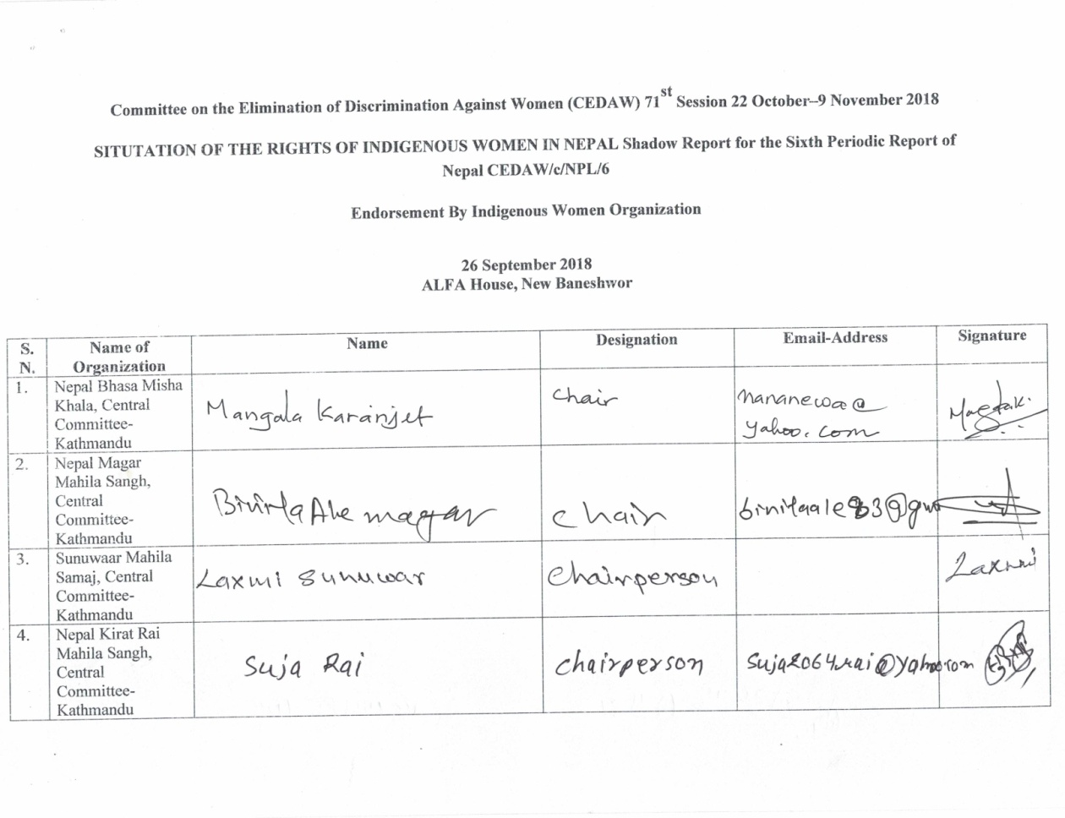
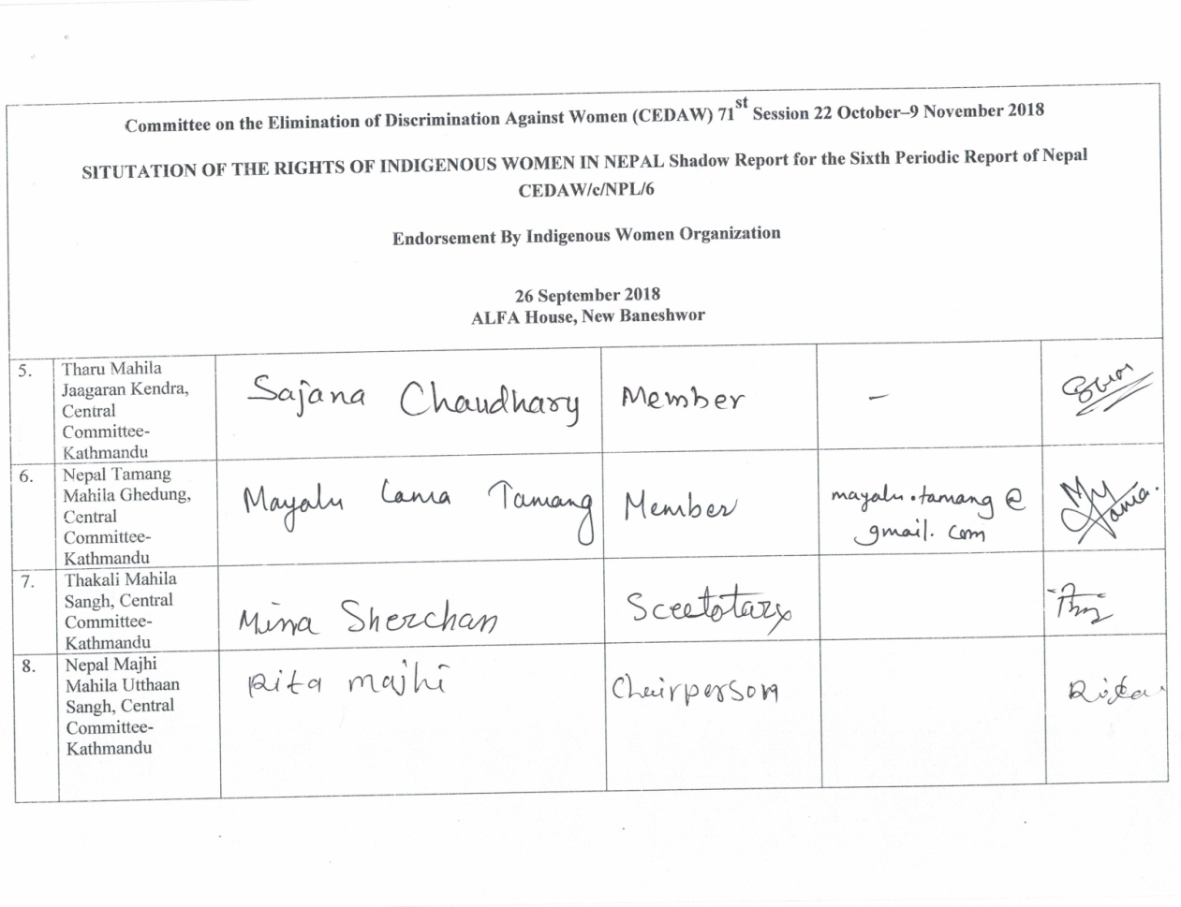
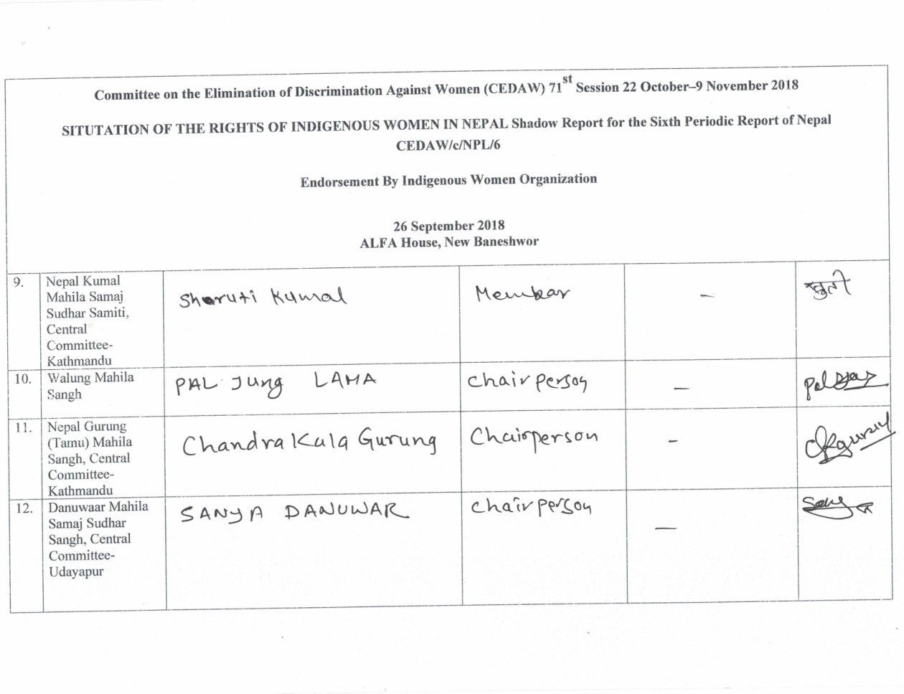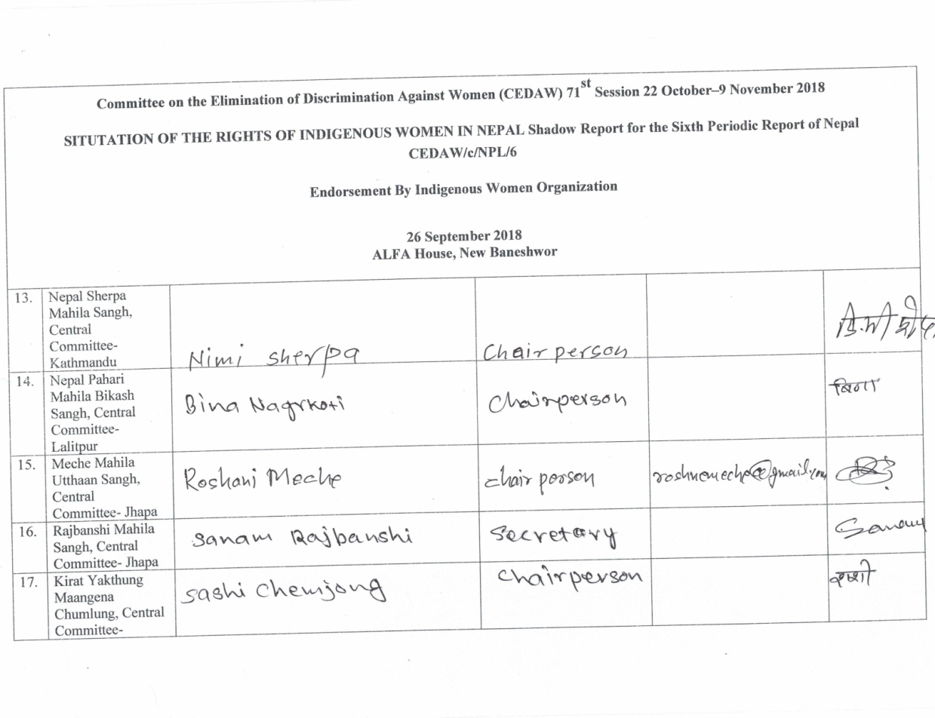
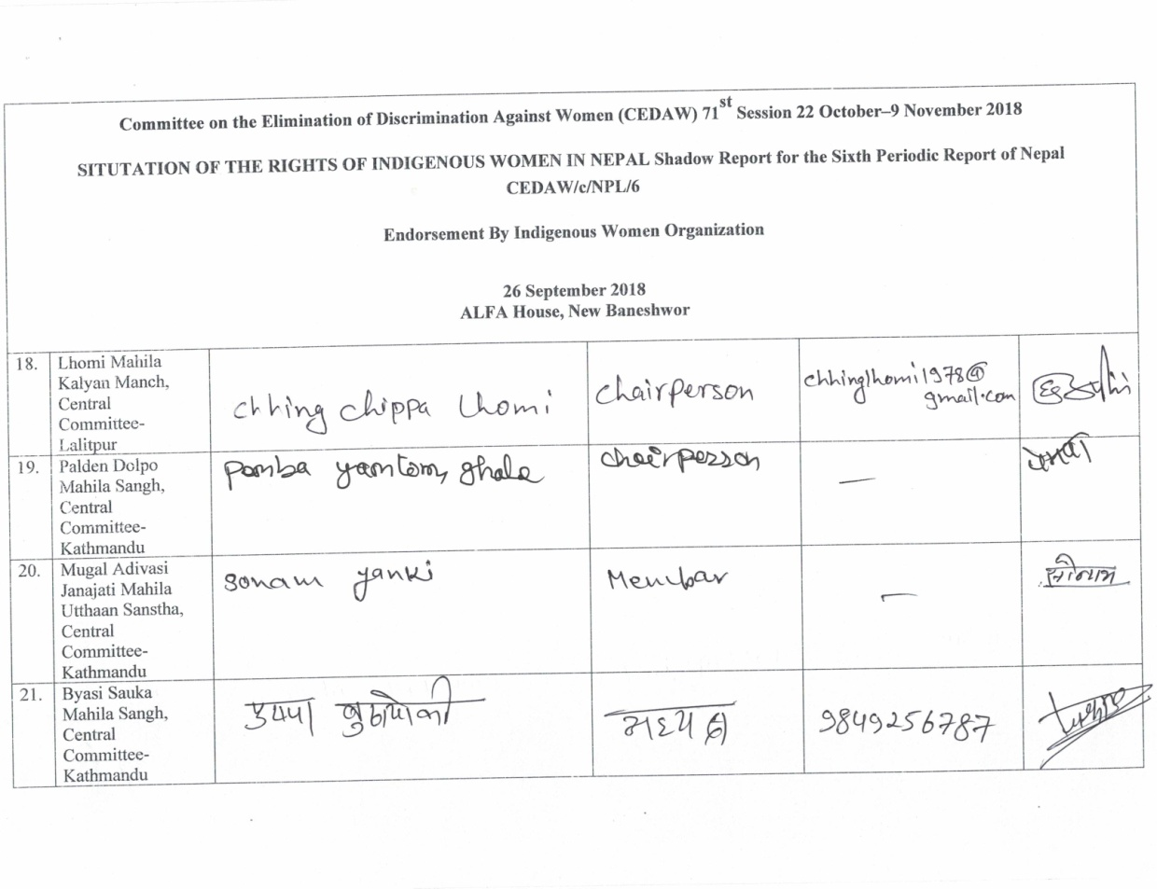
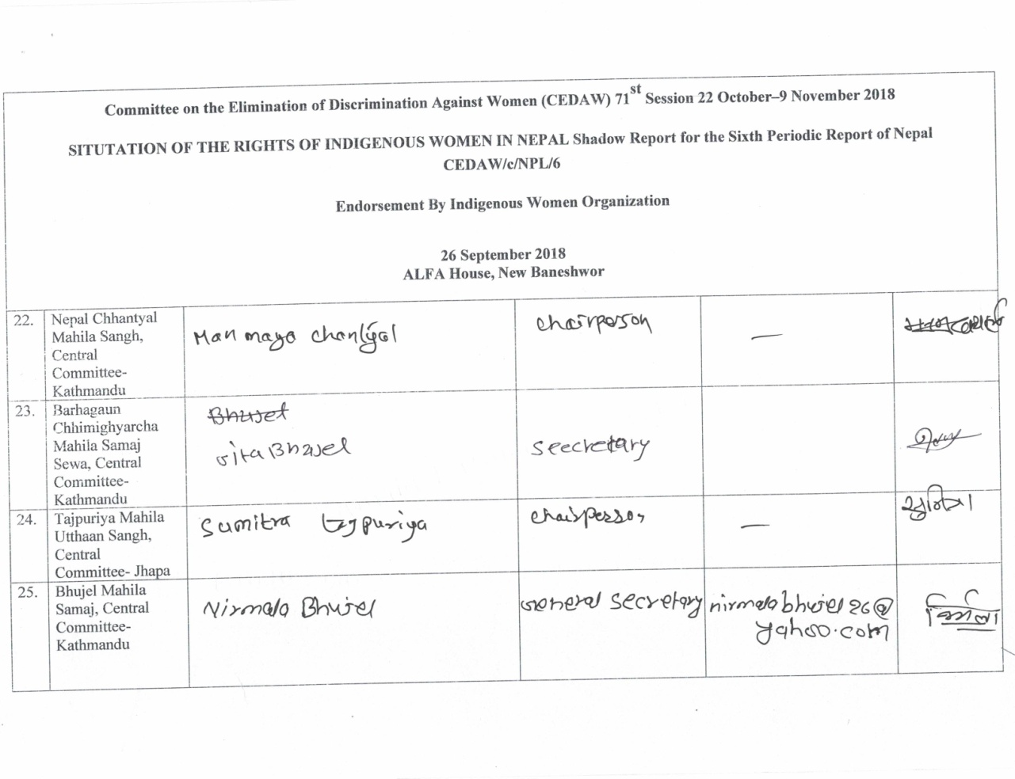
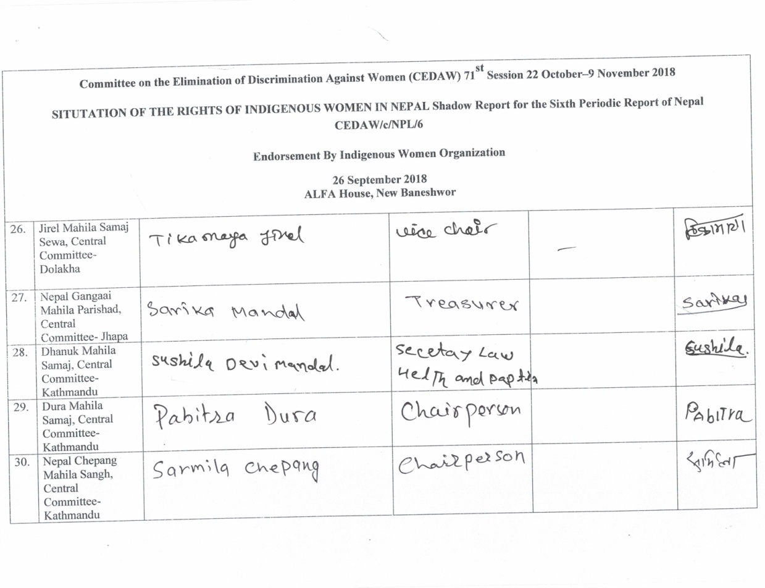
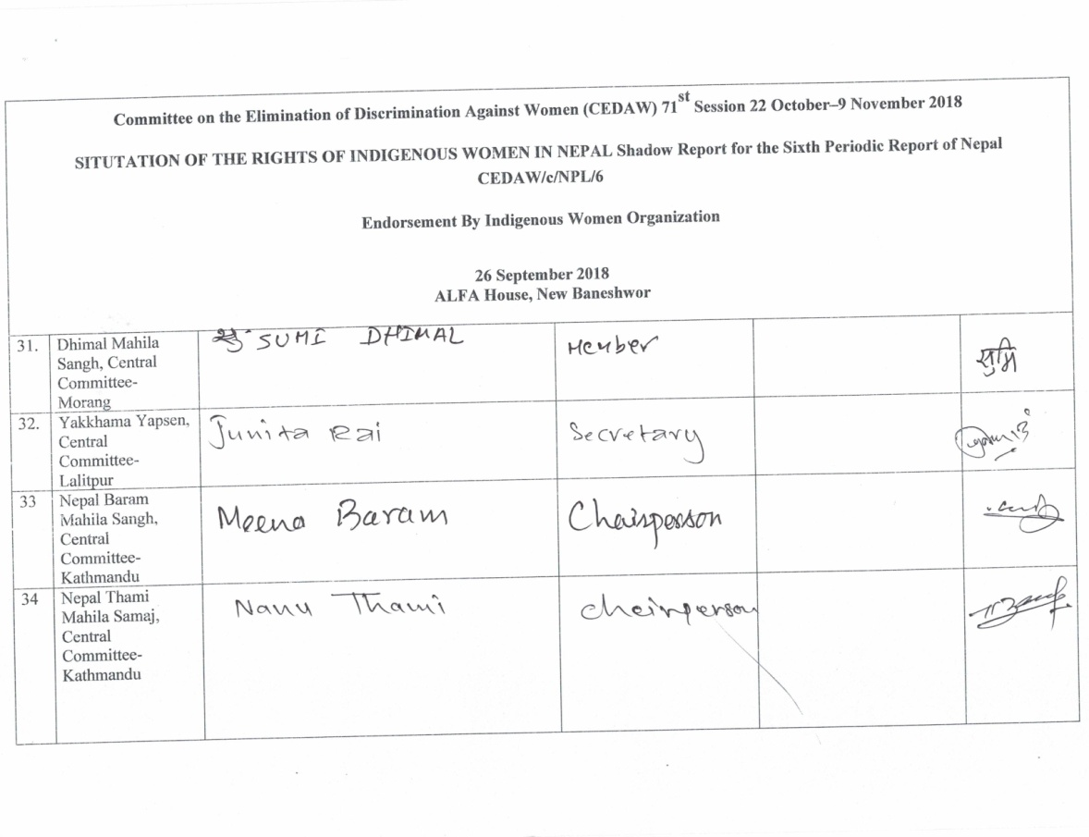

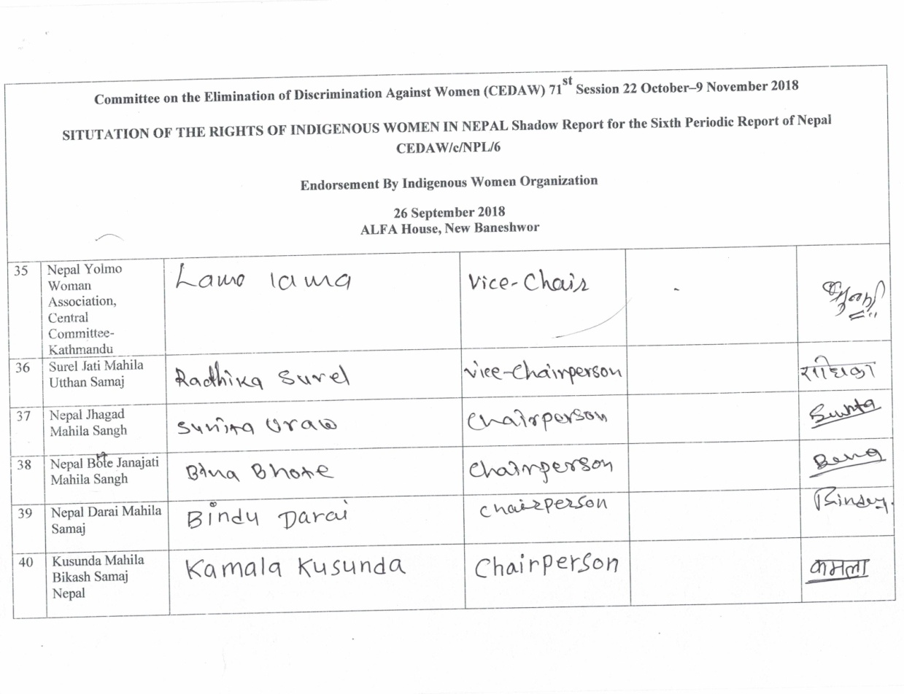
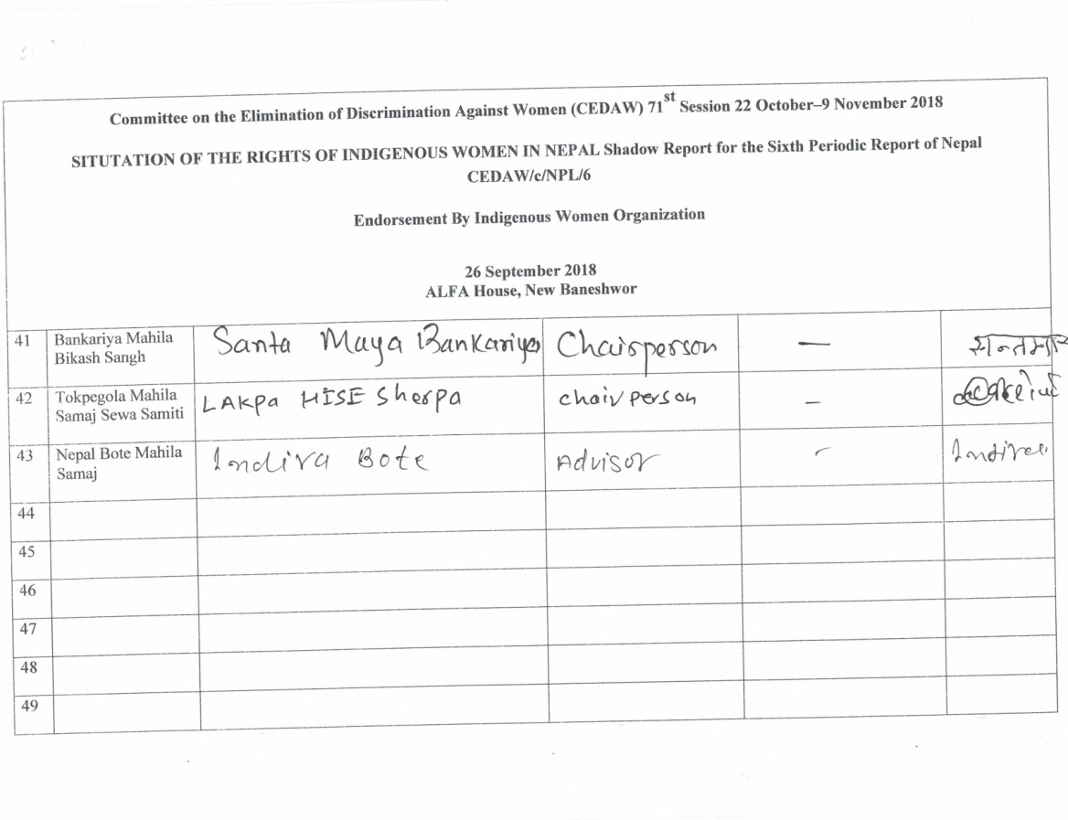

Note: See Annex 1 for a list of 43 Indigenous women’s organizations who endorsed this report.
Preamble, the Constitution of Nepal, 2015. http://www.constitutionnet.org/sites/default/files/2017-07/Constitution-of-Nepal-_English_-with-1st-Amendment_2_0.pdf
CBS (2012) National Population and Housing Census 2011: National Report, Volume 01, Kathmandu: CBS, Government of Nepal.https://unstats.un.org/unsd/demographic-social/census/documents/Nepal/Nepal-Census-2011-Vol1.pdf
Shigeru Iijima. Hinduization of a Himalayan Tribe in Nepal. http://digitalassets.lib.berkeley.edu/anthpubs/ucb/text/kas029-005.pdf
“The Concept of Sanskritization,” Pp. 1-18, In: TekNathSubedi and Milly Joshi (Eds.) Journal of SASS, Volume 1. Kathmandu: SAS & CDSA, TU,Kirtipur, Kathmandu. 2006.
See Concluding Observation (C/NPL/C/CO/4-51) provided to Government of Nepal by CEDAW Committee Paragraph Nos. 23 and 24 (i). https://www2.ohchr.org/english/bodies/cedaw/docs/co/CEDAW-C-NPL-CO-4-5.pdf See CO (CRPD/C/NPL/CO/1) provided to Government of Nepal by CRPD Committee Paragraph Nos. 7,8,9,10,13,14,15,19,39,40,42 and others on March 1st, 2018.https://tbinternet.ohchr.org/_layouts/treatybodyexternal/Download.aspx?symbolno=CRPD/C/NPL/CO/1&Lang=En
Discussion from participants and parents of indigenous girls and women with disabilities from five regional Consultation Workshop for Collecting facts and figures for preparing CEDAW Report held in five regions of Nepal from February 31st, 2016 to March 31st, 2016.
NIDWAN, NIDA, and AIPP. 2018. The Rights of IPWDs in Nepal, submitted to the Committee on the Rights of PWDs. 14 Feb 2018- 9 March 2018.
http://webtv.un.org/search/consideration-of-nepal-2626th-meeting-95th-session-committee-on-elimination-of-racial-discrimination/5786648009001/ http://webtv.un.org/search/consideration-of-nepal-contd-2627th-meeting-95th-session-committee-on-elimination-of-racial-discrimination/5780260860001/?term=
Bhim Rai vs Prime Minister of Nepal (et.al.) case: Madamus at the Supreme court of Nepal (pending 2017)
National Regional Dialogue with the Government and Concerned Authorities, IPs and IWOs. Implementation Process, Status of CEDAW Committee CO and Recommendations relating to Indigenous Women. Project Completion Report submitted to IWGIA by a consortium of NIWF, NIWF, NIDWAN andINWOLAG,May 2nd, 2016.
Ibid. Also, see a report in progress on “National Consultation Program on Indigenous Women’s Issues in 71st Session of CEDAW” held on August 24th, 2018 to be submitted to MADRE by NIWF. Also, see a report in progress on Desk Review and Report Write Up of CEDAW Shadow Report submitted to FIMI by NIWF.
NIWF, NIWF, NIDWAN and INWOLAG (2015) A report on “National Dialogue with the Government and Concerned Authorities, IPOs and IWOs on Implementation Process Status on CEDAW Committee Recommendations relating to Indigenous Women made in the CO” submitted to AIPP, 2nd May, 2016.
The Constitution of Nepal was promulgated on September 20^{th,}2015. See full text of the constitution in English language at http://www.constitutionnet.org/sites/default/files/2017-07/Constitution-of-Nepal-_English_-with-1st-Amendment_2_0.pdf
https://tbinternet.ohchr.org/Treaties/CERD/Shared%20Documents/NPL/INT_CERD_ALE_NPL_7100_E.pdf https://www.ohchr.org/Documents/HRBodies/CERD/EarlyWarning/Nepal28092009.pdf
LAHURNIP et. al. vs PM etal. Certiorari including Mandamus, Decision No 8990, Nepal Kanoon Patrika, 21 April 2013, p. 491. (065-WO-0475). For detail see pages 3 and 4 in https://tbinternet.ohchr.org/Treaties/CERD/Shared%20Documents/NPL/INT_CERD_NGO_NPL_30811_E.pdf
Not the nominate the party leaders who have participated in the elections and ensure the representation of those IPs who have not represented under the FPTP and PR electoral system, Dalit Janajati Party Vs. GoN, Writ No. 070-WO-0476, decision date 12 May 2014. For detail see pages 3 and 4 in https://tbinternet.ohchr.org/Treaties/CERD/Shared%20Documents/NPL/INT_CERD_NGO_NPL_30811_E.pdf
See UNCRPD. UNTS, vol. 2515, p.3. See preamble paragraph (p).
See WCIP Outcome Document 2014 http://www.un.org/en/ga/president/68/pdf/letters/9152014WCIP%20%20CFs%20on%20Draft%20Outcome%20Document.pdf
Embracing Diversity, The Expert Group Meeting on IPWDs Report, 7-8 July 2016, ILO Head Quarter Geneva., See https://www.ohchr.org/EN/Issues/Disability/SRDisabilities/Pages/IPDisabilities.aspx, See https://www.un.org/development/desa/disabilities/issues/the-united-nations-and-indigenous-persons-with-disabilities.html
See https://reliefweb.int/report/nepal/committee-rights-persons-disabilities-reviews-report-nepal, See CRPD/C/NPL/CO/1
In 2007, Nepal was declared as a Federal Republic State by the reinstated Legislative Parliament to address the demand of Nepali people, including IPs, Madhesi, Dalit, Muslim who are highly marginalized, excluded and historically discriminated against. Among others, the Interim Constitution, 2007 was promulgated to institutionalize federalism, secularism, inclusion, proportional representation (Art. 4), self-governance, autonomy to IPs (Art. 138.1.A) vis-à-vis human rights and fundamental freedoms. Various Agreements were concluded between the GoN and IPs in the course of Constitution writing process. Through these agreements, the GoN has agreed to ensure right to self-determination, autonomy and self-governance, recognition rights to lands, territories and natural resources, and meaningful participation of IPs in Constitution writing process. Importantly, there was a provision to nominate at least 13 IPs representatives in the CA by the Council of Ministers. It was to ensure IPs collective representation, from those who were not represented through First-Past-The Post (FPTP) and Proportional Representation (PR) electoral system (Art.63.3.c).
See page 14 of 72 in report European Union Report Election Observation Mission 2017. https://eeas.europa.eu/sites/eeas/files/final_report_eu_eom_nepal_2017.23_march2018.pdf
http://kathmandupost.ekantipur.com/news/2018-03-25/eus-report-undermined-nepal-and-nepalis-pm-oli.html http://english.onlinekhabar.com/election-commission-also-rejects-eus-poll-observers-report.html
https://www.indigenousvoice.com/en.html
Shanti Kumari Rai etal. (2015) (Eds.) ParamparagatSansthaEk Adhyayan [Traditional Institutions. A Study. (Newar, Thakali, Majhi, Dhimal, Tharu, Hyulmo, Jyapura Magar). Kathmandu: LAHURNIP and AIPP. http://www.lahurnip.org/uploads/articles/Traditional%20Institutions.pdf
A total of 17 groups were mentioned as deserving special attention through special measures are ‘Women, Dalit, indigenous people, Adivasi Janajati, Madhesi, Tharu, minorities, persons with disabilities, marginalized communities, Muslim, backward classes, gender and sexual minorities, youth, farmers, labors, oppressed or citizens of backward regions, and indigent Khas Arya shall have the right to participate in state bodies on the basis of principles of inclusion’ (Article 42).
https://www.indigenousvoice.com/en/nepals-new-constitution-makes-mockery-of-reservation-policy.html
Constitution of Nepal, Art. 84 (2) Khas Arya means the Kshetri, Brahmin, Thakuri, Sanyasi (Dashnami) community
See page 14 of 72 in report European Union Report Election Observation Mission 2017.
European Parliament, Report on the situation of minority women in the European Union (2003/2109(INI)), p 13, cited in OHCHR Thematic study on the issue of violence against women and girls and disability, A/HRC/20/5, 30 March 2012, para 21
Amnesty International, Maze of Injustice (2007) and Ministry of Social Development of New Zealand, The Social report, 2010, cited in Permanent Forum on Indigenous Issues, Study on the extent of violence against indigenous women and girls in terms of article 22(2) of the UNDRIP, E/C.19/2013/9, 12 February 2013, para 12.
NIDWAN, NIDA, and AIPP. 2018. The rights of IPWDs in Nepal, Submitted to The Committee on the Rights of Persons with Disabilities. February 14th, 2018- March 9th, 2018.
Maiti Nepal and SaktiSamuh is a civil society organization working to stop women trafficking in Nepal.
Maiti Nepal and SaktiSamuh is a civil society organization working to stop women trafficking in Nepal.
https://www.recordnepal.com/art-letter/books/the-dark-side-of-nepals-national-parks/
NIWF (2014) Indigenous Women's Participation in State Mechanism: Institutional Level Indigenous Women's Participation Survey. Kathmandu: NIWF.
Ibid.
AIWN Participation & Representation of Indigenous Women in Decision Making: Home to Policy level. A final draft report submitted to AWIN &Tebtebba Foundation by CIPRED, NIWF, NIWF, August 2018.
various mode of schooling such as: special education, inclusive education, non-formal education, continuous education, distance education and open school education etc.
Children in School, Global Initiative on Out on School Children (MoE) 2016. This report showed the comprehensive picture of out of school children and multiple dimensions of analyzing this issue. http://unicef.org.np/uploads/files/927615134285223000-all-children-in-school-report-2016.pdf
EU (2017) The Situation of ICWDs. 2017. Directorate General for External Policies: Policy Department European Parliament. http://www.europarl.europa.eu/RegData/etudes/STUD/2017/603837/EXPO_STU(2017)603837_EN.pdf
Subba, Chaitanya et al. (2014) A Study on the Socio-economic Status of Indigenous Peoples in Nepal. Kathmandu: LAHURNIP. http://www.lahurnip.org/uploads/articles/Final-Book-NLSS.pdf
UPR Report
UPR Report NCARD
http://www.moi.gov.np/medpa/
NIWF and UNDP (2018) Economic Empowerment of Indigenous Women. Kathmandu: NIWF and UNDP in Nepal. http://www.np.undp.org/content/dam/nepal/docs/2018_undpnepal/UNDP_NP-Economic-empowerment-of-indigenous-women-in-nepal.pdf http://www.np.undp.org/content/nepal/en/home/library/gender-equality-and-social-inclusion/Economic-empowerment-of-the-indigenous-women-in-Nepal.html
See the statement made by Country Rapporteur in the video footage from 1:25:2 to 1:35:08 at this link. http://webtv.un.org/search/consideration-of-nepal-contd-2627th-meeting-95th-session-committee-on-elimination-of-racial-discrimination/5780260860001/?term=
http://www.lahurnip.org/news-details/62.html SupriyaManadhar Fast Track brings fear of displacement to KhokanaThe Wire. March 19, 2018. https://www.recordnepal.com/wire/fast-track-brings-fear-of-displacement-to-khokana/ Crackdown on anti-road expansion protestors Nepali Times. March 28, 2018 https://www.nepalitimes.com/here-now/crackdown-on-anti-road-expansion-protesters/
See the statement made by Country Rapporteur in the video footage from 1:25:2 to 1:35:08 at this link. http://webtv.un.org/search/consideration-of-nepal-contd-2627th-meeting-95th-session-committee-on-elimination-of-racial-discrimination/5780260860001/?term=
http://www.lahurnip.org/news-details/62.html

