Alternative Report submitted to the
UN Committee on the Economic, Social and Cultural Rights for the
consideration of the Initial Report of Rwanda during the
50th Pre -Sessional Working Group

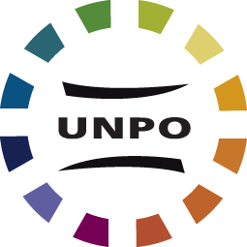

Unrepresented Nations and Peoples Organization
September 2012

Contents of this Report

Section A: Introduction to the Report …………………………………….… 3
Section B: Introduction to the Batwa ……………………………….…….. 4
Section C: Compliance with ICESCR ………………………………….….……. 5
Article 1 – Right to Self-determination ………………………………………….........................5
Article 1.1 …………………………………………………………………………………………………………5
Article 1.2 …………………………………………………………………………………………………………7
Article 2 – Non-discrimination……………………………………………………............................ 9
Article 6 – Right to work …………………………………………………….................................... 10
Article 11 – Right to adequate standard of living …………………………………………...........11
Article 12 – Right to health …………………………………………........................................... 15
Article 13 – Right to education …………………………………………...................................... 16

Section D: Recommendations ………………………………………………….… 18

Contact Information

Unrepresented Nations and Peoples Organization
International Secretariat
Laan van Meerdervoort 70
2517AN The Hague
The Netherlands
www.unpo.org

Section A: Introduction to the Report

This alternative report was submitted by the Unrepresented Nations and Peoples Organization (UNPO) on the occasion of the 50th Pre-Sessional Working Group of the Committee on Economic, Social and Cultural Rights (henceforth, “the Committee”).

The framework of this report will comment upon relevant articles of the International Covenant on Economic, Social and Cultural Rights sequentially. The final section of the report raises questions that should be posed and recommendations regarding concerns which are intended to inform the discussions taking place within the International Covenant on Economic, Social and Cultural Rights (henceforth, “ICESCR” or “the Covenant”) and between the Committee and the Rwandan delegation at the 50th Session.

This alternative report will focus on the situation of the Batwa people in Rwanda and the Rwandan government’s compliance with and implementation of the provisions in the International Covenant as it affects this particular group.

The major issue dealt with in this report is the extreme poverty and marginalization of the Batwa in Rwanda, caused mainly by social and political discrimination and exclusion. This led to the Batwa becoming victims of forced evictions from their ancestral lands, destruction of their houses, as well as lack of access to healthcare, education and work.

The Batwa of Rwanda have been a Member of UNPO since January 1993; initially represented in the organization by the Association for the Promotion of Batwa (APB). At the request of APB, UNPO sent a mission to Rwanda and neighboring countries, Zaire, Tanzania and Burundi in 1994, and again in 2010. The current organization representing the Batwa at UNPO is the Cultural Conservation Act, since restrictions on the freedom of association have interfered with previous organizations, such as the Community of Indigenous Peoples of Rwanda, an amalgamation of three previous Batwa organizations which joined together in the struggle for the rights of the Batwa community.

The Hague, September 2012

Section B: Introduction to the Batwa

The Twa are the oldest recorded inhabitants of the Great Lakes Region in Central Africa. While many people in this area have histories of migration the Batwa emphasize they have no origins elsewhere, but are indigenous to this region. Today they are found in the territories of Rwanda, Burundi, Uganda and the eastern part of the Democratic Republic of Congo. Regarding terminology, Mutwa refers to one person of Twa origin, Batwa to several.

The estimated number of Batwa living in Rwanda lies between 33,000 and 35,000 people, i.e. around 0.4% of the population. They live dispersed over Rwanda in small communities, often at the periphery of mixed communes. Discrimination, extreme poverty and lack of access to health services led to a sharp and quick decrease of the Batwa population. According to a micro study by Minority Rights Group international (MRG), a comparison of census figures from 1978 and 1991 indicates a 40 per cent drop in the Batwa population, as opposed to a 50 per cent rise in the population of other Rwandans. The 1994 genocide has severely affected the Batwa. Rough estimates based on a census carried out by UNPO in late 1994 indicate that up to 10,000 Batwa died and that another 8,000 to 10,000 fled, eventually decreasing the Batwa population in Rwanda by at least another 30%.

The Batwa have a distinct culture and used to live mainly from hunting and gathering. As a result of the creation of national parks and economic development they were displaced form the forest without compensation, making them the poorest and most marginalized section of Rwandan society. Some Batwa, referring to themselves as ‘Impunyu’ still follow this lifestyle. However most of them lack regular access to forests and are often described as squatters or tenants on their ancestral lands which was turned into farmland. Many Batwa turned to pottery to sustain themselves, leading to a new lifestyle and culture. However this is today threatened again because of land policies and decreased demand for pottery products, which causes many Batwa to turn to begging to survive.

In short, the Batwa form a disadvantaged and extremely vulnerable group within Rwandan society. Most Batwa find themselves with neither a viable traditional lifestyle nor with access to the benefits of modern society. The Batwa wish above all to be recognized and treated equal to other people with equal benefits, entitlements and rights as their fellow citizens.

Section C: Compliance with ICESCR

Article 1 – Right to Self-determination
Article 1.1 states that “All peoples have the right of self-determination. By virtue of that right they freely determine their political status and freely pursue their economic, social and cultural development.”

The Rwandan report to the ICESCR Committee carefully avoids the issue of the Batwa, or of any subgroups or division for that matter. It interprets the right of self-determination solely as the right of the Rwandan State to administer itself without any foreign interference, and secondly as requiring a devolution process so that citizens are further in charge of their own affairs. However it does not address the possibility of economic, political, social or cultural devolution to the Batwa.

This comes to no surprise considering that all ethnic identification has been banned in Rwanda since 1994. The Batwa are not recognized as indigenous peoples or even as an ethnic group. Therefore, the report contains practically no information on the Batwa population. The word “Batwa” does not even figure once in it. The expression “historically marginalized people”, a term used by the government of Rwanda to describe the Batwa and other vulnerable groups is present only three times in the 96 pages of the report. The unwillingness to identify the Batwa as a specific group means that despite their marginalized situation there are no specific laws to promote or protect Batwa rights.

The government’s line of argument for not recognizing the Batwa as a group is the strengthening of national unity by encouraging a homogenous Rwandan identity and avoiding the fostering of divisionism which, in the past, led to the genocide. As such, no group of Rwandese is allowed to identify themselves under any ethnic form and claim e.g. on grounds of indigeneity. Anyone referring to ethnic identity is susceptible to being charged with “divisionism” which carries severe punishment despite the fact that the crime is not clearly defined. However, the identification of the Batwa as a minority and as an indigenous group requiring targeted measures should not be seen as a threat. It is a means through which targeted measures can be employed to raise their standard of living and has the additional benefit of reducing the level of inequality in Rwanda, understood by the government themselves to be “rising and high”. The Batwa are a distinct ethnic group with distinct challenges, the solutions to which are also distinct.

The decision to dissuade the use of ethnic terms from official documents has been conflated at times with the outright denial that different ethnic groups exist. For instance in Rwanda’s 9th and 10th Periodic Report under the African Charter on Human and Peoples Rights the government claims it makes no sense in the Rwandan context to talk about indigenous peoples but that all Rwandese share the same territory, language and culture. It is indeed the case that physical, linguistic and religious differences between Batwa, Bahutu and Batutsi are negligible. However, the Batwa stand out for their cultural distinctiveness. Batwa tradition, still today, is rich in songs, dance and music, and cultural gatherings are firmly integrated into their social life.

However the main difference lies in the social status. The Batwa can be described as the lowest social cast. In its mission to Rwanda the African Commission’s Working Group on Indigenous Populations/Communities was informed by a Rwandan Law professor that divisions made in the past were artificial and in reality refer to socio-economic groups, including farmers, pastoralists and hunter-gatherers. The historically marginalized communities today “are disadvantaged as a result of their low level of education and involvement in the management of public affairs”.

The Batwa are almost entirely absent from grassroots, regional or national governing structures, they are largely sidelined from or face challenges to participate in local decision-making procedures, as a result of being numerically small, not recognized as a distinct group and discriminated against. This is still the case despite Article 82, paragraph 2 of the Rwandan Constitution, amended by revision no. 2 of 8 December 2005. The article demands eight members of the Senate to be appointed by the president to ensure representation of historically marginalized groups. At the moment, though, the Batwa have only one representative in the Senate.

Their absence from decision-making processes results in policies disproportionately detrimental to their community, especially in housing policies. To combat this, the Batwa need their own organizations, representing local communities to external institutions like State structures, intergovernmental organizations and NGOs. However, as a result of their marginalization and high levels of illiteracy, active participation in Rwanda’s political life is currently inconceivable for many Batwa.

Furthermore the criminalization of ethnic discourse hampers the establishment of associations and community projects that tackle Batwa-specific problems or challenges. Whilst there are multiple associations, forums, NGOs, programs, scholarships and institutions for other vulnerable groups such as women, youth, people living with disabilities, genocide survivors, and widows, no such national institution exists for the Batwa.

An example of this is the Batwa NGO “Communauté des Autochtones Rwandais” (CAURWA). They were refused legal status until stopping to identify the Batwa as Rwanda’s first inhabitants and referring to the Batwa as a people. In 2007 the organization was forced to change its name and omit the word “indigenous” in order to get their charity license renewed. CAURWA is now called COPORWA (Communauté des Potiers du Rwanda). Organizations promoting the interests of the Batwa are essential for the promotion of community-owned development, institution-building, conflict resolution, technical development skills, research and so on. Therefore, they should be allowed to exist and be supported.

Article 1.2 states that “All peoples may, for their own ends, freely dispose of their natural wealth and resources without prejudice to any obligations arising out of international economic co-operation, based upon the principle of mutual benefit, and international law. In no case may a people be deprived of its own means of subsistence”.

The Batwa have been deprived of their means of subsistence as a result of forced and often aggressive government-sponsored relocations since the 1970’s. In contrast to other dispossessed citizens, the Batwa rarely receive compensation for the expropriation of their lands. As a result, most Batwa live under deplorable conditions. 43% of Batwa families have no access to land, compared to 12% of families nationally. This situation came about through a long history of discrimination, several facets of which are outlined below.

Especially after the 1994 genocide, the Batwa lost much of their land to the thousands of people who came back from exile. During this time there was much confusion as the newly-established land bills gave far-reaching powers to the government to confiscate lands that seemed unused, including the forests and wetlands the Batwa depended upon for hunting or gathering clay. As of today, the Batwa people are still waiting to receive the compensation and land settlements that will allow them to try and rebuild their everyday lives.

Before and after this, attrition through encroachment, intimidation and theft took away the Batwa’s land. Neighbors began extending the boundaries of their fields to incorporate Batwa land, especially if this land was forested or fallow. This is often done subtly and over extended periods, but can also occur in leaps and bounds, often accompanied by threats and intimidation. Only exceptionally do Batwa who lose land this way go to local authorities to complain. They do not believe they will be given a fair hearing and rightfully so. In some cases local authorities are themselves implicated in the attrition. When locals collude with local authorities, as well as with national governments or international donor agencies, direct land theft is common. Unfortunately, many examples show that the government and the justice system are reluctant to challenge this and the Batwa’s right to equality before the law is being severely violated.

While most rural Rwandans live from farming, this is difficult for the Batwa. According to the survey conducted by CAURWA in 2004, 78% of Batwa families are tenants on the land they are cultivating. As the farmers’ settlements grow and demand for land intensifies, areas occupied by tenants are recovered to provide for the needs of the landowners’ relatives. Batwa tenants are routinely the first to be evicted. Batwa often feel this is unfair especially when they have been residents for many years. Many refuse to leave, provoking conflicts in which the probabilities of success are heavily weighted against them.

In 2005 the government established the organic law n°08/2005 of land use in Rwanda to address land disputes and modernize land management in line with the open market economy. For instance it regulates the conditions for ownership of land, makes land registration mandatory, provides for land titling and organizes land consolidation. However, its application violates property rights, especially the right to appropriate and prior compensation for land expropriation, especially in relation to the Batwa. The Parliament in Rwanda has the power to pass laws and convert land from private to public use with little consultation. The Batwa face systemic marginalization in national planning processes and are not consulted on major land use policies and the effects on their livelihoods.

The 2005 law, as well as previous land policies which follow mainstream views of private property, disregard cultural mapping and ignore the Batwa’s customary rights to designated sites, especially wetlands and forests. Traditionally, Batwa have a nomadic lifestyle, as forest dwellers or as potters. Many Batwa see their rights in terms of collective rights, however communal property rights are not recognized under the law and usually ignored. As a result, access to forests, clay groves and swamps are often lost to farmers claiming the land for cultivation. Without these lands many Batwa have been forced into slavery-like conditions and begging to make a living, often working the land of other Rwandans in exchange for food.

The Rwandan government still refuses to recognize their traditional indigenous activities as a viable livelihood, as reflected in the legislation adopted in 1974 prohibiting the activities upon which the Batwa communities survived and thrived, namely fishing, hunting and animal trapping. As a result of this legislation as well as of forests being turned into agricultural land, the Batwa have been denied their traditional sustenance activities. In the early 1990s conservation projects forced the last forest-dwelling Batwa out of the forests, imposing a ban on hunting and collecting in the forest. This took away, without consultation or reparation, the Batwa’s means of subsistence. In the establishment of national parks the interests of game animals are given priority over those of the Batwa. Anyone entering the forest without prior approval is regarded as a poacher and charged accordingly. Although presented as an environmental protective measure, there is no obvious ecological reason for this ban. By contrast, encroaching tea plantations, the construction of roads, illegal gold mining and the frequent use of the forest as military training ground seriously threaten the survival of the forest, and endanger the position of the Batwa. The mountainous regions traditionally inhabited by the Batwa are extremely fertile. This has led to the migration of farmers, turning Batwa’ s traditional lands into some of the most densely populated areas in Africa, leaving the Batwa landless, homeless and devastatingly poor.

Justification for the disrespect for the Batwa’s rights comes from stereotypes of their traditional lifestyle being immoral and depraved, arguing that the Batwa, especially the ones living in the forest, are not really humans. And yet, instead of supporting the Batwa, the international community has ethnically stereotyped the Batwa as well. Many European and North American animal protectionists have forged an identity of the Batwa as poachers, notably of gorillas, an image enhanced by Northern media, as in the Hollywood film “Gorillas in the Mist”. However, no known Batwa groups eat gorilla, and the evidence suggests that they have never done so. Nevertheless many evicted Batwa communities lead persecuted existences as they are constantly blamed for any evidence of hunting discovered in the parks, while those commissioning animal trophies are rarely investigated or prosecuted. The consequences of this for Batwa living near national parks are appalling, as park guards endlessly victimize them; and despite their traditional knowledge of the forest environment, it is almost impossible for Batwa to get jobs in the parks, for instance as rangers or tourist guides.

After they were forced out of the forest many Batwa turned to pottery to sustain themselves and a new culture has developed. However, this new livelihood is recently endangered again and the Batwa are faced with another crisis. Reasons for this are the dropping prices and pottery products being less required because they have been replaced by cheap industrially-produced plastic items. Furthermore access to clay, firewood and grasses needed to make pots is becoming increasingly difficult. Farmers are claiming marshes for cultivation and the government of Rwanda supports this. This is evidenced in sections 209 and 221 of the report submitted to the ICESCR Committee, which refer to policies turning marshland into farmland. This contradicts the Batwa’s collective rights of using the marshes for gathering clay. New land policies, such as the ones mentioned in the State report in section 220 led the Batwa to further lose access to clay as well as to forests.

Article 2 – Non-Discrimination
Article 2.2 requires the States Parties to the Covenant to undertake steps to “guarantee that the rights enunciated in the present Covenant will be exercised without discrimination of any kind as to race, color, sex, language, religion, political or other opinion, national or social origin, property, birth or other status.”

In its report to the ICESCR Committee, Rwanda emphasizes the steps taken to combat discriminatory practices and promote development. However, most of the programs do not benefit the Batwa who are desperately in need of help. UNPO denounces the exclusion of the Batwa from certain development programs and the detrimental effects of some of those programs on them.

Article 9 of the current Constitution of Rwanda (2003) acknowledges the rights of “marginalized and excluded groups”. However, the government refused to recognize the Batwa as a group that is marginalized and discriminated against, and this has led them to be ignored in government programs to provide social welfare and development services such as primary healthcare, shelter and clean water.

In addition to their absence in decision-making, discrimination is the main reason for the Batwa not to benefit from development and most aspects of modern society. Other ethnic groups in Rwanda have traditionally looked down on the Batwa as backward, unintelligent, lazy and dirty, thereby perpetuating their social exclusion. This discrimination is reflected in taboos surrounding eating together with Batwa or even using utensils used by Batwa.

However, since data is not disaggregated by ethnicity, the degree of discrimination is not easily estimable and it is near impossible for Rwandan national authorities to distinguish when discrimination is behind the inappropriate implementation of their policies against poverty in Batwa communities.

Article 6 – Right to work
Article 6.1 states that “[t]he States Parties to the present Covenant recognize the right to work, which includes the right of everyone to the opportunity to gain his living by work which he freely chooses or accepts, and will take appropriate steps to safeguard this right.”

Article 6.2 states that “[t]he steps to be taken by a State Party to the present Covenant to achieve the full realization of this right shall include technical and vocational guidance and training programs, policies and techniques to achieve steady economic, social and cultural development and full and productive employment under conditions safeguarding fundamental political and economic freedoms to the individual.”

The Ministry of Justice outlines in its report to the ICESCR Committee the steps taken to encourage employment of an increased number of people and measures taken to increase productivity of the workforce. The programs and policies target vulnerable populations, in this context referring to people in certain occupations, e.g. agriculture, as well as youth and women. However no mention is made of the Batwa.

The Batwa are unfortunately not merely omitted on paper but also in reality. Most development and assistance programs designed to target the neediest of Rwanda’s population do not reach the Batwa, either because they do not fulfill the minimum requirementsor because staff at a local level have the power and inclination to direct assistance away from Batwa communities Instances have been reported to UNPO of authorities who have tried to appropriate materials for income-generating projects assigned to the poor, largely Batwa communities.

Because Batwa communities are stigmatized, they are often considered for dirty or tedious jobs. These stereotypes, implying a physiological or innate inferiority, are characteristic of racist ideologies used against them. Many Batwa have partly internalized the negative stereotypes incessantly reinforced by the discriminatory behavior of their wealthier neighbors. They seek to assimilate by adopting the outer markers of their neighbors’ status. However, it is rare that their neighbors accept them even when Batwa are able to achieve this.

The second factor leading to Batwa’s marginalization is their lack of skills. 91% of Batwa have no formal education, as a result of poverty, hunger and discrimination. The lack of education makes it very difficult for Batwa to find work and to escape poverty. The biggest hurdle is illiteracy: Only 23% of the Batwa can read and write compared to 52% of the general population in Rwanda. The literacy programs mentioned in the State report do not usually reach the Batwa. Without mentioning the Batwa by name this problem is acknowledged in section 289 of the report, which states that literacy programs are not widely spread and attitudes, stereotypes, ignorance and poverty often prevents people from reaching them.

Many became destitute and today a large portion is made of beggars or conducts activities working as porters, or carrying neighboring farmers’ products to markets. Today, most Batwa lead a hand-to-mouth existence, depending on marginal subsistence strategies like begging or casual day labor. According to the CAURWA survey (2004), the average monthly income of the Batwa is 5 426 Rwandan Francs (10 USD). This is insufficient to feed an average Batwa family, which leads to begging and reinforces marginalization and exclusion. It is also important to mention that more than 30% of the Batwa were unemployed at the time of the survey.

Article 11 – Right to adequate standard of living

Article 11.1 states that “The States Parties to the present Covenant recognize the right of everyone to an adequate standard of living for himself and his family, including adequate food, clothing and housing, and to the continuous improvement of living conditions. The States Parties will take appropriate steps to ensure the realization of this right, recognizing to this effect the essential importance of international co-operation based on free consent.”

Article 11.2 states that “The States Parties to the present Covenant, recognizing the fundamental right of everyone to be free from hunger, shall take, individually and through international co-operation, the measures, including specific programs, which are needed:
(a) To improve methods of production, conservation and distribution of food by making full use of technical and scientific knowledge, by disseminating knowledge of the principles of nutrition and by developing or reforming agrarian systems in such a way as to achieve the most efficient development and utilization of natural resources;
(b) Taking into account the problems of both food-importing and food-exporting countries, to ensure an equitable distribution of world food supplies in relation to need.”

Mr. Karugarama, the Rwandan Justice Minister, stated that the situation of the Batwa had been “aggressively addressed” and that they would probably have the same standard of living as other Rwandans by 2020. He made this assertion during his opening remarks to the UN Human Rights Council at the 10th Session of the Working Group on the Universal Periodic Review on January 24 2011, thus acknowledging not only their existence but also their devastatingly impoverished situation. Nonetheless the Batwa hardly benefit from aid and development programs and international aid rarely reaches them. According to many human rights group, most of the money donated in order the benefit the neediest people in Rwanda, actually flows into the government budget, without donors being aware of this.

Right to adequate housing

Part V.E. Paragraph 3 of the 8th-12th Periodic Report submitted to the Committee on the Elimination of Racial Discrimination in 1999 states: “Special measures have been taken on behalf of the minority Twa people, who until recently lived in cramped and rudimentary huts. As part of a general aid for the poor, the Government is providing them with subsidies to improve their living environment, notably through supplies of corrugated iron sheeting”. In paragraph 229 of the 13th – 17th Periodic Report submitted in 2010, the exact same wording is employed aside from the new non-ethnically aligned terminology of “Historically Marginalized Peoples” used to describe the Batwa.

The reiteration of this phrase word for word in two documents submitted more than 10 years apart suggests woeful neglect of the situation of the Batwa. At the same time both of those reports suggest that Batwa do not live in cramped and rudimentary huts. In the 1987 – 2009 state report to the ICESCR Committee the government denies the problem again. In section 217 it claims:

“…there are no people living in areas of concentrated populations, or living in overcrowded or humid housing. There is basic sanitary equipment in housing, and if some houses do not meet the standards, they are very limited in number and there is no data about them"

This information provided by the State is incorrect. The urgent need of the Batwa for adequate housing was, for instance, noted by Ms. Raquel Rolnik, the UN Special Rapporteur on the Rights to Adequate Housing, who conducted a mission to Rwanda in 2012. UNPO field visits to Rwanda in early December 2010 came up with the same conclusion. The critical status of Batwa housing was noted in Batwa communities living on the lower slopes of Muhabura volcano (Gahunga, Nyangwe sector, Musanze District) where families of 6 or 7 continue to live in tiny cramped shacks composed of plastic sheeting and grass, draped over sticks and wooden poles. These families were forcefully removed from their dwellings in the mid-reaches of the volcano slopes by security officials of the ORTPN – the Office Rwandais du Tourisme et de Parcs Nationaux – in 1994. The community had earlier been expelled from the higher reaches in 1959 without compensation.

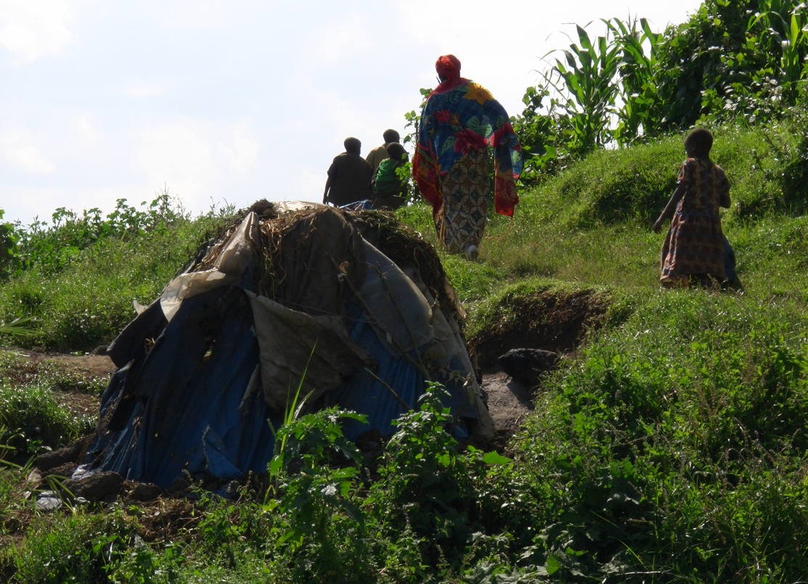

Batwa housing, lower slopes of Muhabura volcano, UNPO field visit, December 4, 2010.

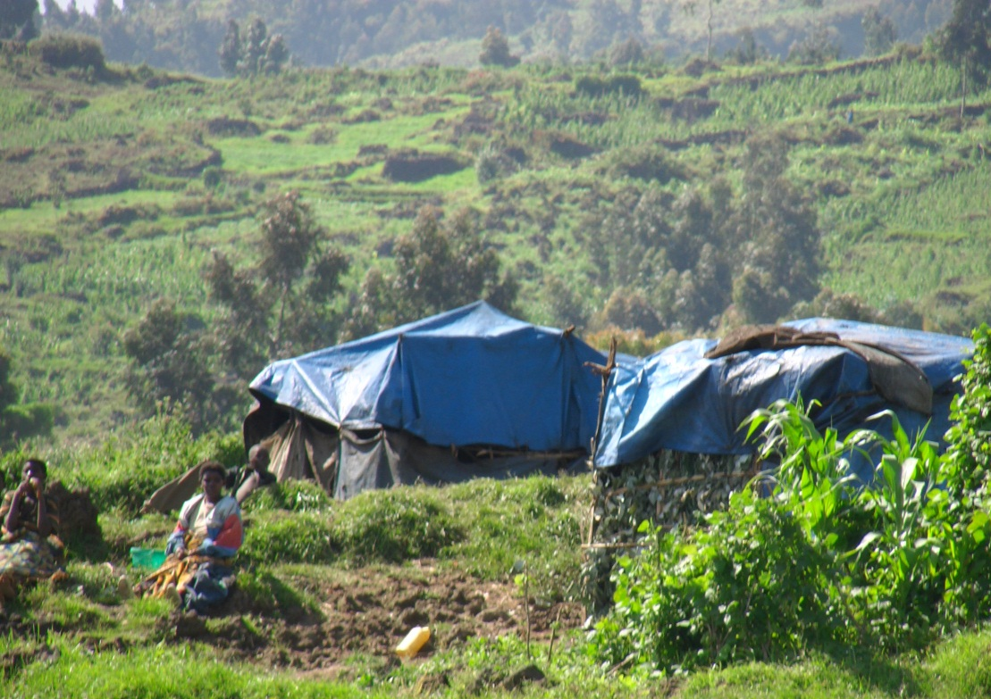

Various government policies have emerged as a result of international pressure and the desire to meet the Millennium Development Goals. However, those have had largely negative impacts on the Batwa, leaving many in worse situations than before and frequently homeless. One example is the “Umudugudu” policy, aimed at relocating people from their rural homes and into villages in order to open up their land for agricultural use and other economic activities and to give them access to infrastructure and better housing. Despite the claims in section 162 of the State report that laws are in place to protect people from forced evictions, many Batwa have been forcefully removed from their homes and their living conditions have not improved after relocation.

The government policy promises a better standard of living, including free land, houses and infrastructure. In reality there is a huge lack of adequate sanitation, land has to be purchased and fees paid to have access to infrastructure. The policy imposes further financial strains on already poor families, and relocation often takes their livelihoods away, since there is often no access to clay and firewood for pottery in new locations.

Forced relocations further resulted from another government policy. As of December 2010, widespread dismantling of thatched homes has taken place across Rwanda, conducted by local authorities as part of a program entitled “Bye-Bye Nyakatsi”. The argument for this policy is that all Rwandese have to live in modern houses to contribute to the success of Rwanda’s Vision 2020 strategy. The government had set May 2011 as the deadline for the elimination of all thatched homes in the country, which number more than 78,000. In theory able-bodied poor are given iron sheets to replace the thatch and the elderly, widows and sick should be designated new homes. In praxis this is rarely the case and thousands have been left homeless. The Southern Province is said to have had 33,000 thatched huts in November 2010 but by January 21 2011, only 3000 remained. This policy disproportionately affects the Batwa.

Current statistics are not available but in 2004 more than 46%, i.e. around 4500 Batwa families lived in grass huts. Musa Ngary Bitaye, commissioner from the African Comission of Human and Peoples Rights noted 734 Batwa families; comprising 2,936 people had been dislodged by mid-January 2011. The vast majority remains without shelter since they lack financial resources to build new houses. Musa Ngary Bitaye further underlined that many of those are left without enough food or blankets, hence exposed to multiple diseases and health problems. Victims have described their situation as catastrophic, resembling that of refugees.

In defense of this tactic Governor of the Southern Province Mr. Fidel Ndayisaba declared at a press conference on January 21 2011 that residents of Nyakatsi houses required such pressure from authorities in order to take action: “People were seemingly happy to stay in their thatched houses and showed no commitment to leave them. But when such houses are demolished, people who have means are encouraged to look for appropriate accommodation in a short period of time while those who have no means are identified and get help. It is really a good strategy of accelerating the anti-Nyakatsi drive because when people are temporary accommodated by their neighbors or paying for rent, they quickly build their own houses”.

Although the Constitution of Rwanda states that “The right to property may not be interfered with except in public interest, in circumstances and procedures determined by law and subject to fair and prior compensation,” the government of Rwanda, whether through badly implemented procedures or rogue local authority employees, is violating the principle of fair and prior compensation for many thousands of families.

In order to improve those housing policies beneficiaries should be consulted and involved in policymaking. Transparency in implementation should be increased and care taken that relocations are always voluntary and human rights respected.

Article 12 Right to health

Article 12.1 states that “The States Parties to the present Covenant recognize the right of everyone to the enjoyment of the highest attainable standard of physical and mental health.”

Article 12.2 states that “The steps to be taken by the States Parties to the present Covenant to achieve the full realization of this right shall include those necessary for:
(a) The provision for the reduction of the stillbirth-rate and of infant mortality and for the healthy development of the child;
(b) The improvement of all aspects of environmental and industrial hygiene;
(c) The prevention, treatment and control of epidemic, endemic, occupational and other diseases;
(d) The creation of conditions which would assure to all medical service and medical attention in the event of sickness.”

The Batwa have the highest incidences of poverty and lowest access to social services of all Rwandans. This is very much reflected on their access to health services. Batwa communities do not have access to healthcare facilities for several reasons. First, even those for whom health insurance has been provided by government or NGO structures, the remaining 10% of the costs of healthcare or medicine sought remains beyond reach of this impoverished community. Second, healthcare facilities are distributed unevenly and often far away from Batwa communities or difficult to access because of the Batwa’s semi-nomadic lifestyle.

In addition, as was noted in the report submitted to the Senate in July 2007 by a Commission in charge of Social Affairs, Human Rights and Social Issues “government structures do not sensitize [the Batwa] enough about resorting to healthcare services”. Finally, as mentioned in the report to the Senate, Batwa are often reluctant to use these public services. The report argues that this is because “they do not wash their body, and they have no clothes or shoes to put on”. It can be assumed therefore that the Batwa are not made welcome in these health facilities, regardless of their need or ability to pay. Anecdotes related to UNPO in December 2010 suggested that doctors and nurses may refuse to see Batwa patients, or make derogatory or contemptuous comments about them, their clothes or appearance, which goes unpunished.

This exclusion from the modern healthcare system is reflected in statistics showing that the population of the Batwa is declining, while the population growth rate in Rwandan society has increased dramatically in the past years. The reason for this occurrence is mostly due to a large drop in child mortality, except in the Batwa population. However, the lack of disaggregated data makes targeted measures to deal with specific cases of Batwa ill health and infant and child mortality exceptionally difficult.

Additionally to this exclusion from the modern health care system, the Batwa situation has worsened as a result of relocations and land confiscation. In the past, the Batwa used their traditional knowledge to source herbs, plants and other medicinal elements that they used for everyday ailments. Indigenous knowledge is being lost at a fast pace because land and environmental policies prohibit access to some of the most fertile areas where they gathered their traditional medicines.

Article 13 Right to education

Article 13.2 states that “The States Parties to the present Covenant recognize that, with a view to achieving the full realization of this right:
(a) Primary education shall be compulsory and available free to all;
(b) Secondary education in its different forms, including technical and vocational secondary education, shall be made generally available and accessible to all by every appropriate means, and in particular by the progressive introduction of free education;
(c) Higher education shall be made equally accessible to all, on the basis of capacity, by every appropriate means, and in particular by the progressive introduction of free education;
(d) Fundamental education shall be encouraged or intensified as far as possible for those persons who have not received or completed the whole period of their primary education;
(e) The development of a system of schools at all levels shall be actively pursued, an adequate fellowship system shall be established, and the material conditions of teaching staff shall be continuously improved.”

As outlined in Rwanda’s report to the ICESCR Committee, primary education in Rwanda is free of charge and secondary education partially free (sections 271-4). Furthermore the report argues in section 297 that children of low-income families are allowed to study free of charge and receive further assistance from the State. In the case of the Batwa, however, no evidence of such assistance exists, making it difficult for Batwa children to attend school. Still, the Batwa’s educational level remains the lowest and dropout rate the highest in Rwanda. According to the survey conducted by CAURWA (now COPORWA) in 2004, only 34% Batwa had attended school, less than 1% secondary school and no one had completed higher education. Illiteracy and lack of other skills have prevented the Batwa from finding work, escaping poverty and improving their situation.

There are a number of reasons for the Batwa not to attend or drop out of school, but most of them revolve around poverty. The waiving of tuition fee by the government is insufficient if it does not follow assistance to Batwa children, because parents usually lack money to buy school uniforms or any kind of clothes or school stationary for their children, or even to pack lunch for them. Many children are malnourished and in poor health, hence can hardly compete with others academically. Many children do not attend schools since food scarcity causes them to abandon their parents and beg on the street. This is especially the case in urban centers where children frequently start begging at the age of four or five. In rural settings access to schools is often difficult because of the remote location of Batwa communities and the lack of transportation and infrastructure. As described above however, the government’s reaction to this problem in form of resettlement schemes has had a negative impact on the Batwa.

Another factor preventing the Batwa from completing education is widespread discrimination. Batwa school children often hide their ethnicity, for fear of harassment by fellow students and teachers. Many do not attend school as a result of harassment. Their severe state of impoverishment and status as a Mutwa means their clothing, footwear or level of hygiene is deemed insufficient or inadequate by teachers. Mutwa or Batwa is a common insult directed at an individual who is lazy, late or unclean. Mr. Elias Hajara, the chairman of Batwa Communities in Echuya Forest Reserve, confirmed this, stating that “although different civil society organizations have tried to empower Batwa children by giving them scholastic materials, discrimination and harassment has made it difficult for them to study well.” Since 2003 the Organic Law No. 20/2003 prohibits discrimination in education; however, there is significant lack of enforcement of this law.

Section D: Recommendations

- Ensure full representation of the Batwa in government and other public institutions.
- Create a national institution for the protection and promotion of the Batwa. Define the number of Senate seats specifically assigned to the Batwa. Allow elections for this position which would be conducted by the newly created national institution.
- Consult the Batwa before taking any measures that may affect their lives.
- Allow the Batwa to identify as a group and form organizations using their own means of identification, which can specifically target Batwa communities for poverty reduction projects, cultural preservation initiatives and community learning schemes.
- Offer training and support to Batwa community organizations to increase their capacity to defend their rights.
- Ensure that data collected about distribution of materials and management of poverty reduction projects is disaggregated along ethnic lines to ensure that Batwa communities are not the target of racial discrimination.
- Ensure accountability in local government to ensure the Batwa are not being sidelined from poverty reduction strategies intentionally or otherwise by local officials.
- Combat discrimination against the Batwa in education system, media and government institutions, as well as by establishing awareness raising campaigns to combat racist stereotypes.
- Cease the destruction of homes immediately until residents are consulted, compensated and provided with new housing. Allow residents to provide input on the program, and allow them the legal recourse to challenge the decision to modify their home or to be relocated.
- Distribute land to the Batwa as a landless group under Article 87 of the Land law. The government, along with Batwa communities, should use participatory and transparent methods to comprehensively ‘map’ the historic dispossession of the Batwa from their lands and devise appropriate and equitable remedies.
- Modify property laws to respect collective rights, especially access to forests and wetlands.
- Clearly demarcate, register and monitor the land, to ensure that the Batwa are not dispossessed.
- Compensate adequately the victims of land evictions. Land allocated to the Batwa must be of good quality, with effective access to water and, where appropriate, to clay, forest resources or lakes.
- Involve the Batwa communities in forest conservation projects in traditional Batwa areas. Consultations with each Batwa community are needed to establish their specific needs in relation to forest and land in a project area. Whenever possible measures should be taken to enable Batwa who wish to do so to maintain their traditional culture while being involved in the conservation of their traditional areas.
- Create a fund specific to the Batwa to facilitate access to justice and implement community-based outreach programs to improve understanding of their legal rights.

- Adopt measures to address the severe poverty of the Batwa caused by the government resettlement policy, including the provision of vocational training and micro-finance schemes.
- Offer skills trainings and literacy courses to Batwa and make existing programs available to them.
- Increase access to health care facilities and combat discrimination against the Batwa in social services.
- Make healthcare free of charge for the most impoverished and vulnerable groups. Follow hereby the strategy Burundi has taken and start by supplying free healthcare to pregnant women and young children.
- Create a dedicated grant system for Batwa students, as is already in place for other vulnerable groups for primary, secondary, tertiary and vocational education which will include provisions for uniforms, equipment and basic necessities.
- Construct schools closer to the Batwa communities and develop a curriculum adapted to their way of life.

http://www.achpr.org/files/sessions/47th/mission-reports/rwanda/achpr47_misrep_specmec_indpop_rwanda_2008_eng.pdf
http://www.iwgia.org/images/stories/sections/regions/africa/documents/IW2011/rwanda_the_indigenous_world-2011.pdf
African Commission’s Working Group On Indigenous Populations/Communities (2010). Report Of The African Commission’s Working Group On Indigenous Populations/Communities: Mission To The Republic Of Rwanda 1 – 5 December 2008. Banjul, The Gambia. p. 8.
International Work Group for Indigenous Affairs. Indigenous peoples in Rwanda, 2011, retrieved from: http://www.iwgia.org/regions/africa/rwanda.
African Commission on Human and Peoples’ Rights (2005). Eighth Periodical Report Of Rwanda To The African Commission On Human And Peoples’ Rights 2002-2004. p. 42.
MINALOC, National Social Protection Strategy (draft) (2010). Pg 12: “The challenge of high poverty levels is exacerbated by rising and high levels of inequality. Inequality as measured by the Gini co -efficient rose from 0.47 in 2000 to 0.51 in 2006.6 To put this in perspective, a Gini co-efficient of 0.40 is regarded as high inequality”.
UNPO (1995). UNPO Mission Report, Investigating the situation of the Batwa People of Rwanda. The Hague, The Netherlands, p. 10.
Republic of Rwanda, Ministry of Justice (2009). “The 9th & 10th Periodic report Of The Republic Of Rwanda Under The African Charter On Human And Peoples’ Rights”. p. 14.
African Commission’s Working Group On Indigenous Populations/Communities (2010). Report Of The African Commission’s Working Group On Indigenous Populations/Communities: Mission To The Republic Of Rwanda 1 – 5 December 2008. Banjul, Gambia. p. 19.
International Work Group for Indigenous Affairs, Indigenous peoples in Rwanda, 2011, retrieved from: http://www.iwgia.org/regions/africa/rwanda.
Minority Rights Group International (2000). The Batwa Pygmies of the Great Lakes Region. London, UK. p. 26.
UNPO (1995). UNPO Mission Report, Investigating the situation of the Batwa People of Rwanda. The Hague, The Netherlands, p. 41.
Society for Threatened Peoples, Written Statement on Rwanda, Right to Adequate Housing. The Destruction of Batwa houses in Rwanda, 2011, retrieved from: http://www.gfbv.de/inhaltsDok.php?id=2143.
Minority Rights Group International (2000). The Batwa Pygmies of the Great Lakes Region. London, UK. p. 26.
Aleternative Report of the Civil society on the Universal Periodic Review of Rwanda, 2011, retrieved from: http://lib.ohchr.org/HRBodies/UPR/Documents/Session10/RW/JS1_JointSubmission1_eng.pdf
An example is a whole Batwa family being imprisoned for five days because of launching a complaint against being evicted from their land. Forest Peoples Program. The Rights of Indigenous Peoples in Rwanda, October 2006, retrieved from: http://www.forestpeoples.org/sites/fpp/files/publication/2010/08/rwandahrcrepoct06eng.pdf
UNCHR. The Batwa Pygmies of the Great Lakes Region, June 2000, retrieved from: http://www.unhcr.org/refworld/pdfid/469cbf89d.pdf.
IWGIA – The Indigenous World, Rwanda, 2011, retrieved from: http://www.iwgia.org/images/stories/sections/regions/africa/documents/IW2011/rwanda_the_indigenous_world-2011.pdf
African Commission’s Working Group On Indigenous Populations/Communities, 2010, Report Of The African Commission’s Working Group On Indigenous Populations/Communities: Mission To The Republic Of Rwanda 1 – 5 December 2008. Banjul, Gambia. pp. 38-9.
Minority Rights Group International, 2000, The Batwa Pygmies of the Great Lakes Region. London, UK. p. 6.
African Commission’s Working Group On Indigenous Populations/Communities (2010). Report Of The African Commission’s Working Group On Indigenous Populations/ Communities: Mission To The Republic Of Rwanda 1 – 5 December 2008. Banjul, Gambia. pp. 38-9. Retrieved from: http://www.achpr.org/files/sessions/47th/mission-reports/rwanda/achpr47_misrep_specmec_indpop_rwanda_2008_eng.pdf
UNPO (1995). UNPO Mission Report, Investigating the situation of the Batwa People of Rwanda. The Hague, The Netherlands, pp. 8-9.
UNCHR. The Batwa Pygmies of the Great Lakes Region, June 2000, retrieved from: http://www.unhcr.org/refworld/pdfid/469cbf89d.pdf.
UNPO Alternative Report - Rwanda CERD/C/RWA/13-17
Minority Rights Group International (2000). The Batwa Pygmies of the Great Lakes Region. London, UK. p. 26.
African Commission’s Working Group On Indigenous Populations/Communities (2010). Report Of The African Commission’s Working Group On Indigenous Populations/Communities: Mission To The Republic Of Rwanda 1 – 5 December 2008. Banjul, Gambia. p. 31.
The one-cow-per-poor-family policy requires that the receiving family have 0.7 hectares of land on which to feed the cow. Evidently, the poorest families lack even that provision and as such are rendered ineligible.
Other instances reported to UNPO include cows intended for Batwa families who do have the means that have been appropriated by local authority staff.
Daily Monitor, Discrimination forces Batwa out of school, 2010, retrieved from: http://www.monitor.co.ug/News/National/-/688334/929040/-/x0a6cn/-/.
African Commission’s Working Group On Indigenous Populations/Communities (2010). Report Of The African Commission’s Working Group On Indigenous Populations/Communities: Mission To The Republic Of Rwanda 1 – 5 December 2008. Banjul, Gambia. pp. 46-7.
Minority Rights Group International, Rwanda’s forgotten people, 2012, retrieved from: http://uk.oneworld.net/article/view/136415/1/2280.
E.g. out of 36 families relocated to the Kanombe village in 2007 only 7 were given government houses.
African Commission’s Working Group On Indigenous Populations/Communities (2010). Report Of The African Commission’s Working Group On Indigenous Populations/Communities: Mission To The Republic Of Rwanda 1 – 5 December 2008. Banjul, Gambia, pp.37-8.
The New Times, Rwanda: Eradication of Nyakatsi Intensifies, (January 21 2011), Web. <http://www.newtimes.co.rw/index.php?issue=14512&article=37623>
International Work Group for Indigenous Affairs (2011). Indigenous peoples in Rwanda Web. <http://www.iwgia.org/regions/africa/rwanda> Accessed 21st September 2012.
Musa Ngary Bitaye, Activities as Commissioner, May 2011, retrieved from: http://www.achpr.org/sessions/49th/intersession-activity-reports/musa-ngary-bitaye/
Survival for Tribal Peoples, Rwanda admits force used in anti-thatch campaign, 2011, retrieved from http://www.survivalinternational.org/news/7303.
43 The New Times, Southern Province Intensifies Nyakatsi Eradication, January 2011, retrieved from: http://www.newtimes.co.rw/index.php?issue=14515&article=37687
Commission in charge of Social Affairs (2007). Human Rights and Social Issues: Report on the Living Conditions of Some Rwandans Disadvantaged Throughout History.
African Commission’s Working Group On Indigenous Populations/Communities (2010). Report Of The African Commission’s Working Group On Indigenous Populations/Communities: Mission To The Republic Of Rwanda 1 – 5 December 2008. Banjul, Gambia. p. 48.
Idem, pp. 46-7.
International Work Group for Indigenous Affairs. Indigenous peoples in Rwanda, retrieved from: http://www.iwgia.org/regions/africa/rwanda
Minority Rights Group International (2000). The Batwa Pygmies of the Great Lakes Region. London, UK, p. 10.
Daily Monitor. Discrimination forces Batwa out of school, 2010, retrieved from: http://www.monitor.co.ug/News/National/-/688334/929040/-/x0a6cn/-/

