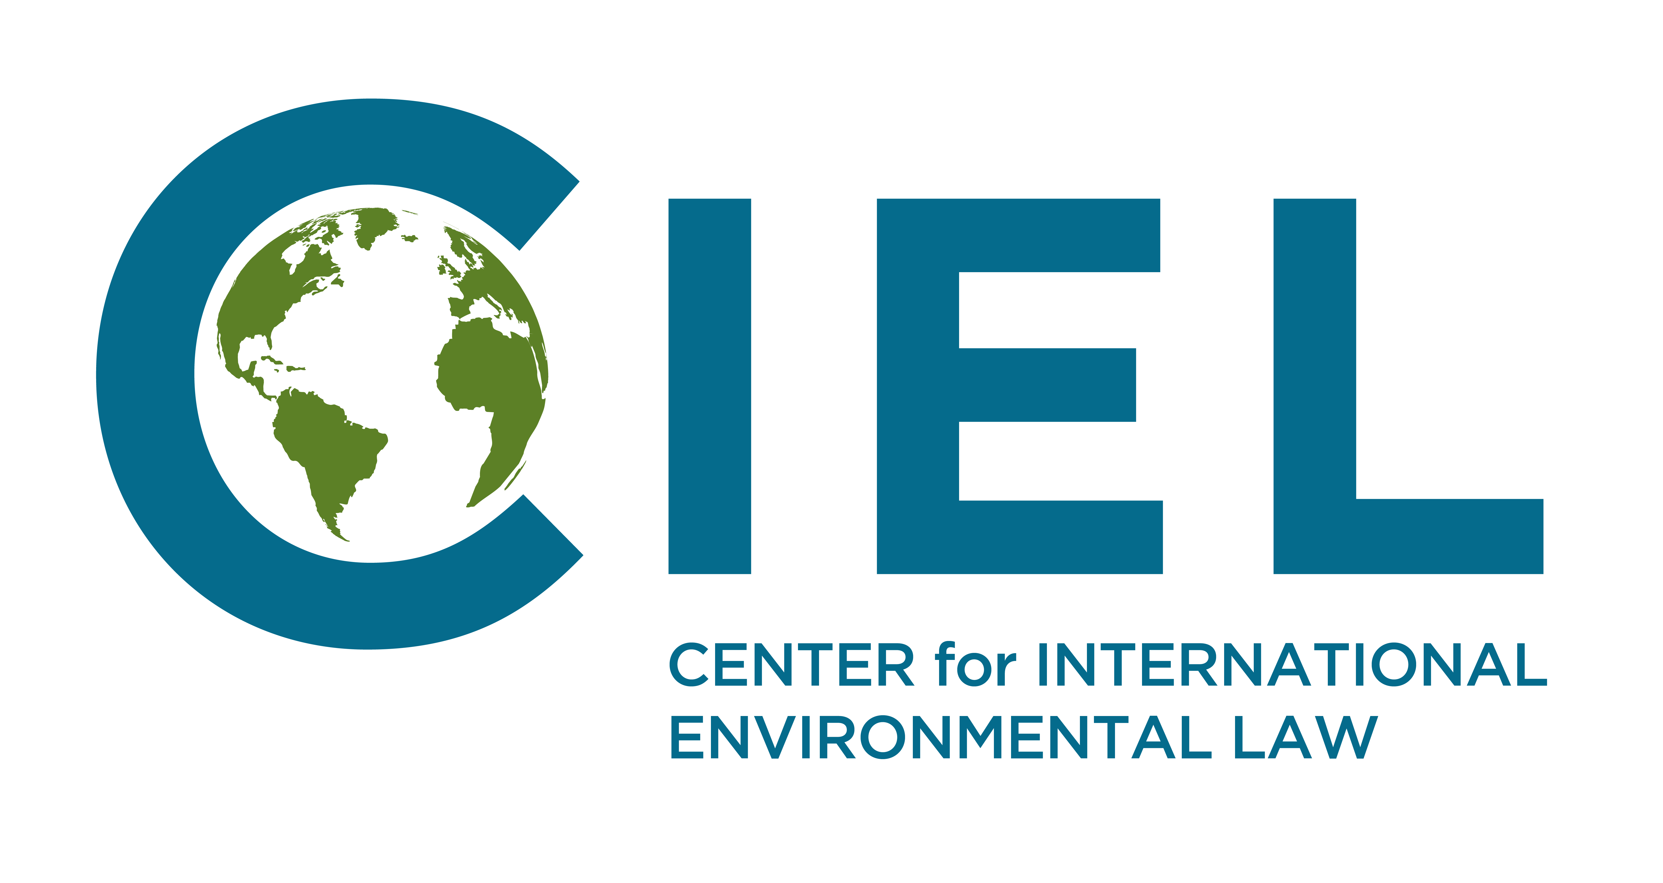
Briefing Note to the Committee on Economic, Social and Cultural Rights, prior to the adoption of the List of Issues Prior to Reporting

Belgium’s climate mitigation and air pollution efforts and its obligations under the International Covenant on Economic, Social and Cultural Rights.

Belgium’s current climate policies are not compatible with recommendations made by climate scientists and therefore contribute to dangerous climate change and its adverse impacts on economic, social and cultural rights in Belgium and extraterritorially. Similarly, Belgium has failed to implement adequate measures to reduce atmospheric pollution so as to prevent adverse impacts on human health as required under article 12.2 of the Covenant.
In this context, we encourage the Task Force to request that Belgium:
- provides information regarding the adequacy of national climate mitigation objectives, policies implemented to reduce domestic greenhouse gas emissions, including in the transport sector, as well as long-term planning to mitigate climate change so as to meet the duty of the State Party to mitigate the adverse effects of climate change in Belgium and abroad,
- also describes the policies and measures adopted to reduce atmospheric pollution, particularly in relation to the transportation sector, in order to protect human health in Belgium and in neighboring countries.

Climate Change

Climate Change Impacts on Economic, Social and Cultural Rights

Under the ICESCR, states have an obligation to progressively realize the “equal right of men and women to the enjoyment of all economic, social and cultural rights.” However, the impacts of climate change on populations around the world pose a significant barrier towards the realization of these human rights. Climate change has the capacity to impair, for example the right to culture and development (article 1), food, water, housing and sanitation (article 11), and health (article 12). If allowed to occur, these impacts will fall disproportionately on disadvantaged and vulnerable populations. The Belgian Government’s own adaptation strategy recognizes the vulnerability of the country’s population to health impacts by increased heat and heat waves and vector born diseases as well as economic losses due to sea level rise and increased extreme weather events and the potential for water shortages.
The foreseeable effects of climate change on human rights give rise to duties upon states to pursue mitigation and adaptation measures to prevent them. CESCR has recognised that the impacts of climate change on the realisation of economic, social and cultural rights gives rise to consequent obligations on polluting states to reduce emissions and has urged States to take measures to mitigate and adapt to climate change.
Faced with a developed country with similarly insufficient climate policies, CESCR for instance recommended in 2017 to Australia that meeting their obligations required an intensification of efforts to reduce greenhouse gas emissions.

Current Policy Efforts

Through its ratification of the Paris Agreement, Belgium has committed to collective efforts aiming at keeping the increase of global temperature well below 2ºC and at striving to prevent warming above 1.5ºC. Belgium has however failed to adopt emissions reduction targets in line with these objectives. Whereas the Intergovernmental Panel on Climate Change (IPCC) suggested in its fourth Assessment Report that in order to meet such targets developed countries would need to reduce their emissions by 25%-40% in 2020 compared to 1990, Belgium has only committed to reduce its emissions by 15% by 2020. Such a level of emission reduction therefore exceeds levels of emissions recommended by the international scientific consensus and is therefore insufficient to meet its obligations. The Hague Court of Appeal for instance ruled on 9. October 2018 that the human rights obligations of the Netherlands required that the States adopts and implements measures that are at least consistent with the emission reductions range suggested by the IPCC.
Additionally, Belgium is not on track to even meet these insufficient commitments. According to the European Environmental Agency progress report in 2017, Belgium was one of only four EU Member States with emissions of greenhouse gases higher than its annual target in relation to economic sectors not covered under the EU Emissions Trading System, such as transport, buildings, agriculture and waste. One of the main drivers of emissions growth in Belgium has come from the Transport sector, jumping from 14.1 % of total GHG emissions in 1990 to 22.6 % in 2015. Looking forward and considering the policies currently implemented, the EEA also projects that Belgium is among the small minority of EU member states the policies of which will not be sufficient to meet the 2020 emissions reductions targets in these sectors. Belgium is also among three EU member states that is not on track to meet its energy efficiency objectives for 2020.
Finally, Belgium has also failed to make progress with the development of a long term low carbon development strategy that would enable the country to set in place a framework to enable the full decarbonisation of its economy. Considering the magnitude of the economic and societal restructuring required toachieve science-based emissions of greenhouse gases reductions, governments must develop long-term and comprehensive climate policies to set a framework directing all actors under their jurisdiction to contribute to the progressive decarbonization of the society. Through the Paris Agreement, all governments have explicitly committed to “formulate and communicate long-term low greenhouse gas emission development strategies, mindful of Article 2”. Belgium has however yet to begin the process of developing such a long-term vision for its energy and climate policies.

Atmospheric Pollution

A second issue associated with environmental policy in Belgium relates to the inadequacy of measures implemented to curb atmospheric pollution and their impact on the enjoyment of the right to health of people in Belgium and in neighboring countries. Article 12.1 of the Covenant provides that “the States Parties to the present Covenant recognize the right of everyone to the enjoyment of the highest attainable standard of physical and mental health”. Article 12.2(b) also provides that “the steps to be taken by the States Parties to the present Covenant to achieve the full realization of this right shall include those necessary for: (b) the improvement of all aspects of environmental and industrial hygiene.”

Through its General Comment 14, the Committee clarified that “the improvement of all aspects of environmental and industrial hygiene comprises, inter alia, (…) the prevention and reduction of the population’s exposure to harmful substances such as radiation and harmful chemicals or other detrimental environmental conditions that directly or indirectly impact upon human health”. CESCR has also held that in order to comply with obligations under the covenant, states must “implement [...] and monitor [...] measures to mitigate environmental pollution”.

A study by the Yale Centre for Environmental Law and Policy ranked Belgium as having the worst air quality in the EU. This has resulted from an increase in atmospheric pollution resulting from vehicle exhaust, a situation worsened by the increase in recent years of the share of diesel vehicles. Diesel engines generate higher rate of pollutants than other types of vehicles. These engines emits significant amount of NO₂ which has particularly adverse impacts for human health. According to the world Health Organization, symptoms of bronchitis in asthmatic children increase in association with long-term exposure to NO_{2.} According to the European Environmental Agency, people in Belgium are among those most exposed in the EU to NO₂ relative to the size of the population. Another hazardous component of air pollution from transport emissions is very fine particulate matter (PM 2.5). Belgium is ranked 120th in the world for exposure to PM 2.5. The health effects of these and other pollutants in Belgian air are a significant barrier to the realization of the right to health.
Belgium’s air pollution policies are furthermore insufficient. The national government has promoted the use of diesel through tax concessions on diesel cars and diesel fuel. While the Brussels Regional Government is introducing a low emissions zone in Brussels, this will have little effect on the cities air pollution as it is only likely to impact 9% of vehicles in the city. Belgium is furthermore required to comply with EU air quality legislation. However, it has consistently failed to comply with the legislated air quality targets. These standards are already less stringent for some pollutants than World Health Organisation Air Quality Guidelines recommend. Without improved air pollution controls, Belgium’s poor air quality will continue to frustrate the full realisation of the right to health in the country. Belgium must therefore increase its efforts to reduce air pollution in order to comply with its obligations under the covenant, particularly article 12.

International Covenant on Economic, Social and Cultural Rights, article 4.
A/HRC/32/23, (Human Rights Council, 2016), paragraph 4.
IPCC Special Report on Global Warming by 1.5c, Summary for Policymakers, finding B 5.1
Belgian National Climate Adaptation Strategy (Federal Government of Belgium, 2010), <https://www.klimaat.be/files/6913/8262/2075/NASpublicatiedruk.pdf>
A/HRC/31/52, (Human Rights Council, 2016), paragraph 33.
E/C.12/AUS/CO/4 (CESCR, 2009)
E/C.12/AUS/CO/4 (CESCR, 2009), E/C.12/AUS/CO/5 (CESCR, 2017), paragraph 12
Paris Agreement on Climate Change (2015), article 2.1(a)
Gupta S./Tirpak D.A./Burger N./Gupta J./Höhne N./Boncheva A.I./Kanoan M./Kolstad C./Kruger A./Michaelowa A./Murase S./Pershing J./Saijo T./Sari A., Policies, Instruments and Co-operative Arrangements. In Climate Change 2007: Mitigation, Cambridge and New York, p. 776 box 13.7.
The Hague Court of Appeal, Ruling Of 9 October 2018, The State Of The Netherlands Vs. Urgenda Foundation, English translation of the ruling available at: https://uitspraken.rechtspraak.nl/inziendocument?id=ECLI:NL:GHDHA:2018:2610
Trends and projections in Europe 2017 (European Environmental Agency, 2017), paragraph 18.
7th National Communication to the UN Framework Convention on Climate Change (Government of Belgium, 2018), paragraph 36.
Ibid, paragraph 27.
Ibid, paragraph 18.
Paris Agreement on Climate Change (2015), article 4.19.
CESCR, General Comment 14 on the right to the highest attainable standard of health (2000), E/C.12/2000/4, at 15.
E/C.12/CHN/CO/2 (CESCR, 2014)
Environmental Performance Index, Belgium (Yale Centre for Environmental Law & Policy, 2018) <https://epi.envirocenter.yale.edu/epi-country-report/BEL>
Ambient (outdoor) air quality and health, (World Health Organization, 2018) http://www.who.int/news-room/fact-sheets/detail/ambient-(outdoor)-air-quality-and-health
Air quality in Europe (European Environmental Agency, 2017), paragraph 58.
Environmental Performance Index, Belgium (Yale Centre for Environmental Law & Policy, 2018) <https://epi.envirocenter.yale.edu/epi-country-report/BEL>
General comment No. 4: The right to adequate housing (CESCR, 1992); General Comment No. 14 The right to the highest attainable standard of health (CESCR, 2000), paragraph 51.
EU workers’ green revolt over Brussels (Simon Marks, Joshua Posaner and Marion Solletty, 2017) <https://www.politico.eu/article/eu-employees-rise-up-against-toxic-air-pollution-emissions-health-air-quality/>
New air quality data show Brussels fails to take air pollution seriously (Client Earth, 2017), <https://www.clientearth.org/new-air-quality-data-show-brussels-fails-take-air-pollution-seriously/>
Ibid
Air pollution: Our health still insufficiently protected (European Court of Auditors, 2018), para 85

