THEMATIC REPORT ON FAMILY LAW AND
MUSLIM WOMEN’S RIGHTS IN

THE GAMBIA

83rd CEDAW Session

October 2022

SUBMITTED BY:
  Women’s Association for Victims’ Empowerment  4 Kembujeh Ville  Off Manjai Highway, near Manjai Police Station  Kanifing Municipal Council  The Gambia  Tel: (+220) 717 9684; (+220) 722 0497  Twitter/FB: @wave-gambia  Website: www.wave-gambia.org | ​​  Think Young Women – Gambia (TYW)  56 Mamamdi Manjang Highway,  Second Floor, Red Cross House,  West Field,  The Gambia  Tel No: (00220) 3934389, 2662128, 7900080  Email: thinkyoungwomen@gmail.com  Website: www.thinkyoungwomen.org
  Child Protection Alliance  Former SOS National Coordination Office  Bakoteh , Kanifing Municipality, P.O. Box 4672  The Gambia  Email: cpagambia@yahoo.com  Website: www.cpagambia.gm | 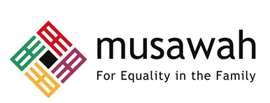  Musawah  15, Jalan Limau Purut, Bangsar Park, 59000 Kuala Lumpur, Malaysia  Tel: +603 2083 0202 Fax: +603 2202 0303  Email: musawah@musawah.org  Web: www.musawah.org

Table of Contents

A. INTRODUCTION 3
B. BACKGROUND AND LEGAL FRAMEWORK 3
C. KEY ISSUES AND RECOMMENDATIONS 4
1. Spousal Equality in the Law, Articles 2, 16 4
2. Child Marriage, Article 16 5
3. Violence Against Women, Articles 11-5, 16 & 19, & GR35 6
4. Polygamy, Article 16 8
5. Inheritance, Article 16 10

A. INTRODUCTION
Musawah, the global movement for equality and justice in the Muslim family, Child Protection Alliance Gambia, Women’s Association for Victims’ Empowerment, and Think Young Women Gambia jointly submit this Thematic Report on concerns related to Muslim women’s legal equality in personal status matters, violence against women, and nationality rights for consideration by the CEDAW Committee in its review of the Government of the Gambia, reporting before the 83rd Session of the CEDAW Committee in October 2022. This is the CEDAW Committee’s sixth periodic engagement with the Gambia. Its last full review was in 2015. The Gambia acceded to CEDAW in April 1993 without any reservations.
This report highlights key legal inequalities that Muslim women face in the Gambia in the personal status sphere and their resulting negative impact on women and girls, along with recommendations to address gaps. We encourage the Gambian government to continue its efforts in eliminating discrimination against women, particularly in the following areas, discussed in detail subsequently:
- Spousal Equality in the Law
- Child Marriage
- Violence Against Women (FGM, Marital Rape, VAW in Covid-19)
- Polygamy
- Inheritance
We hope that the CEDAW Committee will utilize this report as a key resource during its constructive engagement with the State Party and use the recommendations to identify follow-up issues in its Concluding Observations.

B. BACKGROUND AND LEGAL FRAMEWORK

The Republic of the Gambia, situated in West Africa, has a total population of 2.2 million, of which approximately 95.7 percent is Muslim. Most of the Muslims are Sunni, with a small Ahmadi Muslim population.

The Constitution of the Gambia, 1997 is the basic law of the land, the Preamble of which highlights that “the fundamental rights and freedoms enshrined in the Constitution will ensure full respect for and observance of human rights of the people at all times without discrimination based on…gender…” Chapter IV of the Constitution contains provisions which safeguard the fundamental rights of persons. Under this chapter, Section 28 stipulates that women shall be accorded “full and equal dignity of the person with men”, as well as “the right to equal treatment with men, including equal opportunities in political, economic and social activities.”

Section 7 of the Constitution provides that the laws of the Gambia consist of, among others, customary law, so far as it concerns members of the communities to which it applies. The same provision provides for the application of Sharia law as regards matters of marriage, divorce and inheritance among Muslims.

Safeguards against the discrimination of women are also provided for in Section 33(2) of the Constitution, which states that “no law shall make any provision which is discriminatory either of itself or in effect.” However, these safeguards against discrimination are not applicable to Section 33(5), according to which matters of marriage, divorce, and inheritance are usually decided in accordance with Sharia and customary laws through their respective court systems, regardless of any discrimination in such laws. Sharia and customary courts determine an estimated 90 percent of such cases, hence impacting the majority of women in the Gambia. Even where women seek recourse to regular courts, the relevant discriminatory provisions of customary law still apply as a constitutionally guaranteed source of law under Section 7.

The Constitution specifies the Cadi Court as having jurisdiction to apply the Sharia in matters of marriage, divorce and inheritance where the parties or other persons interested are Muslims. Practices and procedures before the sharia courts and district tribunals are regulated by the Cadi Court (Civil Procedure) Rules 2010 and The Cadi Appeals Panel Rules 2009, respectively. This leaves room for an arbitrary and discriminatory application of customary law and sharia law, particularly as it relates to matters of procedure, evidence and substance.

C. KEY ISSUES AND RECOMMENDATIONS

Spousal Equality in the Law Articles 2, 16

As discussed before, Section 33(5) of the Constitution provides that the prohibition of discrimination does not apply in respect of adoption, marriage, divorce, burial and devolution of property upon death, since these matters are to be decided in accordance with Sharia and customary laws. These issues are regulated by personal law, which contains discriminatory provisions, some of which are re-enacted in the Women’s Act 2010. These issues are also subject to the Cadi courts’ interpretation of Sharia law, which is often discriminatory in nature towards women. It was only in 2022 that the Gambian judiciary appointed the first ever two female Cadis for the Sharia court, before which all appointed Cadis were men. Hence, Section 33(5) is inconsistent with international standards on women’s equal right to marriage, inheritance and divorce for Muslim women, and must be repealed.

Moreover, Section 27 of the Constitution states that “men and women of full age and capacity shall have the right to marry and found a family”, and provides that “marriage shall be based on the free and full consent of the intended parties”. The Section, however, does not protect a woman’s right to equality with the man in the marriage or at its dissolution, or any other rights protected under the Maputo Protocol or CEDAW, due to which it should be also be amended to include a provision on matrimonial equality. This would serve as a resource for women whose rights to matrimonial equality are violated through reliance on personal law.

Muslim women are also often denied equal rights in matters of marriage, divorce and inheritance, even where these rights are protected by law. Added to this, women generally do not have adequate knowledge of their rights or of institutions created to protect and promote these rights. Other limitations include lack of institutional capacity, inadequate monitoring, budgetary constraints and widespread illiteracy among women.

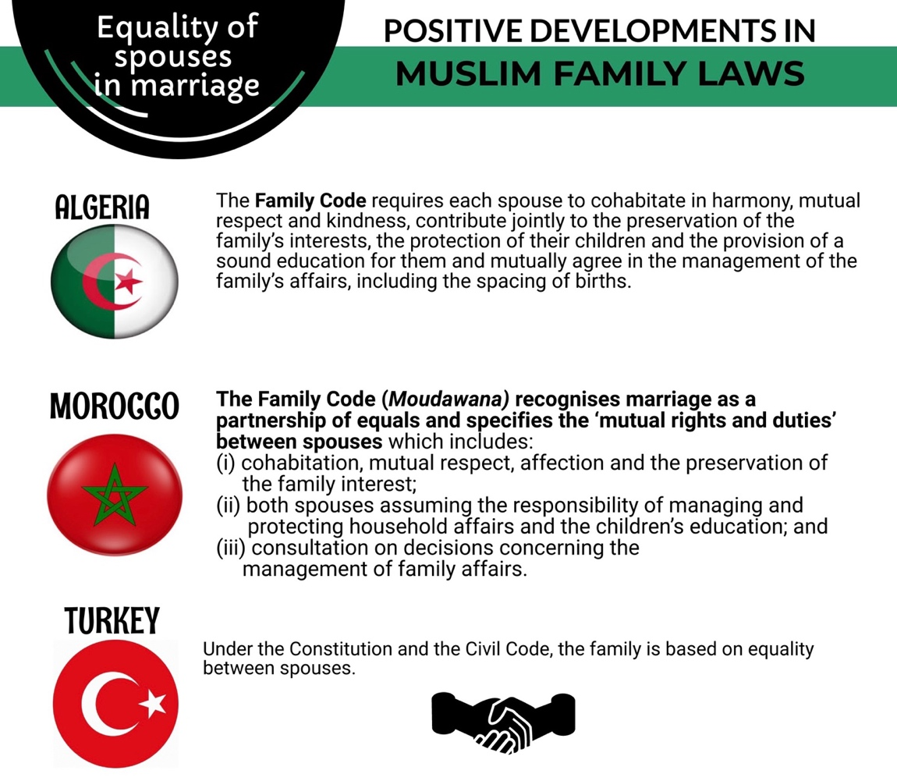

RECOMMENDATIONS
We recommend the CEDAW Committee urge the State party to:
- Urgently repeal Section 33(5)(c),(d) of the Constitution to ensure consistency and harmonization with progressive parts of the Constitution to pave the way for de jure equality between men and women in the area of personal law; make the application of customary law and sharia in The Gambia subject to the principle of non-discrimination as enshrined Section 33(2),(4) of the Constitution; and amend Section 27 of the Constitution to include a provision on matrimonial equality and equality between spouses; and

- Harmonize national legislation, the Women’s Act 2010 and personal laws (Sharia and customary law), by repealing all discriminatory provisions and codifying all laws under Sharia to ensure that Muslim women and girls enjoy the same rights as men in all aspects of family life;

- Encourage and promote the appointment of women judges at all levels of the judiciary, including the Cadi Courts and District Tribunals, and build the capacity of Cadis to respond to personal status laws of women efficiently and without discrimination.

- Strengthen efforts to provide training on women’s rights, analytical tools for gender justice, and violence against women to judges, Cadis, Prosecutors, Police Officers and legal professionals.

- Engage religious scholars, chiefs and traditional leaders to recognize and distinguish discriminatory tradition from Islam in decisions regarding personal status laws for women.

Child Marriage Article 16

In July 2016, the Children’s (Amendment) Act was enacted, which prohibits child marriage and establishes the minimum age for marriage as 18 years. The Act also prohibits the betrothal of a child, and prescribes a punishment of up to twenty years imprisonment for any parent or guardian found wanting. However, the enforcement of these amendments remains a challenge due the ineffective implementation as well as the deep-rooted nature of this practice. Ever since the enactment of the laws prohibiting child marriage and child betrothal through the amendment of Section 24 and 25 of the Children’s Act 2005, prosecutions for child marriage have not taken place.

Data indicates that child marriage is still prevalent: the Multiple Indicator Cluster Survey 2018 indicated 34.2 percent of women aged 20-49 years were married before the age of eighteen, and 17.1 percent of women aged 15-19 years were married at the time of the survey. It is not uncommon to hear of stories of young girls being taken out of school and forced into marriage by their family. Child marriages are particularly common in rural areas, presenting the impact of education and poverty. For instance, the median age of women to marry in the capital city is 21.0, whereas it is 17.6 in Basse, a rural area. Similarly, the median age for women with a secondary education to marry is 22.2, as opposed to girls without an education, wherein the median is 17.3. Furthermore, the figures considering the girl’s family’s wealth are 20.8 for wealthier families and 17.2 years for families that aren’t wealthy.

A 2019 study found that “…ethnicity and the fear that girls may engage in premarital sex are two important factors associated with early marriage in rural Gambia. In addition, a lack of meaningful alternatives to marriage, including work opportunities in rural areas, may also limit the options and resources available to girls, resulting in early wedlock. These findings suggest that in order to decrease early marriages in rural Gambia, future efforts should focus on understanding and addressing the role of ethnicity in determining marriage patterns and allaying the fear around premarital sex. The findings also suggest a need to provide girls with employment-oriented education, such as vocational skills, which may result in increased empowerment and a delay in marriage.”

RECOMMENDATIONS
We recommend the CEDAW Committee urge the State party to:

- Put in place a mechanism for registration of marriages, particularly in rural areas, so that marriages can be documented and recognized by all jurisdictions.

- Provide targeted training programs to law enforcement officials, the judiciary, healthcare workers, and social workers to respond to reports of child marriage, and provide adequate support to victims.

- Enforce penalties on those who conduct, enable, or fail to prevent child marriages, and effectively enforce Section 24 and 25 of the Amendment Act of the Children’s’ Act 2015.

Violence Against Women Articles 11-5, 16 & 19, & GR35

Marital Rape

Marital rape is not legally recognized as rape in The Gambia. Section 3(3) of the Sexual Offense Act 2013 stipulates that “for the purposes of this section, rape shall not apply to married couples”. This provision gives room for women to be exposed to sexual abuse and marital rape, thus compromising their right to dignity, as well as their reproductive health rights.

Female Genital Mutilation (FGM)

FGM involves the cutting away of parts of the outer female genitalia. Although the Gambia prohibited FGM in 2015, the practice remains prevalent. According to an analysis of data from the DHS 2013 by UNICEF, 55 percent of women reported that they were circumcised before the age of five. Another 28 percent of women were circumcised between the ages of 5 and 9, and 7 percent were circumcised between the ages of 10 and 14. Around 85 percent of women circumcised mentioned that what they went through involved cutting and removal of flesh.

This practice violates human rights of girls as guaranteed under international human rights law. This practice is not only a threat to the enjoyment of various rights of the girl-child, including the rights to life, health equality and non-discrimination, liberty, freedom from inhumane degrading treatment, dignity and autonomy but it also impacts the child’s physical, mental and emotional wellbeing. It is also interesting to note that about half the women in the Gambia now openly disapprove of FGM.

The prevalence of FGM in the Gambia can be attributed to the weak enforcement of the Women’s Act, 2010. The general public seldom reports practices of FGM except if there is an outrage like the demise of a youngster. It is important for the State Party to devise effective enforcement mechanisms of the prohibition on FGM. It is pertinent to put in place a detailed plan for implementation and monitoring, as well as the establishment of enforcement mechanisms such as an Anti-FGM Prosecution Unit and the Anti-FGM Board.

The existence of such mechanisms would enable accountability in terms of reporting, investigating and prosecuting FGM cases. The difficulties confronted with the passing of regulation deterring unsafe customary practices are primarily due to the absence of police stations with the requisite tools and resources to carry out an effective investigation, and the lack of understanding of the law by the police officers. Thus, it is important to call for greater awareness raising and enforcement mechanisms around the issues of FGM, particularly within rural areas.

Violence against Women amid Covid-19

A study on VAW in the Gambia during Covid-19 published in 2021 found that in communities where the survey was conducted, the perpetuation of economic and physical violence by an intimate partner had increased during the Covid-19 pandemic, owing likely to the loss of economic income, particularly for husbands and the extended domestic stay that were promoted as Covid-19 mitigation strategies. In general, 43.7 percent of women and girls thought that sexual and gender-based violence against women and girls by their partners, acquaintances or strangers are common in their community during the Covid-19 pandemic. Of the women and girls who reported that SGBV during the Covid-19 is common in their communities, 175 knew of a woman or girl who has been a victim of emotional violence, 144 knew of girls who had been subjected to early and forced marriage, while 125 stated that they knew of a woman or a girl who has been a victim of physical violence.

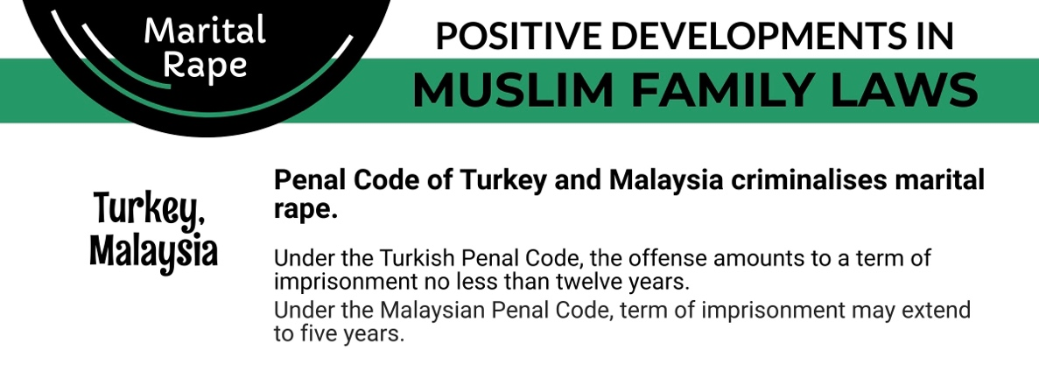

RECOMMENDATIONS
We recommend the CEDAW Committee urge the State party to:

- Repeal Section 3(3) of the Sexual Offence Act 2013 to include marital rape within the ambit of rape.
- Enforce strict penalties for perpetrators of FGM, and strengthen awareness-raising and educational efforts to completely eliminate this practice and its underlying justifications.

- Train law enforcement, the judiciary, healthcare workers, and social workers to respond to reports of FGM effectively and provide adequate support to victims of domestic violence.

- Integrate awareness raising around domestic violence and information about existing resources and hotlines into advocacy programs and public health interventions on Covid-19.

Polygamy Article 16

There is no law prohibiting polygamy in The Gambia. As mentioned before, the issue of marriage is subject to personal law, and according to traditional interpretations of Islam, a man is allowed to marry up to four wives. There is also no law in the Gambia that includes the requirement of a woman’s consent to polygamous arrangements.

According to a PEW Research of 2020, polygamy is most often found in sub-Saharan Africa, where 11% of the population lives in arrangements that include more than one spouse. The practice is widespread in a cluster of countries in West and Central Africa, including the Gambia (30%), including Burkina Faso, (36%), and Mali (34%). In the Gambia, the study found that 30 percent of Muslim individuals and 12 percent of Christian individuals were living in polygamous households. Moreover, according to the Demographic and Health Survey 2019-2020, 34 percent of married women aged 15-49 year are in a polygynous union, meaning they have at least one co-wife. Additionally, the survey found that 14.9 percent of men aged 15-49 years have more than one wife.

The threat of polygamy is often used as a powerful means of control of the wife by the husband. It continues to be practiced in a manner that can results in negative consequences to the financial, psychological and emotional wellbeing of the wives and children of polygamous unions. While the Gambia has introduced laws including the Women’s Act and Domestic Violence Act, which seek to protect women all women including those in polygamous marriages, it is important that polygamy be prohibited without exception to completely eliminate the practice.

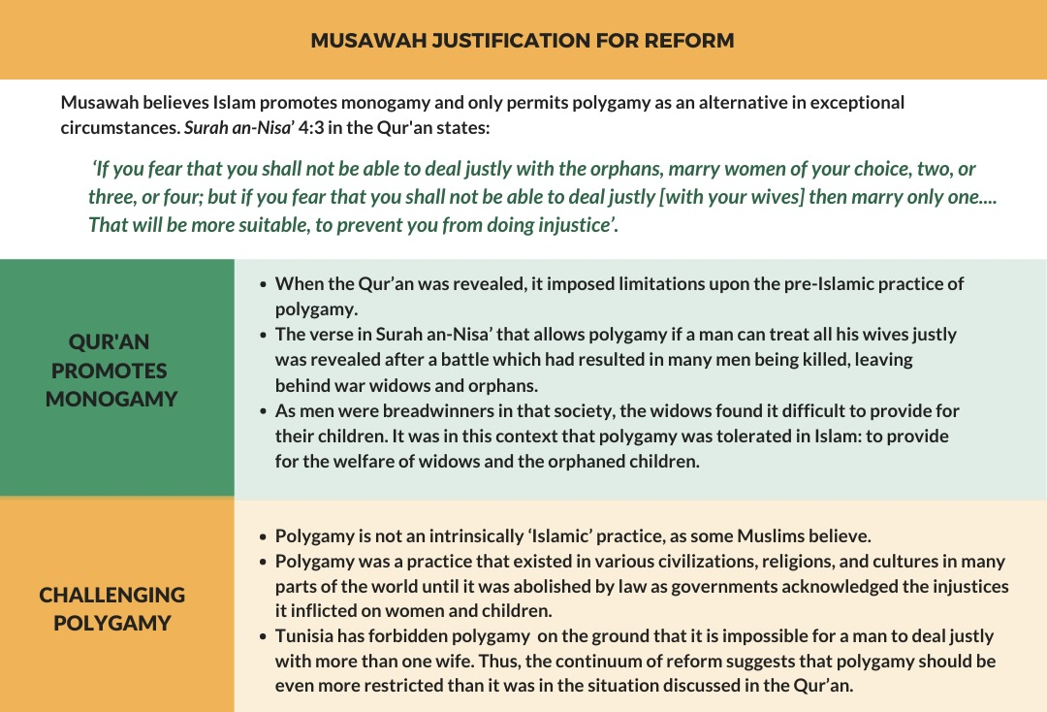

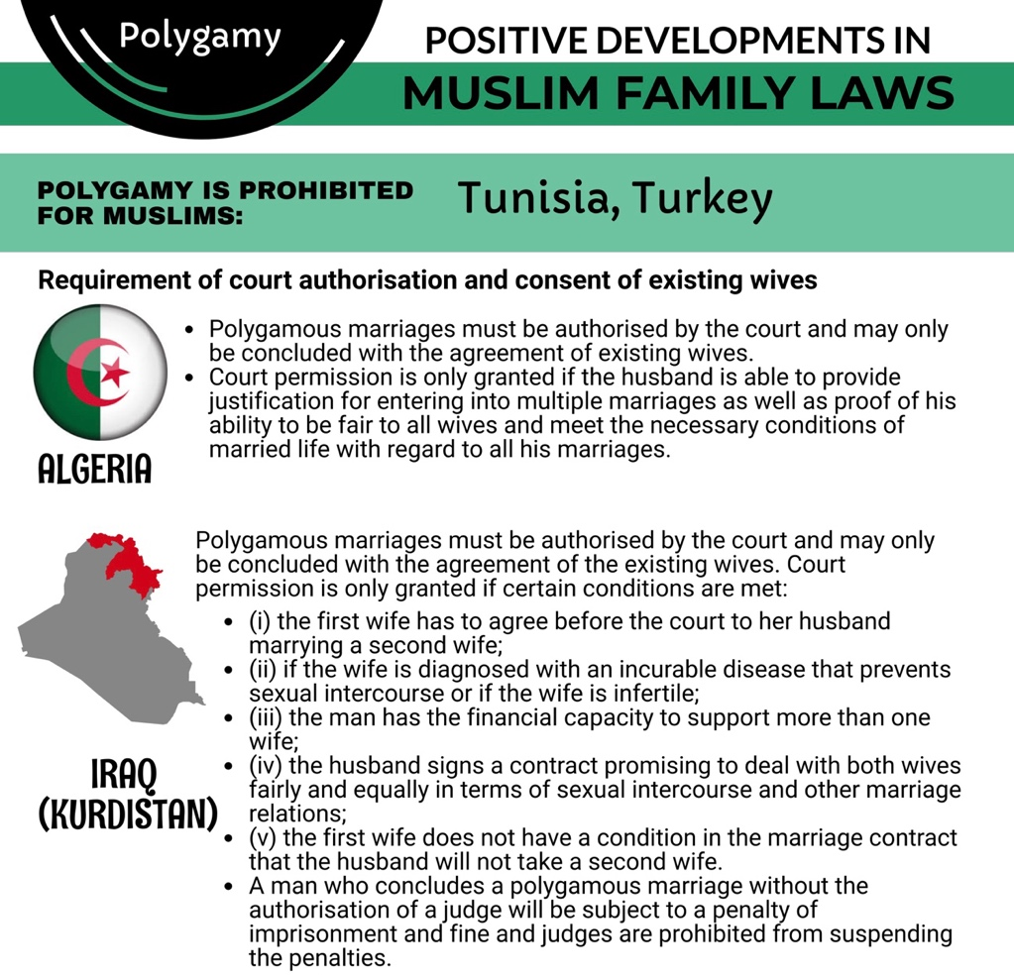

RECOMMENDATIONS
We recommend the CEDAW Committee urge the State party to:

- Adopt legal provisions explicitly prohibiting polygamy without exception, in addition to the previously stated recommendations with respect to harmonizing legislation with progressive parts of the Constitution.

Inheritance Article 16

The devolution of property during inheritance is another issue regulated by personal law. According to the interpretation of Sharia law in the Gambia, Muslim women tend to receive one third, while men receive two thirds of the shared property. The Woman’s Act provides only for women’s “equitable” access to property, which is also not compliant with the CEDAW Committee’s standard of equality.

The Gambia conducted a study on the laws of the country to identify areas of harmonization of legislation, and the State Party Report states that ‘the supplementary gender position paper to the Constitutional Review Commission already recommended the Replacement of the term “equitable” by “equal” as regards women’s access to property in the Women’s Act 2010 and ensure that judges interpret it accordingly in their judgments’. However, no such provision exists in the law till date.

The aforementioned principle resulting in an unequal distribution of inheritance among men and women has been used to determine numerous cases presided over by the Cadi courts in the Gambia. In one such case, the Cadi Appeal Panel affirmed the decision of the lower court on the distribution of the property of late Pa Njie among his beneficiaries: for the wife to inherit 1/8 and the son and the daughter to share the residue, with the male inheriting double the share of the female.

Hence, it is important that Shariah law not be applied discriminatorily against Muslim women. An example of such progressive development can be seen from Ghana, another country in the Sub-Saharan Africa region, where the Supreme Court held that Sharia law cannot be applied discriminatorily against females in matters of property distribution.

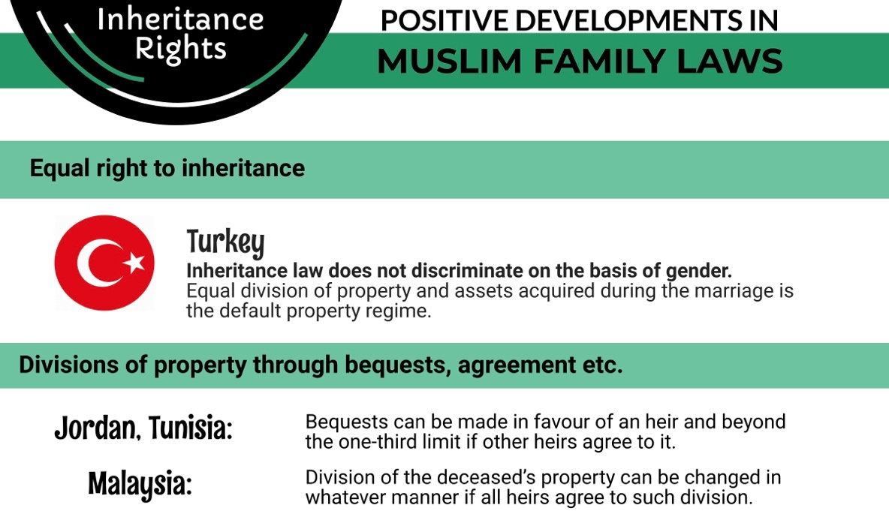

RECOMMENDATIONS
We recommend the CEDAW Committee urge the State party to:

- Replace the term “equitable” with “equal” in references in the Women’s Act 2010 as regards women’s access to property, and ensure that judges interpret the Act accordingly in their judgements, in accordance with the CEDAW Committee’s previous Concluding Observations and the recommendation of supplementary gender position paper to the Constitutional Review Commission as stated in the Gambia’s State Party Report.

- As stated previously, introduce provisions in the relevant laws and the Constitution that ensure that discriminatory interpretations of Sharia or customary laws, resulting in unequal distribution of property among men and women, are prohibited.

2020 Report on International Religious Freedom Report: The Gambia, US Department of State, https://www.state.gov/wp-content/uploads/2021/05/240282-GAMBIA-2020-INTERNATIONAL-RELIGIOUS-FREEDOM-REPORT.pdf.
Constitution of the Republic of The Gambia 1997, (hereinafter “Gambia Constitution”), Preamble
Towards Reversing Discrimination in Law: Mapping and Analysis of the Laws of the Gambia from a Gender Perspective, UN Women and the Commonwealth Secretariat, 2020, (hereinafter “Gender Report UN Women”) p.22, https://africa.unwomen.org/en/digital-library/publications/2020/08/mapping-and-analysis-of-the-laws-of-the-gambia.
Ibid.
Gambia Constitution, sec.137.
Gender Report UN Women supra note 3, p. 21.
Ibid, p. 17.
Gambia Appoints First Women Cadis, The Standard, Feb 17 2022, https://standard.gm/gambia-appoints-first-women-cadis/.
The Gambia Reply to the List of Issues, CEDAW 83rd Session, 20 July 2022, para 92.
Gender Report UN Women, supra note 3, p. 17.
Ibid.
The Gambia Multiple Indicator Cluster Survey 2018, https://mics-surveys-prod.s3.amazonaws.com/MICS6/West%20and%20Central%20Africa/Gambia/2018/Survey%20findings/The%20Gambia%202018%20MICS%20Survey%20Findings%20Report_English.pdf
https://www.orphansinneed.org.uk/news/child-marriage-in-the-gambia/.
Preventing Early Marriage in Rural Gambia, Society for the Study of Women's Health (SSWH); Agency for the Development of Women and Children (ADWAC), November 2019, https://www.alignplatform.org/resources/preventing-early-marriage-rural-gambia.
Female Genital Mutilation in the Gambia, http://accessgambia.com/information/female-circumcision-fgm.html.
Women’s Act (Act No. 12 of 2010), (hereinafter “Women’s Act 2010”), amended by the Women’s Amendment Act 2015, sec. 32A, 32B.
FGM Still a Problem in Gambia Years After it was Banned, Tender, 31 March 2017, https://tender.org.uk/blog/fgm-still-problem-gambia-years-banned/.
Statistical Profile on Female Genital Mutilation/Cutting, United Nations Children's Fund (UNICEF), February 2016, https://data.unicef.org/wp-content/uploads/country_profiles/Gambia/FGMC_GMB.pdf.
The Gambia 2013 Population and Housing Census Preliminary Results (2014), Gambia Bureau of Statistics (GBOS).
Nabaneh & A Muula ‘Female Genital Mutilation/Cutting: A Complex Legal and Ethical Landscape’ (2019) 145(2) International Journal of Gynecology & Obstetrics 253–257.; see also E Durojaye & P Sonne ‘A holistic approach to addressing female genital cutting (FGC) in Africa: The relevance of the protocol to the African charter on the rights of women’ (2011) Akungba Law Review 240–259.
On the Day of the African Child, UNICEF alerts that it’s past time to end female genital mutilation and child marriage in The Gambia, UNICEF, 15 June 2022, https://www.unicef.org/gambia/press-releases/day-african-child-unicef-alerts-its-past-time-end-female-genital-mutilation-and.
Ebenezer Durojaye and Satang Nabaneh, Addressing female genital cutting/mutilation (FGC/M) in The Gambia, (2021), p. 126-127.
Ibid.
A Pandemic of the State and Home: Gambian Women’s Experiences of Sexual and Gender Based Violence during Covid-19, Equals Now; Open Society Initiative for West Africa (OSIWA), 30 September 2021, http://equalsnow.org/wp-content/uploads/2022/07/Pandemic-of-the-State-and-Home.pdf.
The Gambia State Party Report, CEDAW 83rd Session, 2 December 2020, (hereinafter “Gambia State Party Report”), para 78.
Polygamy is Rare Around the World and Mostly Confined to a Few Regions, Pew Research Center, 7 December 2020, https://www.pewresearch.org/fact-tank/2020/12/07/polygamy-is-rare-around-the-world-and-mostly-confined-to-a-few-regions/.
Ibid.
The Gambia Demographic and Health Survey 2019-2020, Gambia Bureau of Statistics, March 2021, https://dhsprogram.com/pubs/pdf/FR369/FR369.pdf.
Musawah, CEDAW and Muslim Family Laws: In Search of Common Ground, 2011, https://www.musawah.org/resources/cedaw-and-muslim-family-laws-in-search-of-common-ground/
Gambia State Party Report, para 161.
Gambia State Party Report, para 161.
Concluding Observations 2015 for the Gambia, CEDAW, 28 July 2015, para 48.
Gambia State Party Report, para 160.
See for example: Musa Sabily v. Hassana Baye (2007) 1 (GSLR) p. 22.
Aji Tide Ceesay v. Modu Njie (2010 1 Gambia Sharia Law Report (GSLR) p. 41 - APPEAL NO. AP/31/2005.
Abdul Rahman Osumanu Giwah, Alhaji Ali Adamu Giwah and Hajia Fatima Alhassan Giwah vs. Baba Ladi [2013] DLSC 2745

