Canada knows better and is not doing better:
Federal Government documents show ongoing discrimination against First Nations children receiving child welfare services on reserve and in the Yukon

International Covenant on Economic, Social and Cultural Rights
55 Pre-Sessional Working Group
Consideration of List of Issues, Sixth Periodic Report, Canada

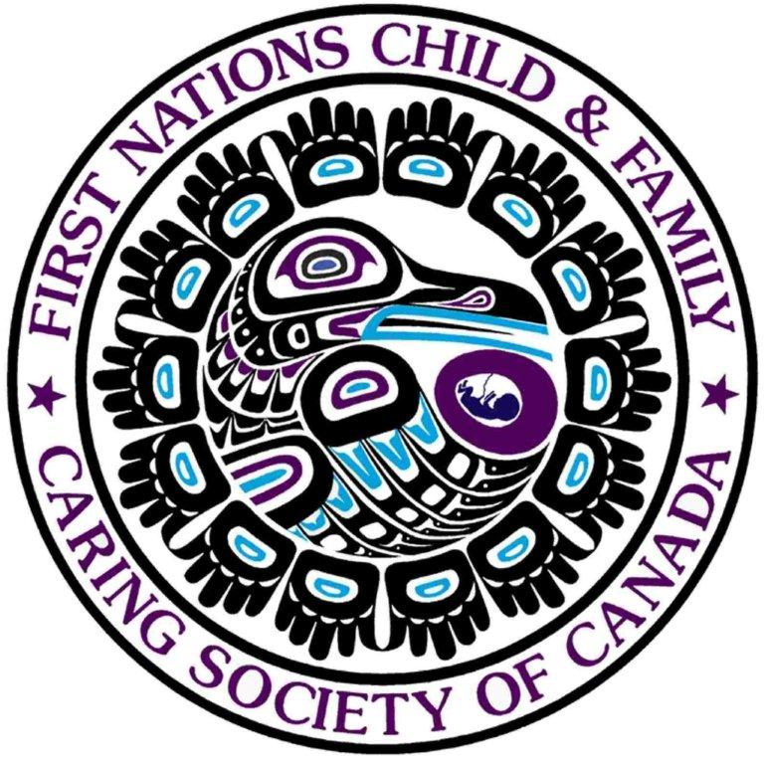

Submitted on February 2, 2015 by:
First Nations Child and Family Caring Society of Canada
Suite 401, 309 Cooper Street,
Ottawa, ON
URL: www.fncaringsociety.com
Email: info@fncaringsociety.com
Phone: +1 613 230-5885

Introduction

First Nations children are dramatically over-represented amongst children being removed from their families and being placed in child welfare care. Researchers from the Canadian Incidence Study on Child Abuse and Neglect report that First Nations children are 12.4 times more likely to be placed via court order than other children. Factors contributing to the over-representation include poverty, poor housing, substance misuse related to multi-generational colonial harm and inequitable child and family services, particularly the lack of prevention services, on reserves. Canada’s failure to provide equitable and culturally based child and family services to ensure the 163,000 children on reserve and their families have an equitable chance to raise their children is contrary to Articles 2 and 10 of the Covenant.

In 2007, the Assembly of First Nations and the First Nations Child and Family Caring Society (the Caring Society) filed a complaint pursuant to the Canadian Human Rights Act alleging that Canada’s flawed and inequitable provision of First Nations child and family services was discriminatory on the basis of race and national ethnic origin. The complaint was filed after the federal government failed to address inequalities that contributed to First Nations children being removed from their families due to a lack of prevention supports. Over the next 8 years, the federal government would spend millions of dollars in its numerous unsuccessful attempts to get the case dismissed on jurisdictional grounds before hearings began before the Canadian Human Rights Tribunal (CHRT) in February of 2013. Although it is not mentioned in Canada’s country report submitted to the Committee on Economic, Social and Cultural Rights, this historic case marks the first time in history that the Canadian government has been held to account for its contemporary treatment of First Nations children before a body that can make a legally binding determination of discrimination and order an enforceable remedy and is expected to set an important legal precedent to address inequalities in First Nations education, health and housing. By the time hearings concluded in October of 2014, over 500 documents were filed as evidence and 25 witnesses testified. The CHRT is expected to issue its ruling in the spring of 2015 (for further information and full copies of the legal documents and submissions see www.fnwitness.ca)

The right for families to raise children in keeping with their culture and traditions free of discrimination is a cornerstone of international law as codified in the United Nations Convention on the Rights of the Child, the Universal Declaration on Human Rights, the Declaration on the Rights of Indigenous Peoples and the Covenant on Economic, Social and Cultural Rights. Canada arguably has a higher obligation to ensure First Nations families fully enjoy these rights given the Government of Canada’s destructive role in separating First Nations children from their families during the residential school era. Unfortunately, as evidenced by the Government of Canada’s own documents, First Nations families continue to experience government sourced discrimination via flawed and inequitable federal child and family services funding programs that contribute to the dramatic over-representation of First Nations children in care. This submission discusses some of the government’s own documents filed as evidence at the Tribunal within the context of its obligations pursuant to the Covenant on Economic, Social and Cultural Rights with an emphasis on Canada’s failure to observe its obligations under Articles 2 and 10.

Canada’s provision of Discriminatory First Nations Child and Family Services

The government of Canada requires First Nations on reserve to operate child and family services agencies pursuant to provincial/territorial child welfare laws. The federal government through the Department of Aboriginal Affairs and Northern Development Canada (AANDC) controls and funds First Nations child and family service agencies whilst the provinces provide these functions to other Canadians. As the Auditor General of Canada (2008, 2011) has repeatedly noted, the federal government’s provision of these services is flawed and inequitable. The federal government relies on three funding regimes to provide First Nations child and family services on reserve. The oldest is the 1965 Indian Welfare Agreement (65 Agreement). It is generally regarded as the most effective of all federal government child and family service regimes. However, the Auditor General of Canada (2008) found this approach to be inequitable and it only applies in Ontario. Federal Government employee evidence at the Canadian Human Rights Tribunal notes that the 65 Agreement reimburses based on the 1978 version of Ontario child welfare legislation and has not been updated since. The result is that some First Nations children and families in Ontario receive no prevention services to keep their children safely at home and statutory provisions in the current Ontario child welfare act such as the requirement for band representatives are not funded at all. The model does not account for the needs of First Nations families and does not explicitly contain a formula adjustment to provide culturally based services (Canadian Human Rights Commission, 2014; First Nations Child and Family Caring Society of Canada, 2014).

A model known as Directive 20-1 was developed in 1989 and has remained relatively unchanged since. It is applied in British Columbia, New Brunswick, Newfoundland and Labrador and the Yukon. Directive 20-1 is formula driven and does not adjust for variances in provincial legislation, First Nations cultures or the needs of families. It has been the subject of two in depth reviews commissioned by the federal government (McDonald & Ladd, 2000; Loxley et al.., 2005) and review by the Auditor General of Canada (2008, 2011). All of these reviews found the funding to be inequitable and flawed. This passage taken from the Department of Indian Affairs Canada’s website (now known as Aboriginal Affairs and Northern Development Canada) in 2007 summarizes the Department’s views of Directive 20-1 (emphasis added):

Changes in landscape: Provinces and Territories have introduced new policy approaches to child welfare and a broader continuum of services and programs that First Nations Child and Family Services must deliver to retain their provincial mandates as service providers. However, the current federal funding approach to child and family services has not let First Nations Child and Family Service Agencies keep pace with the provincial and territorial policy changes, and therefore, the First Nations Child and Family Service Agencies are unable to deliver a full continuum of services offered by the provinces and territories to other Canadians. A fundamental change in the funding approach of First Nations Child and Family Service Agencies to child welfare is required in order to reverse the growth rate of children coming into care and in order for the agencies to meet their mandated responsibilities. (Indian and Northern Affairs Canada, 2007)

As this passage makes clear, the Government of Canada clearly knows about the inequalities in Directive 20-1 and links it directly to the growth of children in care and yet Directive 20-1 continues to be implemented in three provinces and one territory. There has been no increase in prevention services in Directive 20-1 in 24 years and no increase to keep up with cost of living for 20 years. The Government of Canada claimed it had remedied some of the flaws in Directive 20-1 by rolling out what one federal government employee termed “Directive 20-1 plus” however further investigation revealed that the ‘plus’ simply amounted to not reducing the allotment of funding provided under the Directive versus increasing it.

The final model used by the federal government for its provision of First Nations child and family services is known as the Enhanced Prevention Focused Approach (EPFA). EPFA was originally rolled out in Alberta in 2007 and has since been provided to Manitoba, Quebec, PEI and Saskatchewan. As the Auditor General of Canada (2008) and AANDC’s own policy manual (2012) note, EPFA is a modified form of Directive 20-1. Whilst it does provide increased funds for prevention, it incorporates significant flaws from the Directive, is not available across the country and no province or territory has received EPFA funding since 2010. Among the problems with the EPFA formula is that it is not based on children’s needs, it does not provide any funding for the receipt and investigation of child protection complaints nor does it provide any funding for child in care related legal costs. Although prevention funds are improved the budget is insufficient and subject to downward adjustments as AANDC requires agencies to use prevention dollars to cover subsidize shortfalls in the maintenance budget (funds to pay for children in care) if maintenance expenditures are higher than the previous fiscal year.

An AANDC internal presentation prepared for the Assistant Deputy Minister in 2012 acknowledges that an additional 43.10 million dollars per annum are required to (emphasis added):

“Top-up existing EPFA Jurisdictions” to “Ensure agencies are able to meet changing provincial standards and salary rates while maintaining a high level of prevention programming (2012 EPFA Evaluation of NS/SK recommendation)” and “Ensures funding remains reasonably comparable with provinces.”

The theme of shortfalls across AANDC’s various cost regimes and its strategy of covering off shortfalls in programs by reallocating funds from other cash strapped AANDC programs for First Nations peoples is further outlined in an internal AANDC presentation dated June 2013 entitled “Cost Drivers and Pressures- the Case for New Escalators.” In 1996, the federal government capped all First Nations program (i.e.: education, health, child and family services, housing) budget increases at 2 percent per year and this remains in place. As the AANDC presentation confirms, the 2 percent escalator, which also applies to First Nations child and family services, does not properly account for inflation and increased population growth in First Nations communities let alone allow for the redress of existing inequalities across these programs (emphasis added):

Significant re-allocations from infrastructure to other programs have occurred over the past 6 years. For example, AANDC has reallocated approximately $505 million in infrastructure dollars to Social, Education and other programs to try to fill the shortfall in these areas. Since Infrastructure was not able to cover off all Social and Economic needs in each year, other internal resources were used to cover off the remaining shortfall. This ongoing reallocation is putting pressure on an already strained Infrastructure program and has still not been enough to adequately meet the needs of Social and Education programs.

Infrastructure funds provide vital services to First Nations such as housing, water, sanitation, and the building of First Nations schools and numerous reports demonstrate these services are dramatically under-funded and thus reducing funds further via transferring to cover off other program shortfalls heightens the inequities. AANDC’s transfer of funds from First Nations infrastructure budgets heightens the risk of child welfare placement by increasing one of the key factors contributing to First Nations’ children being removed from their families– inadequate housing.

In its final closing submissions to the Canadian Human Rights Tribunal, the Attorney General of Canada (2014) acting on behalf of the Minister of AANDC tries to refute the internal AANDC documents noting (identification of parties and emphasis added):

163. The Complainants (Assembly of First Nations, Caring Society and the Canadian Human Rights Commission) rely on an assortment of internal government documents, which they assert are admissible for the truth of their contents, either as “public documents” or admissions against interest by the Respondents (AANDC). This assertion overshoots the mark. 164. The information in these documents are not admissions. At best, they reflect personal views of employees of the department at particular points of time. While these documents have been admitted into evidence, the Tribunal should assess their weight contextually with reference to the Respondent’s viva voce evidence regarding their proper interpretation.

However, AANDC never produced any evidence supporting its contention that the documents were personal views of employees or that the views shared in these documents were incorrect.

In response to public inquires about the inequities in First Nations child and family services, AANDC has repeatedly pointed to the increases in the First Nations child and family service budget over the past 14 years. However, as AANDC’s presentation “Aboriginal Affairs and Northern Development Canada’s Role as a Funder in First Nations Child and Family Services “ (Updated May 2013 and retrieved from the AANDC website on February 2, 2015) notes these increased costs are largely attributed to children being placed in care versus increases in prevention services. Quoting directly from the presentation:

The reason for this growth in funding was mainly due to the fact that maintenance costs [costs related to children being placed in foster care] per child had more than doubled since 1998-1999. This increase in maintenance costs was driven by: increases in the rates charged by the provinces; an increase in costs for, and the number of, special needs children in care and the greater reliance by agencies on institutional care.

Even in regions receiving EPFA, only a small percentage of the increase in AANDC’s budget for First Nations Child and Family Services can be attributed to increased prevention costs. As AANDC’s presentation (Updated May 2013) makes clear, absolutely no additional EPFA money has been provided to First Nations children and families in Ontario, BC, New Brunswick, Newfoundland & Labrador and the Yukon Territory.

The federal government funds non-First Nations child and family service providers to provide services to First Nations children where there is no First Nations child welfare agency at higher funding levels with greater flexibility and fewer reporting requirements. This not only evidences what one federal government official termed “woefully inadequate” funding levels, but also incentivizes non-culturally appropriate service delivery contrary to Canada’s obligations pursuant to the Covenant.

Questions for Canada

The decision of the Canadian Human Rights Tribunal in the First Nations child and family services case is still under reserve but the Tribunal rules of procedure indicate the ruling will be issued in the spring of 2015 meaning it will be available to the Government of Canada at the time of its in person review before the Committee. Given the grave consequences of removing First Nations children from their families due to inequitable government policies and programs, we respectfully request Canada be asked the following questions:

- Why is the government of Canada not taking immediate and effective measures to remedy the longstanding inequalities in First Nations child and family services despite its own documents confirming the flawed and inequitable child and family services and the resulting unnecessary removals of First Nations children from their families?
- Can Canada specifically identify how it ensures First Nations child and family services are culturally appropriate?
- Can Canada provide a copy of the Canadian Human Rights Tribunal decision in the First Nations Child and Family Services case T1340/7008 expected to be released in the spring of 2015 and explain in detail how it is responding to the decision?
- Why is the government of Canada reallocating vast amounts of funds from infrastructure funding targeted for vital services such as First Nations schools, housing, water and sanitation to cover off shortfalls in the First Nations Child and Family Services program, First Nations education and social assistance versus increasing the overall budget for First Nations services?
- Why did Canada not mention the Canadian Human Rights case on First Nations child and family services in its report to this committee in the “Aboriginal people and foster care” section of its country report set out on page 25 given that the subject matter directly engages articles 2 and 10 of the Covenant?

References:

Aboriginal Affairs and Northern Development Canada (2012). National Social Programs Manual. Ottawa: Aboriginal Affairs and Northern Development.

Aboriginal Affairs and Northern Development Canada (August 29, 2012). First Nations Child and Family Services Program (FNCFS): the Way Forward. Presentation to Francois Ducros, ADM, ESPDPPS.

Aboriginal Affairs and Northern Development Canada (June, 2013). Cost Drivers and Pressures- the Case for New Escalators.

Aboriginal Affairs and Northern Development (May 2013). Aboriginal Affairs and Northern Development Canada’s Role as a Funder in First Nations Child and Family Services. Retrieved February 2, 2015 at https://www.aadnc-aandc.gc.ca/eng/1100100035210/1100100035218

Auditor General of Canada (2008). First Nations child and family services program-Indian and Northern Affairs Canada. 2008 May: Report of the Auditor General of Canada. Retrieved October 4, 2009 from http://www.oag-bvg.gc.ca/internet/English/aud_ch_oag_200805_04_e_30700.
tml#hd3a

Auditor General of Canada (2011). Programs for First Nations on Reserves, June 2011 Status Report of the Auditor General of Canada. Retrieved January 5, 2012 at http://www.oag-bvg.gc.ca/internet/English/parl_oag_201106_04_e_35372.html

Attorney General of Canada (representing the Minister of Indian and Northern Affairs) (2014). Respondent’s closing arguments submitted to the Canadian Human Rights Tribunal in First Nations Child and Family Caring Society et al. v. Attorney General of Canada: T1340/7008.

Canadian Human Rights Commission (2014). Closing submissions of the Canadian Human Rights Commission submitted to the Canadian Human Rights Tribunal in First Nations Child and Family Caring Society et al. v. Attorney General of Canada: T1340/7008.

First Nations Child and Family Caring Society of Canada (2014). Memorandum of Fact and Law of the Complainant First Nations Child and Family Caring Society submitted to the Canadian Human Rights Tribunal in First Nations Child and Family Caring Society et al. v. Attorney General of Canada: T1340/7008.

Indian and Northern Affairs Canada (2007). Fact Sheet: First Nations Child and Family Services. Retrieved: http://www.ainc-inac.gc.ca/pr/info/fnsoccc/fncfs_e.html.

Loxley, J. et. al. (2005). Wen:de the Journey Continues. Ottawa: First Nations Child and Family Caring Society of Canada.

McDonald, D. & Ladd, P. (2000). Joint National Policy Review on First Nations Child and Family Servivces: Final Report. Ottawa: Assembly of First Nations.

According to the Federal Government definition of Aboriginal peoples in Canada, there are three Aboriginal groups: Inuit, Métis and First Nations.

