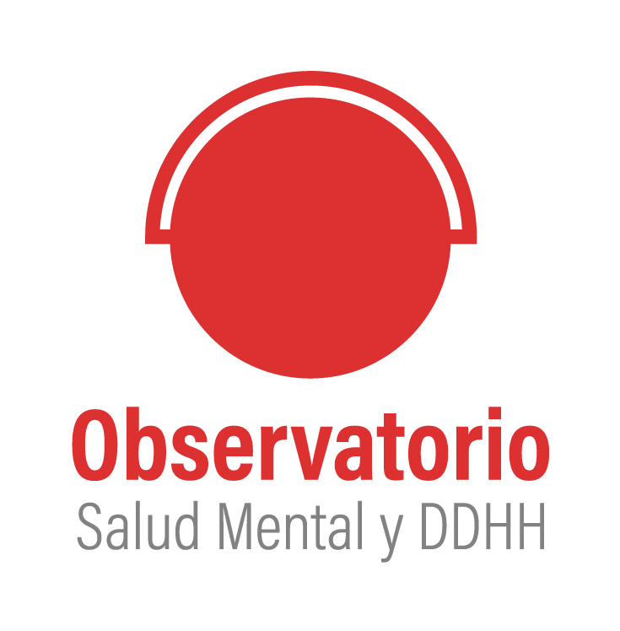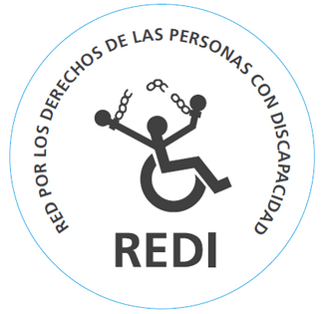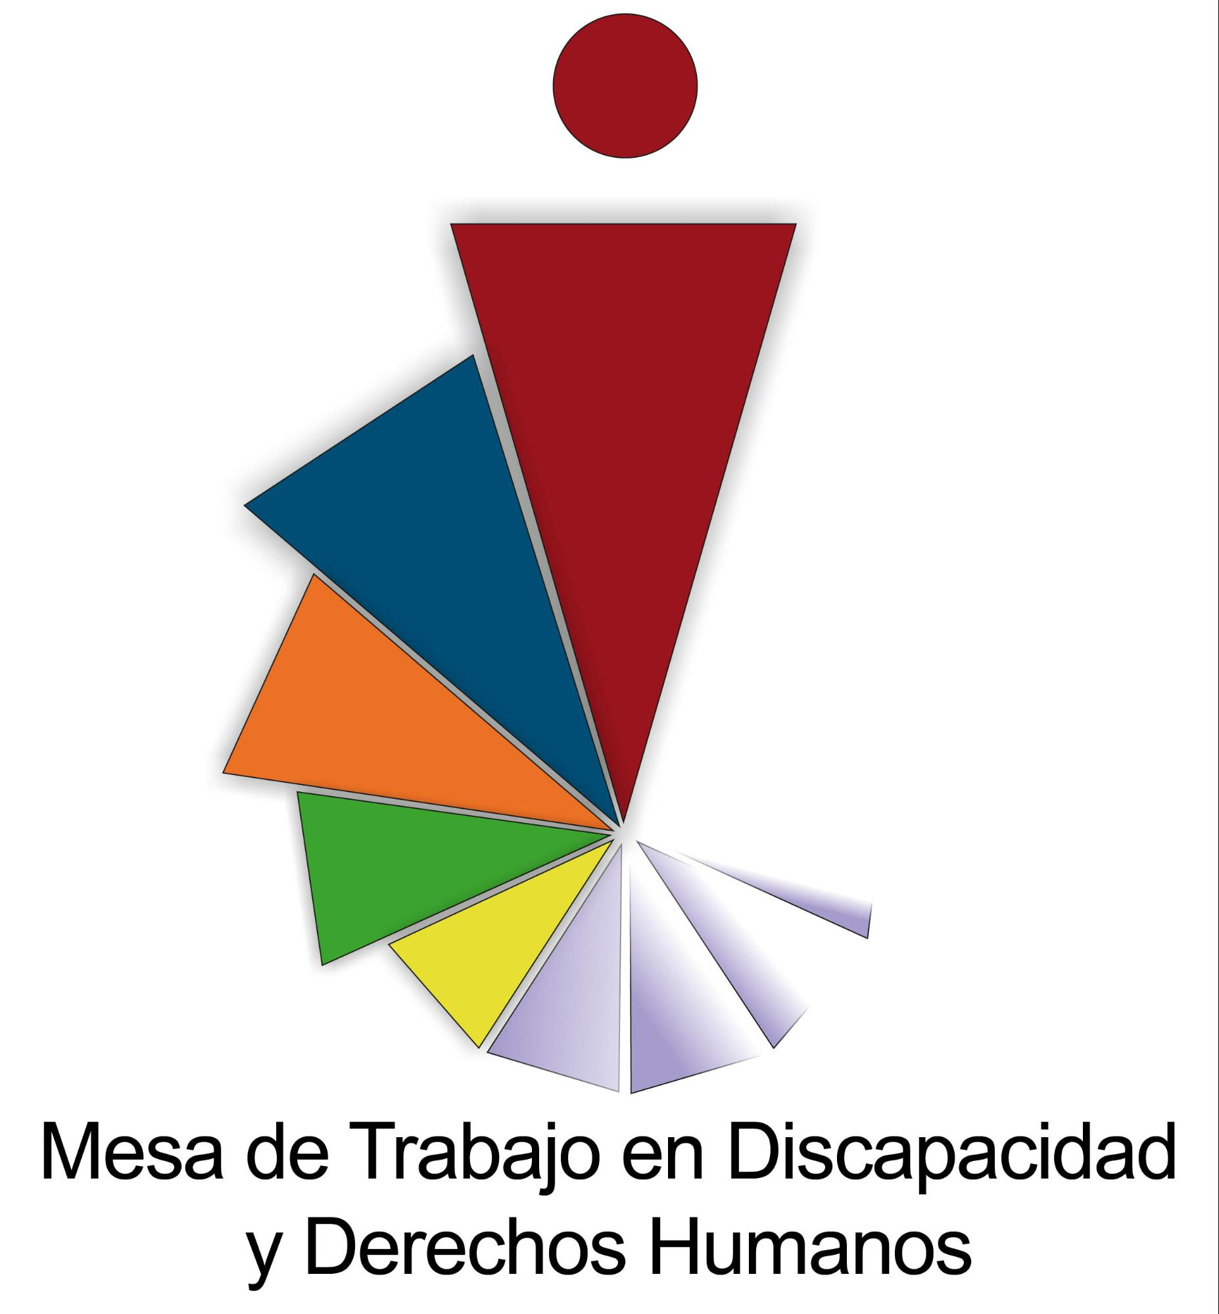

Committee on the Elimination of Discrimination Against Women (CEDAW)

Alternative report
presented by:

Working Group on Disability and Human Rights of Cordoba
Observatorio de Salud Mental y Derechos Humanos de Córdoba (Mental Health and Human Rights Observatory of Córdoba)
Network for the Rights of Persons with Disabilities (REDI)

Argentina
2022
Author organisations:
- Working Group on Disability and Human Rights of Cordoba: it is a collective work space that was established in 2013. It proposes the appropriation, promotion and dissemination of the human rights approach in the field of disability. Participants include people with and without disabilities, family members, workers and/or representatives of different sectors linked to disability-related work. The Committee works to generate public advocacy strategies in relation to the discourses and social representations of those who work, directly or indirectly, in the field of disability.
Authors and contacts: Lucía Bertona (luciabertona@gmail.com) and Mariana Gandolfo (gandolfomariana@gmail.com).

- Mental Health and Human Rights Observatory of Córdoba: it is a civil society organisation that was created in 2011 with the aim of monitoring mental health policies in the province of Córdoba and controlling effective compliance with mental health laws (National Law No. 26.657 and Provincial Law No. 9.848). This civil organisation comprises people and organisations with diverse backgrounds and insertions in the field of mental health, who find in collective work the possible way to ask for and build a respectful mental health according to human rights.
Authors and contacts: Magdalena Arnao Bergero (magdalena.arnao@unc.edu.ar), Ana Heredia (ana.heredia84@gmail.com) and Solana Yoma (solanayoma@gmail.com).

- Network for the Rights of People with Disabilities (REDI): it is a human rights organisation founded in 1998, whose main mission is to advocate for the fulfilment of the rights of people with disabilities under the paradigm of the social model. It is a non-profit civil association comprise of people with disabilities and family members of people with disabilities. Our main objectives are to disseminate the problematics of the collective, promoting an active part of people with disabilities in the struggle for their general and specific civil rights. Advocate to ensure that public policies that directly or indirectly affect us are in line with the Convention. To take legal action, in national and international courts, in the event that violations of people's rights are detected.
Authors and contact: rediderechosdiscapacidad@gmail.com

The author organisations are grateful for the opportunity to jointly present this report to the Committee for the Elimination of Discrimination against Women, on the progressive and regressive measures taken by the Argentine State with the respect to its obligations, following the incorporation into its legislative system of the international covenants and conventions (including the Committee's observations), which represent the guarantee of the rights of girls and women.

Executive summary
This report is written by organisations with extensive experience in activism for the rights of people with disabilities and mental health users of Argentina, who are convinced that the persistent violation of the rights guaranteed in our legislative system represents a serious shortcoming in the daily lives of people. Despite the enormous complexity involved in describing the present scenario, it is our intention to give an account of the main situations that require prompt consideration and action on the part of the Argentine State in terms of guaranteeing the rights of women with disabilities.
We agreed to focus this report on three central themes of deep concern:
- The continued impoverishment of women with disabilities (in the context of a constant feminisation of poverty) and the lack of opportunities for full and quality employment, with limited access and constant precariousness in the world of work.
- secondly, we highlight the exposure to situations of gender-based violence against women and girls with disabilities, which compromise their psychophysical integrity, as well as their full enjoyment of a life free of discrimination and violence.
- Finally, we emphasise the sexual and (non-)reproductive rights as a focus of ongoing violations in this central aspect of the lives of women with disabilities.
The three axes focus on questioning the shortcomings of the Argentinean state in guaranteeing these rights and the absence of public policies that make them effective for women with disabilities. After each section, we develop a series of guiding questions to the Argentinean State, in order to support the view on the enforceability of rights of women with disabilities in our country.

Introduction
Currently, both globally and regionally, and in our country in particular, women's movements and LGTBIQ+ population have been playing a central role in the socio-political scene, questioning various scales of the so-called patriarchal violence and disputing the horizons of expansion of rights known until now. In this new scenario, even what is enunciated under the sign of "feminism" is subject to dispute: on one hand, it allows the expansion of political actions and imaginations and, on the other hand, its hegemonic configuration (classist, racist and ableist) continues to produce multiple exclusions that are enunciated by different activisms, particularly women with disabilities.
It is for this reason that we believe it is important to consider the intersectional perspective in order to show that the multiple and crucially simultaneous articulation of different structural sources of inequality deepens the discrimination, suffering and inequality experienced by certain groups. We are particularly interested in focusing on the violence, exclusion and infringements faced by women and girls with disabilities.
Here it is essential to highlight the role of social organisations, which, in coordination with others, can have an impact on the construction of political agendas for the rights of people with disabilities in general and women with disabilities in particular. It is essential to be able to bring our views and contributions of the international monitoring of human rights, through national and local reports that contribute to the expansion of rights and the curbing of exclusion, violence and violations that certain people and groups constantly face.
- Growing feminisation of poverty among women with disabilities
In a context of deep economic and social crisis, women and girls with disabilities are subject to multiple situations that significantly reduce their possibilities of accessing labour, education, cultural and health rights. This is expressed in the new report of the National Institute of Statistics and Census (INDEC, 2022) which shows the evolution of income distribution for the second quarter of 2022 in Argentina according to the Permanent Household Survey. It shows that inequality (measured by the Gini Coefficient of per capita household income) reached 0.451 in the second quarter of 2020, decreasing to 0.413 in the fourth quarter of 2021 and rising again to 0.430 in the first quarter of 2022.
The frequent increase in inequality leads us to think that impoverishment mainly affects women, since the gap for work activities between men and women (gender gap of the employed population) is 27.7% in the second quarter of 2022. At the same time, the poorest 10% of our country's population is mostly made up of women: 6.4% of poor women and 3.6% of poor men. If we add to this data the existing inequality in access to income and assets for women and girls with disabilities, the situation is worrying.
Although there is still no data disaggregated by disability in the 2022 Census, the data recorded by the INDEC in 2018 , from the National Study on the Profile of Persons with Disabilities showed that for a population aged 14 years and over, the employment rate was 32.2%, with a large difference between men (40.3%) and women (25.8%) with disabilities.
1.1. Caregivers and cared for: Caring tasks and inequality in women with disabilities.
On the other hand, the 2021 National Time Use Survey (ENUT) , shows the inequality between men and women in terms of the distribution of the total time of a full day (which often exceeds 24 hours). While there are no significant gender differences in paid work, there is a difference in unpaid work: women add 1:42 hours simultaneously , while men increase their workload by 0:42 hours. In this sense, it is mainly women who spend more time on unpaid work (home care, care tasks within the home, care of others and the community) and who perform more than one activity simultaneously in unpaid work. This substantial differentiation in the distribution of time has a negative impact on the quality of life of girls and women, while deepening the dynamics of impoverishment in this group and reproducing and sustaining gender stereotypes based on inequality and discrimination.
Women with disabilities are mainly objects of care in our country; it is generally mothers who fulfill this central role of caring for others, and therefore it is imperative to review the feminisation of care and its constant invisibilisation as a secondary measure of unrecognised work. However, it is important to mention that many women with disabilities also play care roles in relation to their children and other cohabiting family members. However, we do not have official data on the specific situation of women with disabilities who are mothers and/or carers, and the implications of this intersection. We believe that this lack of information is not accidental, as it is the result of the invisibility of this population in its double condition (women with disabilities and caregivers). It is therefore urgent for the state to produce reliable information on the care tasks performed by women with disabilities and the gaps associated with these tasks.
From our spaces, we were invited (in February 2021) by the Ministry of Women, Gender and Diversity to initial meetings to promote, through close consultation, a new care law (a one-time call without continuity). There we highlighted that persons with disabilities are not only recipients of care, but can also provide care and that, in both cases, they may or may not need support. Highlighting the caregiving role of women with disabilities leads us to argue that this is a work occupation and should therefore be recognized as such and not be incompatible with the non-contributory pension (which is currently the case with registered jobs) . As an example of this, the "Potenciar Trabajo" programme , as a direct allocation from the State to reverse the unemployment gap, is not compatible with the payment of non-contributory pensions (as a direct transfer from the State to those with a disability), which becomes an important contradiction in the intersectional design of public policy.
Suggested questions to ask the Argentine State
- What continuity measures are foreseen in the short term to implement a new law on care with a disability perspective, its consequent regulation and its implementation in concrete federal public policies? Please specify timeframes.
- How is it ensured that the current regulations on non-contributory pensions for people with disabilities are compatible with specific programmes that promote women's economic autonomy, such as the "Potenciar Trabajo" programme?
- How to guarantee the economic autonomy of women with disabilities considering the historical inequality in access to work, wage inequality and opportunities that affect them integrally?

- Gender-based violence against women with disabilities
In 2016, the Committee on the Elimination of Discrimination against Women (CEDM), , warned the Argentine State in the section "Gender-based violence against women" about the lack of information on accessibility in shelters for women with disabilities and recommended that the State ensure that these shelters provide legal, psychological and other support services that are accessible to women with disabilities. We note with concern the persistence of this violation of the right to accessibility in all its forms and the lack of information in this regard.
It is worth noting that one of the most significant changes in terms of women's rights and dissidences, as well as actions linked to eradicating historical gender inequalities, was the creation of the Ministry of Women, Gender and Diversity (MMGyD).
This Ministry drafted and promotes the National Plan of Action against Gender-Based Violence for the years 2020-2022 , which has a comprehensive and intersectional approach. However, we are still witnessing inaccessibility related to access to justice and communication in specific public policies on violence against women with disabilities.
2.1. Diagnosis and statistics on gender-based violence against women with disabilities
In the aforementioned Action Plan, one of the main results of the Report of the National Registry of Femicides of the Argentine Justice System for 2019 is the identification of specific situations and/or conditions of vulnerability of the victims of femicides: "252 direct victims of femicides were identified in the Argentine Republic between 1 January and 31 December 2019", of which "six (...) were persons with disabilities" .
On the other hand, this same Action Plan provides a diagnosis of the cases registered in the National Hotline 144 during the year 2020. According to the data collected from the "person in a situation of violence", a total of 9692 cases of gender-based violence were registered between January and April 2020, and it is mentioned that in 238 cases the persons in a situation of violence or family members present in the violence reported had some kind of disability.
This diagnosis also highlights a particular point referring to gender-based "violence at work", based on survey data from the Office for Advice on Workplace Violence (OAVL), which is part of the National Ministry of Labour, Employment and Social Security. In this sense, it is indicated that 15% of the surveyed women stated that they were asked for sexual favours in exchange for a work benefit, doubling these experiences among the surveyed women with disabilities (33%).
Based on these diagnoses, it is recognised that there is a strong deficit in the rigorous registration of incoming cases and consultations on Line 144, in which the person in a situation of violence has a disability. It is therefore necessary to detect gaps in access to support and assistance mechanisms for people in situations of gender-based violence, especially for deaf women and women with intellectual disabilities, due to specific inaccessibilities in the reporting process.
Within this framework, the design of the Integrated System of Cases of Gender-Based Violence and the new computerised development for the registration of communications to the 144 hotline, in which a set of disability indicators is included. Regarding these indicators, the new Action Plan 2020-2022 indicates that elements such as: whether the person who consults the line is in a situation of violence, whether he/she is a person with a disability, and whether the impairment is a consequence or sequel of the violence will be surveyed. In addition, it is expected to find out if the person in a situation of violence who consults the hotline has people with disabilities as dependents. Also, if any of these persons were affected by the situation of violence reported.
In summary, the collection of specific statistical data on the number of women with disabilities who experience gender-based violence is foreseen in the National Action Plan, which is an important step forward in the development of specific measures and actions for the prevention and eradication of violence against women with disabilities. This statistical data should be used for decision-making in relation to positive action measures in terms of accessibility. It is necessary to point out here that the Action Plan has been implemented for two years, but there is still no concrete public data on women with disabilities, nor on concrete measures of action for the prevention of violence. The Argentinean State must, therefore, give a concrete account of the measures adopted to generate statistics and public policies in relation to the situations of violence that women with disabilities experience.
2.2. Specific and accessible actions for the prevention of gender-based violence against women with disabilities
Although in the aforementioned Action Plan, the intersectionality perspective can be seen in general, the disability perspective only appears in some specific sections such as training. In this sense, the plan sets out the proposal to develop specific actions for the prevention of gender-based violence in all its forms and types, such as the implementation of training for the deconstruction of gender stereotypes in various areas and aimed at specific groups, including persons with disabilities.

However, in the main measures of action and compensation for gender inequalities that include strengthening plans for victims of violence, there is no provision for the compatibility of these plans (such as the Programmes "Acompañar" and "Potenciar Trabajo" ) with the benefits for persons with disabilities, such as non-contributory pensions . If the Plan of Action intends to strengthen the tools for comprehensive assistance to women and LGBTI+ persons in situations of gender-based violence, this incompatibility should be urgently reviewed as a first action to implement specific tools for groups of women and LGBTI+ persons and persons with disabilities. This aspect is crucial to promote the economic autonomy and emancipation of women with disabilities in situations of gender-based violence, from an intersectional perspective and considering the historical inequality of wages and opportunities that affects women in general and women with disabilities in particular.

Another of the actions on which the National Plan of Action against Gender Violence focuses, is the "Programme for the modernisation, optimisation and dissemination of Line 144" . This involves the strengthening of the specialised human resources of the 144 line, the development and planning of training in the disability perspective for them, the expansion of the channels of attention and the optimisation of quality and accessibility levels. It is foreseen the implementation of a digital application of Line 144 with georeference of institutions for a comprehensive approach, dissemination at the federal level in means of transport, websites of public bodies, among others.

However, we recognise that there are two specific populations such as women and girls with intellectual disabilities and mental health users who are not reached by the campaigns in circulation, there are no dissemination and prevention campaigns with simple language, and there are no shelters with trained professionals to provide access to these populations and guarantee the procedural adjustments required.

2.3. Access to justice for women with disabilities in situations of gender-based violence
Another of the lines of work of this Plan of Action is the strengthening of access to justice. To achieve this, the Plan proposes to develop tools to promote the accessibility of judicial processes for persons with disabilities in coordination with the ADAJUS Programme of the Ministry of Justice and Human Rights and proposes to create a register of interpreters for persons with disabilities and good practice guides with a disability, gender and diversity perspective.
However, it is not clear what kind of mechanisms will be implemented in the Plan to facilitate reporting and access to justice for women, adolescents and girls with disabilities in situations of gender-based violence. Nor is it explicit how adequate economic, technical and human resources will be provided to protect and guarantee the rights of women and girls with disabilities during the judicial process and after its completion.

2.4. On the situation of the institutionalisation of women with disabilities and violence
In 2012, the Committee on the Rights of Persons with Disabilities expressed concern about the lack of protection from violence and abuse that institutionalised persons with disabilities may suffer. In this regard, it recommended that the State party investigate the development of data that would provide information on violence and abuse committed against persons with disabilities, with special attention to women, children and institutionalised persons (UN CRPD/C/ARG/CO/1).
In 2019, the 1st National Census of Persons Admitted for Mental Health Reasons in Public and Private Monovalent Institutions in 21 jurisdictions of the country was carried out in our country, in view of the goal set for the definitive closure of monovalent institutions by 2020, in accordance with the provisions of Regulatory Decree 603/13 of the National Mental Health Law No. 26.657 . However, regarding the differential situation of women and girls with psychosocial disabilities, the data published only reported the number (or absolute number) of men, women and other identities institutionalised in single-sex institutions, without incorporating a gender perspective in the design of the tool: the rest of the data were not presented disaggregated by gender, which made it impossible to know -through official data- the differential situation of discrimination, violence and violation faced by women institutionalised in mental health centres in our country.
Based on records and research carried out by various social organisations and academic spaces, we are particularly concerned about the violence that occurs in psychiatric hospitals for gender-related reasons, which deepens the already serious human rights violations faced by the entire population interned in these institutions. Women and girls hospitalised for mental health reasons and/or with psychosocial disabilities experience continuous situations of mistreatment and are regular victims of sexual abuse. Despite this, only a small proportion of such crimes materialise in concrete complaints due to the questioning of the credibility of the users' word (as a consequence of the underlying stigmatisation processes) and the barriers to access to justice in the context of these involuntary internments.
On the other hand, the places of care for women in situations of gender violence are not prepared to attend to the specific needs of women with disabilities. For example, in the city of Cordoba, the Integral Centre for Women in Situations of Violence, which depends on the Ministry of Women, does not generally take care of people with mental health diagnoses, with a few exceptions due to the willingness of the teams. In most cases, women with psychosocial disabilities who are victims of gender violence are referred to psychiatric hospitals, which are supposed to be institutions prepared to deal with specific mental health problems, even when in such circumstances there is no situation of certain and imminent risk and when the enquiry to the Centre has been motivated by causes of gender violence and not for mental health reasons.
In this context, women with psychosocial disabilities who have been victims of gender-based violence are excluded from the benefits provided by the Centre for women in situations of violence (such as financial aid, rent subsidies, employment grants, temporary shelters, etc.). On the contrary, when they are referred to the psychiatric hospital, the accompaniment during hospitalisation is no different from that received by any other person admitted for mental health reasons: there, the pathology and clinical symptomatology is dealt with almost exclusively and there are no protocols for dealing with situations of gender violence, nor differential and specific approaches for women victims, leaving the strategies to be implemented in these cases to the discretion of each interdisciplinary team, therefore we highlight the measures of inaccessibility and lack of perspective on disability in these episodes.
Suggested questions to ask the Argentine State
- How do you plan to build more comprehensive and above all accessible counselling, assistance, support and complaint mechanisms for women and girls with disabilities, and what place will be given to reasonable accommodation and necessary support in these processes?
- What possibilities and concrete actions exist between the Ministry of Women, Gender and Diversity and other areas of the State to guarantee accessibility for women with disabilities to work, housing, health and education in a comprehensive manner for a life free of violence?
- What adequate financial, technical and human resources will be made available to protect and guarantee the rights of women and girls with disabilities in accessing justice in situations of gender-based violence, and how are reasonable accommodations and supports necessary for the free exercise of the legal capacity of women and girls with disabilities taken into account?
- What concrete steps are being taken to establish local mental health review bodies to monitor and oversee placements and institutionalisations where the rights of women and girls with psychosocial disabilities are violated?

3. Sexual and (non-)reproductive rights
In Argentina, Law 25.673 was passed in 2003, which guarantees sexual and reproductive health rights and, as a result of this law, the National Programme for Sexual Health and Responsible Procreation was created in the National Ministry of Health. One of the objectives of this law is: "[t]o achieve the highest level of sexual health and responsible procreation for the population so that they can make decisions free of discrimination, coercion or violence". However, almost twenty years after this law was passed, there are still physical, communicational and attitudinal barriers that make it difficult for women with disabilities to exercise these rights on equal terms.
3.1. Infrastructure, communication and information
Public and private health facilities have made progress, although unevenly in the different provinces of the country, in terms of accessibility for persons with disabilities to enter and stay in them, although they are not yet fully adapted to enable specific accessibility for these persons in terms of consultations. In fact, many gynaecology and obstetrics services do not have accessible furniture or gynaecological couches, nor do they have adequate equipment to allow women with motor disabilities to carry out control examinations (such as mammograms) .
As far as communication is concerned, such establishments do not have an interpreter service for Argentinean Sign Language (LSA) for medical consultations and/or examinations available 24 hours a day, nor do they have a system of iconic signs to facilitate access to the different services or the presence of a tactile floor . There is also no mass circulation of accessible information materials on sexual and reproductive health for blind, deaf, hard of hearing or intellectually disabled persons produced by the State itself.
For their part, women with hearing impairment encounter numerous communication barriers to sexual, reproductive and non-reproductive health care, as the professionals who provide assistance or counselling do not know about ASL. Therefore, when a deaf or hard of hearing woman goes to a sexual and (non-)reproductive health clinic unaccompanied by an interpreter, she receives no counselling of any kind and the consultation often ends quickly and is limited to routine tests. This has worsened due to the protocols implemented in the framework of the pandemic by COVID-19, which include the use of masks that prevent lip-reading or the interpretation of the spoken word, complicating access to communication for deaf and hard-of-hearing people.
Women with psychosocial disabilities who are institutionalised in psychiatric hospitals generally have little access to medical and gynaecological check-ups due to a lack of specialised staff, which makes it difficult to carry out preventive monitoring of their health situation. In these institutions, there is also a lack of clear, complete and accessible information so that women can make free and informed decisions about their sexuality, and there are still forced contraceptive measures without the necessary informed consent.
3.2. Provision of and access to contraceptive methods
Visually impaired women face barriers in accessing the most commonly used contraceptive methods (such as pills), given that, in general, instructions for use, as well as manufacturing and expiry data are often visual . This situation is replicated in the case of pregnancy tests, which are also visual and make it difficult for blind women to use them independently.
Women and adolescents with intellectual or psychosocial disabilities also face obstacles in accessing contraceptive methods because most health workers do not provide them with adequate information and guidance on existing methods (IUDs, subdermal implants, patches, etc.) due to prejudices associated with their sexuality. Of particular concern here are the attitudinal barriers towards women with psychosocial and intellectual disabilities on the part of members of the health teams, who often hold prejudices and social representations regarding the "asexual" character or lack of sexual desire of these women; that all pregnancies in this population are the result of abuse; or that they should not have children due to an alleged inability to bear children. These conceptions are associated with tutelary welfare practices that obstruct the free deployment of women's will with respect to their possibilities of accessing the contraceptive methods that best suit their needs and desires.
In addition, these prejudices are linked to the compulsive provision of contraceptive methods that are decided by health teams without prior consultation with women with disabilities. As a clear example of this, we find that in many psychiatric institutions contraceptive injections are given to all women inpatients without prior consultation or consent, or they are given oral contraceptives along with the rest of their medication.
3.3. Provision of and access to menstrual management products
As in the case of contraceptive methods and pregnancy tests, visually impaired women and adolescents face barriers in accessing menstrual hygiene products (pads, tampons, dressings, etc.) because their packaging and package inserts are visual and - with some exceptions - do not include alternative or augmentative communication formats such as Braille and QR codes.
Barriers to accessing menstrual hygiene products are also encountered by women in psychiatric hospitals who do not have the capacity to pay for them, or who do not have the capacity to provide them, and who therefore face the fluctuations of their availability within these institutions. As a consequence, some hospitalised women can only opt for the use of cotton pads during their period, which also hinders their possibilities of circulation and participation in group spaces in the institution .
It is necessary to mention that menstrual hygiene products in Argentina are not freely accessible to women in general and to women with disabilities in particular, so the intersection with poverty and lack of access to them is of utmost concern.
3.4. Surgical Contraception and Legal Capacity
In 2021, Article 3 of Law N°26.130 on Surgical Contraception was modified, which exempted from informed consent those persons declared "incapable" and required "judicial authorisation requested by a legal representative". Changing this law was an important achievement of the collective of persons with disabilities in our country, as it prevents practices such as vasectomy or tubal ligation from being performed at the request of families or legal representatives and without the consent of the persons with disabilities themselves, which was commonplace prior to the enactment of this law.
Based on this legislative advance, the State should monitor surgical contraception practices for women with disabilities, in order to guarantee that consent is not reduced to a mere administrative formality and that the signature of the person in question is always obtained in a free and informed manner, with the aim of avoiding the persistence of forced sterilisation practices against this group.
3.5. Right to Family Planning and Voluntary Interruption of Pregnancy
In December 2020, the Argentinean Congress passed Law No. 27.610 , which regulates access to the Voluntary Interruption of Pregnancy (VTP). Although this law was an important achievement, Article 9 expresses a serious violation of the rights of persons with restricted capacity (according to Art. 38 of the CCyC) or persons judicially declared incapable (according to Art. 32 of the CCyC). This article states that in both cases the consent to carry out the termination of pregnancy must be given by the person designated or appointed as the representative or, in the absence or lack thereof, by a related person. Based on Article 12 of the Convention on the Rights of Persons with Disabilities, we maintain that women with disabilities, without discrimination, should be able to decide on abortion in the same way as women without disabilities, with the support they require and with the appropriate safeguards.
Article 9 of Law No. 27.610 also states that in no case should judicial authorisation be requested to access the termination of pregnancy. Unfortunately, it has not been included, as requested by the group of persons with disabilities, that the informed consent of the pregnant woman must always be obtained in order to proceed with the termination of pregnancy. No person may be deprived of his or her legal capacity, in whole or in part, on the grounds of disability (Article 12 of the Convention on the Rights of Persons with Disabilities - CRPD). However, if a person with a disability has a total or partial restriction of his or her legal capacity, imposed in violation of his or her rights, the State cannot use these restrictions as a basis for violating his or her right to give free and informed consent to the termination of pregnancy (Article 25 of the CRPD).
Many psychiatric institutions in the country lack sexual and (non-)reproductive health protocols aimed at detecting pregnancies or sexually transmitted diseases before, during or after hospitalisation for mental health reasons, which hinders the possibility of timely access to prenatal check-ups or early decisions regarding the legal or voluntary termination of such pregnancies.
3.6. Maternity rights
The National Law N° 25.929 (2004) establishes the parameters of Humanised Childbirth, where it is determined that the social works governed by national laws and the prepaid medicine entities must obligatorily provide certain benefits related to pregnancy, labour, childbirth and postpartum, the rights of the pregnant woman, her companion and the newborn and that they must be incorporated into the Obligatory Medical Programme. This law applies to both public and private health care in the national territory and is a counterpart in the fight against obstetric violence, classified as a form of gender violence by Law No. 26.485.
In this law there is a specific item linked to respect for cultural diversity, but the disability perspective is not contemplated. In fact, it does not incorporate as part of the obligations of the health system and social security for pregnant women: the presence of ASL interpreters, information in simple language, personal trained to generate verbal descriptions for blind people, accessible pre-birth booklets, spaces for exchange with other pregnant women in a similar situation before and after giving birth, etc. At the same time, a strongly pathologizing and interventionist model prevails in our country in pregnancy and childbirth situations, a situation that goes against what is established in the present law and contradicts the World Health Organization (WHO) recommendations for a positive birth experience. There is also a lack of publicly available and accessible information on the exercise of the rights of pregnant women with disabilities during childbirth.
In 2020, the Argentinean Congress passed Law No. 27.611 on Comprehensive Health Care and Attention during Pregnancy and Early Childhood, also known as the "1000 Days Plan" . However, the allowances included in this plan, such as the Universal Child Allowance (AUH) and the Pregnancy Allowance for Social Protection (AE); the Alimentary Support and the strategy Safe Sleep (or Plan Qunita), are not compatible with the payment of the Non-Contributory Pension (PNC), which marks an asymmetry in the access to these tools to support family organisation by women and people with the capacity to bear children who are in a situation of disability and receive a non-contributory pension.
In addition to this, in Argentinean society, the social mandate towards women with disabilities in relation to motherhood is prohibition. Often women with disabilities encounter barriers when it comes to having the necessary support both for the realisation of desired pregnancies and for the proper upbringing of their children, so that, in many cases, they are deprived of their maternal responsibility by judicial decision and their children are often institutionalised and taken away from their mothers without any risk situation for them .
In relation to this, many women with psychosocial or intellectual disabilities are victims of obstetric violence and separated from their children from the moment of birth, as a consequence of prejudices about their supposed inability to mother. In addition, women institutionalised for mental health reasons continually face judicial restrictions to maintain the link with their minor children and, in cases where the justice system allows it, they have access to sporadic visits, in common spaces, in the wards, without having adequate places that take into account the particularities and needs for the development, maintenance and/or strengthening of contact .
Forced inhibition of breastfeeding also occurs in institutionalised women due to the interruption of the bond as a result of prolonged hospitalisation, as well as the prescription of medication that prioritises the treatment of psychiatric symptoms to the detriment of other alternatives that make it possible to sustain exclusive or mixed breastfeeding .
In addition, there is a lack of national, provincial and local public policies that include support systems for the exercise of motherhood for women with disabilities, such as the provision of companions, personal assistants, assistive technologies (for example "Baby Call"), materials in accessible formats that offer important information, spaces to share experiences and tools on motherhood, rethinking institutions of internment for the effective coexistence of women with their children, etc.
Suggested questions to ask the Argentine State
- What measures have been taken and are planned to ensure that women with disabilities have access to accessible sexual and reproductive health supplies, services, programmes and information on an equal basis with others?
- What legal, legislative and procedural adjustments will be implemented to avoid the substitution of the will of women with disabilities declared incapable or with restricted capacity in the exercise of their right to the Voluntary Interruption of Pregnancy?
- What care and support policies with a disability focus are planned to be designed and implemented to guarantee the full exercise of motherhood for women with disabilities? What information and support strategies are planned to be designed and implemented to promote and guarantee the right to breastfeeding for people with disabilities?
- How can we rethink the practices of institutionalisation for mental health reasons in a way that guarantees the right to live in a family in a framework of accompaniment and full enjoyment of the right to care and to be cared for?

Evolution of income distribution (EPH). Second quarter of 2022
https://www.indec.gob.ar/ftp/cuadros/poblacion/estudio_discapacidad_12_18.pdf
ENUT (Encuesta Nacional de Uso del Tiempo 2021, Final results, INDEC, October 2022. Available at: https://www.indec.gob.ar/indec/web/Nivel4-Tema-4-31-117
Time with simultaneity is a measure contemplated by the ENUT (National Time Use Survey) that arises from assigning to each activity carried out in the same period the total time spent, and that seeks to represent the impact of activities that are carried out simultaneously (one or more at the same time) on the use of time disaggregated by sex. Based on the consideration of this measure, the day could last more than 24 hours.
See detailed note on participation at: https://latinta. com.ar/2021/03/cuidados-perspectiva-discapacidad/
The Potenciar Trabajo Programme is aimed at promoting socio-productive inclusion and local development. It contributes to improving employment and generating new productive proposals through the obtention of basic education, job training and skills development.
Concluding observations on the seventh periodic report of Argentina", 26 November 2016, available at: https://tbinternet.ohchr.org/_layouts/15/treatybodyexternal/Download.aspx?symbolno=CEDAW/C/ARG/CO/7&Lang=Sp
The Ministry of Women, Gender and Diversity of Argentina is a ministry under the National Executive Branch in charge of gender policy in the country. It was created under the presidency of Alberto Fernández on 10 December 2019, through Decree 7/2019 that modified the Law of Ministries, transferring the competencies of the National Institute of Women (INAM), a decentralised entity created in 2017, under the jurisdiction of the Ministry of Social Development.
National Plan of Action against Gender-Based Violence 2020-2022, PDF: https://www.argentina.gob.ar/sites/default/files/plan_nacional_de_accion_2020_2022.pdf
Supreme Court of Justice of Argentina (2019). Registro Nacional de Femicidios de la Justicia Argentina para el año 2019, p. 26. Available at: https://www.csjn.gov.ar/omrecopilacion/docs/informefemicidios2019.pdf
The Acompañar Programme is aimed at women and LGBTTIQ+ people in situations of gender-based violence throughout the country. Its main objective is to strengthen the economic independence of women and LGBTTIQ+ people in situations of gender-based violence. It consists of: Economic support equivalent to the Minimum, Vital and Mobile Wage for 6 consecutive months to women and LGBTTIQ+ who are in a situation of gender violence. Comprehensive accompaniment and access to psychosocial strengthening devices for people included in the programme, coordinated with provincial and local governments.
This programme in particular contributes to economic autonomy and socio-productive inclusion in general, and indirectly could also be a possibility for women with disabilities in situations of gender-based violence.
This measure consists of a financial benefit to which people in a situation of financial need are entitled if they are disabled or if they have not paid the legally required minimum number of years of social security contributions.
The 144 line in Argentina is the number assigned for attention, support and advice in situations of gender-based violence. It was created by virtue of Article 9 of Law 26.485 on "Comprehensive Protection for Women", passed in 2009.
National Directorate of Mental Health and Addictions (2019). First national census of people hospitalised for mental health reasons. Buenos Aires: National Ministry of Health and Social Development. Available at: https://bancos.salud.gob.ar/sites/default/files/2020-01/primer-censo-nacionalpersonas-internadas-por-motivos-de-salud-mental-2019.pdf
National Law No. 26.657 is an Argentinean legislation that ensures the right to the protection of mental health of all persons, and the human rights of those with mental illness. It was passed on 25 November 2010 and enacted on 2 December 2010.
Information constructed in the framework of a specific project with women with disabilities in Argentina coordinated by the Red por los Derechos de las Personas con Discapacidad (Network for the Rights of Persons with Disabilities). Available at: http://genero.redi.org.ar/wp-content/uploads/2020/10/las-mujeres-con-discapacidad-contamos-nuestrlas-mujeres-con-discapacidad-contamos-nuestras-barreras-para-ejercer-derechos-sexuales-y-reproductivos.pdf Buenos Aires, 2020.
Argentine Sign Language or ASL is the sign language used by the Deaf community in Argentina. It is a natural language, with a complex grammar, complete and distinct from Spanish. Its origin can be traced back to the community born in the first schools for the deaf in Buenos Aires at the end of the 19th and beginning of the 20th century, as a consequence of the foundation of the National Institute for the Deaf and Dumb.
Iconic language can be defined as a visual and discursive representation that seeks to convey a message through the image.
Surface with particular relief incorporated in the floor so that visually impaired people can detect it and recognise it as a warning sign.
It should be noted that, in the absence of national legislation, some laboratories based in the country, responding to a corporate policy of the companies themselves, have incorporated the Braille system in the name of the product, the expiry date and other basic information in some cases.
Information compiled by the Observatory of Mental Health and Human Rights in the framework of a research carried out in 2019 in psychiatric hospitals in the province https://latinta.com.ar/2019/10/no-estamos-todas-mujeres-hospitales-psiquiatricos/
Law 26.130 was passed in 2006 and allows for the contraceptive practices of tubal ligation and vasectomy, requiring the consent of the individual.
The Civil and Commercial Code of the Nation in its Article 32 determines that: "...By exception, when the person is absolutely unable to interact with his/her environment and express his/her will by any appropriate way, means or format and the support system is ineffective, the judge may declare the incapacity and appoint a guardian". Available at: http://servicios.infoleg.gob.ar/infolegInternet/anexos/235000-239999/235975/norma.htm
National Law N°27.610 regulates access to voluntary termination of pregnancy and post-abortion care. The provisions of the law are of public order and therefore of mandatory application throughout the territory of the Argentine Republic.
National Law No. 25.929. Available at: https://www.argentina.gob.ar/normativa/nacional/ley-25929-98805/texto
The 1000 Days Plan offers support and assistance during pregnancy and the first three years of the life of children to all pregnant women who do not have the necessary resources or who are in specific situations covered by the plan. It aims to reduce mortality, malnutrition and undernutrition, as well as to prevent violence and protect emotional and physical development.
The Asignación Universal por Hijo/Hija (AUH) for social protection is a social insurance in Argentina that provides unemployed people, who are not registered or who earn less than the minimum living and mobile wage, with a benefit for each child under the age of 18 and for each child with a disability.
The Social Protection Pregnancy Allowance (Asignación por Embarazo para Protección Social, AE) is a monthly amount that can be paid to the pregnant woman from the beginning of her pregnancy until its interruption or the birth of her son or daughter. It can be paid for a maximum of 9 months and must be requested from the 12th week of gestation. It must be proven that both the pregnant woman and her spouse or partner are unemployed, work in the informal economy, are registered as social unpaid workers or in the special regime of work contract for private housekeepers.
The Alimentary Support consists of a monetary transfer that seeks to accompany the adequate growth and development of pregnant women and children up to 3 years of age. The objective of this support is to guarantee the provision of healthy food for these stages, which can be milk or any other food of the family's choice.
The "Safe Sleep" plan consists of a kit that includes a crib, mattress, sheets, blankets, clothes, backpacks, among other things, and aims to reduce the rate of infant death at home, accompany pregnant women during their pregnancy, as well as contribute to the health and development of the infant. It also aims to improve prenatal care from the first trimester and medical follow-up.
Resolution 03/19 of the National Review Body of the National Mental Health Law n° 26.657. Approval of the document "Sexual and reproductive rights. Right to motherhood of women and other pregnant women with mental disabilities housed in mental health facilities" Available at: https://www.mpd.gov.ar/pdf/saludmental/Res%20SE%2003%202019%20Recomendacion%20Maternaje.pdf
Resolution 03/19 National Review Body of the National Mental Health Law No. 26.657.
Yoma, S.M., Buhlman, S. & Burijovich, J. (2021). We are not all here yet... some of us are not seen. Women in psychiatric hospitals. In Herrera, M., Fernandez, S. & de la Torre, N. (Dir.) Tratado de Géneros, derechos y justicia. Políticas Públicas y Multidisciplina, (pp.151-167). Buenos Aires: Rubinzal Culzoni Editores.

