A conversation with young people on FGM/C
By Monsters Among Us (MAU)

Responding to the list of issues raised by the CRC Committee on FGM/C, we note that the state of Malaysia has the undeniable duties to:
(1) prohibit FGM without exception across all legislation; and
(2) prevent, document, and address such practices against all children in all areas of the country.

To date, the Government has yet to initiate and publicise efforts to prohibit FGM/C in the country. This anti-rights practice has caused a myriad of consequences on the rights of children and young people who remain vulnerable to this patriarchal norm. More concerningly, as the Government does not talk about this issue openly, the lived realities of individuals who have gone through this practice are systematically silenced by the lack of documentation, resulting in a huge data gap.

MAU has identified a glaring gap in how young people’s voices and experiences are rarely captured in the FGM/C discourse. A handful of crucial initiatives have been carried out by other women and human rights groups, including academic researchers, but there are none that centre the experiences of young people when it comes to FGM/C.

Following this, MAU conducted a consultation with several young people in Selangor and Kuala Lumpur, Malaysia, to incorporate their views into this discussion and ensure that their lived realities are heard, seen, and acknowledged. With documented evidence of harm caused by FGM/C, duty bearers can no longer claim a lack of justification for inaction and must take concrete steps.

Young People’s Lack of Awareness on FGM/C and their Rights

Though Malaysia is a State Party to UNCRC, it has yet to comprehensively, or even progressively, realise the Convention’s principles and values in the everyday lives of Malaysians. Many adult-centric norms still govern the bodies and identities of children, including through the practice of FGM/C.

“I never knew this was a thing!”
A common response we received from the young people we consulted is that they did not even know that FGM/C exists. We can only assume that many children grow into adulthood without knowing that they, and some of their peers, may have gone through this practice as minors.
MAU learned that young people have limited avenues to learn about the practice, such as:-

1. If their parents or guardians have told them about it, either through experiences of other relatives in the family or their very own FGM/C story as an infant or toddler.
2. Introduction to FGM/C in formal education curricula in college or university – FGM/C is commonly introduced as a subtopic in courses such as Law. However the approach is not preventive or educational, but rather introductory in nature.

“I think it (FGM/C) is so normalised to the point where, when I heard about it, it was something I took as a matter of fact.” – Young person, 23 years old, Selangor

3. A Google search! Funnily, many young people have to resort to the Internet to understand what their bodies have gone through.

This tells us that the Government has remained silent on the issue and even if conversations were held, they are often organised behind closed doors. This violates young people’s right to meaningfully participate in the efforts to end FGM/C. The Government forgets that they are the ones directly impacted by the practice and that young people are whom can enlighten all of us about their rights, personhood, bodily autonomy and sexuality, as well as the negative short and long-term impacts of FGM/C.

“I never had the choice.”
When asked about their own FGM/C experiences, most of the young people consulted had it performed on them in their late infancy or toddlerhood. Some had memories of it, and some do not have any recollection of FGM/C being performed on them. This proves to us that there is still a strong culture of denying children access to information about their own bodies. There is no established norm of having age-appropriate dialogues between parents and children on decisions regarding their bodies. Instead, the default approach assumes that ‘parents know best’, often without considering the views of young people within the family.

Young People’s Relationship to their Personhood and Bodily Autonomy

“For me, I feel disconnected from my body, it feels like just another one of the things that has been done to my body. Therefore, personally, indifference would be the best way to describe what I felt upon learning that FGM/C was performed onto me.” – Young person, 23 years old, Selangor

We raise children by telling them directly, or by modelling through our actions and inactions, that everyone around them has a say over their bodies, except the child themselves. Girls and those raised as girls, especially grow up believing that their genitalia are subject to societal interventions in the name of maintaining their purity. How can we raise empowered and courageous girls while simultaneously telling them they must undergo a life altering procedure to ensure their behaviour remains within what is considered morally and socially acceptable for girls?

Instead of modelling healthy relationships and educating them on safer sexual practices and behaviours, society believes that it is entitled to infringe upon children’s bodily autonomy. Not only does this mindset reek of deeply rooted misogyny against women and girls, but also reinforces a culture in which children should only be seen and not heard.

One survivor shared that she had undergone medical FGM/C performed by a gynecologist at a private hospital. Her mother insisted on the procedure despite being discouraged by the doctor himself as it did not bring any medical benefits. To ease the mother, the doctor pricked the clitoral hood of the survivor, and she still remembers the sharp pain. She was 5 years old, and she is 29 years old today.

General comment No. 15 (2013) on the right of the child to the enjoyment of the highest attainable standard of health states that one of the key determinants of the right to health for a child is the role of the parents and caregivers. Learning from this case study, it is clear that parents, caregivers and future parents must be educated on gender-based harmful practices such as FGM/C. There are several avenues for the State of Malaysia to do this. One of them is through the compulsory pre-martial course for Muslim individuals. Their current curricula are determined at the state level, as religion affairs fall under state jurisdiction according to the Federal Constitution in Malaysia. Some topics include nutrition, religious teachings on marriage and familyhood, and marital laws. Unfortunately, the State has not taken this opportunity to encourage children’s rights to be incorporated into the syllabus.

The young people consulted stated that they were worried that many parents and caregivers will continue imposing this practice onto their children based on misinformation. Many communities in Malaysia adhere to the practice as it is believed to bring hygiene benefits to the girl child.

It is a must for children to have access to information, for their voices to be included in decision-making processes impacting their lives, and for their best interests to be prioritised in order for them to recognise their right to bodily autonomy. Children must be guided for them to step into their agency and adults must not be the roadblocks for them in achieving that.

When speaking to a friend of an FGM/C survivor, she shared that her friend only learnt that FGM/C was forced onto her as a child when she was a university student. She felt shocked, upset and unsettled by the fact that this huge part of her life was kept a secret until she courageously asked her parents. We often think about the impact of FGM/C on the child, but we rarely think about the mental and emotional toll that young adults experience when they discover that they are victims of FGM/C.

The Effect on Young People’s Gender and Sexuality

It should alarm us that there is a severe underrepresentation of how FGM/C impacts the LGBTQIA+ community. Without putting on the gender lens, it is easy for us to assume that all victims of FGM/C are impacted the same way. Children and young people have the right to safely explore and learn more about their gender and sexuality.

A conversation with a young transman made us realise that as a victim of FGM/C, their gender dysphoria is partly attributed to the fact that his genitalia was modified without his consent.

His experiences as a young transman have not been easy as he struggles with his socially ostracised transmasculine identity. However, going through FGM/C as a child assigned female at birth (AFAB), he lives with the long-term deformity on his genitalia. This adds layers to his relationship with his own body and the feeling of belonging to his body.

“I was frequently confused seeing the vulvas in pornography as it looked nothing like mine, which made me feel dysphoric both in terms of my own transmasculine identity but also in connection with femininity.” Anonymous

Young people have the right to access gender affirming care based on their evolving identity as safeguarded by Article 8 of the UNCRC. For the cisgender community, gender affirming care may be seen as insignificant, but for a gender diverse child and young person, this is their pathway to living a life that aligns with their true identity. Due to the lack of data on the impact of FGM/C on the LGBTQIA+ community, there are anxieties surrounding the ability to achieve the desired transitioning and impact of one’s pleasure caused by FGM/C. The young transman consulted expressed his concern that his clipped clitoris may affect its growth if he considers undertaking hormonal replacement therapy (HRT) as part of his gender affirming care.

Comprehensive Sexuality Education as a Strategic Tool for Change

Malaysia is far from delivering CSE in a rights-based, non-judgmental, and gender affirming approach. The national curriculum, PEERS, is often touted as a source of national pride, presented to the public that CSE is being implemented in school. In reality, PEERS is not only an optional module in schools, but teachers are also not trained to deliver it, and its development and curation processes are not guided by international human rights standards. Therefore, crucial human rights education on gender discrimination, harmful practices, and violence against children are not taught formally.

For many children and young people, their first point of exposure to sex is not from PEERS in school, but through online pornography. It is a sad but very real reality that children do compare themselves to the characters that they see in this material. To compound that, FGM/C survivors also question why their genitalia are not represented in these videos. It is clear that young people do not have a safe space to unpack age-appropriate concerns that they have with regard to their body image, gender dysphoria, toxic sexual relations, self-esteem and others.

Young people have shared with us that they are unsure of their vulva anatomy. It is very interesting that in many local resources for CSE for children, the vulva is never mentioned. The term vagina or in Bahasa Melayu, ‘faraj’ is commonly used to label a body outline referring to the private part of the girl child. This is scientifically inaccurate and is influenced by the socialised stigma that ‘vulva’ carries as it is deemed as sounding “vulgar”.

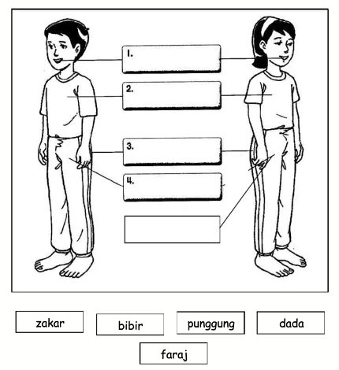

chest

penis

Diagram 1: Sample activity used in a CSE curriculum in Malaysia
(Source: Online)

Translations in Red-coloured Fonts

buttocks

vagina

lip
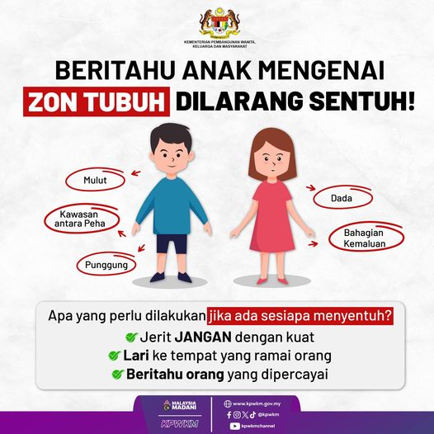

Diagram 2: Social Media Poster on Unsafe Touches Zone
(Source: Women’s Ministry)

Translations in Red-coloured Fonts

mouth

Chest

Area between the thighs

buttock

Private part

This indicates that current efforts being carried out are far from sufficient to equip not just children, but also adults, with the basic sexuality education to live informed, empowered, and meaningful lives.

The communities in Malaysia are not ready to have discussions on bodily autonomy. The moment children display sexualised behaviour, society is alarmed. They do not consider the child’s healthy sexual development and often, the Government proposes controlling and repressive solutions that are in fact not in the best interest of the child.

Sexualisation of Children Disguised as Protection

The young people we spoke to agreed that this practice continues to remain relevant because Malaysia still has strong harmful gender norms affecting women, girls, and gender diverse persons. They feel infuriated that society takes very protective and controlling measures in the name of ‘safety’ and ‘child protection’. It is evident that FGM/C as a norm is also influenced by the fact that it is treated as an encouraged proactive measure to curtail women’s desires.

“I do think it is a very sensitive topic considering how taboo discussions of women’s bodies are in Malaysia. But I feel like khitan is just another way for people in power to police women’s bodies.” Young people, 24 years old, Selangor

A young queer person spoke to us about purity culture which is a driver to FGM/C and how it is specifically targetting girls and gender diverse children. Purity culture may manifest as social scripts and traditional gender roles imposed on marginalised communities. Girl children are subjected to sexual shame as early as their toddlerhood. It is extremely troubling that the culture of sexualising children warrants harmful practices like FGM/C to persist.

Recommendations

COMMUNITY
1. Institutionalise FGM/C prevention education in pre-marital courses, the PEERS CSE curriculum, and other relevant courses
2. Institutionalise parental training on children’s rights, especially on SRHR and bodily autonomy
3. Instutionalise human rights standards in the medical practice through regulating bodies such as the Medical Council

GOVERNMENT
1. Institutionalise children’s participation in stakeholder engagements and dialogues with religious departments, the legal affairs bureau, medical councils, and others
2. Coordinate multistakeholder working committees to end FGM/C between the Women’s Ministry, Health Ministry, Religious Affairs State Departments, and other relevant agencies
3. Institutionalise and implement Article 12 of UNCRC in laws, and at the programme and policy level so that children are part of the advocacy initiatives and survivors’ voices are centered
4. Include FGM/C prevention in the National Policy and Plan of Action on Children and its implementational frameworks
5. Implement gender mainstreaming in all sectors to incorporate the gender lens in law and policymaking
6. Regulate medical business entities by invoking human rights safeguarding and monitoring through mechanisms as such SUHAKAM and HRDDs

CSOs
1. Institutionalise and implement Article 12 of UNCRC at the programme and policy level so that children are part of the advocacy initiatives and survivors’ voices are centered

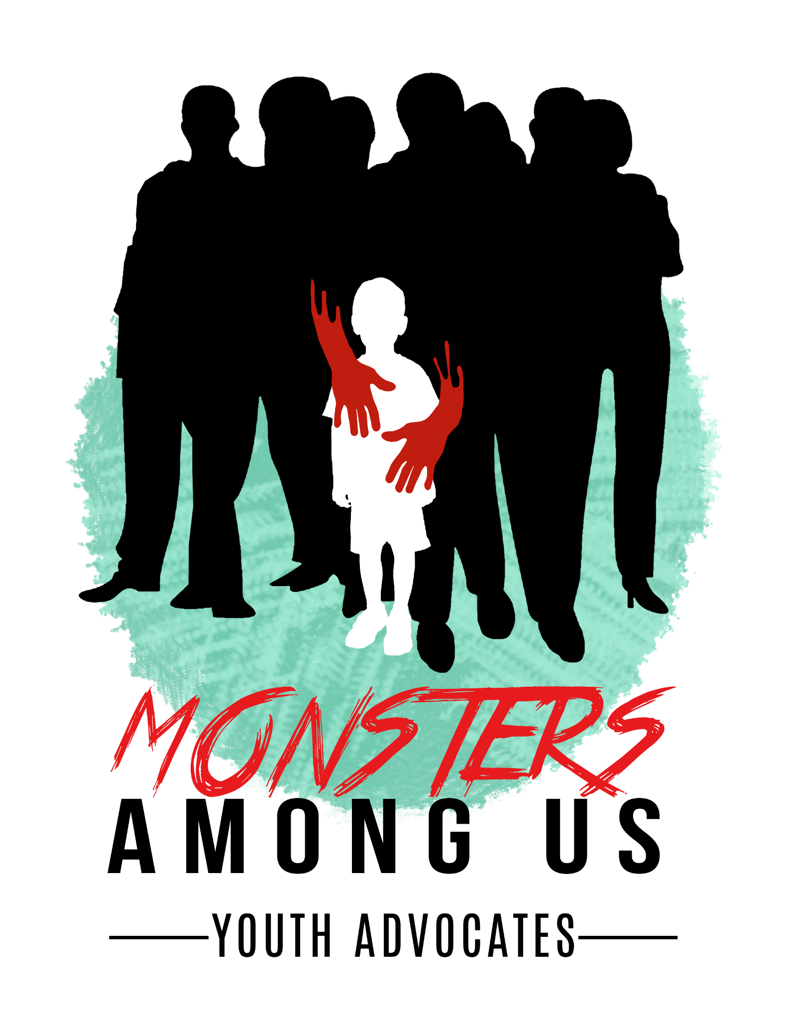
About MAU (Malaysia)

MAU was established in 2017 as a youth-led organisation advocating for the end of systemic violence against children in Malaysia. Founded by a youth herself, MAU centres Article 12 of the UNCRC in their work to ensure safe and meaningful spaces for children and young people to participate in safeguarding their rights.

MAU has implemented activities in partnership with UNICEF Malaysia on digital rights, the principle of the best interest of the child. One of their staple programmes is My Body My Rules, a comprehensive sexuality education tailored for communitiy capacity building and resilience.

Additional Submission to CRC for 100th Session
Malaysia State Review
By Monsters Among Us (MAU)

Written by:
Firzana Redzuan, Founder, Advocacy and Strategy Lead
Monsters Among Us (MAU)

Contributed by:
- Farrah Nur Farena
22 years old
Selangor
- Natasya
23 years old
Young woman
Selangor
- Sashvinisha Maria Balan
24 years old
Young woman
Selangor
- Mithrra Ravinderan Nair
18 years old
Young woman
Selangor

https://www.ohchr.org/en/documents/general-comments-and-recommendations/crccgc15-general-comment-no-15-right-child-highest
https://www.malaysia.gov.my/portal/subcategory/1601
https://oxford-review.com/the-oxford-review-dei-diversity-equity-and-inclusion-dictionary/cisgender-definition-and-explanation/
https://www.transresearch.org.au/post/pelvicpain
https://bernama.com/en/news.php?id=2433668

