Additional submission to the UN Committee on the Rights of the Child

Unrecognized: Assessing Bedouin Children's Rights Infringements in Israel's Negev-Naqab

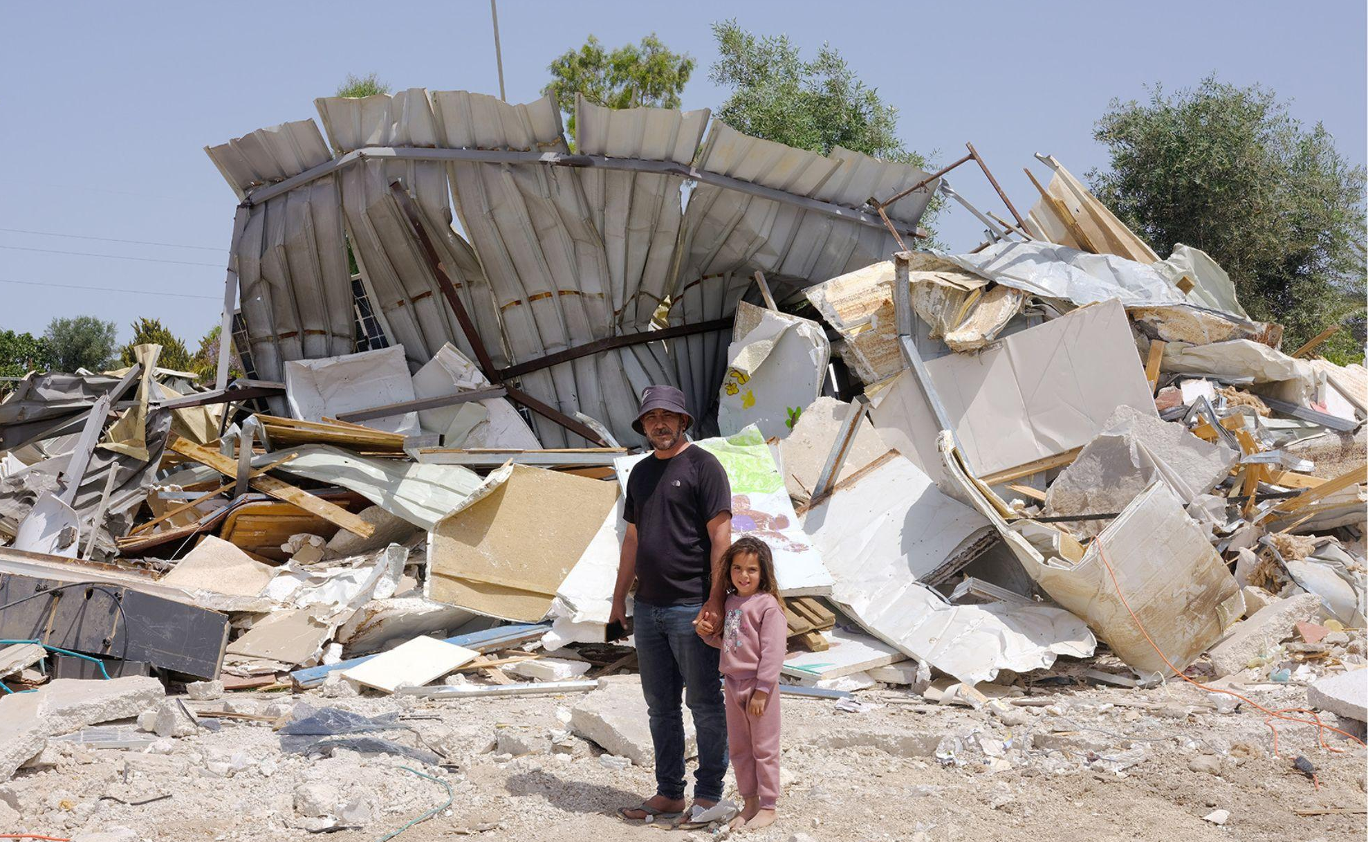
Na'amr Abu Assa and his five-year-old daughter, standing beside the remnants of their home in Wādī al-Khālīl, May 2024.
Photo: Miki Katzman in cooperation with NCF

The Negev Coexistence Forum for Civil Equality (hereinafter NCF) and Sidreh hereby respectfully submit the following report to the Committee of the Rights of the Child, while considering Israel's Third Periodic Report on its Implementation of the Convention on the Rights of the Child. In this report, NCF and Sidreh will demonstrate infringements of the Convention in Israel, specifically among the Bedouin population in the Negev-Naqab region.

Israel’s Bedouin citizens are indigenous to the Negev (Arabic: Naqab) region, where they have lived for centuries as a semi-nomadic people, long before the establishment of the State of Israel in 1948. The Bedouins of the Naqab are part of Israel’s Arab-Palestinian minority population, holding Israeli citizenship. Today, some 300,000 Bedouin citizens of Israel live in the Naqab in three types of communities: government-planned townships, recognized villages, and unrecognized villages. According to the Central Bureau of Statistics, these communities are among the poorest in Israel. The National Insurance Institute documented that in 2018, 79.6% of Bedouin children lived below the national poverty line. In this report, we will highlight Israel’s violations of the Convention on the Rights of the Child in key areas affecting Arab-Bedouin children, including education, poverty, food insecurity, lack of access to healthcare services, discrimination, lack of missile shelter, and psychological well-being.

Negev Coexistence Forum for Civil Equality (NCF) is an Arab-Jewish organization, established in 1997 by a group of concerned Arab and Jewish residents of the Negev-Naqab, whose goal is to promote a shared society and provide a platform for joint activism to address civil rights inequalities. NCF recognizes the neglect of various Israeli governments and their authorities, who have denied full rights to the Bedouin community in the Negev-Naqab, and NCF acts to prevent further affliction and harm to recognized and unrecognized villages and their residents. NCF's activities are varied and include but are not limited to: local and international advocacy, research, community activities, public protests, social media, collaboration with Israeli and foreign media. All activities are based on Arab-Jewish partnership.

Established in 1998, Sidreh’s mission is to support the Palestinian-Bedouin woman in the Negev-Naqab in her pursuit of full self-realization and her rights, as well as those of her community. To achieve our mission, Sidreh focuses on four main strategic objectives: 1) Access to knowledge: improving the educational levels of Bedouin women; 2) Access to resources: promoting economic resilience of Bedouin women by increasing income and maximizing the use of available resources; 3) Gender equality and participation: improving the social position of women and advancing women’s rights; and 4) Sustainable development: professionalization and organizational development.
TABLE OF CONTENT
I. Executive Summary: Overview of key findings and issues addressed.

II. Legal Framework and Discriminatory Practices (Issue 2d and 4a)
A. Legal Framework and Basic Laws
B. Budget Allocations and Resource Disparities
C. Lack of Emergency Shelters and Its Implications
D. Government Actions
E. Recommendations
III. Access to Healthcare (Issue 9b)
A. Challenges
B. Government Measures
C. Recommendations
IV. Land Rights and Food Security (Issue 9d)
A. Land Rights and Confiscation
B. Escalation of Demolitions
C. Food Security
D. Recommendations
V. Mental Health Services (Issue 9e)
A. Unique Challenges
B. Availability of Services
C. Government Actions and Availability of Services
D. Recommendations
VI. Social Services and Poverty (Issue 9f)
A. Poverty Rates
B. Social Safety Net
C. Recommendations
VII. Inclusive Education (Issue 10b)
A. Barriers to Inclusion
B. Government Actions and Initiatives
C. Recommendations for Enhancing Inclusive Education

VIII. Conclusion: Summary of Urgent Needs and Calls for Action.

I. Executive Summary
The Bedouin population in the Negev-Naqab has a rich history, living semi-nomadically in the region long before the establishment of the State of Israel. Approximately 300,000 Bedouins live in government-planned townships, recognized villages, and unrecognized villages. Despite their Israeli citizenship, Bedouin communities are among the poorest in the country, with 79.6% of Bedouin children living below the national poverty line according to the National Insurance Institute. This report highlights violations of the Convention on the Rights of the Child in several critical areas:
- Education: Bedouin children face significant barriers to accessing quality education, due to discriminatory budget allocations, inadequate facilities, and culturally insensitive curricula.
- Poverty and Food Insecurity: The high poverty rate among Bedouin families leads to severe food insecurity, which adversely affects children's physical and cognitive development.
- Access to Healthcare Services: Many Bedouin children suffer from a lack of access to essential healthcare services, which is further exacerbated by the unrecognized status of their villages and inadequate infrastructure.
- Impact of Home Demolitions: Frequent home demolitions create instability and trauma, disrupting children's education and sense of security, both physically and psychologically.
- Discrimination and Lack of Emergency Shelters: Systemic discrimination regarding protection and insufficient emergency shelter provisions leave Bedouin children vulnerable during conflicts. The lack of shelters is especially dire, as highlighted by recent incidents in which Bedouin children were injured or killed by missile attacks due to inadequate protection.
- Psychological Well-Being: The ongoing discrimination, lack of services, and constant threat of home demolitions negatively impact the psychological well-being of Bedouin children.
Our findings underscore the urgency of addressing these issues. Immediate and concrete action from the Israeli government is necessary to ensure the well-being and rights of Bedouin children, in line with the principles of the Convention on the Rights of the Child.

II. Legal Framework and Discriminatory Practices Affecting Bedouin Children (Issues 2d and 4a: 2(d), (Comments on measures taken to guarantee equality and non-discrimination concerning non-Jewish children following the adoption of the Basic Law. - Concerned that the Basic Law can increase ethnic segregation. Comment on budget allocations that can disadvantage non-Jewish children), and Issue 4(a) (progress made in enshrining the principles prohibiting discrimination and guaranteeing equality in the State party’s Basic Laws, repealing discriminatory laws and policies against non-Jewish children).
This chapter addresses the concerns related to the legal frameworks and discriminatory practices that impact non-Jewish children, particularly Arab-Bedouin children, in Israel. It responds to Issues 2(d) and 4(a) by analyzing existing Israeli Basic Laws and policies, examining budget allocations, and proposing steps to ensure non-discrimination and equality.

A. Legal Framework and Basic Laws
Concerns Regarding Basic Law: The adoption of “Israel’s Basic Law: Israel as the Nation-State of the Jewish People” in 2018 has raised significant concerns regarding its potential to increase ethnic segregation and to institutionalize discrimination against non-Jewish citizens, including Bedouin children. The law asserts the unique right of Jewish people to self-determination in Israel, which can be interpreted as marginalizing non-Jewish communities and exacerbating inequalities.
Impact on Bedouin Children: The Basic Laws of Israel, and particularly the “Basic Law: Human Dignity and Liberty”, while foundational to the legal system, do not explicitly prohibit discrimination or guarantee equality for all citizens, including non-Jewish children. The lack of specific anti-discrimination provisions has perpetuated systemic discrimination against the Bedouin community. Bedouin children, in particular, face significant barriers to accessing quality education, healthcare, and other essential services, due to discriminatory laws and policies.

B. Budget Allocations and Resource Disparities

Discriminatory Budget Practices: Budget allocations in Israel have favored Jewish communities, often at the expense of non-Jewish populations. This disparity is particularly pronounced in the Negev-Naqab region, where Bedouin children face significant disadvantages due to insufficient funding for essential services. Schools in Bedouin communities receive significantly less funding per student than schools in Jewish communities. This results in sub-satisfactory educational facilities, fewer resources, and a lower quality of education for Bedouin children. Lack of investment in infrastructure in unrecognized Bedouin villages often results in a lack of essential amenities such as electricity, water, and paved roads. This affects the quality of life and hinders access to education and healthcare.
Bedouin children face significant challenges in their learning environment. Many classrooms are overcrowded, absorbing far more students than the physical space should reasonably allow, impeding effective teaching and learning. In some cases, children have been forced to learn in makeshift tents or other structures, which are inadequate, particularly in extreme weather conditions. The lack of proper educational facilities and infrastructure contributes to higher dropout rates and lower educational achievements among Bedouin children.
Early-childhood Education: In practice, kindergartens for children ages three to five have been established in some villages, but in other villages, there are no kindergartens at all, or there is not a sufficient number of kindergarten classes, causing inequalities among children of the same age. High Court rulings have starkly highlighted legal discrimination, specifically targeted against Bedouin children, with several decisions endorsing policies that prevent the establishment of kindergartens in unrecognized villages in the Negev region. This stands in sharp contrast to other rulings that mandate the establishment of schools and their connection to road networks in other Jewish communities. In a particularly revealing decision, Justice Elyakim Rubinstein suggested that the state should employ creative solutions to provide education to children in these villages, yet, regrettably, no such "creativity" has been prioritized. Despite a national policy that emphasizes the importance and benefits of early childhood education and promises free schooling for children in these age groups, under the initiative dramatically named "Turning the Pyramid Upside Down”, more than 5,000 Bedouin children still lack kindergarten access today (17% of the age group). This inconsistency reveals a profound judicial and policy disjunction that exacerbates the educational challenges faced by Bedouin communities.
C. Lack of Emergency Shelters and Its Implications
Connection to Discriminatory Practices: The lack of emergency shelters in Bedouin villages underscores the broader issue of unjust practices against Bedouin children and is exacerbated in times of conflict. While Jewish communities are more often equipped with adequate protective infrastructure, like the proper number of safety shelters per population and Iron Dome protection, Bedouin children in unrecognized villages are left without safety shelters, exposing them to greater risk during conflicts.
Recent Conflicts and Their Impact: During recent conflicts, such as the outbreak of war between Israel and Hamas in October 2023, the absence of shelters in Bedouin communities has highlighted the severe neglect and discrimination those communities face. Tragically, seven Bedouin children were killed by missiles and rockets–the highest rate of any community in Israel during this time, as a direct result of the lack of adequate protective infrastructure.
In April 2024, during an Iranian attack, a seven-year-old Bedouin child from an unrecognized village was the only person in Israel severely injured. This village of more than 5000 inhabitants had only one shelter, which was not provided by the State and was only large enough to protect 12 people. This incident starkly illustrates the life-threatening risks imposed on Bedouin children due to inadequate shelter provisions.

D. Government Actions
Despite the concerted efforts of the Negev Coexistence Forum for Civil Equality (NCF), in collaboration with the Association for Civil Rights in Israel (ACRI), RCUV, and others, the Israeli government has made little progress in addressing the urgent need for shelters and infrastructure in Bedouin communities. Over the years, NCF has published detailed reports highlighting the risks faced by Bedouin communities, due to the lack of safety shelters. NCF has consistently lobbied to the Knesset for better protection and infrastructure for Bedouin villages and has engaged in media outreach, especially during the initial months of the recent war, to draw attention to these critical issues. Together with other civil society organizations, our work has led the Home Front Command to install dozens of 80 mobile shelters, in schools in Bedouin villages, but these efforts fall significantly short of meeting the needs of the Bedouin population. The Government's actions remain inadequate, leaving Bedouin children and families vulnerable and underserved.
After years of advocacy, some investment has been made to improve infrastructure in Bedouin communities, such as connecting villages to electricity and water grids. However, these efforts remain limited, and many unrecognized villages still lack essential infrastructures, such as paved roads, electricity, sewage systems, and adequate internet access.
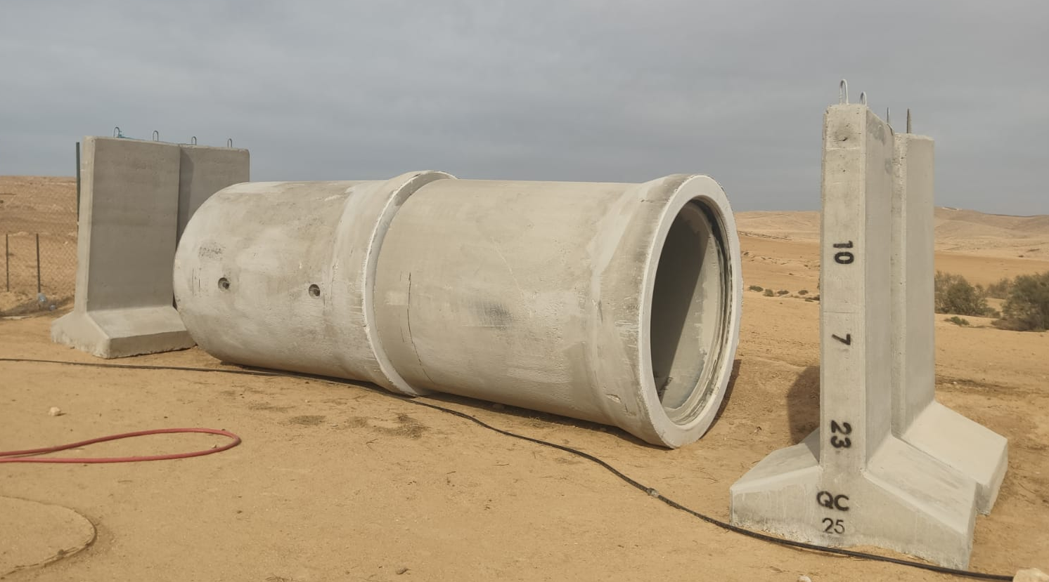
Mobile shelter in the unrecognized village of Al-Bat, installed after four children were killed by missiles launched from Gaza on October 7, 2023.
Photo by NCF staff

E. Recommendations
Legal Reforms:
- Amend the Basic Law: Human Dignity and Liberty to explicitly guarantee equality and non-discrimination for all citizens, regardless of ethnicity or religion.
- Repeal discriminatory laws and policies that disadvantage non-Jewish children, ensuring that all children in Israel have equal rights and opportunities, from birth.
Budget Reallocations:
- Ensure equitable distribution of budget resources to address the disparities faced by Bedouin communities.
- Increase funding for education, infrastructure, and healthcare in Bedouin villages to improve living conditions and provide access to essential services.
Infrastructure Development:
- Construct an adequate number of emergency shelters and the proper protective infrastructure in Bedouin villages to ensure the safety of children during conflicts.
- Invest in essential amenities such as electricity, water, and paved roads in unrecognized villages to enhance the quality of life and access to services.
- Specific policy changes are needed to establish kindergartens and improve transportation for Bedouin children in unrecognized villages. This would ensure that all children, from an early age, have access to foundational education, which is crucial for their long-term development and integration into the broader society.
Addressing the issues raised in this chapter is critical to ensuring the rights and well-being of Bedouin children in Israel. The government must take concrete actions to dismantle discriminatory practices, amend legal frameworks, and ensure equitable resource allocation. By doing so, Israel can move toward a more inclusive society where all children, regardless of their ethnic or cultural background, can thrive and enjoy equal opportunities. The lack of legal recognition status for unrecognized Bedouin villages, coupled with discriminatory policies affecting Arab citizens, undermines Israel's claim as a state for all. NCF maintains that granting full legal recognition and the end of discriminatory practices are essential to ensure that all citizens are equally represented and protected by the law.

III. Access to Healthcare (Issue 9b): Provide information on measures in place to guarantee safe and unconditional access to health services and adequate medical supplies for all pregnant women and children.
This chapter addresses Issue 9(b), focusing on the measures in place to guarantee safe and unconditional access to health services and adequate medical supplies for all pregnant women and children in Bedouin communities. It examines the challenges faced, evaluates existing governmental measures, and provides recommendations for improving healthcare access.
A. Challenges
Geographical and Infrastructural Obstacles: Access to medical services in unrecognized Bedouin villages in the Negev-Naqab is scarce. Bedouin communities are often situated in remote locations with insufficient infrastructure, making it challenging for residents to reach medical clinics. The absence of paved roads usually prevents emergency services, such as Magen David Adom (MDA), from accessing these villages, which significantly impairs the delivery of urgent medical care. As a result, residents must travel considerable distances to obtain necessary treatment, which can pose serious risks during emergencies. Additional reliable public transportation is needed to ensure access to healthcare facilities, when individuals are required to undertake lengthy journeys for medical services.

Systemic Barriers to Basic Services: The Bedouin communities in the Negev-Naqab encounter systemic barriers to accessing basic services, including healthcare. Unrecognized villages lack essential infrastructure, including healthcare facilities. Even when such facilities exist, they often fail to meet the communities' cultural and linguistic needs, leading to exclusion and marginalization. Denying a community’s recognition and, therefore, access to essential services, breaches international legal standards and severely limits the Negev-Naqab Bedouin community’s economic, social, and cultural advancement.

Sanitary Conditions and Health Concerns: The dangerous sanitary conditions in unrecognized villages contribute to health issues. These conditions are particularly hazardous for pregnant women and children, who are more vulnerable to infections and diseases. The physical dwellings in these areas lack adequate infrastructure for safe isolation, which was especially problematic during the COVID-19 pandemic.

Lack of healthcare facilities: The right to health, as recognized in the Universal Declaration of Human Rights and the International Covenant on Economic, Social, and Cultural Rights (ICESCR), entitles all persons to the highest attainable standard of health. However, the State of Israel continuously violates the Bedouin people’s right to health. In most of the 35 unrecognized villages, there are no medical clinics to provide basic health services in those. There are only four clinics among the following villages: Abdeh, Wadi al Na’am, Chirbat al Watan, and al Zarnoug. And in those where they do exist, clinics are often arbitrarily closed, raising considerable obstacles to receiving consistent and reliable care.

Language and Cultural Barriers: As with many other challenges, the language and cultural barriers significantly impede healthcare access for pregnant Bedouin women. Many healthcare providers in the region do not speak Arabic, leading to frequent miscommunications. This issue is particularly acute with Bedouin women, who often cannot navigate healthcare facilities due to language differences. For instance, the use of Hebrew in automated healthcare queue systems often leads to long wait times and missed appointments with non-Hebrew-speaking patients. Additionally, the cultural insensitivity of healthcare providers can further alienate these women, making them reluctant to seek necessary medical care in the first place.

Infant Mortality Rates in Bedouin Communities: The stark disparities in healthcare access for the Bedouin communities in the Negev-Naqab are further illuminated by infant mortality rates, which are significantly higher than the national average in Israel. According to data from 2018 to 2022, the national average for infant mortality rates was 2.8 deaths per 1,000 live births. In contrast, Bedouin localities reported much higher rates, with an average of 8.01 deaths per 1,000 live births.

Impact of Conflict: At the beginning of the recent conflict, Israel shut down medical clinics in numerous Bedouin communities in the Negev, per instructions from the Israeli Army's Home Front Command, due to safety concerns related to the absence of shelters, which the Home Front Command itself did not provide. This two-week closure left residents without any nearby medical facilities, exacerbating their already-limited access to healthcare services.

B. Government Measures
Existing Programs and Initiatives: In response to the healthcare access challenges faced by Bedouin communities in the Negev-Naqab, the Israeli government implemented several measures under the "Tkadum – Progress" plan. This initiative, which is part of a broader five-year strategy involving a budget of approximately 30 billion NIS, aims to enhance healthcare services, among other areas. Despite these efforts, significant infrastructural and logistical barriers persist, especially in unrecognized villages where access to medical services remains severely limited. Additionally, the effectiveness of these measures is questioned, given the ongoing infrastructural deficits and cultural insensitivities that continue to hinder the delivery of healthcare to these communities.
C. Recommendations
Expand Mobile Clinics:
  - Increase the number clinics and mobile clinics and the frequency of their visits in Bedouin communities.
  - Ensure that these clinics are well-equipped with medical supplies and staffed by healthcare professionals trained in appropriate cultural sensitivity and language skills.

Infrastructure Development:
  - Improve infrastructure in unrecognized villages, including paving roads and establishing reliable public transportation routes.
  - Develop permanent medical facilities within these communities, ensuring they are equipped with emergency safety shelters and can provide emergency services.

Cultural Mediation and Language Services:
  - Provide training for healthcare providers in cultural mediation and Arabic language skills to improve communication and trust with Bedouin patients.
  - Employ community health workers from Bedouin communities to act as liaisons between residents and healthcare providers.

Emergency Response Enhancements:
  - Ensure that emergency services, including MDA, have the necessary infrastructure and support to reach unrecognized villages and that existing clinics have protective shelters.
  - Develop contingency plans for maintaining healthcare access during conflicts or other crises, including the establishment of temporary medical facilities.
By implementing these recommendations, Israel can significantly improve the health and well-being of Bedouin children and pregnant women, ensuring they receive the essential medical care they need.

IV. Land Rights and Food Security (Issue 9d) - Actions taken to restore confiscated land to Bedouin families and to ensure their access to safe drinking water, sanitation, and food.
This chapter addresses Issue 9(d), focusing on the measures taken to restore confiscated land to Bedouin families and to ensure their access to food. Specifically, we will highlight the critical issues of home demolitions, displacement, and food security. While access to safe drinking water and sanitation is part of the broader issue, this chapter will concentrate solely on the challenges related to land rights and food security faced by Bedouin communities in the Negev-Naqab region.
A. Land Rights and Confiscation
The Bedouin communities in the Negev-Naqab have a long history of living on and cultivating their ancestral lands. However, since the establishment of the State of Israel in 1948, these communities have faced systematic land confiscation and displacement.
Restoration Efforts: To our knowledge, nothing has been done by the Israeli government and/or other official authorities to restore confiscated land to Bedouin families. Various legal and grassroots initiatives have been advocating for the recognition of Bedouin land rights. During the Bennett-Lapid government, as part of the coalition agreement with MK Mansour Abbas, three unrecognized Bedouin villages (ʿAbdih, Rakhamah, and Khašim Zannih) were recognized. The recognition of more villages was discussed, but the government dissolved. And the current government has not recognized any additional villages, nor restored any land, with several cases of land disputes still pending in court. The case of Wādī al-Khālīl starkly illustrates this pattern of neglect and the dire consequences for Bedouin communities, particularly the children who face disrupted lives and uncertain futures.
Demolition of Wādī al-Khālīl: In May 2024, the entire unrecognized village of Wādī al-Khālīl was demolished by the authorities. 47 houses along with the local mosque and agricultural buildings were razed, leaving approximately 350 residents homeless, half of them children. This demolition was justified as an assertion of sovereignty and to clear land for extending Road 6—a project not yet scheduled for construction nor budgeted by the state, despite the humanitarian crisis it caused. In anticipation of relocation, some villagers had agreed to move to Mitla, near Tel Sheva, but development there has not even started. Currently, the former residents of Wādī al-Khālīl live in temporary tents without proper facilities, a situation that exacerbates the instability and hardship faced by the community, particularly impacting the children who have lost their homes and access to a stable environment. This action is part of a troubling trend of land confiscation under the guise of urban development, further destabilizing the already-precarious situation of Bedouin communities. In June 2024, NCF conducted a Human Rights tour with diplomats. The group met a Bedouin woman cooking and making coffee in her truck, her makeshift home. She took us to her daughters who were forced to study for their upcoming exams under the shade of one of the remaining trees. (Several trees were cut down by the authorities.)
Chikli Plan: In June 2023, the Ministerial Committee for Regulating the Settlement and Economic Development of the Bedouin Community in the Negev approved the Chikli Plan. This plan appears to involve forceful actions targeting specific areas, including Rahat and its surrounding regions, Hurah, Mareit in the Arad Valley, and Bir Hadaj, without considering or involving the families living there. Concerns have been raised that this plan may lead to widespread village evictions, particularly affecting Bedouin inhabitants in Tal-Arad near Arad and Awajan near Lakiya. The plan aims to consolidate existing towns without recognizing or accommodating any unrecognized Bedouin villages, while failing to provide viable alternatives for preserving Bedouin communities and serving their growth.
Be’er Sheva Court Ruling on Rās Jarābā: The Magistrate's Court in Be'er Sheva ruled to evacuate the village of Rās Jarābā to expand the city of Dimona eastward. The ruling affects 550 residents who have lived in Rās Jarābā since before the establishment of the State. They were ordered to evacuate and demolish their homes by March 2024. Residents' requests to integrate into the urban expansion were rejected, and they were only offered housing solutions in settlements designated for Bedouins by the State. The court-imposed attorney's fees of NIS 117,000 on the defendants. The village has strong ties to Dimona, with many residents employed there and receiving most of their services there. Despite the residents' desire to be integrated into the city expansion, their proposals were rejected by the Israeli Land Authority and the Authority for Development and Settlement of the Bedouin in the Negev, which only offered solutions in the village of Qasr al-Sar, which were unacceptable to the residents, as they were based on lands belonging to other Bedouin families. Adalah, a legal organization representing the residents, re-appealed the decision to the district court, and the court gave them until the end of the year to evacuate the village.
Escalation of Demolitions: The trend of increasing demolitions in the Negev reached new heights in 2023, with a record 3,283 structures demolished—a rise of over 15% from the previous year and more than triple the numbers from 2014. These operations utilized advanced aerial mapping technologies like the "Simplex" and "Raphael" systems, facilitating meticulous planning and execution. The surge in demolitions was particularly notable under the policy direction of Minister Ben Gvir, indicating a marked escalation in both the frequency and severity of these actions. Notably, the decrease in humanitarian cancellations of demolition orders—from 33 in 2022 to just 14 in 2023—underscores a diminished regard for the humanitarian needs of the community. The first half of 2023 alone saw 1,767 demolitions, and despite a temporary halt during the early months of the war, the first half of 2024 recorded even more, with 2,007 demolitions. This relentless pace continues unabated in 2024, with demolitions occurring weekly, exacerbating the instability and hardship faced by Bedouin families. This has particularly severe implications for children, who experience disrupted lives and a profound sense of insecurity.
The relentless pace of home demolitions and displacement has severe consequences that extend beyond immediate shelter insecurity. The destruction of homes and agricultural lands directly undermines the food security of Bedouin communities in the Negev. Traditional agricultural practices, which form the basis of their food production and livelihood, are disrupted, pushing families, especially children, into a cycle of food insecurity. The confiscation of land further exacerbates this issue by severing their connection to cultivable land, making it increasingly difficult for them to sustain themselves.
B. Food Security
Impact of Land Confiscation on Food Security: The confiscation of land severely impacts the food security of Bedouin communities. Traditional agricultural practices, which form the basis of their food production and livelihood, are disrupted by land confiscation and home demolitions.
Challenges Faced:
- Loss of Agricultural Land: Confiscated lands often include vital agricultural areas, leading to a significant reduction in food production. The lack of access to these lands results in a decline in traditional farming and herding practices, which are a tradition for Bedouin way of life.
- Economic Impact: The inability to cultivate land or raise livestock directly affects the economic stability of Bedouin families, increasing poverty and food insecurity. Many Bedouin families rely on small-scale agriculture and herding for their livelihood, and the loss of land disrupts these practices.
- Poverty and Restricted Access to Markets: Displacement and the unrecognized status of many Bedouin villages significantly restrict access to markets where they can sell their produce or purchase food. The geographical isolation of these communities exacerbates food insecurity, as they face challenges in accessing affordable and nutritious food. Furthermore, poverty within these communities is closely tied to food safety and security; without stable income, families struggle to procure sufficient food. Even when food is available, the lack of resources to store and prepare it safely poses additional risks. The Bedouins' geographic remoteness, compounded by poor internet and road infrastructure, limits their access to markets and vital information that could improve their food safety knowledge and practices. These conditions underscore the urgent need for policy interventions that enhance both the sense of security and the actual physical and economic accessibility to safe, nutritious food for the Bedouin communities.
Findings from NCF and Adva Research: Research conducted by NCF and Adva Center highlights the severe food insecurity faced by Bedouin families due to land confiscation. The study found that a significant percentage of Bedouin children suffer from malnutrition and stunted growth, directly linked to the lack of access to arable land and nutritious food. The research also indicates that food insecurity is higher in unrecognized villages compared to recognized ones, primarily due to the lack of infrastructure and support services.
Current War Impact: In the wake of the conflict between Israel and Hamas, which erupted on October 7, 2023, Nagabiya - NCF’s Research and Information Hub of Bedouin Society in the Negev-Naqab – swiftly initiated a comprehensive study of food security, by analyzing administrative data and survey responses from 350 Bedouin men and women across the Negev-Naqab. The research scrutinized the economic and occupational repercussions of the hostilities on local Bedouin communities. Administered during the final fortnight of November 2023, the survey captured the sentiment approximately six weeks post-initial conflict, offering insights from a cross-section of society: 46.3% from planned towns, 36.3% from unrecognized villages, and 17.4% from recognized villages. The Israeli Employment Service provided administrative data, aiding an in-depth evaluation of the war's consequences on the Bedouin population.
Emergency Response: During the outbreak of the war, NCF took immediate action to address food security by distributing food packages and five tons of flour to over 3,200 families, even though it is not part of the NGO's usual work. This emergency response provided an important, but only temporary and partial, solution to the urgent need for food aid in unrecognized Bedouin villages amidst the turmoil. NCF’s response underscored the necessity for well-targeted support and strategic interventions to mitigate the compounded risks of food insecurity for the Bedouin community, especially in the aftermath of armed conflict. Targeted support could range from improving educational opportunities to establishing more robust emergency response systems, ensuring that these communities are better prepared to withstand and recover from such crises.
C. Recommendations
Land Rights Recognition:
- Implementation of transparent and fair processes for recognizing unrecognized villages and restoring land rights to Bedouin communities.
- Amendment of discriminatory laws and policies to ensure equitable treatment of Bedouin land claims.
Support for Sustainable Agriculture:
- Providing support for sustainable agricultural practices that enable Bedouins to utilize their land effectively and traditionally.
- Development of programs that ensure access to agricultural resources, including water, seeds, and tools.
- Facilitate access to agricultural resources like water, seeds, and tools, emphasizing educational initiatives for children about sustainable practices and environmental stewardship.
- Introduce school programs and community workshops that engage children in farming techniques, reinforcing their connection to the land and their cultural heritage.
Economic Support:
- Implementation of economic support programs to help displaced families rebuild their livelihoods.
- Ensuring fair compensation for confiscated land that is adequate to cover losses and support sustainable, appropriate resettlement.
Access to Markets:
- Improvement of infrastructure to facilitate access to markets for Bedouin farmers and producers.
- Supporting the creation of local markets within Bedouin communities to enhance food security and economic stability.
The restoration of confiscated land and the assurance of food security are critical for the well-being and sustainability of Bedouin communities in the Negev-Naqab and their children. Addressing these issues requires a multifaceted approach that includes legal recognition of land rights, support for sustainable agriculture, economic assistance, and improved access to markets. By implementing these measures, the Israeli government can promote justice, stability, and the preservation of Bedouin heritage and livelihoods.
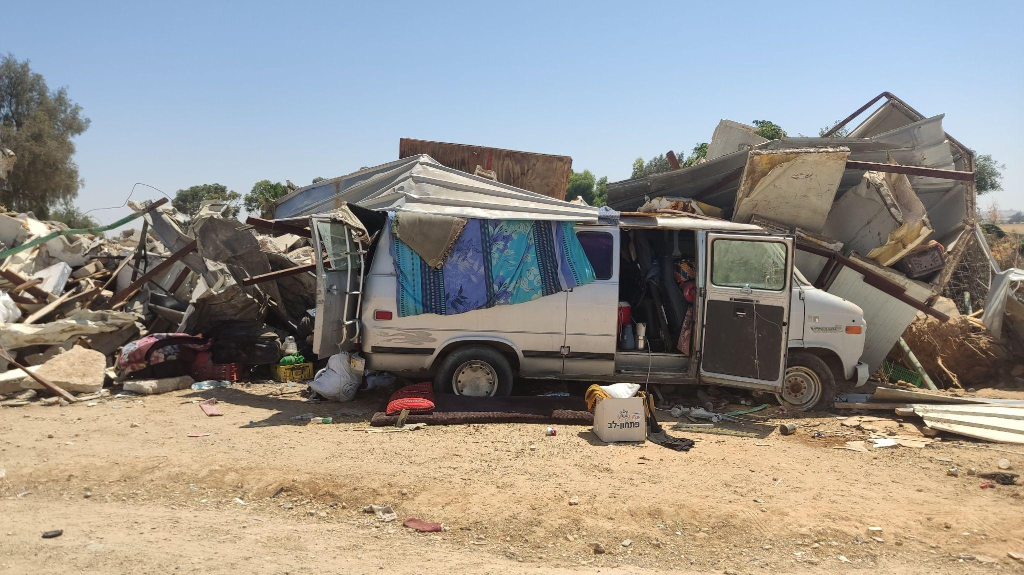
Home demolitions in Wādī al-Khālīl
Photographed by NCF staff.

V. Mental Health Services (Issue 9e): Actions taken by the government to increase access to psychological counseling services for Bedouin children.
A. Challenges
Bedouin children in the Negev-Naqab region face unique and significant mental health challenges due to a combination of socio-economic hardships, displacement, poverty, and discrimination. The constant threat and reality of home demolitions, coupled with the systemic neglect of their communities, create an environment of chronic stress and trauma. Many Bedouin children witness and experience violence and instability, which profoundly impacts their mental well-being. Additionally, cultural stigmas associated with seeking mental health care further complicate their ability to receive the support they need.

Availability of Services: The availability of mental health services for Bedouin children is severely limited. There is a critical shortage of mental health professionals in Bedouin schools, with the ratio of professionals to students being significantly lower than the national average. Geographic isolation and a lack of transportation options exacerbate the difficulty of accessing these services. Even when services are available, they are often not culturally appropriate, leading to a disconnect between the needs of Bedouin children and the care provided. Language barriers and a lack of culturally sensitive training among mental health professionals further hinder effective support.

B. Government Actions and Availability of Services
The Israeli government has made limited efforts to address the mental health needs of Bedouin children. While some initiatives and resources have been directed toward improving mental health services, they remain insufficient and inadequately distributed.
School Psychologists: The government has placed some educational psychologists in Bedouin schools. However, the ratio of mental health professionals to students is significantly lower than the national average. Many Bedouin schools lack the necessary number of trained professionals to provide adequate support.
Mental Health Clinics: There are a few mental health clinics in the Negev-Naqab region, but they are often located far from Bedouin communities, making them difficult to access. The lack of transportation options further limits the ability of Bedouin children to reach these services.

Cultural Appropriateness: Existing mental health services are often not culturally appropriate for Bedouin children. Mental health professionals may lack the training and understanding needed to address the unique cultural and social contexts of Bedouin communities. Language barriers also pose a significant obstacle to effective communication and treatment.
BGU Training Program: In response to the critical shortage of mental health professionals in Bedouin communities, Ben-Gurion University of the Negev, with encouragement from the Israeli Council for Higher Education, has initiated a program to train Arab-Israeli and Bedouin master’s students in educational psychology. This program is designed to address the language and cultural barriers that often hinder effective mental health support in Bedouin schools. Despite the initiative, our own findings show that there's still a gap between the needs of the Bedouin communities and the outcomes of the program.

C. Recommendations
To improve access to psychological counseling services for Bedouin children, the following strategies are proposed:
- Increase Funding and Resources: Allocate more resources specifically for hiring and training mental health professionals to work in Bedouin communities. Ensure that every Bedouin school has an adequate number of educational facilities, psychologists, and counselors.
- Mobile Mental Health Clinics: Develop and deploy mobile mental health clinics to regularly visit remote Bedouin villages. These clinics can provide on-site counseling and support, overcoming geographic and transportation barriers.
- Immediate Crisis Support during House Demolitions: In response to the traumatic impact of house demolitions on Bedouin children and families, it is crucial to deploy social workers and psychologists to affected areas during these events. These professionals can provide psychological first aid and ongoing support, helping to manage acute stress and prevent the development of more severe mental health issues. By offering immediate emotional support and counseling, these specialists can assist children and families in processing their experiences, fostering resilience amidst adversity.
- Cultural Sensitivity Training: Implement comprehensive cultural sensitivity training programs for all mental health professionals working with Bedouin children. This training should include language support, cultural context, and awareness of specific traumas experienced by these communities.
- Community Awareness Programs: Launch education and awareness campaigns within Bedouin communities to reduce the stigma surrounding mental health issues. Encourage families and children to seek help and view mental health care as an essential aspect of their overall well-being.
- Integration of Services: Ensure that mental health services are fully integrated into the school system and accessible to all students. Schools should serve as a primary point of contact for mental health support, with dedicated staff and resources to address students' needs.
- Addressing Root Causes: Beyond immediate mental health interventions, it is essential to address the root causes of trauma among Bedouin children. Advocate for policy changes to prevent home demolitions, ensure safe and stable living conditions, and combat discrimination and socio-economic disparities.
By implementing these recommendations, the government can significantly improve access to psychological counseling services for Bedouin children. Ensuring the mental well-being of these children is not only a matter of human rights but also a critical investment in the future of their communities and the broader society.

VI. Social Services and Poverty (Issue 9f): measures taken by the government to guarantee adequate financial support and social services for children and their families living in poverty.
The Bedouin communities in the Negev-Naqab region face severe socio-economic challenges, with poverty rates significantly higher than the national average. Recent studies indicate that over 60% of Bedouin families live below the poverty line, compared to 22% of the general Israeli population. The impacts of such high poverty rates on children are profound, affecting their physical health, educational attainment, and overall well-being. Children in these communities often lack basic necessities such as adequate nutrition, clothing, and educational resources, which hinders their development and perpetuates the cycle of poverty.

A. Social Safety Net:
Social Services: The social services available to Bedouin families are often inadequate and inaccessible. Many Bedouin families, particularly those in unrecognized villages, do not receive the full spectrum of social benefits provided by the State. The lack of infrastructure, such as proper roads and transportation, further isolates these communities from accessing essential services. Additionally, cultural and linguistic barriers contribute to the underutilization of available social services. While some services are available online, the absence of internet access in unrecognized Bedouin villages and the prerequisite digital literacy, which not everyone possesses, further exacerbates the issue. Furthermore, not all online services are available in Arabic, creating additional barriers.
Digital Literacy: NCF implemented a digital literacy program for Bedouin women in unrecognized villages that aimed to empower them by improving their computer and internet skills and enhancing employment opportunities, facilitating access to information and social rights. The program had positive results and was intended to be adopted by the government during the Lapid-Bennett administration. However, no progress has been made on this front since then. The current government's social safety net programs are not sufficiently tailored to address the unique needs of Bedouin families, resulting in widespread disparities.

B. Recommendations:
- Increase Financial Assistance: The government should enhance financial support for Bedouin families, including direct cash transfers and subsidies for basic needs such as food, housing, and healthcare. This would help alleviate the immediate impacts of poverty and provide families with a more stable foundation.
- Targeted Programs to Address Child Poverty: Implement specialized programs aimed at reducing child poverty, such as school meal programs, scholarships for higher education, and initiatives that support children's health and well-being. These programs should be designed to address the specific needs of Bedouin children, taking into account cultural and socio-economic factors.
- Improve Access to Early Childhood Education and Childcare: Expanding access to early childhood education and childcare services is crucial for the development of Bedouin children. The government should invest in building and maintaining preschools and daycare centers in Bedouin communities, ensuring they are affordable and culturally appropriate. Training and employing local staff from these communities would also enhance the effectiveness and acceptance of these services.
- Enhance Employment Opportunities and Economic Development: Creating more job opportunities for Bedouin families, particularly women, is essential for reducing poverty. This includes vocational training programs, incentives for businesses to hire Bedouin workers, the allocation of more kindergarten facilities and support for Bedouin entrepreneurs. Addressing employment barriers, such as weak cellular reception in unrecognized villages, would also help integrate these communities into the broader economy.
- Strengthen Social Service Delivery: The government should improve the delivery of social services by increasing the number of social workers in Bedouin communities, ensuring they are adequately trained to understand and respect the cultural context. Mobile service units could also be deployed to reach remote and unrecognized villages, providing essential services directly to those in need.
- Expand Digital Literacy Programs: Reinstating and expanding digital literacy programs, especially for women, can significantly improve access to online services and potential employment. The government should ensure these programs are widely available and that online services are provided in Arabic to overcome language barriers.
In conclusion, addressing the high poverty rates and inadequate social services for Bedouin families requires a multifaceted approach that combines financial assistance, targeted programs, improved access to education and childcare, enhanced employment opportunities, stronger social service delivery, and expanded digital literacy initiatives. By implementing these recommendations, the government can make significant strides toward ensuring the well-being and rights of Bedouin children in the Negev-Naqab region.

VII. Inclusive Education (Issue 10b): measures taken for fostering an inclusive education system for all children, regardless of individual differences or difficulties, ethnic or cultural background, or socioeconomic status.
Creating an inclusive education system requires concerted efforts to ensure that all children, regardless of individual differences, ethnic or cultural background, or socioeconomic status, can fully participate and benefit from educational opportunities. This chapter examines the barriers to inclusion faced by Bedouin children, evaluates government initiatives aimed at promoting inclusive education, and provides recommendations to address these challenges.
A. Challenges to Inclusive Education
Dropout rates: The alarmingly high school dropout rates among Bedouin students in the Negev are a stark manifestation of systemic inequities in the education system. Inadequate facilities, limited transportation, and a culturally insensitive curriculum create significant barriers to learning. These challenges are compounded by persistent underfunding of Bedouin schools compared to their Jewish counterparts, resulting in overcrowded classrooms and a scarcity of resources. This lack of investment, coupled with the cultural disconnect between Bedouin students and the education system, fosters alienation and disengagement, ultimately driving students away from education.

Inadequate Facilities: Many schools in Bedouin areas need more infrastructure. Classrooms are often overcrowded. This lack of proper facilities severely impacts the quality of education and the learning environment for Bedouin students.

Insufficient Early Childhood Education: Early childhood education, beginning at age three, is critical for cognitive and social development, yet there needs to be more kindergartens in Bedouin communities. This gap places Bedouin children at a disadvantage at the very start of their educational journey, affecting their readiness for primary education and their overall academic trajectory.

Transportation Barriers: Many Bedouin children live in remote, unrecognized villages lacking reliable public transportation, making it difficult for them to attend schools that are often far from their homes. This lack of transportation options compels students to travel long distances on foot or rely on irregular and unsafe means of transport, which adversely affects their attendance and academic performance. (In September 2023, the situation reached a critical point where no buses were available, forcing 6,500 Bedouin children to resort to traveling on donkeys and camels to reach their schools.)

Culturally Insensitive Curriculum: The national curriculum often lacks cultural sensitivity and fails to incorporate the unique heritage and experiences of Bedouin communities. The absence of culturally relevant content can disengage Bedouin students and foster a sense of alienation, undermining their sense of belonging and respect within the education system.

Digital Divide: The stark digital divide in Bedouin communities, exacerbated during the COVID-19 pandemic and other times of conflict when remote learning was necessary, has significantly impacted Bedouin children. Many areas lack reliable Internet access and computers, preventing these children from participating in online classes, leading to considerable learning losses and further widening the educational gap. During the initial phases of the current conflict, schools were closed and shifted to online learning. Israeli children resumed education virtually, but many Bedouin children, still lacking reliable Internet access, were once again left out, missing out on education for up to two months. This ongoing issue deepens the educational disparities.
B. Government Actions and Initiatives
Despite the clear need for inclusive educational practices, the response from the Israeli government has been mixed. Some initiatives aimed at addressing these disparities include:
Targeted Educational Programs: Programs to improve educational outcomes for Bedouin children, such as special grants and initiatives to increase their representation in higher education, have been implemented. However, the impact of these programs is often limited, and they do not sufficiently address the breadth of challenges faced.
​​Establishment of Daycare Facilities: The recent opening of the first daycare center in the unrecognized village of ʿAbdih represents a positive step towards improving early childhood education within Bedouin communities. This initiative, resulting from the collaborative efforts of the Ramat Negev Regional Council, the Neve Midbar Regional Council, and the Senior Division for the Socio-Economic Development of the Bedouin Society in the Negev, demonstrate the possibility of fostering educational access from a young age, but it also highlighted the difficulty in providing these facilities. Despite these efforts, the single facility is highly insufficient and is unable to meet the demographic demands of the region, underscoring the ongoing need for a more comprehensive approach to address the educational needs of Bedouin children comprehensively.
C. Recommendations for Enhancing Inclusive Education
- Expand Early Childhood Education: Increasing the number of kindergartens in Bedouin areas is essential to bridge the educational gap and improve long-term academic outcomes. This initiative would ensure that all children have access to crucial early education.
- Develop Reliable Transportation: Creating reliable and safe transportation solutions for Bedouin children is crucial. This should include establishing school bus services for remote and unrecognized villages to ensure regular and safe school attendance.
- Enhance Digital Inclusion: Bridging the digital divide by ensuring that all Bedouin communities have access to reliable internet and providing the necessary infrastructure and digital devices will support remote learning and digital literacy programs.
- Cultural Sensitivity Training: Implement comprehensive cultural sensitivity training programs for all educational professionals working with Bedouin children. This training should include language support and an understanding of the cultural and social contexts of Bedouin communities and their history.
By addressing these recommendations, the Israeli government can create a truly inclusive education system to ensure that all Bedouin children can fully participate and succeed in school, regardless of their differences, ethnic or cultural background, or socioeconomic status.
VIII. Conclusion
The urgency of addressing the issues raised in this report cannot be overstated. The Bedouin communities in the Negev-Naqab region continue to face significant challenges that undermine their basic rights and well-being. From land confiscation and home demolitions to food insecurity and barriers to inclusive education, these systemic issues demand immediate and concrete action.
It is imperative that the Israeli government takes responsibility and demonstrates accountability in addressing these problems. Tangible steps must be taken to restore confiscated land, ensure access to essential resources, and foster an inclusive education system that respects the cultural and linguistic diversity of Bedouin children.
The rights of Bedouin children and the importance of ensuring their well-being must be at the forefront of any policy or initiative. These children have the right to a safe and nurturing environment, access to quality education, and the opportunity to thrive without the fear of displacement or discrimination.
To ensure equal rights and representation for all citizens, the Israeli government must grant full legal recognition to unrecognized Bedouin villages. Simultaneously, dismantling discriminatory policies targeting the Arab population is crucial for establishing true equality under the law. NCF urges these steps be taken to affirm Israel's commitment to all its people.
The lack of legal status for unrecognized Bedouin villages, coupled with discriminatory policies affecting Arab citizens, undermines Israel's claim as a State for all. NCF maintains that granting full legal recognition and ending these discriminatory practices are essential for ensuring that all citizens feel equally represented and protected by the law.
By taking these actions, Israel can move towards a more just and equitable society, where the rights and dignity of all its citizens, including the Bedouin community, are upheld and respected.

Online database Life characteristics of Bedouin society in the Negev. 2022. Online Database - Life Characteristics of the Bedouin Population in the Negev - Demographics. [online] Available at: <https://in.bgu.ac.il/humsos/negevSus/SYBSN/Pages/demographics.aspx> [Hebrew, Accessed 10 January 2022].
Dimensions of Poverty and Social Disparities - Annual Report, 2018, retrieved from https://tinyurl.com/6jve9ckz [Hebrew]
Ibid.
Adalah's Position Paper: Proposed Basic Law: Israel - The Nation State of the Jewish People UPDATE - 16 July 2018
Adalah: The Inequality Report, the Palestinian Arab Minority in Israel
Adalah: https://www.adalah.org/uploads/oldfiles/upfiles/2011/Adalah_The_Inequality_Report_March_2011.pdf
Mossawa Center: 2023-2024 Israeli State Budget for Arab Society Report Summary
NCF, 2022: Violations of Human Rights of the Arab Bedouin Community in the Negev/Naqab
HRW: https://www.hrw.org/reports/2001/israel2/ISRAEL0901-06.htm
Adalah demands the opening of a kindergarten in the unrecognized Bedouin village of Al Rowais in the Naqab, 2019
https://rashi.org.il/en/turning-the-pyramid-upside-down/
State Comptroller's Report 2022: systemic issues Implementation of reforms and reducing gaps in education for preschoolers
NCF, 2023: Lack of protection against missiles and rockets in the unrecognized villages in the Negev
Ibid
A 7-Year-Old Girl Is the Lone Serious Casualty of Iran’s Barrage, NYT: https://www.nytimes.com/2024/04/14/world/middleeast/israel-iran-negev-bedouin.html
During a visit, NCF staff and residents tried to enter together in a mobile shelter.
The Regional Council for the Unrecognized Arab Villages in the Negev (RCUV)
See footnote 10.
Maariv: 2,200 times more likely to be killed by a rocket than any other citizens (Hebrew)
https://main.knesset.gov.il/activity/committees/periphery/news/pages/peripheria6.12.23.aspx (Hebrew)
Haaretz; We're Waiting for Death': Israel's Bedouin Still Have No Protection Against Iran's Drones August 2024
Perceptions about the accessibility of healthcare services among ethnic minority women: a qualitative study among Arab Bedouins in Israel, 2021
See note 8
Ibid
See note 22
Haaretz, 2024: 'A Woman or Her Fetus Could Be in Danger, but She Won't Go to the Hospital’
Infant mortality rate data per thousand live births, 2018-2022,annual average (Hebrew).
Adalah: Israel Closes Medical Clinics in Naqab Bedouin Villages, Putting About 20,000 Residents at Risk
Replies of Israel to the list of issues in relation to its combined fifth and sixth periodic reports, to the Committee on the Rights of the Child, 2023
ACRI, 2024: Placing shelters in the unrecognized villages in the Negev (Hebrew)
Haaretz, 2022: Israel Decided to Recognize Three Bedouin Villages, and Now It Stands in the Way
Haaretz, 2024: Israel Starts Demolishing 47 Bedouin Homes Without Offering Promised Alternative Housing
Interviews and discussions conducted by NCF with residents of Wādī al-Khālīl.
NCF Annual Impact Report 2023: https://www.dukium.org/wp-content/uploads/2024/05/NCF-Annual-Activity-Report-2023.pdf
Adalah: Israeli Court Approves Forced Displacement of the Bedouin Village Ras Jrabah to Expand the Jewish City of Dimona
Maariv, 2024: Rās Jarābā will be evicted in favor of a new neighborhood in Dimona: Adalah claims "racism" (Hebrew)
NCF: Home demolitions in Bedouin communities in the Negev-Naqab, 2023
Eye In The Sky: Startup Gifts Aerial Mapping Tool To Israel At War
From the Ministry of National Security, as requested by NCF under the Freedom of Information Law for the year 2023
Ynet, 2024: An increase of about 115% in the demolitions initiated in the Negev: "The government is sabotaging any chance of settlement" (Hebrew)
NCF-ADVA-Nagabyia: Food Insecurity in Bedouin Communities in the Negev-Naqab: Assessing The Multi-Dimensional Impact of Crises on the Most Vulnerable Israeli Citizens, 2024
Ibid
Ibid
The impacts of house demolitions on the well-being of women from the unrecognized Bedouin-Arab villages in the Negev/Israel
The Shortage of Educational Psychologists in the Bedouin Community in the Negev: An Ongoing Failure, NCF 2024 (Hebrew)
Ibid
Ibid
ibid
Ibid
https://www.gov.il/en/pages/psychologists-for-bedoui
Israel Democracy Institute: Statistical Report on Arab Society in Israel 2021
2023-2024 Israel Internet Index Report by ISOC-IL: https://en.isoc.org.il/about/news-room/2023-2024-israel-internet-index-report-by-isoc-il
NCF Project of Digital Literacy for Social Equality: https://www.dukium.org/digital-literacy-for-social-equality/
Myers-JDC Brookdale Institute: School Dropout in the Bedouin Population in the Negev, 2022
NCF: Early childhood frameworks as leverage to reduce gaps Child day care in the Bedouin community in the Negev
Haaretz 2022: Bedouin Children Fall Through Cracks Despite Israel's Compulsory Education Law
ACRI, Thousands of Students are Staying Home Due to the Suspension of Transportation Services:
Ynet: Students in the Negev left without transportation ride camel to school
HRW: https://www.hrw.org/reports/2001/israel2/ISRAEL0901-12.htm
NCF-Sidreh: Internet accessibility solutions for Bedouin students as an integral part of exercising their right to education
https://che.org.il/en/program-integrate-bedouin-studentsfrom-negev-higher-education/
Ministry of Diaspora and the fight against antisemitism/The Bedouin Development and Settlement Authority in the Negev, 2024: A leap forward in social services in the village of Abda - the establishment of a new daycare center (Hebrew)
NCF-Aalah:Legal Actions, Advancing the Human Rights of Arab Bedouins in the Naqab

