REPORT TO THE 99TH PRE-SESSION OF THE COMMITTEE ON THE RIGHTS OF CHILDREN
Monitoring Cycle: Brazil

Submitting organization: Redes da Maré is a Brazilian community-based civil society organization that emerged as a result of longstanding community mobilizations in the 16 favelas of Maré, in Rio de Janeiro. Its institutional mission is to establish the key networks to promote the rights of the population in Maré, where over 140,000 people live. The organization develops more than 60 social projects with actions to produce knowledge and concrete actions, as well as to strengthen advocacy processes. In nearly 20 years of activity, Redes da Maré has developed fundamental strategies to confront the high rates of lethal violence against black youth living in favelas in Brazil, making visible the scenario of State terrorism that is fueled by the so-called "War on Drugs". We also support families and victims directly affected, in their search for justice and reparation, through legal and psychosocial assistance.
Homepage: https://www.redesdamare.org.br/en

Presentation
In the 2021 report presented by the Brazilian State, the issue of violence was addressed in topic 4 "Violence against children" in relation to articles 19, 24, paragraph 3, 28, paragraph 2, 34, 37 (a) and 39 of the Convention on the Rights of the Child. Despite this, the state fails to address the dramatic issues of urban and armed violence that affects the daily lives of thousands of children living in the country's urban peripheries and favelas. In paragraph 19, it briefly reports on the serious context of violent and premature deaths of children and youth, attributing this phenomenon, without providing the slightest grounds, to the supposed involvement of the victims themselves in criminal activities:
“Brazil still faces the challenge of premature and violent deaths among children and adolescents. They arise mainly from the involvement with drug trafficking and other criminal behaviors” (p. 11, para. 19)
In the face of this superficial and discriminatory treatment of this issue, the civil society organization Redes da Maré describes below the serious impacts of armed violence in Brazil's urban peripheries based on its evidence-based knowledge of the living conditions of children in the 16 favelas of Maré, situated in the North Zone of the city of Rio de Janeiro, with a focus on the rights violations that occur during police operations.
The information systematized here is the result of a monitoring methodology of police operations and armed confrontations in Maré, carried out by Redes da Maré since 2016, as a strategy to contribute to the realization of the rights of favela residents, especially the right to public security and the preservation of life. The data collection methodology involves five sources:
(i) on-site documentation of rights violations by researchers from Redes da Maré who accompany the armed confrontation in real-time, recording the cases they attend to, receiving complaints and following up on their consequences;
(ii) a network of collaborators, comprising 197 residents and 21 organizations working in the Maré favelas, who contribute by reporting and validating evidence of rights violations;
(iii) collection of official data from the municipal and state government departments, as well as police and research institutes, such as the Public Security Institute (ISP), the communications departments of the Military and Civil Police and the Municipal Health and Education Departments of Rio de Janeiro.;
(iv) surveys of the media and social networks regarding conflicts in the region; and
(v) fieldwork within 48 hours succeeding armed confrontations to confirm the veracity of all information received.
As a result of this process, substantial evidence has been documented and points to a pattern of violations of individual and collective rights in the modus operandi of police operations, as presented below.
In order to provide the Committee on the Rights of the Child with relevant information on the situation of children's rights in Brazil in the current monitoring cycle, the first part of this report presents data and statistics on police operations and the failure of the Brazilian State to comply with its main obligations to protect children against all forms of violence in the urban peripheries and favela territories of Brazil. The second part presents information on violations of the right to life, security and child development in Brazil, specifically regarding the patterns of rights violations perpetrated by state agents, their impacts on access to education and on food insecurity, and the specific impacts of police operations on early childhood. The third part presents suggestions for questions to the Brazilian state regarding compliance with articles 6, 19, 28 and 39 of the Convention on the Rights of the Child.

1 - ON THE GENERAL CONTEXT OF CHILDREN'S LACK OF PROTECTION AGAINST VIOLENCE IN BRAZIL'S URBAN PERIPHERIES AND FAVELAS
Violence is the main cause of death for young people in Brazil, with an average of 66 young people (aged between 15 and 29) killed every day. According to the "Atlas of Violence 2023", produced by a public research organization, in eleven years (2011-2021), there were 2,166 young children (0 to 4 years old), 7,396 children (5 to 14 years old) and 97,894 adolescents and young people (15 to 19 years old) victims of lethal violence by aggression in Brazil. Adolescents and young people (15 to 19 years old), specifically blacks and males, are the most affected by lethal violence, with homicide accounting for 38.5% of deaths in this age group in 2021. Although significantly lower, the homicide rate among children in early childhood has increased by 5.0% in the last ten years, in contrast to the rate observed in other age groups.
Although a large proportion of these violent deaths of children and adolescents are attributed to criminal contexts in urban peripheries, the significant participation of the state in the production of these deaths must be considered. Specifically with regard to the lethal use of force by the police in Brazil, according to the Brazilian Public Security Forum, in 2022 there were 6,429 deaths due to police intervention, representing 13.5% of all Intentional Violent Deaths (IVD) in the country. In some states, such as Bahia and Rio de Janeiro, these rates reached 22.0% and 27.9% of the total number of intentional violent deaths. In this case too, young boys (76%) and blacks (83%) are the preferred target of police lethality, specifically the poor and residents of the peripheries, considered, in common sense, to be the locus of crime.
Little attention is also given to the role of the state in producing the ideas that urban peripheries and favelas are spaces for crime. Peripheralization and favelization are products of historical processes of exclusion and socio-racial segregation. The vulnerability of the population of favelas and urban peripheries throughout the country is mainly due to state omission and negligence, understood here as: the absence or precariousness of public policies, institutional barriers to accessing rights and the social protection network, associated with the criminalization of poverty and militarized intervention practices that characterize the public security policies of the main urban areas.
This context is described below from the paradigmatic experience of Maré, a conglomerate of 16 favelas with a population of more than 140,000 inhabitants, which represents 9% of the entire population living in favelas in Rio de Janeiro. Officially, Maré is a neighborhood in the city of Rio, although it is larger than 96% of Brazilian cities and could be considered a medium-sized city. And although it is a vibrant and productive part of the city, Maré is historically marked by armed violence, in the context of the disastrous "War on Drugs".
Maré currently has three rival armed groups fighting over its territory - two associated with illicit drug trade and the third a paramilitary militia. In addition to the direct conflicts between these groups, this is an area of recurrent police interventions, which employ a large military and militarized apparatus, resulting in even more intense armed confrontations that hit the civilian population indiscriminately. The structure of war adapted to policing Maré is truly impactful: high-powered weapons and ammunition (such as rifles), uniformed and hooded agents, often without identification, sharpshooters, fleets of armored cars and helicopters (the so-called "caveirões") are mobilized at every police entry.
The widespread terror of these methods of war adopted by the police (civil and military, state and federal) produces serious violations: summary executions, deaths by indirect fire, deaths attributed to resistance or armed groups, torture, forced disappearances, illegal detentions, as well as various forms of damage to the physical integrity of residents, their material goods and the already precarious urban infrastructure of Maré. Children and adolescents are a recurring target, in a scenario of premature violent deaths that is incomparable to that seen in countries at war.
In addition to the lives directly affected, during operations there is a drastic suspension of daily life in Maré. Commerce, transportation, health units, schools and other public and private services have their activities suspended for hours or days, when they are not directly affected. Contrary to the indicators of their ineffectiveness, after decades of investment, police operations persist as the state's main tactic in planning its public security policy, involving a large (and growing) budget outlay in the name of fighting organized crime and preserving public order that seems increasingly distant from reality.

2 - VIOLATIONS OF THE RIGHT TO LIFE, SAFETY AND DEVELOPMENT OF CHILDREN IN BRAZIL (ARTICLES 6, 19, 28 and 39)
In favela territories in Brazil's large metropolitan areas, the impacts of armed violence and police violence on children are diverse and long-lasting. In the Maré favela, human rights violations against adults and children occur in a typical way, following a clear pattern of arbitrary and excessive use of force by police agents that Redes da Maré has been denouncing for years. The complaint has already reached the State Judiciary, the Federal Supreme Court and the Inter-American Court of Human Rights. In all cases, the Brazilian state has been urged to take urgent measures to reverse this scenario, with emphasis on 1) drawing up policies to reduce lethality and police violence; 2) banning police operations near schools, nurseries and health units; 3) making ambulances and health teams available on days of police operations; 4) installing cameras with audio capture and GPS in police vehicles and uniforms.
However, despite the progress made with these domestic and international judicial rulings, Brazilian public institutions systematically fail to comply with them. After moments of greater public and media attention, the arbitrary and excessive use of force by police officers is resumed as standard. This makes it necessary to resort to other international mechanisms for the protection of human rights, and of children in particular, which is why this report is submitted to the Committee on the Rights of the Child. The main damage caused by violence in favela territories on children is detailed below.

a) Patterns of rights violations perpetrated by state agents
The war tactics adopted by the police in favelas often involve shooting and then checking, which explains the high lethality rate – as opposed to the rate of arrests or confiscations – in actions supposedly aimed at fighting crime. From 2016 to October 2023, there were 219 monitored police operations in at least one of Maré's 16 favelas, which led to 218 identified deaths. There were 417 cases of rights violations monitored by Redes da Maré's socio-legal services, including 138 deaths caused by state agents, 57 cases of torture and private imprisonment, 145 cases of physical and verbal aggression, 88 of psychological violence, 199 home invasions without a court order, and 122 cases of damage to or theft of property.
Complaints from residents recount typical situations in which state agents manipulate crime scenes and create incriminating situations of people who are executed or die from their injuries, even though reports from residents and marks at the scene show that the victims were unarmed or had surrendered. Many cases also reveal systematic practices of not providing help, faking an accidental and incriminating death, improvised removal and dumping of bodies, destruction of recordings and videos, distortion of consent and silent intimidation of the population.

Police operations |  | Violations of Rights by State Agents |  |  |  |  |  |  | Social impacts
 |  | Death | Torture | False imprisonment | Psychological violence | Physical and verbal violence | Illegal home invasion | Property damage | Days without school | Days without health services
2016 | 33 | 16 | 4 | 4 | 1 | 4 | 8 | 8 | 28 | 20
2017 | 41 | 20 | 7 | 1 | 8 | 8 | 19 | 11 | 35 | 45
2018 | 16 | 19 | 12 | 8 | 15 | 0 | 15 | 6 | 10 | 11
2019 | 49 | 34 | 4 | 5 | 19 | 61 | 26 | 22 | 24 | 25
2020 | 16 | 5 | 1 | 2 | 3 | 11 | 33 | 12 | 3 | 8
2021 | 20 | 11 | 0 | 0 | 7 | 13 | 34 | 17 | 6 | 14
2022 | 27 | 27 | 27 | 30 | 33 | 33 | 33 | 31 | 15 | 19
2023 | 17 | 6 | 2 | 3 | 8 | 15 | 31 | 15 | 14 | 11

Families who lose their children in this context are mobilizing to demand justice, reparations and accountability from the state. This role has been played especially by the mothers of young people killed by police violence, such as the "Mães da Maré" collective.

b) Impact of police operations on children's access to education and food security
According to the Bulletin "Right to Public Security in Maré", in 2022 alone there were 22 police operations in Maré favelas, as well as 8 confrontations between armed groups. As a result, 39 firearm-related deaths and 283 rights violations were recorded. In addition to the residents, schools and health units are severely affected by these conflicts. In the same year, 15 days of suspended classes and 19 days without health care were recorded.
In other words, in 2022, 62% of these operations took place near schools and daycare centers, even with judicial restrictions prohibiting them, as a measure aimed at protecting the thousands of children and adolescents living in favelas during armed confrontations. What's more, this happened in a year when classes resumed after the covid-19 pandemic, when classes were already deeply affected due to social isolation.
This is a recurring scene in the lives of children growing up in Maré, as illustrated by the image below published in a newspaper.
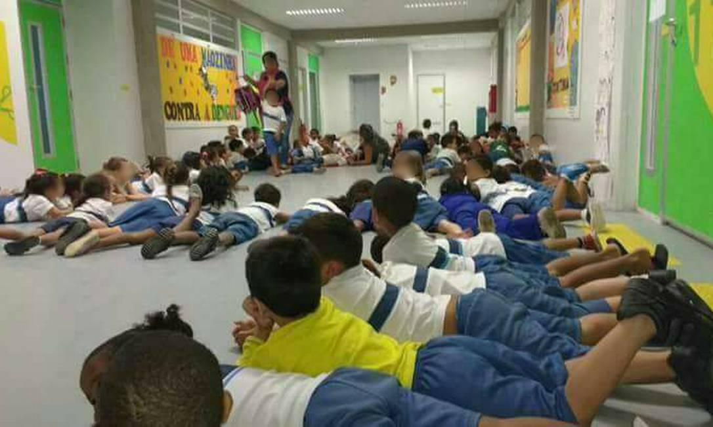
Children and teachers lie on the ground to protect themselves from gunfire in Maré.

The high levels of violence directly affect the situation of insecurity in schools and the way students travel to them. In addition to the risk to life, the presence of armed confrontations during school hours directly affects access to education and the well-being of students and teachers.
Despite the regulation of a 200-day school year, between 2016 and 2023, 146 days of classes were suspended and schools closed due to police operations, harming more than 23,000 students living in Maré, from nursery school to high school. These students not only missed part of the syllabus, but also lost access to school meals (two meals a day) which, in the case of many children living in poverty, is the main source of food security. This association between education and children's diets has also been found in previous studies, which point to significant damage to children's development.
Again, these are the direct effects of state neglect of children. We are talking about a problem caused by the state itself, in the way it conducts its public security policies. It is therefore the state's duty to deal with the problem it creates, without violating even more rights or holding its victims responsible.

c) Specific impacts of police operations on early childhood
In general, children in Maré are exposed to a legacy of intergenerational trauma, especially in the areas most affected by armed confrontations. In a social diagnosis of early childhood in Maré carried out in 2023, reports of children exposed to police violence were identified in all of the 16 favelas of Maré .
The routine of children aged 0 to 6 is affected by violence, according to 29.3% of family respondents, which in turn directly affects their education, mental well-being and integral growth. In 24 homes visited, where 34 children live, someone was killed by the police; in 18 homes, where 27 children live, someone was killed by armed groups; and in 9 homes, where 12 children live, it was reported that someone was killed by the police and also that someone was killed by armed groups in the area.
In addition, in 74 households with 102 children, people had already been shot, with 33 cases of "stray bullet". In 40 households, there was at least one resident in prison at the time of the survey, including parents, step-parents and siblings. In addition to these, in another 104 households, with 6.5% of children aged 0 to 6, someone in the house had already been imprisoned.
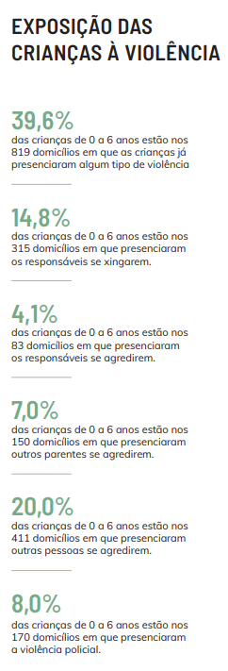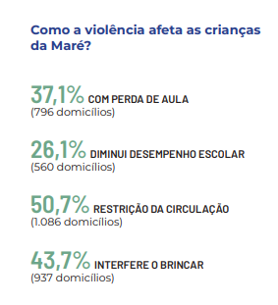
Source: Redes da Maré, “Primeira Infância nas Favelas da Maré: acesso a direitos e práticas de cuidado” 2023.

The experience of children in this territory is deeply disturbing and reflects a systemic failure to protect early childhood. Despite what the Brazilian state claims, the serious exposure of children to violence in favela contexts must be attributed to the state, which is responsible for perpetuating armed violence, either by not combating it effectively or by adopting military-militarized strategies that re-victimize residents. It is not surprising that, without specific public policies for early childhood, care strategies are created mainly in the community and family sphere, often overburdening women who exercise parental care alone.
3 - SUGGESTIONS OF QUESTIONS TO THE BRAZILIAN STATE
Considering the reality pointed out, it is necessary for the Committee on the Rights of the Child to carry out an analysis of the Brazilian state's compliance with its obligations under articles 6, 19, 28 and 39 of the Convention on the Rights of the Child, urging it to provide clarification on the legal regulations and public policies that exist to guarantee the rights of children in Brazil's urban peripheries and favela territories. With this in mind, Redes da Maré presents the following suggestions for questions to the Brazilian state:

1- Are there any rules, recommendations, resolutions or public policies in Brazil that regulate police operations carried out by public security forces at different levels of government?
2- What measures have been adopted at the federal level to monitor and hold accountable the actions of the state police, especially the Military Police, with regard to incursions into favela territories and their impact on children's lives?
3- Is there a training program in Brazil for child protection bodies, especially the Public Prosecutor's Office, bodies in the Social Protection network, Guardianship Councils and the Judiciary, to guarantee the right to life in police operations without discrimination based on housing, income, ethnicity, race or gender?
4- What efforts is the Brazilian state making to promote the rights and mental health of children in early childhood in contexts marked by armed violence?
5- What efforts is the Brazilian state making to promote the right to life of adolescents in contexts marked by armed violence?
6- What efforts does the Brazilian state make to repair the damage and trauma caused by armed violence, practiced and/or encouraged by the state, among children in favelas and urban peripheries?
7- How does the Brazilian state organize itself to guarantee the security of schools located in areas marked by armed violence and recurring police operations?
8- Is there a program for reparations and restitution for the educational losses suffered by children as a result of police operations?

IPEA, Atlas da Violência. Brasília: Ministério do Planejamento e Orçamento, 2023.
Fórum Brasileiro de Segurança Pública, Anuário Brasileiro de Segurança Pública 2022. São Paulo: FBSP, 2022.
See in: Ação Civil Pública da Maré (Processo n o 0215700-68.2016.8.19.0001 - TJRJ); Arguição de Descumprimento de Preceito Fundamental 635 (STF) e caso Cosme Rosa Genoveva, Evandro de Oliveira e outros (Favela Nova Brasília) na Corte Interamericana de Direitos Humanos.
Andrezza Paulo, “Mães das vítimas de violência armada na Maré pedem fim do ‘combate aos corpos pretos e favelados’”, Maré de Notícias, 16/03/2023.
Redes da Maré. Boletim Direito à Segurança Pública na Maré. Rio de Janeiro: Redes da Maré, 2022.
See in: Jéssica Lauritzen, “Foto de crianças deitadas em escola se protegendo de tiros gera revolta na web” O Globo Rio, 31/03/2017.
Redes da Maré, “Toda Menina na Escola”, 2023.

