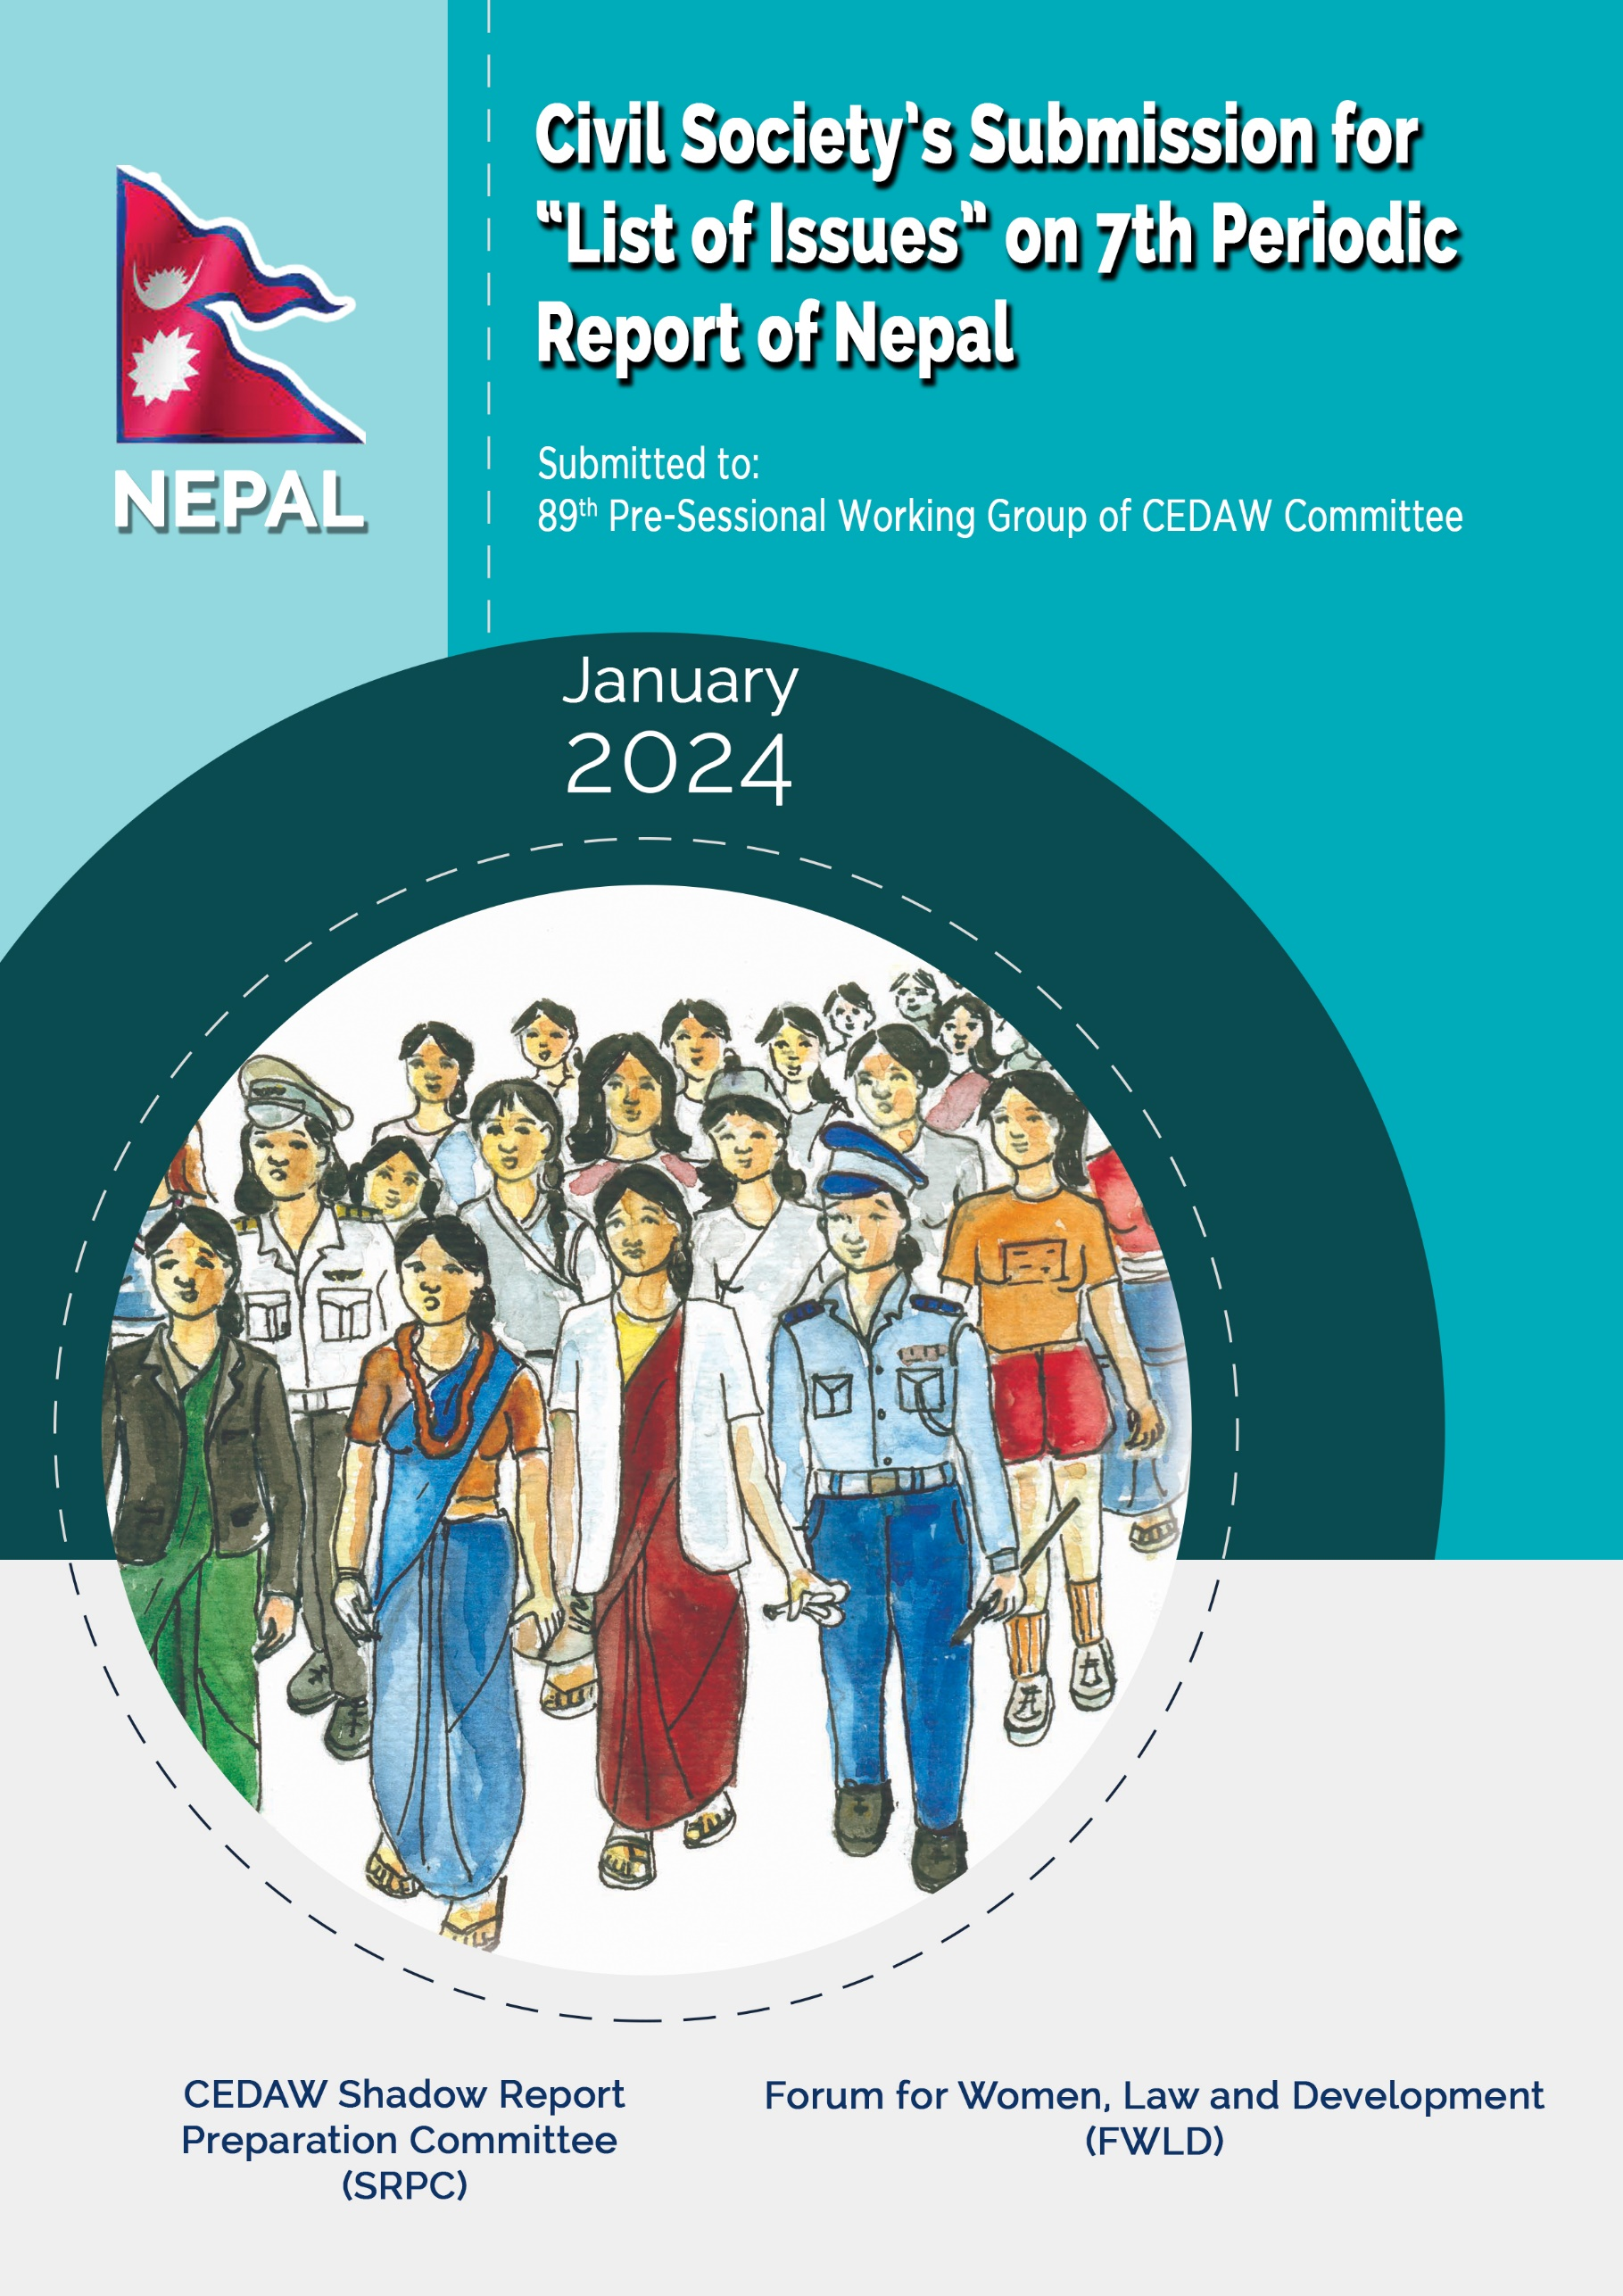

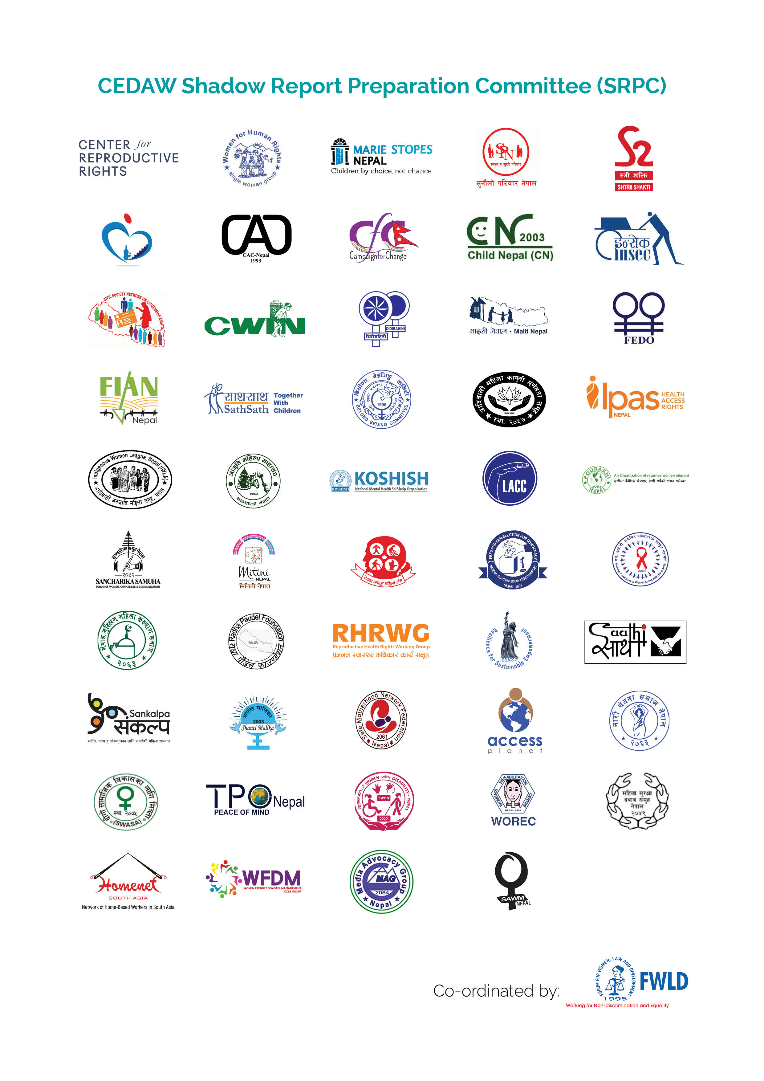
ABBREVIATION

CEDAW Convention on Elimination of All Forms of Discrimination against Women
COs Concluding Observations
CSE Comprehensive Sexuality Education
DCCHT District Committee to Combat Human Trafficking
FPTP First past the post
FWLD Forum for Women, Law and Development
FY Fiscal Year
GBV Gender Based Violence
GoN Government of Nepal
GRB Gender Responsive Budget
ILO International Labor Organization
LBTI Lesbian, Bisexual, Transgender and Intersex
MoF Ministry of Finance
MoWCSC Ministry of Women, Children and Senior Citizens
NAP National Action Plan
NCCHT National Committee to Combat Human Trafficking
NWC National Women's Commission
OCMC One-stop Crisis Management Center
SGBV Sexual and Gender Based Violence
SMRHR Safe Motherhood and Reproductive Health Right
SRPC Shadow Report Preparation Committee
UN United Nation
UNSCR United Nation Security Council Resolutions
WCOs Women and Children Officers

Introduction

This submission has been prepared by CEDAW Shadow Report Preparation Committee, a coalition of 50 civil society organizations with Forum for Women, Law and Development (FWLD) as the Secretariat. The contributors of this submission have been listed under Annex 1. This report includes information on the status of implementation of COs of CEDAW Committee on the Sixth Periodic Report of Nepal and points out issues of attention in relation to Nepal's women’s right.
FWLD has been coordinating Shadow Report Writing Process of CEDAW since the initial report in 1999, combined second and third periodic report in 2004, combined Fourth and Fifth Periodic Report in 2011, and Sixth Periodic Report in 2018. It has also submitted a report for the pre-session of the 71st session of CEDAW Committee on January 29, 2018.

Article 1

DEFINITION OF DISCRIMINATION AGAINST WOMEN

A. Implementation Status of COs
- Nepal has not adopted comprehensive anti-discrimination legislation that includes a definition of discrimination against women, encompassing elements of direct and indirect discrimination and multiple and intersecting forms of discrimination in public and private spheres, and guarantees effective remedies for victims.

B. Issues of Attention
• Absence of definition of discrimination against women in line with definition of discrimination with Article 1.
• No viable steps have been taken to address intersectional and multiple forms of discrimination of women especially multiple discrimination faced by Dalit women, women with disabilities, displaced women, women from religious minorities, LBTI, indigenous women and Madhesi women.

Article 2

STATE OBLIGATION

A. Implementation Status of COs
- Expanded the statute of limitations provision on registration of cases of sexual violence.
- Many discriminatory provisions related to citizenship, birth registration, marriage, family relation, partition of property, foreign employment in the Constitution and various Acts and Regulation have not been amended.

B. Issues of Attention
- Gender Equality has only been considered equality among male and female and not for the LBTI.
- Provision relating to statute of limitations on the registration of cases of sexual violence has not been completely removed. Additionally due to this, there is impunity in cases of conflict related sexual violence.
- Limited outreach activities to disseminate information (including disability friendly and in mother tongue) on the legal provisions and available mechanisms for gaining access to justice.
- Legal Aid is only provided to economically vulnerable people whose income is less than NRs. 40,000 annually but it does not cover socially vulnerable people such as SGBV survivor, LBTI, Dalit, displaced women, women with disabilities, indigenous women, and religious minorities.
- Lack of Universal design and reasonable accommodation structure for women with disabilities, and women and LBTI friendly infrastructures.

Article 3

ADVANCEMENT OF WOMEN THROUGH NATIONAL MACHINERY

A. Implementation status of COs
- GoN is implementing the National Gender Equality Policy, 2021; and Second NAP, 2022 on UNSCR 1325 and 1820 on Women, Peace, and Security, which focuses on localizing strategies at province and local levels, in line with federalization of Nepal’s administrative structure.
- Inadequate financial, technical, and human resources for the full functioning of the NWC.
- MoF has institutionalized the Gender-Responsive Budget Committee, and also formulated a Model Guideline for a Gender-Responsive Budget for the province and local levels. However, it is not mandatory for local and provincial governments to follow the GRB guidelines. The provincial and local levels are yet to establish a system to track gender-responsive within this budget. There is no comprehensive legislation to make GRB compulsory in the local and provincial governments.
- A committee has not been formed by the MoWCSC including NHRC, NWC, and civil societies working in women’s rights, to collect inputs while drafting laws and policies.

B. Issues of Attention
- Lack of inclusiveness in the appointment of commissioners of the NWC. Despite the Constitutional provisions, NWC is yet to establish provincial offices in all seven provinces.
- No provision for a separate and dedicated cadre in the NWC. The secretary and officials of NWC are appointed by the Federal Government, which leads to the appointment of a person with limited experience of the issue and frequent transfers of the secretary and officials.
- The government has dissolved the Women and Children Department under the MoWCSC working for the implementation of women's development programs, policy formulation, skill training, and addressing issues such as trafficking and domestic violence.
- After the adoption of federalism, the District level office of WCOs which were under the MoWCSC, was an important focal institution for advancing women and children’s rights at the local level across all of Nepal’s districts has been dissolved. Separate sections or divisions working on women’s issues were formed at each local level, however, due to limited mandate and insufficient human resources, capacities, and budgets it has prevented from working independently and effectively.
- The women development officers, who were female and had also passed the examination conducted by the Public Service Commission, are made eligible for one post promotion only. They are prohibited from participating in the examination of Public Service Commission.

Article 4

TEMPORARY SPECIAL MEASURES

A. Implementation status of COs
- No adoption of a Special Opportunity Act that includes provisions for special measures in the fields of health, education, employment, and social security.
- Despite Constitution Mandate for appraisal and review of special right by government concurrently with national census which is held every 10 years, government did not review the status of implementation of special rights of women.
B. Issues of Attention
- Failure to enact law to implement the special opportunity provision under fundamental rights of women as per Article 47 of the Constitution.
- Women from marginalized group such as Dalit, Madhesi, and indigenous communities, religious minorities, LBTI, women from geographically disadvantaged locations, women with disabilities and displaced women have lesser representations in all sectors. Intersection and vulnerability within the marginalized women has not taken into consideration in special measures.
- Gender and Sexual Minority group were deprived from opportunities as they were not categorized under the Minority group in the definition by the Constitution, all the Election laws and guideline released by Ministry of Home Affairs.
- Government has not enacted any target-based and time-bound temporary special measures in favor of women together with phase out policy where applicable.

Article 5

SEX ROLES AND STEREOTYPES

A. Implementation Status of the COs
- Law has not been enacted to explicitly prohibit the performance of unnecessary surgical or other medical procedures on intersex children before they reach the legal age of consent and train medical and psychological professionals on the rights of intersex persons.
- There are only 21 safe houses which are inadequate for the victims of GBV ; not disabled-friendly and are not accessible and inclusive to LBTI. They lack social rehabilitation and family reintegration services.
- The National Criminal Code criminalizes practicing social rites and rituals constituting caste-based discrimination. However, it does not criminalize practicing social rites and rituals constituting gender-based discrimination.
- Despite criminalizing Chhaupadi, and dismantling 8,550 chhau goths in two months its prevalence is still persistent. In the survey sampling conducted among 14–19-year-old girls in two local levels of Dailekh district, 77% still actively practice chhaupadi.
- Out of 753 local levels, only 115 have established the GBV elimination fund.
- OCMCs have been established in hospitals in all districts to support GBV victims. However, in practice, OCMCs have not been providing services to those victims who do not file an FIR.
- Nepal Police established 232 Women, Children, and Senior Citizen Service Centers. Though the establishment is a positive initiation, there is no proper physical infrastructure (equipped with separate victim rooms, and separate breastfeeding rooms) and deployment of a low number of women officers in the centers.

B. Issues of Attention
- Despite the Constitutional guarantee, no legislation has been enacted to integrate the services to survivors of GBV such as GBV funds, safe houses, and social rehabilitation making Federal, Provincial, and Local governments accountable and recognizing it as rights of survivors.
- Lack of comprehensive law to address the issues of Cyber Crime. Additionally, legal provisions addressing different forms of GBV do not include direct and indirect forms of technology-facilitated GBV.
- Separate legislation highlighting responsible journalism should be enacted to ensure the sensational reporting of GBV cases and maintain the confidentiality of the victims as it re-traumatizes victims and reinforces harmful stereotypes.

Article 6

TRAFFICKING AND EXPLOITATION OF PROSTITUTION

A. Implementation status of COs
- Protocol to Prevent, Suppress and Punish Trafficking in Person (Especially Women and Children) i.e. Palermo Protocol has been ratified by GoN on 16 June 2020.
- GoN has enacted Crime Victim Protection Act in 2018 and its Regulation in 2022. Supreme Court of Nepal also has established Victim Relief Fund in June 2020 and it has also been established in every district court of Nepal.
- The GoN has not formulated any comprehensive policy, legislative and regulatory framework to ensure monitory and legal protection of women who engages in prostitution.

B. Issues of Attention
- Palermo Protocol has been ratified but various national laws related to anti-trafficking including Human Trafficking and Transportation (Control) Act 2007 has not been amended including the definition of trafficking in line with the Palermo protocol.
- Combating Trafficking in Person needs combined efforts at all three levels of government. There is NCCHT at national level led by MoWCSC. And there were DCCHT at district level but since the Women and Children Office which operated the DCCHT was dissolved, the DCCHT has not been properly functioning. Since Nepal has been transitioned to federal system, the government has not yet formed such mechanisms. And provincial government and local government are also not obliged to form the committees as it has not been mandated by the Human Trafficking and Transportation (Control) Act 2007.
- For the effective implementation of the Palermo Protocol, the provincial and local government also have mandate to formulate laws to combat trafficking at provincial and local level. However, Lumbini province has only formulated provincial law on service and rehabilitation fund and service center and rehabilitation center establishment and operation. Similarly, Bagmati province has formulated Protection Policy but has not formulated any specific law on the issue.
- Private sector/business enterprise involvement is crucial in combating human trafficking and facilitating the socio-economic reintegration of trafficking survivors. By collaborating with private sector especially businesses, the government can create job placement programs, apprenticeships, and skill development initiatives tailored to the specific needs and capabilities of survivors.
- The GoN has not formulated law/polices to prevent violence and exploitation against women involved in prostitution. Similarly, there has been no training and sensitization programs to law enforcement officials regarding protection and support to victims in a gender sensitive manner. Although sex work is in decriminalized state in Nepal but it has not been so in practice as women involved in prostitution has been arrested by the law enforcement officials. Also, the government has not introduced exit plan for the women who wish to leave prostitution.

Article 7 and 8

Participation in Political and Public Life

A. Implementation Status of COs
- Targeted measures to achieve substantive equality between men and women in judiciary, law enforcement and diplomatic service focusing on decision making level, have not been adopted.
- Implementation of electoral quotas and composition of state entities at all three levels has not been monitored by government.
- Proportional representation system of placing candidates on an electoral list, in which women and men are alternated, was not introduced in Election held in 2022.

B. Issues of Attention
- Only 3 out of 21 judges in Supreme Court, 8,969 i.e. 11% out of 75,400 police officers and 3.8% Judiciary are women which reflects that there is under-representation of women in judiciary, and law-enforcement.
- 2.39% women mayor/chairperson, 92.65% women vice-chair/deputy mayor, 0.90% women Ward chairperson were elected in 2017 Local Level Election and there is no significant change in the number as only 3.32% of the mayor/Chairperson, 74.63% of elected Vice-chairperson/Deputy mayor and 1.02% ward chairperson are women in 2022 Election. Women elected in parliament decreased from 34.91% to 33.09% from 2017 to 2022 and only 36.36% of women were elected in Provincial Election. These representations were ensured through the proportional electoral system (indirect) and not through FPTP (Direct). Thus, no additional effort has been made by the government to ensure the participation of women in political and public life.
- Despite legal requirement of at least one Dalit women member in ward committees, 170 seats for Dalit Women were vacant in 2022 Local Level Election which reflects the challenges of Dalit women in participating in political and public life.

Article 9

NATIONALITY

A. Implementation Status of COs
- Amendments were made in 2023 to the Nepal Citizenship Act, 2006 and the Regulation 2006 to align with Constitution of Nepal (2015) which ensures citizenship certificates to children of Nepali citizenship mother if the father is unidentified as well as children of Nepali citizens if one of them had acquired citizenship of Nepal by birth and both the parents are Nepali citizens.
- National ID and Civil Registration Act, 2020 and National ID and Civil Registration Regulation, 2021 came into force, allowing for the registration births through mother or father.
- Failure to implement the recommendation made to adopt amendments or repeals the discriminatory provisions in the Constitution of Nepal and other citizenship related laws of Nepal in order to guarantee that Nepali women independently can confer citizenship to their children independently and to their foreign spouses under same conditions as Nepali men.
- COs on establishing a complaint mechanism for citizenship application denials remained unimplemented.
- No national campaigns for the distribution of citizenship certificate were conducted to bridge the gap of people mainly women, lacking citizenship certificates to ensure proof of nationality.
- Nepal has not initiated process of accede to the 1954 Convention relating to the Status of Stateless Persons and the 1961 Convention on the Reduction of Statelessness.

B. Issues of Attention
- Failure to acknowledge independent existence of Nepali women as mothers, is evident in Article 11(5) of the Constitution. Article 11(5) mandatorily requires that a child of a Nepali mother must be born and reside in Nepal for the Nepali mother to grant citizenship to her children by descent in cases where the father is unidentified. However, if the father is later identified as a foreign citizen, citizenship is subject to conversion into naturalized status, disproportionately impacting women's individual identity.
- Article 11(7) of the Constitution stipulates that a child born to a Nepali woman married to a foreign spouse is only eligible for naturalized citizenship, while a child of a Nepali man married to a foreign spouse is entitled to full citizenship by descent.
- Article 11(6) of Constitution and sections 5(1) and 5(4) of the Nepal Citizenship Act, 2006 permit Nepali men to transmit citizenship to foreign spouses immediately, whereas Nepali women are not allowed the right to confer citizenship to foreign spouses through marriage.
- Requirement of self-declaration by Nepali mothers for citizenship for their children when the father is unidentified, with associated penalties up to 3 years imprisonment if it is proved false later , unlike Nepali fathers, who do not need to make such a declaration.
- 2023 amendments to the Nepal Citizenship Act and its Regulation, 2006 do not ensure the right of transgender or intersex persons, who acquired citizenship previously as male or female to amend their sex and name in the citizenship certificate due to which only limited people have been able to exercise this right.
- Gender and sexual minorities are subjected to a mandatory and degrading medical examination process for gender identification to obtain citizenship under “other” category in practice.
- Non-implementation of court decisions and precedents, coupled with persistent discrimination perpetuated by a patriarchal mindset by the authorities, hindering women from exercising equal citizenship rights in practice.
- Though the law permits the mother or father to register birth of a child, a police report is mandatory, in cases where the father is missing or unidentified, no such document is required for the father when registering his child.
- Despite the fact that law enables a mother or father to register the birth of their child, the mother’s independent right to register the birth of the child is still restricted through administrative procedures as online application mandatorily requires the information of the father of the child and without it, the application for registration cannot be submitted. The 2021 Nepal Census sows that 26 percent of children under five years of age do not have birth registration certificates.
- Insufficient application of the universality principle in birth registration excludes children whose parents lack legal identity documents, particularly children of stateless persons, refugees, migrants or sex workers from being registered at birth.

Article 10

EDUCATION

A. Implementation Status of COs
- Appointed trained school health workers (nurses) in schools.
- Educational institutions are not yet girls, LBTI, and disability friendly.
- No measures taken for safety issues for girls in and out of education institutions and effective investigation and prosecution against acts of bullying, harassment, or GBV.
- Disproportionate number of female teachers from primary to university levels.

B. Issues of Attention
- School Management Committees on education from national to provincial to local level lack representation of women and other marginalized groups.
- Curriculums and course books provoking stereotypes on gender, disability and HIV still exist.
- Adolescent girls face numerous and diverse range of barriers to access education that impact their lives, health and hinder the realization of their human rights requiring barriers faced by out-of-school adolescent girls, especially from marginalized communities to be identified and mitigated.
- The evolving scenario of technology and innovation, especially digitalization is availing new opportunities for expanding access to essential information and services, however such opportunities are not capitalized to accelerate reach to both in-school and out-of-school adolescent girls and young women.

Article 11

EMPLOYMENT

A. Implementation Status of COs
- On March 22, 2023, government expanded the Social Security Fund to include migrant workers and self-employed, however workers in informal sector are not included in the scheme.
- Ban on women workers below age 24 and lactating mother of child below 2 years from seeking foreign employment for domestic work has not been lifted but in 2020 Parliamentary Committee on Commerce, Labor and Consumer Welfare of the Federal Parliament set seven pre-conditions for going to foreign employment as domestic work which is near impossible to implement.
- Regulation of Sexual Harassment at Workplace (Prevention) Act 2015 as well as Model Code of Conduct to ensure effective implementation of the Act has not been formulated.
- ILO Convention concerning decent work for domestic workers (C189), and International Convention on the Protection of the Rights of All Migrant Workers and Members of their Families has not been ratified by the GoN.

B. Issues of attention
- The Labor Act 2017 that provides national Labor and employment standards fails to define informal sector and informal employment. Rates of informality were markedly higher for females than for males. 90.5 percent of women workers in Nepal engage in informal employment. This raises concerns for workers’ rights and decent work conditions given inadequate inspections of workplaces, and lack of access to social security or minimum wage standards. Also, domestic work and home-based work have not been included in Labor Act.
- Contradictory provisions exist on specific laws that guarantees economic and social benefits of women. Section 45(3) of the Labor Act 2017 guarantees 60 days of paid maternity leave and Section 13(1) of SMRHR Act 2018 ensures 98 days of paid maternity leave.
- The provision of Labor Act 2017, "equal pay for work of equal value" stipulating that people should receive equal pay irrespective of gender has not been effectively implemented.
- Lack of specific measures in employment and reservation policies addressing intersectional marginalization, particularly for women with disabilities. Despite the act suggesting data collection on employees with disabilities, the absence of such provisions raises questions about workplace disability inclusion and highlights the need for more comprehensive and inclusive policies particularly in private sectors. Similarly, LBTI in Nepal face challenges in employment as they are subjected to discrimination by employers due to their prejudice against people of gender and sexual minorities community.
- Government has not taken adequate steps to address issue of harassment and violence at workplaces, with a specific focus on informal sectors such as home-based worker and the entertainment sector.
- Alarmingly very low number cases of sexual harassment have been reported despite frequent incidents of sexual harassment at workplace.
- Nepal has not ratified ILO C 177 – Home Work Convention, 1996 on home-based worker and ILOC190 – Violence and Harassment Convention, 2019.

Article 12

SEXUAL AND REPRODUCTIVE HEALTH

A. Implementation Status of COs
- The government adopted Regulations on SMRHR, 2020 and Public Health Service, 2020; Safe Abortion Service Program Management Guideline, 2021; Adolescent Friendly Health Service Operationalization Guideline, 2022 and Disability Friendly Reproductive Health and Safe Motherhood Service Guideline, 2022. Also, an Interim Guidelines for Reproductive, Maternal, Neonatal, and Child Health Service in context of the Covid-19 Pandemic, 2020 was adopted.
- The Curriculum Development Centre (CDC) of the Ministry of Education, Science and Technology (MOEST) has integrated CSE in national curriculum from Grades 6 - 10. Also, a training manual for CSE training and a CSE resource book for teachers were developed and used for both the training of teachers.
- Despite CEDAW committee’s specific recommendations “to fully decriminalize abortion in all cases…”, and government’s acceptance to recommendation received during 37th session of the Universal Periodic Report (UPR) “to decriminalize abortion and concretely protect the rights and sexual and reproductive health of women and girls, no substantive measures has been taken by the government to remove restrictive abortion provisions from the National Criminal Code and SMRHR Act that leads to the prosecution of women and girls for undertaking abortion.
- The government report reveals that “[t]he GON has expanded Comprehensive Emergency Obstetric and Newborn (CEONC) sites to all 77 districts of Nepal”. However, in practice more than 1 amongst 5 women, particularly from rural and poor settings, are compelled to deliver beyond institutional settings; and instances of women delivering without any skilled attendant on roads are rampant in the media reporting that challenges their dignity during pregnancy and childbirth.

B. Issues of Attention
- Even though CSE is integrated in the national curricula, the subject in which most of the CSE content is integrated became optional for Grades 9 – 10, that effectively reduces the amount of CSE that will be provided through school education, as it will not be taught at all in some schools and, where it is taught, students may opt not to take it.
- In the pretext of restrictive abortion provisions that possess continued risk of legal prosecution and imprisonment against women and service providers on a charge of “illegal abortion” in any circumstances, the access to safe abortion services is denied even under legal conditions. Further, the SMRHR Act prohibits abortion beyond 28 weeks of pregnancy even to save woman’s life. However, no concrete action from the government has been taken to reform the SMRHR Act to fully decriminalize abortion in all cases, and to repeal abortion related provisions from the National Criminal Code.
- In line with the recommendation of the WHO Abortion Clinical Guidelines, the Safe Abortion Service Program Management Guideline, 2021 has provisions related to expanding safe abortion services through self-managed abortion and telemedicine, however, there is generic reluctance on the part of the government to implement these provisions.
- Despite guaranteeing safe motherhood and reproductive health as a fundamental right, and progressive provisions of SMRHR Act that makes reproductive healthcare services free of cost at all government health facilities, requires all levels of governments to allocate a specific budget for reproductive health services, and provides for a reasonable amount of compensation to the victim of an offence committed under the Act, there is a rampant media reporting related to unsafe deliveries by women on the road without any skilled attendance. However, the government has not taken any concrete actions to address barriers faced by women to access safe and institutional deliveries, and thereby failed to uphold Nepalese women’s right to dignity during pregnancy and child birth.
- The prevalence of infertility among Nepali married couples ranges between 12 and 15 percent. However, services related to infertility has not been recognized as SRHR issue. Despite Supreme Court’s order to introduce a law related to AR, including surrogacy, there is no initiatives made so far in this regard.
- Even though there are numerous laws including, Disaster Risk Reduction and Management Act, 2017, SMRHR Act and Public Health Service Act, 2018, these laws do not ensure SRHR services as essential services, including during humanitarian situation that is critical to protect and promote SRHR of women, girls and other marginalized communities.
- Adolescent girl’s evolving capacity and their ability to consent, including on matters pertaining to their sexuality is denied due to lack of generic recognition of their rights to bodily integrity and autonomy.
- In order to end the AIDS epidemic, Nepal has set its national target to reach 95-95-95 by 2030 which simply aims to diagnose 95% of all HIV-positive individuals, provide antiretroviral therapy (ART) for 95% of those diagnosed and achieve viral suppression for 95% of those treated by 2030, however, such target is far behind from reaching.

Article 13

ECONOMIC AND SOCIAL LIFE

A. Implementation Status of COs
- As women's ownership of properties has increased, implementation of their
Right to own property has followed a gradual course. 23.8% of households, up 1.1% from the National Census 2011 had their land and home registered in the names of women.

B. Issues of Attention
- Despite constitutional provisions and national policy arrangements towards women's access to participation, resources, socio-economic transformation, it has been challenging to realize those provisions in practice due to inadequate access to information, lack of proper institutional mechanism, patriarchal mindset, discriminatory gender norms and practices.
- Lack of civil documents (Single Women, LBTI, Dalit women, Women with Disabilities and Indigenous women) has been hindered the access to Social and economic benefits from governments.

Article 14

RURAL WOMEN

A. Implementation Status of COs
- Nepal’s 15th Five-Year Plan has given higher priority to gender equality through more consistent planning around implementing various policies and programmes. The major thrusts include women’s dignified life through equal participation and active leadership, enhanced access to and control over resources, and eliminating all forms of gender discrimination.

B. Issues of Attention
- Limited access to information among rural women and inadequate knowledge regarding plans and policies necessitate the establishment of rural women information and learning centers by local government mechanisms, aiming to use of technology and disseminate the information in local languages throughout municipalities with the widely enhance awareness of relevant policies and provisions.
- More than 74 percent of women work in agriculture. Rural women play a significant role in agriculture, poverty indicators illustrate persistent inequalities in terms of poor outcomes for indigenous, Dalit, Madhesi and Tharu women, women of “oppressed classes”, widows in the Hindu community. COVID-19 has imposed adverse impacts on Rural women’s economic empowerment, closures of small local markets have left women vendors unable to sell their products, while women-run microenterprises are hard hit, with many unable to pay or get loans.
- Lack of Universal design and reasonable accommodation structure focusing rural women with disabilities.

Article 15

EQUALITY BEFORE THE LAW

A. Implementation status of COs
- National Census 2021 recognized the population of gender and sexual minority beside women and men and incorporated their data.

B. Issues of Attention
- Section 81(2) of National Civil Code states that the surname of married woman shall be that of husband in case of any question is raised.
- Section 111(5) National Civil Code states that in case any question is raised on a child’s surname, it shall be considered that the child is using father’s surname.
- Section 87 of the National Civil Code states that the wife’s residence shall be considered to be that of husband’s.
- In case any question is raised regarding the address of a child, the child’s address shall be that of father’s.
- Despite legal equality, women, particularly married daughters, are still not considered as an independent coparcener to the ancestral property in practice.
- Women with disabilities are not considered eligible to have insurance policy, to have certain facilities like ATM cards in case of visually impaired people and are compelled to be accompanied by a guardian to hold legal ownership of any properties.

Article 16

MARRIAGE AND FAMILY RELATION

A. Implementation Status of COs
- Following the recommendation made by CEDAW COs to harmonize legal provision of National Criminal Code and National Civil Code pertaining to child marriage, the contrary legal provisions have been harmonized as of right now. However, despite the harmonization of the legislation, the legal provision of prosecuting and penalizing the children in the cases of child marriage exists.
- The provision of National Civil Code on concluding marriage if a child is born from physical contact has been reviewed as per the CEDAW COs stating that marriage will not be considered to be legally conducted if polygamy persists.
- The Supreme Court on 28th June 2023 issued an interim order to maintain a temporary documentation regarding registration of same sex marriage. Two ward offices have already registered same sex marriage as per the interim order.

B. Issues of Attention
- National Criminal Code criminalized child marriage i.e. marriage concluded below the age of 20 and states that nobody should either engage in or arrange underage marriage. This provision prosecutes children who enters into the marriage.
- National Census of Nepal, 2021 shows that 22.3% of people who get married for the first time between ages of 15 and 17 are 22.3%. 0.3% of people who had their first marriage are under age of 10. Likewise, 7% of those who get married for the first time at age of 10-14 years, and overall average age at first marriage is 19 years, including 21 of men and 18 for women. Despite the National Census data, only 52 cases of child marriage have been registered in FY 2021/22. This data shows that cases of child marriage is still highly under reported.
- National Civil Code states that a woman bearing a child is automatically married to father of that child. This provision deprives women from their right of entering into marriage with their free and full consent.
- The husband is not be compelled to provide partition share or alimony to the wife if divorce is caused due to wife, whereas wife is to provide such to husband even if divorce is to be caused due to husband. This provision proved to be discriminatory.
- Even though women’s right to property has pursued a progressive path, daughters, LBTI, women with disabilities and women living with HIV and AIDS have not yet been regarded as coparcener of paternal property.
- The National Civil Code states that a marriage shall be concluded if a man and a woman accept each other as the husband and wife. This definition of marriage is narrow and has not ensured right to marriage of ‘other’ and non-recognition of marriage equality.
- The National Civil Code on providing custody of child after end of matrimonial relationship of a husband and wife gives to mother or father. However, Section 115(b) of the Code makes the custody to mother conditional on entering into another marriage which discriminates mother from having same rights and responsibilities as parents irrespective of their marital status in matters relating to the children.

Annex

Contributors

- Aava Chettri
- Binu Lama
- Deepesh Shrestha
- Didkiksa Singh
- Dipa Khanal
- Laxmi Nepal
- Madhu Gurung
- Mohan Dangal
- Nabin Kumar Shrestha
- Narayani Thakuri
- Prabhakar Shrestha
- Prakriti Karki
- Purna Shrestha
- Rama Dhakal
- Ritu Thapa Magar
- Rojina Shrestha
- Roshana Pradhan
- Sabin Shrestha
- Sagar Pathak
- Sajana Adhikari
- Sajani K.C.
- Santosh Chaudhary
- Seema Dhami
- Shanti Tiwari

Coordinated by : Forum for Women, Law and Development (FWLD)

Section 229(2) of National Criminal Code was amended in 2022 which increased the statute of limitation from 1 year to 3 years in case of a person with disabilities, minors from their age of majority, women above the age of 70 years, and 2 years, in the case of adult women.
Ibid.
https://mof.gov.np/site/publication-detail/3263
https://nwc.gov.np/wp-content/uploads/2023/12/For-Website-Book-1.pdf
https://nwc.gov.np/en/
Ibid
Section 7(14), Civil Service Act 1993
Article 281, Constitution of Nepal.
Article 38(5), constitution of Nepal
Article 306(1)(a), Constitution of Nepal.
Section 2(b), National Assembly Election Act, 2018, 2(b) Provincial Assembly Election Act, 2018, 2(c) Local Level Election Act, 2016.
Nepal's Seventh Periodic Report on CEDAW
The study by NFD in 2020 found that 67 % of women with disabilities were victims of violence, but the rate of complaints was only 16 %, available at https://www.khulamancha.com/english/news/8769
Section 165 of National Criminal Code, 2017
Section 168 (3) of National Criminal Code, 2017
Nepal's Seventh Periodic Report on CEDAW
“What’s missing in MHM? Moving beyond hygiene in menstrual hygiene management”, Sexual and Reproductive Health Matters, Volume 27, 2019 - Issue, available at (https://www.tandfonline.com/doi/full/10.1080/26410397.2019.1684231?scroll=top&needAccess=true)
https://thehimalayantimes.com/nepal/gbv-prevention-fund-established-in-only-115-local-levels
https://www.nhssp.org.np/NHSSP_Archives/gesi/OCMC_Operational_manual_2067_2016.pdf
Nepal's Seventh Periodic Report on CEDAW
Ibid
Article 21, Constitution of Nepal
Out of 4686 victims of cybercrime 2531 are girls and women, Annual Fact Sheet on GBV ,July/Aug 2021 to Jun/July 2022, Nepal Police, available at https://www.nepalpolice.gov.np/media/filer_public/bc/d0/bcd064f5-284a-492a-b424-def0a6800de2/fy-2078-79-annual-infographics-en.pdf
Human Trafficking and Transportation (Control) Act 2007, Foreign Employment Act 2007, Organized Crime (Prevention) Act 2014, Immigration Act 1992, Extradition Act 2014, Legal Aid Act 1997, Labor Act 2017, Mutual Legal Assistance Act 2014, Passport Act 2019, Child Labor (Prohibition and Regulation) Act, 2000, Assets and Goods related to Offence (Freeze, Control and Confiscation) Act, 2014
https://www.ceslam.org/news/call-to-form-local-and-provincial-bodies-to-fight-human-trafficking published on September 2019
https://www.unodc.org/e4j/en/tip-and-som/module-10/key-issues/the-private-sector.html
https://thehimalayantimes.com/kathmandu/police-intensify-crack-down-on-sex-workers published on August 2019
supremecourt.gov.np
https://pahilopost.com/content/20230308090204.html
https://english.onlinekhabar.com/nepali-judiciary-is-dominated-by-men-it-must-change.html
Section 18(1)(b), the National ID and Civil Registration Act, 2020
The study shows that 26% of women lack citizenship certificate of Nepal whereas 13% men lack it. FWLD, ACQUISITION OF CITIZENSHIP CERTIFICATE IN NEPAL, 2014, p. 15
Section 8 (A1), the Nepal Citizenship Act, 2006
Section 21(3C), the Nepal Citizenship Act, 2006
Gender identity has been categorized as Male, Female and Other in the Citizenship Certificate.
https://theannapurnaexpress.com/story/47046/?mibextid=xfxF2i
The National ID and Civil Registration Act, 2020 and the National ID and Civil Registration Regulation, 2021
Necessary Documents to be Included in Birth Information Form, Annex 10, the National ID and Civil Registration Regulation, 2021
Section 18(1)(b), the National ID and Civil Registration Act, 2020
https://public.donidcr.gov.np/BirthRegistrationMain/BirthRegistrationMain?p=ob%2BACF2rxqibas5x2EjHV A%3D%3D
National Population and Housing Census 2021 Available at: https://censusnepal.cbs.gov.np/results/population#birth_reg
Directive on the Management of Sending Domestic Workers for Foreign Employment, 2015
The preconditions included the existence of strong laws for protection of migrant domestic workers, existence of bilateral agreement with the destination countries that ensure basic rights such as wages and leave, inclusion of domestic migrant workers in the social security mechanism of the destination country, provision of occupational safety and health, working hours and additional benefits for extra work, and a 24-hour insurance coverage at the workplace.
Report on the Nepal Labor Force Survey 2017/18, National Planning Commission Central Bureau of Statistics, https://nepalindata.com/media/resources/items/20/bNLFS-III_Final-Report.pdf
Section 7, Labor Act 2017
The Kathmandu Post, Wage gap between men and women persists https://tkpo.st/3guUO5D [Accessed on 28th December 2023]
The Act relating to Rights of Persons with Disabilities, 2017, lacks clear directives regarding the representation of persons with disabilities and specifically women with disabilities.
Evidence to Action: Addressing Violence against LGBTIQ+ People in Nepal, UN Women, 2023, p. 50-51
Dignified and Violence-Free World of Work: A Study of Women Working in Informal Sectors in Nepal, Care Nepal, p.8 accessed on https://careevaluations.org/wp-content/uploads/MbW_Nepal-informal-sector-DW-study_2021.pdf
Experiences of Sexual Harassment among Nurses in a Tertiary Hospital, Journal of Advanced Academic Research (JAAR), Vol. 9, No. 1, March 2022, pg. 21
CEDAW Concluding Observation 2018, Para 39(b) https://documents-dds-ny.un.org/doc/UNDOC/GEN/N18/378/89/PDF/N1837889.pdf?OpenElement, p. 14 (viewed on January 2, 2024)
No. 159.135, suggested by France during the third cycle of Universal Periodic Report (UPR) – Report of the Working Group on the Universal Periodic Review Nepal, rec. 6.135, U.N. Doc. A/HRC/WG.6/37/L.7 (2021). file:///C:/Users/dell/Downloads/Recomendation%20UPR%20-%20Decrimalization%20on%20Abortion%203%20Cycle%20-%2037%20Session%20(159.135)%20(Page%20no.%2019).pdf (viewed on January 2, 2024)
Decriminalization of Abortion in Nepal: Imperative to Uphold Women’s Rights. Factsheet 2021. https://fwld.org/wp-content/uploads/2021/06/Decriminalization-of-Abortion-in-Nepal_02June021_-Final-Version.pdf (view on January 2, 2024)
CEDAW Committee; Seventh periodic report submitted by Nepal under article 18 of the Convention, due in 2022. Date received on 5 July 2023. https://www.ecoi.net/en/file/local/2095255/N2323006.pdf
Nepal Demography and Health Survey 2022, Key Indicator Report, p. 26: 79% of live births and still births in two years proceeding the survey were delivered in health facilities. https://mohp.gov.np/uploads/Resources/Nepal%20Demographic%20and%20Health%20Survey%202022%20Key%20Indicators%20Report.pdf
Nepali Times, News Coverage on April 4, 2022 https://nepalitimes.com/here-now/born-by-the-roadside-in-nepal?fbclid=IwAR00rqIoBR4wRSSBEZhE8-ezZtI5uGGwp-t-nzWuR-yG-CCYqvxmXecBE7s The Himalayan Times, Published at December 6, 2023 https://thehimalayantimes.com/nepal/bajura-mothers-delivering-babies-on-remote-roads-due-to-lack-of-access-to-maternal-health-services?fbclid=IwAR2_JFYCqcgLJGtUWtg21dxTOjh1N6eTUA7tjTjEdqH1wTXInAm4r32oLbw The Raising Nepal, News Coverage on July 13, 2023: Baby delivered in the middle of Dadeldhura Jungle. https://risingnepaldaily.com/news/29365?fbclid=IwAR2WYDUO-2LFXt_UYKTCDakvXGJlkHlYDY9S6Nrx1Ups7H10cawGWa51pew
Abortion Care Guideline, 2022 0f WHO (ISBN 978-92-4-003948-3: Recommendation no. 48 (Telemedicine approaches to delivering medical abortion care), page no. 95. https://iris.who.int/bitstream/handle/10665/349316/9789240039483-eng.pdf?sequence=1&isAllowed=y
The Safe Abortion Service Program Management Guideline, 2021, para 3, no. 4 (Justification), p. 3
The Constitution of Nepal (2015), Article 38(2).
The Kathmandu Post, published at August 6, 2022: Mind the legal gap. https://kathmandupost.com/columns/2022/08/06/mind-the-legal-gap
Pushpa Raj Pandey v Office of Prime Minister, Ministry of Health and Population including others (writ no. 072-WO-0119) and Prabin Pandak v Office of Prime Minister and others (writ no. 072-WO-0120), decision date: August 25, 2015 (https://myrepublica.nagariknetwork.com/news/sc-quashes-all-surrogacy-petitions/)
National Census Report, 2021
The Fifteenth Plan (Fiscal Year 2019/20 – 2023/24), GoN National Planning Commission
Nepal Gender Equality and Social Inclusion Analysis, 2020
World Bank, 2019
Nepal Human Development Report 2020
Women with disabilities in Nepal; Photovoice study on the barriers and enablers to social, economic and political inclusion, 2022
2928 has been recorded by National Census, 2021.
National Civil Code, 2017
Dang District Court in 11th July 2023 held that partition right of married daughter is not an absolute right and held that it is a relative right, consequently denying them their partition right in ancestral property.
CEDAW Concluding Observation, Sixth Periodic Report of Nepal, 2018, 18(b)
National Criminal Code 2017, Chapter on Offense relating to Marriage, Section 173
National Civil Code 2017, Chapter on Marriage, Section 74
CEDAW Concluding Observation, Sixth Periodic Report of Nepal, 2018, 43(a)
National Civil CODE 2017, Section 74(2)(d)
https://www.gendergp.com/nepal-same-sex-marriage/
https://www.bbc.com/news/world-asia-67574710
National Criminal Code 2017, Chapter on Offense relating to Marriage, Section 173
https://myrepublica.nagariknetwork.com/news/male-female-ratio-at-birth-widening/?categoryId=opinion
https://www.nepalpolice.gov.np/media/filer_public/71/ed/71edd99d-a91a-47e5-9e86-a0626d52198e/police-mirror-f-2022.pdf
National Civil Code 2017, Chapter on Marriage, Section 74
National Civil Code 2017, Section 94 (Husband may effect divorce) (b) If the wife deprives the husband of maintenance costs or expels him from the house National Civil Code 2017, Section 99 (Partition of property to be effected before divorce) (6) Notwithstanding anything contained elsewhere in this Section, if a petition is filed for divorce on the ground referred to in clause (b), (c) or (d) of Section 94, the husband shall not be compelled to provide partition share or alimony to the wife pursuant to this Chapter.
National Civil Code 2017, Chapter on Marriage, Section 67
Gender Identity has been categorized as male, female and others in the citizenship certificate.
National Civil Code 2017, Chapter on Relationship of Mother, Father and Son and Daughter, Section 115
Ibid. Section 115 (b): In the case of a minor above five years of age, except where the mother has concluded another marriage, under the custody of the mother, if she so desires.

